Analysing Argumentation Structures
  - A Minimalistic Annotation Scheme for Argumentation Structures (v1.0)
Sebastian Cacean
2026-09-11
Table of contents

Introduction
Welcome to MAnnoSAS (A Minimalistic Annotation Scheme for Argumentation Structures). This manual is written for annotators who will analyse argumentative texts by identifying argumentative components and the support or attack relations between them.
The central challenge of this task is that argument analysis is not purely mechanical. Different competent readers can arrive at different but plausible interpretations of the same text. MAnnoSAS is designed to reduce this variability without demanding advanced training in argumentation theory. Its goal is not to eliminate interpretation entirely, but to narrow it in a transparent and reproducible way.
In practical terms, this manual supports a reliability-oriented annotation process. You will learn how to identify argumentative units, how to decide whether one unit supports or attacks another, and how to handle difficult boundary cases that often produce disagreement across annotators.
The scheme is intentionally minimalistic:
- it focuses on macrostructure (how parts of a text are argumentatively connected),
- it uses relational categories (support and attack),
- it is non-reconstructive (you are not asked to rewrite arguments into formal premise-conclusion form).
The remaining chapters are organised as a step-by-step guide:
- Chapter 1 introduces reason maps and explains how argumentation structures can be visualised.
- Chapter 2 presents the two core annotation tasks: identifying argumentative units and identifying support/attack relations.
- Chapter 3 introduces the running examples used throughout the manual.
- Chapter 4 gives criteria for identifying argumentative units (including linguistic cues, cotext, and distinctions such as justificatory vs. explanatory reasons).
- Chapter 5 explains how to individuate argumentative components, including difficult cases such as reformulations and scattered components.
- Chapter 6 focuses on identifying the target of support and attack relations.
- Chapter 7 answers frequently asked questions and addresses recurring annotation problems.
You should treat this manual as a practical decision aid: when in doubt, follow the explicit rules and clarifications given here, and apply them consistently.
If you work through the manual in order, you will have a compact set of tools for producing annotations that are both interpretable and comparable across annotators.

1. Visualising Argumentation Structures with Reason Maps

1.1 Argumentative Texts
What are argumentative texts and their argumentation structures? A text is argumentative if it contains, among other things, reasons and arguments in favour of one or more claims. It can also contain objections to these arguments and claims, along with refutations of those objections. The term argumentative component will be used as an umbrella term for these different elements. Text segments that formulate argumentative components will be referred to as argumentative units. In other words, an argumentative unit is a text segment that expresses an argumentative component. This distinction is important since different argumentative units can express the same argumentative component. For instance, a claim can be expressed by different text segments in a text.
Essays are typically argumentative. But argumentation can also be found in other texts, such as newspaper articles, scientific articles, transcribed interviews, forum entries, text messages, tweets, blog posts and books.
Argumentative components are usually related to each other by argumentative relations. For instance, an objection is usually directed at a specific argument or claim, and a refutation is usually directed at a specific objection. The argumentation structure of an argumentative text refers to the set of the text’s expressed argumentative components together with the different argumentative relations between them.
Let us have a look at the following hypothetical dialogue:
Clint: I think we should all follow a vegetarian lifestyle.
Audrey: Why?
Clint: Because most mass meat-farming techniques are torture to animals.
Audrey: Is that so?
Clint: Yes! There is good evidence that animals feel fear and pain like us. Mass meat-farming techniques force animals living in them to have an unnaturally short, miserable and confined life.
Clint begins by formulating a claim about vegetarianism, and Audrey challenges this claim by asking for a justification. Clint answers this request by providing a reason or, in other words, an argument in favour of that claim. For this guideline, we shall not distinguish between reasons and arguments. We will treat the two concepts as more or less interchangeable. What is important, though, and exemplified in the dialogue above, is that arguments and reasons are always relational. A reason is always a reason for another statement; similarly, an argument is always an argument in favour of another statement. Therefore, a complete description of an argument (and a reason) should be formulated in the following standard form:
 Reasons in their standard form
x is a reason/argument for y.

Identifying an argument (or a reason) demands identifying both relata ‘x’ and ‘y’. In the above example, we can consider Clint’s answer to Audrey’s first question as a reason (x) for his initial claim (y).
Audrey reacts to Clint’s answer by demanding another justification, and Clint willingly provides a further reason. But for which claim is Clint’s last answer a reason? Without the cotext of Clint’s second answer—that is, all that was said besides this answer—we can easily imagine the answer as another reason for vegetarianism. However, the way the dialogue proceeded, another interpretation is more appropriate: Audrey’s second question refers to Clint’s first answer. She asks whether mass meat farming is torture for animals. Clint answers in the affirmative and justifies why mass meat farming should be considered torture. In this particular dialogue context, the second answer should, therefore, be considered a reason for the first answer.

1.2 Reason Maps
We can thus describe the structure of the argumentation as follows: The argumentation contains a claim for which a reason is presented, and this reason is itself backed up by an additional reason. Figure 1.1 is a reason map, which visualises the main claim, reasons and their relationships to each other. As we will see, reason maps can get more complex.
The nodes of a reason map represent text segments of the dialogue that express argumentative components, and the argumentative relations between them are visualised by arrows. Green arrows represent so called support relations. If a text segment x is presented as a reason or argument for another text segment y, then there is green arrow from x to y.
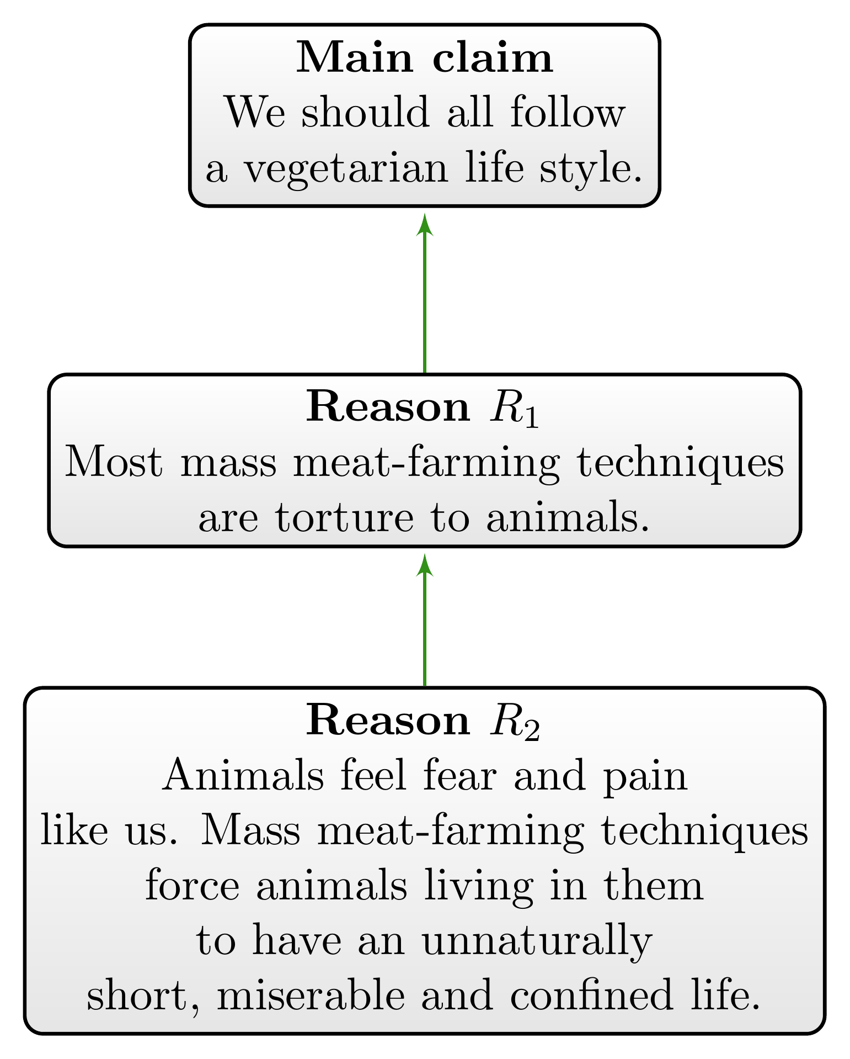
Figure 1.1: Graphical representation of supporting reasons as a reason map.
So far, the dialogue’s argumentation structure is simple. Let us look at the following more complex continuation of the dialogue:
Audrey: But even if that were true, there are alternative ways to breed animals. Grass-fed meat comes from animals raised in open grass pastures and not confined to these cramped living spaces.
Clint: Yes, but there are other reasons to be a vegetarian. Animal farming produces more greenhouse gas emissions than the world’s entire transport system, and these greenhouse gases are causing a dangerous climate change.
Audrey begins by raising an objection. Similar to reasons, objections are relational: An objection is always an objection to another argumentative component and should be described in some standard form (e.g., ‘x is an objection to y’), which makes the relata of that relation explicit. Often, an objection to y is a reason that y is false or implausible.
So, what is the nature and target of Audrey’s objection? She does not question that animals feel fear and pain when they grow up in meat farms. As a consequence, the target of her objection is not the second reason ($R_{2}$). But she formulates a reason that animal suffering is not a sufficient reason for becoming a vegetarian since there are alternatives to mass-produced meat that avoid the suffering of animals, or so her reasoning goes. Hence, the target of Audrey’s objection is Clint’s first reason ($R_{1}$) because her objection questions the relevance or sufficiency of $R_{1}$.
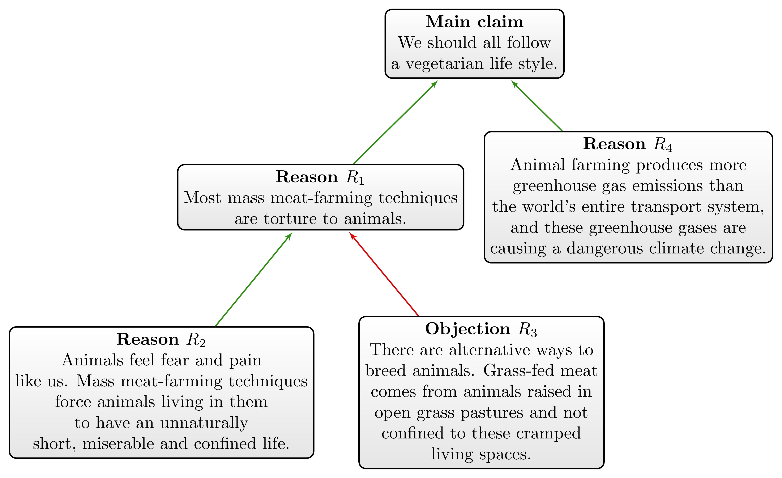
Figure 1.2: Graphical representation of the dialogue’s argumentation structure as a reason map.
Objections will be visualised in a reason map by an attack relation represented by a red arrow, as illustrated in Figure 1.2.
Clint’s point about greenhouse gas emissions illustrates that reason maps can be more branched than the simple serial reasoning we began with (see Figure 1.1). His reply to Audrey does not refute her objection ($R_{3}$). On the contrary, he seems to concede her point. Hence, Clint’s point is not an objection to Audrey’s reasons. Instead, he presents an alternative reason to the main claim as visualised in Figure 1.2.

2. Two Tasks of Analysing Argumentation Structures
The simple dialogue from Chapter 1 exemplifies that analysing the argumentation structure of a text involves two interdependent tasks: The annotation of text segments as argumentative components (i.e., the identification of argumentative units) and the categorisation of their interrelationships as support and attack relations.

2.1 Identifying Argumentative Units
 Tip 2.1: Annotation of argumentative unit (first task)
You should annotate a text segment x as an argumentative unit if and only if one of the following holds:
- x is presented as a justification for some other text segment y, or
- x is the target of a justification or objection.

Text segments that are formulated as arguments, reasons, objections, and refutations (i.e., argumentative components) are argumentative units. Text segments that are formulated with another function (e.g., as a question, an explanation, a description, a narrative, etc.) are not argumentative units. For instance, Audrey’s critical questions are not argumentative units since they do not formulate reasons or objections on their own. But Clint’s replies are argumentative units. Similarly, text segments that are the target of arguments, reasons, objections and refutations are argumentative units. While Clint’s first statement (“I think we should all follow a vegetarian lifestyle.”) is not presented as a justification for some claim, other statements are presented as a justification for it.
As the above example (see Figure 1.2) illustrates, an argumentative component can be the source and the target of argumentative relations. In other words, an argumentative unit can be presented as a justification for some other argumentative unit, and, at the same time, there can be another argumentative unit that is presented as a justification for it. For instance, in Figure 1.2 $R_{1}$ is presented as a reason for the main claim and is, additionally, justified by $R_{2}$.
Statements that are neither presented as a justification nor as an objection, but that are the target of a justification or objection, are also argumentative units. For instance, in Figure 1.2, the main claim is not presented as a justification for another statement but is the target of two reasons ($R_{1}$ and $R_{4}$). In the following, we will refer to argumentative components that have only incoming relations but no outgoing relations as claims or main claims.
It is also important to keep in mind that identifying argumentative units requires understanding the author’s intentions and commitments. It is about understanding what is presented as a justification—independent of how you or someone else would evaluate the success of this presented justification.
Finally, annotating argumentative units requires the individuation of argumentative components. As an annotator, you have to determine the start and endpoint of an argumentative unit by highlighting the corresponding text segment in some way. Argumentative units can encompass sentences, clauses or even smaller units, but they will not split words. Each argumentative unit should correspond to exactly one argumentative component. If a longer text segment formulates more than one argumentative component, you have to split up the longer text segment into smaller units.

2.2 Identifying Support and Attack Relations
The first task (Tip 2.1) is the annotation of argumentative units; the second is the categorisation of their interrelationships by using attack and support relations.
Tip 2.2: Identifying support and attack relations (second task)
Categorise for each argumentative unit its ingoing and outgoing support and attack relations.

A text segment is an argumentative unit to the extent that it is presented as a reason (or objection) for some other text segment or as the target of a reason (or objection). As annotator, you have to categorise argumentative units as targets or sources of these relations and you should only use two relations:
- Support relation: If an argumentative unit x is presented as justification for some other text segment y, we will categorise this justificatory relation as asupport relation between x and y (represented by a green arrow from x to y),
- Attack relation: If an argumentative unit x is being presented as an objection or refutation of some other text segment y, we will categorise this justificatory relation as an attack relation between x and y (represented by a red arrow from x to y).
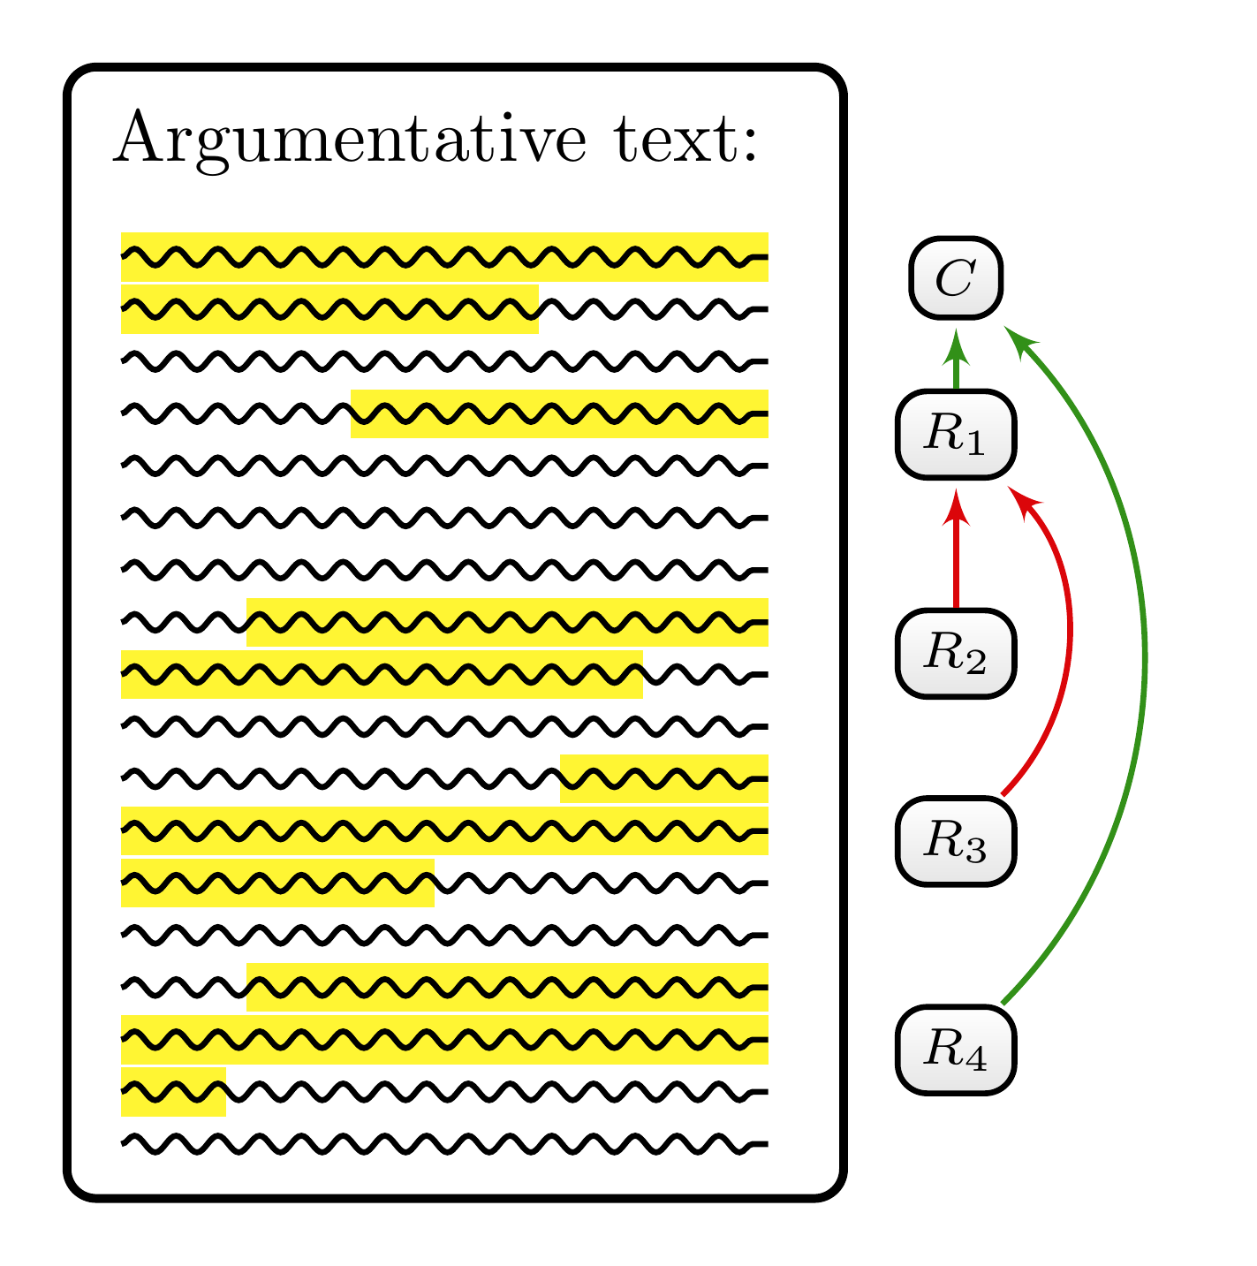
Figure 2.1: A schematic example of annotating the argumentation structure of a text. There are five argumentative units: The first one represents the main claim ($C$), which is supported by two reasons that are formulated by the second ($R_{1}$) and the fifth text segment ($R_{4}$). Both the third ($R_{2}$) and the fourth text segment ($R_{3}$) represent reasons against—that is, objections to the supporting reason $R_{1}$.
Figure 2.1 schematically illustrates the result of completing both tasks: an annotated text with identified argumentative units and with a categorisation of their interrelationships by support and attack relations.

2.3 Challenges in Annotating Argumentation Structures
To analyse the argumentation structure of a text, you have to understand the conveyed meaning of the text. Since understanding a text’s meaning is, to some extent, subjective and can differ from person to person, analysing the text’s argumentation structure is also a process of interpretation that may allow for different interpretations. In other words, the analysis of argumentation structures is interpretational in nature.
You may encounter the following challenges when analysing the argumentation structure of a text:
- First, you may find it difficult to decide whether a particular text segment is meant as a reason, objection or something else. Text segments often serve functions beyond simply formulating reasons and objections. The line between argumentative units and other types of text segments is blurry and continuous.
- Second, it can be unclear to identify the exact beginning and end point of an argumentative unit.
- Third, it can be ambiguous what the target of an argumentative unit is. In other words, it can be difficult to determine which other text segment is supposed to be justified or objected to by a particular argumentative unit. In some cases, the target of a reason or objection is not even explicitly formulated in the text.
- Finally, you may wonder whether a text segment that is formulated as a justification represents just one or several argumentative components. We will refer to this latter challenge as the problem of reason individuation.
In the following, you will be provided with clarifications and maxims that will help you alleviate the problems of interpretive indeterminacy. First, we will better understand how to delineate argumentative units from other text segments. In other words, we will have to say more about what we mean by reasons, arguments and objections and how they can be distinguished from text segments with functions other than justifying something else (Chapter 4). We will then address the problem of individuating argumentative components (Chapter 5). Finally, we will look more closely at how to determine the targets of the support and attack relations (Chapter 6). There are also minor challenges that will be addressed in the frequently asked questions section at the end of these guidelines (Chapter 7).

3. Examples Used
To provide a realistic impression of how reasons are formulated in actual debates, this guideline will use examples from online articles on two debates: germline editing and affirmative action.

3.1 Germline Editing (GE)
The GE debate concerns the use of the biotechnology CRISPR to modify the genes of gametes (eggs or sperm), fertilised eggs, and even human embryos. CRISPR is a gene-editing technology that can alter genetic material more precisely than older gene-modifying technologies. It can be applied to create genetically modified crops, develop vaccines, and treat genetic diseases. In contrast to somatic gene therapies, germline gene therapies target reproductive cells that eventually form embryos, sperm, and oocytes. One possible scenario is to use CRISPR in combination with in vitro fertilisation (IVF). After sperm is introduced into an egg in vitro, CRISPR is used to modify the genes of the fertilised egg to prevent genetic diseases such as Huntington’s disease, Tay–Sachs disease and Duchenne muscular dystrophy. The important difference between somatic and germline gene therapies is that alterations of germline cells will be passed on to future generations. The GE debate gained prominence in 2018 when the Chinese researcher He Jiankui claimed that he had used CRISPR to edit the genomes of the embryos of two twin girls born in 2018. Scientists and ethicists worldwide condemned He’s actions and raised concerns about unknown risks and side effects. The current GE debate is about the following central questions:
- Should we use GE in the future for therapeutic means? Under which conditions should GE be permitted as a therapy?
- Should we research germline editing technologies by using embryos? Under which conditions should we allow scientists to alter embryos’ genes for purposes of research? How should we regulate such research?

3.2 Affirmative Action
Affirmative action is an umbrella term for practices and regulations that seek to eliminate underrepresentation in education, employment, and politics resulting from historical discrimination based on gender, race, or religion. Affirmative action was first introduced in the United States in 1961 by President John F. Kennedy’s Executive Order 10925, which required federal contractors “to ensure that applicants are treated equally without regard to race, colour, religion, sex, or national origin.” Measures of affirmative action can differ in the means they employ and in the targeted groups.
The text snippets we will analyse concern affirmative action in college admissions at universities in the United States. The main question in this debate is whether it is permissible to include race-based categories as admission criteria to promote diversity on campus and counteract the underrepresentation of racial minorities at elite universities.

4. Identifying Argumentative Units
The definition of what counts as an argumentative component provided above (Tip 2.1) covers several different ways to formulate reasons and objections. The notions of reason and objection carry different connotations for different people, and some are irrelevant to the concept of argumentative component. The following clarifications and tips explicate to some extent the concept of argumentative component used in this guideline. They are meant to help you identify argumentative units in a consistent way.

4.1 The Irrelevance of Evaluating Reasons and Objections
Note 4.1: Clarification 1
You do not have to evaluate or assess the strength of reasons and objections.

A text segment counts as an argumentative unit, regardless of whether the presented justification succeeds. It does not matter whether a presented reason is a good reason. What counts are the author’s intention and commitments. As an annotator, you only have to ask yourself whether the author meant the text segment to represent a justification or whether they are committed to it by what they said.

4.2 The Irrelevance of the Author’s Stance
Often, an author will formulate their own stance on a particular issue. They will present their arguments and possibly try to refute other’s objections to their position. However, you may also encounter argumentative texts in which the author presents reasons and objections without revealing their own position. An author might simply describe others’ arguments without evaluating them or revealing their own stance. Understanding the author’s stance might, in some cases, help identify the reasons presented. However, whether a text segment counts as an argumentative unit is independent of whose reasons are presented.
Note 4.2: Clarification 2
A text segment counts as an argumentative unit independent of whose reasons are presented.

Example 4.1 illustrates these points.
Some people worry that it is impossible to obtain informed consent for germline therapy because the patients affected by the edits are the embryo and future generations. The counterargument is that parents already make many decisions that affect their future children, including similarly complicated decisions such as PGD [preimplantation genetic diagnosis] with IVF [in vitro fertilisation]. (NHGRI 2017)
Example 4.1
The authors do not reveal their own stance towards germline therapy. Nevertheless, we have no problems identifying text segments as argumentative units. The first sentence expresses a reason against germline therapy, and the second sentence expresses an objection to that reason. In a similar vein, we cannot determine whether the authors want to persuade the audience of something, which brings us to the following clarification.
Note 4.3: Clarification 3
Whether a text segment formulates an argumentative component does not depend on whether the author intends to persuade the audience.

Often, the author of an argumentative text presents reasons to persuade the audience of the author’s main claims. However, an author might present reasons without such an intention. They might, for instance, seek to summarise a debate. Therefore, identifying argumentative units is independent of why the author presents something as a reason.

4.3 Oblique Reasons
Sometimes reasons are presented in indirect ways. Example 4.2 illustrate this point.
For many people, the very idea [of germline editing] feels unnatural and wrong, and I was one of those people when I first started thinking about the issue. Humans have been reproducing for millennia, aided only by the DNA mutations that arise naturally, and for us to begin directing the process—similar to the way that plant biologists might genetically modify corn—seems almost perverse at first glance. As National Institutes of Health director Francis Collins put it, “Evolution has been working toward optimizing the human genome for 3.85 billion years. Do we really think that some small group of human genome tinkerers could do better without all sorts of unintended consequences?” (Doudna and Sternberg 2017)
Example 4.2
The first two sentences appeal to emotions. It is about what people feel towards the idea of germline editing. There is a common misconception that emotions and arguments are mutually exclusive. While it is true that emotions are no reasons on their own, emotions can express or point to reasons. The reason implicitly formulated in the snippet above is known as the argument from naturalness: we should not pursue germline editing because it is unnatural.
The second reason is formulated as a rhetorical question in the last sentence. The stated reason points to the possibility of severe side effects: Germline editing will have unintended effects because human genome editing cannot be better than the evolutionary optimisation of the human genome.
Again, it is unimportant how we evaluate the argumentative strength of these reasons to categorise them as argumentative components (see Note 4.1). The example shows that reasons can be formulated indirectly, for instance, through appeals to emotion and rhetorical questions.
Clarification 4
Reasons and objections can be presented indirectly.

4.4 Using Linguistic Cues
How do we recognise text segments as expressing argumentative components? Often, authors employ linguistic cues to signal to the audience what they intend as a reason or an objection.
Tip 4.1: Linguistic cues
Search for linguistic cues that indicate the formulation of argumentative components!

Linguistic cues are indicator words, phrases, clauses, or whole sentences used by an author (or interlocutor) to help the audience interpret the text’s (or utterance’s) intended meaning. Linguistic cues for reasons and objections serve as direct or indirect signs that characterise text segments as argumentative units.
Typical phrases that indicate a support relation between x and y include:
- x is true. Hence/Therefore, y.
- y because x.
- y since x.
- y for the reason that x.
- …
Attack relations can be formulated, for instance, by the following phrases:
- x is false/implausible/irrelevant because y.
- x. This is obviously false since y.
- x. This argument is based on the assumption that …, which is false since y.
- An important objection to x is that y.
- …
Often, text segments are presented as reasons by attributing claims together with their reasons and objections to specific groups or people:
- S argues for x by y.
- The main reason for x is put forward by S. According to them … y.
- S objects to x by saying that y.
- …
One important question is whether annotators should consider linguistic cues as part of the corresponding argumentative unit—in other words, whether annotators should count them as belonging to the formulation of reasons. There is no particular reason to do it one way or the other. However, to make the results of different annotators comparable, we should adopt one consistent rule: You should not annotate linguistic cues as part of the argumentative unit (for more details and exceptions, see Section 7.2.2). Nevertheless, searching for linguistic cues and independently annotating them is very helpful for the task of identifying argumentative units. In the following examples, we will either underline or italicise linguistic cues.

4.5 Relevance of the Cotext
While searching for linguistic cues is an indispensable means to identify argumentative units, you cannot always count on finding informative linguistic cues. Often, linguistic cues will be amiss. Fortunately, the surrounding text—which we will refer to as cotext—will often provide enough information to decide on whether a text segment is an argumentative unit.
Let’s have a second look at Example 4.1:
Some people worry that it is impossible to obtain informed consent for germline therapy because the patients affected by the edits are the embryo and future generations. The counterargument is that parents already make many decisions that affect their future children, including similarly complicated decisions such as PGD [preimplantation genetic diagnosis] with IVF [in vitro fertilization]. (NHGRI 2017, emphasis added)
We already characterised the first sentence as a reason against germline therapy. How do we know that? The phrase ‘Some people worry that x.’ is not a unique linguistic cue for x being a reason. It simply presents x as being a worry. But often such ascriptions serve as an indirect means of expressing a reason. In this example, the cotext—here, the second sentence—corroborates this interpretation. It contains a linguistic cue (‘The counterargument is’) for an attack relation. It not only tells us that the second sentence expresses an objection but that some of the preceding sentences must contain a reason to which it is an objection.
Tip 4.2: Cotext
For the task of identifying argumentative units, take the cotext or even the whole text into account.

4.6 Justificatory and Explanatory Reasons
While you should search for linguistic cues, you have to be careful when interpreting them. The same phrase can be utilised for different purposes in different contexts. A prevalent example is the phrase ‘x because y’. Sometimes it will signpost a presented justification, but sometimes it will be used to formulate an explanation without any justificatory relevance. Consequently, we have to distinguish between justificatory reasons and explanatory reasons. Up until now, we have only considered justificatory reasons—that is, reasons that are presented as justifications for some other statement. In contrast to justificatory reasons, explanatory reasons provide explanations.
The relevant difference between the two concepts can be explained in terms of the questions they answer. Justifications for x answer to the question ‘Is x true?’; explanations for x answer to questions such as ‘Why is x true?’, ‘What is the explanation for x?’ or ‘What is meant with x?’ A justification for x is usually formulated to convince the audience that x is true. In this case, the author assumes that the audience needs to be convinced of x and provides reasons that justify the truth of x. An explanation for x is used for different purposes. It can be offered to inform the audience about the cause of x, or it can explain the meaning of x. In contrast to a justification, an explanation for x does not aim to establish the truth of x. The truth is either presupposed or simply not the issue at stake.
The following examples illustrate different types of explanatory reasons. In Example 4.3, the because-phrase expresses a causal explanation:
Meanwhile, the average white household has a net worth 13 times that of the average black household and 10 times that of the average Hispanic household, largely because whites inherit greater generational wealth. (Gordon and Wang 2019, emphasis added)
Example 4.3
The example formulates a causal explanation in terms of cause and effect: The inheritance of greater wealth in white households is offered as a cause for why the average net worth of white households exceeds that of black and Hispanic households. We can think of this sentence as an answer to why white households exhibit a higher average net worth. Consequently, the sentence does not formulate an argumentative component.
In Example 4.4, behaviour is explained in terms of personal preferences:
Some heterosexual couples may hesitate to use this option [using third-party eggs or sperm] because they want a child who is not just spared a deleterious gene in their lineage, but is also genetically related to both of them. (Harris and Darnovsky 2018, emphasis added)
Example 4.4
This sentence answers to the question of why some couples prefer not to have children that result from using third-party eggs or sperm. On its own, the sentence does not contain an argumentative component, as it does not aim to justify the truth of any statement.
Unfortunately, it can get more complicated. Even if a statement formulates an explanatory reason, it can be an argumentative unit at the same time. There are no clear-cut rules for the interpretation of such cases, as Example 4.5 illustrates:
When it comes to experimentation with human embryos, some Christian communities are opposed because they regard the embryo as a person from conception, whereas Jewish and Muslim traditions tend to be more accepting because they do not consider embryos created in vitro to be people. (Doudna and Sternberg 2017, emphasis added)
Example 4.5
The two occurrences of the linguistic cue ‘because’ signal explanatory reasons in this example. The sentence offers explanations for the attitudes of different religious communities towards germline editing on embryos for research purposes. It explains these attitudes in terms of beliefs about the status of embryos. The first part of the sentence explains why Christians are against such experimentation, and the second why Jews and Muslims are “more accepting”.
Additionally, we can plausibly reconstruct the Christians’ belief as a reason justifying their attitude. It tells us not only why they are opposed to germline editing but makes it plausible to reconstruct how they might justify their stance. Christians would justify the prohibition of such research with the status of embryos as persons.
A similar interpretation with the second explanation is considerably less well supported. While it similarly explains Jews’ and Muslims’ stance toward the status of the embryo, their position toward germline editing remains somewhat vague. “more accepting” is comparative and underspecified. Even if they reject the personhood claim, it does not follow that they thereby endorse experimentation. Consequently, it remains far more speculative whether they regard the embryo’s status as a reason for their stance. We only learn that their belief about the status of the embryo is not a reason against germline editing.
Example 4.5 also illustrates that identification of argumentative units can be interpretatively underdetermined. The identification of explanatory reasons in Example 4.5 is relatively unproblematic. However, their classification or reconstruction as argumentative units is, to some extent, speculative.
Example 4.6 provides cotext of the previous Example 4.4 and illustrates how additional information can defeat the earlier interpretation of the because-phrase as a mere explanatory reason.
Would germline gene editing be justifiable, in spite of the risks, for parents who might transmit an inherited disease? It’s certainly not necessary. Parents can have children unaffected by the disease they have or carry by using third-party eggs or sperm, an increasingly common way to form families. Some heterosexual couples may hesitate to use this option because they want a child who is not just spared a deleterious gene in their lineage, but is also genetically related to both of them. They can do that too, with the embryo screening technique called preimplantation genetic diagnosis (PGD), a widely available procedure used in conjunction with in vitro fertilization. (Harris and Darnovsky 2018, emphasis added)
Example 4.6
We already characterised the sentence containing the ‘because’ as expressing an explanation of why some couples prefer not to use third-party eggs or sperm for their reproduction. But now, the sentence can be considered part of an argumentative unit since it is part of a complex argument against germline editing. The authors argue that germline editing is not necessary since there are other options for parents to have children without a genetic disease: There is the option to use egg or sperm donation, and another option (PDG together with IVF) for those who prefer to have a child of their genes.
Example 4.7 employs another linguistic cue for a causal relationship.
While genetic correction poses some ethical concerns regarding which diseases and disabilities should be targeted, genetic enhancement may result in dangerous social implications. […] For example, if parents use CRISPR to select for a specific eye color or skin tone, they will likely choose the most socially preferred traits. As a result, increased discrimination and prejudice may follow for those who stray from those specific traits. (Jain 2021, emphasis added)
Example 4.7
The phrase ‘as a result’ characterises increased discrimination and prejudice as a causal effect of parents selecting socially preferred traits if they were at liberty to choose the genetic makeup of their offspring. Again, the causal explanation is justificatory relevant since the causal statement enters into reasoning against using germline editing for enhancement purposes. According to this argumentation, we should refrain from using germline editing because of a causal relationship—namely, that enhancement would lead to increased discrimination.
These examples suggest that the question of whether explanations are justificatory relevant cannot be answered in general. The surrounding text must be taken into account, and there might be different but equally valid interpretations.
Tip 4.3: Justificatory vs explanatory reasons
Be aware of the difference between justificatory and explanatory reasons. Use linguistic cues and the cotext to decide whether explanations are justificatory relevant.

4.7 The Role of Examples
Examples are often formulated with linguistic cues such as ‘for instance,…’ and ‘for example,…’. Often, they are used to illustrate or elaborate on a statement without being (part of) an argumentative component. However, they can also be used to justify a statement.
How do we decide whether a formulated example is intended as a justification? An example is justificatory relevant only if there is a statement that is supposed to be justified with the example. For instance, propositions that claim the existence of something are typically justified by providing an example that corresponds to an instance of what is claimed to exist.
Tip 4.4: Examples
To assess the justificatory relevance of examples, identify text segments that are meant to be justified by the example.

Take the example we’ve just discussed (Example 4.7):
While genetic correction poses some ethical concerns regarding which diseases and disabilities should be targeted, genetic enhancement may result in dangerous social implications. […] For example, if parents use CRISPR to select for a specific eye color or skin tone, they will likely choose the most socially preferred traits. As a result, increased discrimination and prejudice may follow for those who stray from those specific traits. (Jain 2021, emphasis added)
The first sentence claims the existence of possible dangerous social implications. Such an existential proposition can be justified by providing an instance of what it claims to exist. The example introduced with the linguistic cue ‘for example’ is presented as an attempt to do precisely that. It claims the possibility of increased discrimination and prejudice as a dangerous social consequence. The example is, therefore, presented as a justification for the existential claim.

5. Individuation of Argumentative Components
Categorising one particular text segment as argumentative unit means categorising it as the formulation of one particular argumentative component. But where does the formulation of an argumentative component exactly start and end? Should we, for instance, count text segments that repeat or reformulate reasons as part of the reason’s text segment itself? How do we tell apart different but similar reasons? All these questions pertain to the issue of individuating argumentative components. The following examples will motivate some tips that will help you, as an annotator, to individuate reasons.
Figure 5.1 contains an example with a suggested annotation of argumentative components and their accompanying support and attack relations. In the example, Doudna responds to the argument from evolutionary optimisation against germline editing, which we encountered in Example 4.2. Let us understand the suggested interpretation of the text snippet step by step.
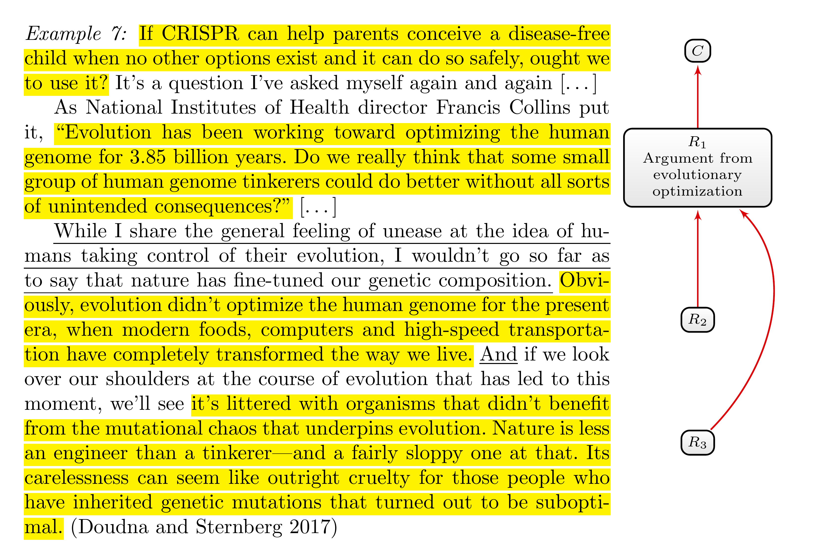
Figure 5.1: An example of a reason ($R_{3}$) that extends over many clauses. Identified linguistic cues are underlined, and justificatory relevant text segments are highlighted.
It is not difficult to determine the exact boundaries of the argumentative units in the first two paragraphs. The text snippet starts with a question, which indirectly formulates the main claim in question. We already understood the rhetorical question of the second paragraph as an objection to germline editing ($R_{1}$). According to this objection, germline editing will have unintended side effects that are to be expected when “human genome tinkerers” try to do better than evolution. The point about evolutionary optimisation seems important for understanding the main idea of the argument. Accordingly, we can consider the sentence preceding the question as part of the reason against germline editing.
The third paragraph is more challenging. The author begins by making explicit her stance on the argument from evolutionary optimisation—namely, that she is not convinced by it. The first sentence does not itself formulate a reason, but it can be considered a linguistic cue that the following sentences present reasons against the argument from evolutionary optimisation. The author goes on to elaborate on two different ways in which our genome is not optimised. This and the used linguistic cue ‘and’ motivate us to interpret the paragraph as formulating two different points—that is, two different objections. The first objection ($R_{2}$) alludes to a lack of genetic fit for our modern world and spans more than one sentence. The second objection ($R_{3}$) points to genetic diseases, which, according to the author, can hardly be described as the result of optimisation. We can regard all three sentences beginning with the ‘and’ as relevant to understanding the main idea of the objection. The main point is that evolution is based on random genetic variations—in contrast to intentional alterations—that yield “suboptimal” outcomes at the individual level. All three sentences contribute to understanding this one point, which motivates us to consider them as formulating a single objection. Only the metaphor about looking over one’s shoulder is irrelevant to the reason itself and should, consequently, not be annotated as part of the reason.
Thus, the example in Figure 5.1 shows that one argumentative unit does not necessarily span exactly one sentence.
Clarification 5
An argumentative component can be formulated by one sentence, a subclause of a sentence, or stretch over more than one sentence.

5.1 Identifying Different Parts of an Argumentative Component
The last clarification shows that it is essential to have some criterion to determine where an argumentative unit starts and ends. The intuitive analysis of the second objection in Figure 5.1 ($R_{3}$) suggests counting text segments that help us understand an argumentative component’s main point or its relevance as part of the argumentative unit. Those text segments should, therefore, be annotated as belonging to the argumentative unit. Typical examples of linguistic cues that signpost such clarifications are ‘This argument rests on the assumption that …’, ‘… presuming …’ and ’This argument is based on the grounds that…’ However, often you won’t find such explicit linguistic cues. The following tip provides a rule of thumb and accompanying questions to help identify the different parts of an argumentative unit.
Tip 5.1: Individuation of Argumentative Components
If sentences or subclauses must be taken together (or are intended to be taken together) to understand an argumentative component’s main idea or relevance, they should be considered as part of the corresponding argumentative unit. In other words, if it makes sense to imagine a sentence or subclause as an answer to one of the following questions—Why is that a reason? Why is that relevant? What is the point of that?—they are part of the argumentative unit.

In Figure 5.2, you will find an example that illustrates how to apply Tip 5.1. The main claim ($C$) is attacked by an argument from naturalness ($R_{1}$), which is itself the target of a presented refutation ($R_{2}$). According to Tip 5.1, we can regard all three sentences as part of a single objection to the argument from naturalness ($R_{1}$), since the last two sentences seem to elaborate on the objection that diseases are natural.
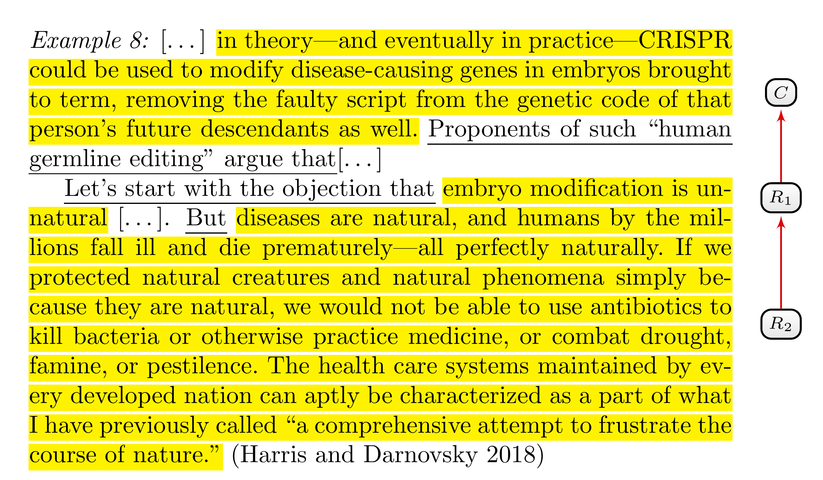
Figure 5.2: An example of applying Tip 5.1. $R_{2}$ corresponds to a text segment spanning over many clauses, which clarifies the main idea and relevance of $R_{2}$.
One way to apply Tip 5.1 is to use text segments from the given text snippet and reformulate them in the form of an imagined dialogue. If it is possible to plausibly use sentences or clauses as answers to the questions ‘Why is that a reason? Why is that relevant? What is the point of that?’, we can regard them as part of the reason.
The following dialogue starts with the first sentence of the refutation ($R_{2}$) of the argument from naturalness ($R_{1}$):
A: “But diseases are natural, and humans by the millions fall ill and die prematurely—all perfectly naturally.”
B: “Why is that a reason against the argument from naturalness?”
A: “Because, if we protected natural creatures and natural phenomena simply because they are natural, we would not be able to use antibiotics to kill bacteria or otherwise practice medicine, or combat drought, famine, or pestilence.”
B: “And? Why is that relevant?”
A: “[Because we do use antibiotics to kill bacteria.] The healthcare systems maintained by every developed nation can aptly be characterized as a part of what I have previously called a comprehensive attempt to frustrate the course of nature.”
$B$ uses the questions of Tip 5.1 to understand better or challenge the relevance of $A^{′}s$ objection to the argument from naturalness. $A$ answers by repeating the annotated sentences in the second paragraph. This, in turn, justifies counting them as part of $A^{′}s$ objection.

5.1.1 Scattered Argumentative Components
In the last two examples (Figure 5.1 and Figure 5.2), we identified reasons that extend over more than one sentence. Since these sentences are contiguous, the corresponding argumentative unit spans over all these contiguous sentences. It can, however, also happen that sentences or clauses that explain the main point and the relevance of an argumentative component are not contiguous, as the example in Figure 5.3 shows.
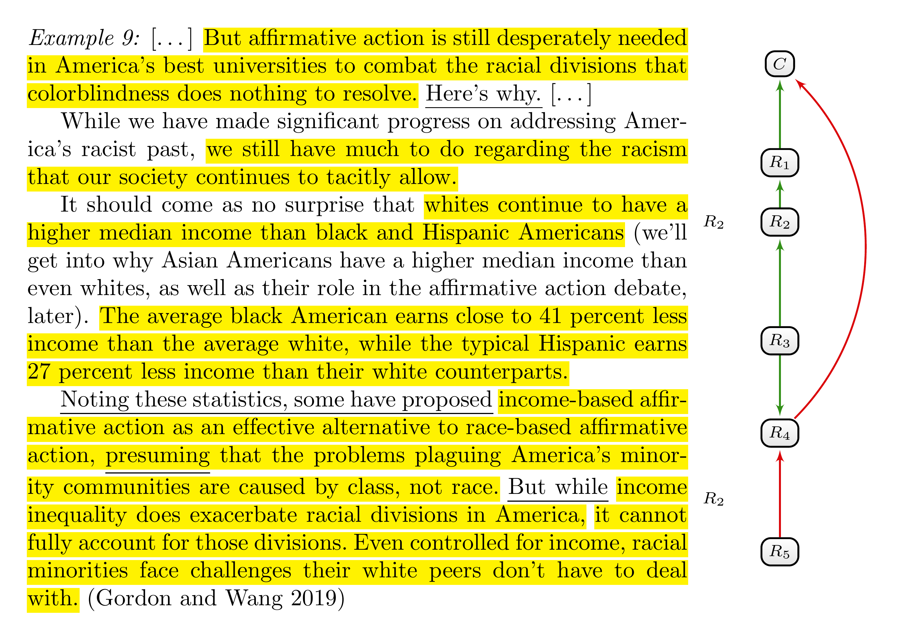
Figure 5.3: An example of applying Tip 5.1. Two non-contiguous text segments belong to one reason ($R_{2}$).
The authors argue that race-based affirmative action is still needed (the main claim $C$) as a means to reduce the still existing racism in the United States ($R_{1}$). In the third paragraph, the authors go on to elaborate on the still existing higher incomes of white Americans as compared to black and Hispanic Americans ($R_{2}$), for which they provide further statistical evidence ($R_{3}$). Naturally, we can interpret these income differences as a supporting reason for contemporary racism without there being linguistic cues to corroborate this interpretation. But why are income differences relevant to racism? The authors provide one answer themselves. As the first clause in the last sentence clarifies, income differences “exacerbate racial divisions.” Therefore, we can regard this clause as explaining the relevance of $R_{2}$ and should annotate it as belonging to $R_{2}$.
The example illustrates that one reason ($R_{2}$) can spread over non-contiguous sentences and clauses. There is one practical difference in the case of non-contiguous sentences and clauses. If the sentences and clauses that belong to an argumentative unit are contiguous, you annotate these sentences as one text segment by determining the start and endpoint accordingly. However, if these sentences and clauses are non-contiguous, you have to annotate different text segments as belonging to one argumentative unit.

5.1.2 Illustrative Examples
According to Tip 5.1, elaborations on the argumentative component’s main idea or relevance should be annotated as part of the corresponding argumentative unit. However, not every text segment that explains something in connection to the argumentative component in question should be annotated this way:
Tip 5.2: Examples are not reasons
Sentences or clauses that provide mere illustrative examples or contextual information and explanations that merely explain the meaning of relevant concepts should not be annotated as belonging to an argumentative unit.


Figure 5.4: An example of applying Tip 5.2. The first paragraph explains the difference between therapy and enhancement, which is mere contextual information and not part of the reason $R_{1}$.
In the example of Figure 5.4, the author provides contextual knowledge that should not be annotated as an argumentative unit. The author’s main claim is formulated at the end of the text. She argues for confining germline editing to therapeutic uses and banning it for enhancement. One of her reasons against genetic enhancement invokes the possibility of “dangerous social implications.” While her explanations of how the treatment of diseases differs from enhancement help clarify the reasoning, they are not necessary to grasp the main point. To understand the main idea of the reason, we simply need to know that enhancement differs from therapy and that enhancement is said to have certain dangerous consequences. Since the second sentence implies both points, we do not need the first sentence to understand the main idea of the reason.

5.1.3 Reformulations
A similar but slightly different case to clarifications and elaborations of argumentative components are text segments that reformulate or repeat an argumentative component. An author might, for instance, explain an already mentioned reason in different words to foster a better understanding or to remind the audience of an important point. Similarly, an author might begin by summarising the main idea of a reason and later provide further details of the same point. In line with clarifications of an argumentative component’s relevance (Tip 5.1), you should consider text segments that are reformulations of the same argumentative component as belonging to that reason:
Tip 5.3: Reformulations of argumentative components
If sentences or clauses are (or are intended to be) reformulations or repetitions of an argumentative component, they should be considered as belonging to the corresponding argumentative unit.

Typical linguistic cues for repetitions and reformulations include:
- ‘In other words, …’
- ‘As x puts it …’
- ‘To put it differently, …’
- ‘As I mentioned earlier …’
- ‘As stated above, …’
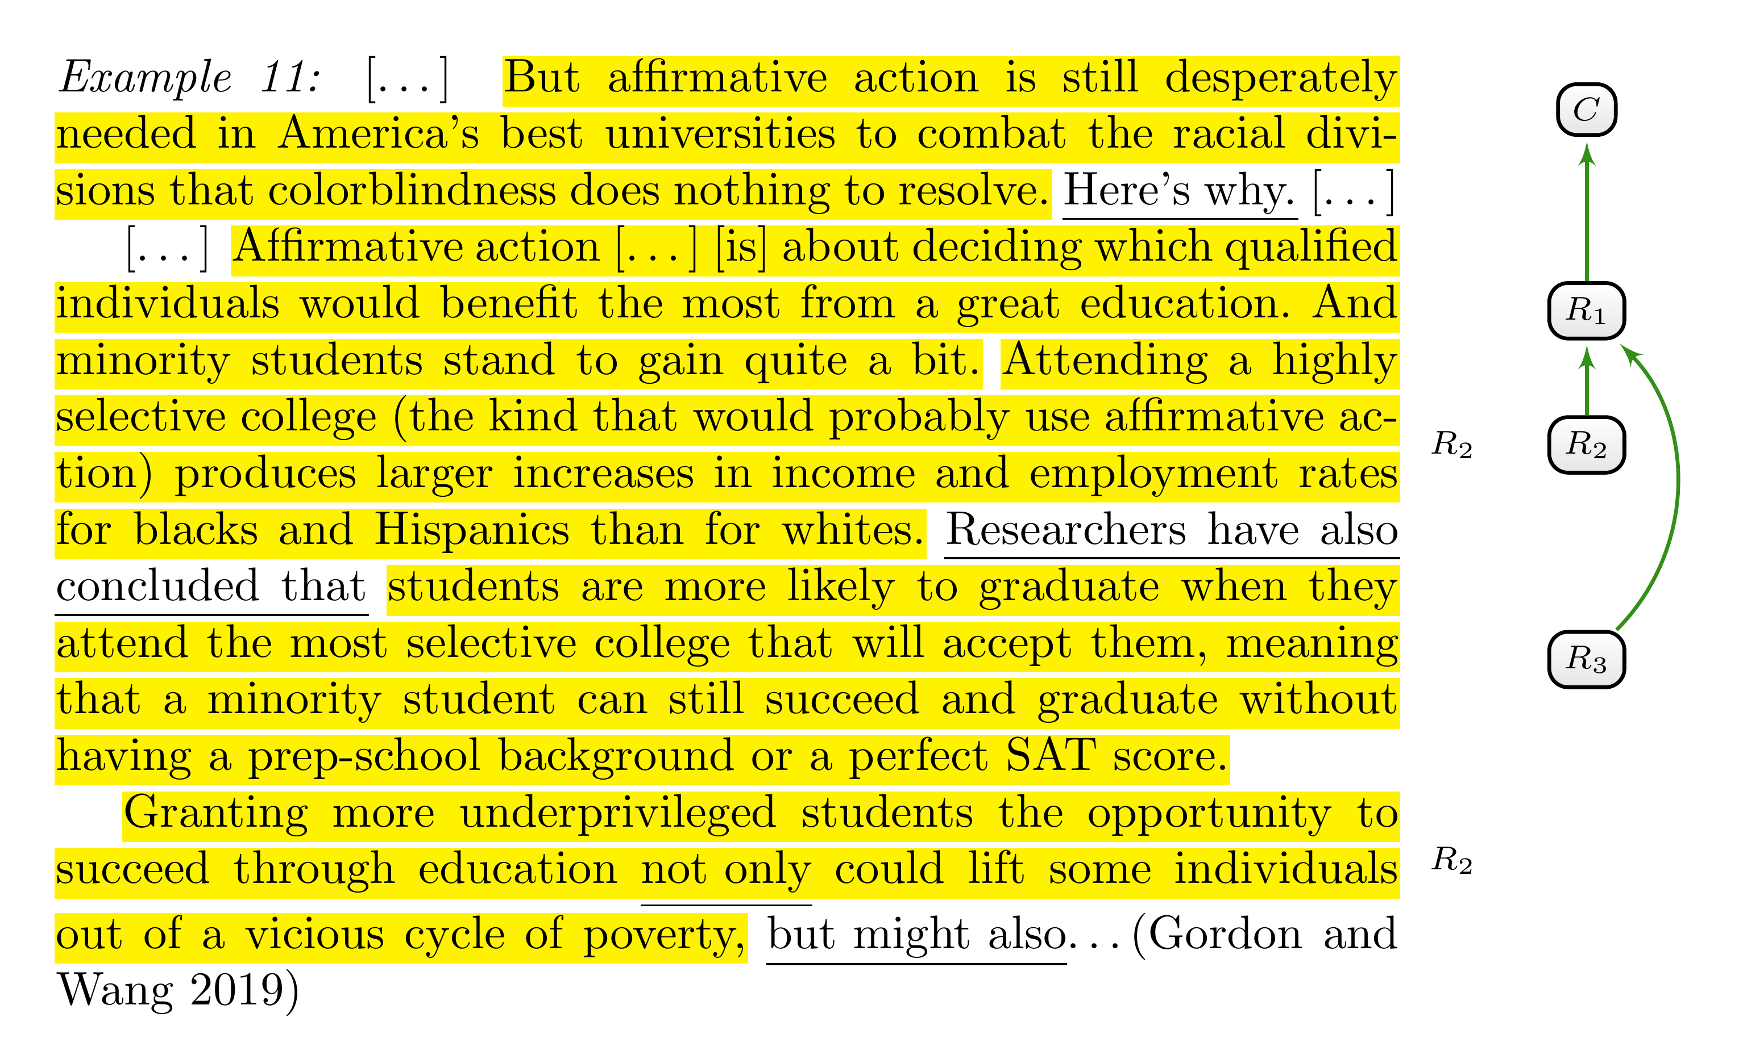
Figure 5.5: An example of applying Tip 5.3 to identify reformulations of reasons. Two non-contiguous text segments formulate the main idea of one reason ($R_{2}$) differently.
Similarly to sentences and clauses that elaborate on the relevance of argumentative components, repetitions and reformulations may be contiguous or non-contiguous to the first text segment that describes the argumentative component. The example in Figure 5.5 depicts an annotation of an argumentation structure with a non-contiguous reformulation of the second reason ($R_{2}$). This reason is formulated as a justification for the claim that minority groups can benefit more from education at elite universities than other groups ($R_{1}$)—namely, that they would benefit more from it in terms of income increase and employment opportunities. After formulating another benefit ($R_{3}$), the authors reformulate the second reason in the third paragraph. By using the phrase “not only $…$, but also $…$” the authors begin to pick up an already formulated point ($R_{2}$) and then move on to add another reason ($R_{3}$).

5.1.4 References
Reformulations and repetitions usually have an explanatory function. They help the audience understand an argumentative component, remind them of its basic idea, and might describe it from another perspective. In contrast to repetitions and reformulations, mere references do not contribute to the understanding of an argumentative component and should not be annotated as part of the corresponding argumentative unit.
Tip 5.4: References to Argumentative Components
Mere references to argumentative components should not be annotated as part of the corresponding argumentative unit.

A reference to an argumentative component can be formulated, for instance, by using demonstrative determiners such as ‘this’, whose referents are context-dependent, by using proper names such as ‘the slippery slope argument’, or by using definite descriptions such as ‘the first argument mentioned by Clint’. References to argumentative components can be used after the author elaborates on them, for instance, to signpost attack and support relations, or even before the author elaborates them, for instance, to announce argumentative components. The following linguistic cues encompass some possibilities to refer to argumentative components:
- ‘… This reason is not convincing since…’,
- ‘… The most prominent objection to the argument from x is …’,
- ‘All of these objections can be refuted.’, ‘There are two relevant arguments: the argument from x and the argument from y …’ and
- ‘After clarifying the stance of y, I will analyse her strongest argument.’

5.2 Identifying Different Argumentative Components and their Relationships
Tip 5.1 and Tip 5.3 will help you as an annotator identify all text segments that belong to the argumentative component. Another important challenge is the correct identification of contiguous text segments corresponding to different argumentative components reasons.
The example in Figure 5.6 begins with an objection ($R_{1}$) against germline editing for therapeutic uses ($C$). The objection rests on the premise that there is an alternative—namely, preimplantation genetic diagnosis (PGD) in combination with in vitro fertilisation (IVF)—that has no downside compared with germline editing. According to the second reason ($R_{2}$), this alternative is, in fact, not an alternative for all prospective parents. The presented refutation of $R_{1}$ is supported by three reasons ($R_{3−5}$). So why should we regard these nearly contiguous text segments as three different supporting reasons for $R_{2}$? The chosen grammatical form is one hint. The authors use an enumeration to list points that seem to be on equal footing.
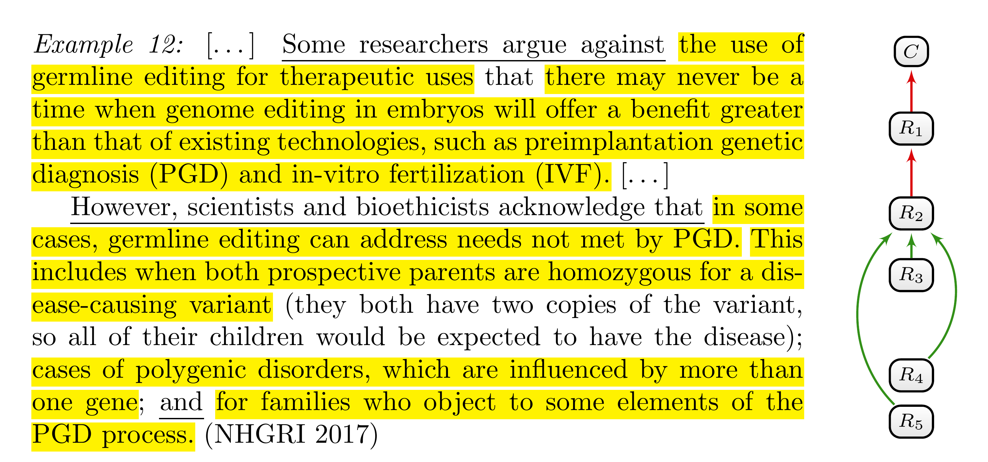
Figure 5.6: An example of applying Tip 5.5. Three nearly contiguous text segments correspond to different reasons ($R_{3−5}$) for one other text segment ($R_{2}$).
Additionally, Tip 5.1 and Tip 5.3 do not suggest considering the text segments as one reason: Neither of these points clarifies the relevance of the others (Tip 5.1), and neither of these points is a reformulation of the others (Tip 5.3). On the contrary, the points are independent. Every one of them supports, or is intended to support $R_{2}$ without needing the other one; every one of them can be imagined as part of a dialogue in which a challenger successively asks for additional reasons that support the claim that PDG and IVF are not an alternative for all prospective parents ($R_{2}$).
To summarise these considerations into another tip:
Tip 5.5: Independent justification
If sentences or clauses provide or are intended to provide independent justification for some claim, or if they are intended to provide support on their own, they should be considered as independent argumentative components. In other words, if it makes sense to imagine each sentence or clause as an answer to the question ‘Can you give me an additional reason/objection?’, they correspond to different argumentative units.

Tip 5.1 and Tip 5.3 tell you to count reformulations of an argumentative component and clarifications of its relevance as part of the corresponding argumentative unit. Sometimes, it is not easy to distinguish a justification for a reason from a clarification of the reason. A text segment presented as a reason for another reason might look at first glance like a repetition or clarification of the second reason’s main point. In this case, this apparent repetition should not be considered as part of the reason it supports. Instead, you should treat both text segments as independent reasons and categorise the first as supporting the second. In other words, you have to split the longer text segment into different ones and use the support relation to categorise the argumentative relation between them. Since it might be challenging to distinguish justifications for reasons from reformulations and clarifications of reasons, you should be attentive to text segments that appear to be one complex reason that stretches over many sentences.
With Example 5.1, we will formulate an additional tip that will not only help you spot the difference between reason-supporting reasons and reformulations of reasons, but will also be useful in analysing the attack and support relations between text segments in general.
But affirmative action is still desperately needed in America’s best universities […] Some well-intentioned people may argue that because of the academic challenges racial minorities tend to face, they may be less qualified than other students to attend elite universities and could struggle to meet the expectations of a rigorous curriculum. This is based in part on the debunked “mismatch” theory, which posits that these students would benefit more from attending less challenging schools more suited to their relative lack of educational attainment. (Gordon and Wang 2019)
Example 5.1
After formulating the main claim, the remaining text snippet is introduced with a clear linguistic cue for an argumentation (‘people may argue that’). The last sentence univocally suggests that this argumentation is intended as an objection to affirmative action at universities. But is it adequate to interpret the paragraph as containing only two justificatory relevant text segments, one that represents the main claim ($C$) and one that represents a complex objection to it ($R_{1}$) as indicated in Figure 5.7? Or is it a more complex reasoning that has to be broken down into different parts?
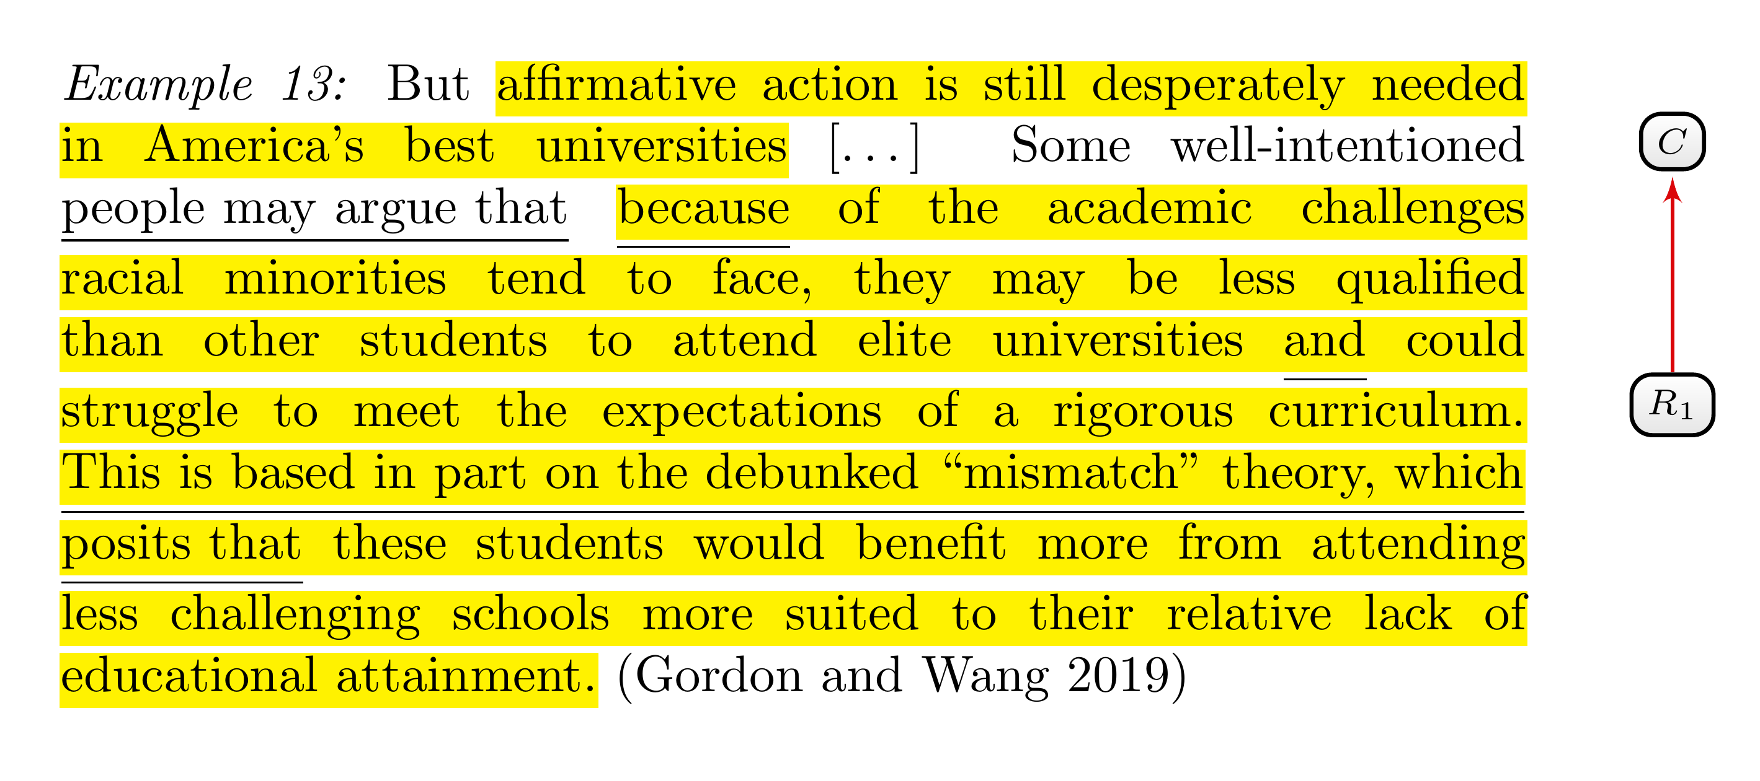
Figure 5.7: First analysis of Example 5.1. Annotating a long text segment as one objection ($R_{1}$) to affirmative action at universities ($C$).
To answer this question, we have to understand the role of the additional linguistic cues. They pose at least two questions:
- What does the ‘because’ indicate? A presented justification, a causal explanation or both (see Tip 4.3)?
- How are we supposed to interpret ‘This is based in part on …’? Does it indicate a clarification or some form of support relation between the text segments that precede and follow this phrase? If this phrase has to be interpreted as expressing a support relation, we should identify at least two reasons in the paragraph.
Our natural language is too flexible to answer such questions with simple and precise instructions. Confronted with such a complex case, you should, instead, employ the following rule of thumb:
Tip 5.6: Paraphrasing
Reformulate the basic idea of argumentative components in your own words to identify support and attack relations. Use the following principles to guide your reformulation:
- Explicitness: Your reformulation should be explicit about the source and target of support and attack relation.
- Accuracy: Stay as close as possible to the original formulation and the known or hypothesized intention of the author.
- Charity: If there are different and conflicting possibilities to reformulate the argumentative component’s basic idea, choose the formulation that results in the most plausible and convincing reasoning.

The idea of this tip is to make your understanding of the reasoning explicit. Explicitness requires reflecting on which text segment is being presented as a justification for which other text segment. That is why you should use a formulation that explicates the relational character of argumentative components.
You could, for instance, use one of the following schemata to explicate a support relation between two argumentative components y and x:
- ‘x because y.’
- ‘x since y.’
- ‘y is a reason for x.’
and the following to explicate an attack relation between y and x:
- ‘x is not true because y.’
- ‘x is implausible because y.’
- ‘y is a reason against x.’
Let us now apply Tip 5.6 to the example from Figure 5.7. How can we formulate the main idea of the objection ($R_{1}$)? One suggestion is the following:
Students from racial minorities (= “these students”) would benefit from attending less challenging schools since they could struggle to meet the expectations of a rigorous curriculum at an elite university.
This reformulation catches an important point of the reasoning and is formulated using one of the suggested forms (‘x since y’). However, the clause following ‘since’ does not directly formulate a reason against affirmative action since x says nothing directly about affirmative action. It is a reason justifying that the described students should not attend elite universities. Fortunately, the context closes this gap: Affirmative action is supposed to enable students from minority groups to attend elite universities. However, since it would be better for these students not to attend elite universities, affirmative action is not needed, or so the argument goes.
This consideration suggests separating the reasoning into two reasons:
Affirmative action is not needed since students from racial minorities would benefit from attending less challenging schools. ($C$ is not true since $R_{1}$)
and
Students from racial minorities (= “these students”) would benefit from attending less challenging schools, since they could struggle to meet the expectation of a rigorous curriculum at elite universities. ($R_{1}$ since $R_{2}$)
According to this interpretation, the paragraph formulates a chain of reasons as illustrated in Figure 5.8: The last annotated text segment represents a reason ($R_{1}$) and is an objection to the main claim $C$, which is represented by the first text segment. The text segment following the ‘and’ is another reason ($R_{2}$), which is presented as a justification to support the first reasons $R_{1}$.
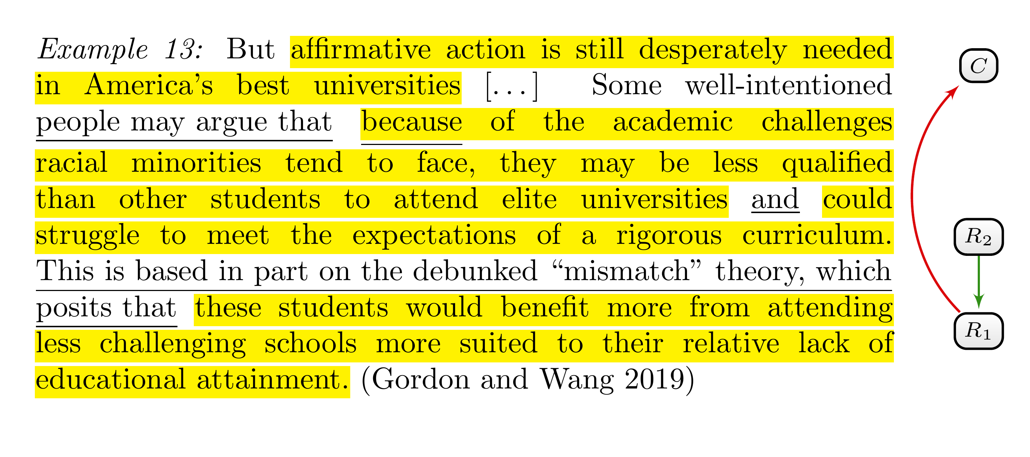
Figure 5.8: Second analysis of Example 5.1. Applying Tip 5.6 reveals a support relation between the third and fourth text segment.
The preliminary result is a much more adequate analysis of the argumentation structure than the first interpretation. The remaining task is to clarify the role of the text segment that precedes the ‘and’. It seems to be justificatory relevant. But so far, we have not used it in our reformulation of the reasoning structure. Additionally, we must still analyse the role of the linguistic cue ‘because’. Does it indicate a justification, a causal relationship or both? The indicator word ‘and’ only suggests that the clauses that are linked together by the ‘and’ are independent points.
Again, it might help to reformulate the presented text segment as reasons (see Tip 5.6). The following reformulations continue to interpret the argumentation structure as a chain of reasoning. We could ask why these students struggle at elite universities ($R_{2}$), and the text seems to answer by pointing to their lesser academic qualification ($R_{3}$); we could ask why they are less qualified, and the text seems to answer by pointing to academic challenges minorities have to face before university ($R_{4}$). In one of the suggested standard forms:
Students from racial minorities could struggle to meet the expectation of a rigorous curriculum at elite universities, since they may be less qualified than other students. ($R_{2}$ since $R_{3}$)
Students from racial minorities may be less qualified than other students, since they tend to face academic challenges before university. ($R_{3}$ since $R_{4}$)
Figure 5.9 illustrates the resulting final interpretation of the argumentation structure. We started with a preliminary analysis by identifying the main claim and a longer text segment whose internal structure raised some questions (see Figure 5.7). We then used the tip to reformulate the main idea of reasons and objections. By making explicit what is presented as a justification and what is presented as justified, we were able to analyse the argumentation structure more deeply and identify four separate text segments that correspond to a chain of reasons ($R_{1}−R_{4}$).
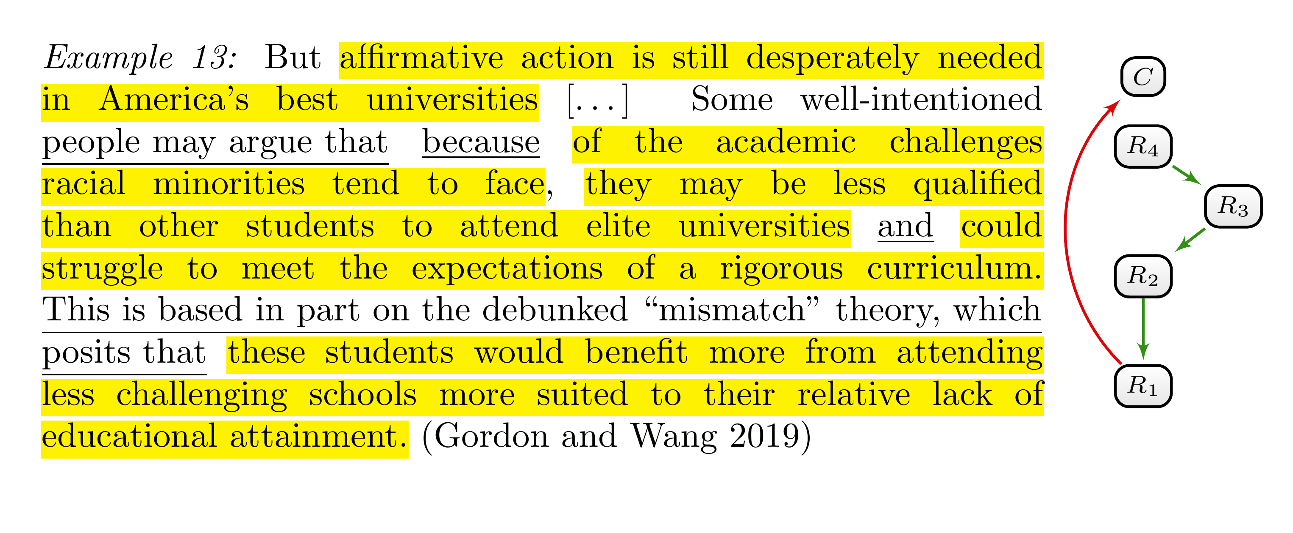
Figure 5.9: Final analysis of Example 5.1. Applying Tip 5.6 reveals a chain of support relations (from $R_{4}$ to $R_{1}$) between four text segments.
In applying Tip 5.6, you must be faithful to the text. That means that your reformulations of reasons must not deviate too much from the author’s formulations and that the reformulation does not distort the author’s intended meaning. Instead, your reformulations should stay as close as possible to the text. In particular, you should not add new information that is not present in the text, and you should be able to identify the text segments that correspond to your reformulations.
Consider the following example. Above, we formulated the attack between the first reason and the main claim as follows:
Affirmative action is not needed since students from racial minorities would benefit from attending less challenging schools. ($C$ is not true since $R_{1}$)
Now, it might make sense to insert another reason step $R^{*}$ between $C$ and $R_{1}$ in the following way:
Affirmative action is not needed since it is supposed to help students from racial minorities, which it doesn’t. ($C$ is not true since $R^{*}$)
Affirmative action is supposed to help students from racial minorities, which it doesn’t, since students from racial minorities would benefit from attending less challenging schools. ($R^{*}$ since $R_{1}$)
Now, we have formulated the additional reason $R^{*}$ that attacks $C$ and is supported by $R_{1}$. However, no text segment corresponds to this reason. Faithfulness to the text demands the use of reformulations that make it possible—and preferably easy—to identify the text segments that correspond to reasons.

6. Identifying the Target of Support and Attack Relations
In the last example (Example 5.1), we used Tip 5.6 to identify a chain of supporting reasons that we did not initially spot. We saw how Tip 5.6 can help to discern support relations between argumentative components, even if there are no obvious linguistic cues for these relations. Reformulating the basic idea of argumentative components in your own words can also help with other problems of analysing the argumentation structure in a text.
For instance, you might identify an argumentative unit that is formulated as a justification without being able to say what it justifies. The linguistic cues might univocally signpost the text segment as a reason but fail to clarify the exact target. Such a situation leaves the annotator to decide among different possibilities regarding what is supposed to be justified. Tip 5.6 might help to decide between these different possibilities. You should formulate the potential relations in some of the suggested standard forms and choose among them by applying the principle of charity and accuracy. The main idea is to choose among these possibilities by comparing the different formulations based on their plausibility and how well they capture the author’s intended reasoning.
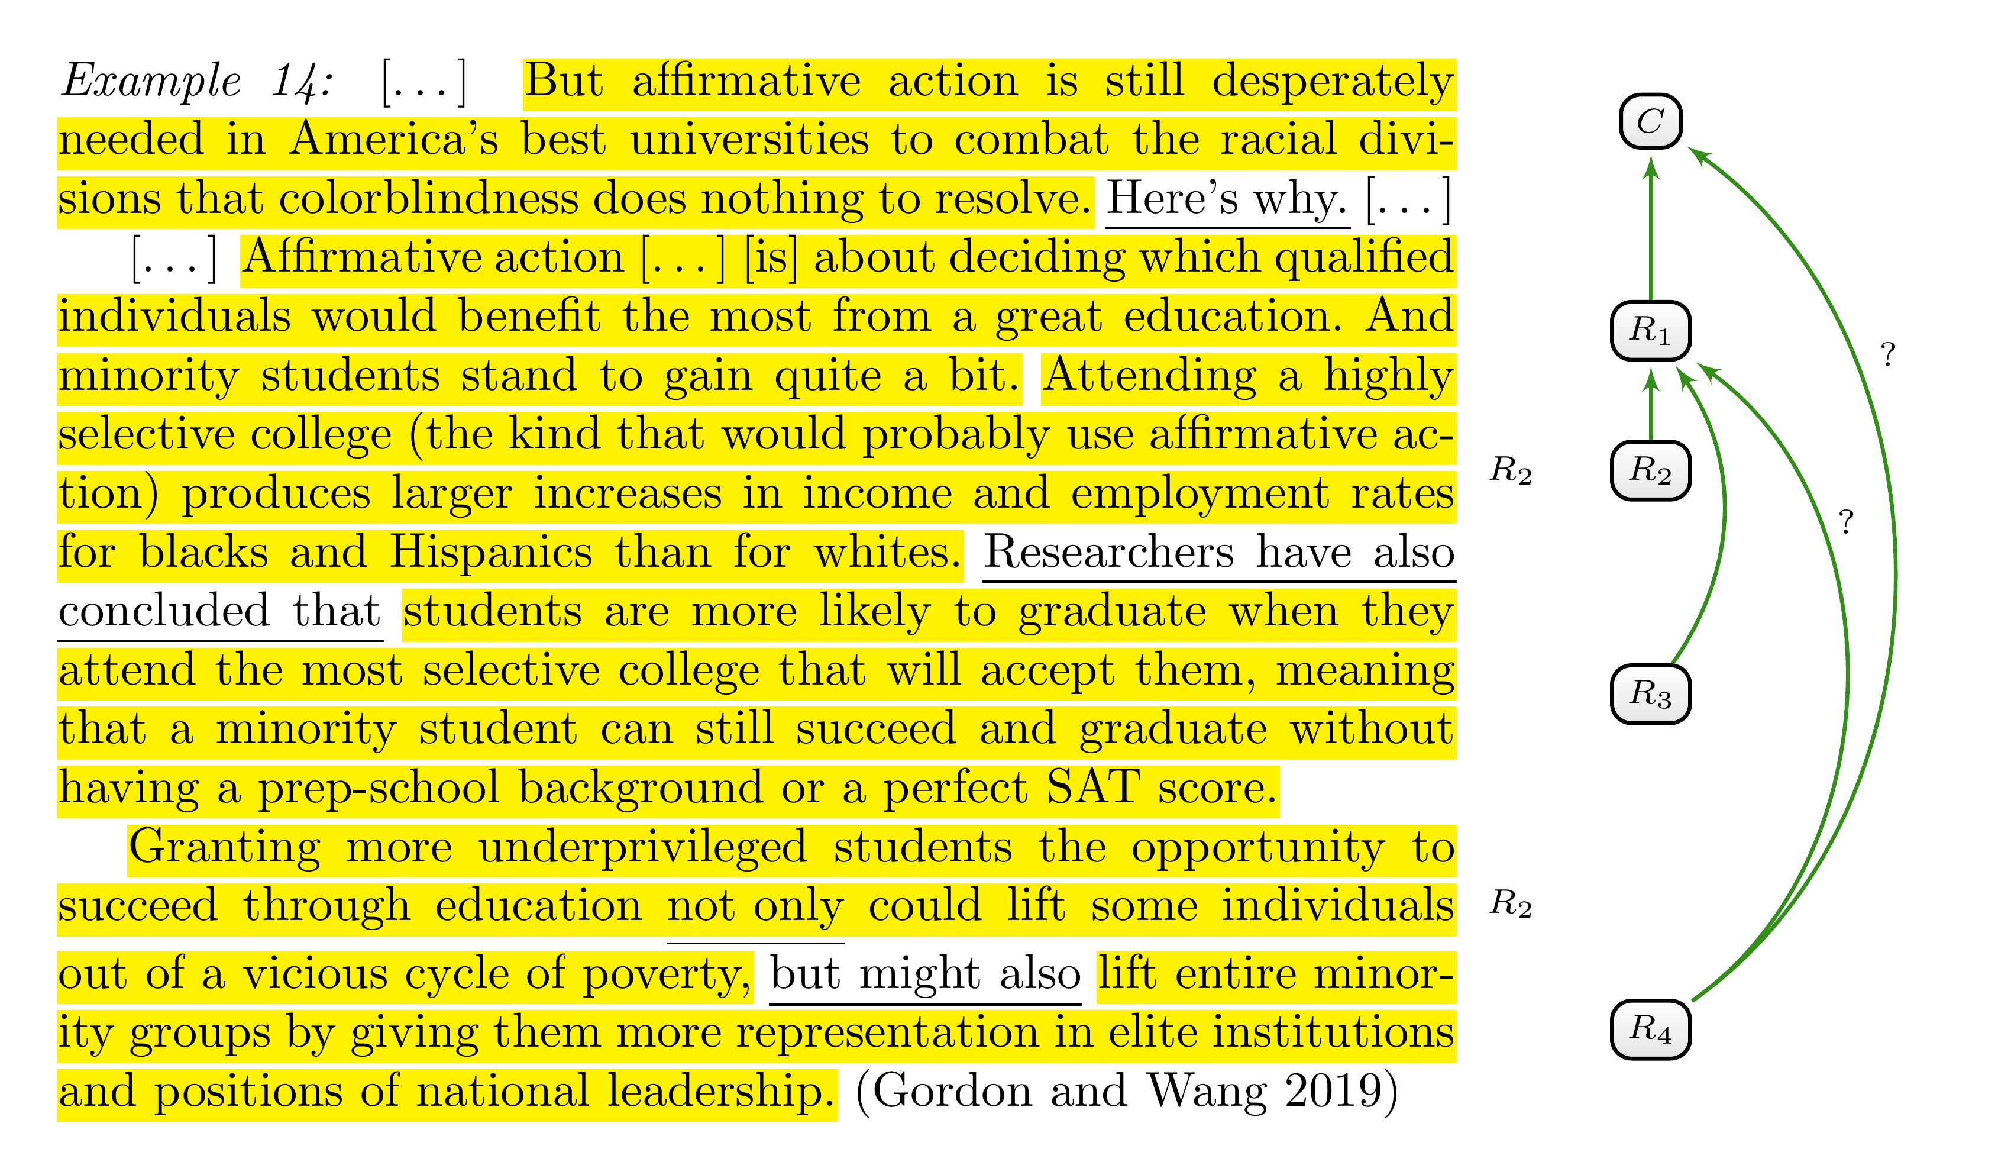
Figure 6.1: Illustrating the problem of identifying the target of a reason ($R_{4}$).
The example in Figure 6.1 extends the example from Figure 5.5 and provides a concrete illustration of the problem. The main claim in favour of affirmative action is supported by a single reason ($R_{1}$), which argues that it will benefit qualified students from minority groups. The text moves on to provide a supporting reason for this claim, pointing to an increase in income and employment ($R_{2}$) and to the fact that qualified students are more likely to graduate from elite universities ($R_{3}$). The last paragraph begins by reformulating $R_{1}$ and goes on to add another point. The phrase ‘not only …, but also…’ designates this last point as a supporting reason. But it is less clear what exactly is being justified. Since the preceding reasons $R_{2}$ and $R_{3}$ support $R_{1}$, one might speculate whether $R_{4}$ is another reason in support of $R_{1}$. However, since the phrase refers to $R_{1}$ in the first clause, which supports the main claim $C$, it is similarly possible that $R_{4}$ is another reason for the main claim.
According to Tip 5.6, we should first formulate both possibilities in a way that makes the reason and its target explicit (explicitness), which might demand reformulating some text segments.
- Support from $R_{4}$ to $R_{1}$: Affirmative action should help those qualified individuals who would benefit the most from an excellent education. Minority students stand to gain quite a bit since it might lift entire minority groups by giving them more representation in elite institutions and positions of national leadership.
- Support from $R_{4}$ to $C$: But affirmative action is still desperately needed in America’s best universities since it might lift entire minority groups by giving them more representation in elite institutions and positions of national leadership.
We now have to compare these different possibilities in terms of how strong or plausible the resulting support is (charity) and which formulations adhere best to the author’s known or hypothesised intention (accuracy). From the viewpoint of plausibility, both possibilities seem to be fine: Since whole minority groups benefit from a better representation (first possibility), students that belong to these groups will benefit as well (second possibility). However, accuracy favours the second interpretation. The author’s intended point is to justify affirmative action not only by the benefits it provides to individuals from minority groups who attend elite universities as a result of affirmative action, but also by how it will benefit other individuals from these minority groups. This point is only captured in the second formulation.
While Tip 5.6 will often help you identify the target of support and attack relations, some cases remain ambiguous. Different possible interpretations might be similarly charitable and accurate, or there might be a trade-off between charity and accuracy. In these cases, you can freely pick one of your interpretations.
However, keep in mind that the author might intend to justify two different things with the same text segment. In such a case, you should annotate all the relations.
We will close this section with a general comment on the usefulness and scope of the provided tips. You might encounter cases where the tips will not disambiguate between all possible interpretations, and different annotators might come up with different interpretations when using the tips. However, while these tips will not always yield unique results, they are intended as rules of thumb that at least narrow down the degree of interpretation.

7. Frequently Asked Questions

7.1 Questions Concerning Main Claims

7.1.1 What are (main) claims? How do I identify and categorise them?
There is no special category for claims—and reasons for that matter—besides them being argumentative components. We simply call argumentative components claims if they are not formulated as reasons for or objections against some other statement and if other text segments are presented as argumentative components for or against them. In other words, a claim is an argumentative component with only incoming and no outgoing attack or support relations. This is, in some sense, a technical definition for the purpose of this guideline since it differs from our ordinary use of the term ‘claim’, according to which someone can formulate a claim without presenting justifications for it.

7.1.2 Question claims: The main claim is implicitly formulated as a question. Should I understand the main claim as a positive or negative answer to the question?
This is an important question because the answer will dictate whether reasons are reasons for or reasons against the claim.
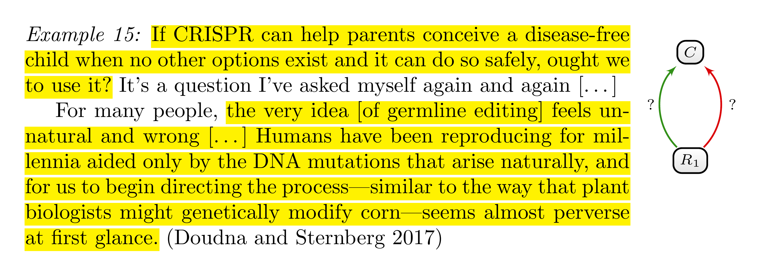
Figure 7.1: Example of a main claim implicitly formulated as a question.
Consider the example in Figure 7.1. The argument concerns germline editing, and the main question is posed in the first sentence. In the second paragraph, we find an argument against germline editing that invokes the notion of naturalness. We can interpret this reason in two ways: Either as a reason against a claim that corresponds to an affirmative answer to the main question or as a reason in favour of a claim that corresponds to a negative answer to the main question. In the first case, we would categorise the relation between the reason and the main claim as an attack; in the second, as support.
There is no rule to decide on this issue, and either possibility is fine. You can choose the main claim according to what feels natural to you. For some, the second paragraph might feel more like an argument against something. These people would tend to understand the main claim as the positive answer to the first question and would categorise the second paragraph as formulating a reason that attacks that claim.
The important thing is to be consistent with that decision. Once you decide to interpret the claim as an affirmative answer or a negative answer, this decision should be regarded as fixed for the analysis of other text segments.

7.1.3 Multiple claims: Can there be more than one claim in a text?
Yes, a single text can contain multiple claims. Sometimes a debate concerns two or more questions that are typically related to each other in some way. Answers to these questions make up different claims. For instance, the debate about germline editing concerns at least two different issues: the question of using this technology for therapeutic purposes and the question of further research into this technology using embryos. Different positions will formulate different answers to these questions, which might represent different claims in the debate about germline editing.

7.1.4 Conditional claims: Can main claims be formulated with conditions?
Yes. It is quite common to formulate claims conditionally, for instance, to express exceptions or qualify claims differently. Consider the following claim:
Example 16: Others argue that genome editing, once proved safe and effective, should be allowed to cure genetic disease (and indeed, that it is a moral imperative). (NHGRI 2017)
The anonymous proponents do not think that germline editing should be allowed unconditionally for therapeutic uses. Instead, they formulate specific sufficient conditions under which germline editing should be allowed as a therapy.

7.1.5 Implicit claims: While the text implicitly pins down the main claim, there is no specific text segment formulating the claim. How should I annotate and categorise reasons that support and attack the main claim?
Such cases represent a widespread phenomenon. Often, the context is clear enough that an author does not think it necessary to formulate their main claim explicitly. In the example in Figure 7.2, the author provides a reason why the use of CRISPR as a therapy would constitute a violation of informed consent without explicitly stating that this violation is a reason against the use of germline editing for therapeutic purposes ($C_{1}$). However, the cotext—which is omitted here—makes it quite clear that she presents it as a reason against germline editing since she goes on to present other reasons against germline editing.
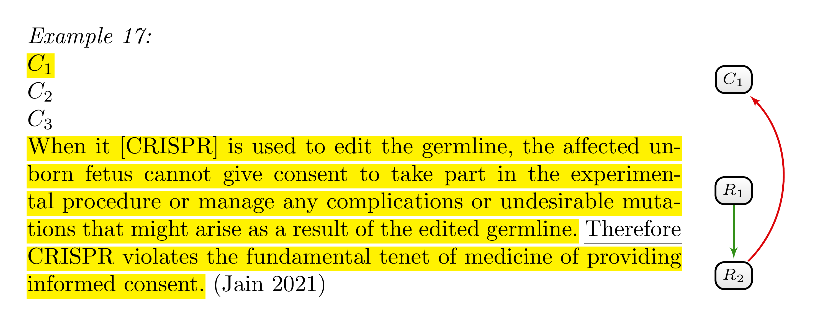
Figure 7.2: Example of dealing with implicit claims.
When there is no explicit claim in the text, argumentative components attacking or supporting this claim will lack an argumentative unit as a target. In other words, attack and support relations will not point to a specific text segment. But how should we specify their targets in such cases? This is, fortunately, only a technical problem. On the practical level you will be provided with labels $C_{1}$, $C_{2}$, $…$ in the text that act as placeholders for implicit claims. If there are implicit claims in the text, you can choose for every implicit claim one of these labels and annotate them as if they were the text segments formulating the claims—as indicated in Figure 7.2.

7.2 Questions Concerning the Notion of Argumentative Unit and Argumentative Component

7.2.1 Can an argumentative component lack incoming and outgoing support or attack relations?
No. According to the used definition of argumentative component (see Tip 2.1), a text segment can only formulate an argumentative component if it is presented as a justification for or objection against some other statement, or if some other text segment is presented as a reason for or against it. In the former case, the text segment has at least one outgoing relation and at least one ingoing relation in the latter.

7.2.2 Should I annotate linguistic cues?
Linguistic cues should usually not be annotated as justificatory relevant. In other words, we do not consider them as belonging to the formulation of reasons and claims. One exception: Linguistic cues that would tear an otherwise contiguous text segment into different non-contiguous text segments can be considered part of the reason or claim. In the example in Figure 7.3, the phrase ‘not only $…$, but also $…$’ is a linguistic cue that signposts the formulation of two different reasons ($R_{1}$ and $R_{2}$) for the main claim $C$. However, not annotating the ‘not only’ as justificatory relevant would mean representing the first reason by two non-contiguous text segments.
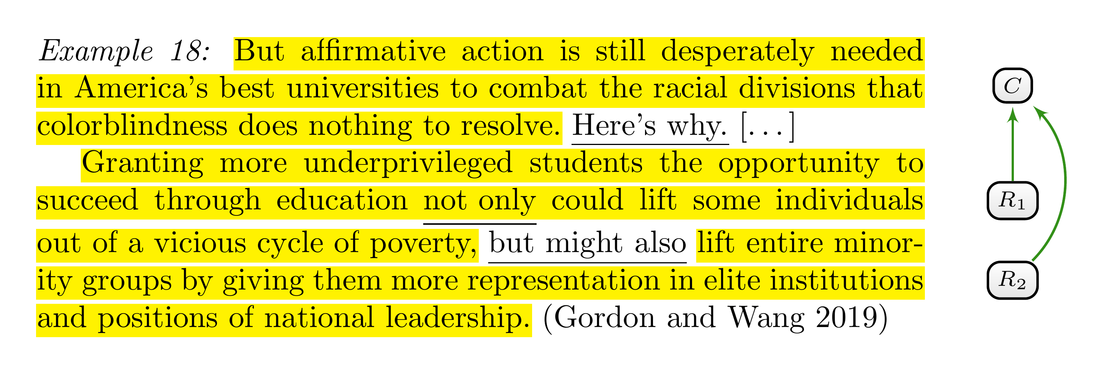
Figure 7.3: Exception to the rule of not annotating linguistic cues as justificatory relevant.
But even if we usually do not consider linguistic cues as belonging to the formulation of reasons, you should explicitly search for linguistic cues. Annotating them in some way might be very helpful for keeping an overview. For instance, linguistic cues are annotated in the examples used here by underlining them.

7.3 Questions Concerning the Individuation of Argumentative Components.

7.3.1 Can a reason or claim extend over a long text segment—let’s say, more than one paragraph in the text?
Yes, that can be the case. As an annotator, you should, however, also ask yourself whether everything the author writes is part of an argumentative unit. Mere contextual information (see Tip 5.2) or illustrative examples (see Tip 4.4) should not be annotated. Keep also in mind that claims and reasons do not necessarily correspond to exactly one single text segment but can be scattered over many non-contiguous text segments (see the next question).

7.3.2 How should I annotate a text if a reason or claim seems to be scattered over non-contiguous text segments?
An argumentative component does not necessarily correspond to exactly one single text segment but may be scattered over many non-contiguous text segments. In this case, annotate these text segments as belonging to the same argumentative component. Tip 5.1, 5.2 and 5.3 will help you to identify text segments that belong to the argumentative component. In short, they tell you that sentences and subclauses that are intended to be taken together to understand the argumentative component’s main idea or its relevance are part of it (see Tip 5.1). Everything else is not.
- On the practical level you will be provided with different labels (R1, R2, …, C1, C2, …) that can be understood as names for argumentative components. If a reason corresponds to many non-contiguous text segments, you simply have to use the same label.

7.3.3 How do I annotate a text segment that belongs to different argumentative components?
The same text segment may belong to different argumentative components according to the formulated tips. For instance, the same text segment can be important for understanding the main idea of two different reasons. According to Tip 5.1, this text segment would belong to both reasons. For the purpose of this guideline, a single text segment can only be annotated to belong to one argumentative component. In such cases, do not annotate the text segment as part of an argumentative unit.

7.3.4 What if linguistic cues conflict with the tips about the individuation of argumentative components?
How do I annotate text segments that, according to the given linguistic cues, belong to one argumentative component but that, according to the formulated tips, constitute separate argumentative components? The short answer: The tips for the individuation of argumentative components (see Tip 5.1, 5.2, 5.3, 5.5 and 5.6) should always be prioritised over what linguistic cues tell you.
A simple example is provided in Figure 7.4. The linguistic cues ‘the objection’ and ‘this argument’ suggest that the authors think of the second paragraph as one objection. However, we can understand the paragraph as presenting two relevant points that provide independent support for the main claim being false. The argument from naturalness is grounded in the idea that the natural is somehow better or preferable to the unnatural. The other point against the main claim seems to rely on the notion of hybris—the idea that we, as mere humans, should not act like gods. These are, admittedly, speculations of what is meant by both points. However, on the presented understanding, both points are independent. According to Tip 5.5, we should, therefore, analyse this paragraph as presenting two objections.
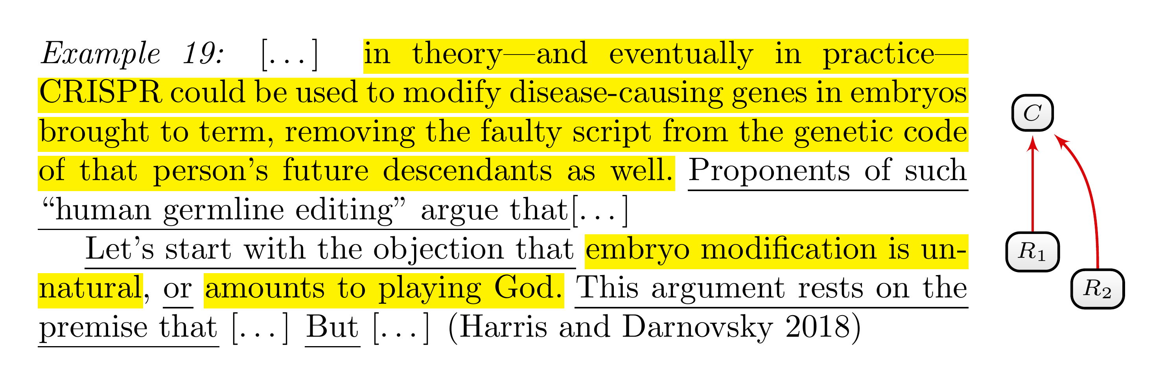
Figure 7.4: Conflict between linguistic cues and tips for the individuation of argumentative components. The linguistic cues suggest that there is one objection; according to Tip 5.5, there are two objections.
Some background: Tips 5.1–5.6 (see Chapter 5) clarify what we understand as one reason and what we understand as different reasons in the context of analysing argumentation structure. In other words, these tips spell out how we individuate and count reasons. The suggested understanding can, of course, conflict with what the author understands as a single reason. Hence, the author may intend one particular text segment to express one reason, whereas tips 5.1–5.6 suggest considering it as many reasons—or the other way around. In such conflicting cases, you should always individuate reasons according to the given tips. This rule is important because we might want to compare the number of reasons in different texts, and the result of such a comparison should be grounded in some text-independent criterion to count arguments. In other words, we should count reasons according to clarified, transparent criteria, not necessarily by the author’s subjective understanding of how they would individuate and count their reasons.

7.4 Questions Concerning Attack and Support Relations

7.4.1 Can a reason be a reason for different statements? In other words, can an argumentative component have more than one outgoing support or attack relation?
Yes, an argumentative component can be formulated as a reason for or objection against different statements. In that case, it would have more than one outgoing support or attack relation, respectively. However, you should always consider the given tips, especially Tip 5.6, to check if there are really multiple outgoing relations (see also the next question).

7.4.2 Target ambiguity: What if I am unsure about what is being supported or objected by a reason?
What should I do if it is not clear what is being justified? How should I choose the targets of outgoing support and attack relations if there are different possible interpretations?
If you are not sure about which other text segment is supposed to be supported or attacked by a text segment, you should, first, use Tip 5.6, which might help to decide between different interpretations of what the target is.
This tip suggests reformulating the possible attack or support relations in your own words and choosing among them using the principles of charity and accuracy. According to these principles, you should choose the formulation that maximises argumentative strength (charity) and is at the same time faithful to the author’s intentions of understanding the presented reasons (accuracy).
However, Tip 5.6 will not always help disambiguate between different interpretations of what a text segment is supposed to justify. If you are still unsure of the best interpretation, you can categorise multiple support and attack relations. In this case, you would include all plausible interpretations of what the target is as a target.

7.4.3 Multiple relations: Can two argumentative components be connected by different justificatory relations?
Usually, there will be, at most, one justificatory relation between two argumentative components.
However, two situations can be plausibly represented by connecting two argumentative components by two justificatory relations:
- First, an author might express that two statements are contradictory to each other. For instance, the author might suggest that two statements are inconsistent, that is, that they cannot both be true at the same time. In such cases, you can connect the two argumentative units with attack relations in both directions.
- Second, an author might express that a justification is a circular (i.e., that it presupposes what it is supposed to justify). Support relations in both directions might represent these cases.
Besides these plausible possibilities, it is conceivable that an author formulates any number of justificatory relations between two argumentative components. For instance, it is conceivable that they use linguistic cues to formulate support and attack relations that connect two argumentative units. However, such combinations will be flawed from an evaluative standpoint. What can it mean, for instance, that something is a reason for and an objection to the same claim? It is doubtful that arguers are prone to such fundamental flaws in argumentation. Accordingly, you should only connect two argumentative components in this way if the linguistic cues point unambiguously in this direction. If there are no such linguistic cues, the principle of charity recommends dispensing with such interpretations.

Literature
Doudna, Jennifer A., and Samuel H. Sternberg. 2017. “Opinion: Should We Use Gene Editing to Produce Disease-Free Babies? A Scientist Who Helped Discover CRISPR Weighs In.” In Ideas.ted.com. https://ideas.ted.com/opinion-should-we-use-gene-editing-to-produce-disease-free-babies-a-scientist-who-helped-discover-crispr-weighs-in/.
Gordon, Jarom, and Miles Wang. 2019. “Why We Still Need Affirmative Action.” OPINION in THE MUSE. https://www.themuseatdreyfoos.com/opinion/2019/12/09/on-affirmative-action/.
Harris, John, and Marcy Darnovsky. 2018. “Pro and Con: Should Gene Editing Be Performed on Human Embryos?” Magazine in Magazine. https://www.nationalgeographic.com/magazine/article/human-gene-editing-pro-con-opinions.
Jain, Aliya. 2021. “Opinion: CRISPR Technology Violates Informed Consent, May Usher Era of Eugenics.” In Bruin Medical Review. https://bruinmedicalreview.com/2021/05/07/opinion-crispr-technology-violates-informed-consent-may-usher-era-of-eugenics/.
NHGRI. 2017. “What Are the Ethical Concerns of Genome Editing?” In Genome.gov. https://www.genome.gov/about-genomics/policy-issues/Genome-Editing/ethical-concerns.

In argumentation theory, an argument is usually considered a complex entity with an internal premise-conclusion structure. The conclusion is what is supposed to be justified with the argument, and the premises are the sentences that formulate the justification. According to this understanding, reasons are premises as parts of arguments.
You will find more information on indirectly and implicitly formulated claims in Section 7.1.2 and Section 7.1.5.
Alternatively, we could regard both non-contiguous text segments (the third and fourth annotation) as one reason. On this interpretation, the fourth text segment is not a presented justification for the third text segment but rather a reformulation that adds numerical details of what is meant by the latter. See Tip 5.2 below.
There are, as often, alternative interpretations of the text. What we categorised as a reformulation can, for instance, be interpreted as a repetition of both points expressed by $R_{2}$ and $R_{3}$. After all, the higher income ($R_{2}$) presupposes that the individual who is lifted out of poverty graduates ($R_{3}$).
However, note that in the case of implicit claims, you will encounter text segments with outgoing relations that do not point to other text segments (see Section 7.1.5).

