Placeholder Name of the conference

Placeholder Session title

https://doi.org/10.52825/xxxx........ DOI placeholder (WILL BE FILLED IN BY TIB Open Publishing)

© Authors. This work is licensed under a [Creative Commons Attribution 4.0 International License](https://creativecommons.org/licenses/by/4.0/)

Published: (WILL BE FILLED IN BY TIB Open Publishing)

Contribution Title

Subtitle

First Author1[](https://orcid.org/0000-1111-2222-3333) https://orcid.org/0000-1111-2222-3333, Second Author2[](https://orcid.org/0000-1111-2222-3333) https://orcid.org/0000-2222-333-4444, and Third Author3[](https://orcid.org/0000-1111-2222-3333) https://orcid.org/0000-1111-3333-4444

1 University College London, UK

2 TIB Open Publishing, Germany

3 Technische Hochschule Wildau, Germany

*Correspondence: Author Name, mail@email.de

**Abstract.** The abstract should summarize the contents of the paper in short terms, i.e. in up to 250 words. Please capitalize all major words in the title/heading, including the second part of hyphenated major words (e.g., Self-Report not Self-report). Please also capitalize all words of four letters or more. Please capitalize the keywords.

**Keywords:** First Keyword, Second Keyword, Third Keyword

# 1. First section

## 1.1 Subsection

Please notice that there is no indent in the first paragraph of a section or subsection.

New paragraphs are indented.

### 1.1.1 Three levels of headlines may be used

**Please only use the formatting styles predefined in this file**. Use the “Standard” formatting for the text. The paragraph format is justified. Please use hyphenation. **Please do not use footnotes.** Make sure to use the format “Paragraph after table” for the paragraph directly following the table.

**Table 1**. Centered table captions should be placed above the tables. Please use the word functionality “insert caption” and then format the caption with the “captions” format.

|  |  |
| --- | --- |
| **Hazard Class** | **A 1 to A III** |
| Flash point | < 21 °C / > 55 °C |
| Density at 15 °C | 720 kg/m3 to 860 kg/m3 |
| Kinematic Viscosity | 0,65 to 4,0 x 10–6 m2/s |

Tables and Figures should be centered. You can cross-reference your tables and figures in the text by using the respective functionality in Word (e.g. *Figure 1*). **Please do not merge cells in tables**. Please do not use in-line math in table captions. Make sure to use the format “Paragraph after table” for the paragraph directly following the table.

Bullet points may be used

….

1. Numbering may be used, too.
2. However, please do not use roman numbers.

Equations should be centred and set on a separate line. All equations need to be numbered 1-n. Please do not use 1a, 1b…

*x + y = z* (1)

where x is a variable.

In addition to the equations in the text, **Authors must provide in-line math and equations formatted in** [**KaTeX**](https://katex.org/docs/supported.html) **in a separate file.** In this file, equations must be numbered as in the Word document.

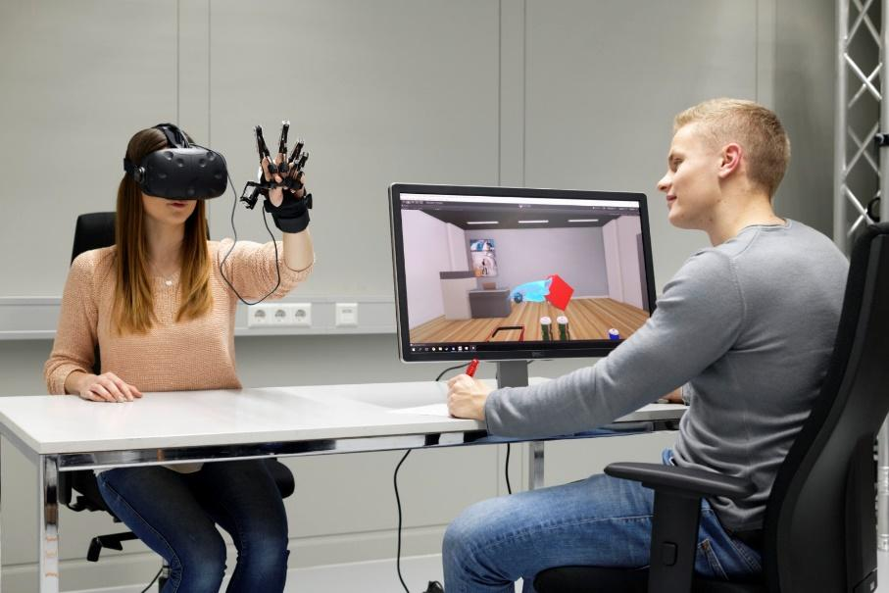

**Figure 1.** A centered figure caption is always placed below the illustration. Please use the word functionality “insert caption” and then and then format the caption with the “captions” format

In addition to the embedded figures in the Word file, **figures must be submitted as separate jpeg or png files.** If your figure consists of more than one panel, please merge all parts into one file. If your figure consists of more than one panel, please merge all parts into one file.

For citations of references, we prefer the use of square brackets and consecutive numbers, e.g. “as shown by Author et al. [2], [3, pp. 5–10]”, “as mentioned earlier [1], [3], [9]”. The first reference mentioned must be [1], the second reference mention [2] etc. **Please do not use reference linking in Word** (e.g. Word functionality “Insert Citation”, Citavi, or Mendeley) **as this causes problem during the XML conversion**. **However, we recommend adding references through the Zotero Word plugin**. If available, **DOIs must be provided.** The bibliography below provides the basic formats as a reference list with entries for journal articles [1], book chapter [2], as well as a URL [3]. For further guidance please refer to <https://ieeeauthorcenter.ieee.org/wp-content/uploads/IEEE-Reference-Guide.pdf>. Please do not forget that data (and other material underpinning the findings) need to be *cited* in the text and the respective reference must be included in the manuscript’s reference list. Please refer to the [data citation principles of FORCE11](https://www.force11.org/datacitationprinciples) or the [FORCE11 software citation principles](https://peerj.com/articles/cs-86/), respectively.

# Data availability statement

Please include a statement on how the data supporting the results of your article/contribution can be accessed. If the submission is not based on data or the data it is based on is restricted (third-party data, legal or ethical constraints), this has to be explained in the data availability statement, too. Ideally, data should be deposited in a FAIR-aligned public repository. A registry to find suitable data repositories is [re3data.org](https://www.re3data.org/). Reciprocal linking of data and the article/contribution through persistent identifiers (e.g. DOIs) is best practice.

# Underlying and related material

If you have other material which supports your findings (e.g. model code) or is closely related to your article/contribution (e.g. supplementary material as videos, samples, etc.) deposited on a repository, please include a brief description and the respective DOI(s) here.

# Author contributions

Please include a statement on authors' contributions according to the [CreDIT guidelines](http://credit.niso.org/) here. CRediT (Contributor Roles Taxonomy)’s intention is to recognize individual author contributions, reduce authorship disputes, and facilitate collaboration.

# Competing interests

Competing interests arise when issues outside research may fairly be viewed as impacting the work's neutrality. All potential competing interests must be disclosed (“The authors declare the following competing interests: …”). If there are no potential competing interests please state “The authors declare that they have no competing interests.”

# Funding

Please insert a funding statement (if applicable) here.

# Acknowledgement

If you want to acknowledge persons or institutions you can do so here.

# References

1. J. K. Author, “Name of paper,” Abbrev. Title of Journal, vol.x, no.x, pp. xxx–xxx, Abbrev. month, year, doi: https.doi.org/……
2. J. K. Author, “Title of chapter in the book,” in Title of Their Published Book, xth ed. City of Publisher, (only U.S. State), Country: Abbrev. of Publisher, year, ch. x, sec. x, pp. xxx–xxx.
3. First Name Initial(s) Last Name. “Page Title.” Website Title. Web Address (date accessed)