**[Experimental](D:/Dict/8.9.9.0/resultui/html/index.html" \l "/javascript:;)** **[environment](D:/Dict/8.9.9.0/resultui/html/index.html" \l "/javascript:;)**：

Cuda 10.1 cudnn 7.6.0 python 3.7 tensorflow-gpu 2.2.0 keras 2.3.1

**How to use code：**

1. Data process for training：
2. Copy origin images and masks to ’ ./data/Raw’
3. Run process0.py
4. Run process1.py
5. Run process2.py
6. Train shape constrained network（SRM）

Prepare data：run process3.py

train：run .\SRM\train.py

1. train binary segmentation network for crop（Crop_Net）

Prepare data：run process4.py

train:run .\Crop_Net\train.py

1. Train final multi_organ_network（ISENet）
2. Replace the path r'.\srm_model.hdf5' in .\Inception_att_resnet\metrics.py to your path of trained SRM model

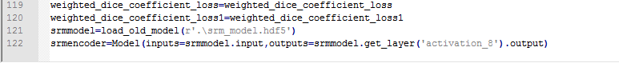

（2）run .\Inception_att_resnet\train.py

5. Test

（1）Replace the path r'..\data\Raw\ValidationImg' in .\Inception_att_resnet\predict.py to your path of test data, and replace the path r'.\model.20-0.02.hdf5' to your path of trained Crop_net model, replace the path r'H:\mutil_CT_seg\result_x1\incep_att_resnet13\ValPrediction_ori2' to your path for saving test result



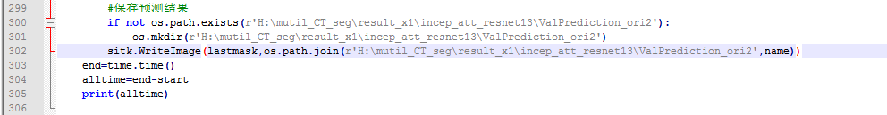

（2）run .\Inception_att_resnet\predict.py