LOFERYX
ONLINE COMPILER
PROJECT REPORT

Submitted in partial fulfillment of the requirements for the degree of
BACHELOR OF TECHNOLOGY
IN
COMPUTER SCIENCE / DATA SCIENCE

Submitted by
ANMOL SINGH

Under the Esteemed Guidance of Department of Computer Science and Engineering


DEPARTMENT OF [DEPARTMENT NAME]
SANSKAR COLLEGE OF ENGINEERING AND TECHNOLOGY
GHAZIABAD, UTTAR PRADESH
ACADEMIC SESSION: [2026–2027]
A browser-based coding environment for writing, compiling, executing, and collaborating on source code.

CERTIFICATE
This is to certify that the project report entitled “LOFERYX ONLINE COMPILER” is submitted by ANMOL SINGH, bearing Roll Number 25DS011, in partial fulfillment of the requirements for the award of the degree of Bachelor of Technology in DATA SCINCE at Sanskar College of Engineering and Technology, Ghaziabad.
The work presented in this report describes the analysis and design of a browser-based programming environment intended to make code writing and execution more accessible. The report has been prepared under the guidance of [GUIDE / FACULTY NAME].
To the best of our knowledge, this report is submitted for academic evaluation and has not been submitted in the same form to another institution for the award of a degree or diploma.

INTERNAL GUIDE | HEAD OF DEPARTMENT
Name: Ms. Richa Chauhan  Signature: __________________ | Name: [HOD NAME]  Signature: __________________

Date: ____________________ Place: Ghaziabad, Uttar Pradesh

DECLARATION
I hereby declare that the project report titled “Loferyx Online Compiler” has been prepared by me for academic purposes. The report describes the problem, system design, technology choices, workflow, and planned or implemented modules of the project to the best of my knowledge.
I understand that any implementation-specific statements must correspond to the actual source code and deployment configuration. Where a feature, integration, test result, or deployment detail has not been independently verified for this report, it should be checked against the current project before final submission.
I further declare that external references used in preparing the report are acknowledged in the bibliography, and that the final submitted copy will be reviewed for accuracy and compliance with the institution’s project-report guidelines.

Student Name: ANMOL SINGH
Roll Number: 2502151540001
Signature: ______________________________
Date: ___________________________________

ACKNOWLEDGEMENT
I would like to express my sincere gratitude to my project guide, [GUIDE / FACULTY NAME], for the direction and academic support provided during the planning and development of Loferyx Online Compiler. The guidance helped structure the project around a practical problem: making a programming workspace accessible through a web browser without requiring every user to configure a local compiler.
I am thankful to the Department of [DEPARTMENT NAME] and Sanskar College of Engineering and Technology for providing an academic environment in which I could explore software engineering, web application development, API integration, and system design.
I also acknowledge the maintainers of the open-source tools and documentation that support modern web development, including React, Node.js, Express, Monaco Editor, and collaborative editing technologies. Their documentation is valuable for understanding component design, server-side request handling, editor integration, and real-time communication.
Finally, I thank my family, peers, and everyone who provided feedback or encouragement during the project. Their support helped me continue improving the idea and document its architecture, constraints, and possible future extensions.

Student: ANMOL SINGH

ABSTRACT

Loferyx Online Compiler is a browser-based programming platform designed to simplify code writing, compilation, and execution without requiring complex local setup. It integrates Monaco Editor for code editing, React for the user interface, Node.js and Express for backend processing, and a code execution API for running programs. The platform also supports real-time collaborative coding using Yjs and y-websocket, allowing multiple users to work on shared code. Its split input/output interface helps users provide program input and view execution results efficiently. This project aims to make programming more accessible, interactive, and convenient for students and developers.

This report presents the project objectives, system requirements, high-level design (HLD), low-level design (LLD), system architecture, workflow, module descriptions, implementation approach, testing strategy, security considerations, limitations, and future enhancements. It also explains how the frontend, backend, collaboration services, and code execution system interact to provide a unified online coding experience.

KEYWORDS: Loferyx, Online Compiler, Monaco Editor, React.js, Node.js, Express.js, Code Execution API, Yjs, y-websocket, Real-Time Collaboration, Input/Output Management.

TABLE OF CONTENTS

SECTION | CONTENTS | PAGE
Preliminary | Cover page, Certificate, Declaration, Acknowledgement | 1–4
Overview | Abstract and Table of Contents | 5–6
Chapter 1 | Introduction and Problem Statement | 7
Chapter 2 | Objectives, Scope and Use Cases | 8
Chapter 3 | Background and Existing-System Review | 9
Chapter 4 | Requirements and Feasibility | 10
Chapter 5 | Technology Stack and Rationale | 11
Chapter 6 | High-Level Design (HLD) | 12
Chapter 7 | Low-Level Design (LLD) | 13
Chapter 8 | System Flow and Execution Sequence | 14
Chapter 9 | Module Design | 15
Chapter 10 | Data Handling and API Design | 16
Chapter 11 | Security, Reliability and Error Handling | 17
Chapter 12 | Implementation Approach and Code Samples | 18
Chapter 13 | Testing Strategy and Test Cases | 19
Chapter 14 | Limitations and Future Enhancements | 20
Chapter 15 | Conclusion and Learning Outcomes | 21
Appendix | Glossary and Bibliography | 22

CHAPTER 1

INTRODUCTION

1.1 Background
Programming is learned through repeated experimentation: writing a small program, compiling or interpreting it, reading the output, correcting errors, and trying again. A local development environment supports this cycle, but setup can be difficult when a user changes machines, works in a restricted lab, or is unfamiliar with compilers and language runtimes. Browser-based coding tools reduce some of this friction by bringing the editor and execution controls into one interface.

1.2 Problem statement
A learner may need to install separate tools for different languages and may encounter configuration errors before reaching the actual learning task. Sharing a reproducible coding environment can also be inconvenient when code, input, and output are spread across different applications. Loferyx addresses this usability problem by offering a unified online workspace where users can edit source code and request execution through a backend-connected service.

1.3 Proposed approach
The frontend presents the editor and execution controls. A backend service validates and forwards code-execution requests to an external execution provider, then returns a normalized response to the interface. The editor provides syntax-aware input. Collaborative editing technology can support shared sessions, while the exact persistence and room behavior depend on the deployed implementation.

1.4 Intended users
- Students who want to test programming exercises without configuring a local compiler.
- Beginners learning language syntax and debugging basics.
- Instructors or peers who want to discuss code in a shared session.
- Developers who need a lightweight browser workspace for short experiments.

1.5 Report organization
The following chapters move from requirements and technology choices to HLD, LLD, execution flow, module design, security, testing, limitations, and future enhancements.

CHAPTER 2

OBJECTIVES, SCOPE AND USE CASES

2.1 Objectives
- Provide a browser-based editor for writing source code.
- Enable code execution through a backend-connected compilation service.
- Display execution output and error information in a readable workspace.
- Use a familiar syntax-aware editor experience through Monaco Editor.
- Keep provider credentials and execution integration on the server side.
- Establish a foundation for real-time collaborative editing using Yjs and y-websocket.
- Structure the application into maintainable modules that can be extended over time.

2.2 Scope
The core scope covers the editor interface, language or runtime selection where supported, execution request handling, result display, and basic error states. Collaboration is included as an architectural capability in the known project direction, but its final behavior should be confirmed from the active implementation. Authentication, persistent project storage, team permissions, and production-grade sandbox infrastructure are not assumed unless present in the codebase.

2.3 Use-case overview
ACTOR | USE CASE | EXPECTED RESULT
Learner | Open workspace and write code | Source appears in the editor
Learner | Select supported language and run | Execution request is submitted
Execution service | Process submitted source | Returns output or an error
Frontend | Render execution response | User can inspect result and status
Collaborator | Join a shared editing session | Editor updates synchronize if configured
Maintainer | Configure API integration | Backend can communicate with provider

2.4 Out of scope unless implemented
This report does not claim that Loferyx provides persistent cloud projects, user accounts, billing, unrestricted execution, guaranteed isolation, or support for every programming language. Such features require explicit implementation and testing.

CHAPTER 3

BACKGROUND AND EXISTING-SYSTEM REVIEW

3.1 Local development environments
Local IDEs and editors provide rich development features, but they generally depend on installed language toolchains. They are appropriate for advanced projects and offline work, yet setup differences can affect beginners and shared lab environments.

3.2 Browser-based compilers
Online compilers move at least part of the editing and execution workflow to a web application. Their strengths include fast access, reduced local setup, and a convenient way to share small examples. Their constraints include network dependence, provider limits, execution-time limits, and restrictions on file access or system-level operations.

3.3 Collaborative editors
Collaborative editing systems synchronize changes between participants. Yjs is a CRDT-based framework used to model shared data, while y-websocket can provide a transport for shared document updates. Reliable collaboration also requires decisions about room identifiers, access control, reconnection behavior, persistence, and conflict handling.

3.4 Comparative view
CRITERION | LOCAL IDE | BROWSER COMPILER | LOFERYX DESIGN GOAL
Initial setup | Toolchain installation | Usually minimal | Open a web workspace
Execution | Local runtime/compiler | Remote or hosted service | Backend-mediated execution
Editor experience | Often rich | Varies by product | Monaco-based editing
Collaboration | Additional tools may be needed | Varies | Yjs-based capability
Environment control | High local control | Provider constrained | Document limits clearly

3.5 Design implication
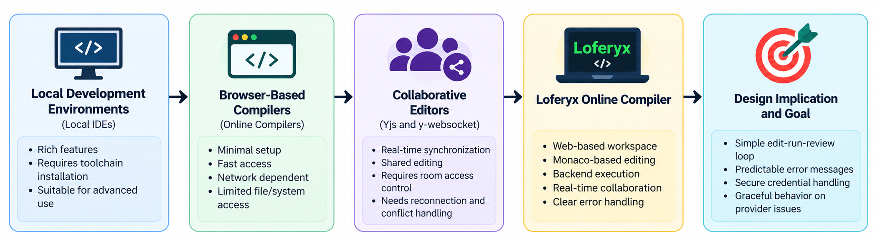
Loferyx should prioritize a clear edit-run-review loop, predictable error messages, secure handling of execution credentials, and graceful behavior when an external provider is slow or unavailable. These priorities are more important than adding many secondary features before the core workflow is reliable.

CHAPTER 4

REQUIREMENTS AND FEASIBILITY

4.1 Functional requirements
ID | REQUIREMENT | ACCEPTANCE EXPECTATION
FR-01 | Display a code editor | Editor accepts text input and supports configured syntax modes
FR-02 | Choose language/runtime | Only configured options are selectable
FR-03 | Submit code for execution | Valid request reaches backend
FR-04 | Display result | Output/status appears in a dedicated result area
FR-05 | Handle errors | Failures show a useful message without crashing the page
FR-06 | Collaborative editing | If enabled, updates synchronize for authorized session members

4.2 Non-functional requirements
- Usability: the editor, run action, language choice, and output should be easy to locate.
- Performance: editor interaction should remain responsive; execution latency depends partly on the external provider.
- Reliability: network errors, invalid responses, and timeouts should be handled explicitly.
- Security: API keys should remain server-side; submitted code must be treated as untrusted input.
- Maintainability: UI, execution service, and collaboration responsibilities should remain separated.

4.3 Feasibility
TYPE | ASSESSMENT
Technical | Feasible using a modern web frontend, Node.js/Express backend, editor component, and external execution API.
Operational | A browser-based workflow reduces installation requirements for end users.
Economic | A prototype can use open-source libraries; external execution and hosting may have quotas or costs.
Schedule | A staged build allows editor, execution, error handling, and collaboration to be developed independently.

4.4 Assumptions and dependencies
Execution requires connectivity to the backend and provider. Available languages, limits, and output formats depend on the configured execution service. The current environment variables, provider contract, and deployment settings must be verified before final evaluation.

CHAPTER 5

TECHNOLOGY STACK AND RATIONALE
LAYER | TECHNOLOGY / COMPONENT | RESPONSIBILITY
Frontend | React | Component-based user interface and state management
Build tooling | Vite | Development server and frontend build pipeline, if used by current setup
Styling | Tailwind CSS | Utility-based responsive styling, if configured in the current frontend
Editor | Monaco Editor | Code editing and language-aware presentation
Backend | Node.js + Express | HTTP endpoints, request validation, provider integration
Execution provider | OnlineCompiler.io API (known integration direction) | Remote code execution; exact API contract depends on current configuration
Collaboration | Yjs + y-websocket | Shared document state and WebSocket-based synchronization

5.1 Why a component-based frontend?
React supports dividing the workspace into independently maintainable interface units such as the editor, toolbar, language selector, output panel, and collaboration status. This separation reduces the risk of one large component becoming difficult to maintain.

5.2 Why a backend intermediary?
A backend keeps provider credentials away from browser code and provides a place to validate request fields, enforce limits, normalize provider responses, log operational failures, and apply rate limiting. It does not automatically make execution safe; the external provider and backend still need appropriate controls.

5.3 Why Monaco Editor?
Monaco provides a familiar code-editing experience with syntax highlighting and editor configuration options. Integration work includes managing editor value, language mode, lifecycle cleanup, resizing, and communicating changes to the execution handler or collaboration provider.

5.4 Why Yjs for collaboration?
Yjs provides shared data structures designed to converge when concurrent changes occur. The surrounding application still needs a consistent shared-document identifier, connection lifecycle management, authorization policy, and a clear indication of connection status.

CHAPTER 6

HIGH-LEVEL DESIGN (HLD)
The HLD describes the main building blocks and the direction in which requests and data move. The diagram below is a logical view of the project architecture; exact endpoint names and deployment topology should be aligned with the current repository.
USER / BROWSER | FRONTEND APPLICATION | BACKEND SERVICES
User types code  selects language  clicks Run | React workspace  Monaco Editor  Run controls  Output panel | Express API  Validation  Provider adapter  Error normalization

→
EXTERNAL EXECUTION PROVIDER | COLLABORATION SERVICE | CONFIGURATION / OPERATIONS
OnlineCompiler.io API  Executes submitted code  Returns status/output | Yjs shared document  WebSocket transport  Shared-session updates | Environment variables  Provider key  Logs and limits  Deployment settings

Figure 6.1. Logical HLD blocks. The execution provider and collaboration service are separate dependencies, even if hosted alongside the application.

6.1 Component responsibilities
- Presentation layer: collects code and options, indicates execution state, and displays the result.
- Application/API layer: validates inputs, calls the execution provider, and returns a predictable response.
- Provider integration layer: isolates provider-specific request and response formats from the UI.
- Collaboration layer: distributes shared-document updates where collaborative sessions are enabled.
- Configuration layer: supplies secrets and environment-specific values without embedding them in frontend source.

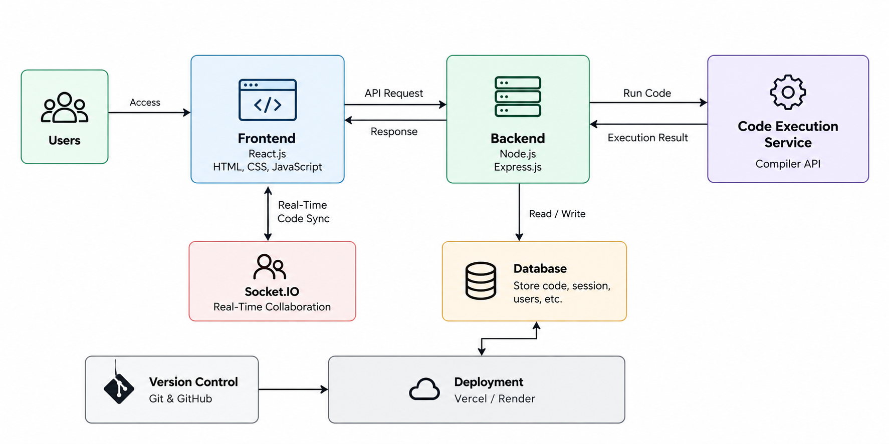
6.2 Architectural decisions
The system is organized around a request-response execution path and a separate real-time collaboration path. This prevents editing synchronization from being tightly coupled to execution. The frontend should not call the execution provider with a private key directly. A provider adapter also makes future provider changes less disruptive.

CHAPTER 7

LOW-LEVEL DESIGN (LLD)
Internal modules • Inputs • Outputs • State transitions

7.1 Frontend component decomposition
COMPONENT / MODULE | INPUT | OUTPUT / RESPONSIBILITY
WorkspacePage | Route and initial settings | Composes the editor workspace
LanguageSelector | Supported-language list | Selected language/runtime identifier
RunController | Source, language, optional input | Execution request and loading state
OutputPanel | Normalized execution response | Readable output, errors, and status
CollaborationAdapter | Room/document identifier | Shared text updates and connection status

7.2 Backend module decomposition
MODULE | DESIGN RESPONSIBILITY
Execution Route | Receives the client request and returns an HTTP response
Request Validator | Checks required fields, types, language allowlist, and size limits
Execution Service | Orchestrates the provider request and timeout behavior
Provider Adapter | Maps internal fields to provider-specific API fields
Response Normalizer | Converts provider success/error formats to a stable client shape
Error Handler | Maps expected failures to safe status codes and messages

7.3 Suggested execution state machine
STATE | EVENT | NEXT STATE
Idle | User selects Run | Validating
Validating | Input is valid | Submitting
Validating | Input is invalid | Error
Submitting | Provider accepts request | Running / Waiting
Running / Waiting | Provider returns result | Completed
Running / Waiting | Timeout or network failure | Error
Completed / Error | User edits or runs again | Idle / Validating

7.4 Separation of concerns
The UI should not contain provider authentication logic. The provider adapter should not depend on React components. Collaboration state should not overwrite the execution result state. These boundaries simplify testing and make it easier to replace a UI component or execution provider without rewriting the whole application.
CHAPTER 8

SYSTEM FLOW AND EXECUTION SEQUENCE

8.1 End-to-end flowchart
STEP | PROCESS BLOCK | DECISION / RESULT
01 | Open Loferyx workspace | Editor and controls load
02 | Write or edit source code | Editor state changes
03 | Select configured language | Language identifier is set
04 | Click Run | Client creates execution request
05 | Backend validates request | Invalid request returns validation error
06 | Execution service calls provider | Provider receives code and language
07 | Provider processes code | Returns output, error, or status
08 | Backend normalizes response | Stable response shape returned
09 | Output panel renders result | User reviews and edits code again

8.2 Sequence diagram in text blocks
ACTOR | MESSAGE / ACTION | RECEIVER
User | Click Run | Frontend
Frontend | POST execution payload | Express API
Express API | Validate payload and limits | Validation module
Execution service | Submit code to provider | Execution API
Execution API | Return output / error / status | Execution service
Express API | Return normalized JSON | Frontend
Frontend | Render status and output | User

8.3 Collaboration flow
When collaboration is enabled, a participant connects to a shared document through the configured WebSocket transport. Local edits are applied to the shared document, update messages are exchanged with the collaboration service, and connected clients apply compatible updates. A disconnected participant should receive a visible connection status; reconnection and persistence behavior must be confirmed in the implementation.

8.4 Important failure branches
- Missing source or unsupported language: reject before calling the provider.
- Provider rejects the request: show a concise error and preserve the user’s source code.
- Network timeout: stop the loading indicator and allow retry.
- Malformed provider response: return a safe generic failure and log diagnostic details server-side.
- Collaboration disconnect: keep local editing available if possible and show that synchronization is unavailable.

CHAPTER 9

PROCESS
The development of Loferyx Online Compiler follows a structured process to provide an efficient, accessible, and collaborative programming environment.
- 1. Requirement Analysis: Identify the main requirements, including online code editing, program execution, real-time collaboration, and separate input/output panels.
- 2. Frontend Development: Develop the user interface using React.js, HTML, CSS, and JavaScript, integrating Monaco Editor for writing and editing source code.
- 3. Backend Development: Use Node.js and Express.js to handle client requests, validate execution requests, and communicate with the code execution service.
- 4. Code Execution: Connect the backend to a compiler API to submit source code, process program input, and return execution results or errors.
- 5. Real-Time Collaboration: Integrate Yjs and y-websocket to synchronize shared code between connected users in real time.
- 6. Input/Output Management: Implement separate panels for entering program input and displaying execution output, making testing and debugging easier.
- 7. Testing and Validation: Test code execution, input handling, collaboration, error responses, and interface functionality to identify and resolve issues.
- 8. Deployment and Maintenance: Manage source code using Git and GitHub and deploy the application using suitable hosting platforms such as Vercel and Render.
- Result: This process combines frontend development, backend integration, code execution, and collaborative editing to create a unified online programming environment.

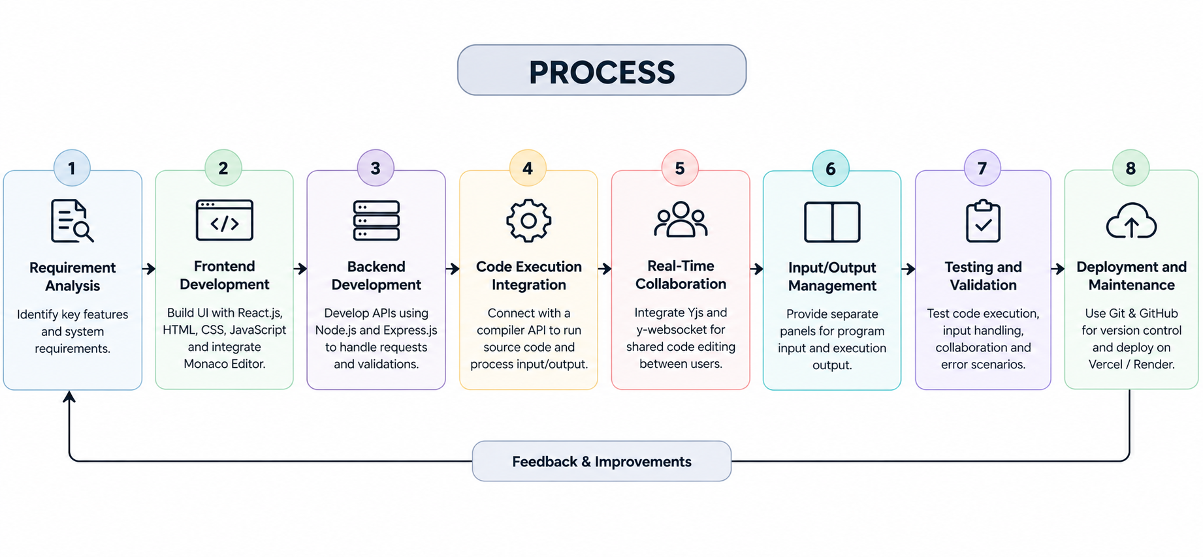

SNAPSHOTS

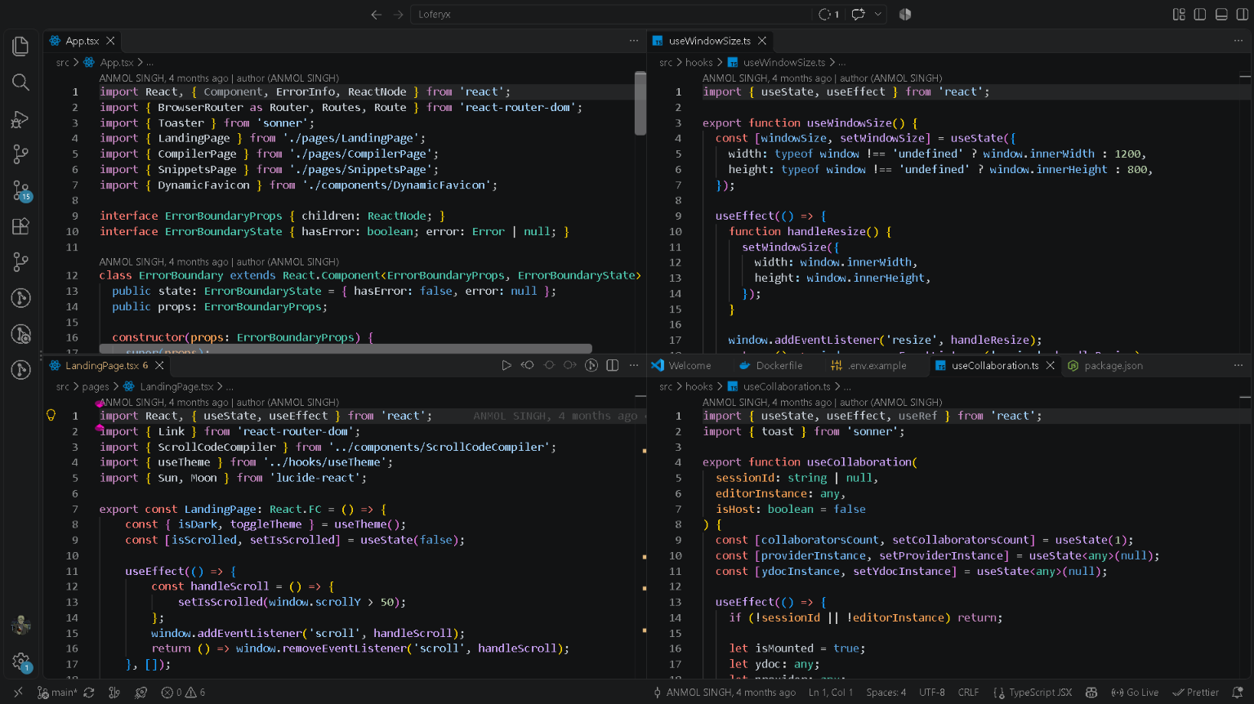
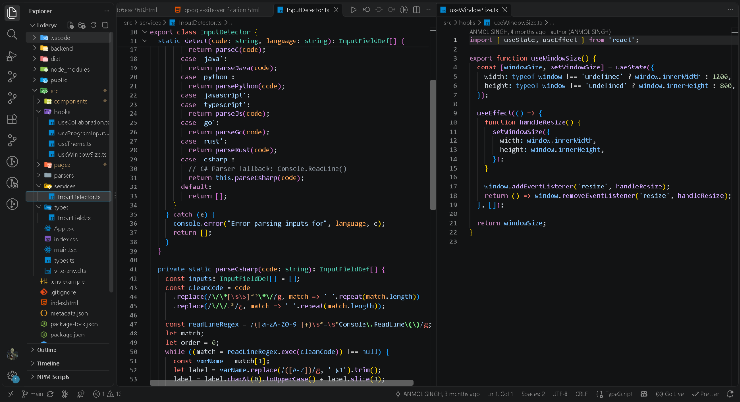

SOURCE CODE

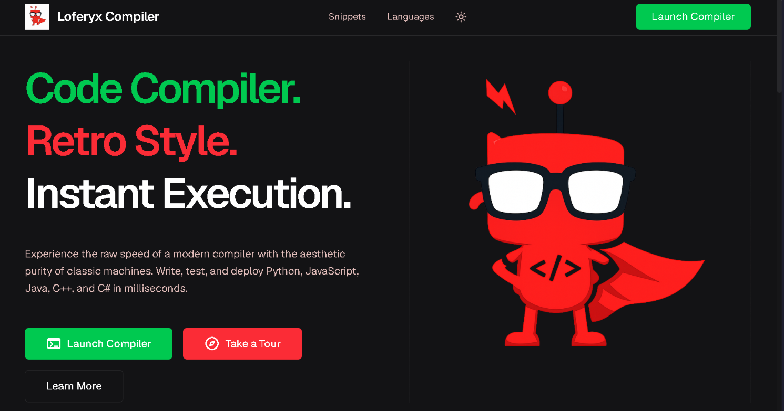

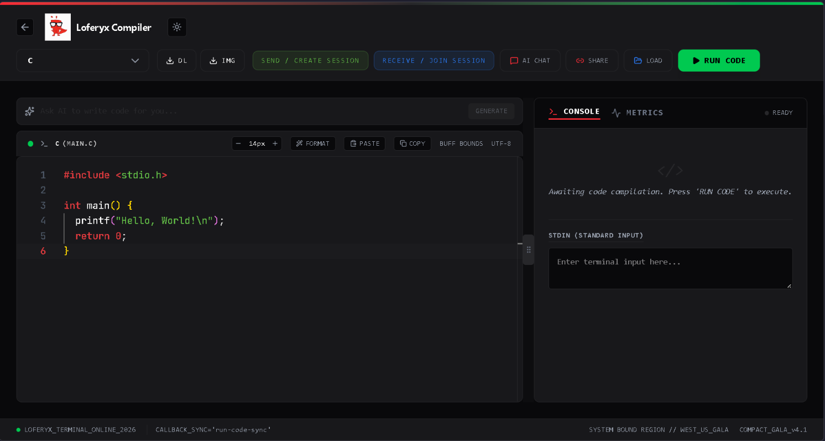

CHAPTER 10
FUTURE SCOPE
- AI Code Assistant: Integrate AI for code suggestions, debugging, and error explanations.
- More Programming Languages: Expand support for additional languages and compilers.
- Advanced Collaboration: Add shared cursors, user presence, and collaborative coding rooms.
- Cloud Storage: Allow users to save, manage, and access projects online.
- Improved Execution: Optimize code execution speed, reliability, and error handling.
- User Authentication: Introduce secure accounts and personalized workspaces.
- Project Sharing: Enable users to share code and collaborate through accessible links.
- Mobile Compatibility: Improve the coding experience on mobile devices.
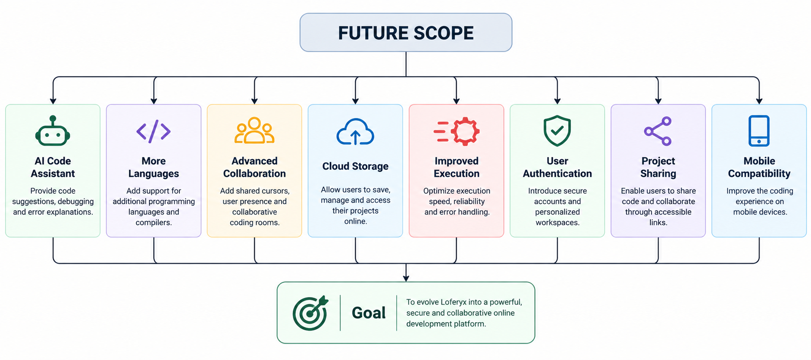
- Goal: To evolve Loferyx into a powerful, secure, and collaborative online development platform.
.

CHAPTER 11

CHAPTER 12

IMPLEMENTATION APPROACH AND CODE SAMPLES

12.1 Implementation stages
Work Item | Deliverable
Design workspace | Editor, toolbar, input/output panel
Integrate Monaco Editor | Code editing and language selection
Develop backend | API for code execution
Connect Compiler API | Program execution and results
Handle errors | Output and error messages
Add collaboration | Real-time code synchronization
Test the system | Working and validated features

12.2 Illustrative backend validation
The snippet below demonstrates the shape of a validation step. It is illustrative pseudocode and should be adapted to the project’s actual endpoint and schema.

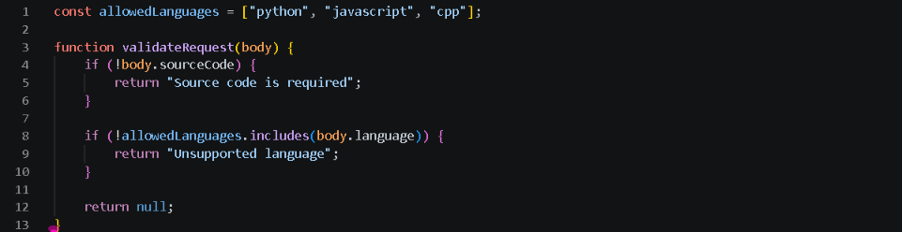

12.3 Illustrative frontend state
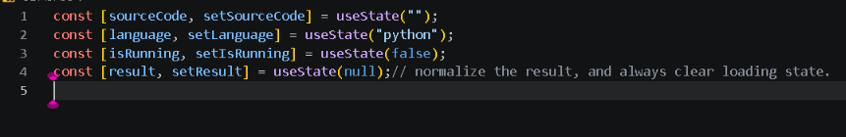

12.4 Code quality principles
- Write clean and reusable code.
- Validate user input before execution.
- Display errors clearly.
- Keep API keys secure using environment variables.
- Test code execution and real-time collaboration.

CHAPTER 13

TESTING STRATEGY AND TEST CASES
- Testing is an important part of the Loferyx Online Compiler project. It helps verify that the code editor, compiler API, input/output panels, and real-time collaboration work correctly. Testing also helps identify errors, improve reliability, and ensure a smooth user experience.
ID | TEST SCENARIO | EXPECTED RESULT | STATUS
TC-01 | Open workspace | Editor and controls render without blocking errors | To verify
TC-02 | Type source code | Editor state updates correctly | To verify
TC-03 | Select supported language | Selected language is reflected in request | To verify
TC-04 | Run valid program | Provider result appears in output panel | To verify
TC-05 | Submit empty source | Validation behavior is clear and consistent | To verify
TC-06 | Choose unsupported language | Request is rejected before provider call | To verify
TC-07 | Provider returns compile error | Error is displayed without losing source | To verify
TC-08 | Provider is unavailable | Timeout/error state appears; UI remains usable | To verify
TC-09 | Double-click Run | Duplicate requests are prevented or safely handled | To verify
TC-10 | Join shared session | Participants see synchronized updates if enabled | To verify
TC-11 | Disconnect collaboration | Status changes and reconnect behavior is understandable | To verify
TC-12 | Inspect browser bundle | No provider secret is exposed to client | To verify

13.2 Testing levels
1. Unit Testing: Individual functions, input validation, language selection, and response handling are tested separately.
2. Integration Testing: The connection between the frontend, backend, and compiler API is tested to ensure requests and responses work correctly.
3. User Interface Testing: The editor, toolbar, input/output panels, loading indicators, and error messages are checked for correct behavior.
4. Security Testing: API key protection, input validation, request limits, and error handling are checked to reduce security risks.
5. Collaboration Testing: Shared editing, simultaneous updates, disconnections, reconnections, and session separation are tested when collaboration functionality is enabled.
6. Performance Testing: The application is checked for reasonable response times, stable execution behavior, and usability under repeated requests.
13.3 Error Handling Tests
Error handling tests verify how Loferyx responds to invalid inputs, compiler errors, network failures, and unexpected API responses. The application should display understandable messages, preserve the user's source code, and allow further interaction whenever possible.
13.4 Testing Evidence
For project documentation, each test should record the test ID, date, software version, test input, expected result, actual result, and final status. This information helps identify unresolved issues and provides evidence of the system's behavior.
13.5 Expected OutcomeThe testing process aims to ensure that Loferyx Compiler provides a stable coding environment, correctly processes execution requests, displays program results, handles errors safely, and supports reliable real-time collaboration.

CHAPTER 14

LIMITATIONS AND FUTURE ENHANCEMENTS

14.1 Current design limitations
- Execution capabilities depend on the configured third-party service, its language list, resource limits, and uptime.
- Network connectivity is required for backend-mediated execution and real-time collaboration.
- Provider latency can affect the perceived speed of the Run workflow.
- A browser editor alone does not provide durable project storage or version history.
- Collaboration requires careful room access control and reconnection handling.
- The current report does not assert that authentication, saved workspaces, or a database are implemented.

14.2 Future enhancements
ENHANCEMENT | VALUE | KEY WORK REQUIRED
User accounts | Personal workspace and identity | Authentication, sessions, account recovery
Cloud project saving | Resume work across devices | Database schema, ownership, CRUD APIs
Execution history | Review earlier runs | Retention rules, indexes, pagination
Git integration | Version control workflow | OAuth, repository permissions, commit handling
Advanced collaboration | Shared cursors and presence | Presence protocol, room authorization, tests
More language support | Broader learning use cases | Provider compatibility and regression tests
Keyboard shortcuts | Faster editor workflow | Accessible shortcut map and conflict checks
AI code explanation | Learning-oriented feedback | Secure AI integration and clear usage limits

14.3 Roadmap priority
A sensible order is to first make execution predictable and secure, then improve error handling and test coverage, then harden collaboration, and only afterward introduce accounts, persistent projects, repository integrations, or AI assistance. This order reduces the risk of adding features on top of an unstable core.
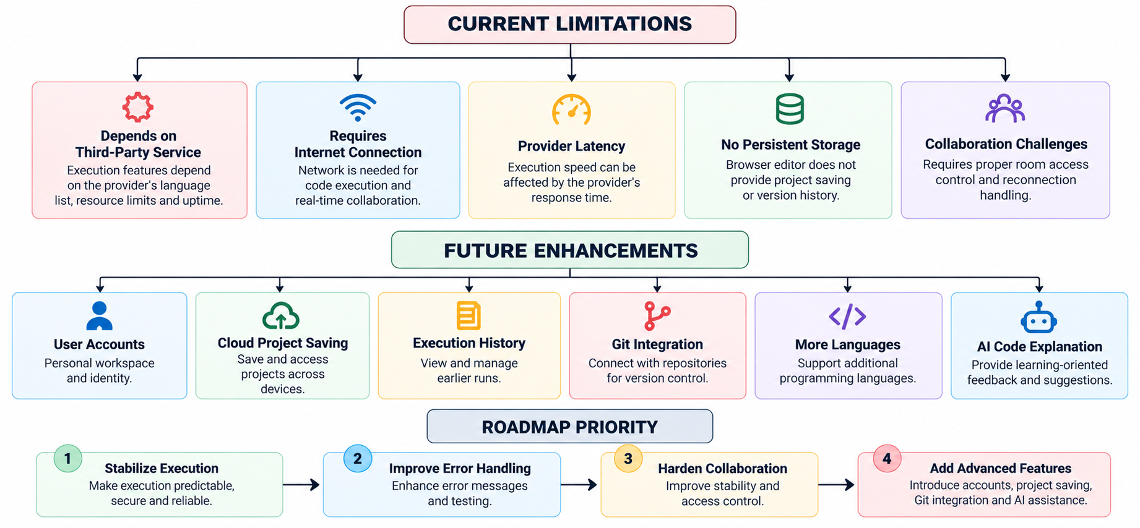
X
CHAPTER 15

CONCLUSION AND LEARNING OUTCOMES
Loferyx Online Compiler is a web-based programming workspace designed to simplify the process of writing and executing code. Its central workflow combines a browser editor, a backend execution route, an external compilation service, and an output interface. The known technical direction uses Monaco Editor for code editing, Node.js and Express for backend integration, and Yjs with y-websocket for collaborative editing capabilities.
The HLD separates the user interface, API layer, execution provider, and collaboration transport. The LLD further divides the implementation into focused modules such as editor management, language selection, request validation, provider adaptation, response normalization, and result rendering. This separation improves maintainability and provides a clear foundation for testing.
The project also highlights important engineering concerns beyond the visible interface. API credentials must remain server-side, source code must be treated as untrusted input, execution must be isolated by a trusted provider or sandbox, and network or provider failures must not leave the interface stuck. Collaboration introduces additional responsibilities around room identifiers, authorization, synchronization status, and reconnect behavior.
The work offers practical learning in frontend component design, backend API development, third-party service integration, asynchronous request handling, collaborative data synchronization, and system documentation. Future versions can add durable projects, user accounts, version control, improved diagnostics, and learning-focused assistance after the core workflow and its security controls are verified.

Learning outcomes
- Understanding how a browser interface communicates with a backend service.
- Separating provider-specific execution logic from frontend presentation.
- Designing HLD and LLD views for a multi-component application.
- Planning functional, integration, security, and collaboration tests.
- Recognizing the operational risks of arbitrary code execution and API-key handling.
Final note: the report should be reconciled with the latest repository before submission, especially supported languages, exact endpoint names, collaboration behavior, deployment details, and test results.

APPENDIX

GLOSSARY AND BIBLIOGRAPHY

A. Glossary
TERM | MEANING
API | Application Programming Interface; a contract for communication between software components.
Backend | Server-side logic that validates requests and coordinates services.
Compiler | A tool that translates source code or prepares it for execution.
CRDT | Conflict-free Replicated Data Type, a structure designed to converge across replicas.
HLD | High-Level Design: major system components and their interactions.
LLD | Low-Level Design: module-level responsibilities, inputs, outputs, and behavior.
Monaco Editor | A browser-based code editor component associated with the Visual Studio Code editing experience.
Provider adapter | A module that translates internal requests and responses to an external service contract.
Yjs | A framework for shared data types and collaborative applications.
y-websocket | A WebSocket provider used to exchange Yjs document updates.

B. Bibliography
- React documentation: https://react.dev/
- Vite documentation: https://vite.dev/
- Node.js documentation: https://nodejs.org/docs/
- Express documentation: https://expressjs.com/
- Monaco Editor repository and documentation: https://github.com/microsoft/monaco-editor

Yjs documentation: https://docs.yjs.dev/
- y-websocket repository: https://github.com/yjs/y-websocket
- OnlineCompiler.io: verify the exact provider documentation and API contract used by the current project before submission.
- MDN Web Docs: https://developer.mozilla.org/
- End of report. Replace all bracketed placeholders, confirm the exact project stack and provider contract, update the contents page if pagination changes, and enter real test outcomes before submitting.

