Xinyi (Nicole) Huang

CS1501-1150

Prof. Sherif Khattab

11/6/2020

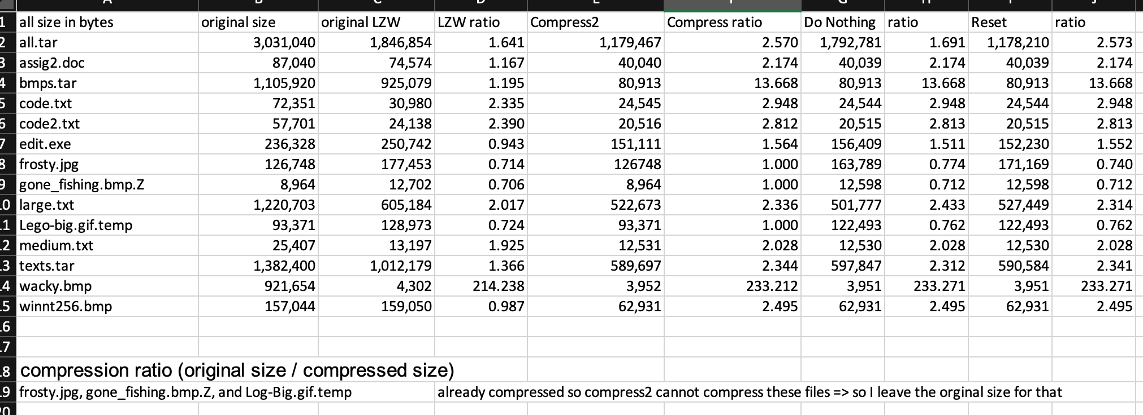Assignment 2 Write-up

Overall, all of the four LZW variation programs performed very similarly, only in some files there are relatively large differences. According to the compression ratios, for the files of assig2.doc, bmps.tar, code.txt, code2.txt, gone_fishing.bmp.Z, Lego-big.gif.temp, medium.txt, wacky.bmp, and winnt256.bmp. LZWMod "do nothing", "reset" and Unix compress2 have the same performance in terms of compressed file size, and Unix compress2 only has some files that are a few bytes difference. But in general, it is the same.

After comparison, we can see that the original LZW performed worst in all files. In bmps.tar, the ratio of original LZW is 12 points different from other compression programs. I think because the original LZW program has a fixed codeword width of 12 bits that the program will run out of codewords quickly. Therefore, the program cannot compress large files well. For the files edit.exe, all.tar, and texts.tar, we can see that Unix compress2 and LZEmod "reset " have a little bit better compression performance than LZEmod "do nothing ". I think it is because Unix compress2 and LZEmod "reset " don't have a fixed codeword width and it can reset the codebook when it full. But this could not work for all cases, for example, large.txt, LZEmod "do nothing " performed better than Unix compress2 and LZEmod "reset ". I think because text usually contains repetitions, it is better to keep the same codebook for compression.

B.

For all algorithms, wacky.bmp gave the best compression ratios which the ratio is over 200. After looking at the file, I guess it was because the file contains a large amount of white space which could allow compression very effectively.

frosty.jpg, gone_fishing.bmp.Z, and Log-Big.gif.temp gave the worst compression ratios, which their ratios are less than 1, especially, gone_fishing.bmp.Z. frosty.jpg, gone_fishing.bmp.Z, and Log-Big.gif.temp did not compress at all when I use Unix Compress and they are even expanded when I use LZWmod and original LZW. Then according to their file extension, I noticed that these files are already compressed. For example, JPG, PNG, GIF, MP3, WMA, AVI, and such multimedia files cannot be compressed more because they already in a highly compressed state. Also, another reason could be that there are some random data/patterns in a file so it won't compress well.