Joova Band Launch: Step by Step
Sep 27, 2026 · @XyntraAI

The launch on one page
If you sign and pay the deposit this week, the Joova Band can be on sale around Nov 18, nine days before Black Friday. It launches with the factory's generic app, published in your own developer accounts under the Joova name and icon; your own custom features come in the next phase.
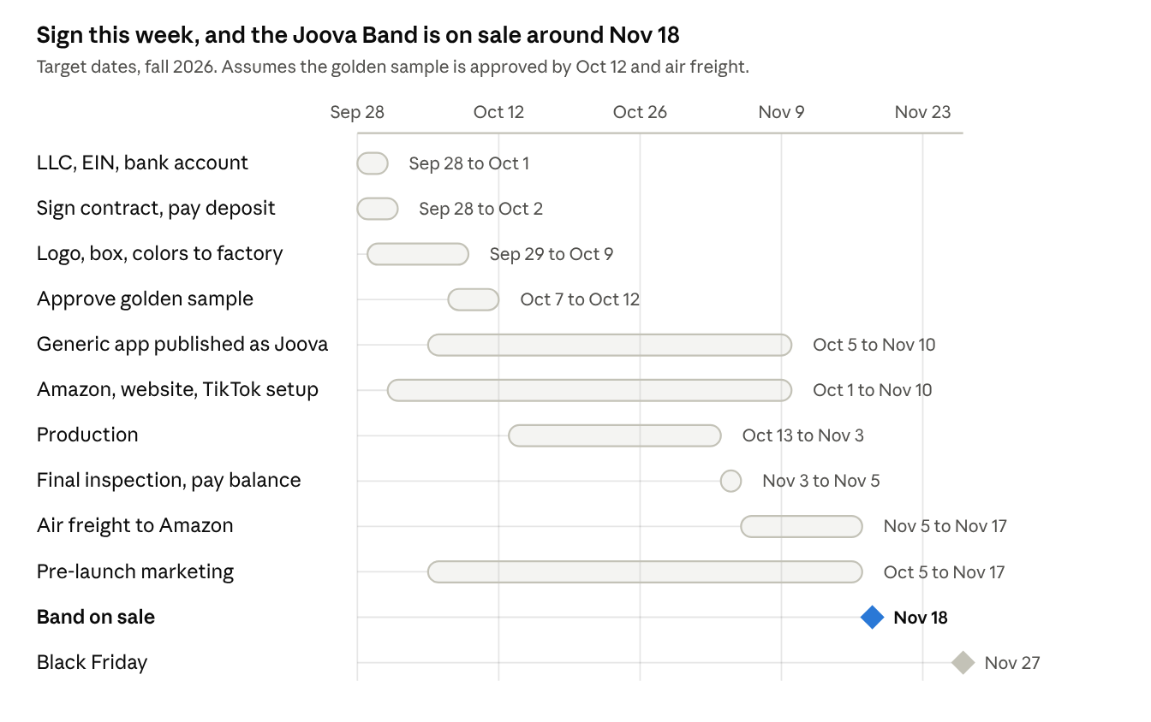
Joova Band launch timeline · signing to first sales
The order: 1,000 bands at $49.99, in 5 colors (Midnight knit 400, Cloud knit 200, Midnight silicone 150, Lilac knit 150, Coral knit 100), 3 straps in every box, "No subscription. Ever." on the front.

11 steps to launch
- Create the LLC and bank account (this week). Form the LLC in your state, get a free EIN from the IRS, and open a business bank account. Everything after this (contracts, D-U-N-S, Amazon, app accounts) is in the LLC's name.
- Sign and pay the deposit (by Oct 2). Sign the order contract, the app license and an NNN agreement. Pay 30%, only to the bank account named in the contract.
- Send your brand files (by Oct 9). Logo, strap colors, box design and user guide in English and French (needed for Canada), and 5 barcodes (one per color).
- Approve the golden sample (by Oct 12). One finished band per color, in the box. Production must match it.
- Publish the app (by Nov 10). Get a D-U-N-S number, open company Apple and Google developer accounts, and have the factory upload its generic app there with the Joova name and icon.
- Production and inspection (Oct 13 to Nov 5). Your partner checks mid-way and at the end. Pay the 70% balance only after the final check passes.
- Ship by air to Amazon (Nov 5 to 17). 850 bands to Amazon, 150 to you for website orders, creators and warranty swaps.
- Set up the stores (by Nov 10). File the JOOVA trademark, then open Amazon, the Joova website and TikTok Shop.
- Create social media and build buzz (Oct 1 to Nov 17). Claim @joova (or the closest match) on Instagram, TikTok, YouTube, Facebook, X, Pinterest, Threads and LinkedIn, all with the same logo and link. Then: website waitlist, free bands to 50 small creators, one short video a day.
- Launch (Nov 18). Amazon Vine for early reviews, a 15% launch coupon, Amazon ads, then Black Friday on Nov 27.
- Watch sales and reorder (from December). Reorder the 2 best-selling colors before stock runs low. Custom app features come in the next phase.
Budget: about $40,000 to $76,000 in total, mostly the 1,000 bands landed at Amazon; the range depends on the US tariff rate.

Selling in the US and Canada
The US launches first (Nov 18); Canada follows in January 2027 using the same stock. Other countries wait until both markets are working.
 | United States | Canada
When | Nov 18, 2026 | January 2027
Where to sell | Amazon.com, Joova website, TikTok Shop; Walmart Marketplace from early 2027 | Amazon.ca, Joova website (ships to Canada)
Stock | 850 bands at Amazon US, 150 with you | Amazon ships Canadian orders from your US stock (North America Remote Fulfillment); send stock straight to Amazon Canada once sales grow
Radio certification | FCC ID (from the factory) | ISED certification number (ask the factory now; most Bluetooth factories already have it)
Box and labels | English | English and French on the box and user guide (Canadian law)
Sales tax | Amazon and TikTok collect it in most states; your website needs a sales-tax app | GST/HST: ask an accountant; Amazon collects it in many cases
Do it once: design the box in English and French this week, so the same 1,000 bands can sell in both countries without relabeling.

This week
- ☐ Form the LLC, get the EIN, open the business bank account
- ☐ Have a lawyer check the contracts, then sign them in the LLC's name
- ☐ Pay the 30% deposit from the business account
- ☐ Apply for the D-U-N-S number (needs the LLC first)
- ☐ File the JOOVA trademark
- ☐ Claim @joova on every social platform
- ☐ Put up a waitlist page on the Joova website

