Java Enterprise Application Development Assignment A

MyPilot——An AI Teaching Assistant Plugin for IntelliJ IDEA


目录
1. Team Member Particulars 4
2. System Functionalities and Features 4
2.1. Core Functionality: Teaching Assistant Q&A(F0) 4
2.2. Extended Feature: Professional Code Modification(F2) 5
2.3. Technical Optimization and Efficiency 6
3. Simple User Manual 7
3.1 Plugin Overview 7
3.2 Installation & Environment 7
3.2.1 Environment 7
3.2.2 Installation 8
3.3 First-Time Configuration 8
3.3.1 Path 8
3.3.2 LLM Configuration (Required) 9
3.3.3 Embedding Configuration (Required for ASK) 10
3.3.4 Embedding Settings 11
3.3.5 Knowledge Base 11
3.4 Interface Overview 13
3.5 Core Features & Workflows 14
3.5.1 RAG Q&A (ASK Mode) 14
3.5.2 Edit Code Assistant (EDIT Mode) 15
3.5.3 Code References 17
3.5. Session Management 19
3.5.1 Historical Session 19
3.5.2 Create A New Session 20
3.5.3 Clear All Sessions 21
4. System Technical Details and Design 21
4.1. System Architecture and Components 21
4.1.1. Architectural Layering 21
4.1.2 Detailed Component Responsibilities 22
4.2. General Workflow 24
4.2.1. Workflow I: RAG Q&A and Multi-Turn Dialogue 24
4.2.2. Workflow II: AI-Driven Code Modification 25
4.3. RAG Data Storage and Structures 26
4.3.1. Core Data Model 26
4.3.2. Document Processing Architecture 28
4.3.3. Embedding service architecture 29
4.4. Key Algorithms and Supporting Techniques 31
4.4.1. Document Chunking Algorithm 31
4.4.2. Vector Retrieval Algorithm 31
4.4.3. Similarity Threshold Filtering Algorithm 32
4.4.4. Asynchronous Request Processing Algorithm 32
4.5. LLM Integration and Prompt Engineering 32
4.5.1. Large Language Model API Wrapper: LlmClient 33
4.5.2. RAG Service Prompt Engineering 33
4.5.3. Edit Service Prompt Engineering 34
4.6. Design Rationales and Efficiency Considerations 37
4.6.1 Design Principles and Core Advantages 37
4.6.2 Efficiency and Performance Considerations 38

1. Team Member Particulars
Name | Matriculation Numbers | Contact Number | Email Address
徐云鹏 | 2353583 | 18001958218 | 2353583@tongji.edu.cn
陈艺龙 | 2352359 | 19117172363 | 2352359@tongji.edu.cn
李雪菲 | 2354093 | 18167879818 | 2354093@tongji.edu.cn

2. System Functionalities and Features
This plugin project strictly adheres to the assignment requirements (F0 + F2), implementing the core Teaching Assistant (TA) Q&A functionality, context-awareness capabilities, and a professional AI-driven code modification service.

2.1. Core Functionality: Teaching Assistant Q&A(F0)
ID | Feature Name | Description
F0.1 | Course-specific RAG Q&A System | It implements a question-answering process based on retrieval-augmented generation (RAG). The system can preprocess course materials and handle user-uploaded materials, establish knowledge indexes, and retrieve the most relevant knowledge blocks based on user questions, then combine LLM to generate accurate and authoritative answers related to the course.
F0.2 | Support for Multiple File Formats | Supports users to upload various formats (pptx/ppt/doc/docx/txt/pdf/md) of course materials to generate knowledge base documents.
F0.3 | Multiple Embedding Service Options | It has implemented the invocation of embedding services from Alibaba Cloud/Zhipu, and can also use local embedding algorithms as an alternative. Users can freely configure the required embedding service according to their choice.
F0.4 | Coexistence of Two Knowledge Base Document Sources | Regardless of whether users actively upload documents, the knowledge base always has documents available for reference. There are two sources of knowledge base documents - 1. Static materials: course PPT materials embedded in the project will be automatically parsed during the initialization stage when the plugin is first launched. 2. User-uploaded materials: users can upload the required Java course materials on the UI interface, which will also be parsed into the knowledge base. When retrieving knowledge base documents, both sources can be processed.
F0.5 | Top-k Most Relevant Knowledge Fragment Retrieval | Users can customize retrieval parameters (relevance threshold and top-k parameters) in the settings interface. When answering user questions, the system will retrieve relevant documents from the knowledge base based on the set parameters. If the user sets the relevance threshold beyond the reasonable range (0.3-0.5), the program will use 0.5 as the threshold during execution to ensure that the answers are based on highly relevant course materials.
F0.6 | Source Citation and Knowledge Traceability | Strictly adheres to citation requirements. All responses generated based on retrieved course materials clearly indicate the name of the source document and the page number/range. For responses generated based on LLM's general knowledge, it will explicitly state "The response is based on general knowledge; no specific course materials were cited."
F0.7 | Persistent Multi-round Dialogue Management | It has implemented a dialogue box interface for user interaction and supports complete multi-round dialogues. All dialogue histories are stored and managed to ensure that the AI teaching assistant can remember the context of the current session and provide a coherent communication experience.
F0.8 | Context-aware Questioning | It has implemented a right-click context menu operation in the IntelliJ IDEA editor. Users can quickly select a code segment and ask the assistant questions through the context menu, and the plugin will automatically send the selected code segment as the code context to the LLM.
F0.9 | Asynchronous Non-blocking User Interface | The chat box and LLM API calls adopt an asynchronous non-blocking design. Users can continue to interact with the IDE while waiting for the LLM response, significantly improving the user experience and response speed.

2.2. Extended Feature: Professional Code Modification(F2)
ID | Feature Name | Description
F2.1 | LLM-Driven Code Refactoring & Remediation | Implements execution of complex code modification tasks based on user natural language instructions, including refactoring methods using design patterns, fixing business logic errors, or large-scale structural code optimization.
F2.2 | Multi-Dimensional Change & File Operation Support | Supports multiple modification types (e.g., adding comments, code optimization, bug fixes, refactoring) and the capability for multi-file changes or new file creation to address real-world enterprise development scenarios.
F2.3 | Structured Code & Dialogue Context Engine | Core Technology: The plugin precisely analyzes selected code and project context (classes, methods, file paths) and integrates full dialogue history, transmitting it to the LLM in a structured, context-aware manner to ensure high-precision and project-convention-compliant code modifications.
F2.4 | Built-in Diff Viewer Approval Workflow | Strictly adheres to professional UX standards. Before applying any change, the plugin enforces the use of the IntelliJ IDEA Built-in Diff Viewer for side-by-side comparison of original code vs. AI-suggested modifications. Users must review line-by-line and manually approve before application, ensuring code safety, control, and traceability.

2.3. Technical Optimization and Efficiency
ID | Feature Name | Description
T.1 | Unified Dialogue-Driven Architecture | Core Architectural Advantage: Both the RAG (Retrieval-Augmented Generation) Service and the Code Modification (Edit) Service are driven and managed by a Unified ChatService. This enables users to seamlessly and dynamically switch between RAG Q&A mode and Code Modification mode within a single conversation thread, eliminating the need for session re-initialization and greatly simplifying the user experience and backend state management.
T.2 | Token Usage Estimation and Structured 6D Memory Compression | Implements real-time estimation of LLM Token usage. When dialogue history exceeds the predefined context limit, HistoryCompressor executes a structured, 6-Dimension compression strategy (Context, Decision, User Goal, Results, Unsolved, Plan) by delegating the summarization task to the LLM itself. This sophisticated approach ensures that the most critical semantic information is retained and passed efficiently, significantly improving memory effectiveness and controlling API costs.
T.3 | CompletableFuture-Driven Asynchronous Service Orchestration | Enhanced Performance & Responsiveness: All internal service methods, including the LLM API calls and complex service orchestration (e.g., RAG pipeline steps: retrieve -> prompt engineering -> call LLM), are implemented using CompletableFuture. This ensures non-blocking execution across the entire backend, maximizes thread utilization, and significantly reduces end-to-end latency, providing the user with the fastest possible TA response time.

3. Simple User Manual
This manual is intended for IntelliJ IDEA users and helps you quickly get started and efficiently use the MyPilot plugin for two main AI-assisted development tasks: RAG-based knowledge Q&A and Agent-powered code modification.

3.1 Plugin Overview
Name:MyPilot
Positioning: AI assistant for JavaEE course learning and project coding
Core Capabilities:
- ASK (RAG Q&A):*Retrieval-augmented generation based on local/project materials to precisely locate knowledge points and code snippets
- EDIT (Code Assistant):*Automatically generates code changes and displays them in a Diff window for review and application
- IDE Integration:Right-side tool window, right-click menus in editor/project view, and settings page (Settings → Tools → MyPilot)

3.2 Installation & Environment

3.2.1 Environment
- IDE Requirements:IntelliJ IDEA 2025.1 or later
- JDK Requirements:JDK 21
- Network:Must be able to access the configured LLM/Embedding services

3.2.2 Installation
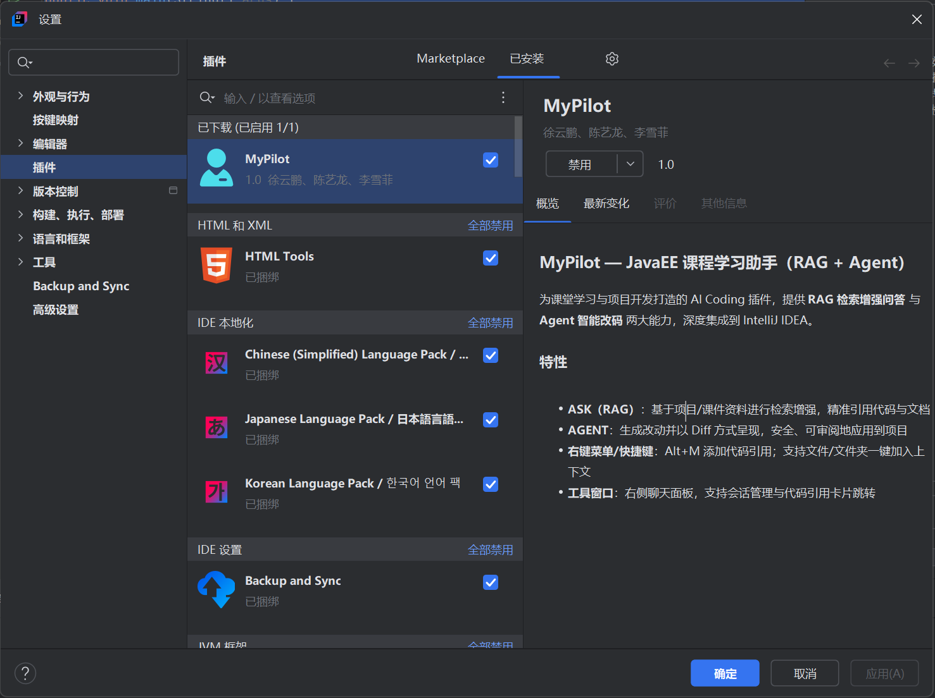

3.3 First-Time Configuration

3.3.1 Path
Settings → Tools → MyPilot or “settings”
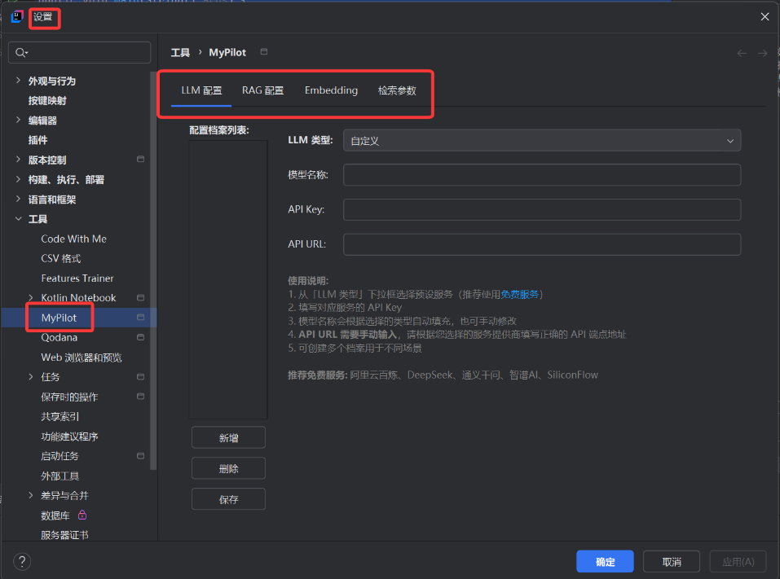

3.3.2 LLM Configuration (Required)
API Base URL, API Key, and Model Name
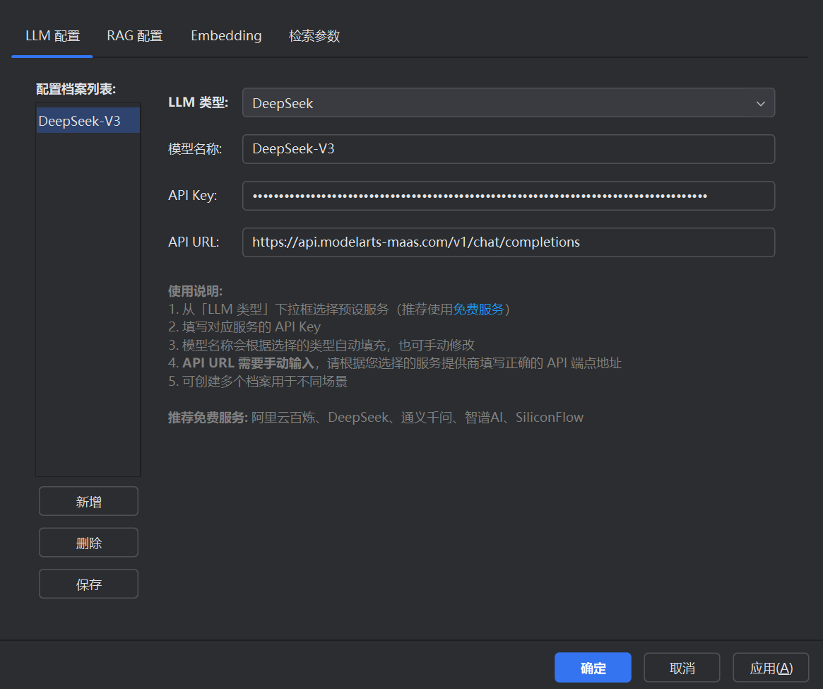
Missing configuration will trigger a warning
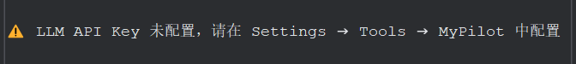

3.3.3 Embedding Configuration (Required for ASK)
API Key, and Embedding Name
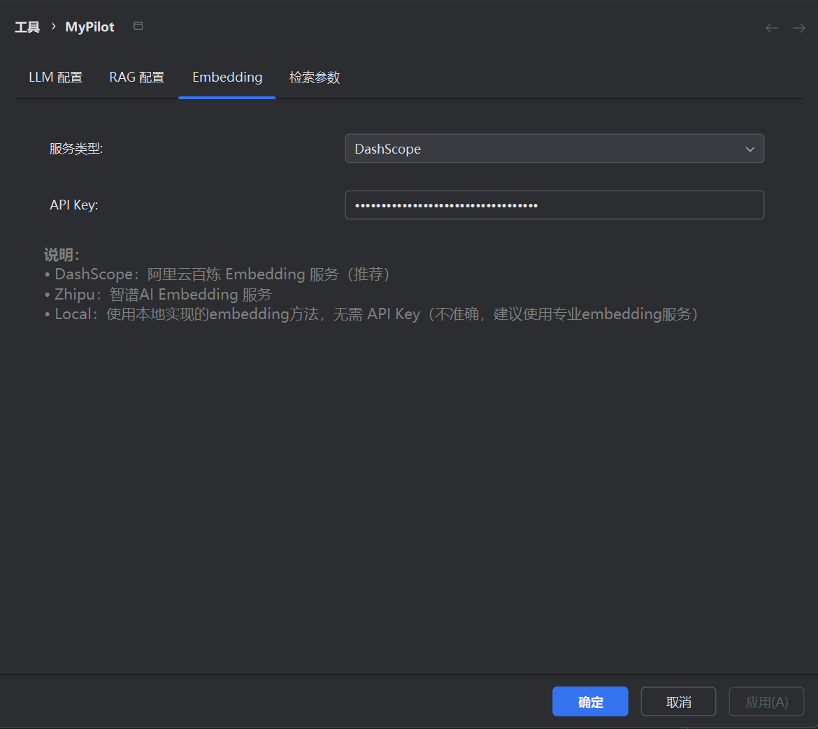
Missing configuration will trigger a warning

3.3.4 Embedding Settings
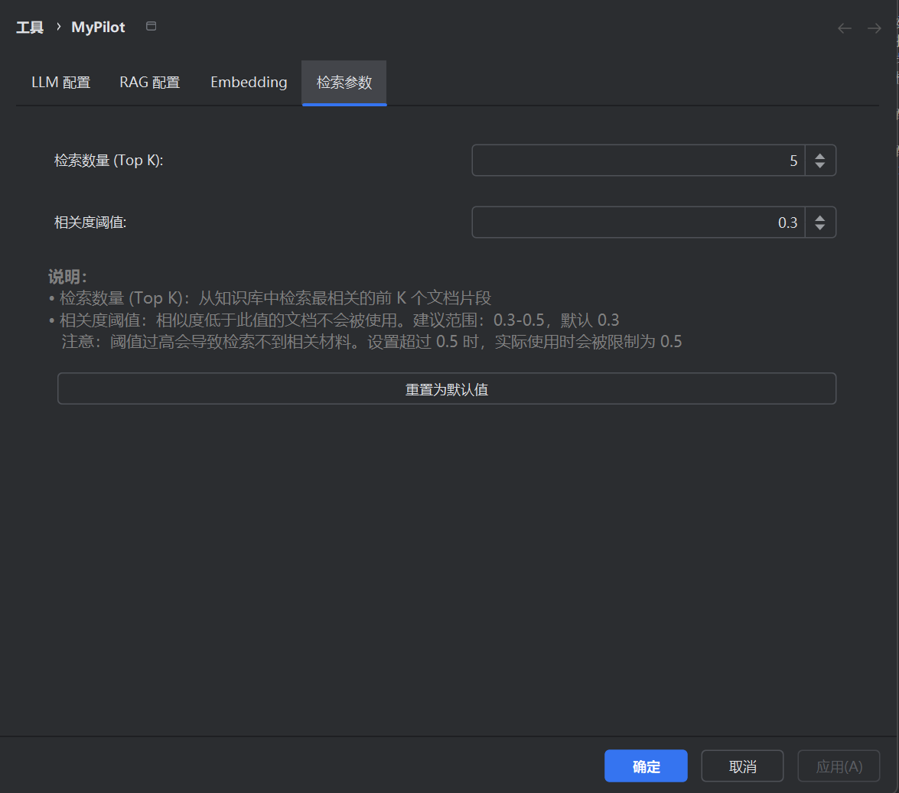

3.3.5 Knowledge Base
Select directories or file types to include in retrieval (supports PDF, PPT, DOC, code files, etc.; see dependency details)
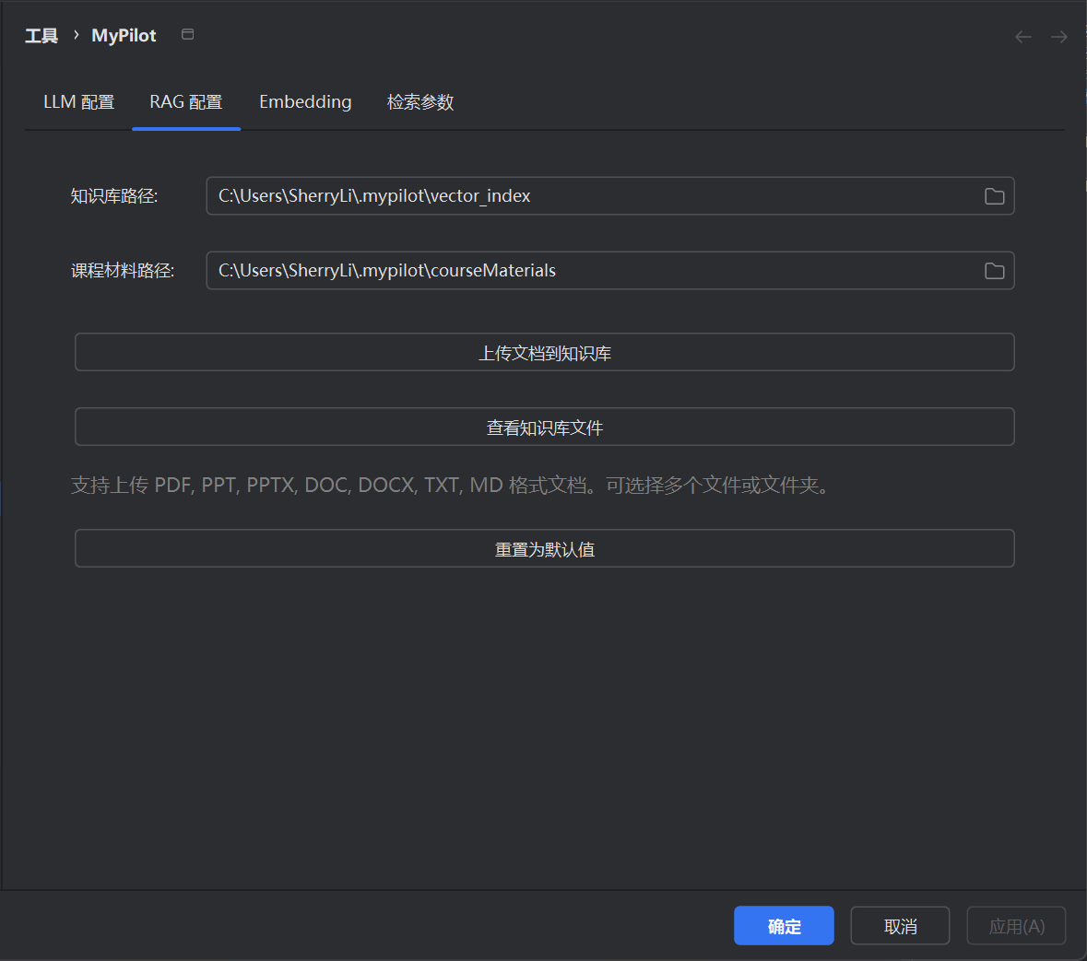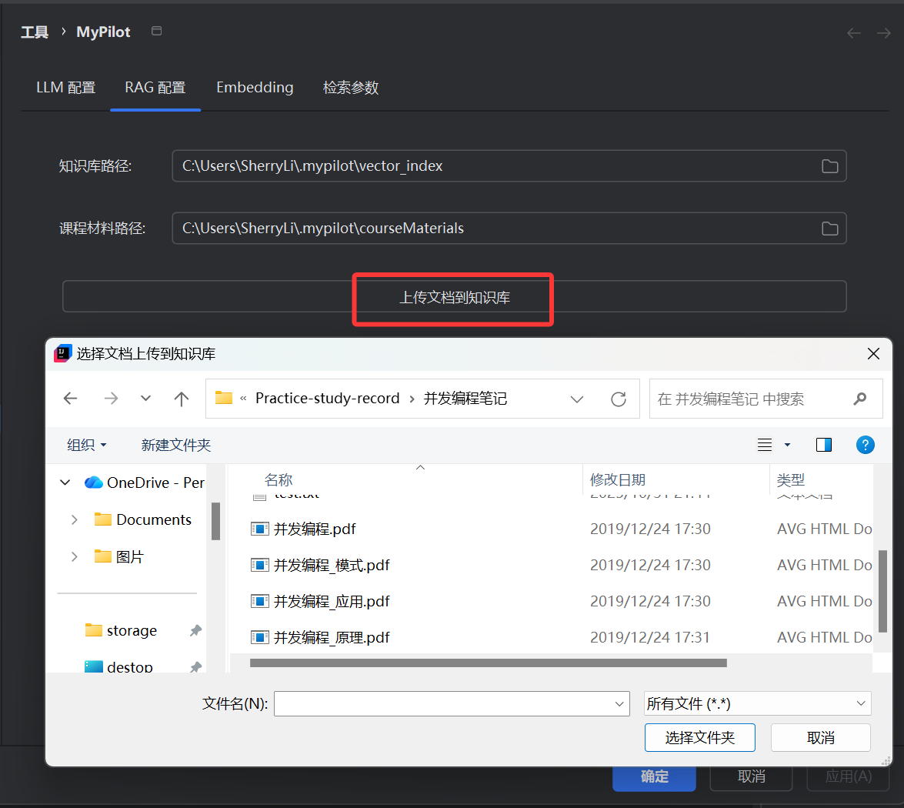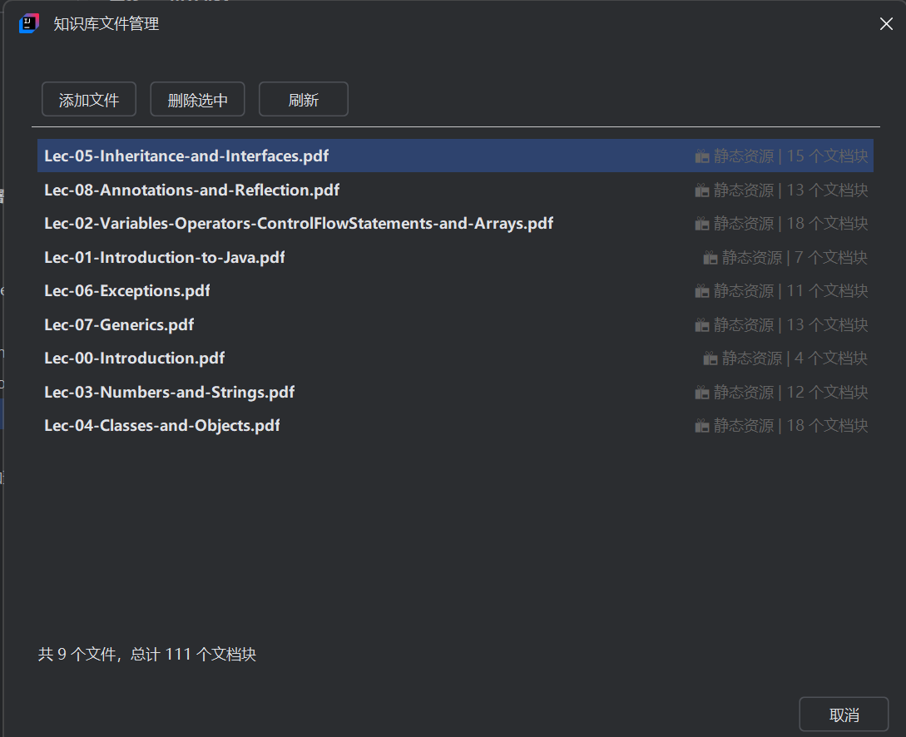

3.4 Interface Overview
Access Methods:Click the MyPilot tool window on the right toolbar, or go to MyPilot → Open Chat Window in the menu.
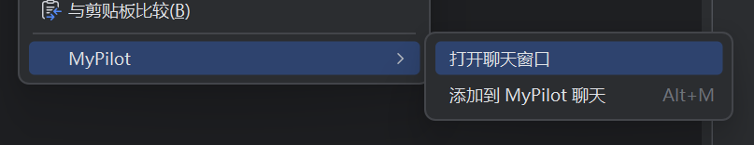
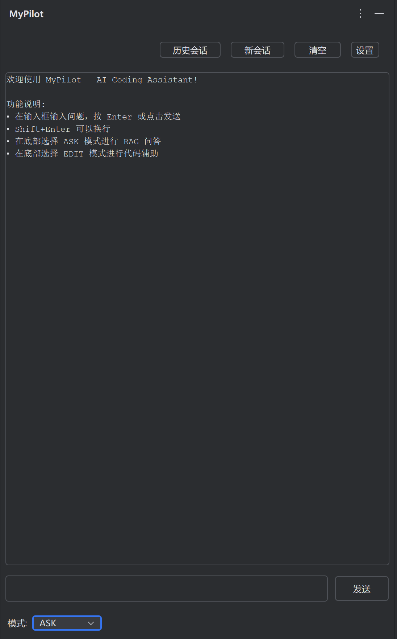

3.5 Core Features & Workflows

3.5.1 RAG Q&A (ASK Mode)
Purpose:For precise Q&A based on project or course materials — locating API usage, explaining code snippets, etc.
Steps:
1.Select ASK mode at the bottom
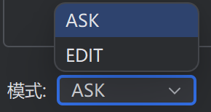
2.(Optional) Add related code/documents to the “Code Reference Bar” via the right-click menu (see 3.5.3)
3. Enter your question and send it — the system will perform retrieval and generation
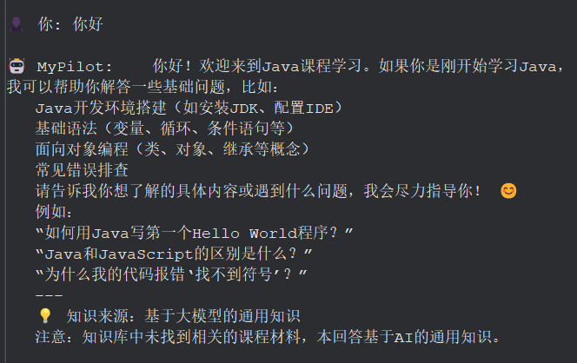
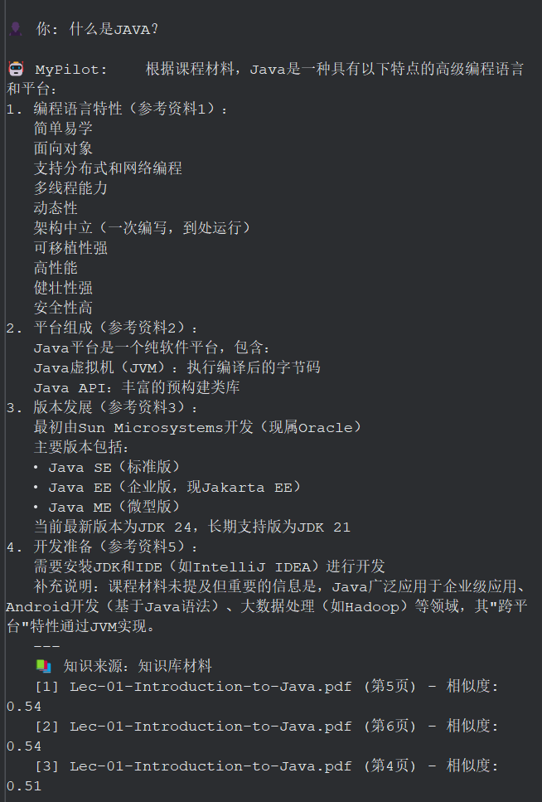

3.5.2 Edit Code Assistant (EDIT Mode)
Purpose:
- Provide a feature that can perform significant code modification tasks according to the user’s instructions.
- Provide a clear and side-by-side comparison and allow the user to review and approve the AI-generated suggestions before applying them.
Steps:
1.Select EDIT mode at the bottom
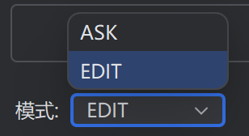
2.Add related code/documents to the “Code Reference Bar” via the right-click menu (see 3.5.3)
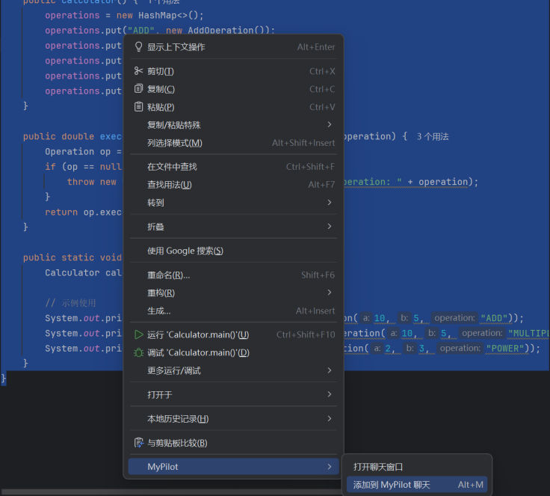
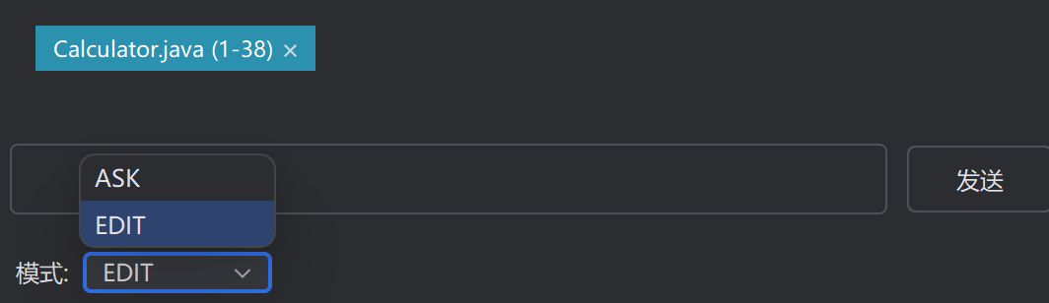
3.Describe your goal in natural language
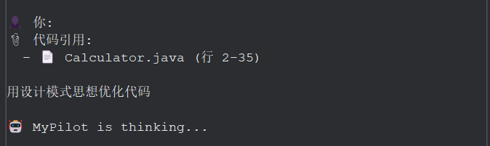
4.While waiting, you’ll see a “thinking…” indicator; once ready, the Diff window opens automatically showing suggested modifications
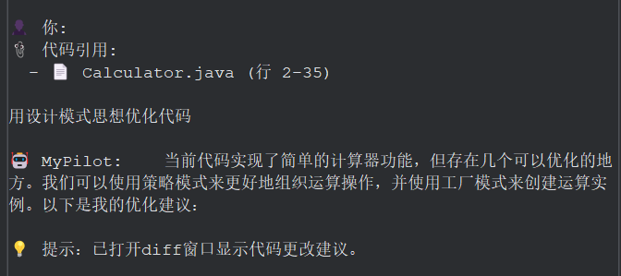
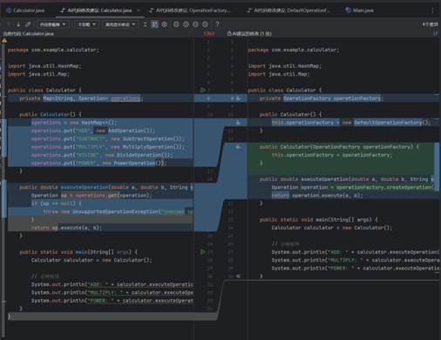
5.You can review the Diff and choose to apply or reject some or all of the changes
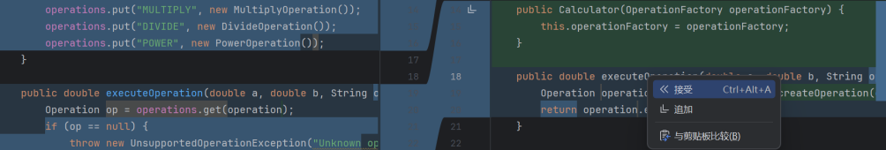

3.5.3 Code References
Purpose:Include selected code/files/directories as context to improve RAG and Agent understanding
How to Add:
1.Select code → right-click `MyPilot` → `Add Code Reference` (shortcut: Alt+M)
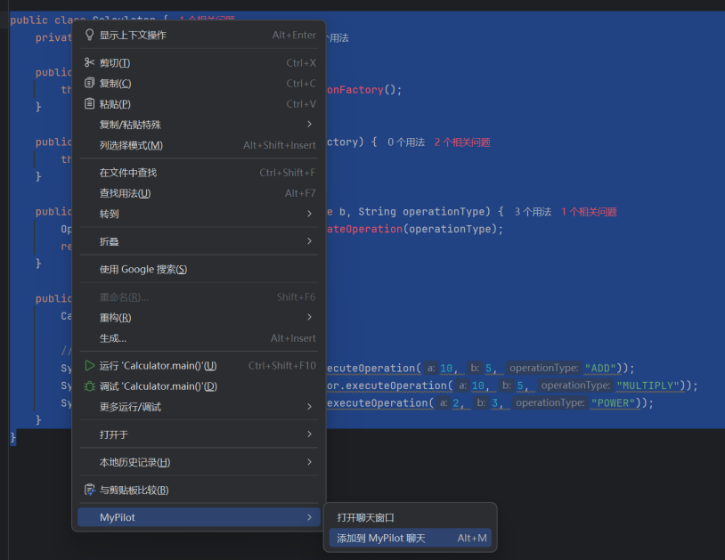
2.Select a file → right-click `MyPilot` → `Add File Code to Chat`
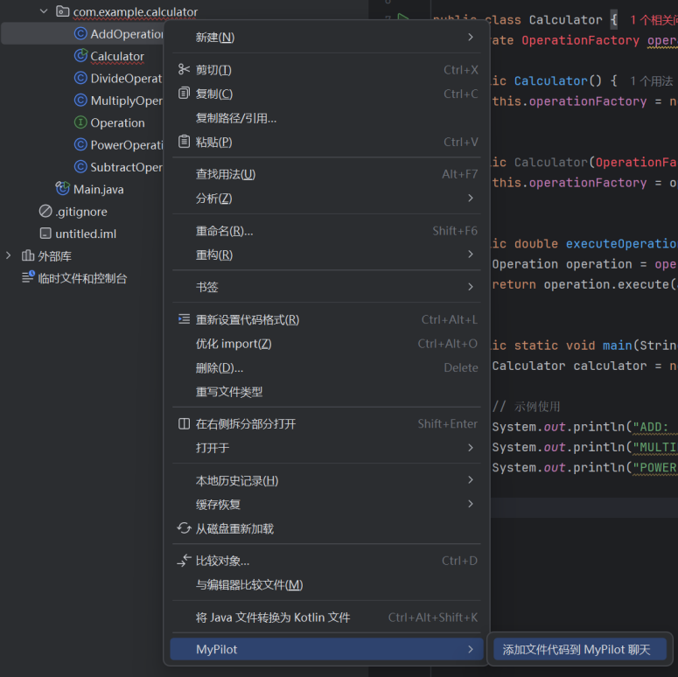
3.Select a folder → right-click `MyPilot` → `Add Folder Code to Chat`
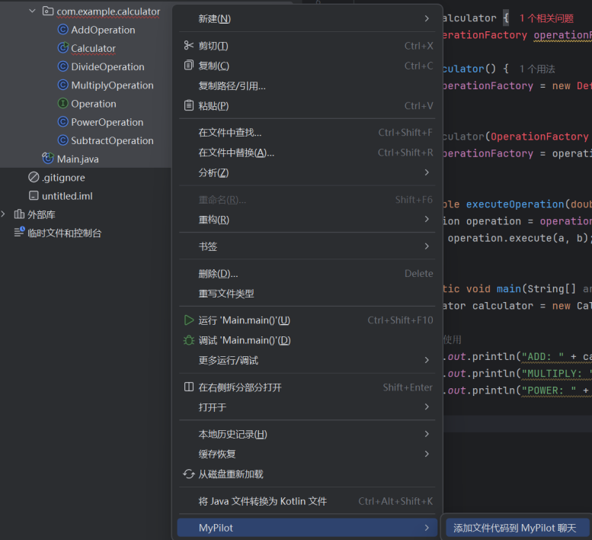

3.5. Session Management
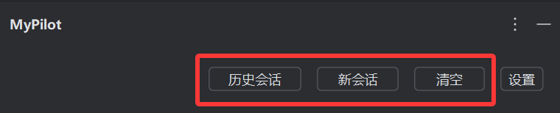

3.5.1 Historical Session
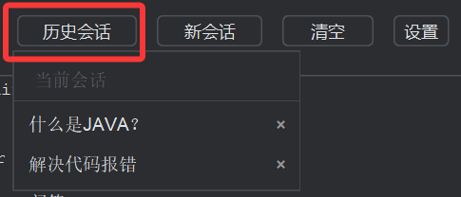
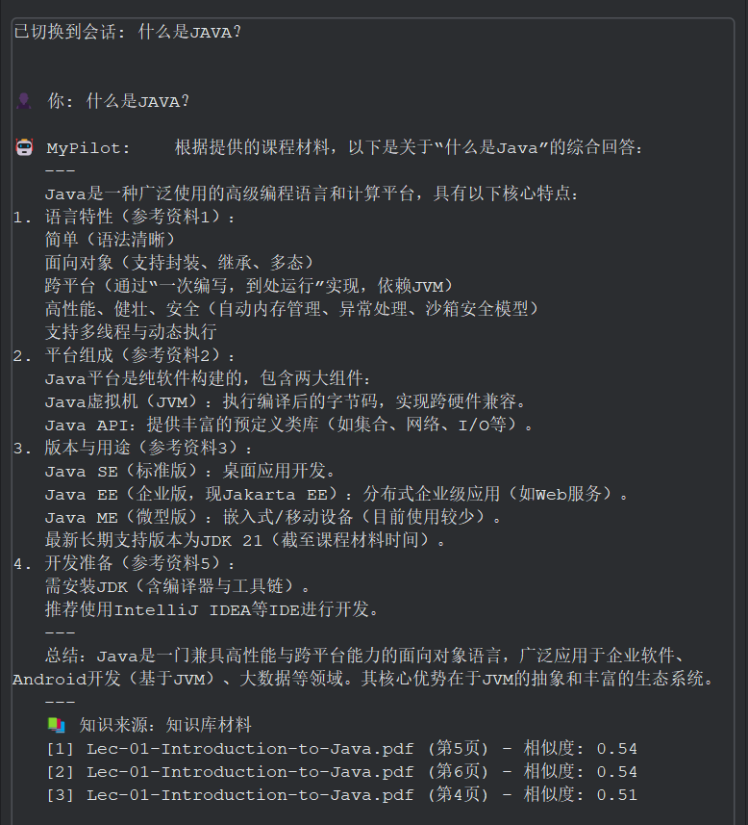

3.5.2 Create A New Session
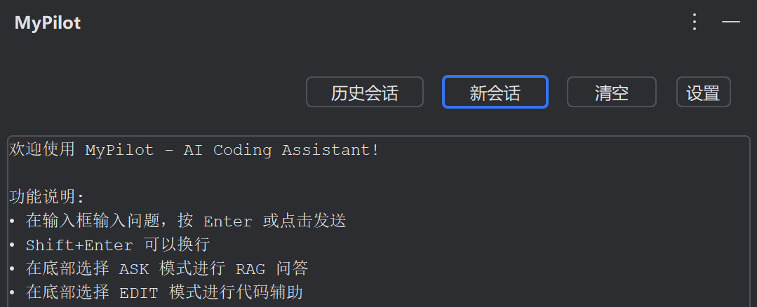

3.5.3 Clear All Sessions
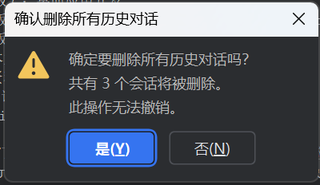

4. System Technical Details and Design

4.1. System Architecture and Components
The project adopts a Four-Layered Architecture design, ensuring robust modularity, clear separation of concerns, and high maintainability. The entire plugin is built on the IntelliJ IDEA platform and Java language features, strictly adhering to Service-Oriented Design (SOD) principles.

4.1.1. Architectural Layering
Layer | Key Responsibility
View Layer | Handles User Interface (UI) presentation, display, and receiving user actions.
Service Layer | Orchestrates core business logic and implements primary functions (Dialogue, RAG, Code Modification).
Infra Layer | Encapsulates underlying general services, external systems (LLM API), and IDEA platform API details.
Model Layer | Defines data structures, data models, and enumeration constants, providing a data contract for all layers.
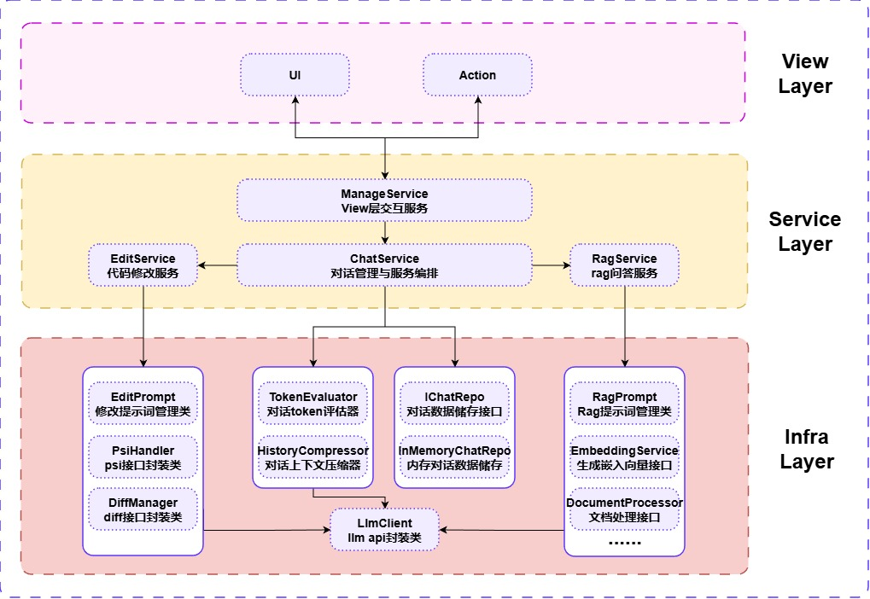

4.1.2 Detailed Component Responsibilities
(1) View Layer
Responsibility: Accepts user input (actions), handles UI events, and displays final results from the Service Layer.
Component | Function/Responsibility
UI Components | The plugin's Tool Window interface, used for asynchronous non-blocking interaction with the TA chatbot, displaying dialogue history and final responses.
Action Handlers | Trigger points for various smart actions (e.g., right-click "Ask about selected code"). Responsible for transforming user actions and context data into structured requests for the Service Layer.
(2) Service Layer
Responsibility: Orchestrates core business logic and coordinates across infrastructure services.
Component | Function/Responsibility
ManageService  (View Interaction Service) | Acts as the bridge between the View and Service Layers, handling complex UI state management, coordinating services, and routing Action requests to the correct business service.
ChatService  (Dialogue Management & Orchestration) | Manages the lifecycle of multi-turn dialogues, calls TokenEvaluator and HistoryCompressor for context management, and interacts with the LLMClient to generate responses.
RagService  (RAG Q&A Service) | Implements the RAG pipeline. Receives user queries, calls EmbeddingService for knowledge retrieval, and combines results with the RagPrompt template to generate the final LLM prompt.
EditService  (Code Modification Service) | Implements the core logic for the F2 Extended Feature. Receives code modification instructions, calls PsiHandler for code context, generates the LLM prompt, and upon receiving suggestions, calls DiffManager for Diff view display and code application.
(3) Infra Layer
Responsibility: Encapsulates underlying technical details, external API calls, data access, and general utilities.
Component | Function/Responsibility
LLMClient  (LLM API Wrapper) | Encapsulates API calls to third-party LLM services (e.g., DeepSeek), handling network communication, authentication, and CompletableFuture-driven asynchronous accelerated calling.
IChatRepo / InMemoryChatRepo  (Dialogue Data Storage) | Defines and implements the dialogue history storage interface.InMemoryChatRepo manages the in-memory storage and persistence of dialogue context.
TokenEvaluator / HistoryCompressor  (Context Compression) | Implements Token usage estimation. When the context limit is exceeded, HistoryCompressor executes a 6-dimension compression strategy (Context, Decision, User Goal, Results, Unsolved, Plan) to ensure context effectiveness and cost control.
PsiHandler  (PSI Interface Wrapper) | Encapsulates IntelliJ IDEA's PSI (Program Structure Interface) core API, abstractly manipulating the Java source code's syntax tree to enable structured extraction of code context.
DiffManager  (Diff Interface Wrapper) | Encapsulates IDEA's built-in Diff Viewer API to display AI-suggested changes, critical for implementing the F2 professional review mechanism.
PromptManager  (Prompt Management) | Centralizes management of LLM system and user prompt templatesfor different scenarios (Code Modification, RAG Q&A), isolating and optimizing prompt engineering.
EmbeddingService / DocumentProcessor | Underlying RAG pipeline components. DocumentProcessor handles course document chunking and indexing. EmbeddingService is responsible for text vectorization and vector search (knowledge retrieval).
(4) Model Layer
Responsibility: Defines the data structures used throughout the application.
Component | Description
POJO / DTO | Plain Old Java Objects (POJO) and Data Transfer Objects (DTO) used to pass data between layers (e.g., ChatMeta, ChatMessage, ChatSession, CodeContext, CodeAction, DocumentChunk).
Enum / Const | Defines various states, types, or role constants (e.g., ChatOpt CodeOpt) as well as global configurations and immutable constants.

4.2. General Workflow
This plugin project is built upon a Unified Dialogue-Driven Architecture (T.1), primarily encompassing two core workflows, both managed by the ChatService as the central orchestrator.

4.2.1. Workflow I: RAG Q&A and Multi-Turn Dialogue
This workflow focuses on providing users with course-relevant, traceable question-answering support.
Step | English Description
1. Trigger and Routing | User inputs a question via the chat UI or uses the right-click context menu with selected code. ManageService receives the request and routes it to ChatService.
2. Context Evaluation | ChatService retrieves history via IChatRepo and triggers TokenEvaluator to check context token usage. HistoryCompressor executes the Structured 6D Compression (T.2) as required.
3. Knowledge Augmentation | ChatService delegates the query to RagService. RagService calls EmbeddingService to retrieve Top-K knowledge chunks and dynamically constructs the RAG prompt using RagPrompt.
4. Asynchronous LLM Call | ChatService sends the final prompt to LLMClient. LLMClient executes a CompletableFuture-driven asynchronous API call (T.3).
5. Result Presentation | Upon LLM response, ChatService adds source citation information (F0.5) and updates the UI via ManageService, achieving an asynchronous non-blocking display (F0.8).

4.2.2. Workflow II: AI-Driven Code Modification
This workflow implements the F2 Professional Code Modification feature, focusing on structured input, atomic modification, and mandatory review.
Step | English Description
5.2.1 Trigger and Instruction | User initiates the code modification process via an Action, inputting instructions (e.g., "Refactor this method to Factory pattern"). ManageService routes the request.
5.2.2 Context Evaluation | (Same as 5.1.2)ChatService evaluates and compresses dialogue history.
5.2.3 Structured Extraction | EditService calls PsiHandler to extract the complete structured context of the current code (class, method, path, etc.).
5.2.4 LLM Request | EditService embeds the instruction, dialogue context, and code context into EditPrompt, enforcing a JSON output format, and sends it to LLMClient.
5.2.5 Suggestion Parsing | LLM returns a JSON response containing an atomic operation list, which is parsed and validated by EditService.
5.2.6 Mandatory Review Mechanism | EditService sends the operation list to DiffManager. DiffManager calls the IntelliJ IDEA Built-in Diff Viewer, mandating user review and approval (F2).
5.2.7 Code Application | Only after user approval, EditServicecalls the IDEA API to atomically apply the modifications to the source code.
5.2.8 Result Presentation | The LLM's textual explanation (from the explanation field) is updated to the UI via ManageService.

4.3. RAG Data Storage and Structures

4.3.1. Core Data Model
(1) DocumentChunk
The most fundamental document unit in the project, defined in com.javaee.mypilot.core.model.rag.DocumentChunk.
Field structure:
content: String - The text content of the document chunk, the original text after splitting
embedding: float[] - A 768-dimensional float vector generated by the embedding service for semantic similarity calculation
source: String - The source file name of the document (e.g., "lecture01.pptx")
pageNumber: int - The page number or paragraph number, used to locate the document chunk in the original file
sourceType: SourceType - An enumeration of document source types (STATIC or USER_UPLOADED)
similarity: float - The similarity score calculated during retrieval (range 0-1, initially 0)
Source type enumeration:
SourceType.STATIC - Static resources, automatically extracted from the resources/courseMaterials/ppt directory of the JAR package
SourceType.USER_UPLOADED - User uploaded, stored in the ~/.mypilot/userUploads directory
Usage scenarios:
The document processor splits the original document into multiple DocumentChunk
Each DocumentChunk calls the embedding service to generate a vector and stores it in the vector database
The retriever returns a list of DocumentChunk from the vector database, sorted by similarity

(2)File Info
Metadata information of files in the vector database, defined in LuceneVectorDatabase.FileInfo.
Field structure:
fileName: String - The file name (e.g., "JavaEE Course - Chapter 1.pptx")
sourceType: SourceType - The document source type
chunkCount: int - The number of document chunks of this file in the vector database
Usage scenarios:
The getKnowledgeBaseFiles() method returns a list of FileInfo for the UI to display the knowledge base content
Users can view the chunking of each file through the UI
When deleting a file, all related DocumentChunk are matched based on fileName

(3)CodeContext
The context of the code snippet selected by the user, defined in com.javaee.mypilot.core.model.chat.CodeContext.
Field structure:
fileName: String - The code file name (e.g., "UserService.java")
language: String - The programming language (e.g., "java", "kotlin")
code: String - The selected code text
lineStart: int - The starting line number of the code
lineEnd: int - The ending line number of the code
Role in RAG: When the user selects code in the editor, CodeContext is attached to ChatSession. When the RAG service detects CodeContext, it builds a prompt that includes the code. During retrieval, the code context and the user's question are concatenated to enhance the relevance of the retrieval.

(4)ChatMessage
Field structure type: ChatMessage.Type
Message type enumeration: USER (user), ASSISTANT (assistant), SYSTEM (system prompt). content: String
The message text content supports Markdown format. timestamp: long
Message timestamp, records the time when the message is sent. error: boolean
Is it an error message for special handling by the front end?

(5)ChatSession
Field structure: messages: List<ChatMessage>
Store all messages of this session (from the user, assistant, system, etc.) in chronological order.
Each message is of the ChatMessage type, including the message content, type, timestamp, etc.
It is used to build the context and support multi-round conversations. codeContexts: List<CodeContext>
Store the context of the code snippets selected by the user, which can include multiple code blocks.
ChatSession serves as the main object for the session, aggregating all messages and code contexts.
Each RAG request retrieves the latest user question from ChatSession (getLastMessage()) and concatenates the historical conversation (buildSessionContextPrompt()).
The code context is passed to RAG retrieval and prompt construction through the codeContexts list, enhancing the accuracy of code-related Q&A.
ChatMessage is responsible for distinguishing message types, storing content, and marking errors, supporting multi-round conversations and exception handling.
CodeContext refines the meta-information of code snippets, facilitating traceability and context enhancement.

4.3.2. Document Processing Architecture
The project implements dedicated processors for different document formats, all of which implement the DocumentProcessor interface:
Interface definition: public interface DocumentProcessor {
List<DocumentChunk> process(File file, DocumentChunk.SourceType sourceType);
}
Processor implementation list:
PPTDocumentProcessor - Process PowerPoint presentations (.ppt, .pptx)
PDFDocumentProcessor - Process PDF documents
DOCDocumentProcessor - Process Word documents (.doc, .docx)
TXTDocumentProcessor - Process plain text files
MarkdownDocumentProcessor - Process Markdown files
Chunk processing flow architecture (using PPT as an example)
Processing steps:
File parsing: Use the Apache POI library to open the PPT file and parse the slide structure
Content extraction: Traverse each slide and extract the title and body text
Chunk division: Each slide is treated as an independent DocumentChunk
Metadata filling:
content - Text content of the slide
source - PPT file name
pageNumber - Slide number (starting from 1)
sourceType - Source type passed in (STATIC or USER_UPLOADED)
Vector generation: Call embeddingService.generateEmbedding(content) to generate a 768-dimensional vector
Return result: Return List<DocumentChunk>, with each slide corresponding to one DocumentChunk

4.3.3. Embedding service architecture
(1) EmbeddingService interface
Defined in com.javaee.mypilot.infra.rag.embedding.EmbeddingService.
Interface methods: public interface EmbeddingService {
float[] generateEmbedding(String text); // Generate the vector of a single text List<float[]> generateBatchEmbeddings(List<String> texts); // Batch generation of vectors }
Three Implementations
DashScopeEmbeddingService (DashScope by Alibaba Cloud):
ZhipuEmbeddingService (Zhipu AI):
LocalEmbeddingService (Local Embedding)

(2) Vector Database Storage Structure
(2.1) Lucene Index Structure
The project uses Apache Lucene as the vector database, and the index files are stored in the ~/.mypilot/vector_index directory.
Lucene Document Field Mapping: Each DocumentChunk is stored as a Document in Lucene, containing the following fields:
content: TextField - Stores the text content of the document chunk, supporting full-text search (although vector search is mainly used currently)
embedding: KnnFloatVectorField - Stores a 768-dimensional float vector for KNN (K-Nearest Neighbor) vector search
source: StringField - Stores the file name, supporting exact matching and deletion operations
pageNumber: IntField - Stores the page number, used for traceability and sorting
sourceType: StringField - Stores the source type string ("STATIC" or "USER_UPLOADED")
Index File Structure: Lucene generates multiple files in the ~/.mypilot/vector_index directory:
segments_N - Segment information file, recording the index version and segment list
_X.cfs - Composite file, containing inverted index, vector index, stored fields, etc.
_X.si - Segment metadata file
write.lock - Write lock file, preventing concurrent writes
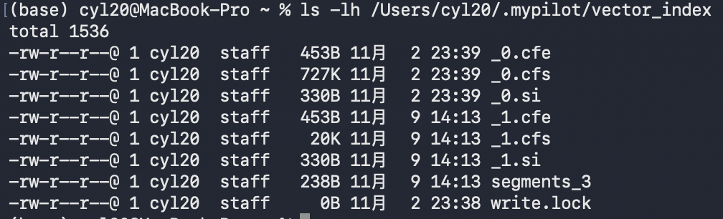
Index update mechanism:
Incremental index: The `index(List<DocumentChunk>)` method directly adds documents to the existing index without the need for re-building.
Deletion operation: The `deleteBySource(String)` method deletes matching documents based on the `source` field.
Clear operation: The `clear(SourceType)` method batch-deletes documents based on the `sourceType` field.

(2.2)Vector retrieval mechanism
Cosine similarity calculation: The project uses cosine similarity to measure the relevance between the query vector and the document vector: similarity = (queryVector · documentVector) / (||queryVector|| × ||documentVector||)
Return value range: [-1, 1], normalized vectors are usually in [0, 1]. The higher the similarity, the more relevant the document. Similarity threshold filtering: Configuration threshold: obtained through ConfigService.getRelevanceThreshold() (default 0.3). Effective threshold: the code limits the maximum use to 0.5 to prevent overly high thresholds from resulting in no results. Filtering logic: only return document blocks with similarity ≥ effective threshold.

4.4. Key Algorithms and Supporting Techniques

4.4.1. Document Chunking Algorithm
Function: Split the original document into multiple indexable document chunks based on content structure for subsequent embedding and retrieval.
Specific Process:
Select the corresponding processor based on the file type (such as PPT, PDF, DOC, TXT, Markdown).
PPT is split by slides, PDF by pages, DOC by paragraphs, TXT by fixed character count or lines, and Markdown by heading levels.
Each chunk generates a DocumentChunk, containing content, source, page number, type, and other metadata.

4.4.2. Vector Retrieval Algorithm
Function: Retrieve the most relevant document chunks from the knowledge base based on the user's query statement.
Specific Process:
The user inputs a question, and the EmbeddingService generates a query vector.
In the Lucene vector database, the KNN (K-Nearest Neighbor) algorithm is used to calculate the cosine similarity between the query vector and all document chunk vectors.
Return the top-K document chunks with the highest similarity, sorted in descending order by score, and filter out irrelevant results based on a threshold.

4.4.3. Similarity Threshold Filtering Algorithm
Function: Ensure the relevance of retrieval results and prevent irrelevant or noisy document chunks from participating in generation.
Specific Process:
After retrieval, obtain the cosine similarity score for each document chunk.
Filter out low-relevance results based on a configured threshold (default 0.3, maximum 0.5).
Only document chunks with scores above the threshold are used for prompt construction and LLM generation.

4.4.4. Asynchronous Request Processing Algorithm
Function: Improve response speed by processing time-consuming operations in parallel.
Specific Process:
User input parsing is executed synchronously, while retrieval and historical context construction are processed asynchronously in parallel.
After merging the retrieval results with the historical context, the LLM API is called asynchronously.
Final result assembly and error handling are completed synchronously to ensure the overall process is efficient and stable.

4.5. LLM Integration and Prompt Engineering
This project utilizes a highly modular and refined prompt engineering strategy for LLM integration to ensure the TA delivers high-quality, context-aware answers and secure, controllable code modification services.

4.5.1. Large Language Model API Wrapper: LlmClient
LlmClient is the unified wrapper class for the Large Language Model API, responsible for shielding the differences of underlying model services and simplifying interaction with external AI capabilities. It resides in the Infrastructure Layer.
Key Design | Description
Service Selection and Initialization | Supports multiple LLM services(e.g., Aliyun DashScope, Zhipu AI, and local models), dynamically selected via configuration. Initializes by validating the API Key for security and reliability.
Unified Asynchronous Interface | Exposes a single, unified CompletableFuture<String>chatAsync(String prompt) method, which receives the fully concatenated Prompt string. Internally, it automatically selects the appropriate model service and sends the Prompt via HTTP request.
Protocol Adaptation and Exception Handling | Implements internal protocol adaptation for each model service (e.g., DashScope's JSON format, Zhipu's specific parameters). Captures and handles exceptions (network errors, invalid API Key, timeouts), returning standardized error messages so that the caller does not need to worry about the underlying details.
High Extensibility | To support a new model service, only the corresponding request implementation needs to be extended within LlmClient and the service type added to the configuration, achieving high decoupling of business logic from the underlying model service.

4.5.2. RAG Service Prompt Engineering
The RAG Service Prompt is constructed by the RagPrompt class, designed to dynamically generate prompts based on multiple contexts to improve the relevance and authority of the answers.
Section | Placeholder | Purpose and Content
System/Role Instruction | Fixed Text | Sets the LLM's persona as a "Professional Java Teaching Assistant." Emphasizes: Prioritize citation of knowledge base material, answers must be concise, accurate, and prohibition of knowledge fabrication.
Knowledge Chunks | {knowledgeChunks} | Populated by the Top-K DocumentChunk list retrieved by the Retriever. Embedded in a structured format (including filename, page number, summary, similarity score) as the sole factual basis for the LLM's answer.
Code Context | {codeContext} | Provided by ChatSession, includes the current file, selected code, relevant class structure, etc., formatted as structured text to help the LLM understand the development scenario.
Session History | {sessionContext} | Includes the most recent multi-turn dialogue history to ensure the LLM's response coherence and context memory.
User Question | {userMessage} | The user's current question, inserted directly at the end of the prompt.
Dynamic Template Selection:
RagPrompt dynamically selects template branches based on the actual retrieval results and context (e.g., embed all when both knowledge chunks and code context are present; generate a generic prompt when neither is available). This ensures that every request maximizes the utilization of the knowledge base and code context, boosting the specificity and accuracy of the answers.

4.5.3. Edit Service Prompt Engineering
The Edit Service's core relies on its highly structured and constrained prompt design. The goal is to strictly limit the LLM's output to a parsable JSON format, enabling seamless integration with the IntelliJ IDEA Built-in Diff Viewer and atomic code operations.
(1) Prompt Structure
Section | Placeholder | Purpose and Content
System/Role Instruction | Fixed Text | Sets the LLM's persona as an "Experienced Java Developer."Emphasizes: Strict compliance with instructions and JSON format.
Code Context | {codeContext} | Includes the content of the file the user is currently viewing, the selected code segment, related class structure, and file path, structurally extracted by PsiHandler.
Session History | {sessionContext} | Contains previous multi-turn dialogue history to maintain the LLM's memory and coherence in complex modification tasks.
User Instruction | {userMessage} | The user's current specific modification request (e.g., "refactor to Factory pattern" or "fix null pointer exception").
(2) Enforced Output Format
The prompt mandatorily requires the LLM to return results in a specific JSON format, which defines atomic operations:
{
"explanation": "<Your Chinese explanation>",
"actions": [
{
"type": "REPLACE" | "INSERT" | "DELETE",
"filePath": "<File path/URL>",
"startLine": <Starting line number in the original file>,
"endLine": <Ending line number in the original file>,
"oldCode": "<Old code text to be replaced/deleted>",
"newCode": "<New code text, only for REPLACE or INSERT>"
}
]
}
(3) Core Execution Rules and Atomic Design
Six core execution rules are defined in the prompt, acting as the technical safeguard for implementing the F2 feature (Precise Diff):
- 【Absolute Line Number/Old Code Match】 'startLine' and 'endLine' must be the physical line numbers of the original file, precisely delimiting the content in the 'oldCode' field.
- 【Exact Code Content Replication (oldCode)】 The 'oldCode' field must match the file's content exactly, character-by-character, whitespace-by-whitespace, and newline-by-newline. Zero tolerance for space/Tab discrepancies.
- 【Newline Format】 For multi-line code, only the escaped newline character \n is to be used for line separation within the JSON string.
- 【Atomic Operations & INSERT Rule】 For modifying existing code, type must be "REPLACE". For deletion, "DELETE" (with "newCode" empty). For insertion, "INSERT" (with "oldCode" empty, and startLine / endLine pointing to the insertion line number).
- 【File Path & New File Creation】 Supports cross-file operations. To create a new file, type must be "INSERT", "filePath" set to the virtual URL of the new file, startLine/endLine set to 1, and "newCode" containing the full content of the new file.
- 【Boundary Integrity】 Ensures the replacement or generated code does not break existing structure or logic. The generated code must be syntactically and logically complete and correct.
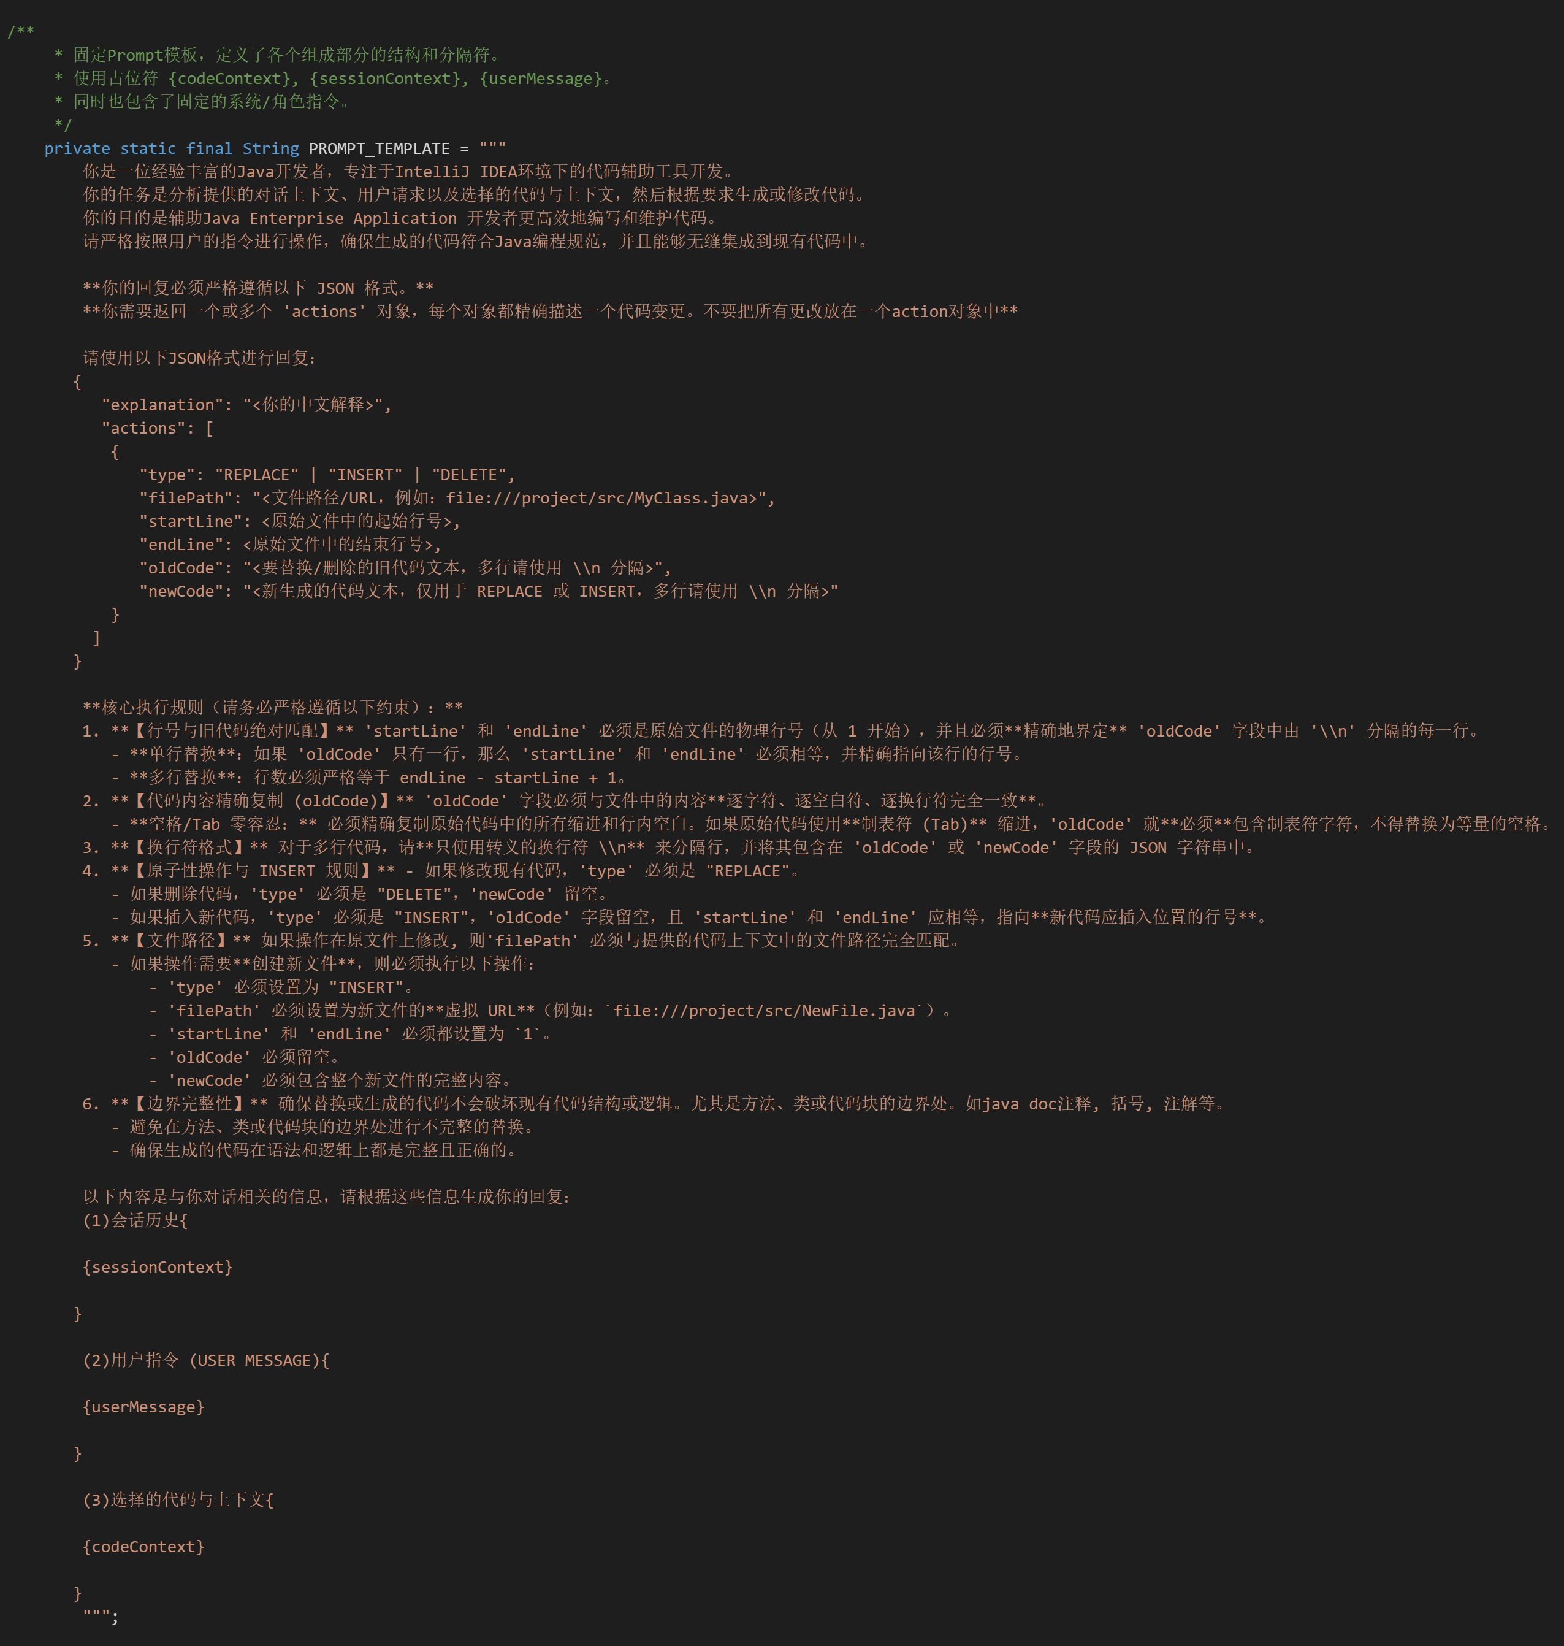
This rigorous prompt design translates the LLM's output into an executable code patch language, allowing the EditService to safely parse the output, generate a precise Diff, and atomically apply the changes upon user approval, thereby guaranteeing code modification quality and user experience.

4.6. Design Rationales and Efficiency Considerations
The core design decisions in this project aim to achieve superior User Experience (low latency, non-blocking), high system maintainability (modularity, separation of concerns), and precise AI result control (structured output, RAG traceability).

4.6.1 Design Principles and Core Advantages
Design Point | Rationale and Goal | Resulting Advantage
Four-Layer Architecture | To achieve Separation of Concerns. Isolates business logic (Service Layer) from the IntelliJ IDEA platform API and external LLM services (Infra Layer), enhancing modularity and testability. | High Maintainability: Core business logic can be tested and iterated independently of the IDEA UI and LLM services.
Unified Dialogue-Driven Architecture (T.1) | To avoid complex session state switching between RAG Q&A and Code Modification (F2). | Seamless User Experience (UX): Users can dynamically switch modes within a single conversation, simplifying state management and process orchestration.
Atomic JSON Patch Output (F2) | To overcome the uncertainty of free-text LLM output. Forces the LLM to return structured, executable JSON format code patches. | Safety and Precision: Ensures the EditService can precisely parse the output, generate Diff views, and atomically apply changes, forming the foundation of the F2 Mandatory Review Mechanism.
RAG Knowledge Traceability (F0.5) | To adhere to assignment requirements, address LLM Hallucination, and ensure the TA's answers are authoritative and trustworthy. | High Trustworthiness: All course-related responses are accompanied by document names and page numbers, guaranteeing verifiable information.

4.6.2 Efficiency and Performance Considerations
Optimization Point | Consideration and Mechanism | Performance Gain
Fully Asynchronous Architecture (T.3) | Goal: Eliminate I/O blocking. All LLM API calls and internal service orchestrations use CompletableFuture. Any blocking operation would freeze the IDE's UI thread. | Non-Blocking UI: Ensures the UI thread remains fully responsive during LLM response times, minimizing perceived latency and optimizing user experience.
Structured Context Compression (T.2) | Goal: Control Token costs and preserve semantics. When dialogue history exceeds the limit, a 6-Dimension JSON summary generated by the LLM is used instead of simple truncation. | Cost Control & Memory Efficacy: Significantly reduces the number of history tokens sent to the LLM while maintaining high-level semantic coherence.
Dynamic RAG Prompting (4.5.2) | Goal: Improve prompt quality and LLM efficiency. RagPrompt dynamically selects the most concise and effective template based on the presence or absence of code context and knowledge chunks. | Inference Efficiency: Avoids sending unnecessary placeholders and empty data, reducing Prompt length, which decreases LLM inference time and API costs.
PSI Structured Extraction (Infra) | Goal: Accurate code context. Uses IDEA's PSI API to precisely extract the code structure, rather than simple text slicing. | Accuracy and Efficiency: Provides the LLM with exact syntax tree information, reducing the time the LLM spends on understanding code structure and improving the accuracy of code modifications.

