A distributed hash table has been designed in this paper. It has no central server, each peer is both a server and a client. As a client, it provides interfaces through which users can issue queries and view search results. As a server, it accepts queries from other peers, checks for matches against its local hash table, and responds with corresponding results. In addition, since there’s no central indexing server, search is done through consistent hashing.

The structure of the distributed hash table is as follows:

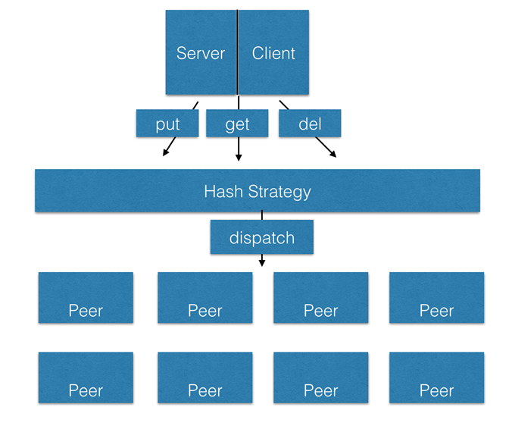

The hash table uses socket to communicate.

The hash table is designed to accept String key and String value. The hash function is String.hashCode().When the user input an operation of ‘put’, ‘get’ or ‘del’, the request is dispatched to the server according to the key’s hashcode.

The server uses thread to deal with the request, so the server can deal with requests from different client at the same time.

For each server, there is a seperate thread to handle with the input from the console. It parses the line to identify the operation from ‘put’. ‘get’ and ‘del’. Then it sends request to the sever, read the response from the server and show it on the screen.