I deployed 8 servers .They are setup on the same machine different directories.Perform an evaluation on running 500K put operations per client.My first experiment have 1 client doing this experiment Then 2 clients concurrently. Then 4 clients And finally 8 concurrent clients.The average response time per client query request is computed as follows.

|  |  |  |  |
| --- | --- | --- | --- |
| number of clients | count of operations | total time for each client(s) | average per put(us) |
| 1 | 500k | 19 | 38 |
| 2 | 500k | 23.5 | 47 |
| 4 | 500k | 47.8 | 96 |
| 8 | 500k | 83.1 | 166 |

The data is drawed as follows:

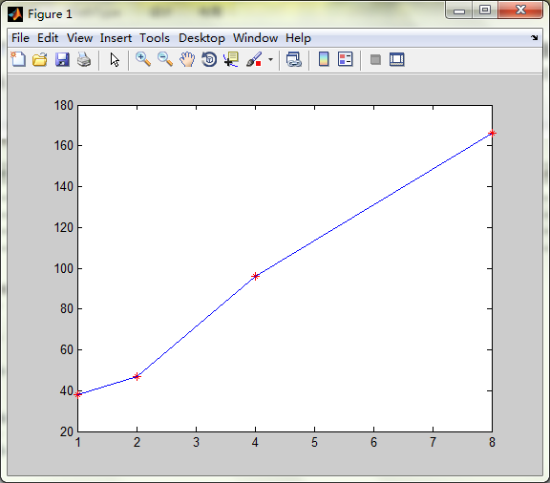

We can see that, the more clients, the slower the operation takes.