Step 1: Config

The config file is named as ‘config.txt’. The content of it is the port of current server listens. It is supposed that the number of servers is 8. So you have to copy the project to 8 different directories and run them. Which means you have to execute step2 and step3 for eight times.

A specific list of project directory is as follows: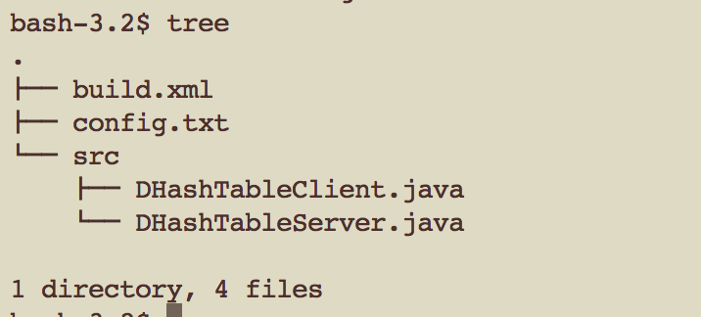

Step 2: Change directory to project

$ cd $ProjectDirectory

Step 3: Run the program

$ ant

After executing order ‘ant’, the server starts running.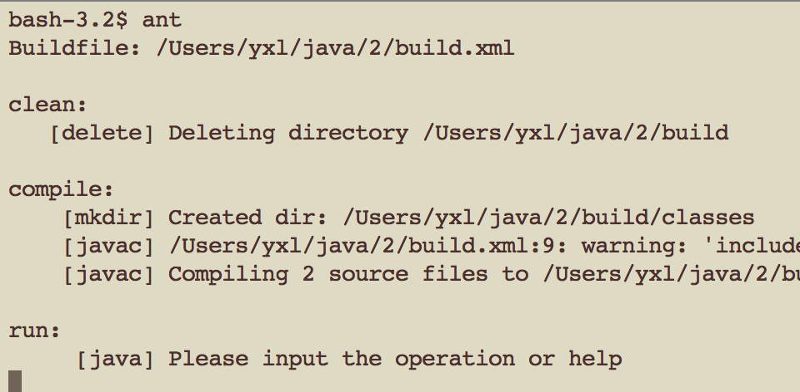

Step 4: Help

$ help

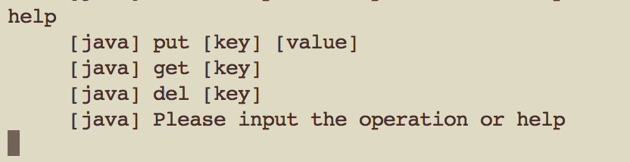

Step 5: Input operations

$ put 1 hello

….