1, put

The input format of put is:

put [key] [value]

$ put 1 hello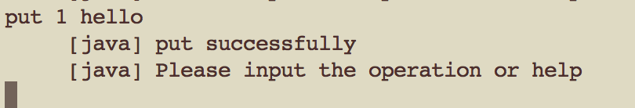

put operation successes.

$ put 2 world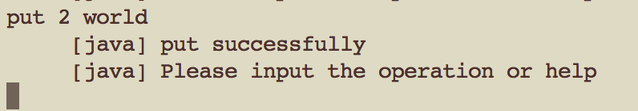

put operation successes.

2, get

The input format of get is:

get [key]

$ get 1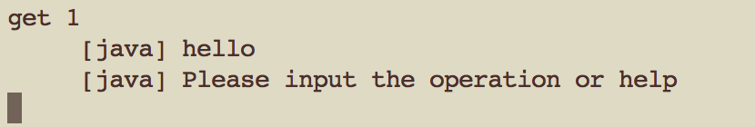

get operation successes.

3, del

The input format of del is:

del [key]

$ del 1

$ get 1

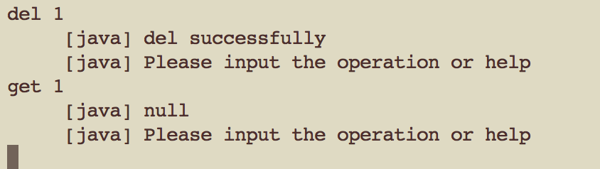

del operation successes, so, the get operation returns null.

More operation records:

