# User testing

## Step 1: The Usability Test

User Feedback: Explain here in detail

1. The title of each page is not clear enough
2. There is not much information about the events.
3. There are too much blank space which is not used appropriately. Well organized

### Proposed Changes as a result of feedback

1. Change the title of each page to be more precise and accurate
2. Add more information about events to make full use of the space.
3. Add more search buttons

## Step 2: Revision

Explanation of changes made

1. The title of each page is not related to the content of each page.
2. There is still many space left blank, to make full use of them I can add more detailed information.
3. Sometimes there is search button designed on the page, users have to return to the previous page if they want to research for the event.

Sketch with changes

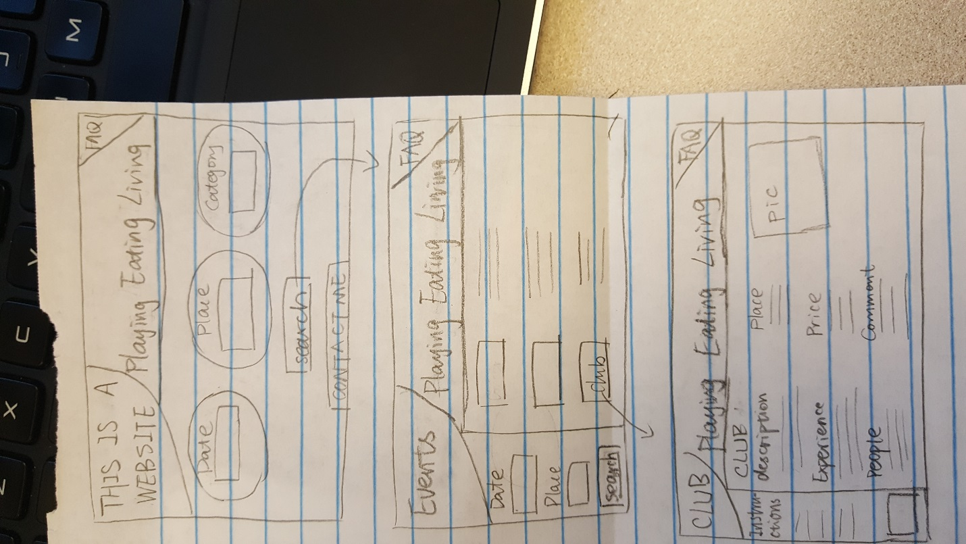

## Step 3: Second Usability Test

User Feedback: Explain here in detail

1. The information could be further enriched.
2. Provide users with more choices and options in the filter when users search for the event.

Proposed Changes as a result of feedback

1. Appending more websites related to the events.
2. When users use filter for their search, I will add a seat option in the filter.

## Step 4: Revision

Explanation of changes made

1. If it is for a restaurant, I will add a reservation link to the page and the official restaurant website so that it will be more convenient for the users to acquire more information.
2. Take restaurant as an example, in the second page, there could be a seat in the filter so that users could know if there are any empty seats in the restaurant.

Sketches with changes

