### ---problem 4--- ###

tbl_funds = read.csv('funds-1584g-mon.csv')

tbl_factors = read.csv('Fama_French_Three_Factors_Monthly.CSV')

tbl_mkt = data.frame(cbind(tbl_factors[1], tbl_factors[2] + tbl_factors[5])) / 100

names(tbl_mkt) = c('Date','Mkt')

tbl_funds[1] = tbl_mkt[1]

# # (a)

funds_mean0 = colMeans(tbl_funds[tbl_funds$Date < 2014.01,2:ncol(tbl_funds)])

mkt_mean0 = mean(tbl_mkt[tbl_mkt$Date < 2014.01, 2:ncol(tbl_mkt)])

funds_mean_annual = funds_mean0*12

mkt_mean_annual = mkt_mean0*12

hist(funds_mean_annual, nclass=40)

abline(v=mean(funds_mean_annual), col="black")

abline(v=mkt_mean_annual, col="red")

percentage = sum(funds_mean_annual - mkt_mean_annual > 0) / length(funds_mean_annual)

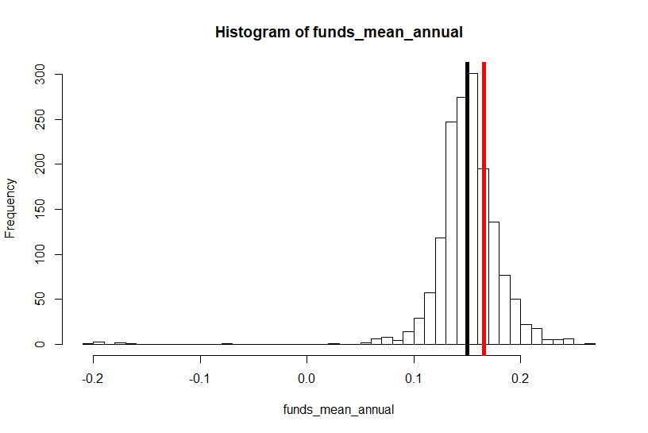

***Figure 1***

## # (b)

funds_mean1 = colMeans(tbl_funds[tbl_funds$Date >= 2014.01,2:ncol(tbl_funds)])

mkt_mean1 = mean(tbl_mkt[tbl_mkt$Date >= 2014.01, 2:ncol(tbl_mkt)])

plot(funds_mean0, funds_mean1, main='R1 vs R0')

points(mkt_mean0, mkt_mean1, col='red', pch=16, cex=2)

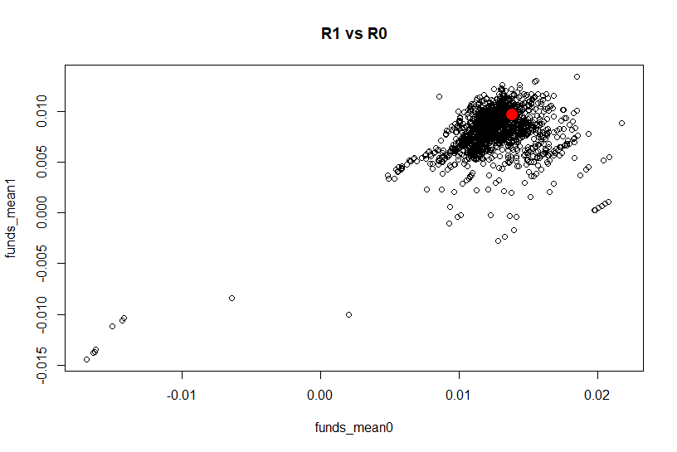

***Figure 2***

quantile0 = quantile(funds_mean0, c(.2, .8))

L0 = funds_mean0[funds_mean0 <= quantile0[1]]

M0 = funds_mean0[funds_mean0 > quantile0[1] & funds_mean0 < quantile0[2]]

W0 = funds_mean0[funds_mean0 >= quantile0[2]]

quantile1 = quantile(funds_mean1, c(.2, .8))

L1 = funds_mean1[funds_mean1 <= quantile1[1]]

M1 = funds_mean1[funds_mean1 > quantile1[1] & funds_mean1 < quantile1[2]]

W1 = funds_mean1[funds_mean1 >= quantile1[2]]

tbl_1a = matrix(0,

nrow=3, ncol=3, dimnames=list(c("L0","M0","W0"), c("L1","M1","W1")))

tbl_1a[1] = length(intersect(names(L0),names(L1)))

tbl_1a[2] = length(intersect(names(M0),names(L1)))

tbl_1a[3] = length(intersect(names(W0),names(L1)))

tbl_1a[4] = length(intersect(names(L0),names(M1)))

tbl_1a[5] = length(intersect(names(M0),names(M1)))

tbl_1a[6] = length(intersect(names(W0),names(M1)))

tbl_1a[7] = length(intersect(names(L0),names(W1)))

tbl_1a[8] = length(intersect(names(M0),names(W1)))

tbl_1a[9] = length(intersect(names(W0),names(W1)))

tbl_1b = round(tbl_1a / sum(tbl_1a),2)

tbl_1c = matrix(0,

nrow=3, ncol=3, dimnames=list(c("L0","M0","W0"), c("L1","M1","W1")))

tbl_1c[1,] = tbl_1a[1,] / sum(tbl_1a[1,])

tbl_1c[2,] = tbl_1a[2,] / sum(tbl_1a[2,])

tbl_1c[3,] = tbl_1a[3,] / sum(tbl_1a[3,])

tbl_1c = round(tbl_1c, 2)

tbl_1d = rbind(c(0.2, 0.6, 0.2),c(0.2, 0.6, 0.2),c(0.2, 0.6, 0.2))

colnames(tbl_1d) = c("L1","M1","W1")

rownames(tbl_1d) = c("L0","M0","W0")

Table 1A

|  |  |  |  |
| --- | --- | --- | --- |
|  | L1 | M1 | W1 |
| L0 | 158 | 144 | 15 |
| M0 | 87 | 632 | 231 |
| W0 | 72 | 174 | 71 |

Table 1B

|  |  |  |  |
| --- | --- | --- | --- |
|  | L1 | M1 | W1 |
| L0 | 0.10 | 0.09 | 0.01 |
| M0 | 0.05 | 0.40 | 0.15 |
| W0 | 0.05 | 0.11 | 0.04 |

Table 1C

|  |  |  |  |
| --- | --- | --- | --- |
|  | L1 | M1 | W1 |
| L0 | 0.50 | 0.45 | 0.05 |
| M0 | 0.09 | 0.67 | 0.24 |
| W0 | 0.23 | 0.55 | 0.22 |

Table 1D

|  |  |  |  |
| --- | --- | --- | --- |
|  | L1 | M1 | W1 |
| L0 | 0.20 | 0.60 | 0.20 |
| M0 | 0.20 | 0.60 | 0.20 |
| W0 | 0.20 | 0.60 | 0.20 |

## # (c)

L0 = funds_mean0[funds_mean0 <= mkt_mean0]

W0 = funds_mean0[funds_mean0 > mkt_mean0]

L1 = funds_mean0[funds_mean1 <= mkt_mean1]

W1 = funds_mean0[funds_mean1 > mkt_mean1]

tbl_2a = matrix(0,

nrow=2, ncol=2, dimnames=list(c("L0","W0"), c("L1","W1")))

tbl_2a[1] = length(intersect(names(L0),names(L1)))

tbl_2a[2] = length(intersect(names(W0),names(L1)))

tbl_2a[3] = length(intersect(names(L0),names(W1)))

tbl_2a[4] = length(intersect(names(W0),names(W1)))

tbl_2b = round(tbl_2a / sum(tbl_2a),2)

tbl_2c = matrix(0,

nrow=2, ncol=2, dimnames=list(c("L0","W0"), c("L1","W1")))

tbl_2c[1,] = tbl_2a[1,] / sum(tbl_2a[1,])

tbl_2c[2,] = tbl_2a[2,] / sum(tbl_2a[2,])

tbl_2c = round(tbl_2c, 2)

pL1 = round(sum(funds_mean1 <= mkt_mean1)/length(funds_mean1),2)

pW1 = round(sum(funds_mean1 > mkt_mean1)/length(funds_mean1),2)

tbl_2d = rbind(c(pL1,pW1),c(pL1,pW1))

colnames(tbl_2d) = c("L1","W1")

rownames(tbl_2d) = c("L0","W0")

Table 2A

|  |  |  |
| --- | --- | --- |
|  | L1 | W1 |
| L0 | 945 | 246 |
| W0 | 295 | 98 |

Table 2B

|  |  |  |
| --- | --- | --- |
|  | L1 | W1 |
| L0 | 0.60 | 0.16 |
| W0 | 0.19 | 0.06 |

Table 2C

|  |  |  |
| --- | --- | --- |
|  | L1 | W1 |
| L0 | 0.79 | 0.21 |
| W0 | 0.75 | 0.25 |

Table 2D

|  |  |  |
| --- | --- | --- |
|  | L1 | W1 |
| L0 | 0.78 | 0.22 |
| W0 | 0.78 | 0.22 |

### ---problem 5--- ###

B = seq(0,90000,1)

EU = 0.5*(-1/((10000+B)*1.3)) + 0.5*(-1/((10000+B)*0.9))

plot(B, EU, main='EU vs B')

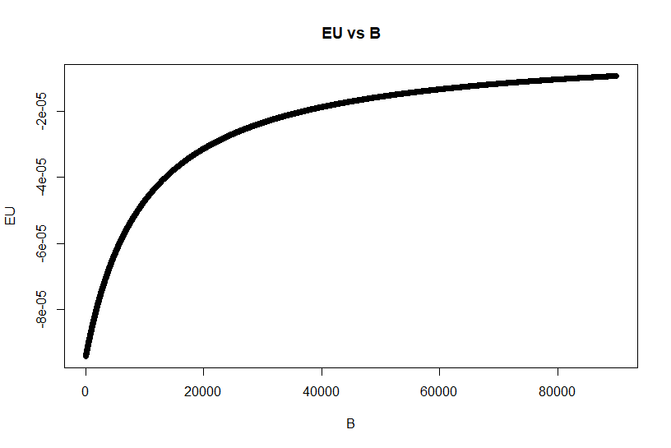

***Figure 3***

CE = 117*(10000+B)/110

plot(B, CE, main='CE vs B')

points(B[which(CE==max(CE))], CE[which(CE==max(CE))],col='red',pch=16, cex=2)

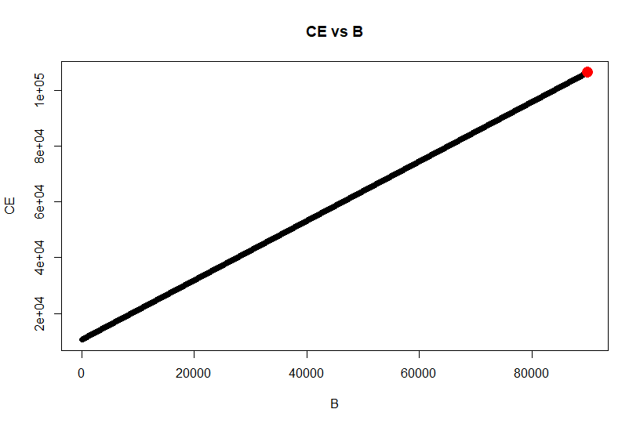

***Figure 4***