### ---problem 2--- ###

# # (a)

x <- runif(10000, min=-2, max=2)

y <- runif(10000,x,2)

plot(density(y), main="marginal univariate density of y")

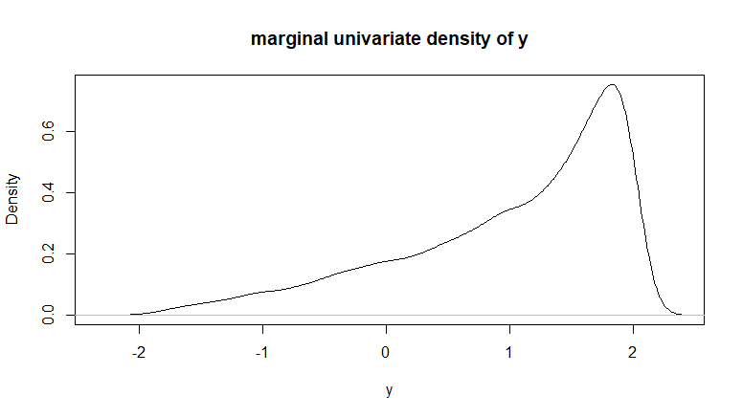

***Figure 1***

library("MASS")

persp(kde2d(x, y),theta = 15, ticktype = "detailed",

xlab = "X", ylab = "Y", main="bivariate density of (X,Y)")

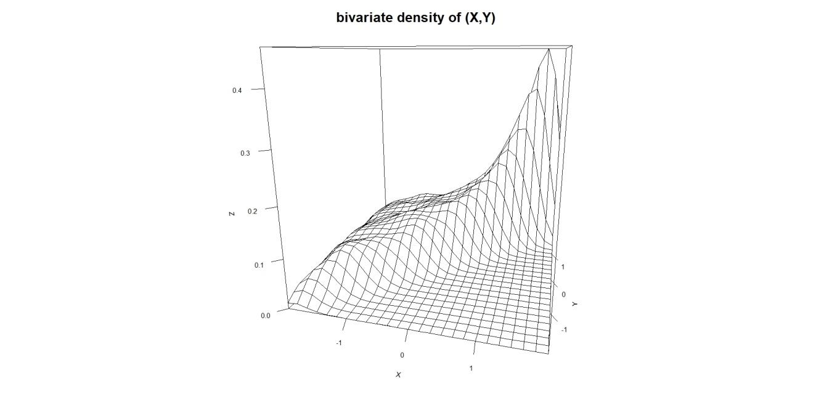

***Figure 2***

# # (b)

mean(y)

### ---problem 4--- ###

# # calculate std through 1584 funds

tbl_funds <- read.csv('funds-1584g-mon.csv')

std <- sapply(tbl_funds[,2:ncol(tbl_funds)], sd)

avg_std <- mean(std)

# # simulate normal random variables

tbl_tstat <- matrix(0,nrow=1,ncol=100)

tbl_high_tstat <- matrix(0,nrow=10000,ncol=5)

tbl_rand_tstat <- matrix(0,nrow=10000,ncol=5)

for (j in 1:10000){

tbl_norm <- rnorm(6000,0.01,avg_std)

dim(tbl_norm) <- c(60,100)

for (i in 1:100) {

tbl_tstat[i] <- abs(t.test(tbl_norm[,i], mu=0.01, conf.level = 0.95)$statistic)

}

high_tstat <- sort(tbl_tstat,decreasing = TRUE)[1:5]

rand_tstat <- sample(tbl_tstat)[1:5]

tbl_high_tstat[j,] <- high_tstat

tbl_rand_tstat[j,] <- rand_tstat

}

# # info required for Table1

round(colMeans(tbl_high_tstat),4)

round(colMeans(tbl_rand_tstat),4)

round(colSums(abs(tbl_high_tstat)>=2)/nrow(tbl_high_tstat),3)

round(colSums(abs(tbl_rand_tstat)>=2)/nrow(tbl_rand_tstat),3)

quantile_high <- matrix(0,nrow=1,ncol=5)

quantile_rand <- matrix(0,nrow=1,ncol=5)

for (i in 1:5) {quantile_high[i] <- round(quantile(tbl_high_tstat[,i], 0.975),4)}

for (i in 1:5) {quantile_rand[i] <- round(quantile(tbl_rand_tstat[,i], 0.975),4)}

**Table 1: Simulated Type 1 error – probability of rejection under the H0**

|  |  |  |  |  |  |
| --- | --- | --- | --- | --- | --- |
|  | Highest five (of 100) t-statistics | | | | |
|  | t1 | t2 | t2 | t4 | t5 |
| 1) Mean | 2.8583 | 2.4879 | 2.2879 | 2.1493 | 2.0426 |
| 2) Pr(reject H0|H0 true) | 0.994 | 0.963 | 0.884 | 0.744 | 0.569 |
| 3) 97.5% of ti | 3.8904 | 3.1612 | 2.8296 | 2.6313 | 2.4711 |
|  | Randomly chosen five t-statistics | | | | |
|  | t1 | t2 | t2 | t4 | t5 |
| 1) Mean | 0.0157 | -0.0129 | 0.0021 | 0.0052 | 0.0050 |
| 2) Pr(reject H0|H0 true) | 0.053 | 0.050 | 0.050 | 0.052 | 0.048 |
| 3) 97.5% of ti | 2.0233 | 1.9949 | 1.9972 | 2.0095 | 1.9813 |

# # plot figure3

hist(tbl_high_tstat[,5], nclass=100,

xlab="the fifth highest t-statistic",

main="histogram of the fifth highest t-statistic")

abline(v=2, col="black",lwd=3)

abline(v=quantile_high[5], col="black",lwd=3)

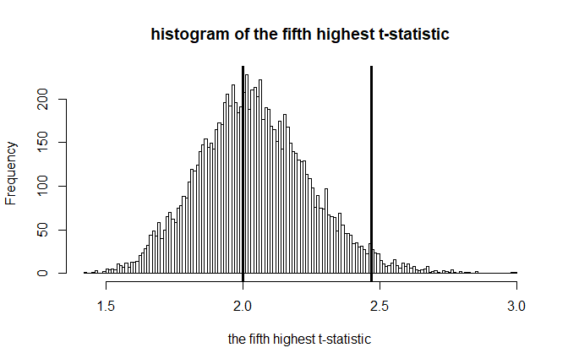

***Figure 3***