### ---problem 1--- ###

# # A. Preliminary Work

setwd("C:/Users/47494/GitHub/MF793/data")

daily_rets <- read.csv("stk-day.csv",header=T)

monthly_rets <- read.csv("stk-mon.csv",header=T)

# # (a)

log_monthly_rets <- cbind(monthly_rets[,1],log(1 + monthly_rets[,2:13]))

log_daily_rets <- cbind(daily_rets[,1],log(1 + daily_rets[,2:13]))

x <- unlist(log_monthly_rets[,2:12])

y <- unlist(monthly_rets[,2:12])

plot(x,y,xlab="log_return",ylab="return",

main="return vs log-return")

abline(a=0, b=1)

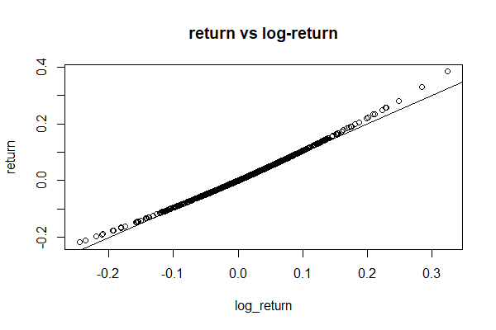

***Figure1***

# # (b)

# daily statistics

library("moments")

T <- round(dim(daily_rets)[1] / 8, 2)

daily_mean <- colMeans(log_daily_rets[,2:12])

daily_ann_mean <- T * daily_mean

daily_sd <- vector(mode="numeric",length=length(daily_mean))

daily_ann_sd <- vector(mode="numeric",length=length(daily_ann_mean))

names(daily_sd) <- names(daily_mean)

names(daily_ann_sd) <- names(daily_ann_mean)

for (i in 2:12) {

daily_sd[i-1] <- sd(log_daily_rets[,i])

daily_ann_sd[i-1] <- sqrt(T) * daily_sd[i-1]

}

# table 1

round(daily_mean,4)

round(daily_ann_mean,4)

round(daily_sd,4)

round(daily_ann_sd,3)

daily_acf <- vector(mode="numeric",length=length(daily_mean))

daily_skewness <- vector(mode="numeric",length=length(daily_mean))

daily_kurtosis <- vector(mode="numeric",length=length(daily_mean))

daily_jbtest <- vector(mode="numeric",length=length(daily_mean))

names(daily_acf) <- names(daily_mean)

names(daily_skewness) <- names(daily_mean)

names(daily_kurtosis) <- names(daily_mean)

names(daily_jbtest) <- names(daily_mean)

for (i in 2:12) {

daily_acf[i-1] <- acf(log_daily_rets[,i])[["acf"]][2]

daily_skewness[i-1] <- skewness(log_daily_rets[,i])

daily_kurtosis[i-1] <- kurtosis(log_daily_rets[,i])

daily_jbtest[i-1] <- jarque.test(log_daily_rets[,i])[["statistic"]]

}

round(daily_acf,4)

round(daily_skewness,2)

round(daily_kurtosis,2)

round(daily_jbtest,2)

round(mean(daily_mean),4)

round(mean(daily_ann_mean),4)

round(mean(daily_sd),4)

round(mean(daily_ann_sd),3)

round(mean(daily_acf),4)

round(mean(daily_skewness),2)

round(mean(daily_kurtosis),2)

round(mean(daily_jbtest),2)

ew_daily_ret <- rowMeans(log_daily_rets[,2:12])

ew_daily_mean <- mean(ew_daily_ret)

ew_daily_ann_mean <- T * ew_daily_mean

ew_daily_sd <- sd(ew_daily_ret)

ew_daily_ann_sd <- sqrt(T) * ew_daily_sd

ew_daily_acf <- acf(ew_daily_ret)[["acf"]][2]

ew_daily_skewness <- skewness(ew_daily_ret)

ew_daily_kurtosis <- kurtosis(ew_daily_ret)

ew_daily_jbtest <- jarque.test(ew_daily_ret)[["statistic"]]

round(ew_daily_mean,4)

round(ew_daily_ann_mean,4)

round(ew_daily_sd,4)

round(ew_daily_ann_sd,3)

round(ew_daily_acf,4)

round(ew_daily_skewness,2)

round(ew_daily_kurtosis,2)

round(ew_daily_jbtest,2)

vw_daily_ret <- log_daily_rets[,13]

vw_daily_mean <- mean(vw_daily_ret)

vw_daily_ann_mean <- T * vw_daily_mean

vw_daily_sd <- sd(vw_daily_ret)

vw_daily_ann_sd <- sqrt(T) * vw_daily_sd

vw_daily_acf <- acf(vw_daily_ret)[["acf"]][2]

vw_daily_skewness <- skewness(vw_daily_ret)

vw_daily_kurtosis <- kurtosis(vw_daily_ret)

vw_daily_jbtest <- jarque.test(vw_daily_ret)[["statistic"]]

round(vw_daily_mean,4)

round(vw_daily_ann_mean,4)

round(vw_daily_sd,4)

round(vw_daily_ann_sd,3)

round(vw_daily_acf,4)

round(vw_daily_skewness,2)

round(vw_daily_kurtosis,2)

round(vw_daily_jbtest,2)

# # B. Mean and Variance

# monthly statistics

N = 12

monthly_mean <- colMeans(log_monthly_rets[,2:12])

monthly_ann_mean <- N * monthly_mean

monthly_sd <- vector(mode="numeric",length=length(monthly_mean))

monthly_ann_sd <- vector(mode="numeric",length=length(monthly_ann_mean))

names(monthly_sd) <- names(monthly_mean)

names(monthly_ann_sd) <- names(monthly_ann_mean)

for (i in 2:12) {

monthly_sd[i-1] <- sd(log_monthly_rets[,i])

monthly_ann_sd[i-1] <- sqrt(N) * monthly_sd[i-1]

}

# table 2

round(monthly_mean,4)

round(monthly_ann_mean,4)

round(monthly_sd,4)

round(monthly_ann_sd,3)

monthly_acf <- vector(mode="numeric",length=length(monthly_mean))

monthly_skewness <- vector(mode="numeric",length=length(monthly_mean))

monthly_kurtosis <- vector(mode="numeric",length=length(monthly_mean))

monthly_jbtest <- vector(mode="numeric",length=length(monthly_mean))

names(monthly_acf) <- names(monthly_mean)

names(monthly_skewness) <- names(monthly_mean)

names(monthly_kurtosis) <- names(monthly_mean)

names(monthly_jbtest) <- names(monthly_mean)

for (i in 2:12) {

monthly_acf[i-1] <- acf(log_monthly_rets[,i])[["acf"]][2]

monthly_skewness[i-1] <- skewness(log_monthly_rets[,i])

monthly_kurtosis[i-1] <- kurtosis(log_monthly_rets[,i])

monthly_jbtest[i-1] <- jarque.test(log_monthly_rets[,i])[["statistic"]]

}

round(monthly_acf,4)

round(monthly_skewness,2)

round(monthly_kurtosis,2)

round(monthly_jbtest,2)

round(mean(monthly_mean),4)

round(mean(monthly_ann_mean),4)

round(mean(monthly_sd),4)

round(mean(monthly_ann_sd),3)

round(mean(monthly_acf),4)

round(mean(monthly_skewness),2)

round(mean(monthly_kurtosis),2)

round(mean(monthly_jbtest),2)

ew_monthly_ret <- rowMeans(log_monthly_rets[,2:12])

ew_monthly_mean <- mean(ew_monthly_ret)

ew_monthly_ann_mean <- N * ew_monthly_mean

ew_monthly_sd <- sd(ew_monthly_ret)

ew_monthly_ann_sd <- sqrt(N) * ew_monthly_sd

ew_monthly_acf <- acf(ew_monthly_ret)[["acf"]][2]

ew_monthly_skewness <- skewness(ew_monthly_ret)

ew_monthly_kurtosis <- kurtosis(ew_monthly_ret)

ew_monthly_jbtest <- jarque.test(ew_monthly_ret)[["statistic"]]

round(ew_monthly_mean,4)

round(ew_monthly_ann_mean,4)

round(ew_monthly_sd,4)

round(ew_monthly_ann_sd,3)

round(ew_monthly_acf,4)

round(ew_monthly_skewness,2)

round(ew_monthly_kurtosis,2)

round(ew_monthly_jbtest,2)

vw_monthly_ret <- log_monthly_rets[,13]

vw_monthly_mean <- mean(vw_monthly_ret)

vw_monthly_ann_mean <- N * vw_monthly_mean

vw_monthly_sd <- sd(vw_monthly_ret)

vw_monthly_ann_sd <- sqrt(N) * vw_monthly_sd

vw_monthly_acf <- acf(vw_monthly_ret)[["acf"]][2]

vw_monthly_skewness <- skewness(vw_monthly_ret)

vw_monthly_kurtosis <- kurtosis(vw_monthly_ret)

vw_monthly_jbtest <- jarque.test(vw_monthly_ret)[["statistic"]]

round(vw_monthly_mean,4)

round(vw_monthly_ann_mean,4)

round(vw_monthly_sd,4)

round(vw_monthly_ann_sd,3)

round(vw_monthly_acf,4)

round(vw_monthly_skewness,2)

round(vw_monthly_kurtosis,2)

round(vw_monthly_jbtest,2)

|  |  |  |  |  |  |  |  |  |
| --- | --- | --- | --- | --- | --- | --- | --- | --- |
| **Table 1:** Monthly returns summary statistics | | | | | | | |  |
|  | Mean | Ann. Mean | Stdev | Ann. Stdev | Skewness | Kurtosis | JB test | ρ(1) |
| Apple | 0.0191 | 0.2291 | 0.0701 | 0.243 | -0.25 | 2.78 | 1.19 | 0.0296 |
| Amazon | 0.0225 | 0.2703 | 0.0770 | 0.267 | 0.15 | 2.83 | 0.50 | -0.0208 |
| Biogen | 0.0194 | 0.2332 | 0.0839 | 0.291 | 0.09 | 3.89 | 3.27 | -0.0598 |
| Citygroup | 0.0087 | 0.1050 | 0.0835 | 0.289 | -0.48 | 3.36 | 4.28 | 0.0185 |
| GE | 0.0042 | 0.0503 | 0.0633 | 0.219 | -0.04 | 3.16 | 0.13 | -0.0141 |
| Nike | 0.0150 | 0.1796 | 0.0599 | 0.208 | -0.59 | 4.37 | 12.95 | -0.0588 |
| Pepsi | 0.0095 | 0.1139 | 0.0333 | 0.115 | -0.18 | 2.80 | 0.70 | -0.0568 |
| State Street | 0.0098 | 0.1173 | 0.0713 | 0.247 | -0.02 | 3.91 | 3.32 | -0.0601 |
| Toyota | 0.0060 | 0.0716 | 0.0542 | 0.188 | -0.19 | 3.60 | 2.03 | 0.0952 |
| Valero | 0.0207 | 0.2482 | 0.0932 | 0.323 | 0.08 | 3.54 | 1.28 | -0.0464 |
| Verizon | 0.0096 | 0.1153 | 0.0483 | 0.167 | 0.10 | 2.66 | 0.61 | -0.1569 |
| Average | 0.0131 | 0.1576 | 0.0671 | 0.232 | -0.12 | 3.35 | 2.75 | -0.0300 |
|  |  |  |  |  |  |  |  |  |
| EW Portfolio | 0.0131 | 0.1576 | 0.0395 | 0.137 | -0.09 | 3.05 | 0.15 | -0.0618 |
| VW US | 0.0099 | 0.1193 | 0.0352 | 0.122 | -0.31 | 3.65 | 3.29 | -0.0937 |

* 96 months, 8 years, 1/2010 – 12/2017

|  |  |  |  |  |  |  |  |  |
| --- | --- | --- | --- | --- | --- | --- | --- | --- |
| **Table 2:** Daily returns summary statistics | | | | | | | |  |
|  | Mean | Ann. Mean | Stdev | Ann. Stdev | Skewness | Kurtosis | JB test | ρ(1) |
| Apple | 0.0009 | 0.2295 | 0.0159 | 0.253 | -0.26 | 7.97 | 2094.55 | 0.0243 |
| Amazon | 0.0011 | 0.2703 | 0.0195 | 0.310 | 0.23 | 11.31 | 5810.98 | -0.0063 |
| Biogen | 0.0009 | 0.2332 | 0.0200 | 0.317 | -0.54 | 19.82 | 23812.82 | -0.0215 |
| Citygroup | 0.0004 | 0.1051 | 0.0205 | 0.325 | -0.45 | 9.11 | 3199.23 | -0.0244 |
| GE | 0.0002 | 0.0502 | 0.0136 | 0.216 | -0.01 | 7.78 | 1916.32 | 0.0358 |
| Nike | 0.0007 | 0.1796 | 0.0146 | 0.232 | 0.43 | 12.18 | 7129.44 | -0.0412 |
| Pepsi | 0.0005 | 0.1140 | 0.0086 | 0.136 | -0.17 | 5.53 | 547.74 | -0.0463 |
| State Street | 0.0005 | 0.1173 | 0.0169 | 0.268 | -0.12 | 7.45 | 1662.86 | -0.0566 |
| Toyota | 0.0003 | 0.0715 | 0.0135 | 0.214 | -0.09 | 5.24 | 424.08 | -0.0290 |
| Valero | 0.0010 | 0.2484 | 0.0214 | 0.339 | -0.14 | 6.43 | 991.13 | -0.0093 |
| Verizon | 0.0005 | 0.1154 | 0.0103 | 0.163 | 0.05 | 5.53 | 536.66 | 0.0086 |
| Average | 0.0006 | 0.1577 | 0.0159 | 0.252 | -0.10 | 8.94 | 4375.07 | -0.0151 |
|  |  |  |  |  |  |  |  |  |
| EW Portfolio | 0.0006 | 0.1577 | 0.0103 | 0.164 | -0.50 | 7.18 | 1550.66 | -0.0315 |
| VW US | 0.0005 | 0.1195 | 0.0094 | 0.149 | -0.50 | 7.92 | 2112.78 | -0.0343 |

* 251.62 days per year, T = 2013 days, 2010 – 2017

# # D.Normality

par(mfrow=c(2,1))

qqnorm(log_daily_rets[,4],main="Normal Q-Q Plot for BIIB daily returns")

qqline(log_daily_rets[,4])

qqnorm(log_monthly_rets[,4],main="Normal Q-Q Plot for BIIB monthly returns")

qqline(log_monthly_rets[,4])

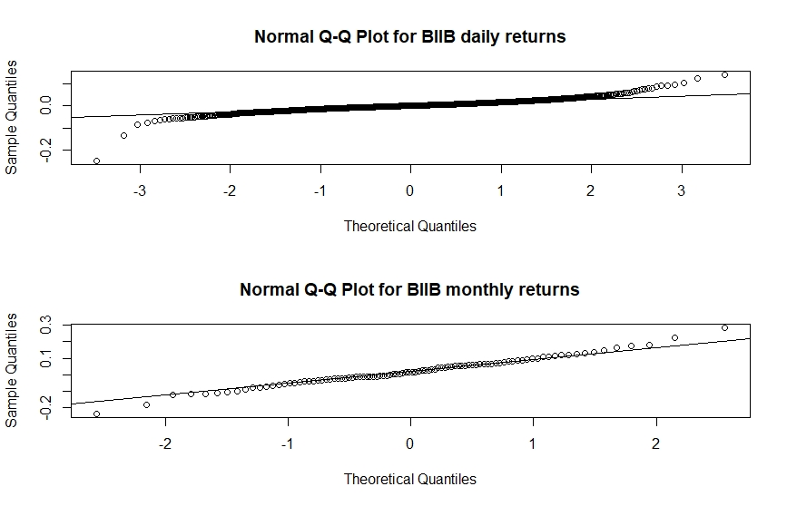

***Figure2***

par(mfrow=c(2,1))

qqnorm(log_daily_rets[,14],main="Normal Q-Q Plot for portfolio daily returns")

qqline(log_daily_rets[,14])

qqnorm(log_monthly_rets[,14],main="Normal Q-Q Plot for portfolio monthly returns")

qqline(log_monthly_rets[,14])

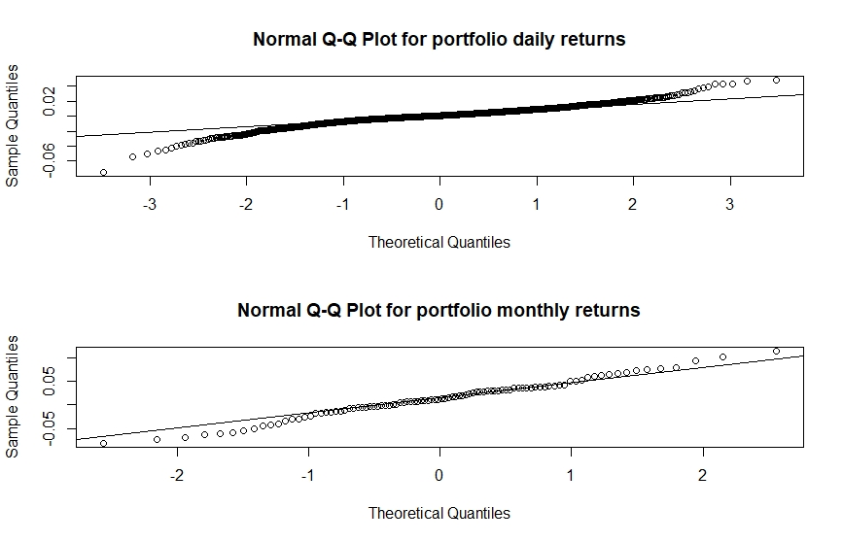

***Figure3***

### ---problem 2--- ###

# # pepsi

mean(monthly_rets[,8]) * 12

sd(monthly_rets[,8]) * sqrt(12)

quantile(monthly_rets[,8], probs=c(0.05,0.95))

quantile(log_monthly_rets[,8], probs=c(0.05,0.95))

# # valero

mean(monthly_rets[,11]) * 12

sd(monthly_rets[,11]) * sqrt(12)

quantile(monthly_rets[,11], probs=c(0.05,0.95))

quantile(log_monthly_rets[,11], probs=c(0.05,0.95))

### ---problem 4--- ###

# # (1)

daily_matrix <- cor(log_daily_rets[,2:12])

daily_cor <- unlist(daily_matrix[daily_matrix<1])

quantile(daily_cor, prob=c(0,0.25,0.5,0.75,1))

monthly_matrix <- cor(log_monthly_rets[,2:12])

monthly_cor <- unlist(monthly_matrix[monthly_matrix<1])

quantile(monthly_cor,prob=c(0,0.25,0.5,0.75,1))

# # (2)

quantile(ew_monthly_ret,0.05)

qnorm(0.05, mean(ew_monthly_ret),sd(ew_monthly_ret))

quantile(ew_daily_ret,0.05)

qnorm(0.05, mean(ew_daily_ret),sd(ew_daily_ret))

**Table: Cross-correlations of stock returns**

|  |  |  |  |  |
| --- | --- | --- | --- | --- |
|  | Ann. Mean | Ann. Stdv | 5% | 95% |
| Pepsi |  |  |  |  |
| R | 0.1210 | 0.116 | -0.0377 | 0.0644 |
| log(1+R) | 0.1139 | 0.115 | -0.0384 | 0.0624 |
| Valero |  |  |  |  |
| R | 0.3037 | 0.334 | -0.1080 | 0.1520 |
| log(1+R) | 0.2482 | 0.323 | -0.1143 | 0.1414 |