### ---problem 1--- ###

setwd("C:/Users/47494/GitHub/MF793/data")

monthly_rets <- read.csv("stk-mon.csv",header=T)

daily_rets <- read.csv("stk-day.csv",header=T)

# # (a)

log_monthly_rets <- cbind(monthly_rets$date,log(1 + monthly_rets[,2:13]))

log_monthly_rets[,14] <- rowMeans(log_monthly_rets[,2:12])

names(log_monthly_rets)[c(1,14)] <- c('date','ewret')

log_monthly_rets_a <- log_monthly_rets[log_monthly_rets$date<='20151231',]

log_monthly_rets_b <- log_monthly_rets[log_monthly_rets$date>'20151231',]

monthly_sd_a <- apply(log_monthly_rets_a[,2:14], 2, sd)

monthly_sd_b <- apply(log_monthly_rets_b[,2:14], 2, sd)

ann_monthly_sd_a <- monthly_sd_a * sqrt(12)

ann_monthly_sd_b <- monthly_sd_b * sqrt(12)

round(ann_monthly_sd_a, 3)

round(ann_monthly_sd_b, 3)

monthly_vr <- ann_monthly_sd_a^2 / ann_monthly_sd_b^2

round(monthly_vr, 3)

**Table 1: Volatility for the 2010-15 and 2016-17 periods**

|  |  |  |  |  |  |  |
| --- | --- | --- | --- | --- | --- | --- |
|  | σ1M (ann.) | σ2M (ann.) | VRM | σ1D (ann.) | σ2D (ann.) | VRD |
| Apple | 0.247 | 0.235 | 1.102 | 0.267 | 0.207 | 1.667 |
| Amazon | 0.281 | 0.224 | 1.571 | 0.327 | 0.255 | 1.643 |
| Biogen | 0.293 | 0.284 | 1.067 | 0.324 | 0.295 | 1.204 |
| Citygroup | 0.301 | 0.254 | 1.409 | 0.345 | 0.257 | 1.800 |
| GE | 0.222 | 0.189 | 1.376 | 0.224 | 0.188 | 1.433 |
| Nike | 0.213 | 0.186 | 1.319 | 0.235 | 0.221 | 1.135 |
| Pepsi | 0.117 | 0.111 | 1.126 | 0.142 | 0.118 | 1.450 |
| State Street | 0.242 | 0.265 | 0.831 | 0.274 | 0.248 | 1.225 |
| Toyota | 0.193 | 0.174 | 1.234 | 0.222 | 0.189 | 1.381 |
| Valero | 0.348 | 0.235 | 2.190 | 0.359 | 0.271 | 1.760 |
| Verizon | 0.165 | 0.177 | 0.868 | 0.163 | 0.165 | 0.975 |
| US VW | 0.133 | 0.080 | 2.759 | 0.161 | 0.108 | 2.241 |
| EW 11 | 0.145 | 0.110 | 1.735 | 0.174 | 0.126 | 1.910 |

# # (b)

montly_cutoffs <- qf(c(0.05, 0.95), 71, 23)

round(montly_cutoffs, 3)

barplot(monthly_vr, main="barplot of VRs", ylim=c(0,3))

abline(h=1,lwd=3)

abline(h=montly_cutoffs[2],lwd=3)

round(sqrt(1/monthly_vr[12]) - 1, 3)

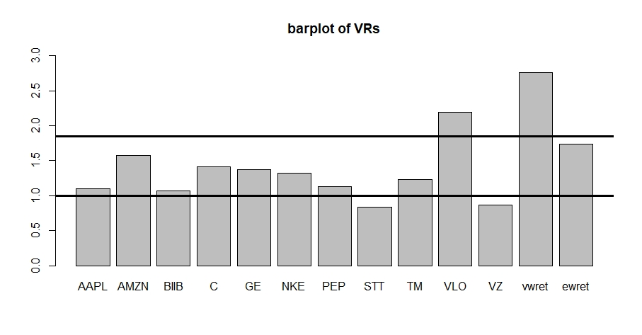

***Figure 1***

# # (c)

log_daily_rets <- cbind(daily_rets$date,log(1 + daily_rets[,2:13]))

log_daily_rets[,14] <- rowMeans(log_daily_rets[,2:12])

names(log_daily_rets)[c(1,14)] <- c('date','ewret')

log_daily_rets_a <- log_daily_rets[log_daily_rets$date<='20151231',]

log_daily_rets_b <- log_daily_rets[log_daily_rets$date>'20151231',]

daily_sd_a <- apply(log_daily_rets_a[,2:14], 2, sd)

daily_sd_b <- apply(log_daily_rets_b[,2:14], 2, sd)

ann_daily_sd_a <- daily_sd_a * sqrt(252)

ann_daily_sd_b <- daily_sd_b * sqrt(252)

round(ann_daily_sd_a, 3)

round(ann_daily_sd_b, 3)

daily_vr <- ann_daily_sd_a^2 / ann_daily_sd_b^2

round(daily_vr, 3)

daily_cutoffs <- qf(c(0.05, 0.95), 1509, 502)

round(daily_cutoffs, 3)

# # (d)

vw_monthly_mean <- mean(log_monthly_rets[,13])

vw_monthly_sd <- sd(log_monthly_rets[,13])

sim_monthly_ret <- matrix(

rnorm(96*20000, mean=vw_monthly_mean, sd=vw_monthly_sd),

ncol=20000)

sim_monthly_ret_a <- sim_monthly_ret[1:72,]

sim_monthly_ret_b <- sim_monthly_ret[73:96,]

sim_monthly_sd_a <-apply(sim_monthly_ret_a, 2, sd)

sim_monthly_sd_b <-apply(sim_monthly_ret_b, 2, sd)

sim_monthly_vr <- sim_monthly_sd_a^2 / sim_monthly_sd_b^2

round(quantile(sim_monthly_vr,0.95), 3)

round(mean(sim_monthly_vr),3)

monthly_frac <- sum(sim_monthly_vr > qf(0.95, 71, 23))/length(sim_monthly_vr)

sim_daily_ret <- matrix(rt(2016*20000,6),ncol=20000)

sim_daily_ret_a <- sim_daily_ret[1:1512,]

sim_daily_ret_b <- sim_daily_ret[1513:2016,]

sim_daily_sd_a <-apply(sim_daily_ret_a, 2, sd)

sim_daily_sd_b <-apply(sim_daily_ret_b, 2, sd)

sim_daily_vr <- sim_daily_sd_a^2 / sim_daily_sd_b^2

round(quantile(sim_daily_vr,0.95), 3)

round(mean(sim_daily_vr),3)

daily_frac <- sum(sim_daily_vr > qf(0.95, 1511, 503))/length(sim_daily_vr)

qqplot(qf(ppoints(20000),71,23),sim_monthly_vr,

main="F-probability plot of VRs against theoretical F\nmonthly case",

xlab="theoretical quantiles", ylab="sample quantiles")

abline(0,1)

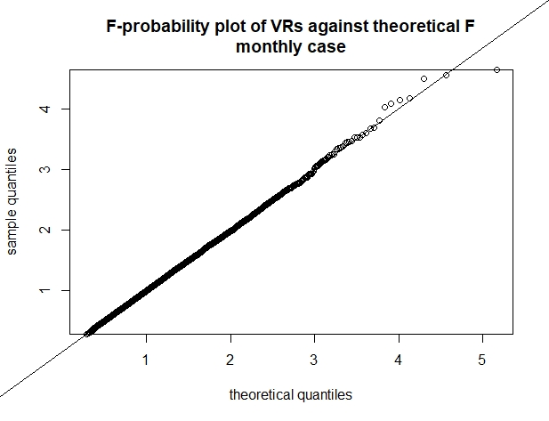

***Figure 2a***

qqplot(qf(ppoints(20000),1511,503),sim_daily_vr,

main="F-probability plot of VRs against theoretical F\ndaily case",

xlab="theoretical quantiles", ylab="sample quantiles")

abline(0,1)

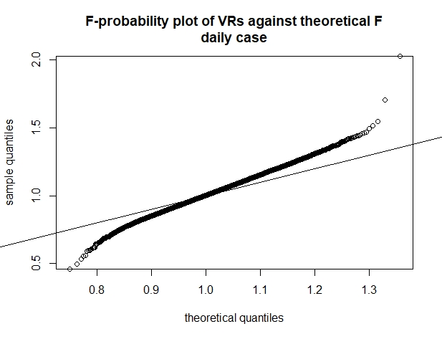

***Figure 2b***

**Table 2: Theoretical and simulated Mean and 95th quantiles of the Chow Test**

|  |  |  |  |  |  |  |  |
| --- | --- | --- | --- | --- | --- | --- | --- |
|  | ν1 | ν2 | F0.95 | Frac | $${VR}_{0.95}$$ | E(F) | $$\overline{VR}$$ |
| Monthly, Normal | 71 | 23 | 1.849 | 4.85% | 1.840 | 1.095 | 1.094 |
| Daily, t(6) | 1511 | 503 | 1.130 | 13.71% | 1.197 | 1.004 | 1.009 |
| Normal ρ = 0.3 | 95 | 95 | 1.404 | 4.11% | 1.379 | 1.022 | 1.019 |
| Normal ρC,STT =0.73 | 95 | 95 | 1.404 | 0.86% | 1.263 | 1.022 | 1.011 |

### ---problem 2--- ###

# # (a)

C_mothly_ret <- log_monthly_rets[,5]

STT_mothly_ret <- log_monthly_rets[,9]

C_mothly_sd <- sd(C_mothly_ret)

STT_mothly_sd <- sd(STT_mothly_ret)

monthly_vr_CS <- C_mothly_sd^2 / STT_mothly_sd^2

round(monthly_vr_CS,3)

round(qf(c(0.05,0.95),95,95),3)

# # (b)

sim_monthly_ret2_a <- matrix(

rnorm(96*20000),ncol=20000)

sim_monthly_ret2_b <- 0.3*sim_monthly_ret2_a +

sqrt(1-0.3^2)*matrix(rnorm(96*20000),ncol=20000)

sim_monthly_sd2_a <- apply(sim_monthly_ret2_a, 2, sd)

sim_monthly_sd2_b <- apply(sim_monthly_ret2_b, 2, sd)

sim_monthly_vr2 <- sim_monthly_sd2_a^2 / sim_monthly_sd2_b^2

round(quantile(sim_monthly_vr2, 0.95), 3)

round(mean(sim_monthly_vr2),3)

monthly_frac2 <- sum(sim_monthly_vr2 > qf(0.95, 95, 95))/length(sim_monthly_vr2)

rho <- cor(C_mothly_ret, STT_mothly_ret)

sim_monthly_ret3_a <- matrix(

rnorm(96*20000),ncol=20000)

sim_monthly_ret3_b <- rho*sim_monthly_ret3_a +

sqrt(1-rho^2)*matrix(rnorm(96*20000),ncol=20000)

sim_monthly_sd3_a <- apply(sim_monthly_ret3_a, 2, sd)

sim_monthly_sd3_b <- apply(sim_monthly_ret3_b, 2, sd)

sim_monthly_vr3 <- sim_monthly_sd3_a^2 / sim_monthly_sd3_b^2

round(quantile(sim_monthly_vr3, 0.95), 3)

round(mean(sim_monthly_vr3),3)

monthly_frac3 <- sum(sim_monthly_vr3 > qf(0.95, 95, 95))/length(sim_monthly_vr3)

qqplot(qf(ppoints(20000),95,95),sim_monthly_vr3,

main="F-probability plot of VRs against theoretical F\nC / STT monthly case",

xlab="theoretical quantiles", ylab="sample quantiles")

abline(0,1)

qqplot(qt(ppoints(20000),95,95),sim_monthly_vr3,

main="t-probability plot of VRs with\ndegree of freedom=95\nnon-centrality parameter=95",

xlab="theoretical quantiles", ylab="sample quantiles")

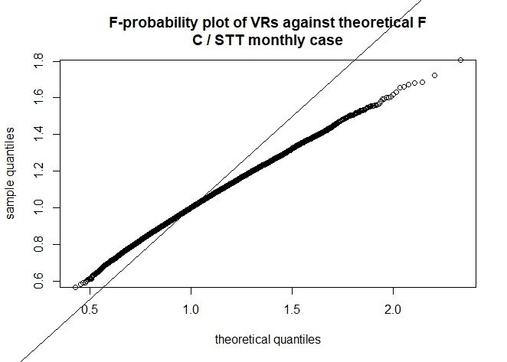

***Figure 3***

