### ---problem 6--- ###

monthly_rets <- read.csv("stk-mon.csv",header=T)

daily_rets <- read.csv("stk-day.csv",header=T)

log_monthly_rets <- cbind(monthly_rets$date,log(1 + monthly_rets[,2:13]))

log_monthly_rets[,14] <- rowMeans(log_monthly_rets[,2:12])

names(log_monthly_rets)[c(1,14)] <- c('date','ewret')

log_daily_rets <- cbind(daily_rets$date,log(1 + daily_rets[,2:13]))

log_daily_rets[,14] <- rowMeans(log_daily_rets[,2:12])

names(log_daily_rets)[c(1,14)] <- c('date','ewret')

# monthly regression

y_monthly <- log_monthly_rets[,13]

res_monthly_itcpt <- vector(mode="numeric",length=12)

res_monthly_x <- vector(mode="numeric",length=12)

res_monthly_itcpt_s <- vector(mode="numeric",length=12)

res_monthly_x_s <- vector(mode="numeric",length=12)

res_monthly_itcpt_t <- vector(mode="numeric",length=12)

res_monthly_x_t <- vector(mode="numeric",length=12)

names(res_monthly_itcpt) <- names(log_monthly_rets[,c(2:12,14)])

names(res_monthly_x) <- names(log_monthly_rets[,c(2:12,14)])

names(res_monthly_itcpt_s) <- names(log_monthly_rets[,c(2:12,14)])

names(res_monthly_x_s) <- names(log_monthly_rets[,c(2:12,14)])

names(res_monthly_itcpt_t) <- names(log_monthly_rets[,c(2:12,14)])

names(res_monthly_x_t) <- names(log_monthly_rets[,c(2:12,14)])

j = 1

for (i in c(2:12,14)) {

res_monthly <- lsfit(log_monthly_rets[,i], y_monthly)

res_monthly_itcpt[j] <- coef(res_monthly)[1]

res_monthly_x[j] <- coef(res_monthly)[2]

res_monthly_itcpt_s[j] <- ls.print(res_monthly)[2][["coef.table"]][[1]][,2][1]

res_monthly_x_s[j] <- ls.print(res_monthly)[2][["coef.table"]][[1]][,2][2]

res_monthly_itcpt_t[j] <- ls.print(res_monthly)[2][["coef.table"]][[1]][,3][1]

res_monthly_x_t[j] <- ls.print(res_monthly)[2][["coef.table"]][[1]][,3][2]

j = j + 1

}

round(res_monthly_itcpt,4)

round(res_monthly_x,2)

round(res_monthly_itcpt_s,4)

round(res_monthly_x_s,2)

# daily regression

y_daily <- log_daily_rets[,13]

res_daily_itcpt <- vector(mode="numeric",length=12)

res_daily_x <- vector(mode="numeric",length=12)

res_daily_itcpt_s <- vector(mode="numeric",length=12)

res_daily_x_s <- vector(mode="numeric",length=12)

res_daily_itcpt_t <- vector(mode="numeric",length=12)

res_daily_x_t <- vector(mode="numeric",length=12)

names(res_daily_itcpt) <- names(log_daily_rets[,c(2:12,14)])

names(res_daily_x) <- names(log_daily_rets[,c(2:12,14)])

names(res_daily_itcpt_s) <- names(log_daily_rets[,c(2:12,14)])

names(res_daily_x_s) <- names(log_daily_rets[,c(2:12,14)])

names(res_daily_itcpt_t) <- names(log_daily_rets[,c(2:12,14)])

names(res_daily_x_t) <- names(log_daily_rets[,c(2:12,14)])

j = 1

for (i in c(2:12,14)) {

res_daily <- lsfit(log_daily_rets[,i], y_daily)

res_daily_itcpt[j] <- coef(res_daily)[1]

res_daily_x[j] <- coef(res_daily)[2]

res_daily_itcpt_s[j] <- ls.print(res_daily)[2][["coef.table"]][[1]][,2][1]

res_daily_x_s[j] <- ls.print(res_daily)[2][["coef.table"]][[1]][,2][2]

res_daily_itcpt_t[j] <- ls.print(res_daily)[2][["coef.table"]][[1]][,3][1]

res_daily_x_t[j] <- ls.print(res_daily)[2][["coef.table"]][[1]][,3][2]

j = j + 1

}

round(res_daily_itcpt,5)

round(res_daily_x,2)

round(res_daily_itcpt_s,5)

round(res_daily_x_s,2)

|  |  |  |  |  |  |  |  |  |
| --- | --- | --- | --- | --- | --- | --- | --- | --- |
| **Table 1:** | | | | | | | | |
|  | Monthly Regressions | | | | Daily Regressions | | | |
|  | α | sα | β | sβ | α | sα | β | sβ |
| Apple | 0.0054 | 0.0033 | 0.24 | 0.05 | 0.00018 | 0.00018 | 0.32 | 0.01 |
| Amazon | 0.0049 | 0.0033 | 0.22 | 0.04 | 0.00020 | 0.00018 | 0.25 | 0.01 |
| Biogen | 0.0067 | 0.0034 | 0.17 | 0.04 | 0.00026 | 0.00018 | 0.23 | 0.01 |
| Citygroup | 0.0072 | 0.0024 | 0.32 | 0.03 | 0.00033 | 0.00014 | 0.35 | 0.01 |
| GE | 0.0084 | 0.0027 | 0.36 | 0.04 | 0.00037 | 0.00014 | 0.51 | 0.01 |
| Nike | 0.0065 | 0.0034 | 0.23 | 0.06 | 0.00021 | 0.00017 | 0.37 | 0.01 |
| Pepsi | 0.0054 | 0.0034 | 0.47 | 0.10 | 0.00020 | 0.00018 | 0.61 | 0.02 |
| State Street | 0.0065 | 0.0026 | 0.35 | 0.04 | 0.00028 | 0.00014 | 0.42 | 0.01 |
| Toyota | 0.0081 | 0.0032 | 0.31 | 0.06 | 0.00036 | 0.00017 | 0.41 | 0.01 |
| Valero | 0.0054 | 0.0030 | 0.22 | 0.03 | 0.00020 | 0.00016 | 0.27 | 0.01 |
| Verizon | 0.0078 | 0.0035 | 0.22 | 0.07 | 0.00025 | 0.00018 | 0.48 | 0.02 |
| Average | 0.0066 | 0.0031 | 0.28 | 0.05 | 0.00026 | 0.00017 | 0.38 | 0.01 |
|  |  |  |  |  |  |  |  |  |
| EW Portfolio | 0.0006 | 0.0017 | 0.80 | 0.04 | 0.00006 | 0.00007 | 0.86 | 0.01 |

### ---problem 7-- ###

APPL <- log_daily_rets[,2]

mkt <- log_daily_rets[,13]

mod1<-lm(APPL~mkt)

mod1res<-rstandard(mod1)

plot(mod1res, mkt, xlab="standardized residuals", ylab="market return",

main="Standardized residuals vs the market return")

plot(abs(mod1res), mkt, xlab="abs(standardized residuals)", ylab="market return",

main="Abs(standardized residuals) vs the market return")

library("forecast")

Acf(mod1res)

library("sandwich")

library("lmtest")

coeftest(mod1,vcov=vcov(mod1))

coeftest(mod1,vcov=vcovHC(mod1))

vcov(mod1)[2,2]

vcovHC(mod1)[2,2]

coefci(mod1,vcov.=vcov(mod1),level=0.90)[2,]

coefci(mod1,vcov.=vcovHC(mod1),level=0.90)[2,]

# # (a)

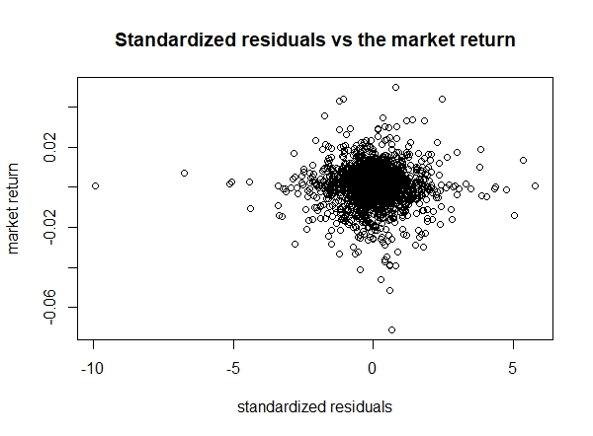

***Figure 1***

# # (b)

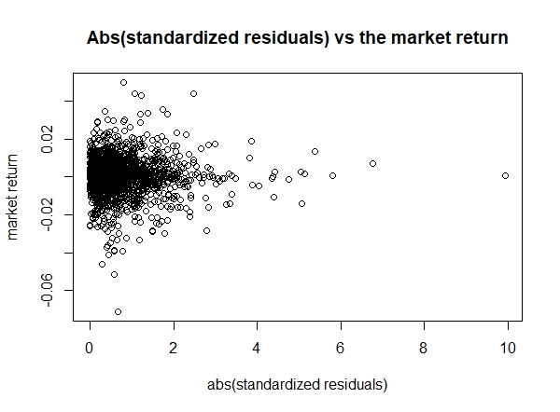

***Figure 2***

# # (d)

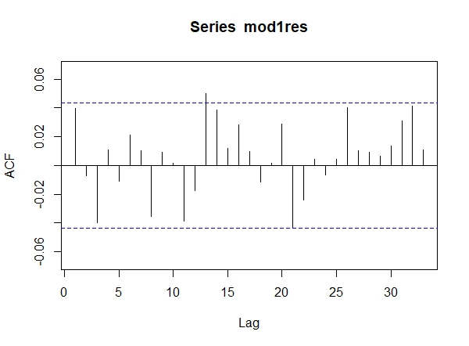

***Figure 3***

# # (f)

Table 2: Sandwich estimates of the slope standard error for the APPL daily regression

|  |  |  |  |  |  |
| --- | --- | --- | --- | --- | --- |
|  |  | s | Cov[2,2] | 5% | 95% |
| OLS – iid | 0.92 | 0.0317 | 0.0010 | 0.87 | 0.97 |
| HC – White | 0.92 | 0.0330 | 0.0011 | 0.87 | 0.98 |