### ---problem 1--- ###

# # (a) and (b)

setwd("C:/Users/47494/GitHub/MF793/data")

monthly_rets <- read.csv("stk-mon.csv",header=T)

daily_rets <- read.csv("stk-day.csv",header=T)

log_monthly_rets <- cbind(monthly_rets$date,log(1 + monthly_rets[,2:13]))

names(log_monthly_rets)[c(1,14)] <- c('date','ewret')

log_daily_rets <- cbind(daily_rets$date,log(1 + daily_rets[,2:13]))

names(log_daily_rets)[c(1,14)] <- c('date','ewret')

ticker_list <- c("AAPL", "BIIB", "PEP", "VZ", "vwret")

sub_daily_rets <- log_daily_rets[ticker_list]

sub_monthly_rets <- log_monthly_rets[ticker_list]

daily_ret_sd <- apply(sub_daily_rets, 2, sd)

monthly_ret_sd <- apply(sub_monthly_rets, 2, sd)

daily_ret_sd2 <- sqrt(colMeans((sub_daily_rets - 0)^2))

monthly_ret_sd2 <- sqrt(colMeans((sub_monthly_rets - 0)^2))

round(daily_ret_sd, 3)

round(daily_ret_sd2, 3)

round(monthly_ret_sd, 3)

round(monthly_ret_sd2, 3)

Table 1: Annualized Standard Deviations with and without mean

|  |  |  |  |  |
| --- | --- | --- | --- | --- |
|  | Daily | Daily, mean = 0 | Monthly | Monthly, mean = 0 |
| AAPL | 0.016 | 0.016 | 0.070 | 0.072 |
| Biogen | 0.020 | 0.020 | 0.084 | 0.086 |
| Pepsi | 0.009 | 0.009 | 0.033 | 0.034 |
| Verizon | 0.010 | 0.010 | 0.048 | 0.049 |
| VW US | 0.009 | 0.009 | 0.035 | 0.036 |

### ---problem 2--- ###

# # (c)

Table 2: Forecasting with the stationary AR(1)

|  |  |  |  |
| --- | --- | --- | --- |
|  | Mean | Variance | Standard Error |
| XT | 8 | 0 | 0 |
| XT+1 | 11.4 | 16 | 4 |
| XT+2 | 14.12 | 26.24 | 5.12 |
| XT+3 | 16.30 | 32.79 | 5.73 |
| X∞ | 25 | 44.44 | 6.67 |

### ---problem 3-- ###

# # (b)

vix <- read.csv("vix-mon.csv",header=T)

vix$Date <- format(vix$Date, format="%m/%d/%y")

sub_vix <- vix[vix$Date >= 2007.01,]

library(forecast)

library(tseries)

par(mfrow=c(3,1),mgp=c(1.5,0.5,0),mar=c(3,3,2,0.5))

ts.plot(ts(sub_vix[,2],frequency=12,start=c(2007,1)),

ylab="VIX",xlab="Day")

title("Time Series of VIX")

Acf(sub_vix[,2]);title("ACF of VIX")

Acf(sub_vix[,2],type="partial");title("PACF of VIX")

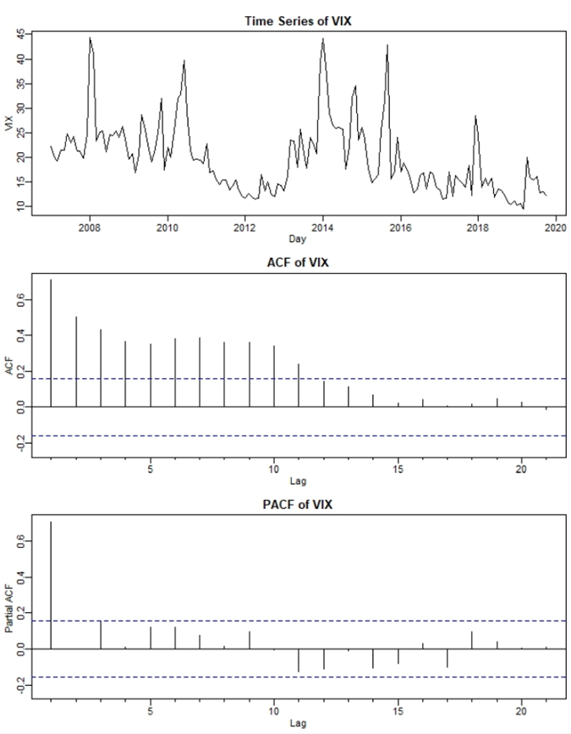

***Figure 1***

# # (c)

mod <- arma(sub_vix[,2],order=c(1,0))

names(mod)

residuals(mod)

fitted.values(mod)

# # (d)

valid_resi <- residuals(mod)[2:length(residuals(mod))]

valid_fit_val <- fitted.values(mod)[2:length(fitted.values(mod))]

abs_resi <- abs(valid_resi)

fit_val <- valid_fit_val

par(mfrow=c(2,1))

plot(fit_val, abs_resi,

main='Abs(residuals) vs Fitted Value')

abline(lsfit(fit_val, abs_resi))

qqnorm(residuals(mod),main="Normal Q-Q Plot for Residuals")

qqline(residuals(mod))

library("moments")

skew_resi <- skewness(valid_resi)

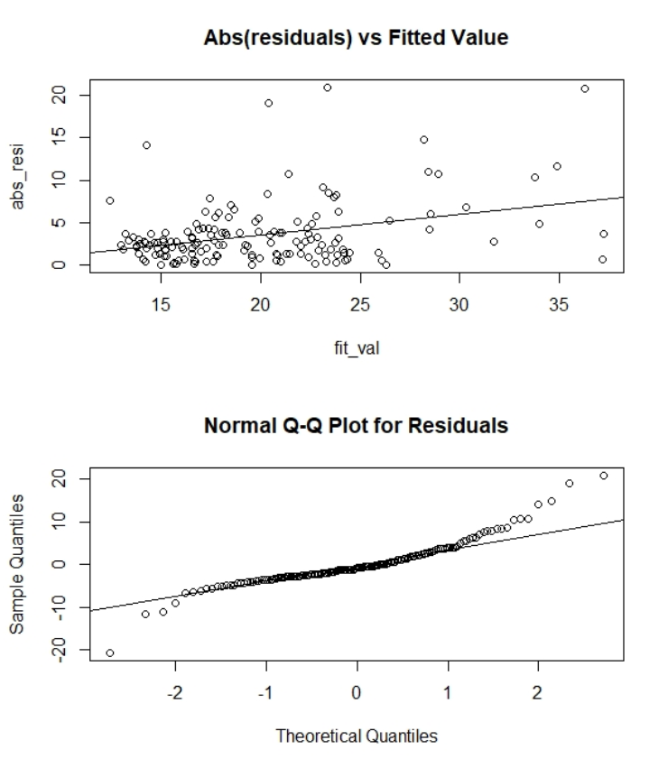

***Figure 2***

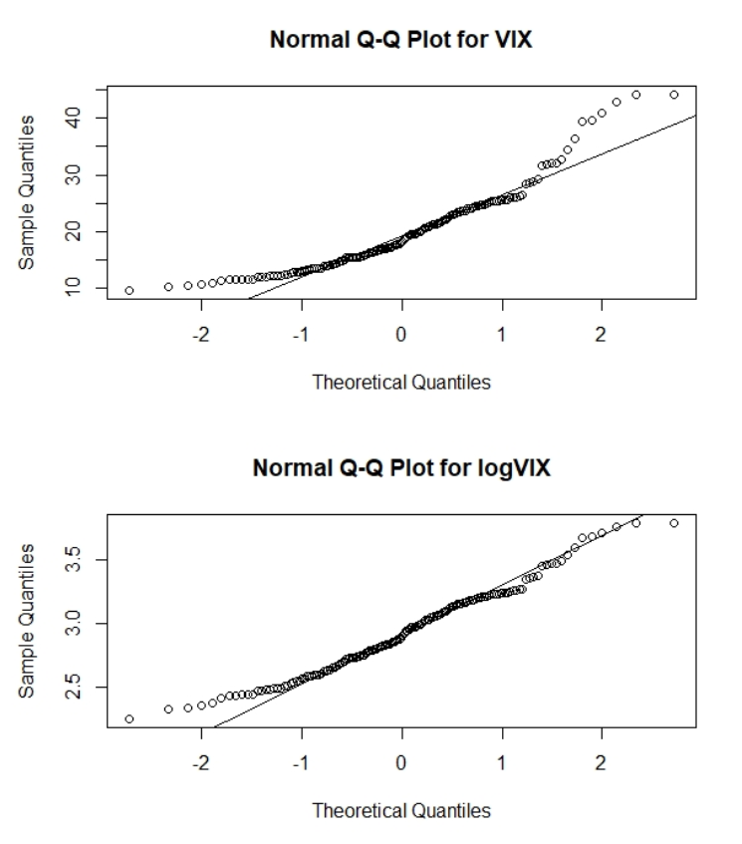

***Figure 3***

# # (i)

mod2 <- arma(log(sub_vix[,2]),order=c(1,0))

valid_resi2 <- residuals(mod2)[2:length(residuals(mod2))]

valid_fit_val2 <- fitted.values(mod2)[2:length(fitted.values(mod2))]

abs_resi2 <- abs(valid_resi2)

fit_val2 <- valid_fit_val2

par(mfrow=c(2,1))

plot(fit_val2, abs_resi2,

main='Abs(residuals) vs Fitted Value')

abline(lsfit(fit_val2, abs_resi2))

qqnorm(residuals(mod2),main="Normal Q-Q Plot for Residuals")

qqline(residuals(mod2))

skew_resi2 <- skewness(valid_resi2)

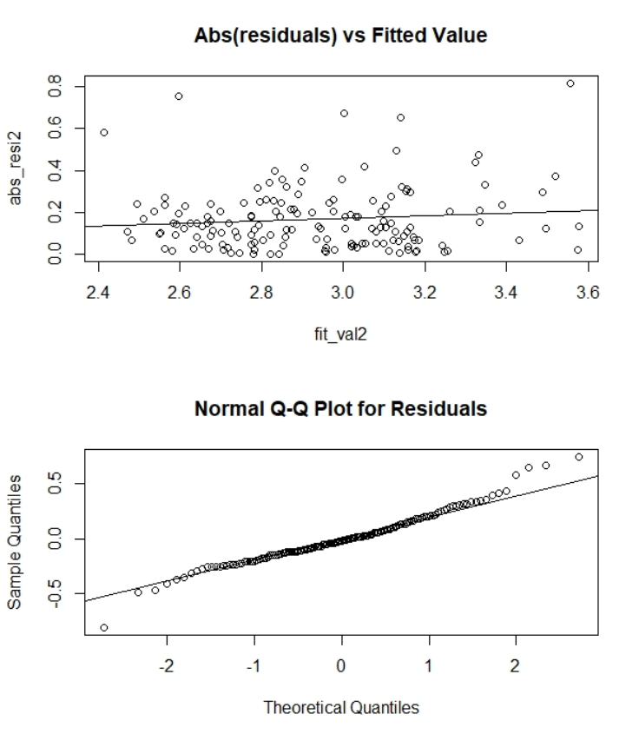

***Figure 4***

# # (j)

sd(valid_resi)

sd(valid_resi2)

bound <- quantile(valid_resi, c(0.25,0.75))

bound2 <- quantile(valid_resi2, c(0.25,0.75))

alpha <- coef(mod)[2]

beta <- coef(mod)[1]

alpha2 <- coef(mod2)[2]

beta2 <- coef(mod2)[1]

LB <- alpha + beta * tail(sub_vix[,2],1) + bound[1]

UB <- alpha + beta * tail(sub_vix[,2],1) + bound[2]

LB2 <- exp(alpha2 + beta2 * tail(log(sub_vix[,2]),1) + bound2[1])

UB2 <- exp(alpha2 + beta2 * tail(log(sub_vix[,2]),1) + bound2[2])

**Table 3:** Forecasting with the AR(1) vs. LogAR(1)

|  |  |  |
| --- | --- | --- |
|  | With AR1 | With Log-AR1 |
| Φ0 | 5.62 | 0.71 |
| Φ1 | 0.71 | 0.76 |
| σϵ | 5.12 | 0.22 |
| E(VIXT+1) | 14.28 | 13.42 |
| LB(VIXT+1) | 11.55 | 11.77 |
| UB(VIXT+1) | 16.43 | 15.30 |

### ---problem 4-- ###

# # (a)

poundeuro <- read.csv("poundeuro-day.csv",header=T)

names(poundeuro) <- c("date","pound","euro")

poundeuro$date <- format(poundeuro$date, format="%y%m%d")

pound <- poundeuro[poundeuro$date>=2012.01 & poundeuro$date<2018.01,1:2]

Acf(pound[,2]);title("ACF of Pound")

pound_logret <- diff(log(pound[,2]))

# # (b)

library(zoo)

roll_pound_sd <- rollapply(pound_logret,88,sd)

roll_pound_sd2 <- sqrt(rollapply(pound_logret^2,88,mean))

annu_roll_pound_sd <- roll_pound_sd * sqrt(252)

annu_roll_pound_sd2 <- roll_pound_sd2 * sqrt(252)

par(mfrow=c(3,1))

ts.plot(ts(pound[88:nrow(pound),2],frequency=252,start=c(2012,5,7)),

main ='Pound Price',xlab='day',ylab='Price')

ts.plot(ts(pound_logret[88:length(pound_logret)],frequency=252,

start=c(2012,5,7)), main ='Pound Logret',xlab='day',ylab='ret')

ts.plot(ts(roll_pound_sd,frequency=252,start=c(2012,5,7)),

ts(roll_pound_sd2,frequency=252,start=c(2012,5,7)),

col=c("red","black"),main ='Rolling Sd of Pound',xlab='day',ylab='sd')

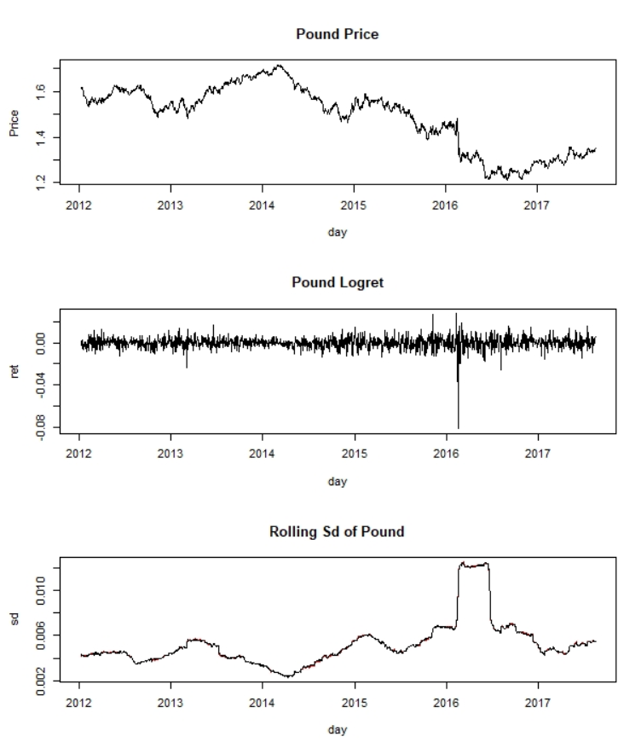

***Figure 5***

# # (c)

lam <- 0.96

rm=array(dim=length(roll_pound_sd2))

rm[1] <- roll_pound_sd2[1]^2

for (i in 2:length(rm)){

rm[i]=lam * rm[i-1] + (1-lam) * pound_logret[i+87]^2

}

annu_rm <- sqrt(rm) * sqrt(252)

par(mfrow=c(1,1))

ts.plot(ts(annu_rm,frequency=252,start=c(2012,5,7)),

ts(annu_roll_pound_sd2,frequency=252,start=c(2012,5,7)),

col=c("black","red"),main ='RW and RM',xlab='day',ylab='sd')

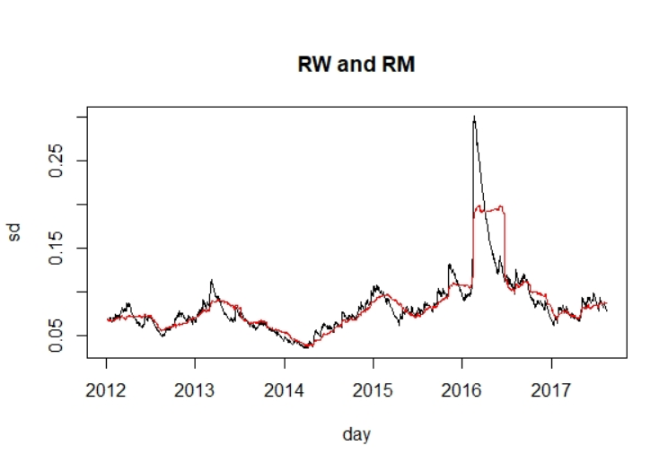

***Figure 6***