Name 1: Zhao, Chengyu

Name 2: Xie, You

**Report on Incoming Senate Confidential Election**

**Monday Nov. 5th**

The random variable we forecast is: R = Number of Republican Senators in the 2019 Senate

a) The Basics

* The Senate has **100** Seats
* **42** Republicans (R) seats are **not** up for reelection
* **23** Democrats (D) seats are **not** up for reelection
* **35** Total seats are up for reelection
* Senators Sanders (VT) and King (ME) caucus with the Democratic party. Therefore the bounds for the number of Republicans senators after the Nov. 6th election are:

**[ 42 , 77 ]**

b) Safe Elections, Elections in play

With the help of our data manager Dr. J., we collected and aggregated the most recent and reliable polls.

After further verification, we concluded that some races are essentially a “done deal”. The following races are safe:

Democrats: **CT, DE, HI, MA, MD, ME, MN, NY, PA, RI, VI, VT, WA**

Republicans: **MS, UT, WY**

There are  **3** safe Democrat races

There are **13** safe Republican races

Therefore, we revise our lower and upper bound for $\tilde{R}$: **[ 45 , 64 ]**

* The percent polled indicating a (R) or (D) vote, p1 and p2 do not sum to 1 because of possible third party candidates and undecided voters. We rescale them to sum to 1.

Note that this assumes the following behavior for undecided voters:

**Undecided voters will vote for the two parties with rescaled p1 and p2 respectively.**

* Just using the average estimates of % voting Republican for each rate, Column $\hat{p}$ in Table 1 below, we expect  **8** Republican senators from the races “in play”.

Therefore we expect  **53**  Republican and  **47**  Democrats in the 2019 Senate.

d) Estimating the uncertainty

We can now estimate the uncertainty. See the complete Table 1

Table 1: Polls Results, Expectations and Uncertainty

|  |  |  |  |  |  |  |
| --- | --- | --- | --- | --- | --- | --- |
| **State** | $$\hat{p}$$ | **% U** | **s($\hat{p}$)** | **MOE** | **P(Win)** | **sMAX** |
| Arizona | **47** | **5** | **0.013** | **0.026** | **0.02** | **0.026** |
| Florida | **48** | **10** | **0.009** | **0.018** | **0.01** | **0.026** |
| Indiana | **52** | **5** | **0.013** | **0.025** | **0.89** | **0.026** |
| Michigan | **45** | **6** | **0.017** | **0.034** | **0.00** | **0.034** |
| Minnesota | **47** | **12** | **0.018** | **0.035** | **0.03** | **0.035** |
| Mississippi | **57** | **33** | **0.022** | **0.043** | **1.00** | **0.043** |
| Missouri | **52** | **5** | **0.012** | **0.023** | **0.91** | **0.026** |
| Montana | **47** | **6** | **0.014** | **0.028** | **0.01** | **0.028** |
| Nebraska | **58** | **7** | **0.019** | **0.037** | **1.00** | **0.037** |
| Nevada | **53** | **12** | **0.015** | **0.029** | **0.99** | **0.029** |
| New Jersey | **47** | **11** | **0.019** | **0.038** | **0.07** | **0.038** |
| New Mexico | **41** | **21** | **0.013** | **0.026** | **0.00** | **0.026** |
| North Dakota | **54** | **0** | **0.013** | **0.025** | **1.00** | **0.026** |
| Ohio | **45** | **17** | **0.013** | **0.025** | **0.00** | **0.026** |
| Tennessee | **52** | **4** | **0.014** | **0.028** | **0.93** | **0.028** |
| Texas | **53** | **3** | **0.015** | **0.030** | **0.95** | **0.030** |
| West Virginia | **47** | **8** | **0.014** | **0.028** | **0.01** | **0.028** |
| Wisconsin | **42** | **7** | **0.014** | **0.028** | **0.00** | **0.028** |

* Average MOE for all the races: **2.9%**
* **0**  of the Polls are reporting an MOE better than 5% ?  
  Note: %U is % undecided in unscaled poll estimate. MOE is 1.96 s($\hat{p})$, P(Win) is the probability of the Republican winning. sMAX is, for each state, the worst of Nate Silver’s 2.6% standard error (5/1.96) and the poll’s self reported standard error.

e) Ready to simulate

* See Figures. 1 (based on Col. 4) and 2 (based on Col. 7) next page for the Senate Distribution.
* Given on the self-reported sp, the probability of a Republican senated is **more concentrated**. Taking the larger sP, it is **more dispersed**.

**Using larger Sp would make distribution more dispersed.**

* We warn however that it is not reasonable to assume that the races are uncorrelated. Being Senate races they are all affected by national views on national issues such as (Kavangaugh, Metoo, The Economy, Immigration, etc..). A reasonable single factor could be simulated via an equal-correlation across the races.
* The effect of a positive correlation of the races would lead to a distribution **with larger deviation** compared to those of Figures 1 and 2.

THIS PAGE FOR THE TWO FIGURES

Figure 1:

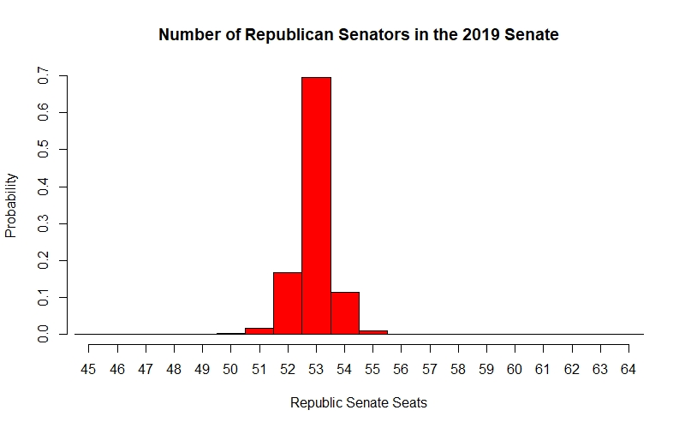

Figure 2

