# # (a)

The Senate has 100 seats.

42 Republicans (R) seats are not up for reelection.

23 Democrats (D) seats are not up for reelection.

35 seats are up for reelection.

The range for variable R is [42, 77].

# # (c)

Undecided voters will vote for the two parties with rescaled p1 and p2 respectively.

3 Republicans are “safe”.

13 Democrats are “safe”.

Revised domain for the variable R is [45, 64].

montly_cutoffs <- qf(c(0.05, 0.95), 71, 23)

round(montly_cutoffs, 3)

barplot(monthly_vr, main="barplot of VRs", ylim=c(0,3))

abline(h=1,lwd=3)

abline(h=montly_cutoffs[2],lwd=3)

round(sqrt(1/monthly_vr[12]) - 1, 3)

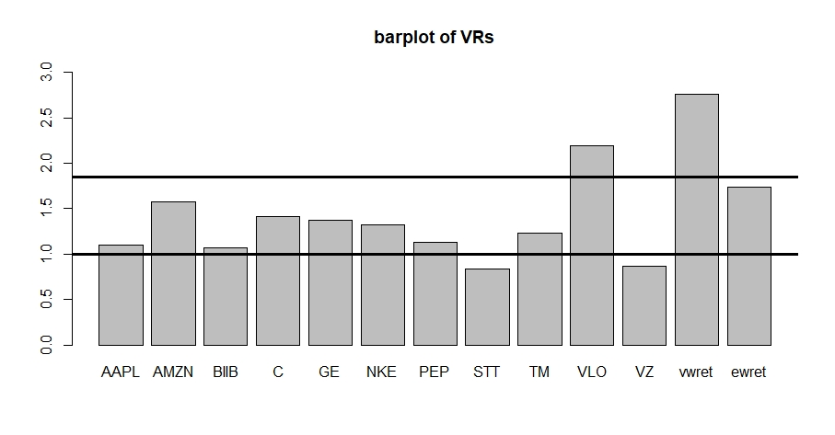

***Figure 1***

# # (c)

log_daily_rets <- cbind(daily_rets$date,log(1 + daily_rets[,2:13]))

log_daily_rets[,14] <- rowMeans(log_daily_rets[,2:12])

names(log_daily_rets)[c(1,14)] <- c('date','ewret')

log_daily_rets_a <- log_daily_rets[log_daily_rets$date<='20151231',]

log_daily_rets_b <- log_daily_rets[log_daily_rets$date>'20151231',]

daily_sd_a <- apply(log_daily_rets_a[,2:14], 2, sd)

daily_sd_b <- apply(log_daily_rets_b[,2:14], 2, sd)

ann_daily_sd_a <- daily_sd_a * sqrt(252)

ann_daily_sd_b <- daily_sd_b * sqrt(252)

round(ann_daily_sd_a, 3)

round(ann_daily_sd_b, 3)

daily_vr <- ann_daily_sd_a^2 / ann_daily_sd_b^2

round(daily_vr, 3)

daily_cutoffs <- qf(c(0.05, 0.95), 1509, 502)

round(daily_cutoffs, 3)

# # (d)

vw_monthly_mean <- mean(log_monthly_rets[,13])

vw_monthly_sd <- sd(log_monthly_rets[,13])

sim_monthly_ret <- matrix(

rnorm(96*20000, mean=vw_monthly_mean, sd=vw_monthly_sd),

ncol=20000)

sim_monthly_ret_a <- sim_monthly_ret[1:72,]

sim_monthly_ret_b <- sim_monthly_ret[73:96,]

sim_monthly_sd_a <-apply(sim_monthly_ret_a, 2, sd)

sim_monthly_sd_b <-apply(sim_monthly_ret_b, 2, sd)

sim_monthly_vr <- sim_monthly_sd_a^2 / sim_monthly_sd_b^2

round(quantile(sim_monthly_vr,0.95), 3)

round(mean(sim_monthly_vr),3)

monthly_frac <- sum(sim_monthly_vr > qf(0.95, 71, 23))/length(sim_monthly_vr)

sim_daily_ret <- matrix(rt(2016*20000,6),ncol=20000)

sim_daily_ret_a <- sim_daily_ret[1:1512,]

sim_daily_ret_b <- sim_daily_ret[1513:2016,]

sim_daily_sd_a <-apply(sim_daily_ret_a, 2, sd)

sim_daily_sd_b <-apply(sim_daily_ret_b, 2, sd)

sim_daily_vr <- sim_daily_sd_a^2 / sim_daily_sd_b^2

round(quantile(sim_daily_vr,0.95), 3)

round(mean(sim_daily_vr),3)

daily_frac <- sum(sim_daily_vr > qf(0.95, 1511, 503))/length(sim_daily_vr)

qqplot(qf(ppoints(20000),71,23),sim_monthly_vr,

main="F-probability plot of VRs against theoretical F\nmonthly case",

xlab="theoretical quantiles", ylab="sample quantiles")

abline(0,1)

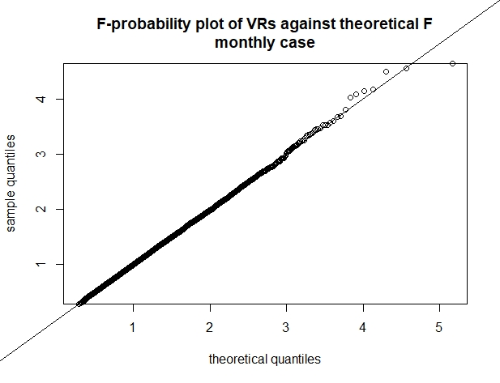

***Figure 2a***

qqplot(qf(ppoints(20000),1511,503),sim_daily_vr,

main="F-probability plot of VRs against theoretical F\ndaily case",

xlab="theoretical quantiles", ylab="sample quantiles")

abline(0,1)

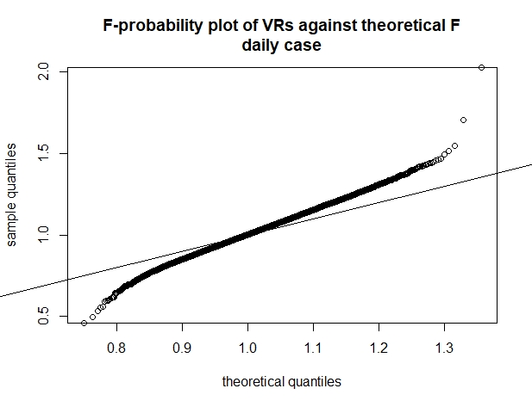

***Figure 2b***

**Table 2: Theoretical and simulated Mean and 95th quantiles of the Chow Test**

|  |  |  |  |  |  |  |  |
| --- | --- | --- | --- | --- | --- | --- | --- |
|  | ν1 | ν2 | F0.95 | Frac | $${VR}_{0.95}$$ | E(F) | $$\overline{VR}$$ |
| Monthly, Normal | 71 | 23 | 1.849 | 4.85% | 1.840 | 1.095 | 1.094 |
| Daily, t(6) | 1511 | 503 | 1.130 | 13.71% | 1.197 | 1.004 | 1.009 |
| Normal ρ = 0.3 | 95 | 95 | 1.404 | 4.11% | 1.379 | 1.022 | 1.019 |
| Normal ρC,STT =0.73 | 95 | 95 | 1.404 | 0.86% | 1.263 | 1.022 | 1.011 |

### ---problem 2--- ###

# # (a)

C_mothly_ret <- log_monthly_rets[,5]

STT_mothly_ret <- log_monthly_rets[,9]

C_mothly_sd <- sd(C_mothly_ret)

STT_mothly_sd <- sd(STT_mothly_ret)

monthly_vr_CS <- C_mothly_sd^2 / STT_mothly_sd^2

round(monthly_vr_CS,3)

round(qf(c(0.05,0.95),95,95),3)

# # (b)

sim_monthly_ret2_a <- matrix(

rnorm(96*20000),ncol=20000)

sim_monthly_ret2_b <- 0.3*sim_monthly_ret2_a +

sqrt(1-0.3^2)*matrix(rnorm(96*20000),ncol=20000)

sim_monthly_sd2_a <- apply(sim_monthly_ret2_a, 2, sd)

sim_monthly_sd2_b <- apply(sim_monthly_ret2_b, 2, sd)

sim_monthly_vr2 <- sim_monthly_sd2_a^2 / sim_monthly_sd2_b^2

round(quantile(sim_monthly_vr2, 0.95), 3)

round(mean(sim_monthly_vr2),3)

monthly_frac2 <- sum(sim_monthly_vr2 > qf(0.95, 95, 95))/length(sim_monthly_vr2)

rho <- cor(C_mothly_ret, STT_mothly_ret)

sim_monthly_ret3_a <- matrix(

rnorm(96*20000),ncol=20000)

sim_monthly_ret3_b <- rho*sim_monthly_ret3_a +

sqrt(1-rho^2)*matrix(rnorm(96*20000),ncol=20000)

sim_monthly_sd3_a <- apply(sim_monthly_ret3_a, 2, sd)

sim_monthly_sd3_b <- apply(sim_monthly_ret3_b, 2, sd)

sim_monthly_vr3 <- sim_monthly_sd3_a^2 / sim_monthly_sd3_b^2

round(quantile(sim_monthly_vr3, 0.95), 3)

round(mean(sim_monthly_vr3),3)

monthly_frac3 <- sum(sim_monthly_vr3 > qf(0.95, 95, 95))/length(sim_monthly_vr3)

qqplot(qf(ppoints(20000),95,95),sim_monthly_vr3,

main="F-probability plot of VRs against theoretical F\nC / STT monthly case",

xlab="theoretical quantiles", ylab="sample quantiles")

abline(0,1)

qqplot(qt(ppoints(20000),95,95),sim_monthly_vr3,

main="t-probability plot of VRs with\ndegree of freedom=95\nnon-centrality parameter=95",

xlab="theoretical quantiles", ylab="sample quantiles")

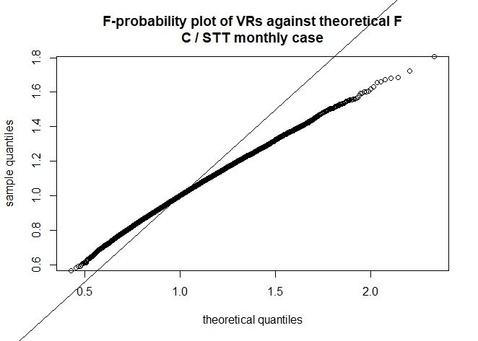

***Figure 3***

