Homework 3rd Report

You Xie (U65584921) [xyshell@bu.edu](mailto:xyshell@bu.edu)

(a)

Downloaded the SPY and VIX from Yahoo Finance, and saved them as “SPY.csv” and “^VIX.csv”.

(b)

The autocorrelation of SPY is: -0.0444, and the autocorrelation of VIX is: 0.9809.

I found strong evidence of autocorrelation in VIX. I would expect VIX to be more auto-correlated.

(c)

|  |  |  |
| --- | --- | --- |
|  | SPY | VIX |
| SPY | 1.0000 | -0.1784 |
| VIX | -0.1784 | 1.0000 |

|  |  |  |
| --- | --- | --- |
|  | SPY | VIX |
| SPY | 1.0000 | -0.4763 |
| VIX | -0.4763 | 1.0000 |

the correlation is negative, and more significant on a monthly basis,

the implication is that the assumption of BS model that the volatility is constant doesn't hold, as the price of underlying asset is moving.

(d)

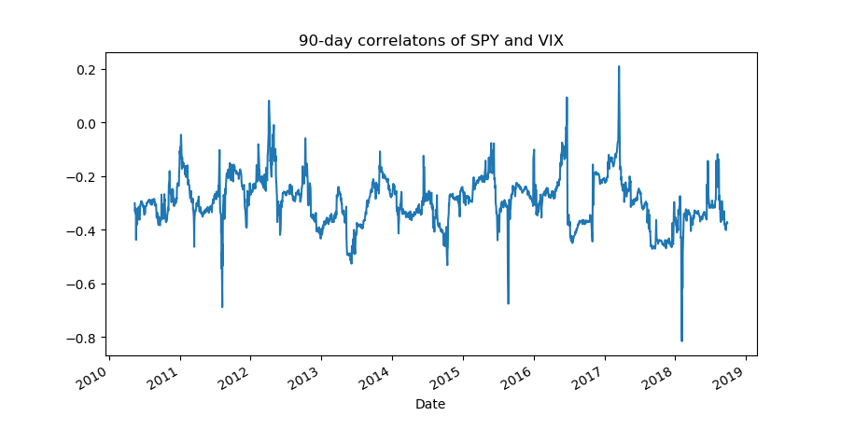

As it's shown in the picture, correlation deviates the most from long-run average in year 2018

(e)

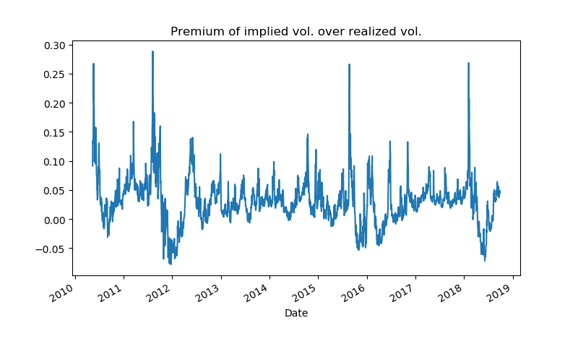

The premium is generally positive. Both of the highest and the lowest premium are in year 2011.

(f)

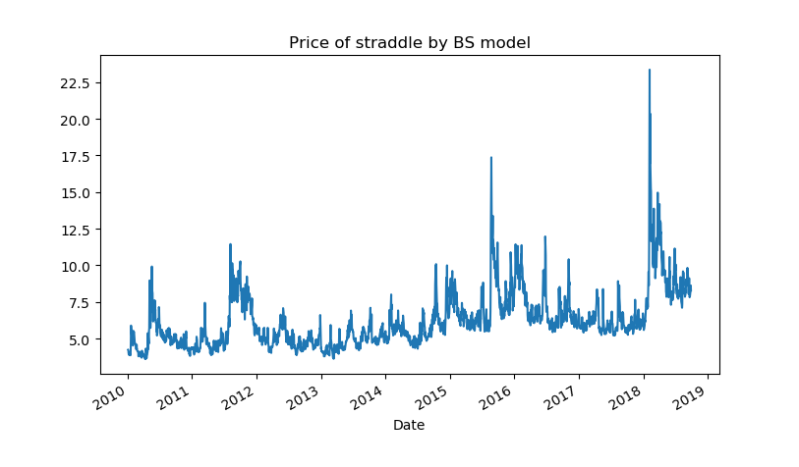

(g)

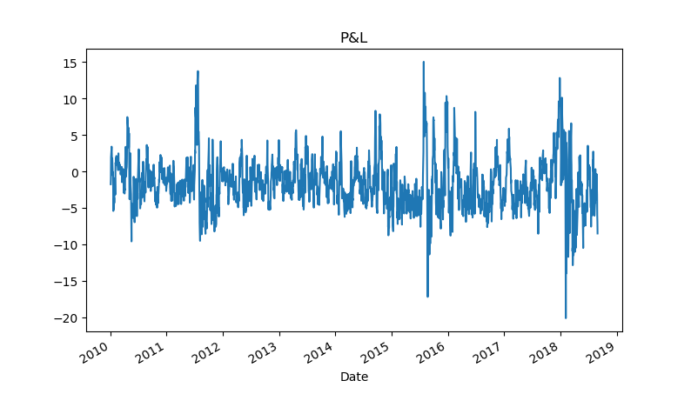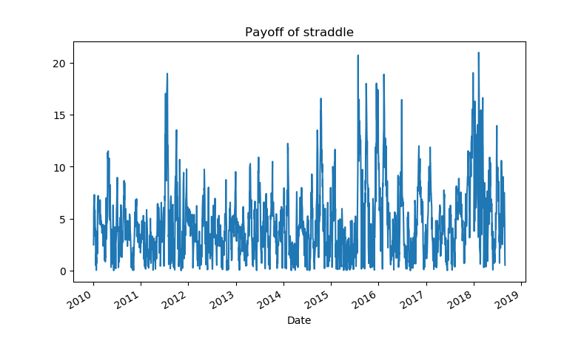

the average of P&L is: -1.7417

(h)

