Setup Boss Character
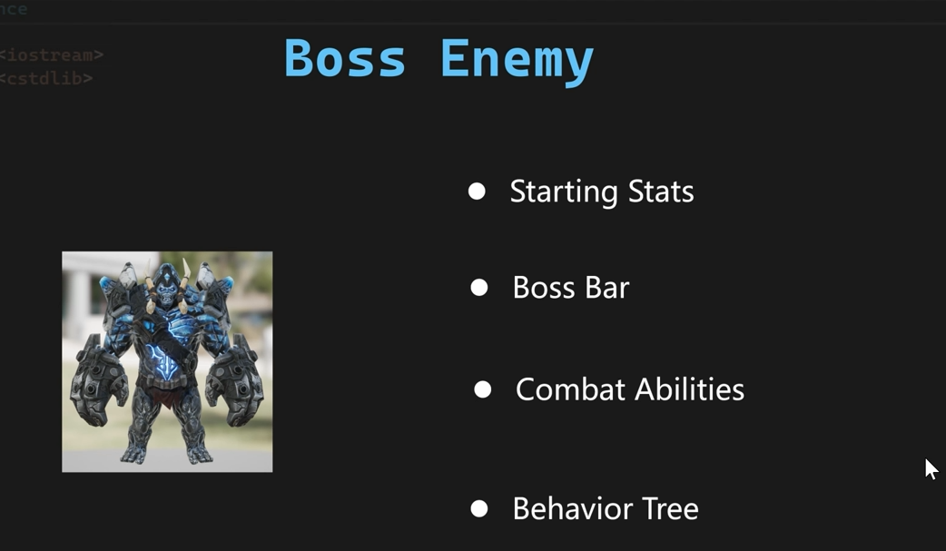
新建一个蓝图，父类选择BP_EnemyCharacter_Base，取名BP_FrostGiant，然后打开这个新的蓝图类，指定骨架。
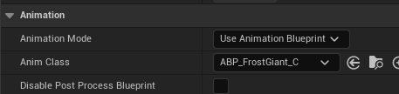
然后通过ABP_Enemy_Base来新建一个子类，取名ABP_FrostGiant
然后我们在建立一个blendspace。取名BS_FrostGiantDefaultLocomotion
Giant Starting Stats
首先先建立CT_FrostGiant和GE_Giant_StartUp，DA_FrostGiant，全部都配置好
Boss Bar Widget
首先新建一个Blueprint的类，取名WarriorTextBlock
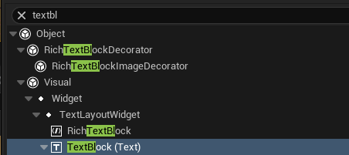
然后可以设置字体，或者选择是否有字体轮廓线，然后建立的Widget，父类选择
WarriorWidgetBase取名叫WBP_DefaultBossHealthBar
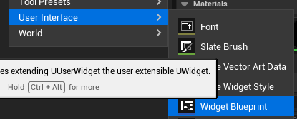
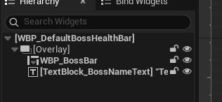
Draw Boss Bar To Screen
首先新建一个GameplayAbility蓝图能力类，父类选择UWarriorEnemyGameplayAbility ， 取名GA_Enemy_DrawBossBar_Base，这个是用来绘制Boss的HealthBar的，DA_FrostGiant配置的这个能力。
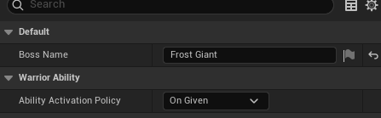
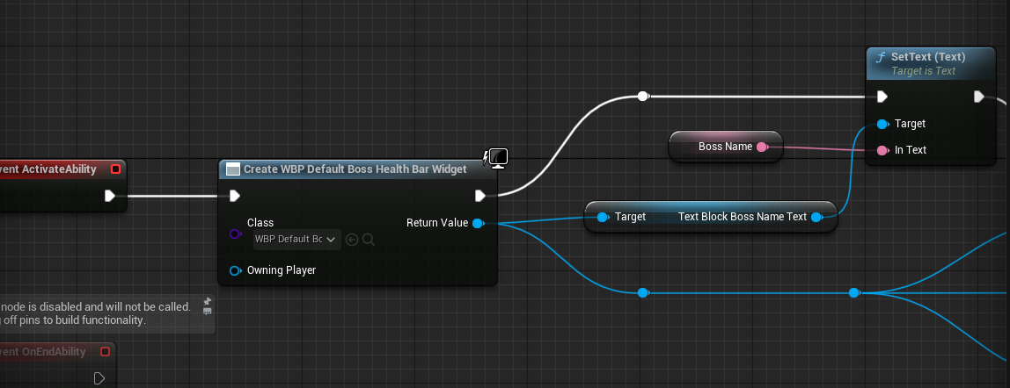
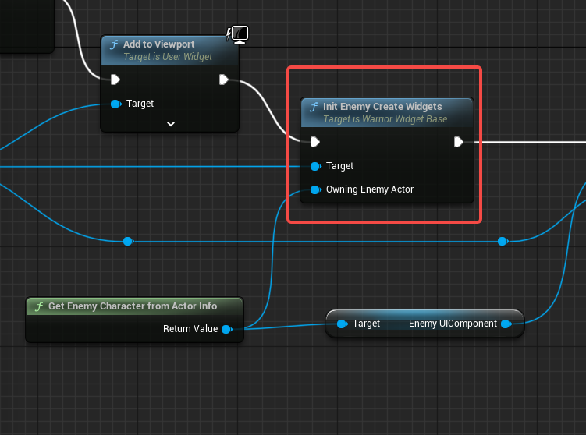
红框中的功能就里面有绑定了刷新boss血条的接口。通过GA_Enemy_DrawBossBar_Base这个在产生一个子类，取名为GA_Giant_DrawBossBar
Giant Hit React
首先我们新建一个能力，通过GA_Enemy_HitReact_Base这个类建立一个子类，取名叫做GA_Giant_HitReact，设置如下
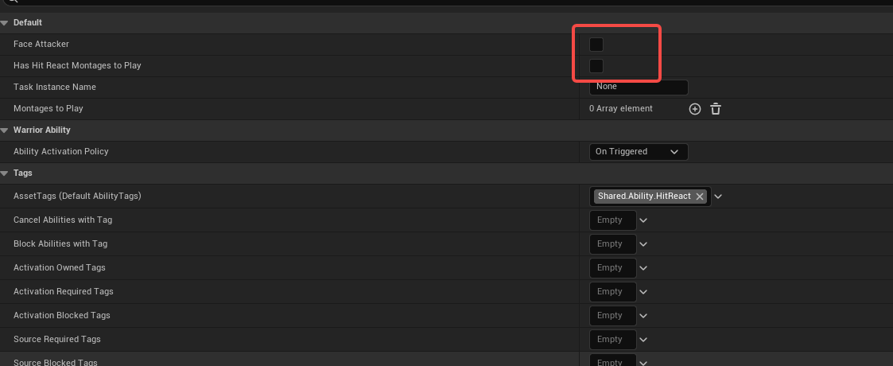
然后打开DA_FrostGiant，把这个能力授予给Boss
Giant Death
首先我们通过GA_Enemy_Death_Base建立一个子类，取名叫GA_Giant_Death
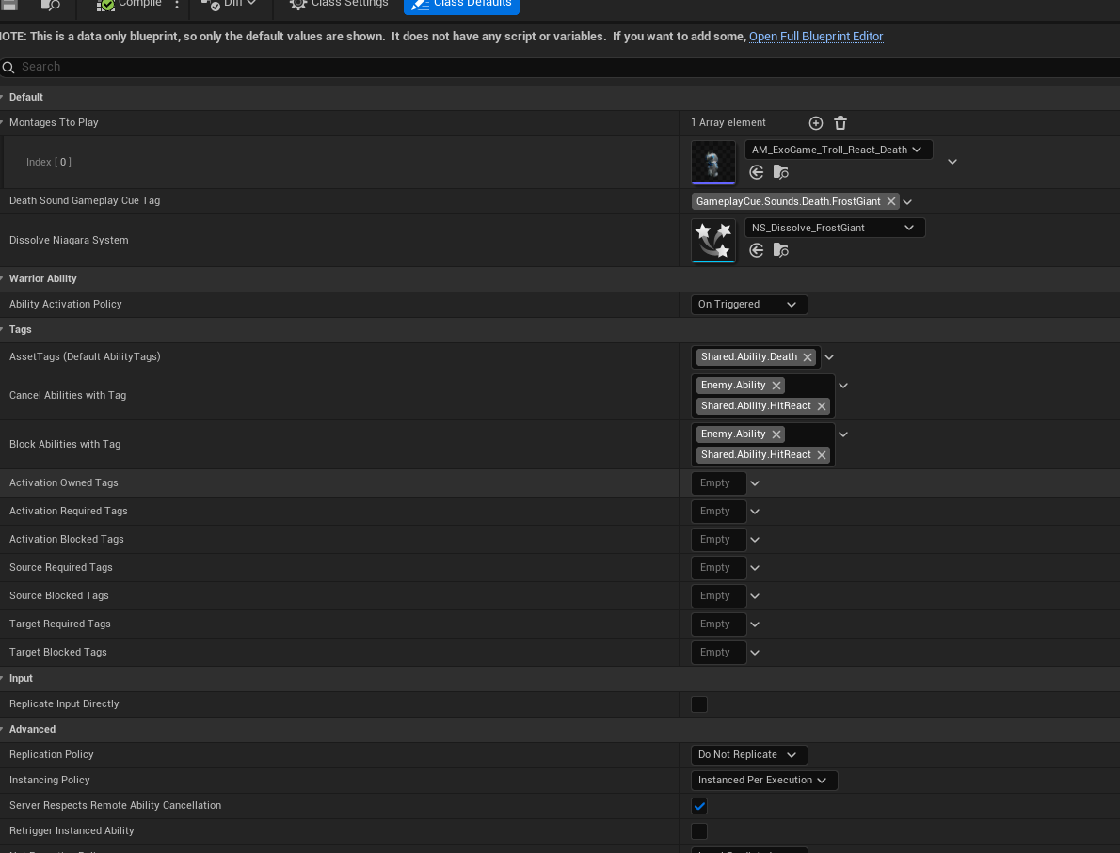
然后打开DA_FrostGiant，把这个能力授予给Boss
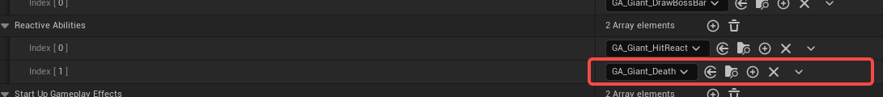

Remove Boss Bar
打开UEnemyUIComponent 类添加接口
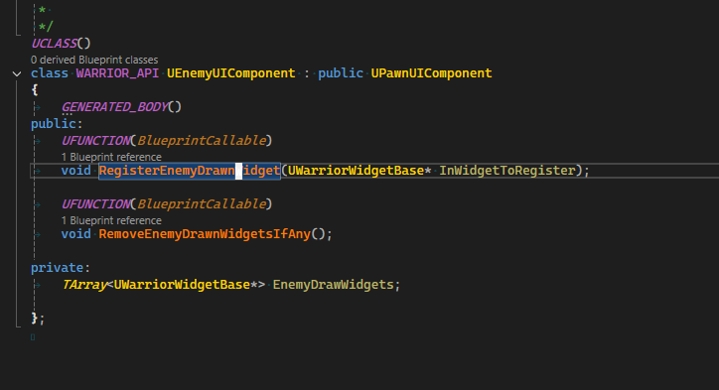
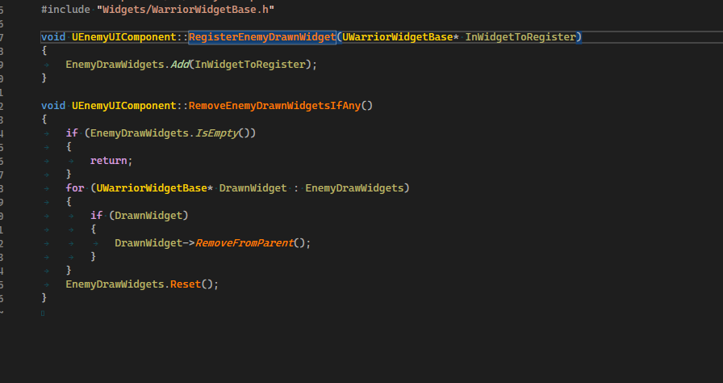
打开GA_Enemy_DrawBossBar_Base这个蓝图类，先注册
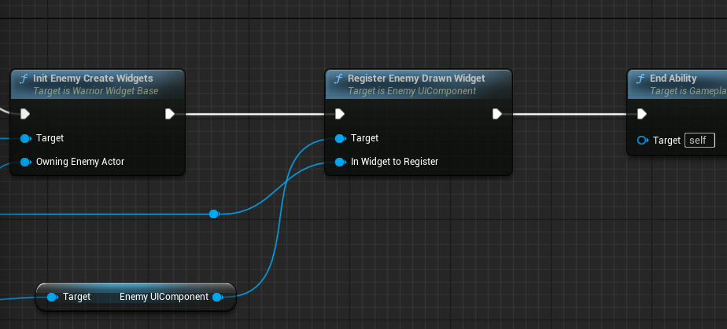
在BP_EnemyCharacter_Base里面添加移除ui的功能
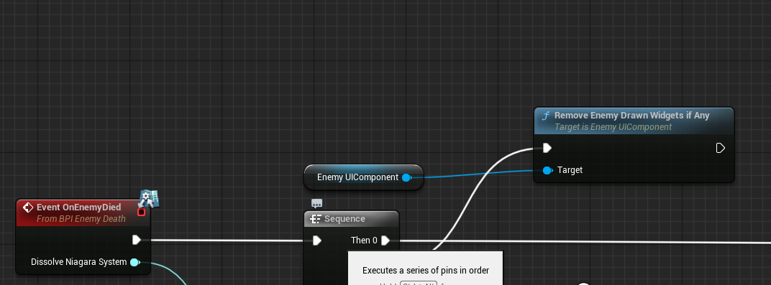
Giant Behavior Tree
首先通过AIC_Enemy_Base派生一个子类，取名AIC_FrostGiant，然后建立一个行为树BT_FrostGiant，在AIC_FrostGiant里面配置好行为树
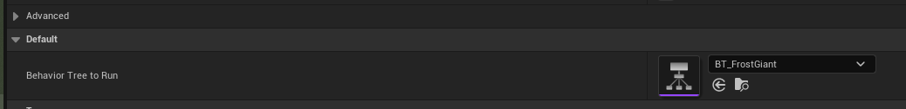
然后打开BP_FrostGiant，配置好AIC
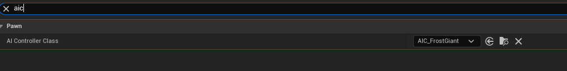
Giant Melee Ability
首先我们通过GA_Enemy_MeleeAttack_Base产生一个子类GA_Giant_MeleeAttack_1和GA_Giant_MeleeAttack_2和GA_Giant_MeleeAttack_3的3个攻击子类，然后我们开始修改
AM_ExoGame_FrostGiant_Attck_Melee_A这个动画，
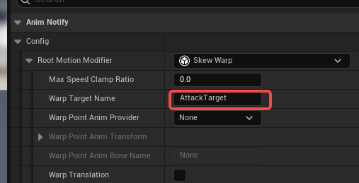
设置GA_Giant_MeleeAttack_1如下图
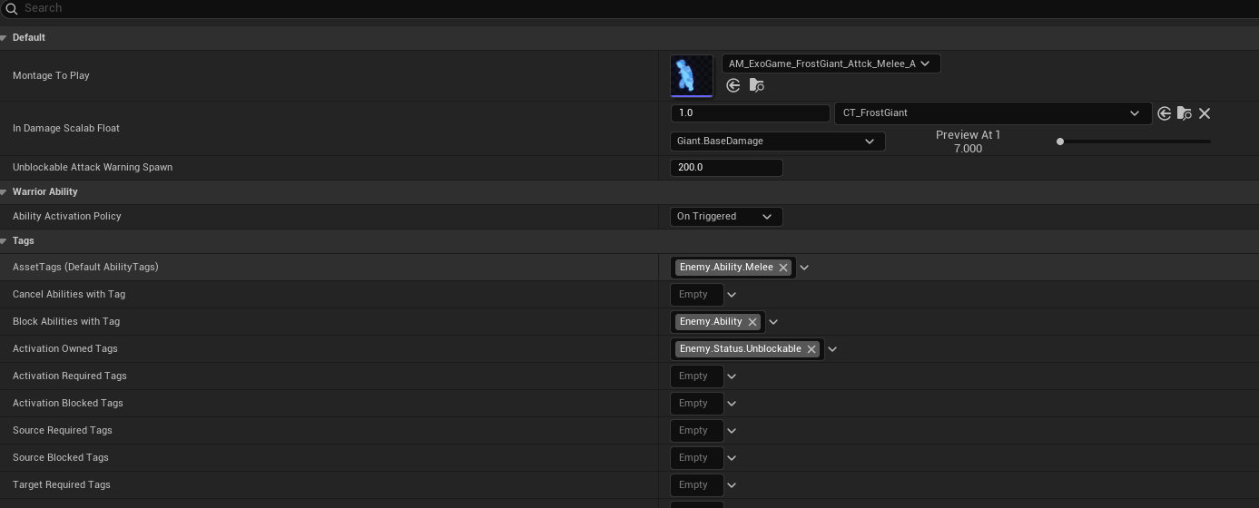
然后打开DA_FrostGiant设置刚才的能力
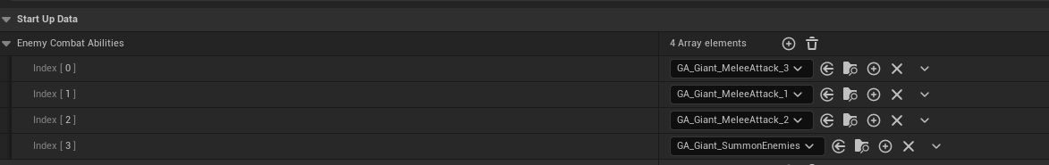
然后我们还需要修改行为树
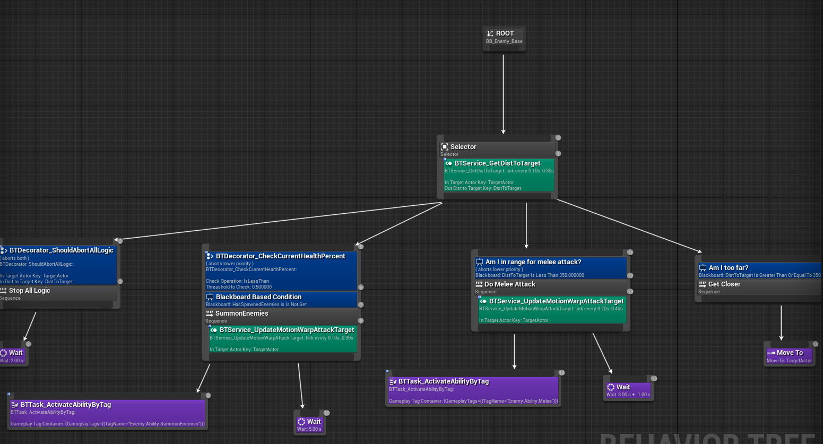
Hand Collision Box
我们首先打开AWarriorEnemyCharacter 添加下面的成员，给Enemy添加左右手的攻击碰撞盒子
UPROPERTY(VisibleAnywhere, BlueprintReadOnly, Category = "Combat")
UBoxComponent* LeftHandCollisionBoxPtr;

UPROPERTY(EditDefaultsOnly, BlueprintReadOnly, Category = "Combat")
FName LeftHandCollisionBoxAttachBoneName;

UPROPERTY(VisibleAnywhere, BlueprintReadOnly, Category = "Combat")
UBoxComponent* RightHandCollisionBoxPtr;

UPROPERTY(EditDefaultsOnly, BlueprintReadOnly, Category = "Combat")
FName RightHandCollisionBoxAttachBoneName;

FORCEINLINE UBoxComponent* GetLeftHandCollisionBox() const
{
return LeftHandCollisionBoxPtr;
}

FORCEINLINE UBoxComponent* GetRightHandCollisionBox() const
{
return RightHandCollisionBoxPtr;
}
在构造函数中来建立这些碰撞盒
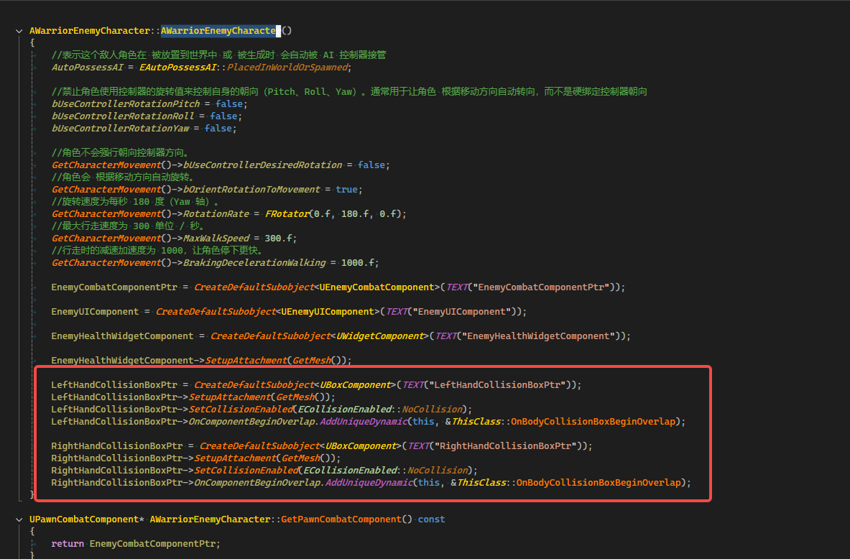
碰撞的回调函数
UFUNCTION()
virtual void OnBodyCollisionBoxBeginOverlap(UPrimitiveComponent* OverlappedComponent, AActor* OtherActor, UPrimitiveComponent* OtherComp, int32 OtherBodyIndex, bool bFromSweep, const FHitResult& SweepResult);

void AWarriorEnemyCharacter::OnBodyCollisionBoxBeginOverlap(UPrimitiveComponent* OverlappedComponent, AActor* OtherActor, UPrimitiveComponent* OtherComp, int32 OtherBodyIndex, bool bFromSweep, const FHitResult& SweepResult)
{
if (APawn* HitPawn = Cast<APawn>(OtherActor))
{
if (UWarriorFunctionLibrary::IsTargetPawnHostile(this, HitPawn))
{
EnemyCombatComponentPtr->OnHitTargetActor(HitPawn);
}
}
}

Post Edit Change Property
首选继续添加接口PostEditChangeChainProperty， 这个函数的作用
#if WITH_EDITOR
virtual void PostEditChangeChainProperty(struct FPropertyChangedChainEvent& PropertyChangedEvent) override;
#endif

#if WITH_EDITOR
void AWarriorEnemyCharacter::PostEditChangeChainProperty(struct FPropertyChangedChainEvent& PropertyChangedEvent)
{
Super::PostEditChangeChainProperty(PropertyChangedEvent);
if (PropertyChangedEvent.GetMemberPropertyName() == GET_MEMBER_NAME_CHECKED(ThisClass, LeftHandCollisionBoxAttachBoneName))
{
LeftHandCollisionBoxPtr->AttachToComponent(GetMesh(), FAttachmentTransformRules::SnapToTargetNotIncludingScale, LeftHandCollisionBoxAttachBoneName);
}
if (PropertyChangedEvent.GetMemberPropertyName() == GET_MEMBER_NAME_CHECKED(ThisClass, RightHandCollisionBoxAttachBoneName))
{
RightHandCollisionBoxPtr->AttachToComponent(GetMesh(), FAttachmentTransformRules::SnapToTargetNotIncludingScale, RightHandCollisionBoxAttachBoneName);
}
}
#endif

Toggle Box Collision
首先完善下列函数
void AWarriorEnemyCharacter::OnBodyCollisionBoxBeginOverlap(UPrimitiveComponent* OverlappedComponent, AActor* OtherActor, UPrimitiveComponent* OtherComp, int32 OtherBodyIndex, bool bFromSweep, const FHitResult& SweepResult)
{
if (APawn* HitPawn = Cast<APawn>(OtherActor))
{
if (UWarriorFunctionLibrary::IsTargetPawnHostile(this, HitPawn))
{
EnemyCombatComponentPtr->OnHitTargetActor(HitPawn);
}
}
}
然后打开UPawnCombatComponent 这个类的接口ToggleWeaponCollision
增加一个枚举，区分武器和左右手
UENUM(BlueprintType)
enum class EToggleWeaponType : uint8
{
CurrentWeapon,
LeftHand,
RightHand,
};

void UPawnCombatComponent::ToggleWeaponCollision(bool bShouldEanble, EToggleWeaponType InToggleWeaponType)
{
if (EToggleWeaponType::CurrentWeapon == InToggleWeaponType)
{
ToggleCurrentEquippedWeaponCollision(bShouldEanble);
}
else
{
ToggleBodyCollisionBoxCollision(bShouldEanble, InToggleWeaponType);
}
}
然后建立2个函数来区分武器和手的碰撞
virtual void ToggleCurrentEquippedWeaponCollision(bool bShouldEanble);
virtual void ToggleBodyCollisionBoxCollision(bool bShouldEanble, EToggleWeaponType InToggleWeaponType);

void UPawnCombatComponent::ToggleCurrentEquippedWeaponCollision(bool bShouldEanble)
{
AWarriorWeaponBase* WeaponToToggle = GetCharacterCurrentEquippedWeapon();
check(WeaponToToggle);
if (bShouldEanble)
{
WeaponToToggle->GetWeaponCollisionBoxPtr()->SetCollisionEnabled(ECollisionEnabled::QueryAndPhysics);
}
else
{
WeaponToToggle->GetWeaponCollisionBoxPtr()->SetCollisionEnabled(ECollisionEnabled::NoCollision);
OverlappedActors.Empty();
}
}
void UPawnCombatComponent::ToggleBodyCollisionBoxCollision(bool bShouldEanble, EToggleWeaponType InToggleWeaponType)
{

}

void UEnemyCombatComponent::ToggleBodyCollisionBoxCollision(bool bShouldEanble, EToggleWeaponType InToggleWeaponType)
{
AWarriorEnemyCharacter* OwningEnemyCharacter = GetOwningPawn<AWarriorEnemyCharacter>();
check(OwningEnemyCharacter);

UBoxComponent* LefitHandCollisionBoxPtr = OwningEnemyCharacter->GetLeftHandCollisionBox();
UBoxComponent* RightHandCollisionBoxPtr = OwningEnemyCharacter->GetRightHandCollisionBox();
check(LefitHandCollisionBoxPtr && RightHandCollisionBoxPtr);

if (EToggleWeaponType::LeftHand == InToggleWeaponType)
{
LefitHandCollisionBoxPtr->SetCollisionEnabled(bShouldEanble ? ECollisionEnabled::QueryOnly : ECollisionEnabled::NoCollision);
}
else if (EToggleWeaponType::RightHand == InToggleWeaponType)
{
RightHandCollisionBoxPtr->SetCollisionEnabled(bShouldEanble ? ECollisionEnabled::QueryOnly : ECollisionEnabled::NoCollision);
}
if (bShouldEanble)
{
OverlappedActors.Reset();
}
}
然后打开AM_ExoGame_FrostGiant_Attck_Melee_A，添加一个NotifyState
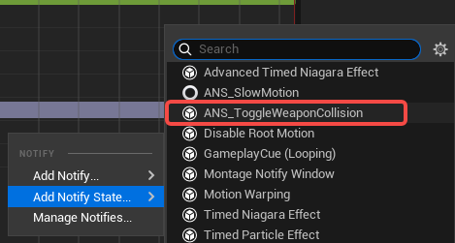
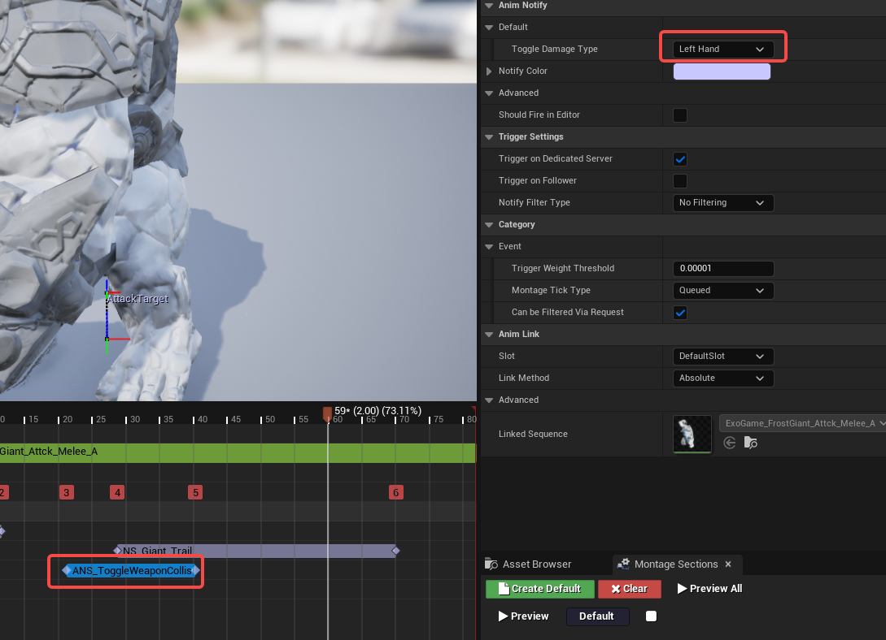
Giant Second Melee Ability
首先打开AM_ExoGame_FrostGiant_Attck_Melee_C这个蓝图，设置如下
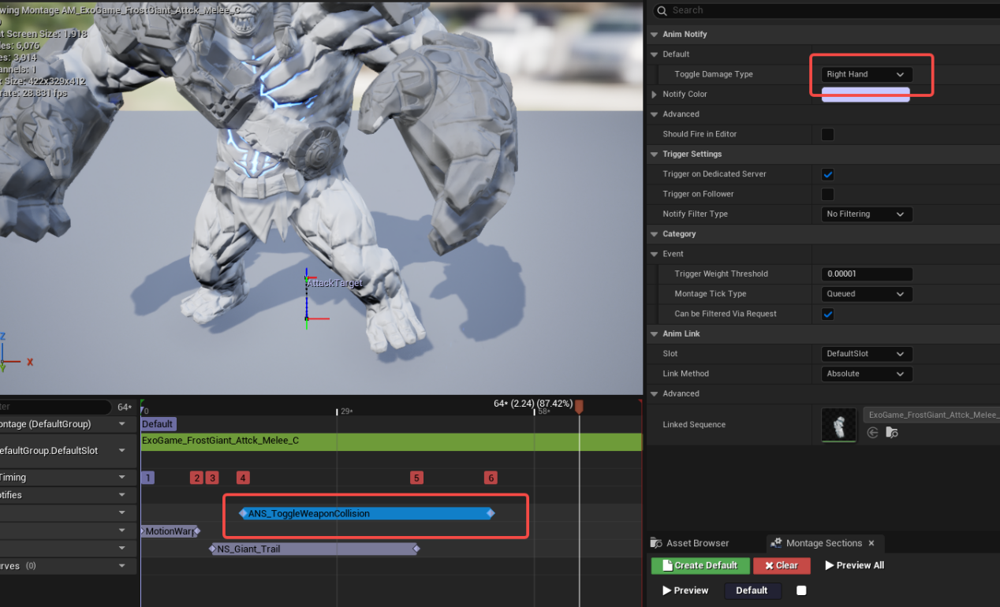
然后打开GA_Giant_MeleeAttack_2
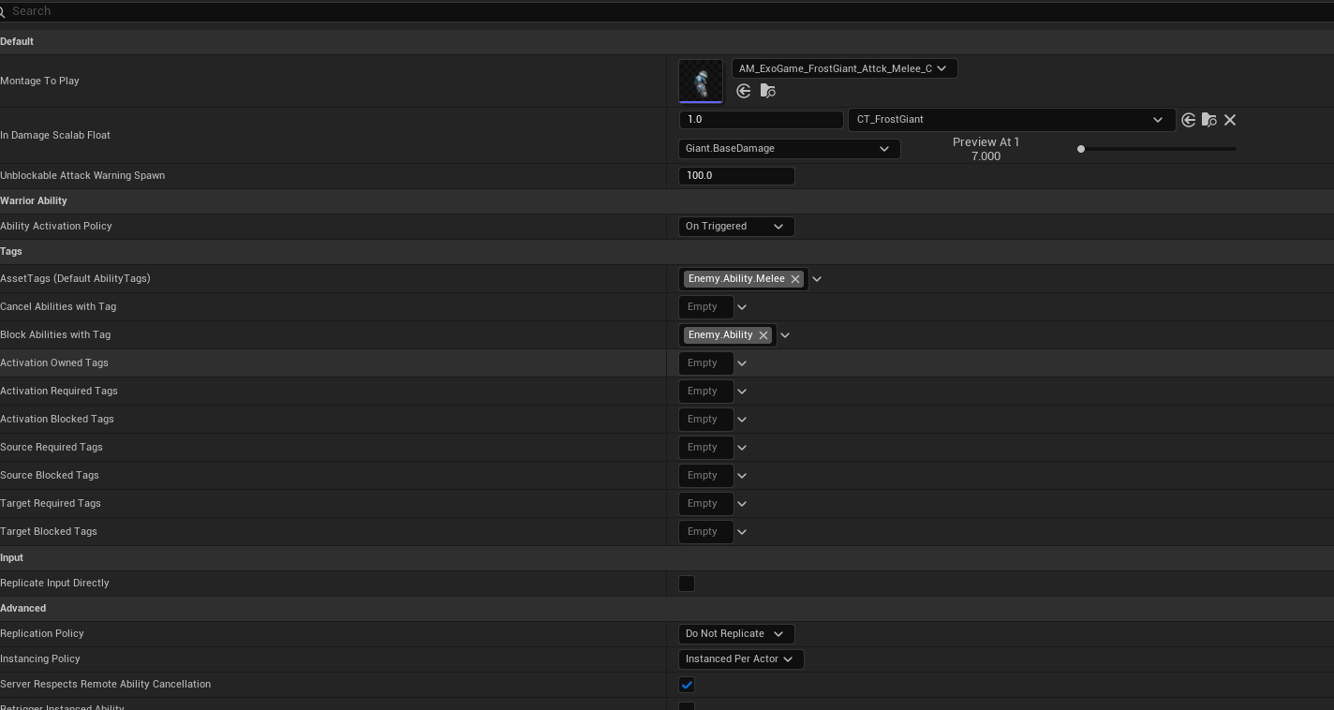
然后把GA_Giant_MeleeaAttack_2授予给boss， 打开DA_FrostGiant
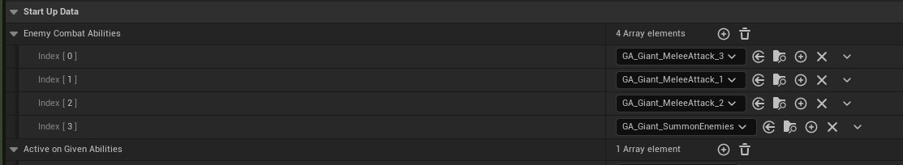

Giant Combo
这个和GA_Giant_MeleeAttack_2一样的配置
WaitSpawnEnemies
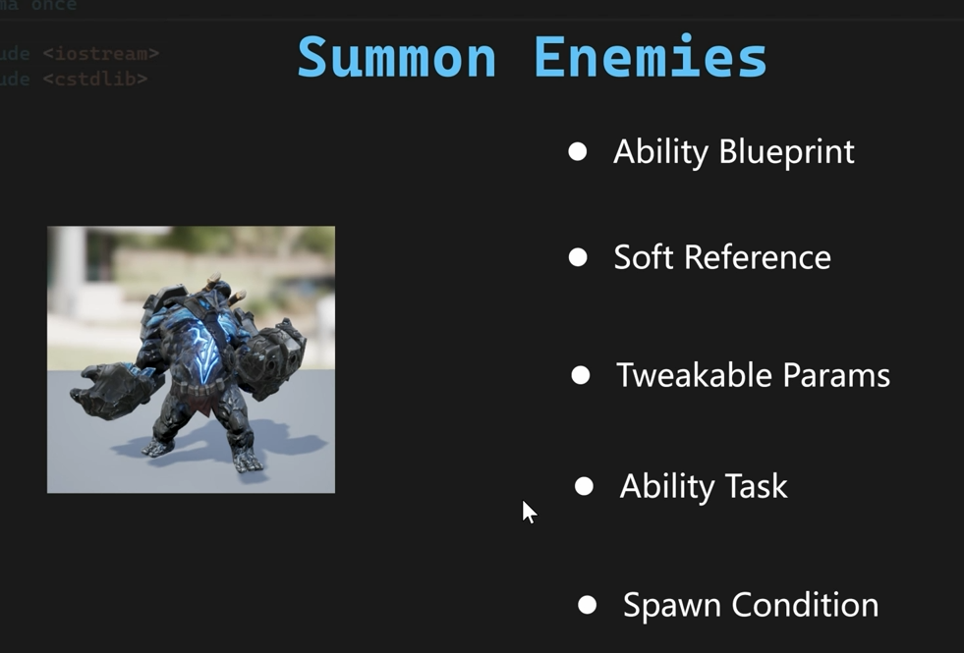
首先我们新建立一个c++的AbiliyTask，取名UAbilityTaskWaitSpawnEnemies，父类选择AbilityTask，在类中添加一个接口
public:
UFUNCTION(BlueprintCallable, Category = "Warrior|AbilityTasks", meta = (DisplayName = "Wait Gameplay Event and Spawn Enemies", HidePin = "OwningAbility", DefaultToSelf = "OwningAbility", BlueprintInternalUseOnly = "true", NumToSpawn = "1", RangdomSpawnRadius = "200"))
static UAbilityTaskWaitSpawnEnemies* WaitSpawnEnemies(
UGameplayAbility* OwningAbility,
FGameplayTag EventTag,
TSoftClassPtr<AWarriorEnemyCharacter> SoftEnemyClassToSpawn,
int NumToSpawn,
const FVector& SpawnOrigin,
float RangdomSpawnRadius);

UAbilityTaskWaitSpawnEnemies* UAbilityTaskWaitSpawnEnemies::WaitSpawnEnemies(UGameplayAbility* OwningAbility, FGameplayTag EventTag, TSoftClassPtr<AWarriorEnemyCharacter> SoftEnemyClassToSpawn, int NumToSpawn, const FVector& SpawnOrigin, float RangdomSpawnRadius)
{
UAbilityTaskWaitSpawnEnemies* NodePtr = NewAbilityTask<UAbilityTaskWaitSpawnEnemies>(OwningAbility);
NodePtr->CachedEventTag = EventTag;
NodePtr->CachedSoftEnemyClassToSpawn = SoftEnemyClassToSpawn;
NodePtr->CachedNumToSpawn = NumToSpawn;
NodePtr->CachedSpawnOrigin = SpawnOrigin;
NodePtr->CachedRangdomSpawnRadius = RangdomSpawnRadius;
return NodePtr;
}

添加成员变量，先定义一个宏
DECLARE_DYNAMIC_MULTICAST_DELEGATE_OneParam(FWaitSapwnEnemiesDelegate, const TArray<AWarriorEnemyCharacter*>&, SpawnedEnemies);

UPROPERTY(BlueprintAssignable)
FWaitSapwnEnemiesDelegate OnSpawnFinished;

UPROPERTY(BlueprintAssignable)
FWaitSapwnEnemiesDelegate DidNotSpawn;

private:
FGameplayTag CachedEventTag;
TSoftClassPtr<AWarriorEnemyCharacter> CachedSoftEnemyClassToSpawn;
int CachedNumToSpawn;
FVector CachedSpawnOrigin;
float CachedRangdomSpawnRadius;
FDelegateHandle DelegateHandle;
然后我们新建一个GameplayAbility，取名GA_Enemy_SummonEnemies_Base，父类选择
UWarriorEnemyGameplayAbility
SummonAbility
我们新建一个GameplayTag
WARRIOR_API UE_DECLARE_GAMEPLAY_TAG_EXTERN(Enemy_Ability_SummonEnemies);
WARRIOR_API UE_DECLARE_GAMEPLAY_TAG_EXTERN(Enemy_Event_SummonEnemies);

UE_DEFINE_GAMEPLAY_TAG(Enemy_Ability_SummonEnemies, "Enemy.Ability.SummonEnemies");
UE_DEFINE_GAMEPLAY_TAG(Enemy_Event_SummonEnemies, "Enemy.Event.SummonEnemies");
打开GA_Enemy_SummonEnemies_Base的设置，添加上GameplayTag
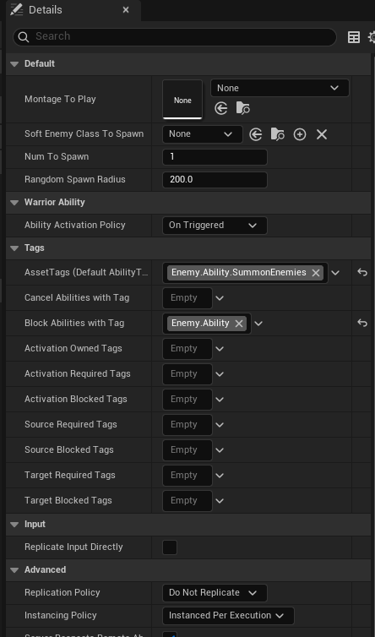
然后播放Montage
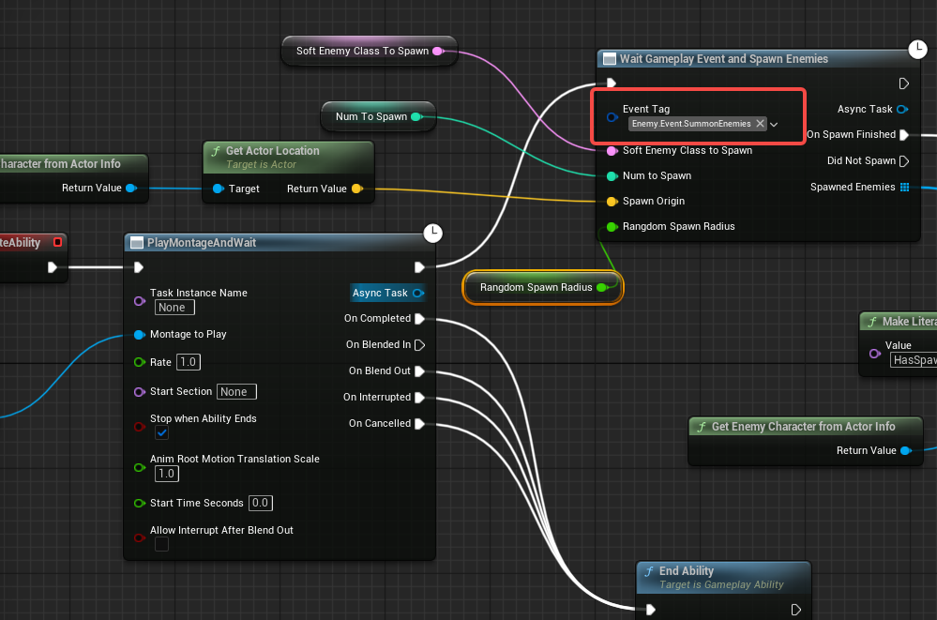
然后通过GA_Enemy_SummonEnemies_Base，建立一个子类GA_Giant_SummonEnemies，然后指定播放的montage和软引用
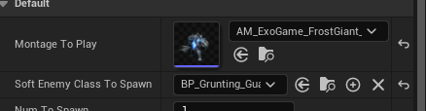
然后把这个能力授予给Boss,打开DA_FrostGiant
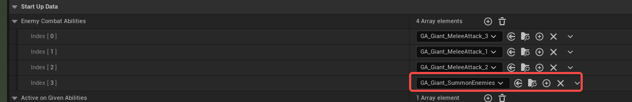
ListenForGameplayEvent
实现的几个步骤
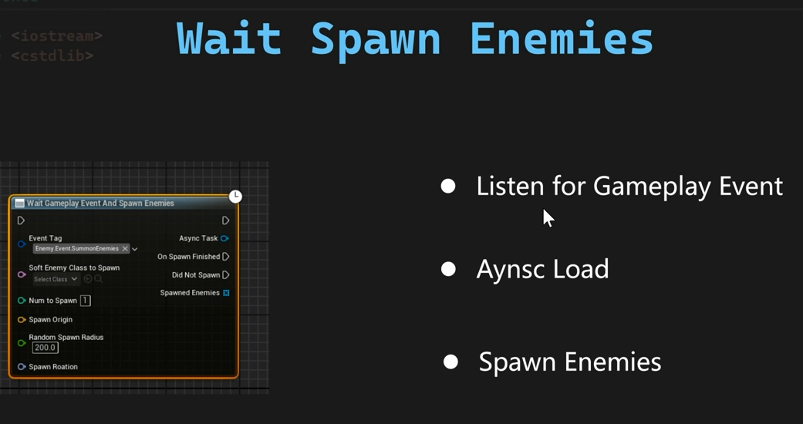

首先增加一个成员变量，用来保存回调的句柄
FDelegateHandle DelegateHandle;

然后给UAbilityTaskWaitSpawnEnemies类添加2个重载的函数

virtual void Activate() override;

virtual void OnDestroy(bool bInOwnerFinished) override;

void UAbilityTaskWaitSpawnEnemies::Activate()
{
FGameplayEventMulticastDelegate& Delegate = AbilitySystemComponent->GenericGameplayEventCallbacks.FindOrAdd(CachedEventTag);
DelegateHandle = Delegate.AddUObject(this, &ThisClass::OnGameplayEventReceived);
}

void UAbilityTaskWaitSpawnEnemies::OnDestroy(bool bInOwnerFinished)
{
FGameplayEventMulticastDelegate& Delegate = AbilitySystemComponent->GenericGameplayEventCallbacks.FindOrAdd(CachedEventTag);
Delegate.Remove(DelegateHandle);
//这个一定要最后调用
Super::OnDestroy(bInOwnerFinished);
}

然后我们添加一个回调函数
void OnGameplayEventReceived(const FGameplayEventData* InPayload);

void UAbilityTaskWaitSpawnEnemies::OnGameplayEventReceived(const FGameplayEventData* InPayload)
{
if (ensure(!CachedSoftEnemyClassToSpawn.IsNull()))
{
UAssetManager::Get().GetStreamableManager().RequestAsyncLoad(
CachedSoftEnemyClassToSpawn.ToSoftObjectPath(),
FStreamableDelegate::CreateUObject(this, &ThisClass::OnEnemyClassLoaded));
}
else
{
if (ShouldBroadcastAbilityTaskDelegates())
{
DidNotSpawn.Broadcast(TArray<AWarriorEnemyCharacter*>());
}
EndTask();
}
}
然后我们可以在Montage添加一个GameplayEvent的通知了，打开AM_ExoGame_FrostGiant_Aggro这个文件。
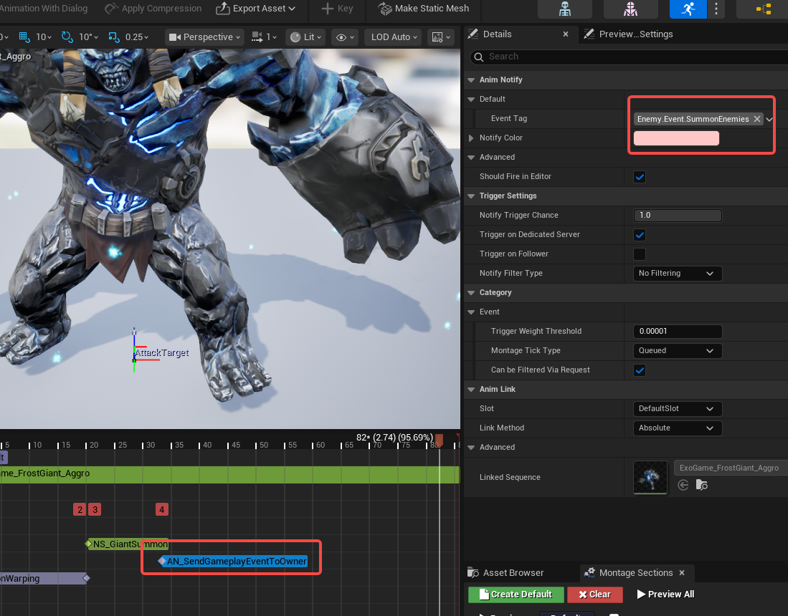

Async Load And Spawn Enemies
实首先我们在下列的函数中来实现Enemy的建立
void UAbilityTaskWaitSpawnEnemies::OnGameplayEventReceived(const FGameplayEventData* InPayload)
{
if (ensure(!CachedSoftEnemyClassToSpawn.IsNull()))
{
UAssetManager::Get().GetStreamableManager().RequestAsyncLoad(
CachedSoftEnemyClassToSpawn.ToSoftObjectPath(),
FStreamableDelegate::CreateUObject(this, &ThisClass::OnEnemyClassLoaded));
}
else
{
if (ShouldBroadcastAbilityTaskDelegates())
{
DidNotSpawn.Broadcast(TArray<AWarriorEnemyCharacter*>());
}
EndTask();
}
}
然后我们还需要配置好红框中的内容，这个是我们建立Enemy需要的函数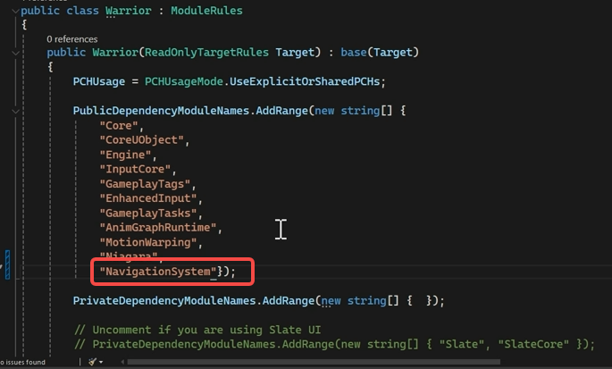
然后产生Enemy的回调函数如下
void UAbilityTaskWaitSpawnEnemies::OnEnemyClassLoaded()
{
UClass* LoadedClass = CachedSoftEnemyClassToSpawn.Get();
UWorld* WorldPtr = GetWorld();
if (!LoadedClass||!WorldPtr)
{
if (ShouldBroadcastAbilityTaskDelegates())
{
DidNotSpawn.Broadcast(TArray<AWarriorEnemyCharacter*>());
}
EndTask();
return;
}

FActorSpawnParameters SpawnParam;
SpawnParam.SpawnCollisionHandlingOverride = ESpawnActorCollisionHandlingMethod::AdjustIfPossibleButAlwaysSpawn;

TArray<AWarriorEnemyCharacter*> SpawnedEnemies;
for (int32 i = 0; i < CachedNumToSpawn; ++i)
{
FVector RandomLocation;
UNavigationSystemV1::K2_GetRandomReachablePointInRadius(
this,
CachedSpawnOrigin,
RandomLocation,
CachedRangdomSpawnRadius);
RandomLocation += FVector(0.f, 0.f, 150.f);
const FRotator SpawnFacingRotation = AbilitySystemComponent->GetAvatarActor()->GetActorForwardVector().ToOrientationRotator();
AWarriorEnemyCharacter* SpawnEnemy = WorldPtr->SpawnActor<AWarriorEnemyCharacter>(LoadedClass, RandomLocation, SpawnFacingRotation, SpawnParam);
if (SpawnEnemy)
{
SpawnedEnemies.Add(SpawnEnemy);
}
}
if (ShouldBroadcastAbilityTaskDelegates())
{
if (!SpawnedEnemies.IsEmpty())
{
OnSpawnFinished.Broadcast(SpawnedEnemies);
}
else
{
DidNotSpawn.Broadcast(TArray<AWarriorEnemyCharacter*>());
}
}
EndTask();
}
修改蓝图，打开GA_Enemy_SummonEnemies_Base蓝图
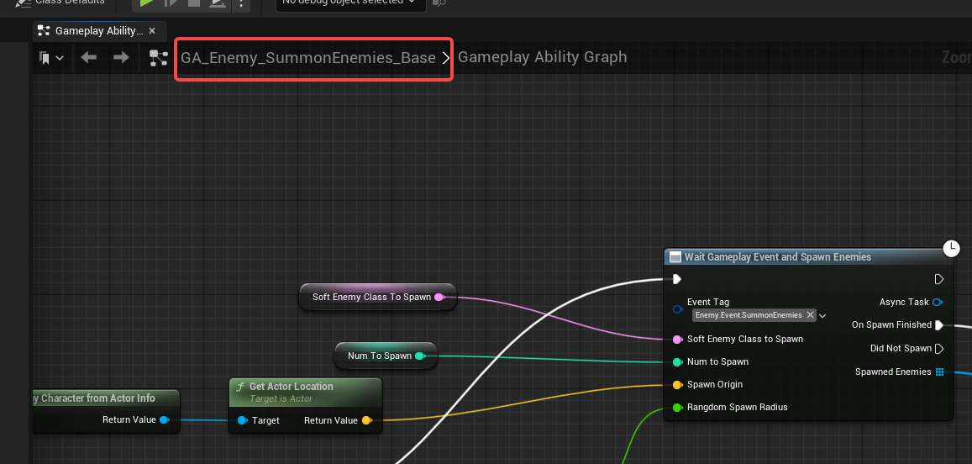
然后在打开GA_Giant_SummonEnemies蓝图，设置SoftEnemyClassToSpawn
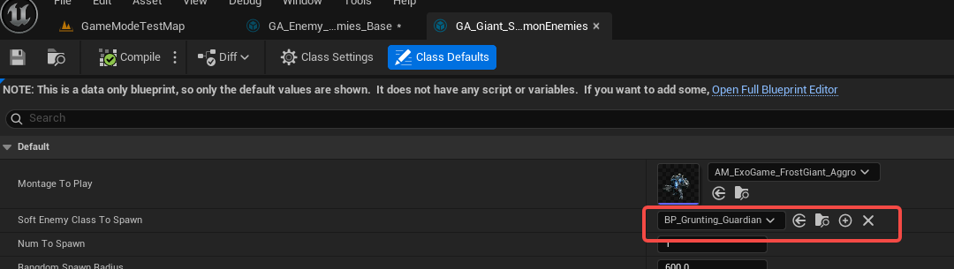

FixFacingRotations
首先我们在下列的蓝图中来实现
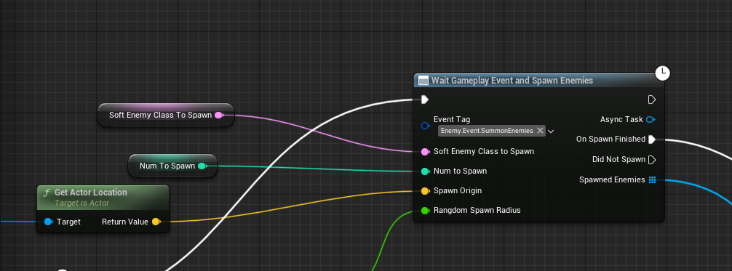
然后打开AM_ExoGame_FrostGiant_Aggro，通过添加一个扭曲组件的方式，首先让boss面向玩家。
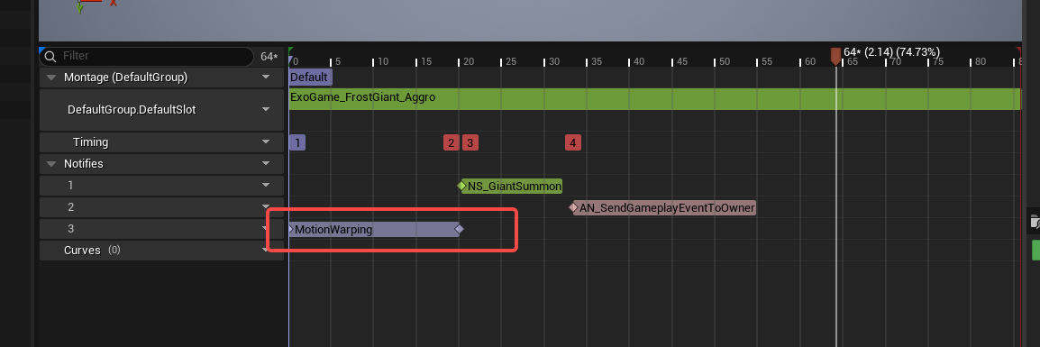
然后修改行为树BT_FrostGiant，添加上一个服务节点，让扭曲组件发生作用
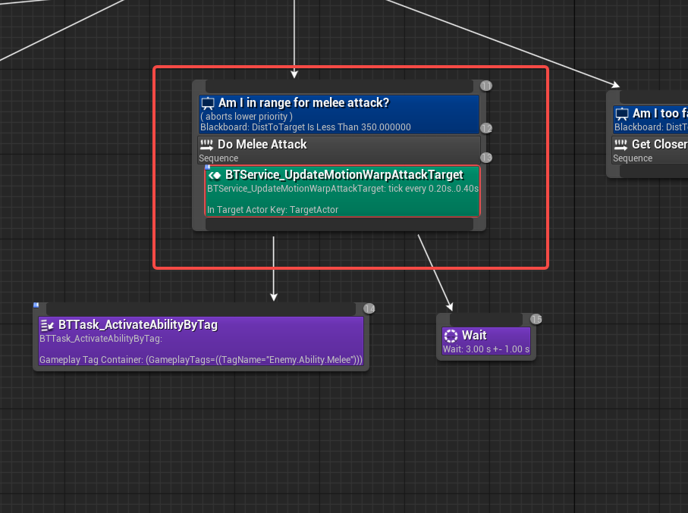

Stop Spawning Enemies
首先我们打开BB_Enemy_Base这个节点，添加一个bool值
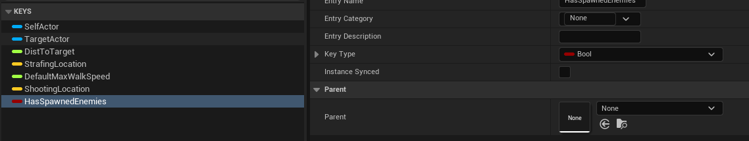
然后我们打开boss的行为树，添加一个新的装饰器
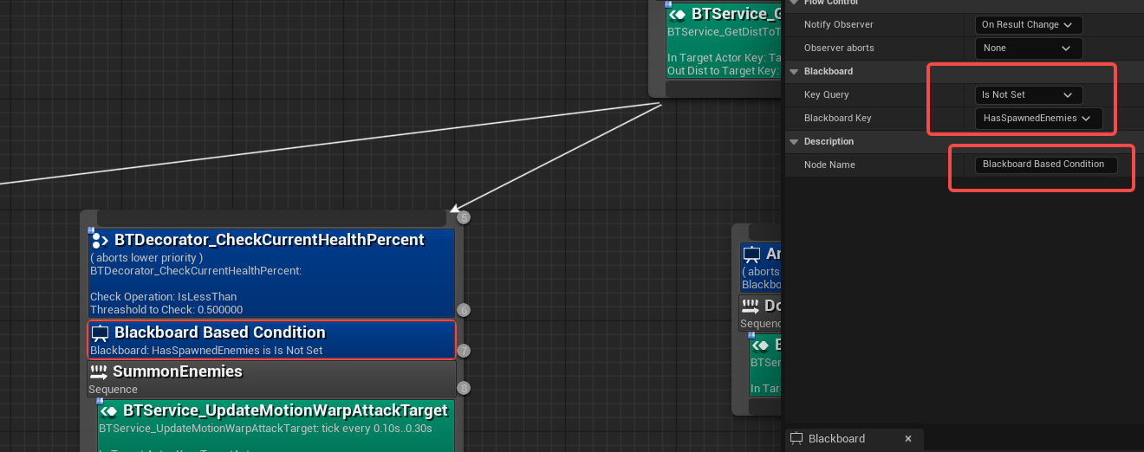
然后我们打开共享的能力文件夹，选择GA_Enemy_SummonEnemies_Base能力，设置黑板值HasSpawnedEnemies 为True
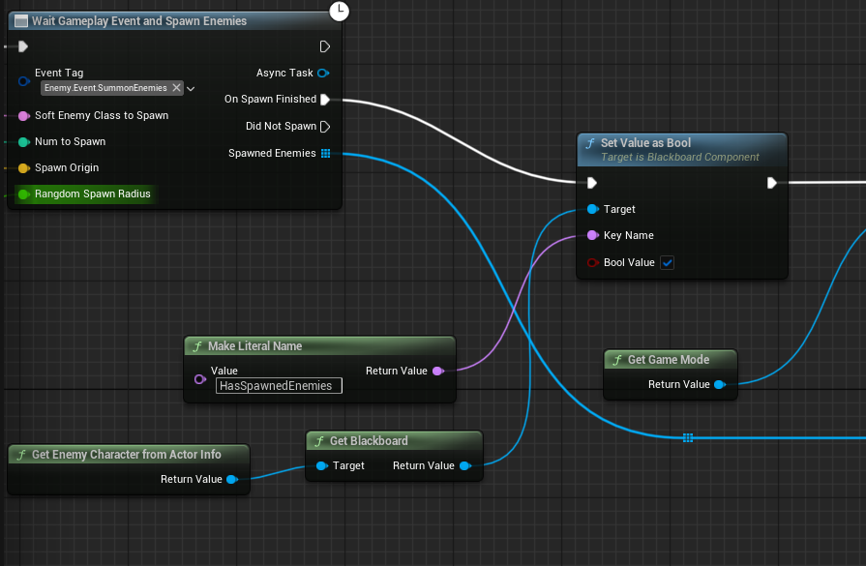
Enemy EntryFx
这里是解决Enemy第一次加载的时候，ui显示不对的bug，Enemy刚出现的时候不应该有血条
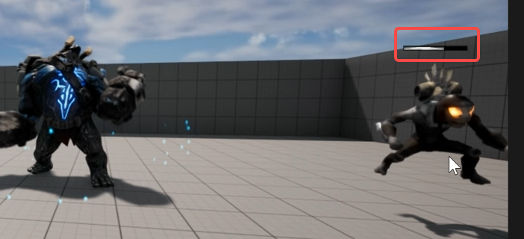
打开WBP_DefaultEnemyHealthBar 这个节点，在构造函数中设置为不显示
