TargetLock实现的组成部分，大部分使用c++来实现
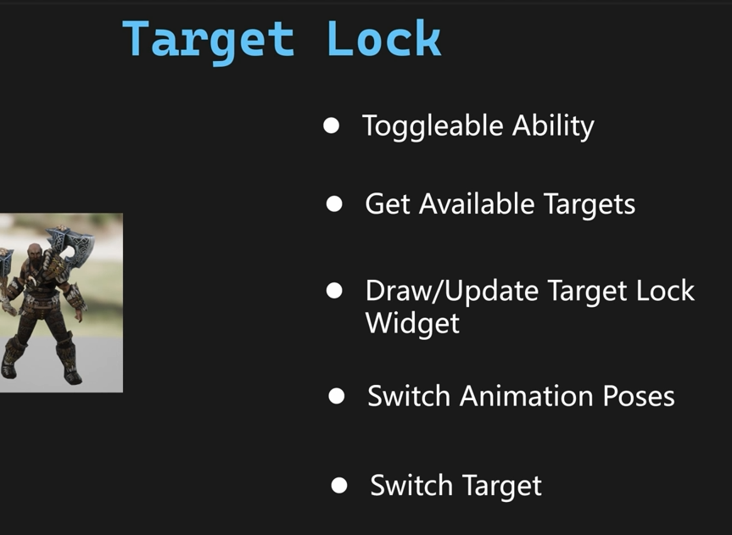
首先我们建立一个c++类，父类UWarriorHeroGameplayAbility ，取名UHeroGameplayAbilityTargetLock 然后我们重载2个函数
virtual void ActivateAbility(const FGameplayAbilitySpecHandle Handle, const FGameplayAbilityActorInfo* ActorInfo, const FGameplayAbilityActivationInfo ActivationInfo, const FGameplayEventData* TriggerEventData) override;

virtual void EndAbility(const FGameplayAbilitySpecHandle Handle, const FGameplayAbilityActorInfo* ActorInfo, const FGameplayAbilityActivationInfo ActivationInfo, bool bReplicateEndAbility, bool bWasCancelled) override;

void UHeroGameplayAbilityTargetLock::ActivateAbility(const FGameplayAbilitySpecHandle Handle, const FGameplayAbilityActorInfo* ActorInfo, const FGameplayAbilityActivationInfo ActivationInfo, const FGameplayEventData* TriggerEventData)
{

Super::ActivateAbility(Handle, ActorInfo, ActivationInfo, TriggerEventData);
}

void UHeroGameplayAbilityTargetLock::EndAbility(const FGameplayAbilitySpecHandle Handle, const FGameplayAbilityActorInfo* ActorInfo, const FGameplayAbilityActivationInfo ActivationInfo, bool bReplicateEndAbility, bool bWasCancelled)
{
Super::EndAbility(Handle, ActorInfo, ActivationInfo, bReplicateEndAbility, bWasCancelled);
}
然后我们添加一下GameplayTag
WARRIOR_API UE_DECLARE_GAMEPLAY_TAG_EXTERN(InputTag_Toggleable);
WARRIOR_API UE_DECLARE_GAMEPLAY_TAG_EXTERN(InputTag_Toggleable_TargetLock);
WARRIOR_API UE_DECLARE_GAMEPLAY_TAG_EXTERN(Player_Ability_TargetLock);
WARRIOR_API UE_DECLARE_GAMEPLAY_TAG_EXTERN(Player_Status_TargetLock);

UE_DEFINE_GAMEPLAY_TAG(InputTag_Toggleable, "InputTag.Toggleable");
UE_DEFINE_GAMEPLAY_TAG(InputTag_Toggleable_TargetLock, "InputTag.Toggleable.TargetLock");
UE_DEFINE_GAMEPLAY_TAG(Player_Ability_TargetLock, "Player.Ability.TargetLock");
UE_DEFINE_GAMEPLAY_TAG(Player_Status_TargetLock, "Player.Status.TargetLock");
然后启动编辑器，建立一个GameplayAbility，父类选择UHeroGameplayAbilityTargetLock，取名GA_Hero_TargetLock，下面是设置
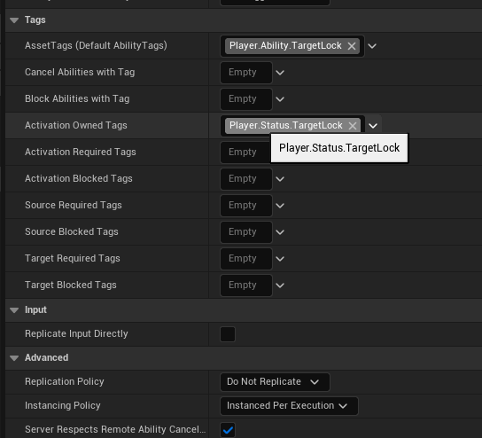
ToggleTargetLock
首先我们修改一下这个函数,在按下的时候判断一下是否切换的标记
void UWarriorAbilitySystemComponent::OnAbilityInputPressed(const FGameplayTag& InInputTag)

void UWarriorAbilitySystemComponent::OnAbilityInputPressed(const FGameplayTag& InInputTag)
{
if (InInputTag.IsValid())
{
for (const FGameplayAbilitySpec& AbilitySpec : GetActivatableAbilities())
{
if (AbilitySpec.DynamicAbilityTags.HasTagExact(InInputTag))
{
if (InInputTag.MatchesTag(WarriorGameplayTags::InputTag_Toggleable) && AbilitySpec.IsActive())
{
CancelAbilityHandle(AbilitySpec.Handle);
}
else
{
TryActivateAbility(AbilitySpec.Handle);
}
}
}
}
}
然后我们打开DA_InputConfig，配置一下输入
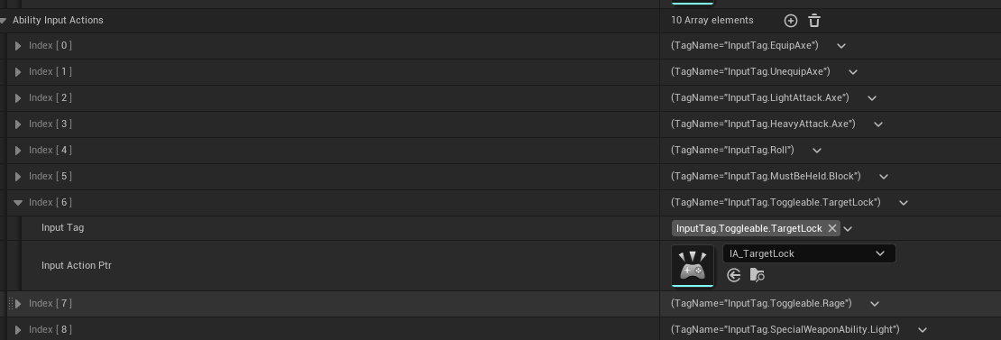
建立一下IA_TargetLock，然后我们打开IMC_Axe这个。因为锁定是装备了武器才有的能力。
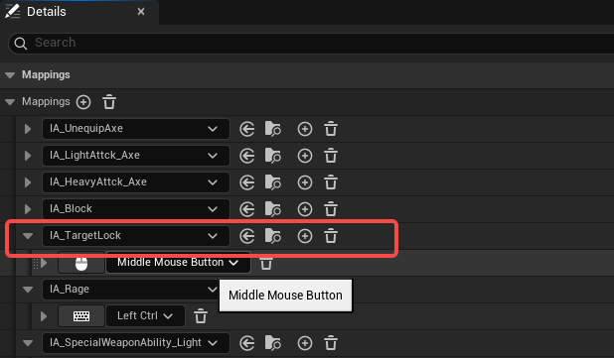
然后我们打开BP_HeroAxe蓝图，在装备上武器的时候给予能力。
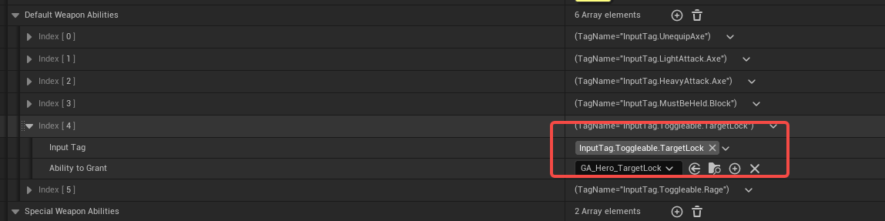
GetAvailableTargets
首先我们打开UHeroGameplayAbilityTargetLock 这个类，添加一个接口
void TryLockOnTarget()，然后在激活能力的时候就调用这个接口，
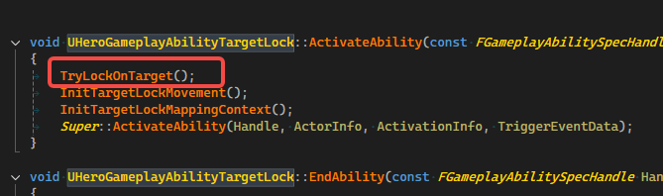
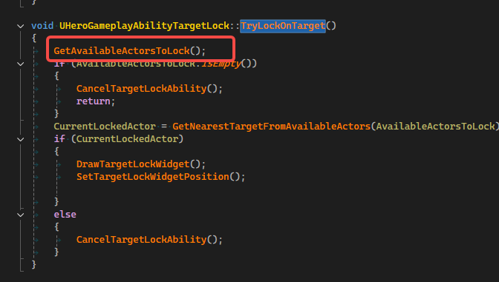
然后添加第二个接口
void GetAvailableActorsToLock();这个接口调用的BoxTraceMuliForObjects这个接口需要的参数，我们都放到头文件，并且让编辑器可以编辑
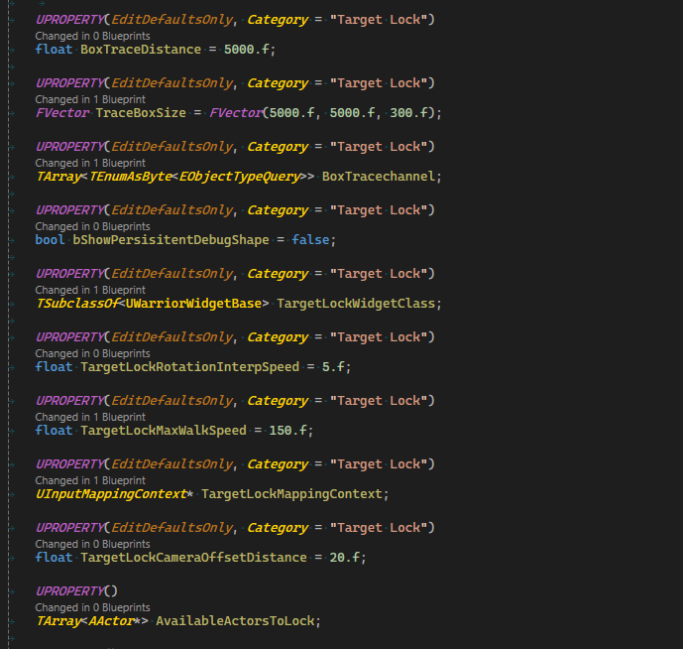
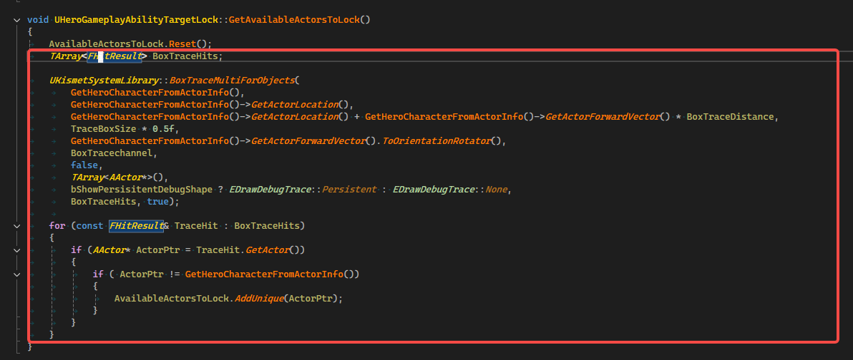
然后启动编辑器，打开GA_Hero_TargetLock，设置好追踪的对象
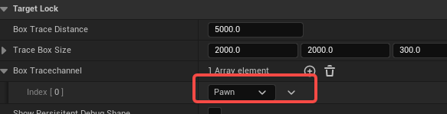
GetNearestTarget
我们继续添加一个函数
void CancelTargetLockAbility();
void UHeroGameplayAbilityTargetLock::CancelTargetLockAbility()
{
CancelAbility(GetCurrentAbilitySpecHandle(),
GetCurrentActorInfo(),
GetCurrentActivationInfo(),
true);
}
然后我们在TryLockOnTarget函数里面增加一点代码，如果没有任何锁定的对象，取消这个能力。
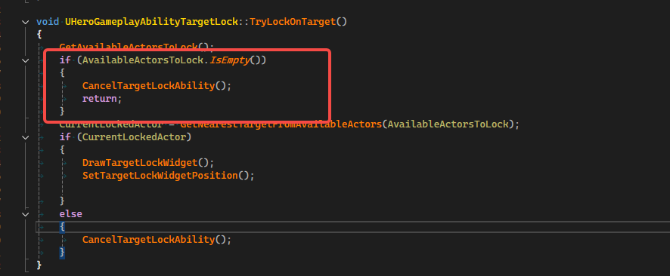
然后添加一个函数
void CleanUp();
void UHeroGameplayAbilityTargetLock::CleanUp()
{
AvailableActorsToLock.Reset();
CurrentLockedActor = nullptr;
if (DrawnTargetLockWidget)
{
DrawnTargetLockWidget->RemoveFromParent();
}
DrawnTargetLockWidget = nullptr;
TargetLockWidgetSize = FVector2D::ZeroVector;
CachedDefaultMaxWalkSpeed = 0.f;
}
在void UHeroGameplayAbilityTargetLock::EndAbility()这个接口调用Cleanup这个接口清理
void UHeroGameplayAbilityTargetLock::EndAbility(const FGameplayAbilitySpecHandle Handle, const FGameplayAbilityActorInfo* ActorInfo, const FGameplayAbilityActivationInfo ActivationInfo, bool bReplicateEndAbility, bool bWasCancelled)
{
CleanUp();
Super::EndAbility(Handle, ActorInfo, ActivationInfo, bReplicateEndAbility, bWasCancelled);
}
然后在添加一个函数，获取最近的 Enemy
AActor* GetNearestTargetFromAvailableActors(const TArray<AActor*>& InAvailableActors);
AActor* UHeroGameplayAbilityTargetLock::GetNearestTargetFromAvailableActors(const TArray<AActor*>& InAvailableActors)
{
float ClosestDistance = 0.f;
return UGameplayStatics::FindNearestActor(GetHeroCharacterFromActorInfo()->GetActorLocation(), InAvailableActors, ClosestDistance);
}
然后在TryLockOnTarget函数里面使用。
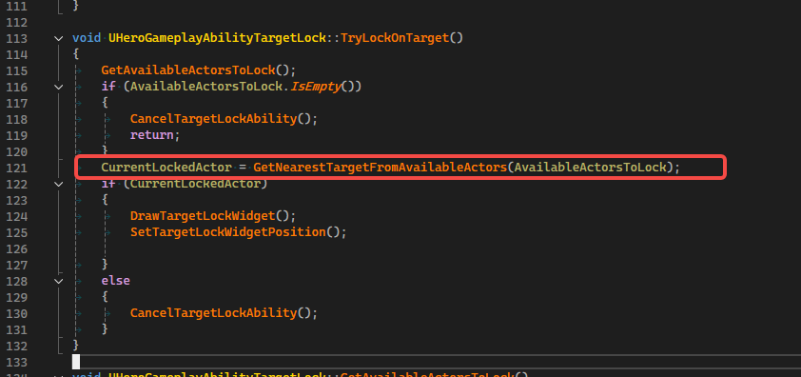
DrawTargetLock Widget
首先我们需要建立一个Widget，取名叫WBP_TargetLockIndicator，父类选择UWarriorWidgetBase
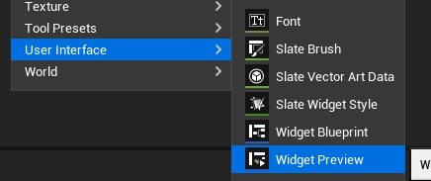
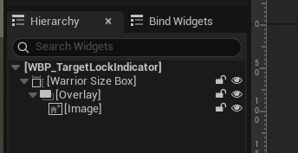
然后在UHeroGameplayAbilityTargetLock类添加一个Widget的成员变量
UPROPERTY(EditDefaultsOnly, Category = "Target Lock")
TSubclassOf<UWarriorWidgetBase> TargetLockWidgetClass;

UPROPERTY()
UWarriorWidgetBase* DrawnTargetLockWidget;

添加一个绘制这个Widget的接口
void DrawTargetLockWidget();
void UHeroGameplayAbilityTargetLock::DrawTargetLockWidget()
{
if (nullptr == DrawnTargetLockWidget)
{
checkf(TargetLockWidgetClass, TEXT("Forgot to assign a valid widget class in blueprint"));
DrawnTargetLockWidget = CreateWidget<UWarriorWidgetBase>(GetHeroControllerFromActorInfo(), TargetLockWidgetClass);
check(DrawnTargetLockWidget);
DrawnTargetLockWidget->AddToViewport();
}
}
然后在TryLockOnTarget这个接口里调用
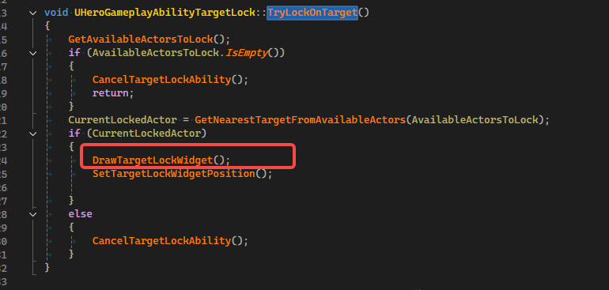
并且我们需要在Cleanup这个函数里面清理这个Widget
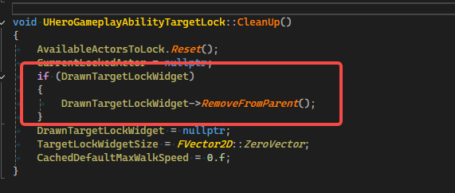
然后我们打开GA_Hero_TargetLock这个蓝图，设置好Widget的类

SetTargetLockWidgetPosition
添加一个新的接口
void SetTargetLockWidgetPosition();
void UHeroGameplayAbilityTargetLock::SetTargetLockWidgetPosition()
{
if (!CurrentLockedActor || !DrawnTargetLockWidget)
{
CancelTargetLockAbility();
return;
}
FVector2D ScreenPosition;
UWidgetLayoutLibrary::ProjectWorldLocationToWidgetPosition(
GetHeroControllerFromActorInfo(),
CurrentLockedActor->GetActorLocation(),
ScreenPosition,
true);
if (TargetLockWidgetSize == FVector2D::ZeroVector)
{
DrawnTargetLockWidget->WidgetTree->ForEachWidget(
[this](UWidget* FoundWidget)
{
if (USizeBox* FoundSizeBox = Cast<USizeBox>(FoundWidget))
{
TargetLockWidgetSize.X = FoundSizeBox->GetWidthOverride();
TargetLockWidgetSize.Y = FoundSizeBox->GetHeightOverride();
}
}
);
}
ScreenPosition -= TargetLockWidgetSize * 0.5f;
DrawnTargetLockWidget->SetPositionInViewport(ScreenPosition, false);
}
使用一个成员变量来存储这个Widget的大小
UPROPERTY()
FVector2D TargetLockWidgetSize = FVector2D::ZeroVector;

ExecuteTaskOnTick
首先我们需要通过c++建立一个abilityTask类，父类选择AbilityTask，取名叫UAbilityTaskExecuteTaskOnTick
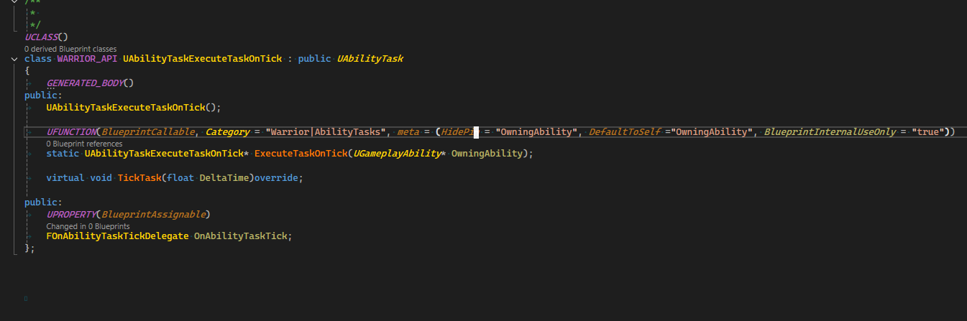
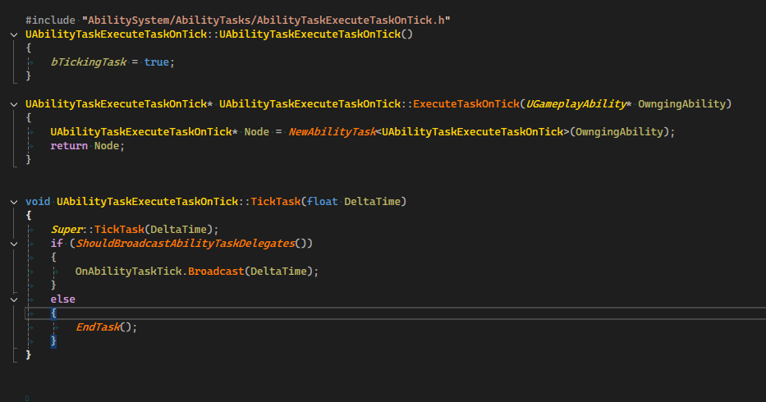
然后我们打开GA_Hero_TargetLock 这个蓝图能力节点
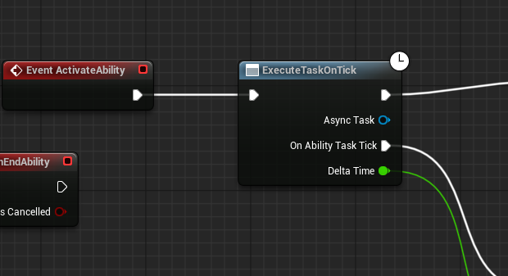

OnTargetLockTick
我们打开UHeroGameplayAbilityTargetLock添加接口
UFUNCTION(BlueprintCallable)
void OnTargetLockTick(float DeltaTime);
void UHeroGameplayAbilityTargetLock::OnTargetLockTick(float DeltaTime)
{
if (!CurrentLockedActor ||
UWarriorFunctionLibrary::NativeDoesActorHaveTag(CurrentLockedActor, WarriorGameplayTags::Shared_Status_Dead) ||
UWarriorFunctionLibrary::NativeDoesActorHaveTag(GetHeroCharacterFromActorInfo(), WarriorGameplayTags::Shared_Status_Dead))
{
CancelTargetLockAbility();
return;
}
SetTargetLockWidgetPosition();
const bool bShouldOverrideRotation = !UWarriorFunctionLibrary::NativeDoesActorHaveTag(GetHeroCharacterFromActorInfo(), WarriorGameplayTags::Player_Status_Rolling)
&& !UWarriorFunctionLibrary::NativeDoesActorHaveTag(GetHeroCharacterFromActorInfo(), WarriorGameplayTags::Player_Status_Blocking);
if (bShouldOverrideRotation)
{
FRotator LookAtRot = UKismetMathLibrary::FindLookAtRotation(GetHeroCharacterFromActorInfo()->GetActorLocation(), CurrentLockedActor->GetActorLocation());
const FRotator CurrentControlRot = GetHeroControllerFromActorInfo()->GetControlRotation();
LookAtRot -= FRotator(TargetLockCameraOffsetDistance, 0.f, 0.f);

const FRotator TargetRot = FMath::RInterpTo(CurrentControlRot, LookAtRot, DeltaTime, TargetLockRotationInterpSpeed);
GetHeroControllerFromActorInfo()->SetControlRotation(FRotator(TargetRot.Pitch, TargetRot.Yaw, 0.f));
GetHeroCharacterFromActorInfo()->SetActorRotation(FRotator(0.f, TargetRot.Yaw, 0.f));
}
}
Cleanup的接口，也需要让绘制的Widget和WidgetSize都清空一下
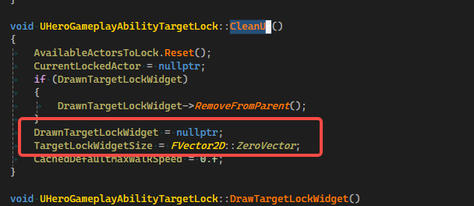

Orient To TargetWhileTargetLock
在OnTargetLockTick的接口里面，如果Hero滚动或者防御，那么就不要让Hero朝向被Lock的enemy了。
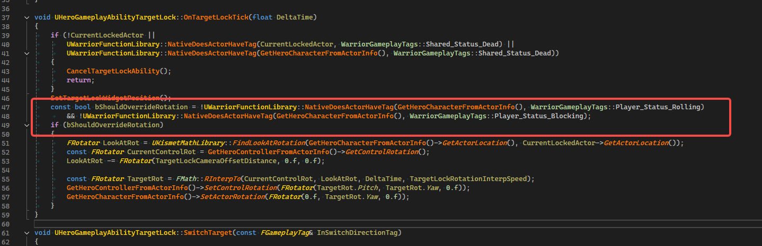
添加一个成员函数，这个是用来控制旋转的速度的
UPROPERTY(EditDefaultsOnly, Category = "Target Lock")
float TargetLockRotationInterpSpeed = 5.f;

Switch To Target Lock Poses
首先建立一个BlendSpace,取名BS_DirectionalLocomotion_Axe
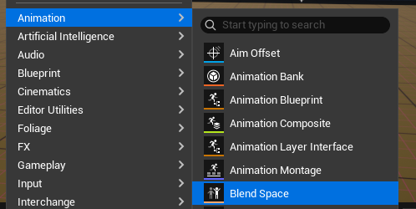
然后我们打开MasterAnimLayer_Hero，配置好如下
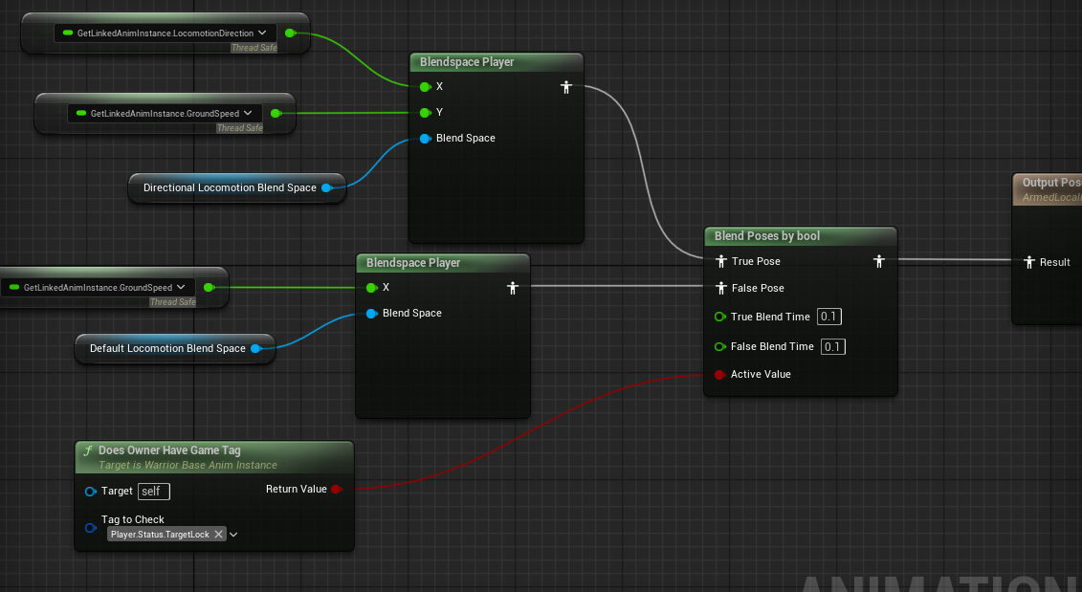
然后我们打开AnimLayer_HeroAxe，设置好混合空间
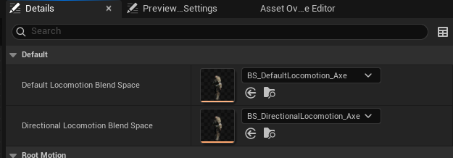
TargetLockWalkSpeed
继续打开UHeroGameplayAbilityTargetLock 这个类，添加接口

void InitTargetLockMappingContext();
void UHeroGameplayAbilityTargetLock::InitTargetLockMappingContext()
{
const ULocalPlayer* LocalPlayerPtr = GetHeroControllerFromActorInfo()->GetLocalPlayer();
UEnhancedInputLocalPlayerSubsystem* SubSystem = ULocalPlayer::GetSubsystem<UEnhancedInputLocalPlayerSubsystem>(LocalPlayerPtr);
check(SubSystem);
SubSystem->AddMappingContext(TargetLockMappingContext, 3);
}

void ResetTargetLockMovement();
void UHeroGameplayAbilityTargetLock::ResetTargetLockMovement()
{
if (CachedDefaultMaxWalkSpeed > 0.f)
{
GetHeroCharacterFromActorInfo()->GetCharacterMovement()->MaxWalkSpeed = CachedDefaultMaxWalkSpeed;
}
}
然后我们添加一个成员变量，用来保存原始的最大速度
UPROPERTY()
float CachedDefaultMaxWalkSpeed = 0.f;

然后在添加一个成员变量，这个变量用来设置LockTarget之后的最大速度。
UPROPERTY(EditDefaultsOnly, Category = "Target Lock")
float TargetLockMaxWalkSpeed = 150.f;
然后我们在ActivateAbility这个接口里面调用InitTargetLockMovement这个接口。
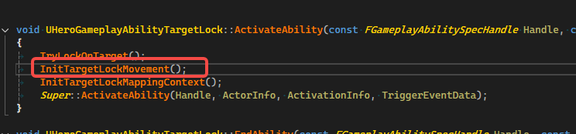
然后我们选在EndAbility这个接口里面恢复原始的最大速度。
