CombatInterface的实例图，功能块如下
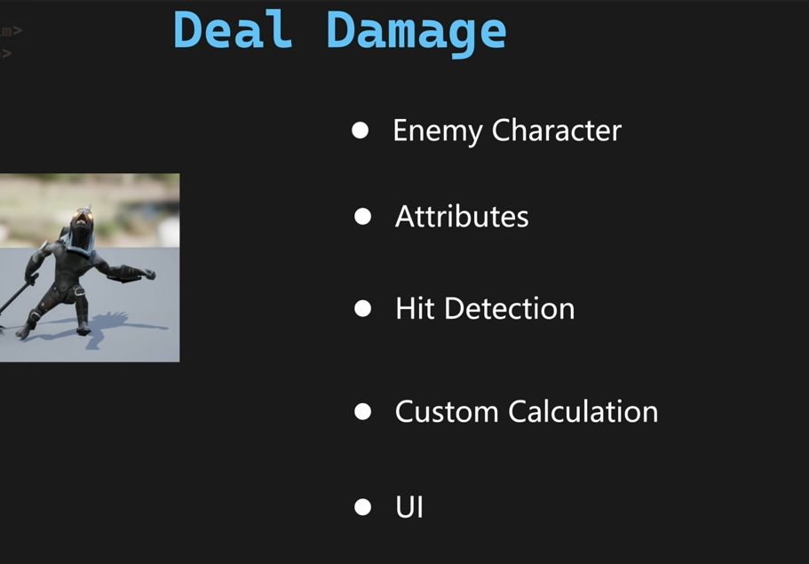
然后PawnCombat Interface的功能设计
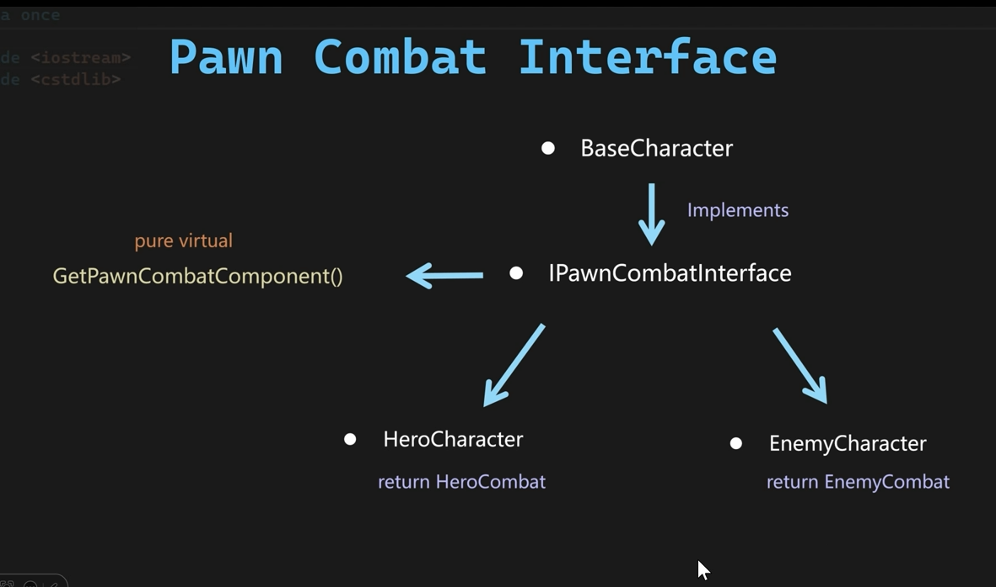
首先我们先建立一个新的接口类，代码如下：
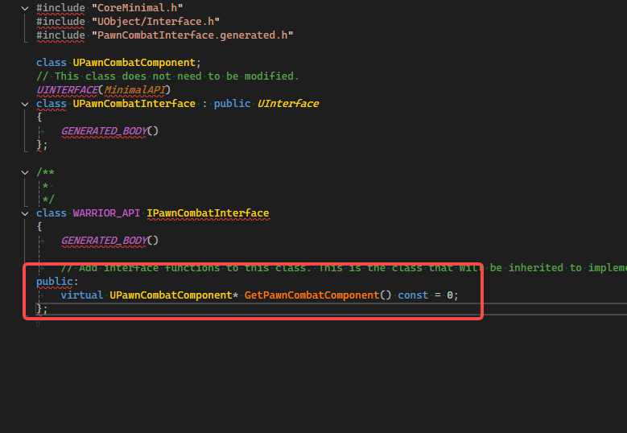
然后AWarriorBaseCharacter 这个类继承一下IPawnCombatInterface
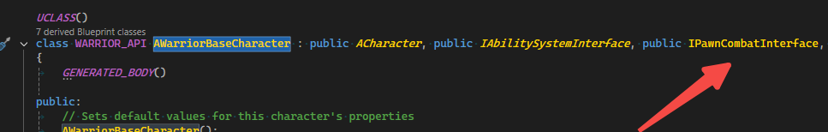
然后要实现IPawnCombatInterface的虚函数接口
virtual UPawnCombatComponent* GetPawnCombatComponent() const override;

UPawnCombatComponent* AWarriorBaseCharacter::GetPawnCombatComponent() const
{
return nullptr;
}
在AWarriorBaseCharacter 的子类中去实现具体的GetPawnCombatComponent内容
//AWarriorHeroCharacter类实现的接口内容
UPawnCombatComponent* AWarriorHeroCharacter::GetPawnCombatComponent() const
{
return HeroCombatComponentPtr;
}
//AWarriorEnemyCharacter类实现的接口内容
UPawnCombatComponent* AWarriorEnemyCharacter::GetPawnCombatComponent() const
{
return EnemyCombatComponentPtr;
}
然后我们在UWarriorFunctionLibrary 这个类中建立一个获取PawnCombatComponet的接口，代码如下：
static UPawnCombatComponent* NativeGetPawnCombatComponent(AActor* InActor);

UPawnCombatComponent* UWarriorFunctionLibrary::NativeGetPawnCombatComponent(AActor* InActor)
{
checkCode(InActor);
if (IPawnCombatInterface* PawnCombatInterface = Cast<IPawnCombatInterface>(InActor))
{
return PawnCombatInterface->GetPawnCombatComponent();
}
return nullptr;
}
然后先建立一个枚举，是否有效的枚举值
UENUM()
enum class EWarriorValidType : uint8
{
Valid,
Invalid,
};
然后我们建立一个蓝图函数来获取PawnCombatComponent组件，代码如下
//头文件
UFUNCTION(BlueprintCallable, Category = "Warrior|FunctionLibrary", meta = (DisplayName = "GetPawnCombatComponent", ExpandEnumAsExecs = "OutValidType"))
static UPawnCombatComponent* BP_GetPawnCombatComponent(AActor* InActor, EWarriorValidType& OutValidType);
//cpp的实现
UPawnCombatComponent* UWarriorFunctionLibrary::BP_GetPawnCombatComponent(AActor* InActor, EWarriorValidType& OutValidType)
{
UPawnCombatComponent* PawnCombatComponet = NativeGetPawnCombatComponent(InActor);
OutValidType = PawnCombatComponet ? EWarriorValidType::Valid : EWarriorValidType::Invalid;
return PawnCombatComponet;
}
完成上述代码的添加后，打开编辑器，然后建立一个通知的蓝图，取名叫ANS_ToggleWeaponCollision,继承AnimNotifyState,打开这个蓝图
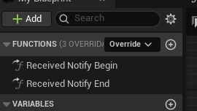需要实现Received Notify Begin 和 Received Notify End 这2个接口，蓝图如下
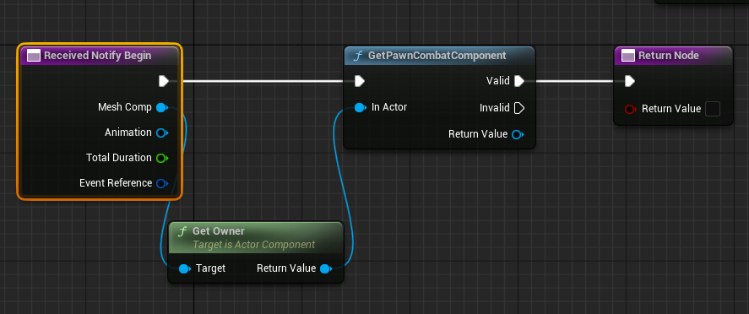
然后我们的打开montages，AM_Hero_Axe_LightAttack_1这个蓝图打开，添加上AnimNotifyState，如下图
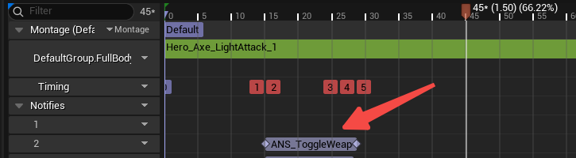
然后我们建立一个枚举
UENUM(BlueprintType)
enum class EToggleWeaponType : uint8
{
CurrentWeapon,
LeftHand,
RightHand,
};
然后我们在UPawnCombatComponent 这个类添加ToggleWeaponCollision接口如下代码
UFUNCTION(BlueprintCallable, Category = "Warrior|Combat")
void ToggleWeaponCollision(bool bShouldEanble, EToggleWeaponType InToggleWeaponType = EToggleWeaponType::CurrentWeapon);
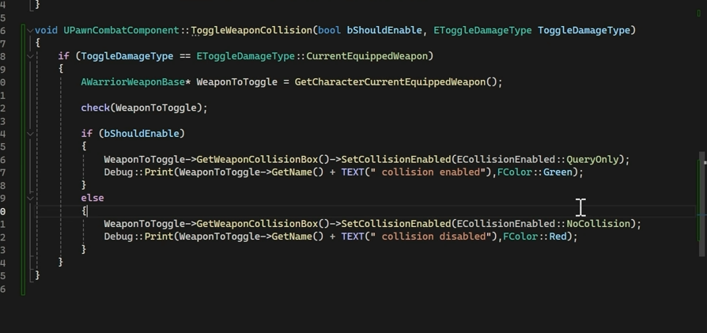
然后打开一下AM_Hero_Axe_LightAttack_1，修改一下ReceivedBegin
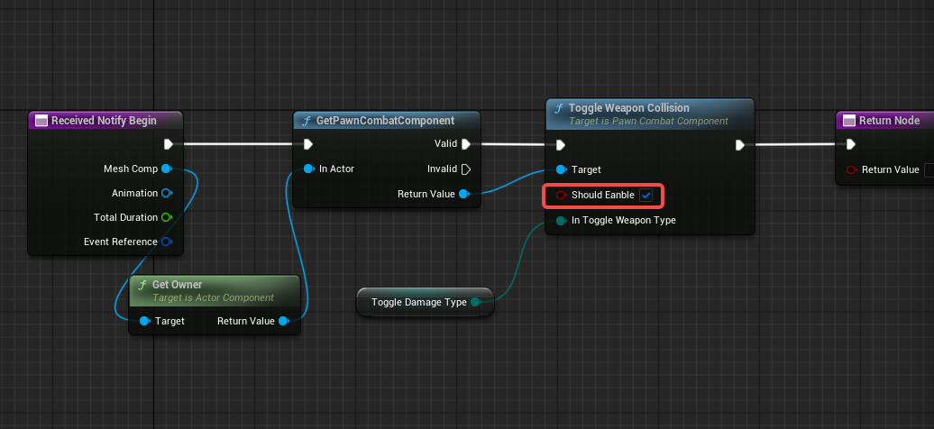
Received End接口
