StartUpDataStruct的实例图
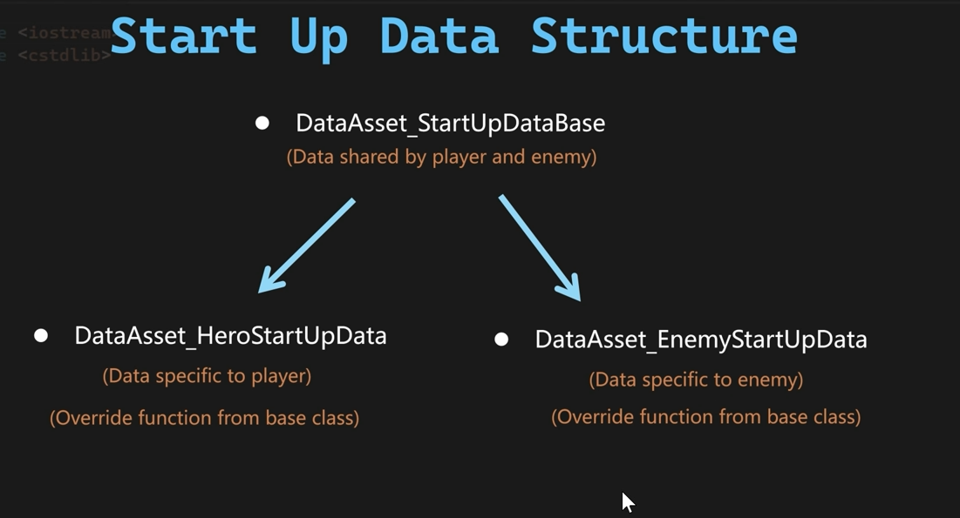
添加如下代码，设置UDataAsset_EnemyStartUpData的类，代码如下
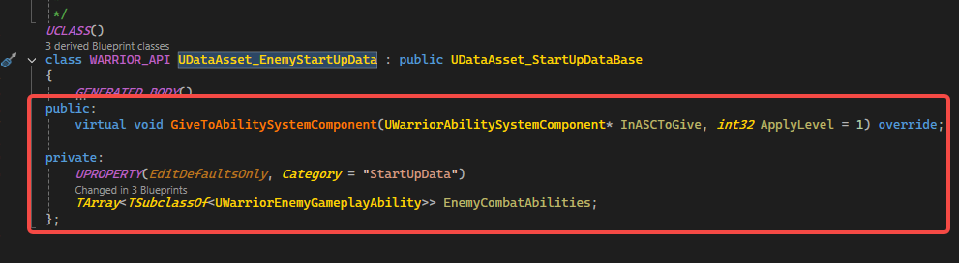
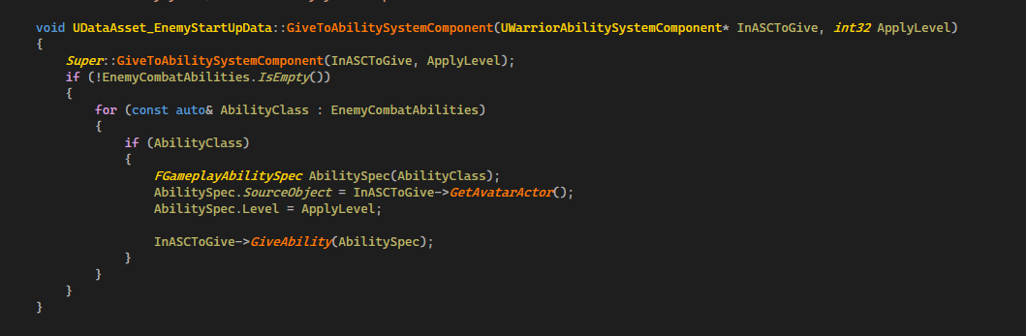
然后打开编辑器。添加一个DataAsset,取名DA_Guardian
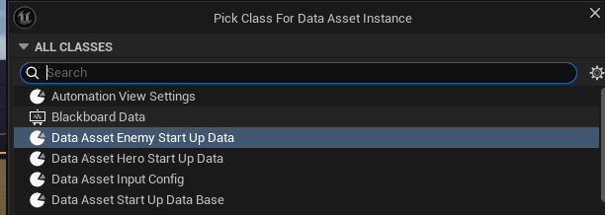
然后修改AWarriorEnemyCharacter这个类，添加接口
// ~Begin APawn Interface.
virtual void PossessedBy(AController* NewController) override;
// ~End APawn Interface.
private:
void InitEnemyStartUpData();

void AWarriorEnemyCharacter::PossessedBy(AController* NewController)
{
Super::PossessedBy(NewController);
InitEnemyStartUpData();

}
void AWarriorEnemyCharacter::InitEnemyStartUpData()
{
if (CharacterStartUpData.IsNull())
{
return;
}

UAssetManager::GetStreamableManager().RequestAsyncLoad(
CharacterStartUpData.ToSoftObjectPath(),
FStreamableDelegate::CreateLambda(
[this]()
{
if (UDataAsset_StartUpDataBase* LoadedData = CharacterStartUpData.Get())
{
LoadedData->GiveToAbilitySystemComponent(WarriorAbilitySystemComponentPtr);
}
}
)
);
}
然后打开编辑器，打开BP_Grunting_Guardian节点，设置好开始启动的数据
