首先我们需要建立一下GameplayTag
WARRIOR_API UE_DECLARE_GAMEPLAY_TAG_EXTERN(InputTag_SwitchTarget);
UE_DEFINE_GAMEPLAY_TAG(InputTag_SwitchTarget, "InputTag.SwitchTarget");
然后我们打开 AWarriorHeroCharacter 这个类，添加新的接口
Void Input_SwitchTargetTriggered(const FInputActionValue& InputActionValue);

void AWarriorHeroCharacter::Input_SwitchTargetTriggered(const FInputActionValue& InputActionValue)
{
SwitchDirection = InputActionValue.Get<FVector2D>();
}

void Input_SwitchTargetCompleted(const FInputActionValue& InputActionValue);
void AWarriorHeroCharacter::Input_SwitchTargetCompleted(const FInputActionValue& InputActionValue)
{
FGameplayEventData Data;
UAbilitySystemBlueprintLibrary::SendGameplayEventToActor(
this,
SwitchDirection.X > 0.f ? WarriorGameplayTags::Player_Event_SwitchTarget_Left : WarriorGameplayTags::Player_Event_SwitchTarget_Right,
Data);
}
然后我们在SetupPlayerInputComponent的接口里绑定
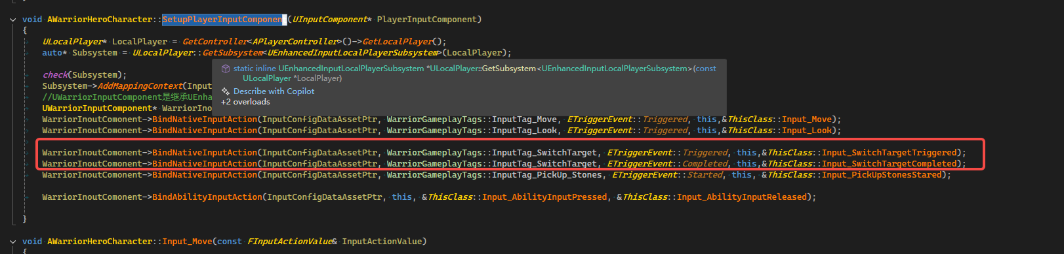
我们打开DA_InputConfig，然后配置如下
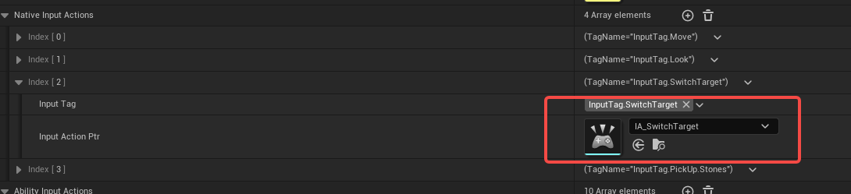
然后新建立一个InputAction，取名叫IA_SwitchTarget
TargetLockMappingContext
给UHeroGameplayAbilityTargetLock 这个类添加一个InputMappingContext对象
UPROPERTY(EditDefaultsOnly, Category = "Target Lock")
UInputMappingContext* TargetLockMappingContext;

继续添加2个新的接口
void InitTargetLockMappingContext();
void ResetTargetLockMappingContext();

void UHeroGameplayAbilityTargetLock::InitTargetLockMappingContext()
{
const ULocalPlayer* LocalPlayerPtr = GetHeroControllerFromActorInfo()->GetLocalPlayer();
UEnhancedInputLocalPlayerSubsystem* SubSystem = ULocalPlayer::GetSubsystem<UEnhancedInputLocalPlayerSubsystem>(LocalPlayerPtr);
check(SubSystem);
SubSystem->AddMappingContext(TargetLockMappingContext, 3);
}

void UHeroGameplayAbilityTargetLock::ResetTargetLockMappingContext()
{
if (nullptr == GetHeroControllerFromActorInfo())
{
return;
}
const ULocalPlayer* LocalPlayerPtr = GetHeroControllerFromActorInfo()->GetLocalPlayer();
UEnhancedInputLocalPlayerSubsystem* SubSystem = ULocalPlayer::GetSubsystem<UEnhancedInputLocalPlayerSubsystem>(LocalPlayerPtr);
check(SubSystem);
SubSystem->RemoveMappingContext(TargetLockMappingContext);
}
然后我们在ActivateAbilit接口里面调用这个InputMappingContext就可以了
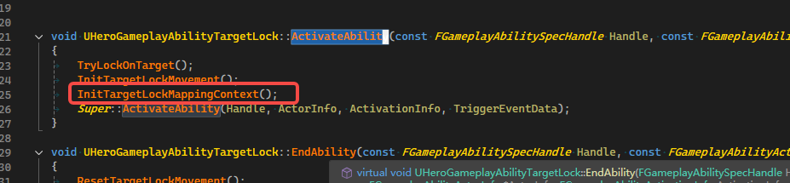
在EndAbility接口里面来Reset这个InputMappingContext就可以了
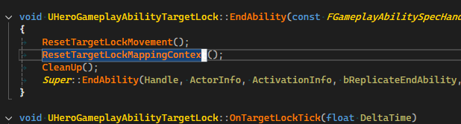
然后我们打开编辑器，新建一个InputMappingContext，取名IMC_TargetLock
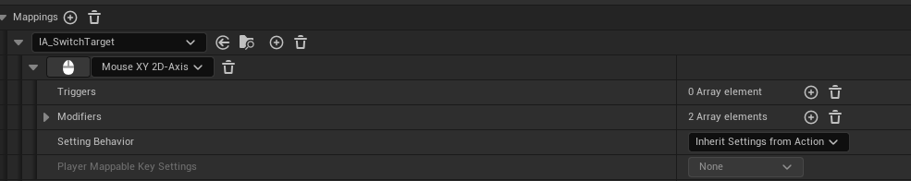
然后我们的打开GA_Hero_TargetLock,指定上需要的InputMappingContext
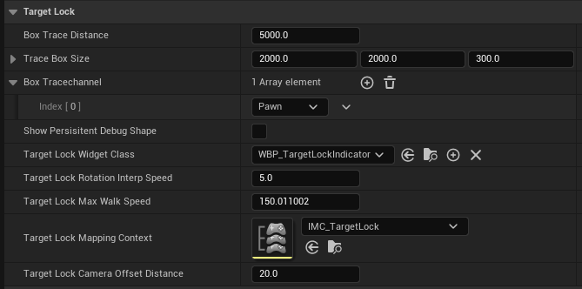
NotifySwitchTarget
实现的过程
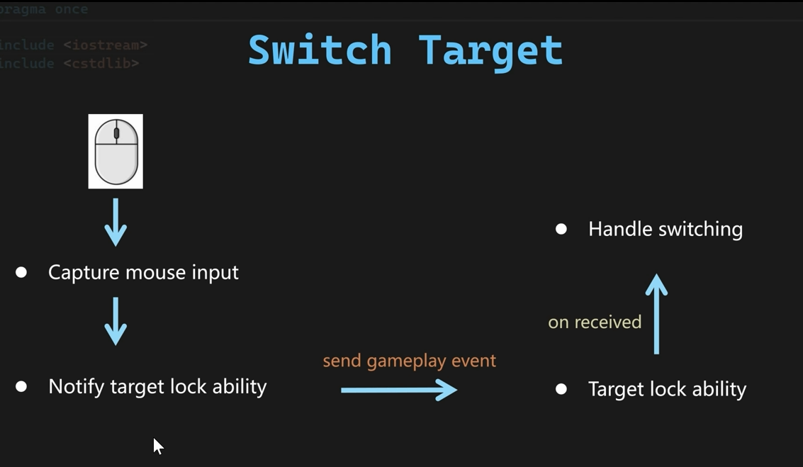
首先我们添加2个GameplayTag
WARRIOR_API UE_DECLARE_GAMEPLAY_TAG_EXTERN(Player_Event_SwitchTarget_Left);
WARRIOR_API UE_DECLARE_GAMEPLAY_TAG_EXTERN(Player_Event_SwitchTarget_Right);

UE_DEFINE_GAMEPLAY_TAG(Player_Event_SwitchTarget_Left, "Player.Event.SwitchTarget.Left");
UE_DEFINE_GAMEPLAY_TAG(Player_Event_SwitchTarget_Right, "Player.Event.SwitchTarget.Right");

然后再这2个函数实现如下 的代码，并且添加新的成员变量
UPROPERTY()
FVector2D SwitchDirection = FVector2D::ZeroVector;

void AWarriorHeroCharacter::Input_SwitchTargetTriggered(const FInputActionValue& InputActionValue)
{
SwitchDirection = InputActionValue.Get<FVector2D>();
}

void AWarriorHeroCharacter::Input_SwitchTargetCompleted(const FInputActionValue& InputActionValue)
{
FGameplayEventData Data;
UAbilitySystemBlueprintLibrary::SendGameplayEventToActor(
this,
SwitchDirection.X > 0.f ? WarriorGameplayTags::Player_Event_SwitchTarget_Left : WarriorGameplayTags::Player_Event_SwitchTarget_Right,
Data);
}
然后我们打开GA_Hero_TargetLock这个蓝图，添加一个WaitGameplayEvent节点，等待发送的游戏事件，一定要取消OnlyMatchExact，因为这里等待的是left和right2个event。
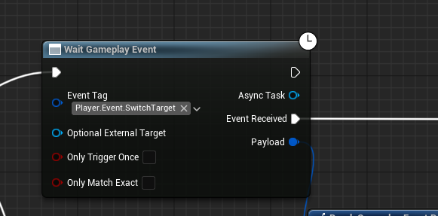
HandleSwitchTarget
首先我们打开UHeroGameplayAbilityTargetLock 添加一个新的蓝图函数
UFUNCTION(BlueprintCallable)
void SwitchTarget(const FGameplayTag& InSwitchDirectionTag);

void UHeroGameplayAbilityTargetLock::SwitchTarget(const FGameplayTag& InSwitchDirectionTag)
{
GetAvailableActorsToLock();
TArray<AActor*> ActorsOnLeft;
TArray<AActor*> ActorsOnRight;
AActor* NewTargetToLock = nullptr;

GetAvailableActorsAroundTarget(ActorsOnLeft, ActorsOnRight);
if (InSwitchDirectionTag == WarriorGameplayTags::Player_Event_SwitchTarget_Left)
{
NewTargetToLock = GetNearestTargetFromAvailableActors(ActorsOnLeft);
}
else
{
NewTargetToLock = GetNearestTargetFromAvailableActors(ActorsOnRight);
}
if (NewTargetToLock)
{
CurrentLockedActor = NewTargetToLock;
}
}
然后我们再添加一个函数，用来区分左边和右边的Actor
void GetAvailableActorsAroundTarget(TArray<AActor*>& OutActorsOnLeft, TArray<AActor*>& OutActorsOnRight);

void UHeroGameplayAbilityTargetLock::GetAvailableActorsAroundTarget(TArray<AActor*>& OutActorsOnLeft, TArray<AActor*>& OutActorsOnRight)
{
if (!CurrentLockedActor || AvailableActorsToLock.IsEmpty())
{
return;
}
const FVector PlayerLocation = GetHeroCharacterFromActorInfo()->GetActorLocation();

const FVector PlayerToCurrentNormalized = (CurrentLockedActor->GetActorLocation() - PlayerLocation).GetSafeNormal();

for (AActor* AvailableActor : AvailableActorsToLock)
{
if (!AvailableActor || AvailableActor == CurrentLockedActor)
{
continue;
}

const FVector PlayerToAvailableNormalized = (AvailableActor->GetActorLocation() - PlayerLocation).GetSafeNormal();
const FVector CrossResult = FVector::CrossProduct(PlayerToCurrentNormalized, PlayerToAvailableNormalized);
if (CrossResult.Z > 0 )
{
OutActorsOnLeft.AddUnique(AvailableActor);
}
else
{
OutActorsOnRight.AddUnique(AvailableActor);
}
}
}
然后我们打开GA_Hero_TargetLock这个能力蓝图，接收到GameplayEvent后，就调用这个SwitchTarget的接口
