WarriorFunctionLibrary
首先添加一个c++类，取名WarriorFunctionLibrary
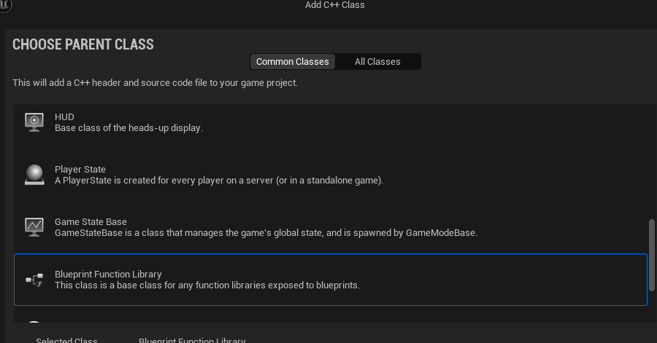
首先添加几个接口
Static UWarriorAbilitySystemComponent* NativeGetWarriorASCFromActor(AActor* InActor);

UWarriorAbilitySystemComponent* UWarriorFunctionLibrary::NativeGetWarriorASCFromActor(AActor* InActor)
{
check(InActor);
return CastChecked<UWarriorAbilitySystemComponent>(UAbilitySystemBlueprintLibrary::GetAbilitySystemComponent(InActor));
}

UFUNCTION(BlueprintCallable, Category = "Warrior|FunctionLibrary")
static void AddGameplayTagToActorIfNode(AActor* InActor, FGameplayTag TagToAdd);

UFUNCTION(BlueprintCallable, Category = "Warrior|FunctionLibrary")
static void RemoveGameplayTagToActorIfNode(AActor* InActor, FGameplayTag TagToRemove);

void UWarriorFunctionLibrary::AddGameplayTagToActorIfNode(AActor* InActor, FGameplayTag TagToAdd)
{
UWarriorAbilitySystemComponent* ASC = NativeGetWarriorASCFromActor(InActor);
if (!ASC->HasMatchingGameplayTag(TagToAdd))
{
ASC->AddLooseGameplayTag(TagToAdd);
}
}

void UWarriorFunctionLibrary::RemoveGameplayTagToActorIfNode(AActor* InActor, FGameplayTag TagToRemove)
{
UWarriorAbilitySystemComponent* ASC = NativeGetWarriorASCFromActor(InActor);
if (ASC->HasMatchingGameplayTag(TagToRemove))
{
ASC->RemoveLooseGameplayTag(TagToRemove);
}
}

static bool NativeDoesActorHaveTag(AActor* InActor, FGameplayTag TagToCheck);
UFUNCTION(BlueprintCallable, Category = "Warrior|FunctionLibrary", meta = (DisplayName = "Does Actor Have Tag", ExpandEnumAsExecs = "OutConfireType"))
static void BP_DoesActorHaveTag(AActor* InActor, FGameplayTag TagToCheck, EWarriorConfirmType& OutConfireType);
bool UWarriorFunctionLibrary::NativeDoesActorHaveTag(AActor* InActor, FGameplayTag TagToCheck)
{
UWarriorAbilitySystemComponent* ASC = NativeGetWarriorASCFromActor(InActor);
return ASC->HasMatchingGameplayTag(TagToCheck);
}

void UWarriorFunctionLibrary::BP_DoesActorHaveTag(AActor* InActor, FGameplayTag TagToCheck, EWarriorConfirmType& OutConfireType)
{
OutConfireType = NativeDoesActorHaveTag(InActor, TagToCheck) ? EWarriorConfirmType::Yes : EWarriorConfirmType::No;
}

添加一个枚举
UENUM()
enum class EWarriorConfirmType : uint8
{
Yes,
No,
};

JumpToFinisher
从lightAttach跳转到HeavyAttach，首先添加一个Tag
WARRIOR_API UE_DECLARE_GAMEPLAY_TAG_EXTERN(Player_Status_JumpToFinisher);
UE_DEFINE_GAMEPLAY_TAG(Player_Status_JumpToFinisher, "Player.Status.JumpToFinisher");
然后打开GA_Hero_LightAttackMaster蓝图节点，蓝图逻辑修改如下
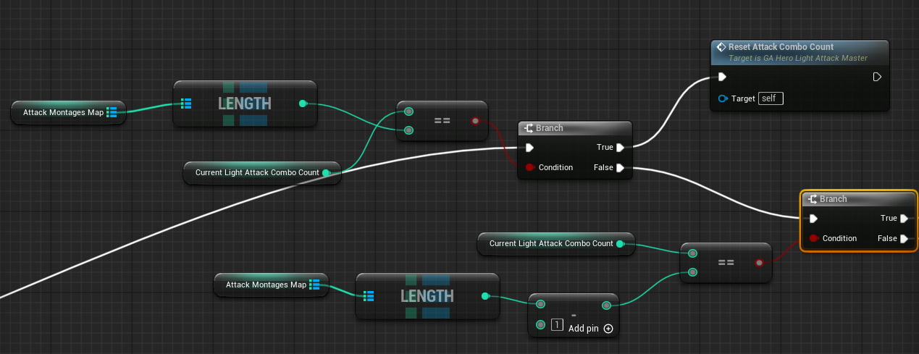
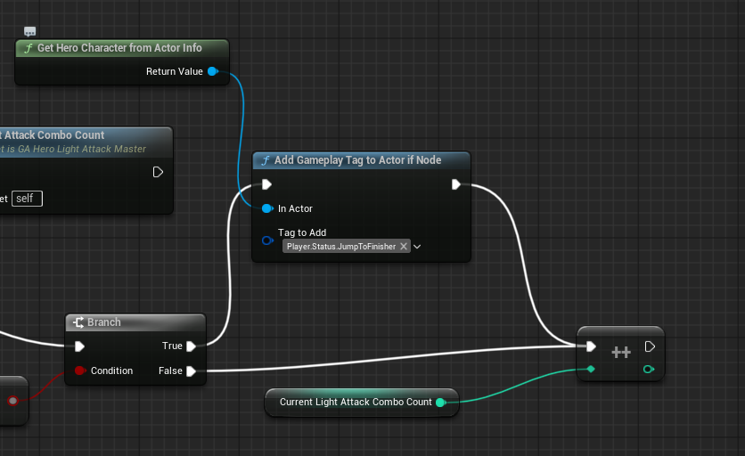
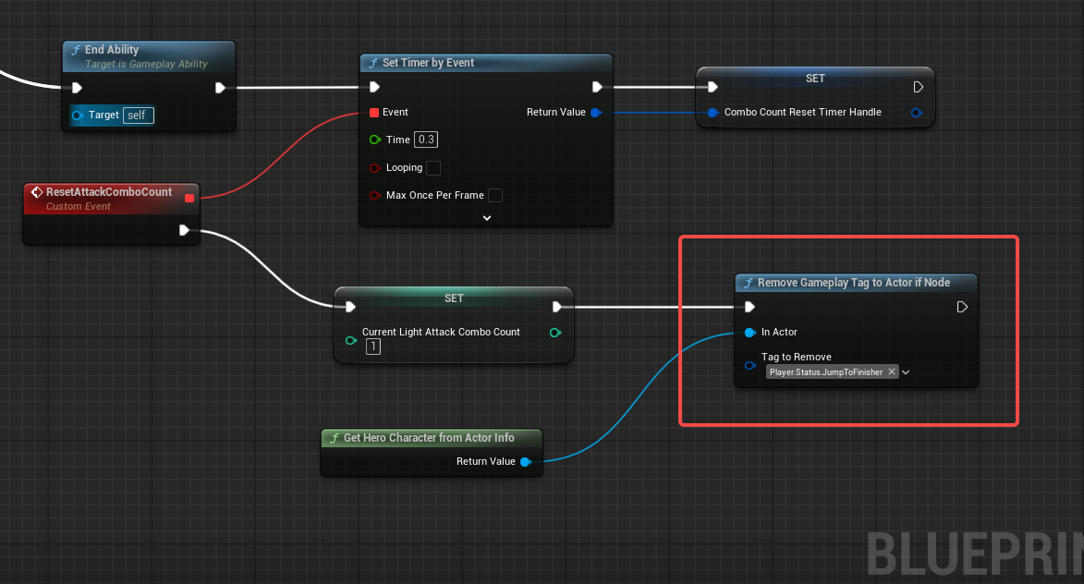在结束的时候还需要remove掉添加的Tag
然后打开
首先移除标签Tag
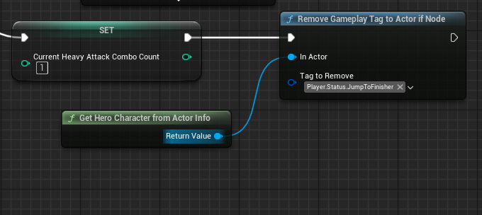
然后判断一下是否有可以跳转到Finisher的Tag
