**Plot the neighborhoods in Toronto with Folium**

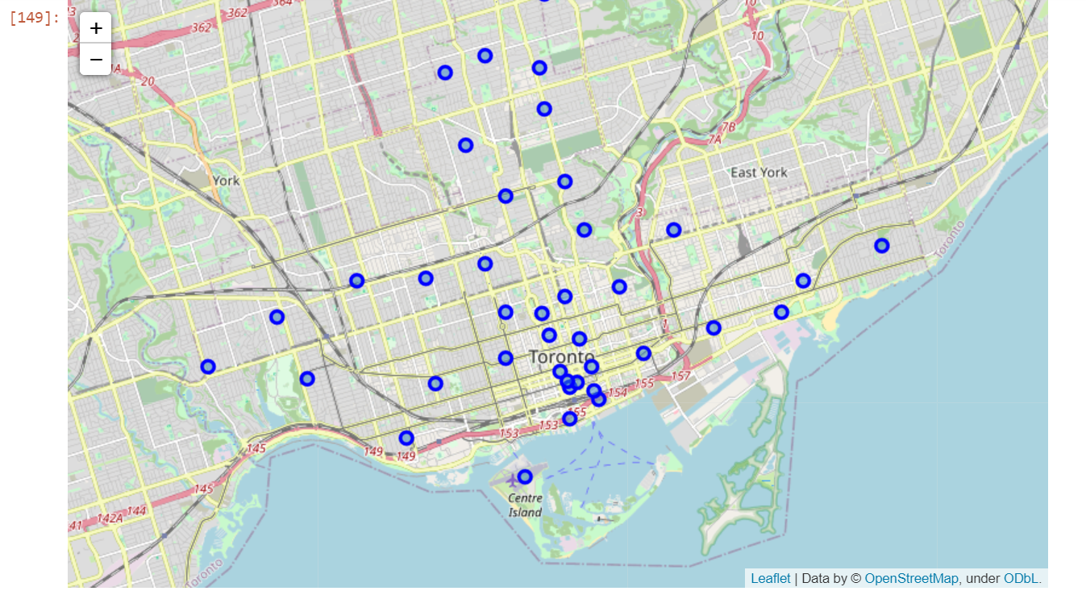

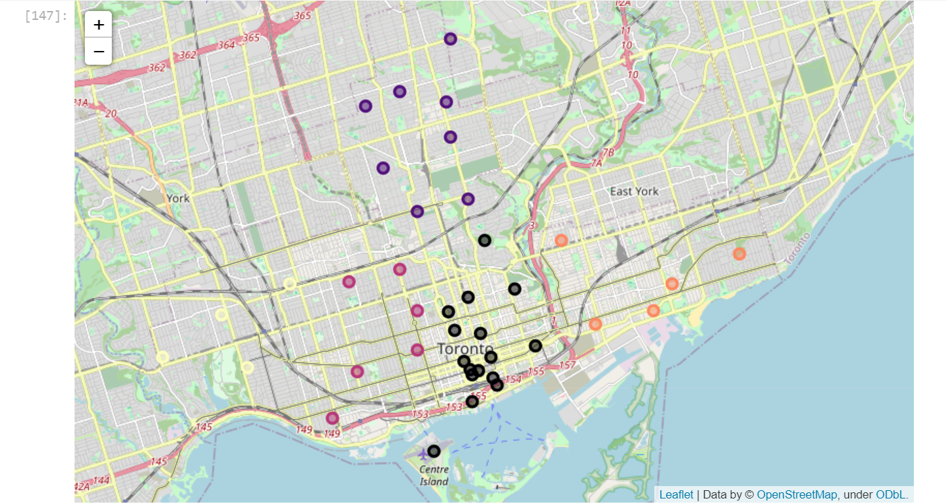**Plot the neighborhoods in Toronto after clustering with Folium**