Coin Kingdom Aztec Casino Game Review
BetMGM Feb 17, 2026, 3:53 PM
8 min read
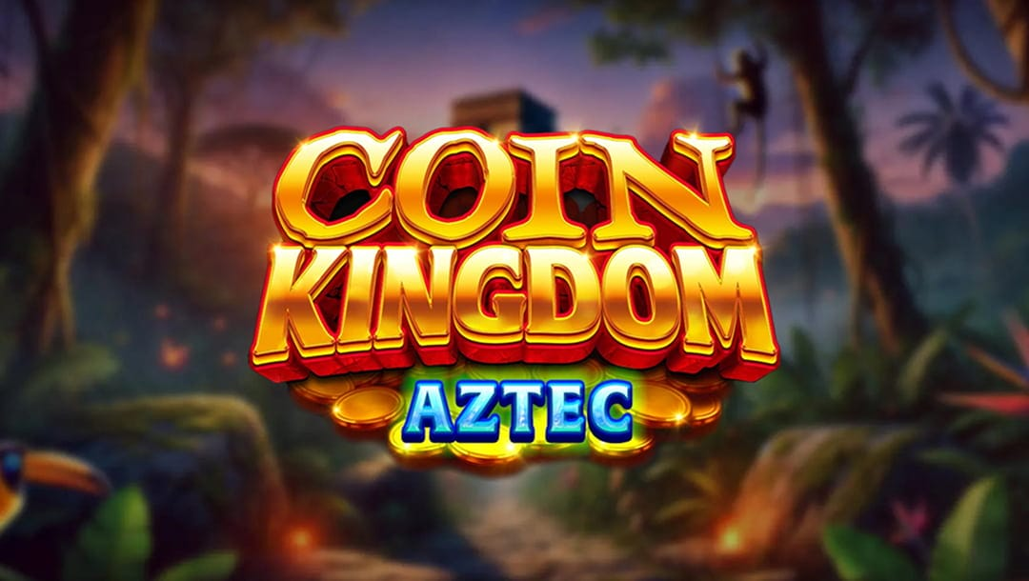
Welcome BonusCasino Promotions
- 3 distinct free game modes featuring multiplier wilds, expanded ways, and royal twists.
- Reel expansions that can boost the layout from 1,024 to 3,456 ways in bonus play.
- Stackable feature combinations that can layer multiple enhancements into one dynamic round.
- A mystery match 3 bonus with jackpot tiers and bet-multiplied credit prizes.
Coin Kingdom Aztec drops players into a jungle of ancient temples, glowing relics, and towering stone reels, where royal figures and hidden powers bring every spin to life. Blending cinematic flair with clever mechanics, it delivers expanding reels, multiplier wilds, and shifting symbols that can flip the action in an instant, much like pulling the right lever in a booby-trapped treasure vault. Among today’s online slot machines, it shines with bold visuals, layered bonuses, and just enough surprise to make each spin feel like a fresh adventure.
Play this Game with BetMGM Online Casino Bonuses
Before you start playing any game at BetMGM online, be sure to check the Promotions page on your account homepage to see if any current offers apply or sign up to get a one-time introductory offer.
No matter what kind of player you are, BetMGM online casino bonuses are generous and consistent. If it’s your first visit to the site, start off with the BetMGM Casino welcome bonus, valid only for new player registrations. For existing players, there are always multiple ongoing BetMGM Casino offers and promotions, ranging from limited-time game-specific bonuses to leaderboards and sweepstakes. Be sure to visit the page on how bonus codes work for more information and FAQs.
Log in or register at BetMGM Casino to explore more than 3,000 of the best casino games online.
Coin Kingdom Aztec Game Highlights
Here are the standout highlights that bring the ancient world in this Ainsworth slot game to life and keep every spin charged with possibility:
- Multiplier wilds free games: Watch wild symbols ignite with multipliers that can supercharge winning combinations and turn ordinary spins into powerful moments.
- Expanded ways free games: See the reels rise higher and wider, unlocking up to 3,456 ways to win as the jungle temple opens up new paths to payouts.
- Royals removed free games: With low symbols stripped away, every spin focuses on premium icons for sharper, more impactful win potential.
Coin Kingdom Aztec Slot Quick Facts and Features
Software Provider | Ainsworth
RTP | 94.31%*
Volatility | N/A
Jackpot Type | Fixed
Paylines | 1,024 up to 3,456 Ways
Reels | 5×4
Max Wager | $44
Max Win | 625x
* Please note that the return to player (RTP) rate for this slot game may differ from one jurisdiction to another.
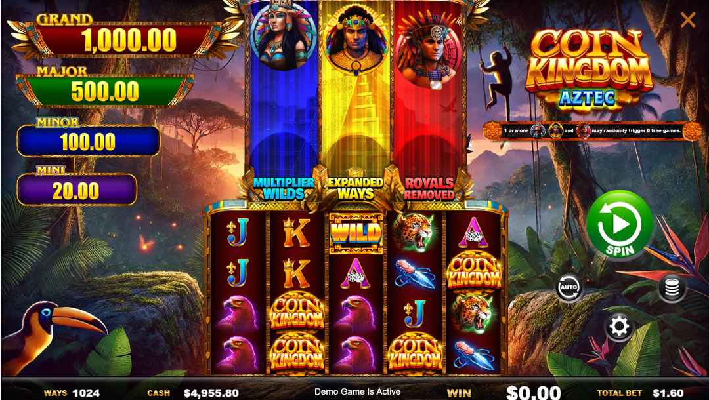
Does the Coin Kingdom Aztec Slot Pay Real Money?
Yes, you can win real-money payouts when playing at BetMGM Casino. To qualify for real rewards, you must play from a state where BetMGM is regulated. Players in New Jersey, Pennsylvania, Michigan, and West Virginia can enjoy slots for real money, as well as payouts from other online casino games, when playing at BetMGM.
How To Play the Coin Kingdom Aztec Slot
- Step 1. Set your bet: Choose your stake anywhere from $0.80 to $44 using the on-screen bet controls before spinning the reels.
- Step 2. Start the game: Hit “Spin” to activate the 1,024-ways layout and watch for winning symbol combinations landing from left to right across adjacent reels.
- Step 3. Unlock the bonuses: Land the queen, king, or warrior symbols to trigger free games features, or enter the mystery match 3 bonus when no feature symbols appear for a shot at credit prizes and jackpots.
Coin Kingdom Aztec Game Features
Here’s how the Coin Kingdom Aztec slot game’s core features come together to shape every spin and unlock its biggest moments of potential:
Coin Kingdom Aztec Wild Symbol Feature
The wild symbol substitutes for all regular paying symbols in the base game, helping complete winning combinations across the 1,024-ways layout on adjacent reels. During Multiplier Wilds free games, enhanced wilds can appear to elevate winning moments, while remaining fully compatible with expanded reel and symbol-removal features. This keeps the wild symbol impactful in both standard play and bonus rounds without overcomplicating the action.
Coin Kingdom Aztec Multiplier Wilds Free Games Feature
This feature is linked to the queen symbol, which appears only on reel 1. When one or more feature symbols land on their designated reels, they may randomly trigger 8 Free Games. If activated, the Multiplier Wilds mode introduces wild symbols carrying multipliers of x2, x3, x4, or x5, which apply to any winning combination they help complete. Two to five coin symbols during the feature award 3, 8, 15, or 20 additional free games, respectively.
Coin Kingdom Aztec Expanded Ways Free Games Feature
The King symbol appears only on reel 3 and, when part of a qualifying combination, may randomly trigger 8 Free Games. During this feature, reels 2, 3, and 4 expand to six rows high, increasing the layout from 1,024 ways to win up to 3,456 ways. Coin symbols retrigger extra free games in the same 2-to-5 coin structure.
Coin Kingdom Aztec Royals Removed Free Games Feature
The Warrior symbol appears only on reel 5 and may randomly trigger 8 Free Games when it lands. In this mode, all royal symbols (10, J, Q, K, and A) are removed from the reels, concentrating gameplay on premium symbols and Wilds. Coin symbols continue to retrigger additional free games under the same award scale.
Coin Kingdom Aztec Combined Free Games Feature
If two or all three of the queen (reel 1), king (reel 3), and warrior (reel 5) symbols land together, their respective features may randomly trigger simultaneously. When activated, the mechanics layer together by combining multiplier wilds, expanded reel layouts, and royal symbol removal into a single stacked bonus round.
Coin Aztec Kingdom Mystery Match 3 Feature
Even if you’ve read a guide to slot bonus symbols, you’ll discover games with symbols that unlock multiple benefits. The Mystery Match 3 feature can randomly trigger on paid spins where no queen, king, or warrior symbols appear. In this feature, the coin icon plays a dual role, acting as both a Free Games retrigger and the central pick element within the bonus round. Players select from 20 concealed coin tiles until three matching symbols are revealed, awarding either a bet-multiplied credit prize or one of four jackpot tiers.
Coin Kingdom Aztec Slot Bonuses and Jackpots
These are the four jackpot prizes that you can win during the Mystery Match 3 feature: Mini jackpot that pays 12.5x, Minor that pays 62.5x, Major that pays 312.5x, or Grand that pays 625x the total bet.
How To Win Coin Kingdom Aztec Slot
Wins are formed through a ways-to-win system where symbol combinations land on adjacent reels starting from the leftmost reel, creating up to 1,024 possible paths in the base game. Rather than relying on fixed paylines, any matching symbols that connect across neighboring reels can generate a payout, with only the highest win per combination awarded on each spin. Wild symbols help bridge gaps between matching icons to help complete combinations, while Free Games could expand the layout and increase the total number of winning ways.
For players who enjoy flexible reel structures and layered bonus mechanics when they play slots online, this approach keeps each spin dynamic and full of evolving win possibilities.
Coin Kingdom Aztec Slot Graphics and Design
Coin Kingdom Aztec delivers cinematic adventure styling through lush jungle backdrops, glowing embers, and towering stone-framed reels that feel drawn from a lost-temple expedition. Premium animal symbols, carved royal glyphs, and the queen, king, and warrior figures are presented like sacred guardians of hidden treasure, while towering feature pillars rise above the reels like mystical totems that clearly signal each bonus mode. As a themed slot, it favors dramatic lighting, warm gold tones, and immersive depth over cartoon excess, creating a rich sense of atmosphere. The experience is heightened by a mysterious soundtrack of echoing drums and haunting choir vocals that evoke temples, opulence, and the thrill of the unknown.
Coin Kingdom Aztec Slot Symbols
At a $1.60 spin level, this online slot game’s highest-paying symbols are clearly led by the Coin Kingdom emblem, which delivers $4.00 for five matching symbols across adjacent reels. The premium animal icons come next, with both the Jaguar and the Eagle awarding $1.60 for a five-of-a-kind combination. Just behind them, the ceremonial Knife symbol pays $1.20 at its top payout. In contrast, the royal card symbols – A, K, Q, J, and 10 – each cap out at $0.30, reinforcing that the game’s biggest base-game moments come from its richly themed premium imagery.
