Barangay Disaster Risk Reduction and Management Plan

YEARS COVERED: (2024 to 2026)

Barangay: HINAPLANON
_________________________________
City/Municipality: CITY OF ILIGAN
_________________________________
Province: LONE DISTRICT OF ILIGAN
_________________________________
Region: X- NORTHERN MINDANAO
_________________________________

Vision:

A barangay where every resident is empowered, prepared, and actively involved in building a safe, resilient, and thriving community, capable of mitigating risks and thriving in the face of any disaster.

Mission:

To foster a culture of preparedness and resilience within the barangay, through collaborative efforts that prioritize:

Risk Reduction and Prevention: Proactively identifying and mitigating disaster risks through community-based planning, infrastructure improvements, and education initiatives.

Community Empowerment: Equipping residents with the knowledge, skills, and resources to understand and manage risks, participate in preparedness activities, and support each other during emergencies.

Effective Emergency Response: Establishing robust systems and protocols for timely and efficient response to disasters, ensuring the safety and well-being of all residents.

Sustainable Recovery: Promoting rapid and equitable recovery from disasters, leveraging community resources and partnerships to rebuild stronger and more resilient infrastructure and livelihoods.

Key Principles:

Community Ownership: Engaging residents in all stages of disaster risk reduction, from planning and implementation to response and recovery.

Collaboration and Partnerships: Working closely with local government agencies, community organizations, private sector partners, and other stakeholders to leverage resources and expertise.

Data-Driven Decision-Making: Utilizing data and technology to inform risk assessments, improve early warning systems, and optimize resource allocation.

Continuous Learning and Improvement: Regularly evaluating disaster preparedness and response efforts, adapting to changing conditions, and seeking opportunities for improvement.

BASIC INFORMATION OF THE BARANGAY

- Barangay History

Long before Barangay Hinaplanon came into existence, the barrio was originally known as Tambo, a name derived from a tall grass called “tambo” which abundantly grew in the barangay. Barrio Tambo was then comprised of Hinaplanon, Cabaro, Linanggongan, Sombuyan, Luinab, Manggas, Bayug, Bayug Island, Ludo, and Bucana. The areas were devoted to corn and sugar production.

In the early seventies, these areas were teemed with people. Sometimes in 1965, a law was sponsored by Vice-President Emmanuel Pelaez who was then a senator. The enactment of the law calls for the registration of all barrios in the Philippines as a prelude to the coming election of Barrio Officials particularly the Teniente del Barrio. Before the law, the Teniente del Barrio was appointed by the mayor. The incumbent Teniente del Barrio at that time was Mr. Dioscoro Llanes, a resident of Hinaplanon. He had the name of the barrio registered as Hinaplanon, which surprises the residents of Tambo, through a Resolution Number 329, series of 1966 which was then enacted by the City Council of Iligan on January 20, 1967 and subsequently approved by the city mayor. Barangay Hinaplanon formally came into existence.

The name Hinaplanon was derived from the word “hinana”, a medicinal plant effective for the treatment of skin diseases of the children and other skin illnesses.

The principal products of the barangay were corn and sugar. There were four corn mills in Tambo and three in Hinaplanon. In the entire barangay, there were six local sugar mills. Other products were coconut and bananas. Fish were also abundant along the shore particularly in Bayug Island.

The first barangay election for one year term of office of the Teniente del Barrio and five (5) councilmen was held in 1966 and the second was in 1967. In the 1968 election, the term of office of the Barrio Officials was increased to four (4) years. However, barrio officials who elected in 1968 were caught by the Declaration of Martial law in 1972 and they were on a holdover capacity until 1976, when an election was called for, to refresh the people’s mandate.

Influx of people in Iligan City were experienced. Attracted and lured by the booming industrialization of the city, people all over the country came over to work and settle down in the place. This tremendously affected the barangays of Iligan and particularly Hinaplanon. The fields devoted to corn and sugar were converted to highways, subdivisions and residential areas. Because of the increase in population in some places of the barangay, some residents agreed to create their own barangay and separate from the mother barangay which is Hinaplanon. This leads to the creation of Barangay Sto. Rosario, Barangay Bagong Silang, Barangay Upper Hinaplanon, and Barangay Luinab.

Despite the creation and separation of the four barangays, Barangay Hinaplanon still possesses a land area of 551.54 hectares with a population of 15,424 as of the year 2022. It has 23 puroks, has two Day care centers and a complete Elementary and Secondary schools, to answer the educational needs of the people.

The Barangay Officials who administered the operations and responsible for the development of the Barangay for the current year is shown in Table No.

TABLE 1

List of Barangay Officials: CY 2023 – 2026

Administrators | 2022-2023 | 2023-2024 | 2024-2025
Punong Barangay | Veronico Suico Echavez | Girlie Nanaman Cadalin | Girlie Nanaman Cadalin
Kagawad | Nestor Sebua Aquino | Veronico Suico Echavez | Veronico Suico Echavez
Kagawad | Girlie Nanaman Cadalin | Clyde Suson Fernan | Clyde Suson Fernan
Kagawad | Jerry Actub Villamor | Isabelo Macasero Mariquit Jr. | Isabelo Macasero Mariquit Jr.
Kagawad | Dante Tejano Clavano | Nila Bado Bordaje | Nila Bado Bordaje
Kagawad | Rio Morado Gonzaga | Rio Morado Gonzaga | Rio Morado Gonzaga
Kagawad | Ronald Galorio | Judith Samante Ermac | Judith Samante Ermac
Kagawad | Clyde Suson Fernan | Leonila Rico Arnoco | Leonila Rico Arnoco
SK Chairman | Jamika Crystal Ermac Diango | Christian Jay Idul Ermac | Christian Jay Idul Ermac

Physical and Geographical Classification of the Barangay

Location and Boundaries:
Barangay HINAPLANON has a total land area of 551.54 (hectare), where 37.00 (hectare) used in agriculture, 514.54 (hectares) in residential, X (hectare) is timberland and X (hectare) are alienable and disposable land (A and D). The barangay is in the North-eastern part of Iligan City, Lone District of Iligan. It is 4 (in kilometer) away from city/municipal hall and it takes 9 minutes to reach the barangay hall. It is accessible by passenger jeepney, minibus, and motorcycle. It is bounded on the north by Barangay Sto. Rosario, on the east Barangay Luinab, on the west Barangay Santiago (name of barangay) and on the south San Roque.
Land and Water Forms:

Land Forms | Check (√) if present (X) if not present in the barangay
Mountains Range/Hills | x
Mountain | x
Volcano | x
Cliff | x
Archipelago | x
Islands | √
Plains | √
Valley | x

Water Forms | Check (√) if present (X) if not present in the barangay
Sea | √
River | √
Gulf, Inlet | x
Lake | x
Spring | x
Falls | x
Creek | √

Socio-Economic and Community Information

BARANGAY POPULATION | Number
Number of Individual | 15,424
Number of Household | 4,250
Number of Families

Population According to Sex

SEX | Number
Male | 7,100
Female | 8,300
TOTAL | 15,424

Population According to Age

AGE BRACKET (YEAR) | FEMALE | MALE | TOTAL
0 – 11 mos.
1 – 2
3 – 5
6 - 12
13 – 17
18 – 59
60 and above
TOTAL

Number of Households according to the type of Materials used in Construction

TYPE OF MATERIALS USED | TOTAL
Concrete | 9,284
Semi or Half Concrete | 4,642
Made up of Light Materials | 1,293
Salvaged House | 255
TOTAL | 15,474

Total Households by Type of Ownership

TYPE OF OWNERSHIP | TOTAL
Owned | 7,750
Rented | 6,195
Shared with Owner | 1,090
Shared with Renter) | 419
Informal Settler Families (ISF) | 20
TOTAL | 15,474

Socio-Economic Information

Main Source of Income of the Population

TYPE OF LIVELIHOOD (SOURCE OF INCOME) | TOTAL NUMBER OF PERSONS
Farming | 48
Fishing | 46
Poultry and Livestock
Carpentry
Professional (example: Doctor, Lawyer, etc)
Government Employee
Private Employee
Vending
Formal/ Licensed Driver
Non-licensed Driver
Barker
Porter
Masseur
House helper
Electricians
Laborer
Mining
Lending
Others (please specify)
TOTAL

Basic Infrastructures and Facilities

ELECTRICITY | TOTAL NO. OF HOUSEHOLD
With Electricity
Without Electricity
CLEAN WATER | TOTAL NO. OF HOUSEHOLD
Deep Well (Level 1)
Common (Level 2)
Faucet (Level 3)
WASTE MANAGEMENT | TOTAL NO. OF HOUSEHOLD
Burned
Buried
Recycled
Others (Please specify)
COMFORT ROOM / TOILET | TOTAL NO. OF HOUSEHOLD
Water Sealed
Antipolo type
Others (please specify)
No Latrine

Buildings and Other Infrastructure in the Barangay

TYPES OF INFRASTRUCTURE | TOTAL
Covered Court or Gymnasium | 1
Barangay Hall | 1
Multi-purpose Building | 2
Evacuation Centers | 3
Public Schools | 3
Private Schools | 0
Churches | 9
Government Hospitals | 0
Private Hospitals | 0
Barangay Health Centers | 1
Others (please specify)

Basic Services in the Barangay

BASIC SERVICES | TOTAL
Barangay Hall | 1
Health: Hospital | 0
Health: Health Center | 1
Health: Birthing Clinic/Center | 1
Nutrition Post | 1
School: Elementary | 1
School: Secondary | 2
Secondary: College | 0
Day Care Center | 3
Playground for Children | 1
Office of Senior Citizen Association (OSCA) | 0
Center for PWDs | 1
Center for Women/ Gender | 1
Police Station / Civilian Volunteer Organization Post | 1
Jail | 0
Youth Center / SK Center | 1
Others (Please specify)

List of Community or Civil Society Organizations and Number of Members in the Barangay

NAME OF ORGANIZATION | TOTAL NUMBER OF MEMBERS
Women’s Association | 570
4Ps | 534
Solo Parents | 63
Senior Citizens Association | 750
PWD Association | 200
Purok Presidents Association | 23
Fisherfolks Association | 46
Farmers Association | 48

Institutional and Human Resource

HUMAN RESOURCE | TOTAL
Health Facilities and Professionals (Doctor, Midwives o Nurse) (please specify what profession) | 1 - Doctor (City Health Office)  1 - Midwife  2 - Nurses
Trained Barangay Health Workers | 8
Trained Barangay Nutrition Scholars | 2
Trained Barangay Emergency Response Teams | 10
Trained Community Volunteer Organizations | 20
Pool of Community Volunteers | 6
Trained Day Care Workers | 3
BDRRM Operations Center and Trained Personnel | 6
Others (Please specify)

ORGANIZATIONAL STRUCTURE

The Barangay Disaster Risk Reduction Management Committee (BDRRMC) is one of the committees of the Barangay Development Council which is designated by law (RA 10121, otherwise known as the “Philippine Disaster Risk Reduction and Management Act of 2010”) to oversee and facilitate the activities for the safety and security of the population living in the community. The committee is responsible for implementing programs, projects and activities within the community or barangay to prevent or minimize the impact of natural or human-induced hazards to people, property, business, critical facilities and infrastructure, environment and other elements at risk in the community.

The BDRRMC, under the Barangay Development Council, has the functions to be implemented in accordance with RA 10121. These are as follows:

To approve, monitor and assess the implementation of the barangay disaster risk reduction management plan in accordance to the city or municipal and other higher-level programs and projects;

Ensure that the disaster risk reduction and climate change adaptation will be integrated into the local development plans, activities, projects and programs and will be funded as strategy for sustainable development and poverty reduction in the community.

Recommend for the strict implementation of mandatory and forced evacuation if there is a threat to the people, especially those who are living in a high-risk zones or areas; and

Convene the committee and conduct quarterly meeting or as needed.

The Organization of the BDRRMC

The committee consists of members of the council, representatives from education sector, church-based organization, civil-society organization and other vulnerable groups in the barangay. It is headed by the Punong Barangay as Chairperson. The following sectors should have an active and meaningful role in BDRRMC which is duly approved through an ordinance or resolution passed by the council.

- Children Sector
- Youth Sector
- Women’s Group
- Elderly
- People with Disability (PWD)
- Indigenous Peoples
- Farmer’s Sector
- Fisherfolk
- Professional Group
- Church-Based Organization
- Private Sector
- Community/Barangay Police of Volunteer
- Overseas Filipino Workers
- Cooperatives
- Other sector or group in the barangay

The primary basis of the sectoral membership to BDRRMC is the legitimacy of the organizations with barangay programs or projects. A legitimate organization is duly registered, accredited to any authorized government agency or recognized by the Sangguniang Bayan or Barangay.
They must also actively participate in any barangay or community development activities. If they are not yet registered in any government agency, they may also submit a letter to the Sangguniang Barangay in order to identify them as a legitimate organization in the barangay.

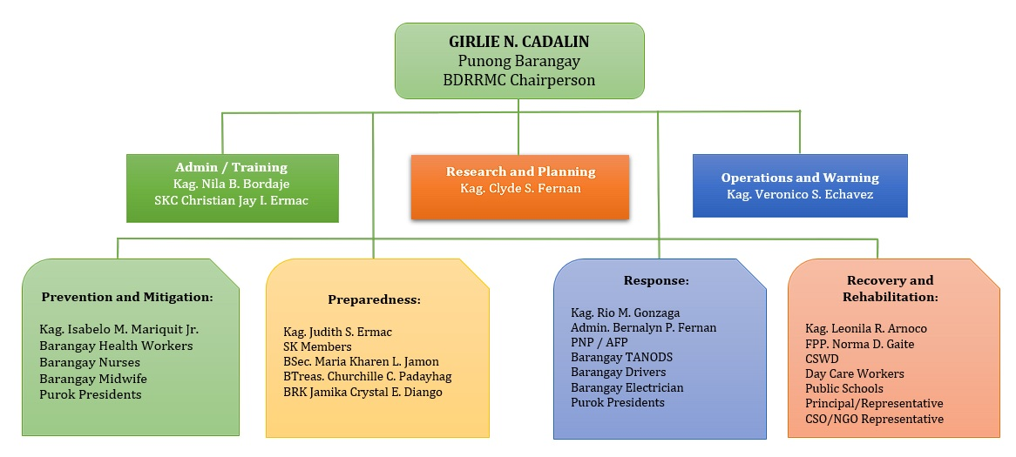
The Barangay Council will provide evidence of the recognition that they are a legitimate organization that implements programs, projects and activities in the barangay through the Executive Order from the Punong Barangay or Barangay Resolution.
Proposed Barangay Disaster Risk Reduction Management Committee Structure

[Cite your source here.]
Composition:

The BDRRMC’s overall leadership Girlie N. Cadalin is the responsibility of the Punong Barangay with the heads of the different sub-committees Kagawad Clyde S. Fernan with the support of the Operations and Admin Unit.

Every sub-committee will be headed by the Vice-Chairperson with the support of team leaders.

Each sub-committee will be led by the member of the Sangguniang Barangay while the Teams will be chaired by the sectoral organizations or groups representatives. The Chairperson or Team leader of the Teams will perform the tasks as required by the team. (For example, the Education Team will be Chaired by the education representative (School DRR Focal or the Principal) in the committee).

Roles and Responsibilities of Administrative Support:

Ensures that all BDRRMC requirements are in place and are in good order, such as legal documents, forms to be used to provide immediate support and necessary actions to carry out a barangay activity or project;

Ensures that all plans, activities, Memorandum of Agreements / Memorandum of Understandings, BDRRM Plans and policies pertaining to DRRM and CCA are in place and available anytime.

Roles and Responsibilities of the Committee:
The Four Sub-committee (based on the four thematic area of DRRM)

- Prevention and Mitigation / Research
Conducts research and study on developing initiatives related to DRR and CCA;
Recommend measures on the implementation of environmental laws, such as but not limited to RA 10121, RA, 10821, RA 9729 and RA 9003;
Assists in the implementation of laws, programs, projects and activities to prevent or mitigate the impact of natural or human-induced hazards;
Initiates forest and mangrove planting and rehabilitation; and
Conducts risk, exposure, vulnerability and capacity assessments,

- Preparedness / Planning and Training
Provides support in the development and formulation of the quality BDRRM plan;
Provides support in the conduct of disaster preparedness activities such as training of response volunteers, orientation, seminar or any DRRM related activities;
Initiates the conduct of simulation exercise or drill to identified priority hazard in the community; and
Disseminates disaster preparedness information to public especially the high-risk areas.

- Response / Operations
Initiates the implementation of programs, projects and activities related to disaster risk reduction and climate change adaptation;
Establish appropriate community early warning system linked to the city/municipality and other higher level government agencies;
Initiates implementation of the forced and preemptive evacuation activities of families living in a high-risk area;
Ensures that warning signals are received by the affected population people especially those who are living in a high risk or danger zones on time with corresponding recommendation of what to do per level of warning or alert.

- Recovery and Rehabilitation
Assist in the repair and retrofitting of damaged public properties/infrastructures, critical facilities and social services;
Recommend to higher level of what kind of programs, projects and activities should be given to them through a participatory assessment, planning, implementation and monitoring; and

Roles and Responsibilities of Team or Group under the BDRRMC:

Communication and Warning Team
Monitors water level of the river, creek, dam or any water ways and the installed warning devices/instruments that provide information for possible flooding or landslide in the community and report immediately to BDRRMC or the Punong Barangay about the condition to make appropriate decision or action of the BDRRMC;
Provides accurate and timely information or warning for an early and prompt decision of the BDRRMC if the people living in a high-risk zones will be evacuated to a safe area;
Ensures that early warning system and protocol are in place and properly disseminated to the families likely to be affected by hazards
Ensures that the communication protocols are in place and tested regularly; and
Collaborates and engages other BDRRM sub-committees or local government agencies regarding BDRRM especially during emergencies or disasters.

Transportation Team

Ensures that there is a readily available functional transportation system in the barangay that can be used before, during and after emergency or disaster;
Conducts regular inventory of available transportation vehicle and its capacity to transport population from high risk to safe areas;
Coordinates private or business sectors for possible use of their vehicle especially during evacuation movement or any disaster related activities within the barangay;
Ensures that the private or business sectors are agreed to use their vehicle in times of emergency or disaster through a Memorandum of Agreement or Understanding.

Security and Safety Team

Ensures that all members of the community are safe especially in time of emergency or disaster;
Ensures that all facilities, equipment, supplies and materials of the BDRRMC are safe and free from any form of theft;
Provides security to the responders and the affected population during relief distribution in times of emergency or disaster;
Ensures that the evacuation centers or areas are safe from any intruders during emergency or disaster; and
Initiates in developing mechanisms for relief distribution and service delivery to the affected population.

Education Team

Ensures that children and youth are included in community-based disaster risk reduction and management and climate change adaptation activities in the community;
Ensures that the private and public organizations and agencies are involved in DRR and CCA activities;
Educates people especially the most vulnerable groups in the community on disaster risk reduction and management and climate change adaptation;
Develops information education campaign materials on DRR and CCA and share these to the public; and
Coordinates regularly to education sectors in the community for possible partnership on DRR and CCA advocacy and project implementation.

Protection Team

Ensures that all disaster risk reduction and management and climate change adaptation programs, projects and activities did not violate the rights of the people especially children, women, persons with disability, elderly and other vulnerable sectors or groups in the community;
Ensures that the vulnerable groups or sectors such as children, youth, women, pregnant and lactating mother, elderly, people with disability, indigenous people are protected and free from any harm before, during and after emergency or disaster; and
Assures compliance with the legal procedures for the implementation of disaster risk reduction and management and climate change adaptation laws in the barangay and other protocols, policies and guidelines related to DRRM.

Damage Control Team

Assists research and planning team in the conduct of rapid damaged assessment and needs analysis (RDANA) and post damaged assessment and needs analysis (PDNA);

Ensures that all affected structures, livelihood and other critical facilities brought by hazards are reported to BDRRMC and other concerned agency or organization for immediate and long-term intervention;

Initiates inventory of all possible damages to infrastructure, houses, evacuation center, livelihood and other critical facilities in the barangays that can be impacted by the identified hazards.

Research and Planning Team

Facilitates and supports risk assessment and contingency planning activities of the BDRRMC and other groups in the community;

Conduct research and development initiatives on barangays disaster risk reduction and management and climate change adaptation;

Initiates development of plans with appropriate mechanisms for monitoring and evaluation of the plan’s implementation;

Ensures that all vulnerable groups or sectors such as children, youth, women, pregnant and lactating mothers, elderly, people with disability, indigenous people in the community are involve and participate actively in risk assessment, planning, implementation, monitoring and evaluation processes.

Roles and Responsibilities of the Team under Response Sub-Committee:

Rapid Damage Assessment and Needs Analysis (RDANA)Team
Conducts Rapid Damage Assessment and Needs Analysis (RDANA) using the simplified assessment template provided by the local governments and submit the report to BDRRMC or Punong Barangay;
Lists all affected population or families who need immediate assistance or support especially the vulnerable groups or sectors;
Submits complete and easy to understand RDANA reports to BDRRMC or Punong Barangay right after the event to decide if the committee ask immediate support from the higher-level local government units or private organizations.

Search, Rescue and Retrieval Team
Provides immediate assistance to population or families that need to evacuate or transfer from high risk to safe areas;
Leads in the conduct of search, rescue and retrieval operations during emergency or disaster; and
Assists higher level government units or responders in the conduct of search, rescue and retrieval operations during emergency or disaster.

Evacuation and Camp Management Team
Ensures that the information of each evacuee inside and outside evacuation center or evacuation area / site are complete and updated;
Ensures that all evacuation centers/sites are assessed and prepared before the occurrence of the hazards;
Makes sure that all evacuation centers/sites facilities and materials are available ready to use during evacuation.

Ensures that all persons or staff involved in evacuation and camp management are trained or at least have knowledge on camp management.
Relief Distribution Team
Ensures that relief management such as receiving, packaging, distribution and other aspect of handling goods either food and non-food items are in accordance to relief procedure and protocol of the barangay;
Makes sure everyone involved in relief distribution are trained or at least know how to properly handle and distribute the goods to affected population; and
Ensures that all affected population especially the vulnerable groups or sectors received sufficient amount of goods.

Health/First Aid and Psychosocial Support Team
Makes sure that there is an available basic medicine in the evacuation that can be used by the evacuees especially for children, youth, women, pregnant and lactating mother, elderly, people with disability and indigenous people;
Provides appropriate health and psychosocial intervention to affected population especially the vulnerable groups or sectors such as children, youth, women, pregnant and lactating mother, elderly, people with disability and indigenous people;
Ensures that health facility and material are readily available at the evacuation centers / sites and health centers

Fire Management Team
Assigns people at the Operation Center 24/7;
Provides immediate response to affected area or population and coordinates with the nearest fire stations as necessary
Initiates conduct of training on basic firefighting and management using the available materials within the barangay;
Requests necessary materials and equipment for fire suppression and safety paraphernalia for responders and volunteers to BDRRMC or Punong Barangay for outside fund sourcing;
Prepares map showing the available safe routes for fire trucks and responders going to the affected area.

Roles and Responsibilities of the Team under Recovery and Rehabilitation Sub-Committee:

Livelihood Team

Conducts study together with other groups or sectors in the barangay on the economic impacts brought about by the hazards or disaster;
Provides recommendations or solution about what they have learned and what long term solutions people can make in collaboration with higher government offices or agencies that people recovered or rehabilitated their livelihood.

Infrastructure and Shelter Team

Conducts study about the total cost of damages to infrastructure and shelter within the barangay; and
Submits the result of study with initial recommendations or suggestions for recovery and rehabilitation of damaged infrastructures and shelters.

Post Damage Assessment and Needs Analysis (PDANA) Team

Conducts comprehensive studies about the total damages caused by the hazards or disaster in the barangay for a long-term recommendations and solutions;

Records major damages to property, infrastructure and environment because of the hazards or disaster events; and

Submits consolidated result of the assessments and analysis to BDRRMC or Punong Barangay.

COMMUNITY RISK ASSESSMENT (CRA)

A Community Risk Assessment (CRA) or sometimes called as Hazard, Vulnerability and Capacity Assessment (HVCA) is a process that uses a participatory approach which enables the community to Identify potential hazards and determine the nature and extent of risks they pose. It determines also the strengths and opportunities available within the barangay that will help us minimize or at least cope with these risks.

It is a means to collectively analyze community vulnerabilities, highlight capacities and identify gaps for integrated and strategic investment of resources to reduce their occurrence or impact to population, property and environment.

Processes and Contents of Community Risk Assessment (CRA)

Barangay Disaster Risk Profile

Barangay Hinaplanon is one of the most densely populated barangays in Iligan City and lies along the flood-prone areas of the Mandulog River. The barangay covers 23 puroks, several of which are located in low-lying and riverbank areas, making them highly vulnerable to hydrometeorological hazards such as flooding, flash floods, and landslides.
On December 17, 2011, Barangay Hinaplanon was severely devastated by Typhoon Sendong (Washi), which brought unprecedented rainfall that caused the Mandulog River to overflow, resulting in massive flash floods. This disaster claimed hundreds of lives, displaced thousands of families, and caused irreparable damage to infrastructure, homes, and livelihoods.
Given its geographical location, Hinaplanon remains at high risk for recurring flooding, particularly during the rainy season and in the event of tropical cyclones. Climate change has increased the unpredictability of these hazards, intensifying the urgency for proactive disaster risk reduction measures.
Other hazards identified in the barangay include:

- Earthquakes, due to Hinaplanon’s proximity to the Western Mindanao Fault.
- Fire incidents, especially in congested residential areas.
- Health emergencies, such as outbreaks of waterborne diseases post-flooding.

The community’s socio-economic vulnerability, including the presence of informal settlers in hazard zones and limited access to resilient infrastructure, further compounds its risk.
This risk profile underlines the need for continuous investment in disaster preparedness, infrastructure resilience, early warning systems, environmental protection, and capacity building among residents to reduce the long-term impact of future disasters.

Disaster or emergency historical events in the community.
(List down all emergencies/disasters event happened in the community and its impact for the past 5 to 20 year)

Type of Emergency/ Disaster Event: | Flood | Fire |  | Storm Surge
Year: | 2011 | 2007 |  | 2012
EFFECTS/IMPACTS
POPULATION
Dead
Injured
Missing
Separated from the family
Lost Houses
LIVELIHOOD
Partially Damaged
Totally Damaged
HOUSEHOLD PROPERTY
Damaged
Missing
INFRASTRUCTURE
Slightly Damaged
Moderately Damaged
Totally Damaged
HOUSEHOLD
Slightly Damaged
Moderately Damaged
Totally Damaged
COMMUNICATION
Damaged
Lost Communication
ELECTRICITY
Lost Power Supply
WATER
Damaged
Lost Water
HEALTH CENTER
Partially Damaged
Totally Damaged
SCHOOL
Partially Damaged
Totally Damaged

Hazard Identification and Risk Assessment.
(Identify hazards either natural or human-induced and its probability to happen and possible impacts using the scale rating below)

Hazards | Probability | Impact | Remarks | Ranking
Flood | 5 | 4 | Drainage canals should be cleaned every week, de-clogging of waterways and small canals | 1
Fire | 4 | 4 | Need to clear the roadways for easy access for firetrucks. Safety education to avoid fire. | 2
Storm Surge | 3 | 2 | Educate the constituents near the shore for evacuation plan | 4
Traffic Accidents |  | 20% | More traffic signs like “Slow Down” and “Accident Prone Area”. | 3

Probability Impact

1 – Most Unlikely 1 – Negligible
2 – Low Probability 2 – Low Impact
3 – Perhaps 3 – Maintain Impact
4 – High Probability 4 – High Impact
5 – Almost Certain 5 – Devastating
Vulnerability Assessment

Aspect | Check (√) the box if appropriate in your Barangay | Reasons Why the Barangay is Vulnerable to Emergency or Disaster
Physical and Material  Physical Characteristic of the place | √ | Near the sea or shorelines
Physical and Material  Physical Characteristic of the place | √ | Located along river banks
Physical and Material  Physical Characteristic of the place | ☐ | Near the mountains
Physical and Material  Physical Characteristic of the place | ☐ | Near or along the fault line
Physical and Material  Physical Characteristic of the place | ☐ | Near the volcano
Physical and Material  Physical Characteristic of the place | √ | There is no proper drainage system
Physical and Material  Physical Characteristic of the place | ☐ | Soft soil in the residential areas
Physical and Material  Physical Characteristic of the place | ☐ | Deforested mountains
Physical and Material  Physical Characteristic of the place | ☐ | Presence of sinkholes
Physical and Material  Physical Characteristic of the place | √ | Blocked canals or waterways
Physical and Material  Physical Characteristic of the place | ☐ | No proper waste disposal
Physical and Material  Physical Characteristic of the place | ☐ | Majority of the buildings have no ramps
Physical and Material  Physical Characteristic of the place | ☐ | There are many rocks on the edge of the mountain near the houses
Physical and Material  Physical Characteristic of the place | √ | Majority of the buildings have no fire exits
Physical and Material  Physical Characteristic of the place | √ | 40% of houses are made up of light materials
Physical and Material  Physical Characteristic of the place | ☐ | Majority of the building and houses have no circuit breakers
Physical and Material  Physical Characteristic of the place | √ | Majority of the buildings have no fire extinguisher
Physical and Material  Physical Characteristic of the place | √ | Lack of response equipment and materials
 | ☐ | Others (please specify)
Evacuation Center | ☐ | Lack of evacuation centers
Evacuation Center | ☐ | There is an available evacuation center but no comfort room (separated male and female)
Evacuation Center | ☐ | No available evacuation centers
Evacuation Center | ☐ | There is an evacuation center but no ramp
Community Facility | ☐ | Signal of all networks in the evacuation centers are not available
Community Facility | ☐ | No network signal in some areas in the barangay
Community Facility | ☐ | Damaged roads
Community Facility | √ | Hospital is very far from the residents
Community Facility | ☐ | No electricity
Community Facility | √ | 1% of the population rely on level 1 water supply (deep well)
Community Facility | ☐ | Others (Please specify)
Early Warning System (EWS) | ☐ | NO available EWS signage in the designated areas for a particular hazard
Early Warning System (EWS) | ☐ | Lack of early warning devices or materials that provide real time warnings or signs to the community
Early Warning System (EWS) | √ | No available early warning or sign for people with disability (PWD)
Early Warning System (EWS) | √ | No specific early warning system for specific hazard
Barangay Disaster Operation Center | √ | No designated Barangay Disaster Operation Center (BDOC)
Barangay Disaster Operation Center | √
Barangay Disaster Operation Center | √ | Barangay Disaster Operation Center (BDOC) has no standby generator
Household/houses | √ | 40% of houses are made up of light materials
Household/houses | √ | 20% of houses living near the river
Household/houses | ☐ | ___% of houses living near the mountain
Household/houses | √ | 5% of houses are illegally constructed
Livelihood | √ | Majority of the population in the barangay are concentrating only in one livelihood or source of income
Livelihood | √ | Lack or limited livelihood opportunity
Livelihood | ☐ | Others (please specify)
Social and Organizational
BDRRM Committee | ☐ | BDRRM Committee is not organized
BDRRM Committee | ☐ | There is no clear roles and responsibilities of the BDRRMC members
BDRRM Committee | √ | Lack of capacity of the BDRRMC members because they don’t have enough trainings or capacity building activities
BDRRM Committee | √ | 20% of BDRRMC members are not active
BDRRM Committee | √ | 10% of the members are not aware with DRR and CCA laws and their functions
BDRRM Committee | √ | 30% of the BDRRMC members are not aware with RA 10121, RA 10821 and other related policies
BDRRM Committee | √ | BDRRMC has no regular meeting
BDRRM Committee | ☐ | Others (please specify)
Civil Society Organization | √ | There is an existing community organization but no knowledge of DRRM or CCA
 | √ | There is an existing community organization, but they don’t have specific programs, projects or activities on DRRM or CCA
 | √ | There is an existing organization, but they don’t participate in barangay activities specifically on DRRM or CCA
Attitudinal or Motivational
People think and feel | ☐ | People didn’t respect the barangay officials and other leaders in the community
 | ☐ | Majority of the population in the community are not following the government instructions especially during evacuation activities
 | ☐ | Majority of the community leaders or officials didn’t motivate people to participate in community development activities
Initiative to help others | ☐ | Others do not care about their neighbors

Capacity Assessment

Aspect | Check (√) the box if appropriate in your Barangay | Reasons Why the Barangay is Vulnerable to Emergency or Disaster
Physical and Material
Physical Characteristic | √ | With enough and sufficient available evacuation centers
Physical Characteristic | ☐ | Forest and coastal areas have plenty of planted trees
Physical Characteristic | √ | Regular cleaning and repair of drainage canals
Early Warning System | √ | With complete response equipment and materials that can be used in times of emergency or disaster
Early Warning System | √ | Early Warning System (EWS) for specific hazard is established and posted in different parts in the barangay which is visible to population and vulnerable groups
Early Warning System | √ | Early Warning System (EWS) is easy to understand because it is written in local language with images
Early Warning System | ☐ | There is an available early warning system (ESW) for people with disability and other vulnerable groups
Early Warning System | √ | There is mechanism, system and materials for disseminating warning to affected population.
Early Warning System | ☐ | Barangay has available generator with standby gasoline
Social and Organizational | √ | Community organizations are actively participating in all community development activities especially on DRRM and CCA
 | √ | Community organizations or sectors are activity participating in problem identification and assessment, planning, implementation, monitoring and evaluation related to disaster
Attitudinal/  Motivational | √ | The spirit of “BAYANIHAN SYSTEM” is still exist
Attitudinal/  Motivational | √ | Majority of the people in the community are listening to barangay officials and they follow the protocols that the barangay officials are implemented especially for the protection and safety on the population

Hazard Maps of the Barangay

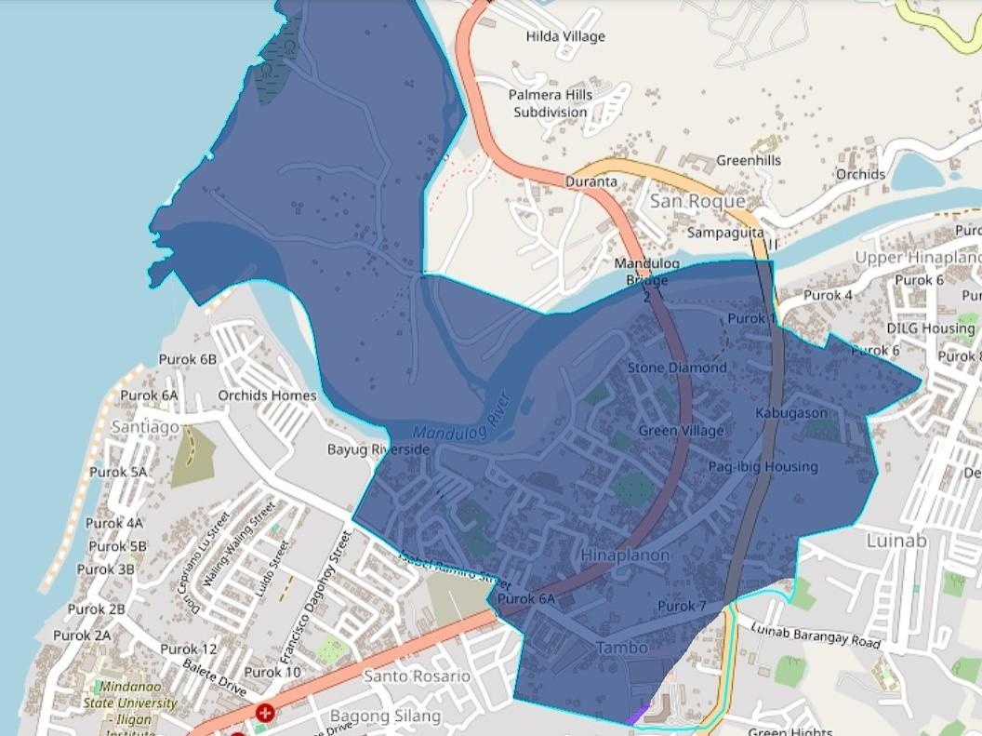
Safe Evacuation Route Map

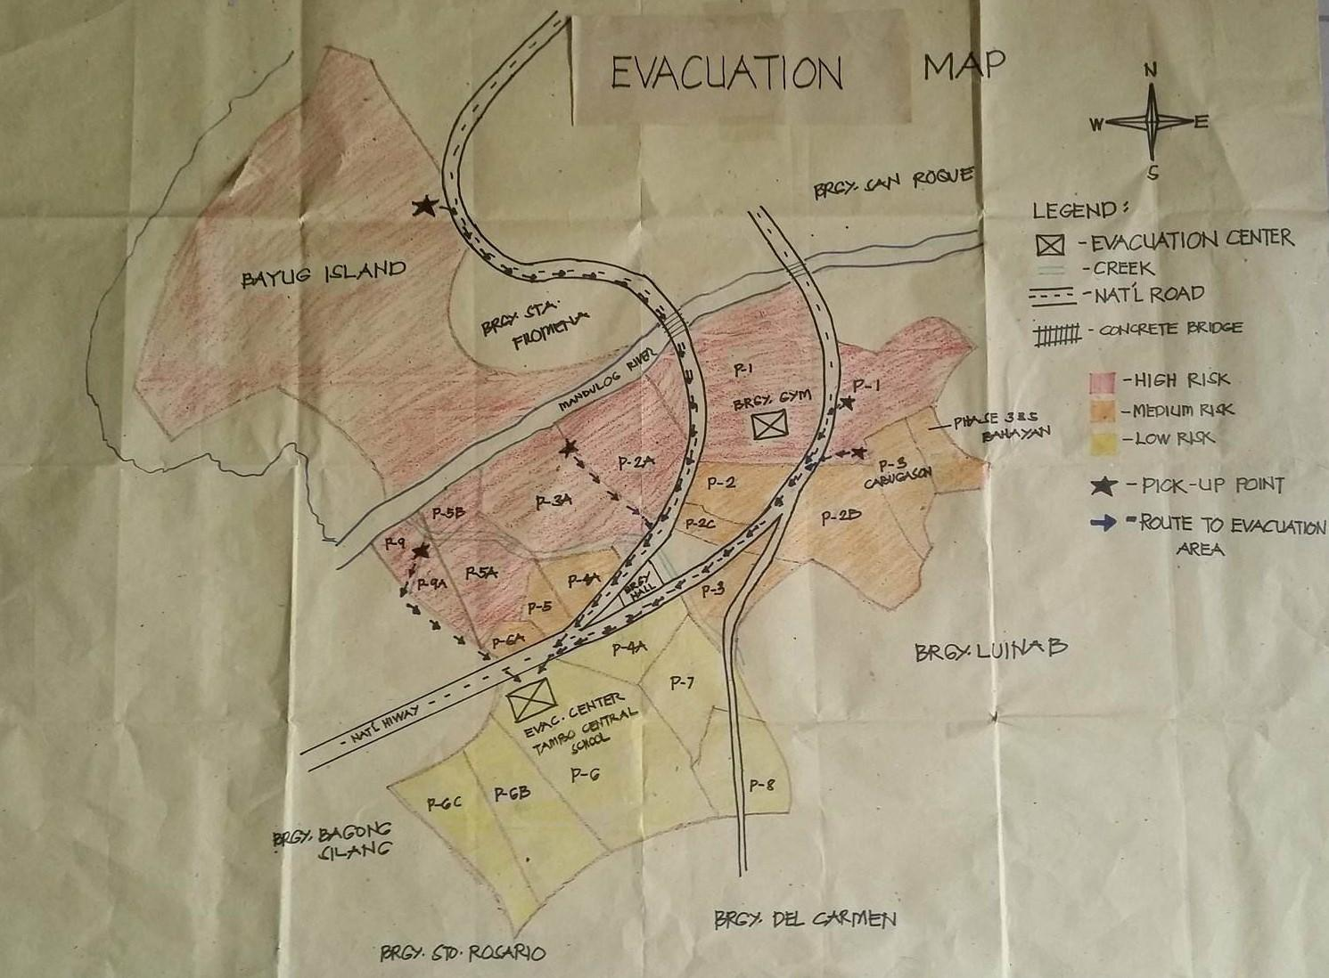

Number of families and population that can be affected by a particular hazard.

- FLOOD

SITIO/ PUROK | TOTAL Number of Families | TOTAL Number of Persons |  | Infant  (0-11 months) |  | Children  17 y/o and below |  | ADULT  (18-59 y/o) |  | ELDERLY  60 y/o & above |  | Persons with Disability (PWD) |  | WITH SICKNESS  (All Ages) |  | PREGNANT WOMEN
SITIO/ PUROK | TOTAL Number of Families | L | B | L | B | L | B | L | B | L | B | L | B | L | B | PREGNANT WOMEN
Zone Diamond, Purok 1
Zone Emerald, Purok 1
Zone Moonstone, Purok 1
Zone Sapphire, Purok 1
Purok 2, Katipunan
Purok 2A, Green Village
Purok 2B, Katipunan
Purok 2C, Katipunan
Purok 3, Cabugason
Purok 3 Dao
Purok 3A, Pioneer Village & Red Cross Village
Purok 4, Tambo
Purok 4A, Tambo
Purok 5, Tambo
Purok 5A, Tambo
Purok 5B, NEUPODA Village
Purok 6, Tambo
Purok 6A, Tambo
Purok 6B, Tambo
Purok 6C, Tambo
Purok 7, Tambo
Purok 9A, Bayug
Purok 9, Bayug Riverside
Phase 3 & 5, Bahayan
Bayug Island
TOTAL

Number of Person with Sicknesses:

Types of Sickness | Age Bracket |  |  |  |  |  |  |  | Sex |  |  | TOTAL
Types of Sickness | 0 – 11 mos. | 1 – 2 | 3 – 5 | 6 - 12 | 13 – 17 | 18 – 59 | 60 – > | B |  | L
Hearing Impairment
Speech and Language Disorder
Visual Impairment
Mentally Disorder
Autism
Intellectual Disability
Developmental Delay
Physical Disability
Disability to walk or move
Multi-Disabilities
Health Disability
Others (please specify)
TOTAL

Number of families and population that can be affected by Flood.

Types of Families | Age Bracket |  |  |  |  |  |  |  | Sex |  |  | TOTAL
Types of Families | 0 – 11 mos. | 1 – 2 | 3 – 5 | 6 - 12 | 13 – 17 | 18 – 59 | 60 – > | B |  | L
Hearing Impairment
Speech and Language Disorder
Visual Impairment
Mentally Disorder
Autism
Intellectual Disability
Developmental Delay
Physical Disability
Disability to walk or move
Multi-Disabilities
Health Disability
Others (please specify)
TOTAL

Number of families and population that can be affected by a particular hazard.

- FIRE

SITIO/ PUROK | TOTAL Number of Families | TOTAL Number of Persons |  | Infant  (0-11 months) |  | Children  17 y/o and below |  | ADULT  (18-59 y/o) |  | ELDERLY  60 y/o & above |  | Persons with Disability (PWD) |  | WITH SICKNESS  (All Ages) |  | PREGNANT WOMEN
SITIO/ PUROK | TOTAL Number of Families | L | B | L | B | L | B | L | B | L | B | L | B | L | B | PREGNANT WOMEN
Zone Diamond, Purok 1
Zone Emerald, Purok 1
Zone Moonstone, Purok 1
Zone Sapphire, Purok 1
Purok 2, Katipunan
Purok 2A, Green Village
Purok 2B, Katipunan
Purok 2C, Katipunan
Purok 3, Cabugason
Purok 3 Dao
Purok 3A, Pioneer Village & Red Cross Village
Purok 4, Tambo
Purok 4A, Tambo
Purok 5, Tambo
Purok 5A, Tambo
Purok 5B, NEUPODA Village
Purok 6, Tambo
Purok 6A, Tambo
Purok 6B, Tambo
Purok 6C, Tambo
Purok 7, Tambo
Purok 9A, Bayug
Purok 9, Bayug Riverside
Phase 3 & 5, Bahayan
Bayug Island
TOTAL

Number of families and individual that are likely to be affected by hazard based on three categories.

- Effects of Hazard.

Areas to be Affected | Low |  | Medium |  | High
Areas to be Affected | Family | Person | Family | Person | Family | Person
Zone Diamond, Purok 1
Zone Emerald, Purok 1
Zone Moonstone, Purok 1
Zone Sapphire, Purok 1
Purok 2, Katipunan
Purok 2A, Green Village
Purok 2B, Katipunan
Purok 2C, Katipunan
Purok 3, Cabugason
Purok 3 Dao
Purok 3A, Pioneer Village & Red Cross Village
Purok 4, Tambo
Purok 4A, Tambo
Purok 5, Tambo
Purok 5A, Tambo
Purok 5B, NEUPODA Village
Purok 6, Tambo
Purok 6A, Tambo
Purok 6B, Tambo
Purok 6C, Tambo
Purok 7, Tambo
Purok 9A, Bayug
Purok 9, Bayug Riverside
Phase 3 & 5, Bahayan
Bayug Island
Total

Inventory of the existing equipment, materials, infrastructures, establishments, livelihood activities and other critical facilities within the barangay which may be affected by the occurrence of hazard.

- Effects of Hazard

Item | Number | Percentage
Infrastructure
Bridge
Barangay Hall
Multi-purpose Building
Houses
Kiosk
Schools
Others (please specify)
Establishment
Sari-Sari Store
Restaurant
Bakery
Others (please specify)
Facility
Water
Electricity
Communication
Roads
Hospital
Barangay Health Center
Others (please specify)
Livelihood
Rice
Vegetable
Banca (motorized and non-motorized)
Fish nets
Fish Ponds
Others (please specify)
Environment
Forest
Mangroves
Others (please specify)

- Other Hazards.

Common issues and problem faced by the vulnerable groups or sectors such as children. youth, women, pregnant women and lactating mothers, elderly, people with disability, indigenous people in times of disaster or emergency.

Vulnerable Groups | Check () the box if present and (x) if none | Issues and problem face by each of the vulnerable groups | Immediate action or response of BDRRMC or barangay officials
Children and Youth | ☐ | No separate comfort room for boy and girl
Children and Youth | ☐ | Disruption of classes
Children and Youth | ☐ | Separation from family members during disasters or emergencies
Children and Youth | ☐ | Loss of shelters
Children and Youth | ☐ | Loss of important documents such as birth certificates and school records
 | ☐ | Injury and psychosocial distress during  disasters or emergencies
Women | ☐ | Women can easily abused at the evacuation center
Women | ☐ | Health problem
Pregnant Women | ☐ | Can’t walk quickly to the evacuation center
Pregnant Women | ☐ | Lack of equipment and facilities at the evacuation center to protect and monitor birthing pregnant women during disasters
Nursing Mother / Lactating Mother | ☐ | No spaces for breastfeeding mothers at the evacuation centers
Nursing Mother / Lactating Mother | ☐ | No available trained community personnel which can provide counseling to nursing mothers
People with Disability | ☐ | No ramp at the evacuation center
People with Disability | ☐ | No specific early warning system for people with disability such as deaf and mute
People with Disability | ☐ | No available wheel chair at the evacuation center
Elderly / Senior Citizen | ☐ | No ramp at the evacuation center
Elderly / Senior Citizen | ☐ | Prone to illnesses
Elderly / Senior Citizen | ☐ | Health problem
Indigenous People | ☐ | No permanent settlement or shelters
 | ☐ | No source of safe potable water
 | ☐ | shelters are not safe to stay because it made up of light materials
 | ☐ | Absence of communication devices to receive warnings from the authority if there is an impending threat in the community

Evacuation plan of the affected population in times of disaster or emergency.

Purok No. | Total Population |  | Total Population at Risk |  | Name of Evacuation Center (Plan A) Government Owned Property | Total Number of populations to be Accommodated |  | Total Number of Population not to be Accommodated |  | Name of Evacuation Center (Plan B) Private Owned Property | Total Number of Population not to be Accommodate ng Plan A and B |  | Remarks
Purok No. | Families | Persons | Families | Persons |  | Families | Persons | Families | Persons |  | Families | Persons
Zone Diamond, Purok 1
Zone Emerald, Purok 1
Zone Moonstone, Purok 1
Zone Sapphire, Purok 1
Purok 2, Katipunan
Purok 2A, Green Village
Purok 2B, Katipunan
Purok 2C, Katipunan
Purok 3, Cabugason
Purok 3 Dao
Purok 3A, Pioneer Village & Red Cross Village
Purok 4, Tambo
Purok 4A, Tambo
Purok 5, Tambo
Purok 5A, Tambo
Purok 5B, NEUPODA Village
Purok 6, Tambo
Purok 6A, Tambo
Purok 6B, Tambo
Purok 6C, Tamb
Purok 7, Tambo
Purok 8, Tambo
Purok 9A, Bayug
Purok 9, Bayug Riverside
Phase 3 & 5, Bahayan
Bayug Island

List of possible places or haven where the affected population be evacuated in times of emergency or disaster. FIRE

Purok | Total Number of Population |  |  | Total Number of Population likely to be Affected |  | Name of Places or Haven where the Population be Evacuated
Purok | Families | Persons | Families |  | Persons
Zone Diamond, Purok 1
Zone Emerald, Purok 1
Zone Moonstone, Purok 1
Zone Sapphire, Purok 1
Purok 2, Katipunan
Purok 2A, Green Village
Purok 2B, Katipunan
Purok 2C, Katipunan
Purok 3, Cabugason
Purok 3 Dao
Purok 3A, Pioneer Village & Red Cross Village
Purok 4, Tambo
Purok 4A, Tambo
Purok 5, Tambo
Purok 5A, Tambo
Purok 5B, NEUPODA Village
Purok 6, Tambo
Purok 6A, Tambo
Purok 6B, Tambo
Purok 6C, Tambo
Purok 7, Tambo
Purok 8, Tambo
Purok 9A, Bayug
Purok 9, Bayug Riverside
Phase 3 & 5, Bahayan
Bayug Island
Total

Evacuation and safe route map of the barangay where population are safe to evacuate in times of disaster or emergency.
Evacuation Map

Safe Evacuation Route Map

Inventory of designated evacuation center of the barangay and city and municipal level (government and private owned)

Name of Evacuation Center | Owner (please check which is applicable) |  |  | Assessed by the Engineer  Check if Yes or Not |  |  | Agreement to Use (MOU/MOA)
Name of Evacuation Center | Government | Private | Yes |  | No | Have |  | None
School | ✓ |  | ✓ |  |  | ✓
Barangay Hall | ✓ |  | ✓ |  |  | ✓
Day Care Center | ✓ |  |  |  | ✓ |  |  | ✓
Barangay Health Center | ✓ |  |  |  | ✓ | ✓
Multi-purpose Building | ✓ |  | ✓ |  |  | ✓
Private House (please write the name of house owner) |  | ✓ |  |  | ✓ |  |  | ✓
Others (please specify)

Relief distribution processes or protocols for food and non-food items in the designated evacuation centers or places.

Name of Evacuation Center or Place | Type of Relief Goods (food or non-food) | Number | Quantity | Name of families or Individual who will Receive Goods | Places where they come from  (Name of purok/sitio/street/etc.)
Tambo Central School | - rice  - groceries,  - personal kit,  - emergency kit |  | -5 kg - rice  -5,000 groceries, personal kit, emergency kit

Inventory of received or acquired training by BDRRMC members

Title of the Training or Orientation | Check () if HAVE and (x) if NONE | Duration of the Training or Orientation | Agency or Organization that provides Training or Orientation | Date of the activity conducted | Number of Attended Participants
Orientation on RA 10821 (Children’s Emergency Relief and Protection Act) | √
Orientation on RA 10121 (Philippine Disaster Risk Reduction and Management Act) | √
Orientation on Pre-Disaster Risk Assessment | √
Orientation on Protocol for Management of the Dead & Missing | √
Orientation on Camp Management | √
Orientation on Incident Command System | √
Training on First Aid and Basic Life Support | √
Training on Search and Rescue (Basic) | √
Training on Community-Based Disaster Risk Reduction and Management (CBDRRM) | √
Training on Psychosocial Support | √
Training on how to Conduct Simulation/Drills for Priority Hazards | √
Training on Rapid Damage Assessment and Needs Analysis (RDANA) | √
Others (please specify)

Inventory of existing response equipment and materials of the BDRRMC that can be used during emergency or disaster.

Equipment or Material | Check () if have and (x) if None | Remarks
Spine Board | X
Axe | X
Fuel | ✓
Emergency Kit | ✓
Hand-held Radio | ✓
Helmet o hard hat | ✓
Batteries | ✓
Boots | ✓
Ropes | ✓
Search Light
Flash Light | ✓
Megaphone | ✓
Portable Generator or equivalent (e.g. solar panel) | ✓
Chainsaw (optional) | ✓ | 1 unit
Life ring | ✓
Life jackets | ✓

COMMUNITY – BASED EARLY WARNING SYSTEM (ESW) FOR IDENTIFIED PRIORITY HAZARD

Warning Level | Criteria | Description / Interpretation of the Situation | Required Actions for every Warning Level
RED Alert | 1 | Need evacuation status | - ICDRRMC Chairman (City Mayor) places Iligan City under EVACUATION and RESPONSE status.  - BDRRMC chairman relay the signal status to BDRRMC members & Purok Presidents and to implement the evacuation.  - Transportation, Security & Health task units proceed to evacuate. Pick-up points where pre-postponed vehicles are located. Other evacuees nearer to the evacuation centers go directly through their own means (walking).  - Protection, CCCM, Health and MDM clusters are dispatched to assist evacuation movements: BHWs deployed to pick-up points.
ORANGE Alert | 2 | Preparedness status | - At this alert level, BDRRMC chairman transmit the said advisory to BDRRMC members & Purok Presidents.  - monitoring the river & creek conditions
YELLOW Alert | 3 | Alert and monitoring status | - DRRMO transmits advisory No.1 (Alert and monitoring status) to the DRRMC Chairman.  - The BDRRMC chairman will then transmit the advisory to all BDRRMC members and Purok Presidents.  - Continue monitoring rainfall and river conditions. (CVOs/Tanod/Volunteers)
FLOOD DUE TO HEAVY RAINFALL

Warning Level | Criteria | Description / Interpretation of the Situation | Required Actions for every Warning Level
1 | Rain at 1-2.5 mm per hour | Alert Stage | Monitoring of river condition  Bandillo  Inspection of Evacuation Centers
2 | Rain of 2.5-4.5 mm per hour | Preparedness Stage | Activate BDRRMC  Preparation for evacuation  Preparation of transportation of & equipment  Acquisition of food and supplies  Inventory of response equipment
3 | Rain of 4.5 to 5 mm per hour | Evacuation stage | Evacuation movement  Strategic deployment of vehicles  Distribution of food supplies

LEGAL BASES OF BDRRM PLAN

International

SENDAI FRAMEWORK Paragraph 33, Priority of the Framework “National and local government shall prepare or review and periodically update disaster preparedness and contingency policies, plans and programs”

National

RA 10121, Rule 6, Sec 4 (3) IRR “The Provincial City and Municipal DRRMO’s or BDRRMC’s in coordination with concerned national agencies and instrumentalities, shall facilitate and support risk assessments and contingency planning activities at the local level”
NDRRMC_NSC JNC No 1, 2016 “All DRRMC’s at all levels and individual government departments, bureaus, agencies, offices, units and instrumentalities shall formulate contingency plans for natural and/or human-induced hazards appropriate to their areas in accordance with the prescribed Contingency Planning handbook”
RA 10821, Children’s Emergency Relief and Protection Act
RA 9729 (Climate Change Act)
RA 1074 (People Survival Fund)
All DILG Memorandum Circular or Joint Memorandum Circular with other Government Agencies and NDRRMC in relation to all DRRM.

Local

Executive Order No. 05 series 2024 (year): Creation of the Barangay Disaster Risk Reduction and Management Committee (BDRRMC)
Barangay Resolution Adopting the BDRRM Plan
Barangay Ordinance Approving the Utilization of the LDRRM Fund
Others (Please specify)

SUMMARY OF THE BDRRM PLAN

Functional Area | Primary Activities | Fund | How to Monitor | Who will Monitor
Prevention and Mitigation  Objective: Reduce the likelihood and impact of hazards on people, property, and the environment. | - Hazard mapping and risk profiling of all 23 puroks.  - Enforce zoning and building regulations (e.g., no-build zones in flood-prone areas).  - Strengthen infrastructure (e.g., drainage systems, flood barriers).  - Conduct tree planting and environmental management programs.  - Advocate for climate change adaptation at the local level. | 5% of NTA –  Php 962,985.58 | - Regular inspection reports from Barangay Engineering/Infrastructure Committee.  - Update hazard maps annually.  - Review zoning compliance with LGU. | BDRRMC
Preparedness  Objective: Ensure the community is ready to respond effectively to disasters. | - Organize and train the Barangay DRRM Committee and community responders.  - Conduct quarterly drills and simulation exercises in all puroks.  - Establish and maintain early warning systems and evacuation plans.  - Stockpile emergency supplies and ensure operational evacuation centers.  - Educate the community through IEC campaigns and workshops. | Php 674,090.00 | - Maintain attendance and evaluation reports from trainings and drills.  - Monthly inventory of emergency supplies.  - Annual audit of early warning equipment and communication tools. | BDRRMC
Response  Objective: Provide timely, effective, and coordinated assistance during disasters. | - Activate the Incident Command System (ICS) and emergency protocols.  - Implement evacuation, search and rescue, and emergency medical services.  - Disseminate real-time information through barangay communication systems.  - Operate evacuation centers with assigned management teams. | Php 288,895.58 | - Daily situation reports during emergencies.  - Post-response debriefings to assess performance.  - Documentation of all actions taken (logbooks, photos, incident reports). | BDRRMC
Rehabilitation & Recovery  Objective: Restore normalcy and improve community resilience post-disaster. | - Conduct damage and needs assessment (DANA).  - Distribute relief goods and assistance in coordination with LGU and DSWD.  - Provide psychosocial support and temporary shelter.  - Rehabilitate infrastructure and livelihoods.  - Update DRRM Plan based on lessons learned. |  | - Regular progress reports on recovery activities.  - Feedback from beneficiaries via community consultations.  - Post-disaster evaluation report within 30 days of event. | BDRRMC

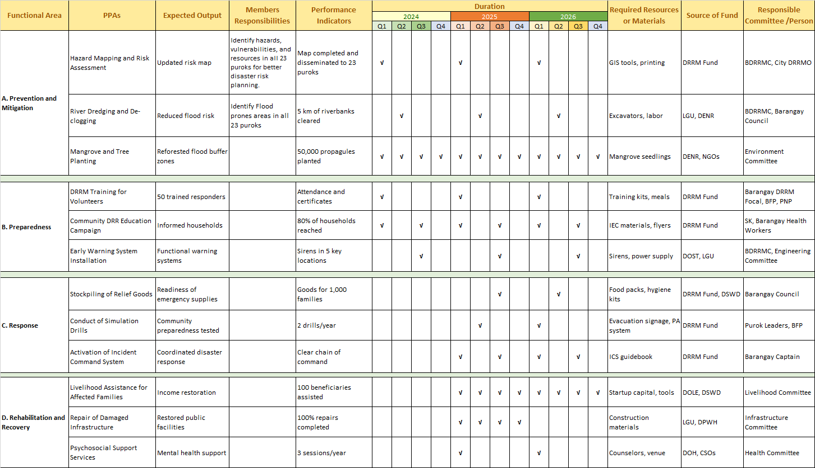
DETAILED PROGRAMS, PROJECTS AND ACTIVITIES (PPAs)

Project, Program, Activities | Expected Output | How to Monitor  MONITORING AND EVALUATION | Who will Monitor | When or how many times the monitoring and evaluation will be done | Reports or forms and documents to be used | Prepared by: | Submitted to:
Hazard Mapping and Risk Assessment | Updated risk map | Field validation and barangay consultation | BDRRMC, City DRRMO | Quarterly | Mapping reports, GIS outputs | Barangay DRRM Focal | ICDRRMO
River Dredging and De-clogging | Reduced flood risk | Site inspection, photo documentation | BDRRMC, Barangay Council | Biannually | Inspection forms, before-and-after photos | Barangay Secretary | City Engineering Office
Mangrove and Tree Planting | Reforested flood buffer zones | Survival rate surveys | Environment Committee | Semi-annually | Seedling monitoring forms | Committee Chair | CENRO/DENR
DRRM Training for Volunteers | 50 trained responders | Attendance, feedback surveys | BDRRMC, BFP, PNP | Annually | Training attendance and evaluation forms | Barangay DRRM Focal | ICDRRMO
Early Warning System Installation | Functional sirens in key areas | Equipment checks, feedback | BDRRMC, Engineering Committee | Quarterly | Maintenance logbooks | Punong Barangay | ICDRRMO, DOST

Note: The assigned monitoring group or sub-committee is required to submit reports on the monitoring and evaluation results every time there is a BDRRMC’ or Barangay Development Council’s meeting.

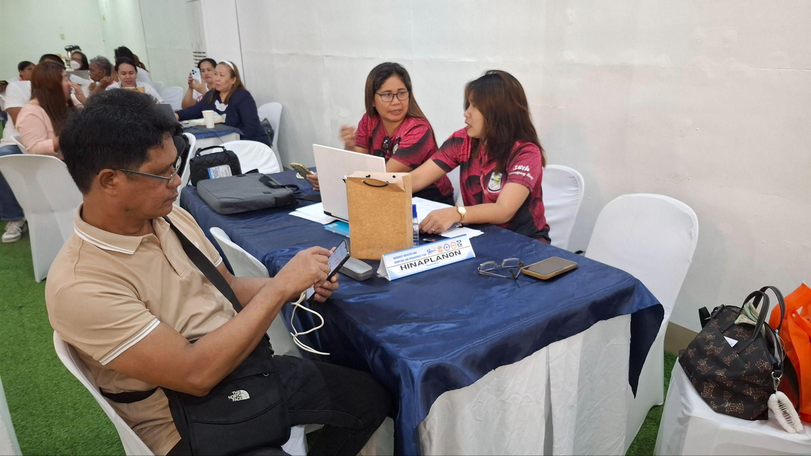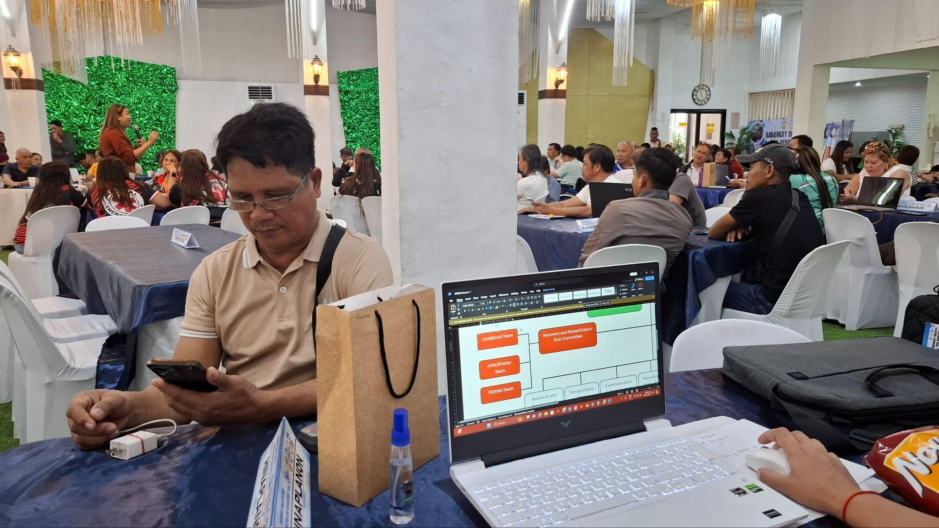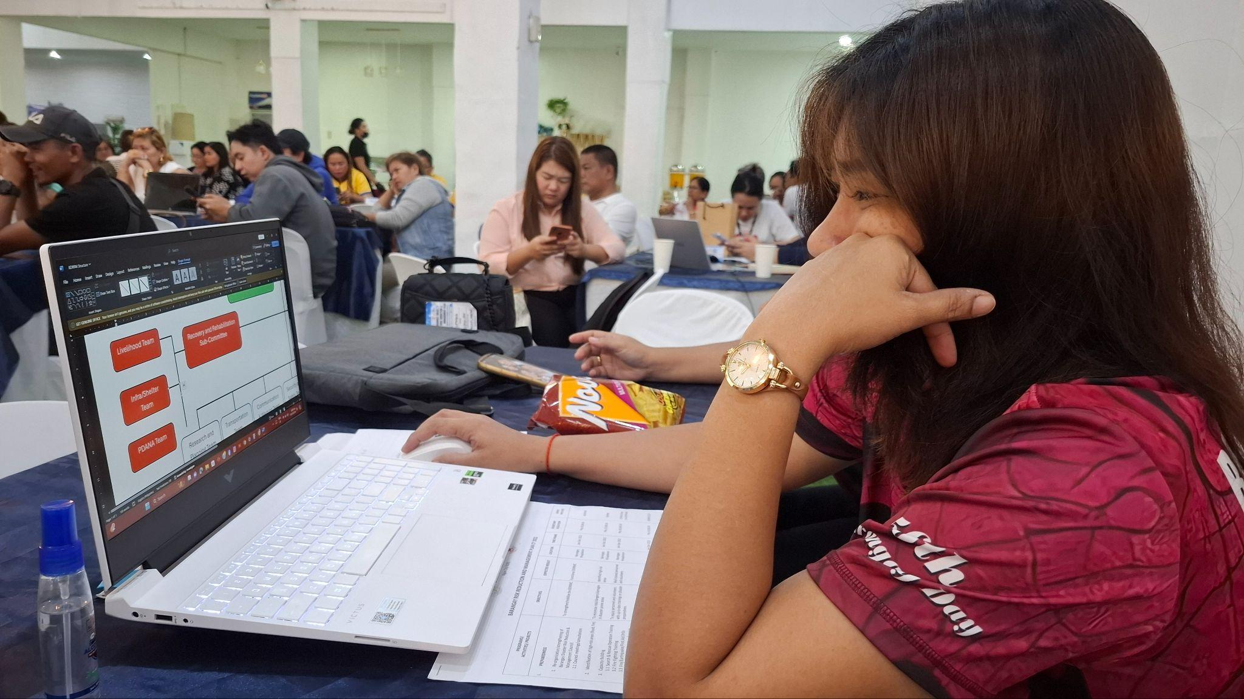

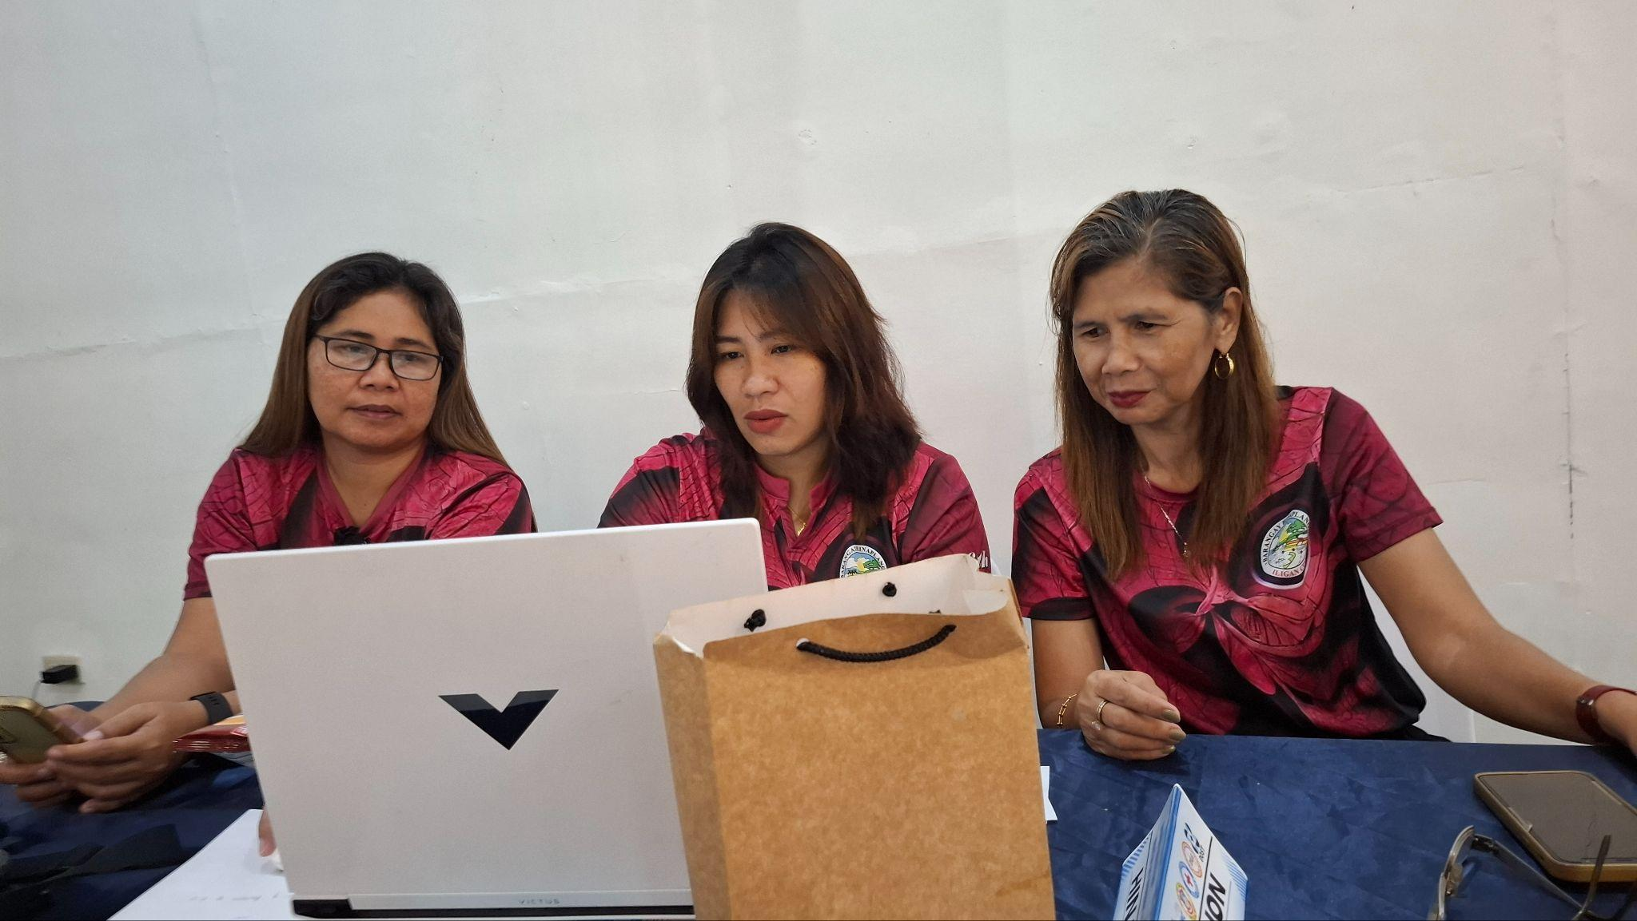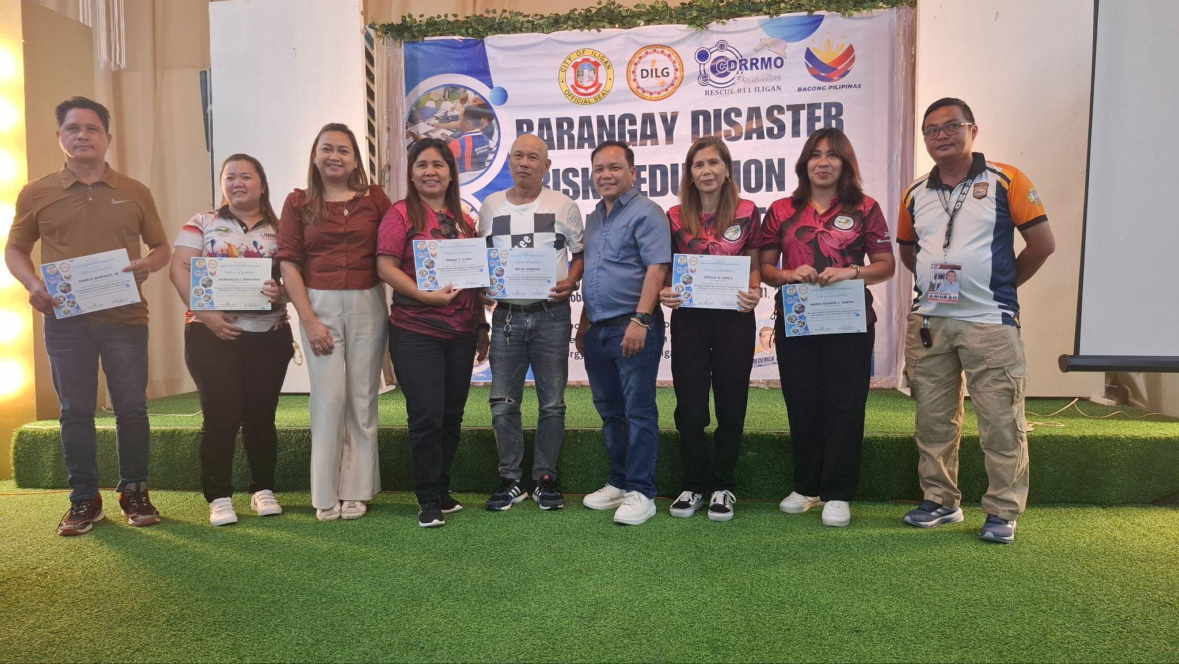

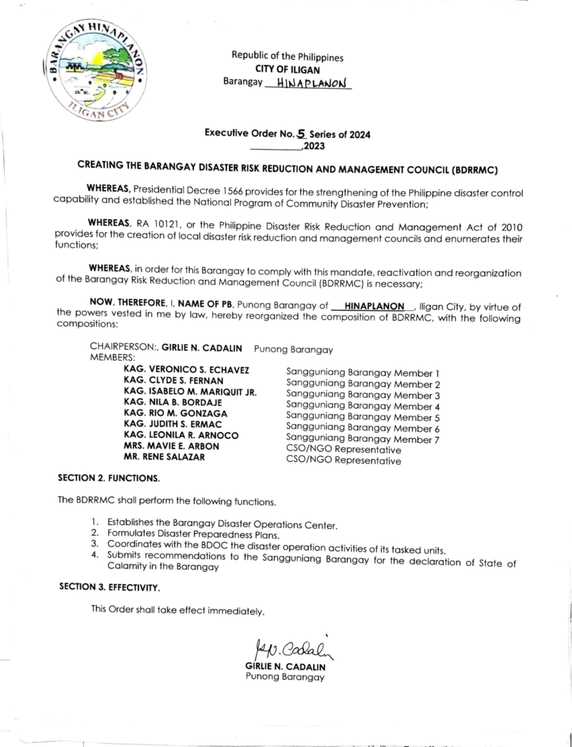
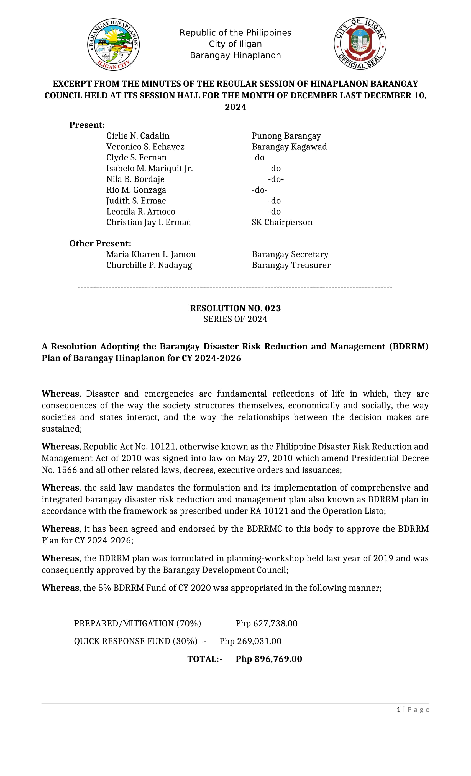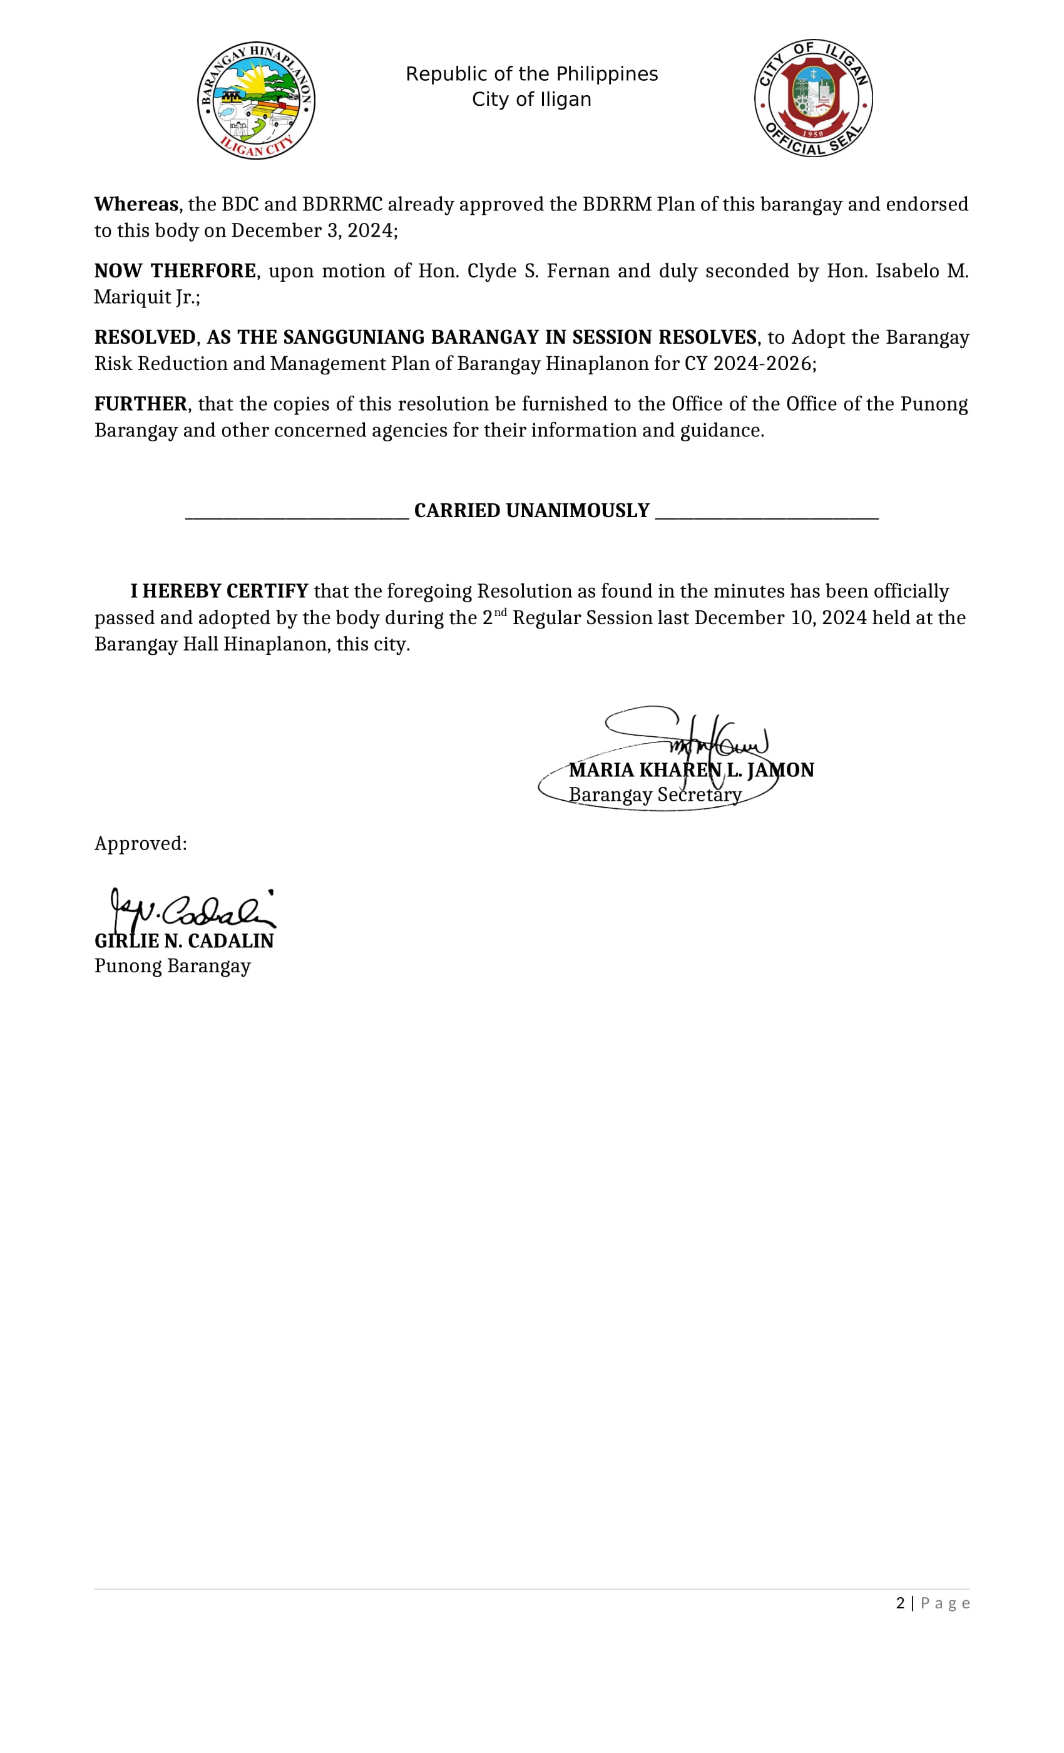
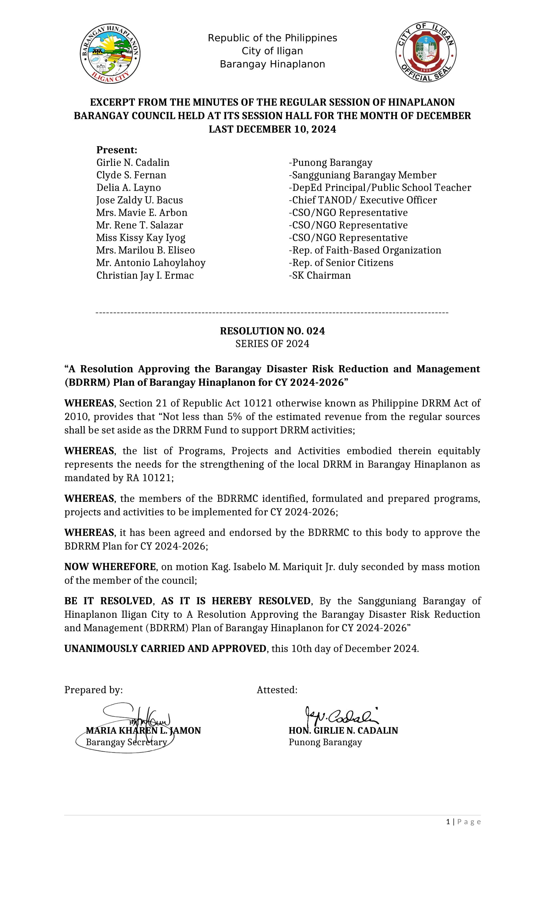

ANNEXES OF BDRRM PLAN

Sangguniang Barangay Resolution adopting the BDRRM Plan
Sangguniang Barangay Ordinance on the Utilization of BDRRM fund
EO on the Creation and Composition of BDRRM Committee
Specific Members of the Committee and other Partners (Directory)
Memorandums of Agreement (MOA) o Memorandum of Understanding (MOU) with partners (schools, private and others)
Protocols (Communication, Relief, Response, etc)
Contingency Plan
Photos
Others

