A brief introduction on using R to fit mixed models

The R package has a number of functions that fit mixed models. Two main functions are lme in the nlme package and lmer in the lme4 package. Selected functions in the lme4 package require functions in the Matrix package. My analysis uses the psid data in the faraway package (which contains data sets and functions used in Faraway’s book ``Extending the Linear Model with R.’’) and graphing functions in the lattice package. All of these packages are available from CRAN and needed to be loaded in R prior to the analysis.

A main difference between lme and lmer is that lme allows correlated within individual fluctuations that are a standard part of many longitudinal analyses, whereas lmer apparently does not, except if they are induced by random effects. Using SAS terminology, lme allows for more flexibility in the repeated specification of the model and lmer allows more flexibility in the random specification of the model. This is an overly simplistic assessment of the capabilities of these functions. Jack Weiss’ web site for his Ecology 145 class at UNC http://www.unc.edu/courses/2006spring/ecol/145/001 nicely illustrates some of the more compelling features of R for mixed model analysis.

The Panel Study of Income Dynamics (PSID) is a longitudinal study of a representative sample of US individuals. The study began in 1968 and continues to this day. There are currently over 8000 households in the study. Faraway analyzed data from a sample of 85 heads-of-households who were age 25-39 in 1968 and had complete data for at least 11 of the years between 1968 and 1990. He considered the following variables in his analysis: annual income, gender, years of education and age in 1968.

Loading the psid data and examining the first few and last few cases, using the head and tail functions shows the relevant variables. Note that age is at baseline level and does not change within a person. Education was not defined to be education level at baseline, but a quick assessment of the data suggests that it does not change for any head-of-household in the data set.

> data(psid)

> head(psid)

age educ sex income year person

1 31 12 M 6000 68 1
2 31 12 M 5300 69 1
3 31 12 M 5200 70 1
4 31 12 M 6900 71 1
5 31 12 M 7500 72 1
6 31 12 M 8000 73 1

> tail(psid)

age educ sex income year person
1949 33 6 M 4050 84 85
1950 33 6 M 6000 85 85
1951 33 6 M 7000 86 85
1952 33 6 M 10000 87 85
1953 33 6 M 10000 88 85
1954 33 6 M 2000 89 85

Our analysis will focus on modeling income as a function of time. Here is a plot of income and time for a subset of individuals. I will try to verbally explain the various parameters in the code.

> xyplot(income ~ year | person, psid, type="l", subset= (person < 21),strip=FALSE)

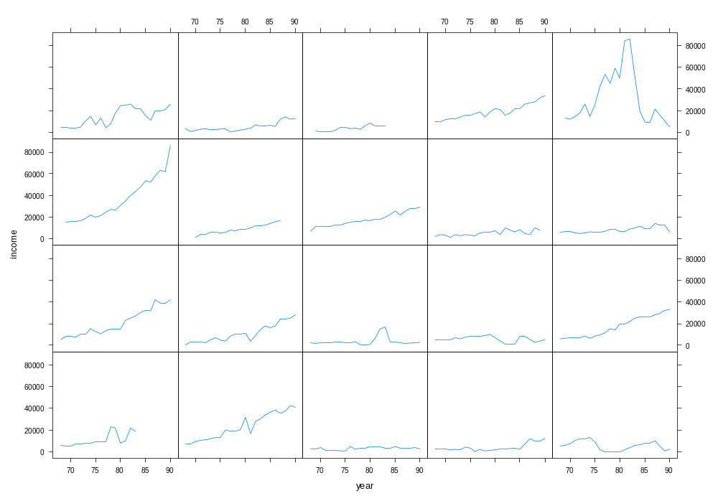

We see that some individuals have a slowly increasing income, typical of persons with a steady income, whereas the trend for others is more erratic. In practice, income is typically analyzed on a log scale. Here are side-by-side boxplots of the raw income distributions on a log scale. The latter 2 boxplots add 100 and 1000 to income before taking the log transformation, as a means of potentially shrinking the lower tail of the income distribution, thereby eliminating the effect of some households having very low incomes for short periods of time.

> vv = psid$income

> boxplot(log(vv),log(vv+100),log(vv+1000))

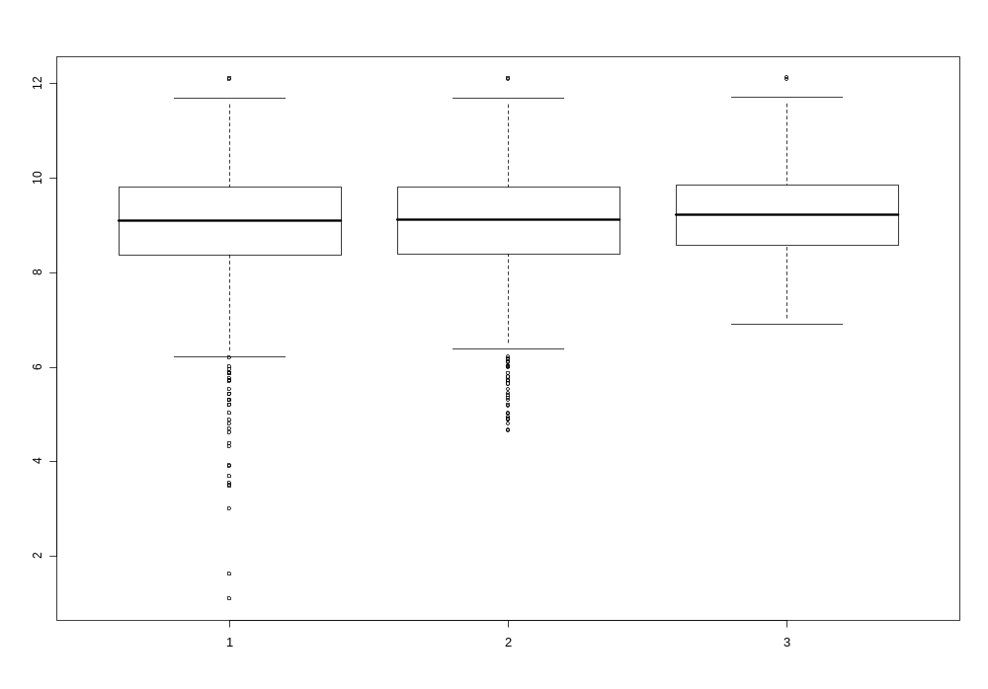

Having settled on log(income + 1000) as a response, I made spaghetti plots of the individual trajectories, one plot for males and one for females. Faraway comments that male incomes are typically higher and less variable while female incomes are more variable, but perhaps increasing more quickly.

> xyplot( log(income+1000) ~ year | sex, psid, type="l")
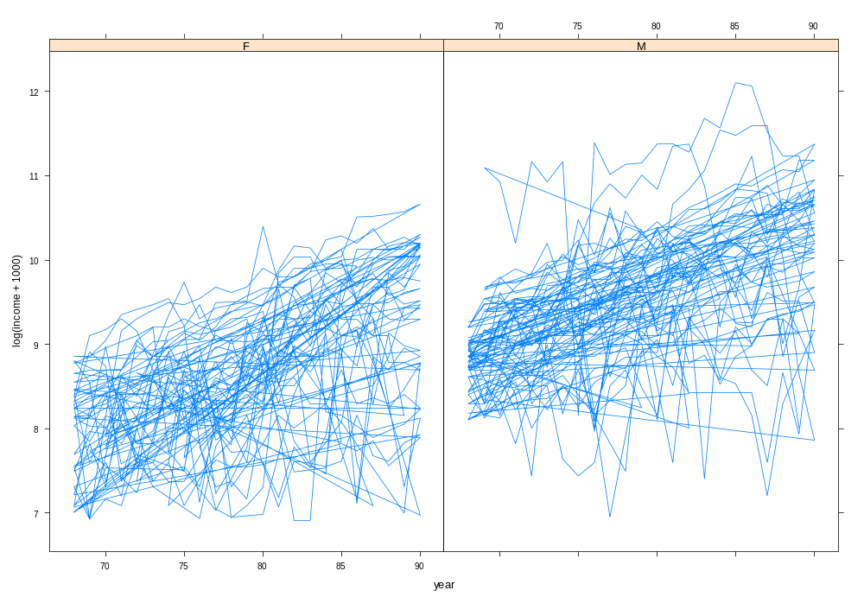

Let us continue with some further exploratory analysis. In the code below, I create numerical vectors of length 85 (the number of persons in our data set) and then fit by least squares a linear relationship between log(income+1000) and year. I centered year at
1978 (the midpoint in time), so that the intercept is mean income in 1978. The I( ) function in the formula is used to inhibit the interpretation of the minus sign operator as a formula operator, so it is correctly used. I then plotted the intercepts against the slopes for the 85 fits. It would appear that the relationship between intercepts and slopes is very weak – that is, rate of change of income does not appear to be related to the overall level of income.

> slopes = numeric(85); intercepts = numeric(85)

> for (i in 1:85) {

+ lmod = lm( log(income+1000) ~ I(year-78), subset = (person==i), psid)

+ intercepts[i] = coef(lmod)[1]

+ slopes[i] = coef(lmod)[2]

+ }

> plot(intercepts, slopes, xlab="Intercept", ylab="Slope")

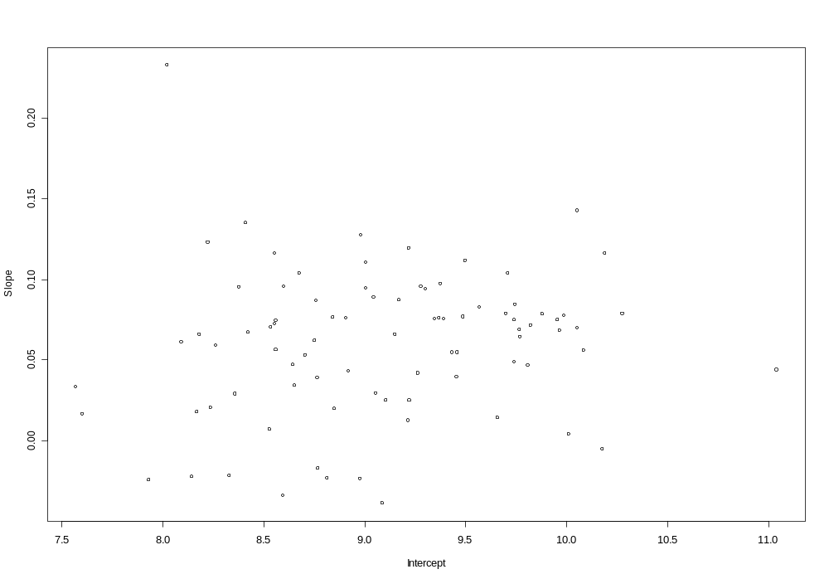

As a next step, I considered the distribution of slopes by sex. To do this I needed a way to identify which slopes corresponded to males and which to females. I can determine this by matching person labels 1 to 85 with rows in data set. The first R command below can be interpreted in 2 steps: first select 1 row in psid for which the person ID matches a given value between 1 and 85, and then assign the sex of that person to the variable psex. From the output below we see that psex contains 85 M and F labels, as desired. I then made side-by-side boxplots, splitting the slopes into groups defined by psex – i.e. one boxplot for males, one for females.

> psex = psid$sex[match(1:85,psid$person)]

> psex

[1] M M F F F M F F F M M F M M M M F F M M F F F M M F F F M M F M F F M M M M M M F M F F F F M M M F F M M F M M M M M M M M F F F F M M M M M M M F M M F F F F F F F F M

Levels: F M

> boxplot( split (slopes, psex) )
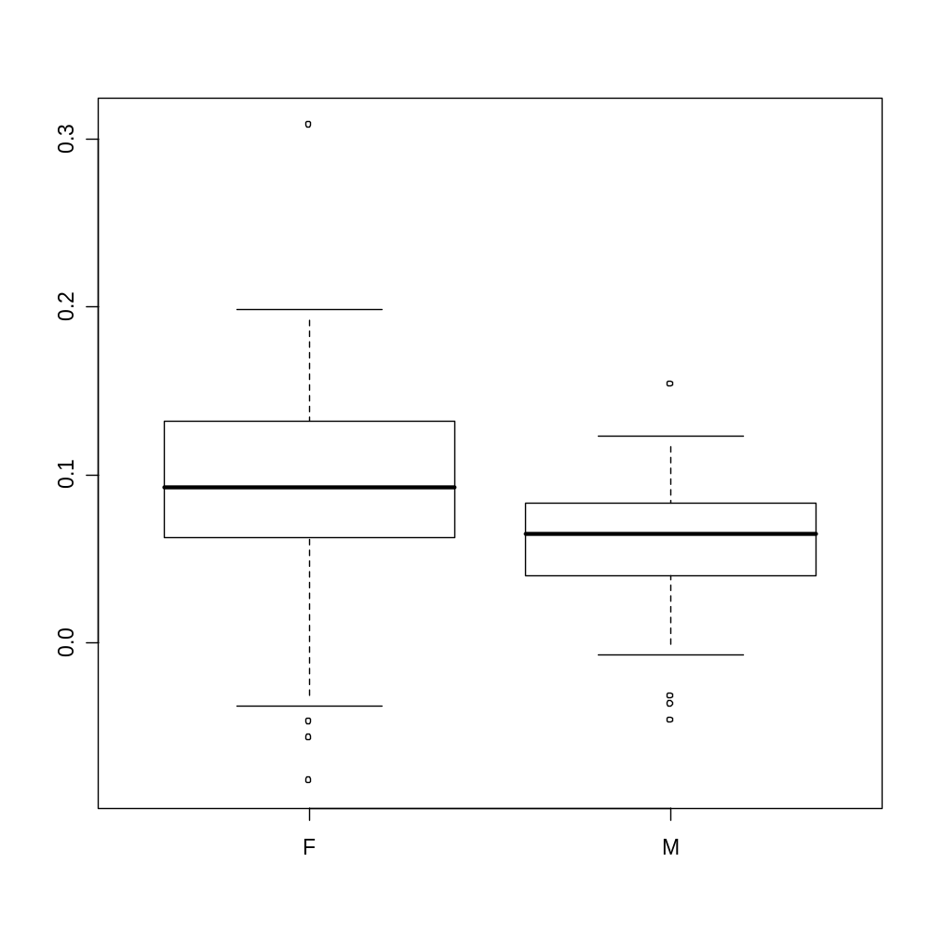

We clearly see that the rate of change for women’s income is typically greater than that for men. A similar summary for the intercepts show that the typical intercept for females to be lower than that for men – what does this mean?

> boxplot( split (intercepts, psex) )

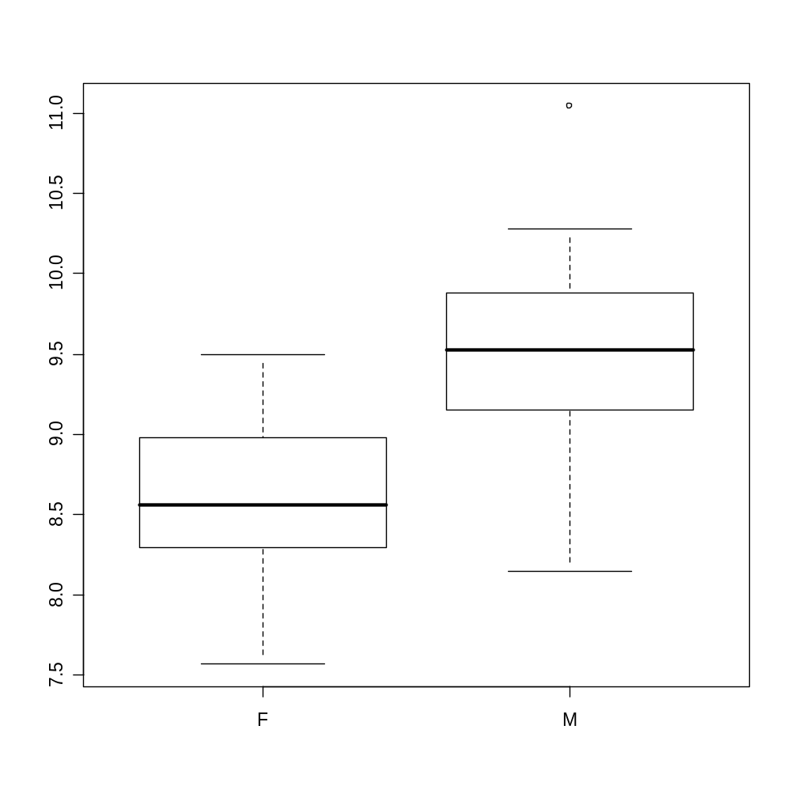

Continuing with the exploratory analysis, I computed 2-sample t-tests comparing the mean intercepts and slopes for males and females. Here, “x” is M and “y” is F in the mean summary (which then tells you what difference the CI is considering). We see significant differences in mean slope and intercepts between sexes, with females having higher average slope and lower average intercept, as observed in the boxplots.

> t.test( slopes[ psex=="M" ], slopes[ psex=="F" ] )

Welch Two Sample t-test

t = -2.3786, df = 56.736, p-value = 0.02077

alternative hypothesis: true difference in means is not equal to 0

95 percent confidence interval: -0.05916871 -0.00507729

mean of x mean of y

0.05691046 0.08903346

> t.test( intercepts[ psex=="M" ], intercepts[ psex=="F" ] )

Welch Two Sample t-test

t = 8.2199, df = 79.719, p-value = 3.065e-12

alternative hypothesis: true difference in means is not equal to 0

95 percent confidence interval: 0.8738792 1.4322218

mean of x mean of y

9.382325 8.229275

As a next step I created a centered age variable (cyear) and stored it in the psid data frame. Following Faraway’s lead, consider a model where the mean income (transformed) changes linearly with time. The model has subject specific intercepts and slopes that follow a bivariate normal distribution. The population average intercept is modeled as a function of baseline education, age and sex, whereas the population average slope varies with sex. This corresponds to a model with fixed effects for time, education, age, sex and a sex-by-time interaction, and random effects for the intercept and the time coefficient. In lme, we specify the fixed effects part of the model using a standard glm formulation (recall how the formula was written in R for a glm). Specifying a cyear*sex interaction includes a main effect for year and time in addition to a product term between year and sex. The analysis uses females as the baseline group – note the parameter effects summary indicates a sexM (male effect), which means that the single binary indicator chosen to represent sex is 1 for males and 0 for females, so women are the baseline group. Thus we have a DGP here with the intercept and time effect giving the female intercept and time coefficient, while the sexM coefficient and the cyear:sexM coefficient give the difference in intercepts and time effects between males and females.
The random intercept and time coefficients are indicated following the random = ~ syntax. The | person syntax indicates that person is the grouping variable. The last bit of syntax psid identifies the data frame containing all the variables referenced in the lme command. The model does not specify a correlation structure for the within individual fluctuations so these are assumed to be independent with common variance. Unless a fitting method is specified, REML is used. The lme help describes how to change the fitting routine to ML or to use a different structure for the within individual fluctuations.

> psid$cyear = psid$year – 78

> mmod = lme ( log(income+1000) ~ age + educ + cyear*sex, random = ~ 1 + cyear | person, psid)

Looking at the summaries, we see the model AIC and BIC, and estimated standard deviations (not variances) for the two random effects (intercept and slope) and the within individual component. The correlation between intercepts and slopes is also given. It should not be to surprising that the estimated variability in intercepts far exceeds the estimated variability in slopes (WHY?). In the fixed effects summary we see that the sexM coefficient is positive and the cyear:sexM coefficient is negative – this is consistent with the boxplots seen earlier. Interestingly, after adjusting for age and education, the sex-by-time interaction is not significant, implying the population average rate of change in income for males and females (i.e. slope coefficients for time) are not significantly different. Similarly, the population mean intercept does not appear to depend on the baseline age.

> summary(mmod)

Linear mixed-effects model fit by REML

Data: psid

AIC BIC logLik
2311.209 2365.325 -1145.605

Random effects:

Formula: ~1 + cyear | person

Structure: General positive-definite, Log-Cholesky parametrization

StdDev Corr

(Intercept) 0.42459709 (Intr)
cyear 0.03946496 0.303
Residual 0.42170164

Fixed effects: log(income + 1000) ~ age + educ + cyear * sex

Value Std.Error DF t-value p-value

(Intercept) 7.331250 0.4159016 1574 17.627364 0.0000
age 0.008292 0.0103533 81 0.800946 0.4255
educ 0.086905 0.0163808 81 5.305278 0.0000
cyear 0.066377 0.0068954 1574 9.626216 0.0000
sexM 0.890944 0.0952837 81 9.350433 0.0000
cyear:sexM -0.012141 0.0093858 1574 -1.293535 0.1960

Correlation:
(Intr) age educ cyear sexM Estimated correlations
between estimated
regression coefficients
age -0.873
educ -0.595 0.166
cyear 0.043 0.000 0.000
sexM -0.110 -0.023 0.010 -0.188
cyear:sexM -0.025 -0.005 -0.006 -0.735 0.271

Standardized Within-Group Residuals:

Min Q1 Med Q3 Max
-6.2724002 -0.3199546 0.0648636 0.4750799 3.5389011

Number of Observations: 1661
Number of Groups: 85

The VarCorr command applied to the fitted object gives estimated variance components.

> VarCorr(mmod)

person = pdLogChol(1 + cyear)

Variance StdDev Corr
(Intercept) 0.180282692 0.42459709 (Intr)
cyear 0.001557483 0.03946496 0.303
Residual 0.177832274 0.42170164

The intervals command applied to the fitted object gives approximate confidence intervals for all the parameters in the model. For the variance structure, the CI are for standard deviations and correlations versus variances and covariances.

> intervals(mmod)

Approximate 95% confidence intervals

Fixed effects:
lower est. upper

(Intercept) 6.51547015 7.331249681 8.14702921
age -0.01230735 0.008292403 0.02889216
educ 0.05431209 0.086904766 0.11949745
cyear 0.05285179 0.066377012 0.07990223
sexM 0.70135900 0.890943619 1.08052824
cyear:sexM -0.03055076 -0.012140826 0.00626911

Random Effects:

Level: person
lower est. upper

sd((Intercept)) 0.36059408 0.42459709 0.49996021
sd(cyear) 0.03284476 0.03946496 0.04741952
cor((Intercept),cyear) 0.05858404 0.30312428 0.51334539

Within-group standard error:

lower est. upper

0.4068097 0.4217016 0.4371387

The next command makes a residual plot for the fitted model. Note that for glms this command gave much richer output (leverages, Cook’s D etc.). Here we get a basic plot of standardized residuals against fitted values, where I believe both summaries include predicted random effects. Nothing obvious is apparent in the plot.

> plot(mmod)

> qqmath(~resid(mmod)| sex, psid)
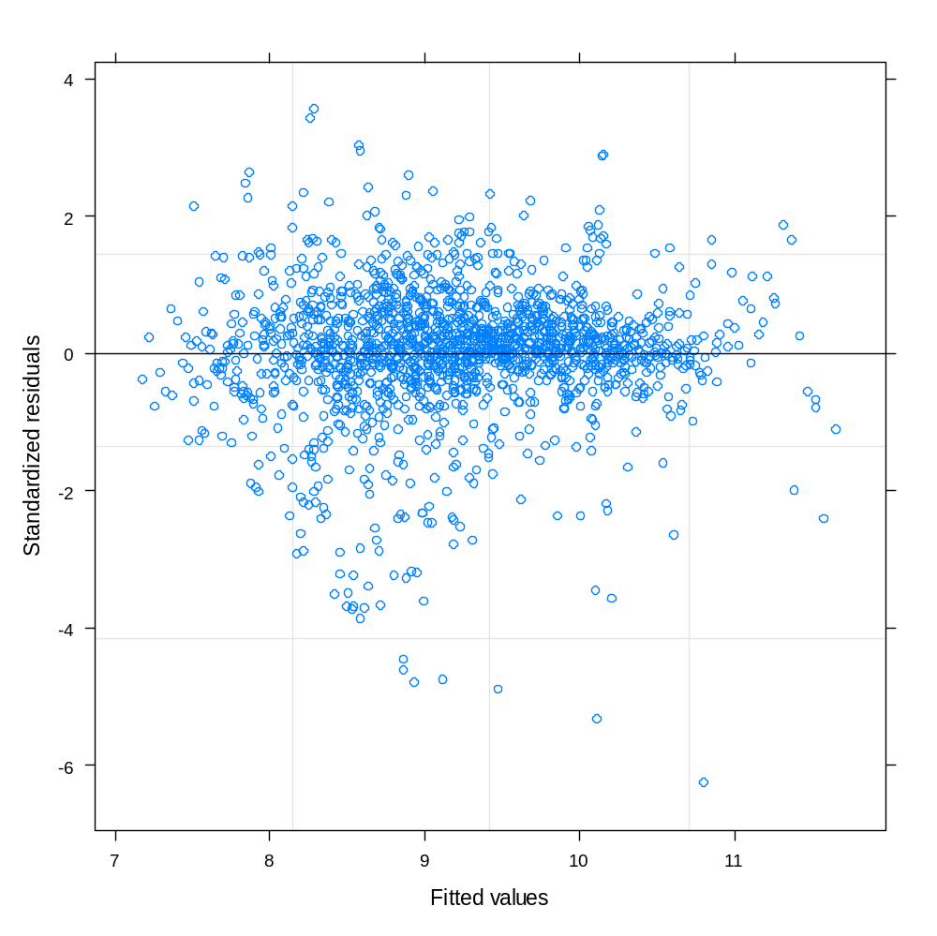

The following command (available in lattice library) generates qq plots for the residuals by sex. A nice view of the distribution of the residuals is obtained by boxplots, so that was considered as well. The distribution of residuals appears heavy tailed, both for males and females.

> qqmath(~resid(mmod)| sex, psid)

> boxplot( split ( resid(mmod), psid$sex ) )
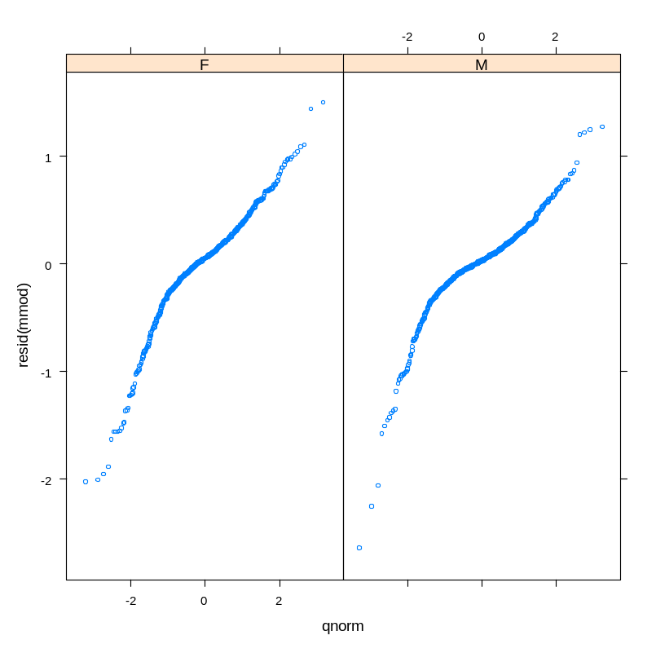

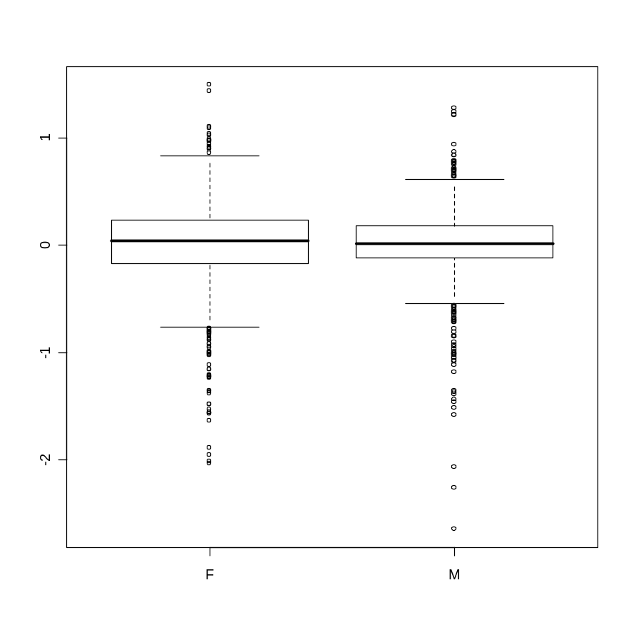
To illustrate another option, the ranef( ) command provides estimates of the subject specific random effects (i.e. deviations from population mean intercepts and slopes). A bivariate plot shows the weak estimated correlation between the intercepts and slopes, and the greater variation in intercepts and slopes.

> rf = ranef(mmod)
> head(rf)

(Intercept) cyear

1 -0.042719023 0.0165546405
2 0.031661254 0.0214645402
3 -0.177982363 -0.0410504350
4 0.070680580 -0.0062430843
5 -0.341951875 -0.0894904947

> plot( rf[,1], rf[,2], xlab = " Intercept ", ylab = " Slope " )
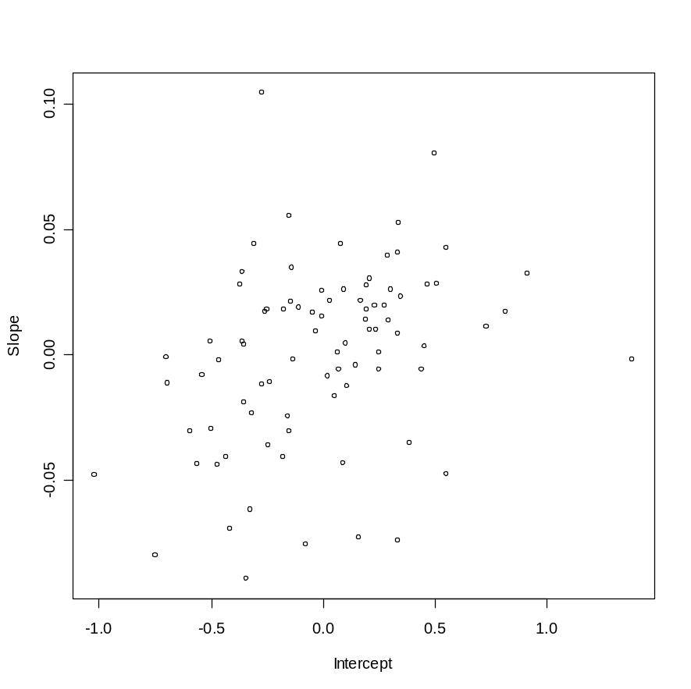

What are further steps in the analysis? Weiss’s notes show how to create subject specific trajectories for mixed models using R output and other analysis features for mixed models. This is worth examining.

Faraway suggests that an alternative transformation of the response is warranted to deal with the non-normal residuals, but he does not offer any suggestions. This is clearly a limitation of the model. It is unclear what effect the non-normality has on inferences here, but in general standard tests for normality are somewhat conservative with heavy tailed distributions.

