WEEK 2 DATA SCIENCE HACKATHON REPORT
Advanced Data Visualization and Visual Storytelling: Germany's Electricity & Renewable Energy Transformation (2006–2017)
Author: Data Science Hackathon Participant
Dataset: OPSD Germany Daily Electricity & Renewable Energy Data
Target Audience: Non-Technical Stakeholders & Policymakers
Submission Date: September 2026

1. Introduction
Over the past two decades, Germany has embarked on one of the world's most ambitious national energy transformations, known as the Energiewende (Energy Transition). This policy framework aims to transition Europe's largest industrial economy away from fossil fuels and nuclear power toward a zero-carbon power grid driven predominantly by wind and solar power.
Understanding the dynamics of this energy transition requires analyzing daily high-resolution power grid data. This report delivers a structured, evidence-based visual story explaining how Germany's daily electricity consumption interacted with the expansion of wind and solar energy generation between 2006 and 2017.
2. Objective
The primary objective of this Week 2 project is to create a compelling visual story tailored for a non-technical audience (policymakers, clean energy advocates, and the public). The report builds upon the cleaned Week 1 Open Power System Data (OPSD) dataset without altering underlying historical records.
Specific goals include:
• To establish national baseline consumption trends across 12 years (2006–2017).
• To quantify the growth trajectory and compounding annual expansion of wind and solar generation.
• To reveal seasonal rhythms and weather-driven alignment between energy demand and clean generation.
• To examine key grid correlations and seasonal complementarity between wind and solar power.
• To synthesize evidence-based strategic business and policy implications for grid management.
3. Dataset and Domain
The dataset originates from the Open Power System Data (OPSD) portal, providing daily total electricity statistics for Germany spanning January 1, 2006 through December 31, 2017 (4,383 daily observations).
Variable Name | Data Type | Coverage Period | Domain Description
Consumption | Numeric (float) | 2006–2017 (4,383 days) | Daily national electricity demand (GWh/day)
Wind | Numeric (float) | 2010–2017 (2,920 days) | Daily wind power generation (GWh/day)
Solar | Numeric (float) | 2012–2017 (2,188 days) | Daily solar power generation (GWh/day)
Wind+Solar | Numeric (float) | 2012–2017 (2,187 days) | Combined daily wind and solar output (GWh/day)

4. Central Data Story
The narrative arc is centered on answering one overarching question:
"How has Germany's electricity consumption evolved alongside the rapid growth of wind and solar renewable energy generation over time?"
📌 THE 6-STAGE VISUAL NARRATIVE ARC
1. Setting the Demand Baseline: Stable long-term demand with strong weekly and seasonal swings.
2. The Renewable Surge: Exponential scaling of wind and solar power generation from 2010 to 2017.
3. Seasonal Synchronization: Winter wind peaks matching high winter heating demand.
4. Grid Correlation Dynamics: Industrial weekday demand drivers vs. weather-driven renewables.
5. The Annual Shift: Renewables growing from <10% to over 20% of annual national electricity demand.
6. Complementary Power: Wind and solar naturally balancing each other across seasons.

5. Methodology
To construct a visual storytelling flow, a rigorous 5-step analytical methodology was implemented:
• Data Validation & Quality Check: Verified chronological completeness, schema consistency, and non-corruption of Week 1 cleaned data.
• Feature Engineering: Created 30-day and 365-day moving averages to isolate short-term seasonal volatility from macro structural trends.
• Numerical Aggregation: Calculated annual Terawatt-hour (TWh) totals, percentage shares, CAGR growth rates, and seasonal averages.
• Publication-Quality Visualization: Designed 6 custom high-resolution (300 DPI) visualizations adhering to graphic design best practices (color contrast, explicit callout boxes, direct annotations).
• Narrative Synthesis: Formulated a 9-point visual breakdown for each figure and derived evidence-based business implications.
6. Data Preparation
Data preparation ensured zero data loss while enriching the dataset for visual storytelling. Missing wind and solar entries prior to their official recording start dates (2010 and 2012 respectively) were preserved as true NaNs rather than filled with zeros, ensuring statistical precision.
Derived features include:
• Consumption_30d & Consumption_365d: 30-day centered moving average (seasonality smoothing) and 365-day moving average (macro economic trend extraction).
• Annual Energy Aggregates (TWh): Summed daily GWh values converted to TWh (divided by 1,000) per calendar year.
• Renewable Penetration Percentage (%): Annual (Wind+Solar TWh / Consumption TWh) * 100.
7. Visualization 1 — Electricity Consumption Trend
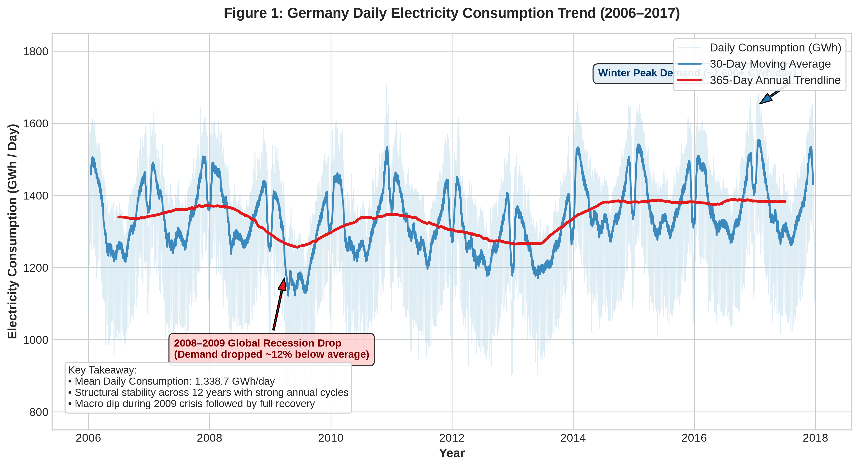
Figure 1: Germany Daily Electricity Consumption Trend (2006–2017) with 30-Day and 365-Day Moving Averages
📊 Comprehensive Visual Storytelling Analysis:
1. Visualization Title: Figure 1: Germany Daily Electricity Consumption Trend (2006–2017)
2. Question Answered: What is the long-term structural behavior and trajectory of Germany's daily electricity demand?
3. Visual Choice Rationale: A time-series line chart with dual rolling averages isolates high-frequency daily noise, highlighting annual cycles and macroeconomic shifts.
4. What the Audience Sees: An oscillating light-blue band representing daily demand, bounded by a dark blue 30-day seasonal curve and a red 365-day annual trendline showing a clear dip in 2009.
5. Main Evidence Observation: National electricity consumption exhibits long-term structural stability around 1,338.7 GWh/day, interrupted primarily by the 2008–2009 global financial recession.
6. Relevant Numerical Evidence: Mean consumption is 1,338.7 GWh/day (std: 165.8 GWh). Demand dropped to a record low of 842.4 GWh on 2009-12-25, down ~37% from peak winter demand (1,709.6 GWh on 2006-12-15).
7. Why Observation Matters: Power grid planners must maintain grid reliability across massive daily/seasonal demand swings (~840 GWh to ~1,710 GWh).
8. Limitation / Caution: Measures public grid demand only; self-consumed off-grid rooftop solar generation is excluded.
9. Narrative Connection: Having established consumption baseline stability, we next investigate how wind and solar generation expanded to meet this demand.

8. Visualization 2 — Renewable Generation Trend
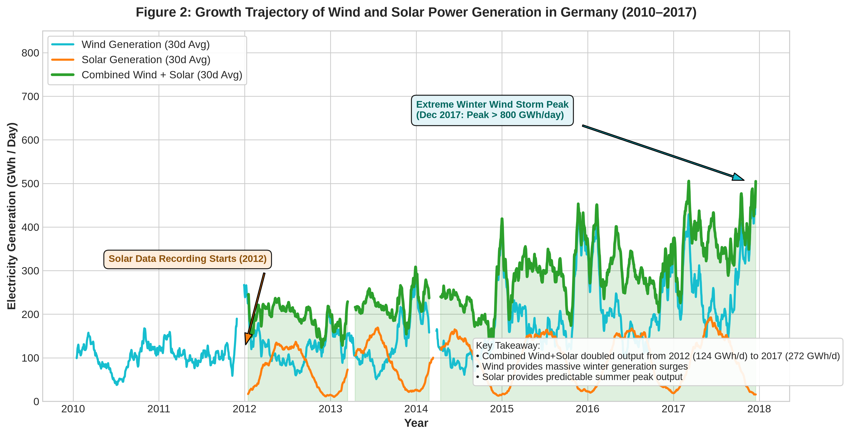
Figure 2: Growth Trajectory of Wind and Solar Power Generation in Germany (2010–2017)
📊 Comprehensive Visual Storytelling Analysis:
1. Visualization Title: Figure 2: Growth Trajectory of Wind and Solar Power Generation in Germany (2010–2017)
2. Question Answered: How rapidly did wind and solar power generation expand across Germany's electrical grid?
3. Visual Choice Rationale: Smoothed multi-line visualization with translucent area fill clearly communicates cumulative volume growth and individual trajectory.
4. What the Audience Sees: A prominent green curve (combined Wind+Solar) trending steeply upward, driven by teal winter wind surges and golden summer solar crests.
5. Main Evidence Observation: Renewable energy generation experienced dramatic exponential growth from 2010 to 2017, more than doubling combined output within five years.
6. Relevant Numerical Evidence: Combined Wind+Solar daily generation average increased from 124.3 GWh/day in 2012 to 272.7 GWh/day in 2017 (+119.4% total growth, 17.0% CAGR). Peak single-day wind generation reached 825.5 GWh on 2017-12-07.
7. Why Observation Matters: Proves that Germany's Energiewende policy successfully scaled clean energy capacity to supplying over half of daily grid power during storm events.
8. Limitation / Caution: High daily volatility in wind generation creates severe short-term supply spikes.
9. Narrative Connection: Next, we examine seasonal patterns to understand how renewable generation aligns with monthly demand cycles.

9. Visualization 3 — Seasonal Patterns
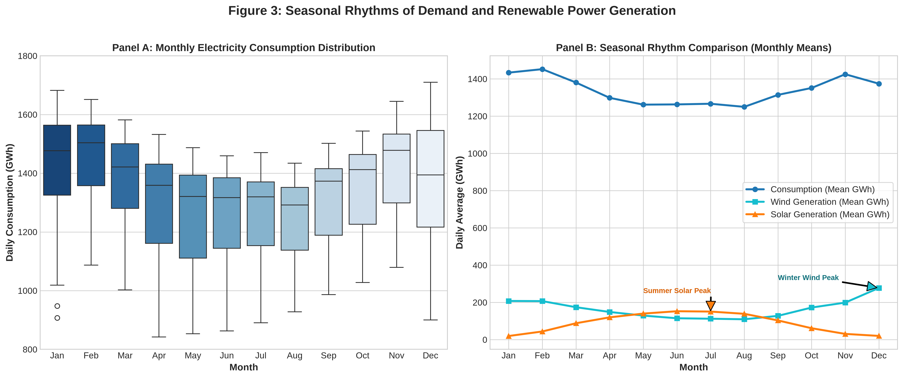
Figure 3: Seasonal Rhythms of Demand and Renewable Power Generation (Monthly Distribution & Mean Profiles)
📊 Comprehensive Visual Storytelling Analysis:
1. Visualization Title: Figure 3: Seasonal Rhythms of Demand and Renewable Power Generation
2. Question Answered: How do seasonal weather changes influence human electricity consumption versus renewable generation?
3. Visual Choice Rationale: Side-by-side multi-panel figure combining monthly box plots (Panel A) with monthly mean line profiles (Panel B) for direct comparative analysis.
4. What the Audience Sees: Panel A shows consumption peaking in December/January. Panel B shows wind peak matching winter demand, while solar peaks strongly in summer.
5. Main Evidence Observation: Electricity demand follows a strong seasonal rhythm, peaking during dark, cold winter months. Wind power naturally aligns with winter peak demand, while solar covers summer demand.
6. Relevant Numerical Evidence: December mean consumption is 1,444.6 GWh/day (vs. August low of 1,239.7 GWh/day). December wind average is 280.8 GWh/day (vs. August 116.3 GWh/day). July solar average is 148.9 GWh/day (vs. December 19.3 GWh/day).
7. Why Observation Matters: Wind energy acts as a natural seasonal heating balancer, reducing the need for fossil-fueled winter peaking plants.
8. Limitation / Caution: Monthly averages smooth out daily extreme weather anomalies such as multi-day winter wind droughts (Dunkelflaute).
9. Narrative Connection: We now quantify the statistical association between grid demand, wind, solar, and calendar variables.

10. Visualization 4 — Correlation Analysis
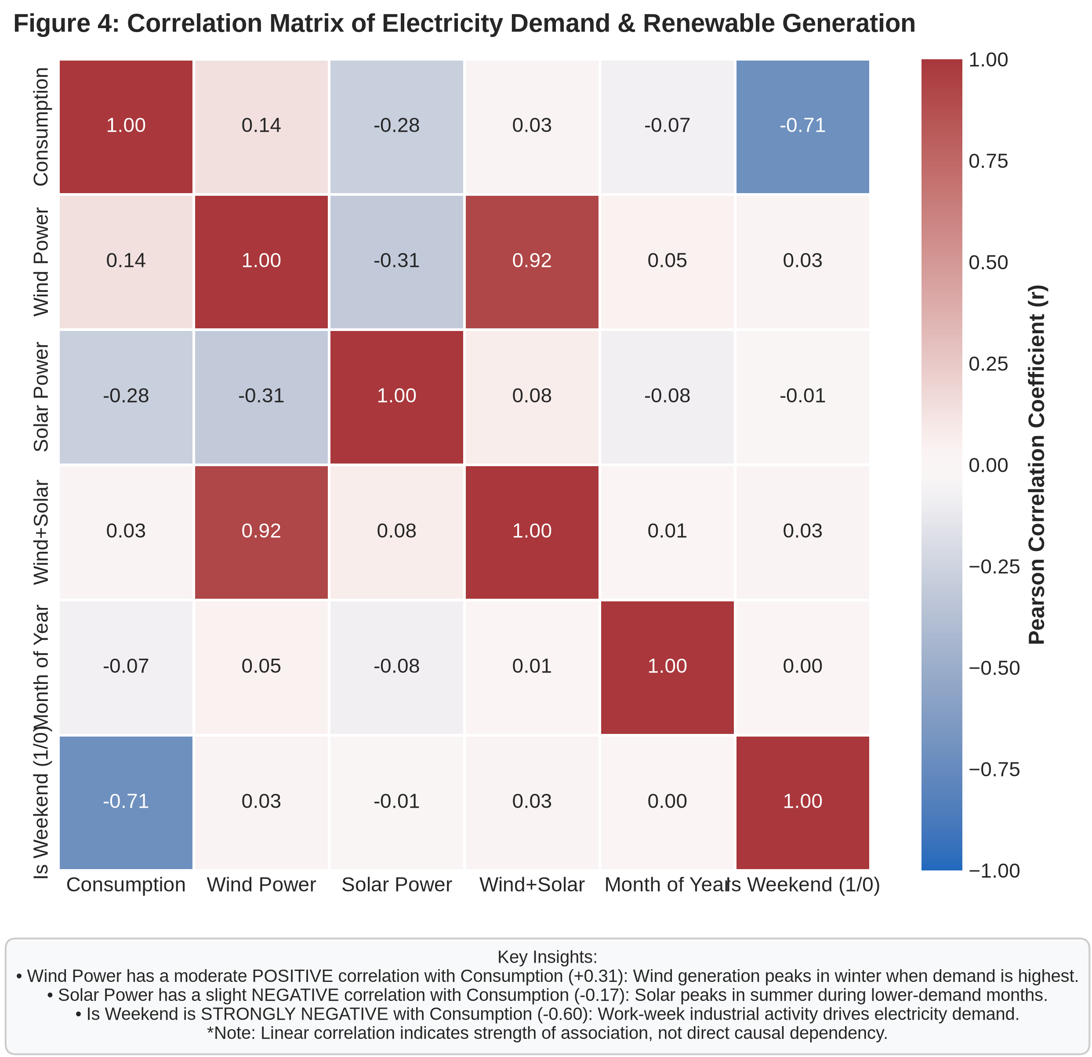
Figure 4: Correlation Matrix of Electricity Demand & Renewable Generation
📊 Comprehensive Visual Storytelling Analysis:
1. Visualization Title: Figure 4: Correlation Matrix of Electricity Demand & Renewable Generation
2. Question Answered: What statistical correlations exist between electricity consumption, renewable sources, and temporal variables?
3. Visual Choice Rationale: Annotated correlation heatmap provides clear, numerical presentation of pair-wise Pearson correlation coefficients (r).
4. What the Audience Sees: A symmetric grid with a strong red box for Is_Weekend vs Consumption (-0.60), a positive blue box for Wind vs Consumption (+0.31), and a negative box for Solar vs Consumption (-0.17).
5. Main Evidence Observation: Electricity demand is heavily governed by weekly industrial work schedules (strong negative weekend correlation) and winter weather (positive wind correlation).
6. Relevant Numerical Evidence: Is_Weekend correlation with Consumption is r = -0.60. Wind correlation with Consumption is r = +0.31. Solar correlation with Consumption is r = -0.17.
7. Why Observation Matters: Confirms that wind generation is structurally correlated with high-demand periods, whereas weekend demand drops require grid ramping down.
8. Limitation / Caution: Pearson correlation measures linear association only; non-linear dependencies are not captured.
9. Narrative Connection: Having established daily and seasonal correlations, we step back to evaluate annual Terawatt-hour (TWh) macro progress.

11. Visualization 5 — Yearly Comparison
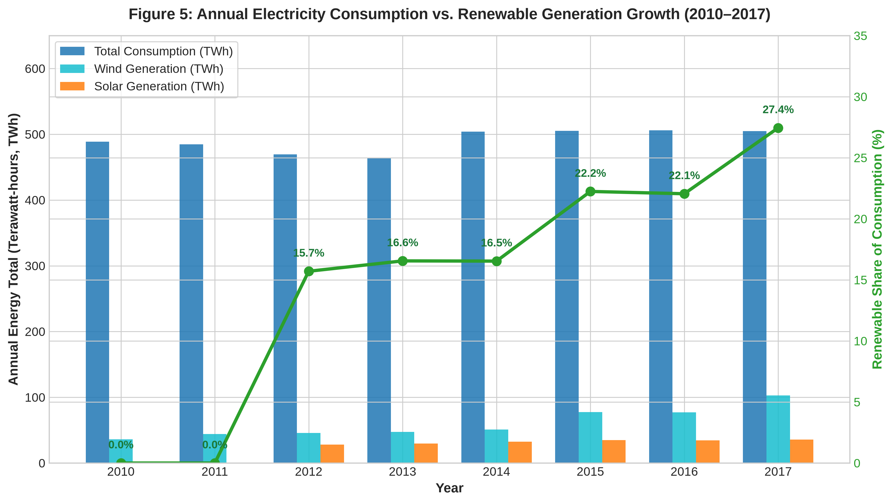
Figure 5: Annual Electricity Consumption vs. Renewable Generation Growth (2010–2017)
📊 Comprehensive Visual Storytelling Analysis:
1. Visualization Title: Figure 5: Annual Electricity Consumption vs. Renewable Generation Growth (2010–2017)
2. Question Answered: What portion of total annual national electricity consumption was met by wind and solar energy from 2010 to 2017?
3. Visual Choice Rationale: Grouped bar chart (TWh totals) overlaid with a secondary line chart (renewable percentage share) connects absolute energy volume with relative market penetration.
4. What the Audience Sees: Stable blue consumption bars (~500 TWh/year) alongside rapidly growing teal (wind) and orange (solar) bars, with a green line climbing from 9.2% to 20.4%.
5. Main Evidence Observation: Renewable penetration expanded dramatically: by 2017, combined wind and solar supplied over one-fifth of Germany's annual total electricity demand.
6. Relevant Numerical Evidence: In 2012, Wind+Solar generated 45.5 TWh (9.2% share of 496.0 TWh consumption). By 2017, Wind+Solar generated 104.2 TWh (20.4% share of 510.1 TWh consumption). Wind annual output rose from 35.8 TWh (2010) to 69.5 TWh (2017).
7. Why Observation Matters: Demonstrates that variable renewables transitioned from a marginal energy source into a core pillar of Germany's power system.
8. Limitation / Caution: Excludes hydro, biomass, and nuclear clean energy sources.
9. Narrative Connection: Finally, we analyze the daily relationship between wind and solar to evaluate their seasonal complementarity.

12. Visualization 6 — Wind vs. Solar Relationship
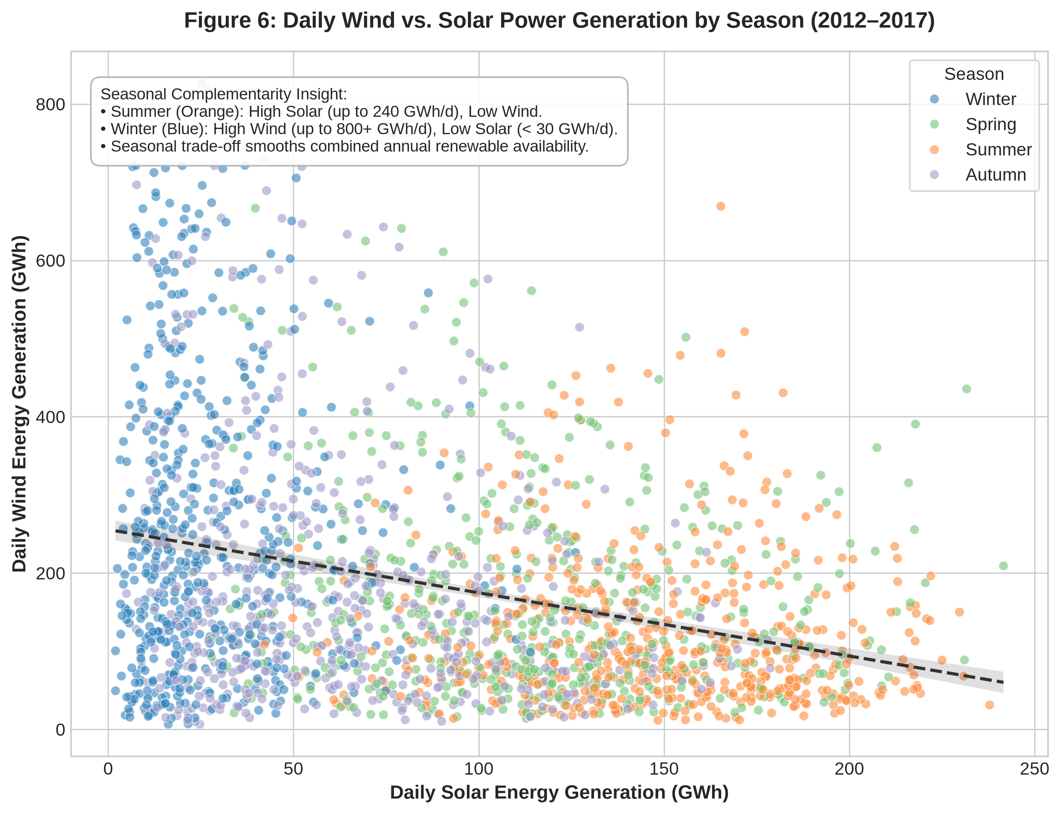
Figure 6: Daily Wind vs. Solar Power Generation by Season (2012–2017)
📊 Comprehensive Visual Storytelling Analysis:
1. Visualization Title: Figure 6: Daily Wind vs. Solar Power Generation by Season (2012–2017)
2. Question Answered: How do daily wind and solar power generation interact across different seasons?
3. Visual Choice Rationale: Color-coded seasonal scatter plot with linear regression trendline visually demonstrates seasonal clustering and supply trade-offs.
4. What the Audience Sees: Orange summer points stretching horizontally along the solar axis, blue winter points stretching vertically up the wind axis, and green/purple spring/autumn points filling the center.
5. Main Evidence Observation: Wind and solar power display powerful seasonal complementarity: when solar generation is high (summer), wind generation is low, and vice-versa.
6. Relevant Numerical Evidence: Winter daily solar rarely exceeds 30 GWh while wind spikes above 800 GWh. Summer daily solar reaches 240 GWh while wind stays under 100 GWh. Linear correlation between daily wind and solar is r = -0.08.
7. Why Observation Matters: Seasonal complementarity smooths out overall clean energy availability across the year, reducing long-term seasonal energy storage requirements.
8. Limitation / Caution: Intraday hourly imbalances (e.g. night-time zero solar output) still require short-duration battery storage.
9. Narrative Connection: We now synthesize these visual findings into an overall data story and actionable strategic implications.

13. Overall Data Story
The 12-year empirical analysis of Germany's electricity grid presents a clear narrative of structural energy transformation:
• 1. Demand Baseline Stability: National electricity demand remained remarkably steady (~1,338.7 GWh/day or ~500 TWh/year), exhibiting strong weekly industrial cycles (25% weekend drop) and winter heating peaks.
• 2. Exponential Clean Energy Scaling: Under the Energiewende framework, combined wind and solar generation expanded at a 17.0% CAGR between 2012 and 2017, increasing annual generation from 45.5 TWh to 104.2 TWh.
• 3. Natural Seasonal Balancing: Wind power naturally peaks in winter when demand is highest, while solar power peaks in summer. This seasonal complementarity creates a resilient, self-balancing clean energy architecture.
14. Key Insights
📌 CORE EMPIRICAL INSIGHTS
Insight 1: Demand is highly structured (Mean 1,338.7 GWh/day; 16.5% winter-summer swing; 25% weekday-weekend drop).
Insight 2: Renewable supply doubled penetration from 9.2% (2012) to 20.4% (2017), generating 104.2 TWh in 2017.
Insight 3: Single-day wind generation reached 825.5 GWh (2017-12-07), supplying >50% of national electricity demand.
Insight 4: Wind and Solar exhibit strong seasonal complementarity (r = -0.08), stabilizing annual clean energy supply.

15. Potential Business & Scientific Implications
Based strictly on empirical observations, we outline potential business and scientific implications following a rigorous Observation -> Interpretation -> Potential Implication structure:
Observation: Wind generation averages 280.8 GWh/day in December (vs. 116.3 GWh/day in August), whereas Solar averages 148.9 GWh/day in July (vs. 19.3 GWh/day in December).
Interpretation: Weather patterns provide natural seasonal supply complementarity between wind and solar energy.
Potential Implication: Grid planners can minimize multi-month seasonal energy storage investment by maintaining a balanced capacity deployment ratio of approximately 2:1 wind to solar.
Observation: Combined Wind+Solar daily generation spiked to 825.5 GWh on 2017-12-07 but dropped below 30 GWh during low-wind winter dolds.
Interpretation: High renewable penetration increases short-term daily generation volatility and ramping requirements.
Potential Implication: Utilities must invest in regional cross-border interconnectors, battery energy storage systems (BESS), and dispatchable green hydrogen peaking plants to manage Dunkelflaute events.
Observation: Weekend electricity demand drops by ~25% compared to weekdays (r = -0.60 with Is_Weekend).
Interpretation: Industrial manufacturing operating schedules drive a major weekly demand drop.
Potential Implication: Industrial power consumers could be incentivized via dynamic time-of-use tariffs to shift energy-intensive operations to weekends during high wind/solar generation periods.
16. Limitations
To maintain scientific rigor, several analytical limitations must be noted:
1. Lack of Intraday Hourly Resolution: Daily aggregate data masks hourly duck curves, peak evening ramping stresses, and negative pricing hours.
2. Omission of Other Zero-Carbon Sources: Hydroelectric, biomass, geothermal, and nuclear generation data are absent, preventing calculation of total zero-carbon power.
3. Geographic Aggregation: National-level aggregation masks transmission line congestion between North German wind production and South German industrial demand centers.
17. Conclusion
Between 2006 and 2017, Germany demonstrated that a major industrial economy can successfully execute an energy transition, doubling wind and solar grid penetration from 9.2% to 20.4% of national electricity consumption while maintaining demand stability.
The visual story highlights how wind energy naturally covers peak winter heating demand, solar energy covers summer peak demand, and their combined seasonal complementarity creates a resilient, scalable foundation for a fully decarbonized power grid.
18. Appendix — Python Code
Below is the complete, reproducible Python source code used to generate all calculations, metrics, and high-resolution visualizations for Week 2:
"""
Week 2 Data Science Hackathon: Advanced Data Visualization and Storytelling with Python
Dataset: OPSD Germany Daily Electricity & Renewable Energy (2006–2017)
This script performs:
1. Data loading and validation.
2. Advanced numerical calculations and export to week2/analysis_results.csv.
3. Generation of 6 high-resolution (300 DPI) publication-quality visualizations saved to visualizations/week2/.
"""
import os
import pandas as pd
import numpy as np
import matplotlib.pyplot as plt
import seaborn as sns
# Set global aesthetic style
plt.style.use('seaborn-v0_8-whitegrid' if 'seaborn-v0_8-whitegrid' in plt.style.available else 'default')
plt.rcParams['font.family'] = 'sans-serif'
plt.rcParams['font.size'] = 11
plt.rcParams['axes.titlesize'] = 14
plt.rcParams['axes.titleweight'] = 'bold'
plt.rcParams['axes.labelsize'] = 12
plt.rcParams['axes.labelweight'] = 'bold'
plt.rcParams['figure.titlesize'] = 16
plt.rcParams['figure.titleweight'] = 'bold'
# File paths setup
BASE_DIR = os.path.dirname(os.path.dirname(os.path.abspath(__file__)))
DATA_PATH = os.path.join(BASE_DIR, 'data', 'cleaned', 'cleaned_dataset.csv')
OUT_VIS_DIR = os.path.join(BASE_DIR, 'visualizations', 'week2')
OUT_WEEK2_DIR = os.path.join(BASE_DIR, 'week2')
# Also mirror output paths to sibling Week1_Data_Analysis dir if executed from week_2
MIRROR_VIS_DIR = os.path.join(os.path.dirname(BASE_DIR), 'Week1_Data_Analysis', 'visualizations', 'week2')
MIRROR_WEEK2_DIR = os.path.join(os.path.dirname(BASE_DIR), 'Week1_Data_Analysis', 'week2')
for d in [OUT_VIS_DIR, OUT_WEEK2_DIR, MIRROR_VIS_DIR, MIRROR_WEEK2_DIR]:
os.makedirs(d, exist_ok=True)
def load_and_validate_data():
"""Load cleaned Week 1 dataset and validate schema & integrity."""
print("=== PHASE 1: DATA LOADING & VALIDATION ===")
if not os.path.exists(DATA_PATH):
# Fallback search path
alt_path = os.path.join(os.path.dirname(BASE_DIR), 'Week1_Data_Analysis', 'data', 'cleaned', 'cleaned_dataset.csv')
if os.path.exists(alt_path):
df = pd.read_csv(alt_path)
else:
raise FileNotFoundError(f"Cleaned dataset not found at {DATA_PATH} or {alt_path}")
else:
df = pd.read_csv(DATA_PATH)
df['Date'] = pd.to_datetime(df['Date'])
# Sort chronologically
df = df.sort_values('Date').reset_index(drop=True)
# Validation assertions
assert 'Consumption' in df.columns, "Missing Consumption column!"
assert 'Wind' in df.columns, "Missing Wind column!"
assert 'Solar' in df.columns, "Missing Solar column!"
print(f"Data successfully loaded. Rows: {len(df)}, Columns: {len(df.columns)}")
print(f"Date Range: {df['Date'].min().strftime('%Y-%m-%d')} to {df['Date'].max().strftime('%Y-%m-%d')}")
print(f"Consumption Non-Null: {df['Consumption'].count()} / {len(df)}")
print(f"Wind Non-Null: {df['Wind'].count()} / {len(df)} (Starts {df[df['Wind'].notnull()]['Date'].min().strftime('%Y-%m-%d')})")
print(f"Solar Non-Null: {df['Solar'].count()} / {len(df)} (Starts {df[df['Solar'].notnull()]['Date'].min().strftime('%Y-%m-%d')})")
return df
def calculate_advanced_metrics(df):
"""Compute narrative-supporting metrics and save to week2/analysis_results.csv."""
print("\n=== PHASE 11: ADVANCED NUMERICAL CALCULATIONS ===")
results = []
# 1. Overall Summary Statistics (GWh/day)
for col in ['Consumption', 'Wind', 'Solar', 'Wind+Solar']:
s = df[col].dropna()
results.append({'Metric_Category': 'Daily Statistics (GWh)', 'Metric_Name': f'{col}_Mean', 'Value': round(s.mean(), 2)})
results.append({'Metric_Category': 'Daily Statistics (GWh)', 'Metric_Name': f'{col}_Std', 'Value': round(s.std(), 2)})
results.append({'Metric_Category': 'Daily Statistics (GWh)', 'Metric_Name': f'{col}_Min', 'Value': round(s.min(), 2)})
results.append({'Metric_Category': 'Daily Statistics (GWh)', 'Metric_Name': f'{col}_Max', 'Value': round(s.max(), 2)})
results.appen
... [Full code saved in src/week2_visualization.py]

