**Transcriptional activation of *CsNCED2* by CsbHLH106 mediates ABA accumulation and drought response in *Camellia sinensis***

Yezi Xiao1+, Yongheng Zhang2+, Hongyan Deng1, Qiongshen Wang1, Mingke Zhang1, Ziyao Ge1, Yingao Zhang1, Lu Liu1, Pengjie Wang1*, Youben Yu1*

1 College of Horticulture, Northwest A&F University, Yangling 712100, Shaanxi, China.

2 Key Laboratory of Biology, Genetics and Breeding of Special Economic Animals and Plants, Ministry of Agriculture and Rural Affairs, National Center for Tea Plant Improvement, Tea Research Institute, Chinese Academy of Agricultural Sciences, 9th South of Meiling Road, Hangzhou 310008, China.

+Yezi Xiao and Yongheng Zhang contributed equally to this work.

* Corresponding Author:

**Pengjie Wang** **−** College of Horticulture, Northwest A&F University, Yangling, 712100, Shaanxi, China; Email: wpjtea@163.com. Phone: +86 157-5082-0154.

**Youben Yu −** College of Horticulture, Northwest A&F University, Yangling 712100, Shaanxi, China; Email: yyben@163.com. Phone: +86 187-2956-53.

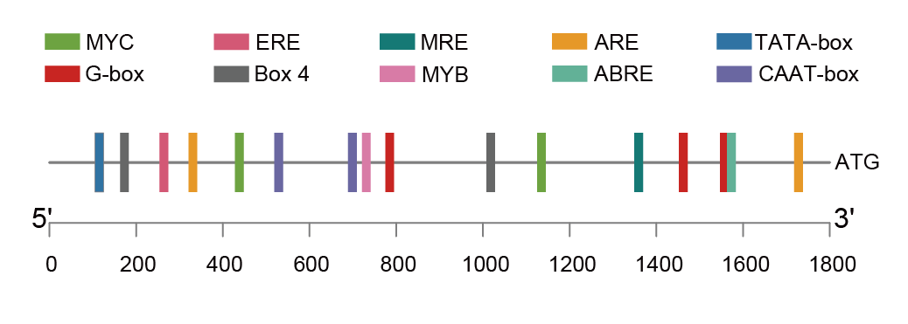

**Supplementary Figure S1.** Distribution of predicted cis-acting elements within the 2 kb promoter region of the *CsNCED2* gene.

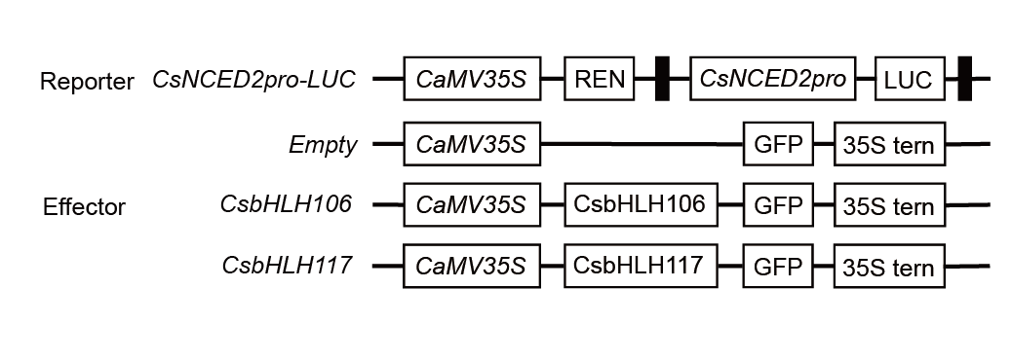

**Supplementary Figure S2.** Schematic diagrams of the reporter and effector constructs used in the dual-luciferase assay.

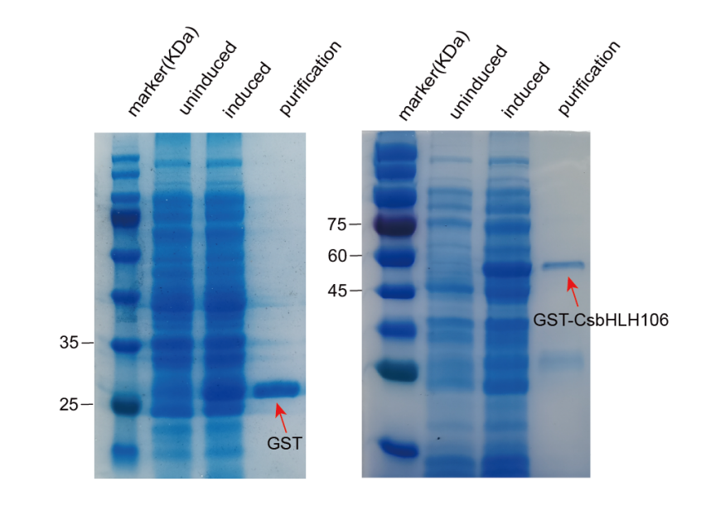

**Supplementary Figure S3.** SDS-PAGE analysis of GST and GST-CsBHLH106 fusion protein expression and purification.

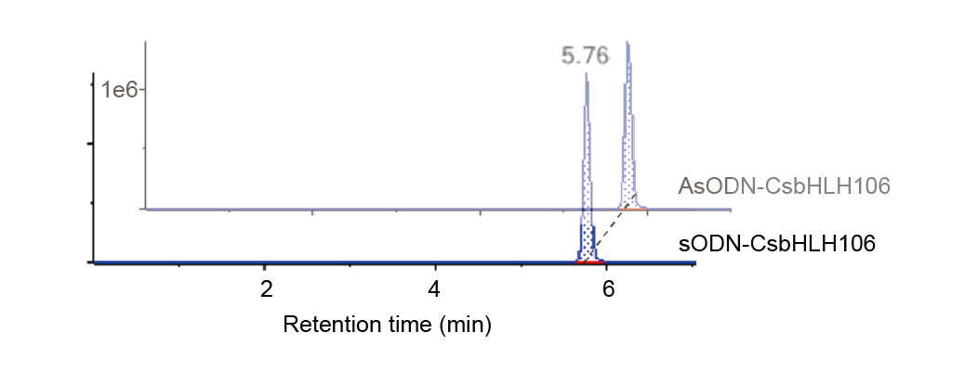

**Supplementary Figure S4.** HPLC detection of ABA levels in tea leaves after antisense (AsODN) and sense (sODN) oligonucleotide treatment targeting *CsbHLH106*.