National Institute for Health and Care Excellence
Draft for consultation

Osteoporosis: risk assessment
[E] Effectiveness of fragility fracture risk prediction tools
NICE guideline <number>
Evidence review underpinning recommendations 1.3.1-1.3.9, 1.4.1-1.4.4 and 1.7.1-1.7.3 in the NICE guideline
January 2026
Draft for Consultation
Commissioned by the National Institute for Health and Care Excellence

DRAFT FOR CONSULTATION
Disclaimer
The recommendations in this guideline represent the view of NICE, arrived at after careful consideration of the evidence available. When exercising their judgement, professionals are expected to take this guideline fully into account, alongside the individual needs, preferences and values of their patients or service users. The recommendations in this guideline are not mandatory and the guideline does not override the responsibility of healthcare professionals to make decisions appropriate to the circumstances of the individual patient, in consultation with the patient and/or their carer or guardian.
Local commissioners and/or providers have a responsibility to enable the guideline to be applied when individual health professionals and their patients or service users wish to use it. They should do so in the context of local and national priorities for funding and developing services, and in light of their duties to have due regard to the need to eliminate unlawful discrimination, to advance equality of opportunity and to reduce health inequalities. Nothing in this guideline should be interpreted in a way that would be inconsistent with compliance with those duties.
NICE guidelines cover health and care in England. Decisions on how they apply in other UK countries are made by ministers in the Welsh Government, Scottish Government, and Northern Ireland Executive. All NICE guidance is subject to regular review and may be updated or withdrawn.

Copyright
© NICE [Year of publication]. All rights reserved. Subject to Notice of rights.
ISBN:

Contents
1. Effectiveness of fragility fracture risk prediction tools 6
1.1. Review question: What is the clinical and cost effectiveness of risk prediction tools for predicting the risk of fragility fracture and bone assessment methods for predicting fragility fracture? 6
1.1.1. Introduction 6
1.1.2. Summary of the protocol 6
1.1.3. Methods and process 7
1.1.4. Effectiveness evidence 7
1.1.5. Summary of studies included in the effectiveness evidence 8
1.1.6. Summary of the effectiveness evidence 9
1.1.7. Economic evidence 11
1.1.8. Summary of included economic evidence 13
1.1.9. Existing criteria for BMD assessment and intervention and cost-effectiveness 15
1.1.10. Economic analysis 18
1.1.11. Unit costs 37
1.1.12. Evidence statements 37
1.2. The committee’s discussion and interpretation of the evidence 38
1.2.1. The outcomes that matter most 38
1.2.2. The quality of the evidence 38
1.2.3. Benefits and harms 39
1.2.4. Conclusions and committee experiences 39
1.2.5. Cost effectiveness and resource use 46
1.2.6. Other factors the committee took into account 51
1.2.7. Recommendations supported by this evidence review 51
1.3. References 52
1.3.1. Effectiveness 52
1.3.2. Economic (included studies) 52
1.3.3. Other 52
1.3.4. Economic analysis 53
Appendices 54
Appendix A Review protocols 54
Appendix B Literature search strategies 65
Appendix C Effectiveness evidence study selection 86
Appendix D Effectiveness evidence 87
Appendix E Forest plots 116
Appendix F Full GRADE tables 118
Appendix G Economic evidence study selection 124
Appendix H Economic evidence tables 125
Appendix I Health economic analysis – additional methods and results 133
Appendix J Excluded studies 141

Effectiveness of fragility fracture risk prediction tools

Review question: What is the clinical and cost effectiveness of risk prediction tools for predicting the risk of fragility fracture and bone assessment methods for predicting fragility fracture?

Introduction
This review question examines how UK-validated fragility fracture risk assessment tools can be combined with bone assessment methods to prevent fragility fracture. This question will address comparison of different risk prediction tools and bone assessment methods to each other or compared to usual care or no risk assessment.

Summary of the protocol
For full details see the review protocol in Appendix A.
Table 1: PICO characteristics of review question
Population | Inclusion: Adults (18 years and older) who are at suspected risk of fragility fractures (people with or at risk of primary or secondary osteoporosis or have had a previous fragility fracture).
Intervention(s) | Risk prediction tools  - CFracture  - FRAX®-UK/FRAXplus®-UK  - Without bone mineral density assessment (BMD)  - With BMD  - With BMD and trabecular bone score (TBS)  - FRAX®-UK with National Osteoporosis Guideline Group (NOGG) thresholds  - IDFracture  - QFracture  Strata: Version or iteration of risk prediction tool; Type of fracture: major osteoporotic fracture (MOF) or hip fracture (HF).  Bone assessment methods  The following methods to assess bone density and quality to predict major osteoporotic fracture (MOF) and hip fracture (HF) will be included:  - Dual X-ray absorptiometry (DXA, DEXA) or dual x-ray and laser (DXL) of hip, spine, or forearm (areal BMD ± TBS)  - Quantitative computed tomography scans (QCT), including: Asynchronous calibration QCT (phantom-less scanning); high resolution peripheral QCT (HR-pQCT); peripheral QCT (pQCT), and photo counting CT (volumetric BMD)  - Quantitative ultrasound (QUS) (for example, Bindex) (BUA, SOS)  - Digital radiography (IBEX BH Software) (aBMD)
Comparison(s) | - To each other in sequence or combination  - Usual care/ no risk assessment or bone assessment
Outcomes | All outcomes are considered equally important for decision making and therefore have all been rated as critical:  - Fragility fracture  - Generic health-related quality of life (continuous outcomes will be prioritised [validated measures])  - EQ-5D  - SF-6D  - SF-36  - SF-12  - Other utility measures (AQOL, HUI, 15D, QWB)  - Mortality  - Adverse events of tests (for example, radiation exposure)  - Adverse events of the screening process (for example, those cases missed by tools).  - Starting treatment (time to starting treatment)
Study design | Randomised controlled trials (RCTs).

Methods and process
This evidence review was developed using the methods and process described in Developing NICE guidelines: the manual. Methods specific to this review question are described in the review protocol in Appendix A and the methods document.
Declarations of interest were recorded according to NICE’s conflicts of interest policy.

Effectiveness evidence

Included studies
Three RCTs, reported in 5 papers, were included in the review; these are summarised in Table 2 below. Evidence from these studies is summarised in the clinical evidence summary below (Table 3 and Table 4).
See also the study selection Appendix CError! Reference source not found., study evidence tables in Appendix D, forest plots in Appendix E and GRADE tables in Appendix F.
The following comparisons were included:
Two-step screening compared to usual care:
- The ROSE study was a Danish participant-blinded parallel group RCT and compared women who had a FRAX assessment with an invitation to have a DXA scan if their 10-year risk of major osteoporotic fracture was 15% or more (MOF) to women who were not informed of their FRAX score (Rubin 2018 reports 5-year follow up and Petersen 2024 reports 10-year follow up).
- The SCOOP study was a UK open parallel group RCT and compared women who had a FRAX assessment with invitation to have a DXA scan using age-dependent thresholds to UK usual care in which the same demographic and clinical information needed to calculate a FRAX score was collected (Shepstone 2018 and Turner 2018 report 5-year FU).
One-step-screening compared to usual care:
- The SALT osteoporosis study (SOS) was a Dutch pragmatic assessor-blinded parallel group RCT and compared one-step screening using DXA, FRAX age-dependent thresholds, and vertebral fracture assessment (VFA) to Dutch usual care (Merlijn 2019).
All included studies recruited participants that were not on osteoporotic treatment.
Number of people with fragility fracture, major osteoporotic fracture, hip fracture, quality of life and mortality outcomes were reported. No studies were identified that reported adverse events or time to starting treatment. Outcomes reported as all fractures, which would include other kinds of fractures, were excluded.

Excluded studies
See the excluded studies list in Appendix J.

Summary of studies included in the effectiveness evidence
Table 2: Summary of identified studies included in the evidence review
Study  Trial name  Country | Population | Intervention and comparison | Outcomes | Comments
Two-step screening
Rubin 2018/Petersen 2024  ROSE study  Denmark | Women born between 1930-46 in Southern Denmark identified using Danish Health Registries (65-80 years age range) | Two-step screening program (FRAX assessment with invitation to DXA scan if 10-year MOF≥15%) (n=17072)  Vs  Usual care (FRAX assessment but participants not informed of the result) (n=17157) | - Fragility fractureª  - Major osteoporotic fracture^{b}  - Hip fracture  - Mortality | 5-year (Rubin 2018) or 10-year FU (Peterson 2024)  Women excluded if on osteoporotic treatment.  Number of people reported for fracture outcomes
Shepstone 2018, Turner 2018  SCOOP study  UK | Women aged 70-85 years identified through primary practice lists | Two-step screening program (FRAX assessment with invitation to DXA scan if participant’s risk above age-dependent threshold) (n=6233)  Vs  Usual care (Collection of same demographic and clinical information used to calculate FRAX without FRAX calculation) (n=6250) | - Fragility fracture^{c}  - Hip fracture  - Mortality  - Quality of life | 5-year FU  Women excluded if on prescription anti-osteoporotic drugs.  Number of people reported for fracture outcomes
One-step screening
Merlijn 2019  SALT Osteoporosis study (SOS)  Netherlands | Women aged 65-90 years with at least 1 clinical risk factor for fractures. Participants identified from GP registries | Screening (FRAX-UK assessment with invitation to DXA scan if participant’s risk score above age-dependent thresholds, VFA, fall assessment, and blood tests). Participants with a FRAX-UK score above threshold or with vertebral fracture were offered treatment) (n=5575)  Vs  Usual care (Collection of same demographic and clinical information used to calculate FRAX with participants added to wait list to undergo screening after trial end. Participants with indication for DXA and VFA advised to contact GP) (n=5457) | - Fragility fracture^{d}  - Major osteoporotic fracture^{b}  - Hip fracture  - Mortality | 1.5 and 3-year FU  No show for screening in intervention group (n=1347)  Women excluded if current use of anti-osteoporosis osteoporosis medication or in preceding 5 years.  Number of people reported for fracture outcomes
Abbreviations: DXA, dual x-ray absorptiometry; FU, follow up; MOF, major osteoporotic fracture; VFA, vertebral fracture assessment.
Notes:
- Outcome includes all fragility fractures except fractures of fingers, toes, skull, or face as identified by ICD-10 codes.
- Outcome is defined as hip, spine (clinical), shoulder and wrist fragility fractures.
- Outcome includes all fragility fractures except fractures of the hand, foot, nose, skull and cervical vertebrae.
- Outcome is defined as all fragility fractures except fractures of the hand, foot, skull, finger and toe.
See Appendix D for full evidence tables.

Summary of the effectiveness evidence
Table 3: Clinical evidence summary: two-step screening versus usual care
Outcomes  Follow up (FU) | № of participants  (studies) | GRADE certainty | Relative effect  (95% CI) | Anticipated absolute effects
 |  |  |  | Risk with control | Risk difference with two-step screening
Participants not on osteoporotic treatment
Fragility fracture  5-year FU | (2 RCT) | Very low^{a,b} | HR 0.99 (0.94 to 1.04) | 230 per 1,000 | 2 fewer per 1,000 (from 12 fewer to 8 more)
Major osteoporotic fracture  10-year FU | 34229  (1 RCT) | Low^{c,d} | HR 1.0 (0.95 to 1.05) | 173 per 1,000 | 0 fewer per 1,000 (from 8 fewer to 8 more)
Hip fracture  5-year and 10-year FU | 46712  (2 RCT) | Very low^{a,e,f} | HR 0.86 (0.63 to 1.17) | 54 per 1,000 | 7 fewer per 1,000 (from 19 fewer to 9 more)
Quality of life at final values, higher is better (EQ-5D-3L)  5-year FU | 12483  (1 RCT) | Low^{c,d,g} | - | Mean control 0.67 | MD 0.01 lower (from 0.02 lower to 0.01 higher)
Mortality  5-year and 10-year FU | 46712  (2 RCTs) | High | HR 1.0 (0.97 to 1.04 | 227 per 1,000 | 0 fewer per 1000 (from 6 fewer to 6 more)
Abbreviations: FU, follow up; HR, hazard ratio.
Notes:
a. Outcome is at very serious risk of bias because both studies are at high risk of bias due either to measurement of outcome (various methods used for fracture ascertainment; only verified fractures included)
b. Both studies are partially applicable because both studies excluded some fragility fractures (e.g., finger, hand, toe, skull, face, and/or cervical vertebrae).
c. Outcome is at very serious risk of bias because study is at high risk of bias due to measurement of outcome (various methods used for fracture ascertainment; only verified fractures included)
d. Heterogeneity not assessed as there is only one study.
e. Very serious inconsistency with I²>80% suggesting heterogeneity.
f. Serious imprecision because 95% CI crosses 1 clinical decision threshold (0.8 or 1.25).
g. Established MID for this outcome is +/-0.03.
Table 4: Clinical evidence summary: One-step screening group versus usual care
Outcomes  Follow up (FU) | № of participants  (studies) | GRADE certainty | Relative effect  (95% CI) | Anticipated absolute effects
 |  |  |  | Risk with Usual care | Risk difference with screening group
Participants not on osteoporotic treatment
Fragility fracture  3-year FU | 10921  (1 RCT) | Very low^{a,b,c.d} | HR 0.91 (0.81 to 1.03) | 110 per 1,000 | 9 fewer per 1,000 (from 20 fewer to 3 more)
Major osteoporotic fracture  3-year FU | 10921  (1 RCT) | Very low^{a,b,c,e} | HR 0.91 (0.80 to 1.04) | 84 per 1,000 | 7 fewer per 1,000 (from 16 fewer to 3 more)
Hip fracture  3-year FU | 10921  (1 RCT) | Very low^{a,b,c,f} | HR 0.91 (0.71 to 1.15) | 26 per 1,000 | 2 fewer per 1,000 (from 7 fewer to 4 more)
Mortality  3-year FU | 10921  (1 RCT) | Very low^{a,b,c} | HR 1.03 (0.91 to 1.17) | 89 per 1,000 | 3 more per 1000 (from 8 fewer to 14 more)
Abbreviations: FU, follow up; HR, hazard ratio.
Notes:
a. Trial at high risk of bias due to deviations from intended intervention (GPs allowed to use off-protocol application for consult (follow up) notification, may have improved adherence).
b. Heterogeneity not assessed as there is only one study.
c. Intervention is partially applicable due to intervention including non-protocol intervention (VFA).
d. Outcome is partially applicable due to exclusion of fragility fractures of the skull, finger, hand, toe, and foot.
e. Study is partially applicable because analysis for this outcome was completed post-hoc.
f. Serious imprecision because 95% CI crosses 1 clinical decision threshold (0.8 or 1.25).
See Appendix F for full GRADE tables.

Economic evidence
For methods, see the health economic review protocol in Appendix A.

Included studies
Two health economic studies with relevant comparisons were included in this review (Soreskog 2020, Turner 2018).
These were both cost-effectiveness analyses based on the SCOOP RCT that compared usual management of osteoporosis (defined as no systematic risk assessment but including referral for DXA scans and treatment if deemed clinically appropriate) to a community-based screening programme using FRAX.
These are summarised in the health economic evidence profile below (Table 5) and the health economic evidence tables in Appendix H.
No health economic studies were included that included the following: CFracture, FRAX (or DXA) plus trabecular bone score (TBS), QFracture, Quantitative ultrasound (QUS), quantitative CT scans (asynchronous CT, pQCT, QCT, high resolution pQCT) and X-ray.
See also the health economic study selection flow chart in Appendix G.

Excluded studies
Two relevant health economic studies were excluded due to limited applicability and methodological limitations (Martin-Sanchez 2019, Soreskog 2025), with reasons for exclusion listed in Appendix J.
A simple cost comparison developed for the previous version of the NICE guideline on osteoporosis (published 2012, updated 2017) was excluded as an updated version with current costs has been included in the unit costs section below.

Summary of included economic evidence
Table 5: Health economic evidence profile: Risk assessment tools and bone assessment methods compared to each other in sequence or combination
Study | Applicability | Limitations | Other comments | Incremental cost | Incremental effects | Cost effectiveness | Uncertainty
Soreskog 2020  (UK) | Partially applicable^{(a)} | Potentially serious limitations^{(b)} | - Cost-utility analysis (QALYs)  - Markov model based on UK SCOOP RCT (Shepstone 2018).  - Population: women aged 70 to 85 years not currently prescribed anti-osteoporosis medicines.  - Comparators:  - Usual management: referral for DXA scan and anti-osteoporosis treatment if deemed clinically appropriate by GP.  - FRAX plus BMD: systematic identification from primary care records and FRAX risk assessment; those with FRAX (no BMD) hip fracture score above an age-dependent threshold were invited to have a DXA scan to assess BMD and were given treatment based on age-dependent FRAX+BMD thresholds^{(c)}  - Time horizon: Lifetime | 2-1: saves £281^{(d)} | 2-1: 0.015 QALYs | Dominant | Probability intervention 2 cost effective (£20/£30K threshold): 97%/98%  Study results remained robust under sensitivity analyses, including a 10-year horizon, 0% discounting, and full attribution of excess mortality to fractures. Screening was cost-neutral at age 71 and remained dominant even when assumed to affect only hip-fracture risk.
Turner 2018 (UK) | Partially applicable^{(e)} | Potentially serious limitations^{(f)} | - Cost-utility analysis (QALYs)  - Within-trial analysis of UK SCOOP RCT (Shepstone 2018).  - Population: women aged 70 to 85 years not currently prescribed anti-osteoporosis medicines  - Comparators:  - Usual management: referral for DXA scans and anti-osteoporosis treatments if deemed clinically appropriate by GP.  - FRAX plus BMD: systematic identification from primary care records and FRAX risk assessment; those with FRAX (no BMD) hip fracture score above an age-dependent threshold were invited to have a DXA scan to assess BMD and were given treatment based on age-dependent FRAX+BMD thresholds.^{(c)}  - Time horizon: 5 years | 2-1: £68^{(g)} | 2-1: 0.024 QALYs | £2,772 per QALY gained | Probability intervention 2 cost effective (£20/£30K threshold): 93%/NR  Conclusion not changed in sensitivity analysis using complete cases only.
Abbreviations: BMD= bone mineral density; scan= dual-energy X-ray absorptiometry scan; EQ-5D-3L= EuroQol-5 Dimensions, three-level version (scale: 0.0 [death] to 1.0 [full health], negative values mean worse than death); FRAX= fracture risk assessment tool – score can be calculated with or without BMD information incorporated; GP= general practitioner; NR= not reported; QALYs= quality-adjusted life years; RCT= randomised controlled trial; SCOOP= Screening Of Older women for Prevention of fracture.
- 2013/2014-unit costs and 2001-2013 resource use may not reflect current NHS context.
- Hierarchical structure of the Markov model causes a slight underestimation of the number of less severe fractures, as patients suffering a hip or vertebral fracture cannot subsequently sustain wrist or other fractures in following cycles (i.e. remain in post hip/vertebral state). Limited information provided about fracture costs and what costs were as incorporated, whether published costs were inflated, and whether national unit costs were used. Some potentially relevant resource use was not included in Turner 2018 costs such as routine primary care contacts (may increase with increased treatment rates).
- See Table 22 for FRAX age-dependent hip fracture risk thresholds for invitation for BMD measurement and treatment by age group.
- 2013-2014 UK pounds (£). Costs incorporated: routine risk assessment intervention costs (identification of eligible patients, administration of FRAX questionnaire and risk calculation, BMD measurement via DXA scans, calculation and clinical review of final fracture risk, written notification of initial and final fracture risk, and a GP consultation for identified high fracture risk individuals), non-SCOOP intervention related DXA scans, treatment and fracture-related costs (inpatient, outpatient and nursing care).
- 2008-2013 resource use estimates, and 2013/14 UK unit costs may not reflect current NHS context.
- The 5-year time horizon will not capture long-term costs and benefits. Some potentially relevant resource use was not collected such as routine primary care contacts (may increase with increased treatment rates) and admissions to residential care (may be impacted by reduced fracture). Some pharmaceutical funding declared by authors but not related to this work.
- 2013-2014 UK pounds (£). Costs incorporated: routine risk assessment intervention costs (identification of eligible patients, administration of FRAX questionnaire and risk calculation, BMD measurement via DXA scans, calculation and clinical review of final fracture risk, written notification of initial and final fracture risk, and a GP consultation for identified high fracture risk individuals), non-intervention related DXA scans, treatment and fracture-related costs (procedure costs, A&E, inpatient stay, outpatient attendance).

Existing criteria for BMD assessment and intervention and cost-effectiveness
In order to help inform committee discussions about recommendations for DXA and treatment criteria, Table 6 below summarises existing UK guidance relating to criteria for BMD assessment and treatment and the role of cost effectiveness in their development.

Table 6: Summary of current UK recommendations for bone mineral density (BMD) assessment and osteoporosis treatment criteria
 | BMD assessment and treatment criteria | Basis for selection | Role of cost-effectiveness evidence
NOGG | - Age-dependent risk thresholds for BMD assessment and treatment (increase with age)  - BMD assessment: 10-year MOF risk 3% [age 50] to 11% [age 70+])^{(a)}  - Treatment: 10-year MOF risk 7% (age 50) to 20% (age 70+) or 10-year hip fracture risk 1% (age 50) to 5% (70+)^{(a)} | - For men and women, the intervention threshold up to age 70 years is set at a risk equivalent to that of a woman of the same age with a prior fracture, in line with current clinical practice. At age 70 years and above, fixed thresholds are applied  - BMD assessment thresholds followed current practice guidelines where people were considered eligible if one or more CRF  - An upper assessment threshold was based on optimisation of the positive predictive value of the assessment tool | - Guideline notes that “approach is underpinned by cost-effectiveness analysis with oral or intravenous bisphosphonates as the intervention” with reference to Kanis 2008a and NICE TA464  - Kanis 2008a states that the intervention thresholds exceed the health economic limit of 7% at which treatment becomes cost effective for all ages based on Kanis 2008b (included case finding costs – risk assessment and DXA)
SIGN | - BMD assessment if 10-year MOF risk 10% or more, or prior fragility fracture  - Treatment (in those meeting criteria for BMD assessment) based on T-score (<-2.5 if <65 years, <-1 if >65 years) or presence of hip or vertebral fracture | - Pragmatic approach based on consideration of clinical trials of pharmacological treatments  - Only 3 studies included information about risk. Studies were generally limited to people with low BMD | - Cost effectiveness is not specifically mentioned as part of the rationale for selecting the criteria  - The NICE TA464 bisphosphonates cost-effectiveness results are noted
NICE | - Explicit criteria not defined  - 2012 NICE osteoporosis guideline recommended BMD assessment when risk is “in the region of an intervention threshold”. Intervention thresholds were out of scope and use of local guidelines was advised. BMD assessment related to other purposes (such as a baseline for treatment or informing treatment choice) was out of scope.  - NICE bisphosphonates technology appraisal (TA464) does not specify a treatment initiation threshold but refers to NICE’s quality standard  - NICE osteoporosis quality standard (QS149) includes criteria based on NOGG age-dependent BMD assessment and treatment thresholds |  | - Cost-effectiveness modelling to determine a risk threshold for bisphosphonate treatment was done as part of TA464. Initially recommendations included explicit reference to risk thresholds where treatment was cost-effective (1% for oral bisphosphonate and 10% for iv bisphosphonates), but these were later removed due to concerns from MHRA that these encouraged use outside of the evidence
BMD = bone mineral density; CRF = clinical risk factor; MHRA = Medicines and Healthcare products Regulatory Agency; NOGG = National Osteoporosis Guideline Group; QS = quality standard; SIGN = Scottish Intercollegiate Guideline Network; TA = technology appraisal.
- People are initially classified as low, intermediate, high or very high risk based on 10-year MOF risk without BMD. If risk is classed as high or very high based on MOF without BMD, treatment is recommended; BMD assessment is however still recommended to provide a baseline and inform treatment choice. If MOF risk without BMD is classed as intermediate, BMD assessment and recalculation of risk including BMD is recommended with treatment if recalculated risk is above either MOF or hip fracture risk threshold for age.

Economic analysis

Introduction
As part of the guideline update, the committee looked at the role of fracture risk assessment (using tools such as FRAX and QFracture) and bone mineral density (BMD) assessment (using DXA) in identifying people that needed treatment to reduce their fragility fracture risk. This included reviewing recommendations about who should have risk assessment, BMD assessment and treatment.
Current UK guidelines generally advise similar approaches to who should have risk assessment but take different approaches to criteria for BMD assessment and treatment. For example, the National Osteoporosis Guideline Group (NOGG) 2024 guideline uses risk thresholds that increase with age to define who should have BMD assessment and treatment, whereas the Scottish Intercollegiate Guideline Network (SIGN) Osteoporosis guideline uses a single risk threshold or presence of fragility fracture as an indication for BMD assessment, and BMD or fracture information to determine who should have treatment. The committee advised that a NOGG-based approach is more widely used in England currently, with SIGN used more widely in Scotland, although it was also noted that currently local criteria are often developed taking different guidance into account.
The committee wished to explore the implications of using simpler DXA criteria compared to the NOGG age-dependent criteria. As the purpose of undertaking DXA is to inform decisions about need for treatment, it was considered important to also capture this.
This analysis aims to quantify DXA resource use under different criteria, and also numbers and demographics of those who could be identified for treatment.

Methods

Analysis overview
A simulated population that contained individual-level information about clinical risk factors including BMD and FRAX 10-year fracture risk was used to compare the implications of using different criteria for BMD assessment and treatment in terms of resource use and the people that receive treatment.
The simulated population was previously used by McCloskey et al (2015) to evaluate changes to NOGG guideline criteria. More detail is provided in Section 1.1.10.2.3 below. The output of the simulation was provided by the authors and used for this analysis.
Population
The population for this analysis was women over 50 years with a prior fracture or another clinical risk factor. This aimed to reflect a population potentially eligible for risk assessment. It did not vary between comparators as the aim of this analysis was primarily to investigate the implications of different criteria for DXA.
In the analysis, other clinical risk factors were older age (65 years and over), low BMI, current smoking, daily alcohol intake greater than 3 units, parental history of hip fracture, rheumatoid arthritis, glucocorticoid use (5mg prednisolone or equivalent for 3 or more months) at any point or secondary osteoporosis. These were what was included in the original population simulation used for the analysis as they are the risk factors used in the FRAX calculator.
Comparators
Comparators with different BMD assessment and treatment criteria based on existing guidelines and committee alternatives were included in the analysis. These are summarised in Table 7 below and a more detailed description is included in Appendix I. Note that implementation of the committee BMD assessment and treatment criteria in the analysis required some simplifications and so are an approximation. DXA resource was included whether it was related to determination of treatment eligibility or for other purposes such as a baseline measurement or to inform treatment choice. This is important to appropriately assess differences in DXA resource use.
The analysis uses FRAX 10-year fracture risk for all comparators as this was what was available in the population simulation. Table 7: Analysis comparators
Strategy | BMD assessment (any reason^{(a)}) criteria | Treatment criteria
NOGG guideline | If 10-year MOF risk above age-dependent threshold (from 3% [age 50] to 11% [age 70+])^{(b)} | If 10-year MOF or hip fracture risk^{(b)} above age-dependent threshold  - MOF: 7% (age 50) to 20% (age 70+)  - Hip fracture: 1% (age 50) to 5% (70+)
SIGN guideline 142 | If any previous fragility fracture, or 10%+ 10-year MOF risk^{(c)} | - If hip or vertebral fragility fracture^{(c)}  - If eligible for BMD assessment and BMD -2.5 or less if age <65; -1 or less if age 65+
Committee alternative 1 (Alt 1) | If previous hip or vertebral fragility fracture^{(d)}, or 10%+ 10-year MOF risk | If any of^{(e)}:  - Previous hip or vertebral fragility fracture  - Eligible for BMD assessment and BMD T-score -2.5 or less  - Eligible for BMD assessment, BMD T-score of -1.5 or less and any of the following:  - any fragility fracture  - glucocorticoid use  - secondary osteoporosis
Committee alternative 2 (Alt 2) | If previous hip or vertebral fragility fracture^{(d)}, or 5%+ 10-year MOF risk
Abbreviations: BMD = bone mineral density; MOF = major osteoporotic fracture; NOGG = National Osteoporosis Guideline Group; SIGN = Scottish Intercollegiate Guideline Network.
- BMD assessment may be used to determine treatment eligibility and/or to inform treatment choice and/or provide a baseline measurement for future monitoring in people eligible for treatment
- People are initially classified as low, intermediate, high or very high risk based on MOF risk without BMD. If risk is classed as high or very high based on MOF without BMD, treatment is recommended; BMD assessment is however still recommended to provide a baseline and inform treatment choice. If MOF risk without BMD is classed as intermediate, BMD assessment and recalculation of risk including BMD is recommended with treatment if recalculated risk is above either MOF or hip fracture risk threshold for age.
- If hip or vertebral fracture treatment is recommended, but BMD assessment is still recommended to provide a baseline measurement and inform treatment choice.
- The committee recommendation also included multiple fragility fractures as an indication for DXA that was not incorporated into the analysis.
- Glucocorticoid use at any time (available in the population simulation dataset) was used in the analysis as an approximation for the committee recommendation related to current or recent glucocorticoid use. Secondary osteoporosis (available in the population simulation dataset) was used in the analysis as an approximation for the committee recommendation related to medicines or secondary causes known to be associated with accelerated bone loss. The committee recommendation also included the following treatment criteria that was not included in the analysis: people with BMD T-score -1.0 or less and both aged over 65 and on high-dose glucocorticoids.
Deviations from NICE reference case
The analysis only assesses the potential implications of different approaches to BMD assessment and treatment initiation criteria on the numbers of people receiving BMD assessment and treatment. It is not a full cost-effectiveness analysis and does not assess lifetime costs and QALYs. If numbers treated or the risk and age profile of the population that gets treated varies between strategies, then this may confer differences in fractures downstream, and this could result in differences in costs and QALYs. The analysis does not include probabilistic analysis to quantify uncertainty.

Approach to analysis
The output of the published population simulation was provided by the authors. Type of fracture was not included but was needed in order to implement some of the BMD assessment and treatment criteria and so was incorporated. Details of methods are described below.
For each individual in the population simulation, the BMD assessment and treatment criteria for each comparator outlined in the methods were applied to determine whether they would be eligible for BMD assessment and treatment.
Proportions of women over 50 with a clinical risk factor (CRF), eligible for BMD assessment and treatment with each comparator were then summarised along with demographic information (related to age, risk and BMD) about the population meeting the criteria. Unit costs were applied to key resource use items to allow comparison.

Population simulation
McCloskey et al. (2015) developed a simulated population that was used to compare different NOGG assessment and intervention thresholds. This was based on a UK age distribution and used European age-specific risk factors prevalences and covariance estimated from FRAX derivation cohorts.
Risk factors in the simulation were those required for the FRAX calculator: age, prior fracture, low BMI, current smoking, alcohol take greater than 3 units per day, parental history of hip fracture, rheumatoid arthritis, glucocorticoid use, secondary osteoporosis and BMD (T-score).
For each person in the simulated population, as well as information about the presence of each risk factor, FRAX 10-year MOF and hip fracture risk with and without BMD was reported. The simulated population output was 50,633 women over aged over 50 years of age. It was provided in Excel.
80% of the total simulated population of women aged 50 years and over had at least one CRF, with 30% having had prior fracture and 50% another CRF (age 65 years+, low BMI, current smoking, daily alcohol intake greater than 3 units, parental history of hip fracture, rheumatoid arthritis, glucocorticoid use or secondary osteoporosis). Individual CRF rates in the population and CRF rates by age are included in Appendix I.3.
The age distribution in the analysis population of women over 50 with at least one CRF is shown in Table 8.
Table 8: Age distribution in population (women over 50 with at least one CRF)
Age band | 50 to 54 | 55 to 59 | 60 to 64 | 65 to 69 | 70 to 74 | 75 to 79 | 80 to 84 | 85 to 89 | 90+
% of population | 13% | 12% | 13% | 16% | 14% | 12% | 9% | 6% | 3%
Incorporation of fracture type
SIGN recommendations and the committee alternative criteria incorporated different approaches for people based on their fracture type, but this was not part of the original population simulation and so was estimated.
Age-dependent distributions of fracture type (hip, vertebral, other) were used to randomly assign the fracture type for each person with a prior fracture in the population simulation (see Table 9). Covariance with other risk factors was not incorporated as information was not identified. Additional information about data sources in provided in Appendix I.2.
Table 9: Fracture type distribution by 5-year age bands in women
Age (years) | Hip | Vertebral | Other
50-54 | 4.4% | 11.2% | 84.4%
55-59 | 4.8% | 12.9% | 82.3%
60-64 | 6.7% | 11.9% | 81.4%
65-69 | 7.5% | 11.0% | 81.5%
70-74 | 10.8% | 15.2% | 74.0%
75-79 | 15.1% | 14.6% | 70.3%
80-84 | 21.0% | 13.2% | 65.8%
85+ | 24.3% | 11.4% | 64.2%
Data used in TA791 and TA991 from International Osteoporosis Foundation analysis (Svedbom 2013, Hernland 2013) that used data from Singer 1998 (UK) and Kanis 2000 (Sweden).

Unit costs
Identification costs
No costs have been attributed in the analysis related to identifying people eligible for risk assessment. These are assumed to be the same between comparators as the populations eligible for risk assessment have been kept the same.
It is assumed that people that have a fragility fracture will either be referred to a fracture liaison service or their GP will be advised that they should have a fracture risk assessment and possibly treatment for osteoporosis. It is assumed that people with other risk factors will be opportunistically identified in primary care.
Initial fracture risk assessment
No difference in costs between comparators has been attributed in the analysis related to initial risk assessment as the population being risk assessed does not vary between comparators in this analysis.
It was noted that SIGN recommends BMD assessment for all people with a fragility fracture without calculation of fracture risk and this differs from NOGG guidance which requires risk assessment to determine eligibility for BMD assessment. However, the committee agreed it was unlikely that people would be referred for BMD assessment without an initial appointment even if risk assessment was not required to determine eligibility and so this was considered unlikely to result in differences in resource use.
BMD assessment
It was assumed that BMD assessment was by DXA scan and that a follow-up appointment would be required afterwards to discuss the results. Follow-up appointment costs were based on a GP surgery appointment lasting 15 minutes. A 15-minute appointment duration was based on committee expert opinion as they advised that standard appointment lengths are increasingly 15 minutes and this would allow time to discuss results lifestyle changes and treatment as needed. The unit costs applied are shown in Table 10.
The NOGG strategy involves recalculating FRAX to include BMD in some people whereas other strategies do not require this. It is assumed that recalculating risk would either be done as part of the DXA scan and included in the report or by the healthcare professional in the follow-up appointment. No additional cost was therefore incorporated.
Table 10: Unit costs
Item | Unit cost | Source
DXA scan | £84 | NHS England National Cost Collection 2023/24
GP surgery appointment lasting 15 minutes | £59 | PSSRU 2023/24. Cost per minute of patient contact excluding direct care staff costs, with qualification costs (adjusted to removed individual and productivity costs). 15-minute duration based on committee expert opinion.
PSSRU unit costs incorporate salary, oncosts, and overheads.
It was noted that sometimes this discussion may take place in secondary care if that is where the risk assessment took place, but the majority of the time it would be in primary care and so use of primary care appointment costs following DXA was considered a reasonable simplification. In some cases, assessment and treatment decisions may take place during a hospital admission (such as for hip fracture) and in these cases costs would be lower.
Treatment
Treatment costs have not been included in this analysis as the analysis was limited to DXA-related resource use.

Analysis validation
Analysis methods and results were reviewed and agreed with the committee.
Analysis calculations were checked by a second Health Economist. The analysis approach used in the original McCloskey paper was also implemented and outputs were checked against the published report.

Results

BMD assessment and treatment eligibility comparison
Figure 1 shows the proportion of women over 50 with a CRF eligible for BMD assessment and treatment when different criteria were applied.
DXA resource use in women over 50 years with a CRF varied depending on the criteria applied: NOGG 89%; SIGN 73%; committee Alternative 1 (10% risk or hip/vertebral fragility fracture) 68%; committee Alternative 2 (5% risk or hip/vertebral fragility fracture) 95%.
Treatment rates also varied although to a lesser degree: NOGG 44%; SIGN 52%; committee Alternative 1 (10% risk or hip/vertebral fragility fracture) 41%; committee Alternative 2 (5% risk or hip/vertebral fragility fracture) 47%.
Note that this analysis cannot determine whether lower treatment numbers are better (reduced over treatment) or worse (missed treatment) where different treatment criteria are used, and results need to be considered alongside the different clinical rationales for the criteria for BMD assessment and treatment.
Figure 1: Proportion of women over 50 with a CRF eligible for BMD assessment and treatment using different criteria
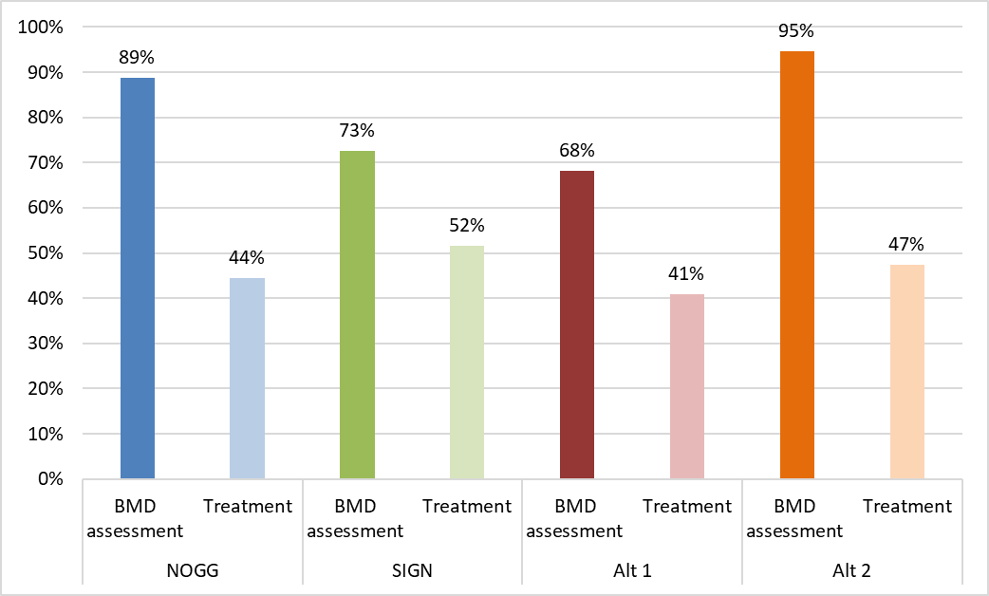
Alt 1 = BMD assessment if 10%+ MOF risk (without BMD) or hip or vertebral fracture
Alt 2 = BMD assessment if 5%+ MOF risk (without BMD) or hip or vertebral fracture
BMD = bone mineral density; CRF = clinical risk factor (including prior fracture); MOF = major osteoporotic fracture.
BMD assessment numbers above include people indicated for BMD assessment to determine eligibility for treatment, and also those considered eligible for treatment without reference to BMD information (for example, people determined to be high or very high risk based on initial risk assessment in the NOGG strategy or with a hip or vertebral fragility fracture with SIGN) but indicated for BMD assessment to provide a baseline measurement and/or inform treatment choice. The latter category was 22% in the NOGG strategy and 9% in the SIGN strategy. Analyses of initial categorisation by age are included in I.3.2.
Table 11 shows the total proportions in the graph above broken down into people with and without prior fracture. Fewer people with prior fragility fracture were eligible for BMD assessment with committee alternative 1 than other strategies. Around half as many people without fracture were eligible for BMD assessment with the SIGN and committee alternative 1 strategies than the NOGG and Committee alternative 2 strategies.
In people without prior fracture the number of people eligible for treatment was highest with SIGN (27%) and lowest with committee Alternative 1 (15%), with NOGG and committee Alternative 2 in between (both 20%). Treatment numbers in people with fracture were more similar across strategies.

Table 11: Proportion of BMD assessment and treatment eligibility in women 50 years and over with a CRF: with and without prior fracture
 | NOGG |  | SIGN |  | Alt 1 |  | Alt 2
 | BMD assessment | Treatment | BMD assessment | Treatment | BMD assessment | Treatment | BMD assessment | Treatment
Fracture | 38% | 25% | 38% | 24% | 33% | 26% | 38% | 27%
No Fracture | 51% | 20% | 35% | 27% | 35% | 15% | 57% | 20%
Total | 89% | 44% | 73% | 52% | 68% | 41% | 95% | 47%
Alt 1 = BMD assessment if 10%+ MOF risk (without BMD) or hip or vertebral fracture
Alt 2 = BMD assessment if 5%+ MOF risk (without BMD) or hip or vertebral fracture
BMD = bone mineral density; CRF = clinical risk factor (including prior fracture); MOF = major osteoporotic fracture.

The population eligible for BMD assessment
Figure 2 shows the proportion of women over 50 with a CRF eligible for BMD assessment by age group and Table 12 shows the age distribution of the population eligible for BMD assessment. Differences between strategies in terms of BMD assessment rates arise in the lower age groups. The biggest difference is seen in the 50-54 years age group where under 20% of women with a CRF are eligible for BMD assessment with committee alternative 1 and over 90% with NOGG. Risk assessment rates with SIGN and committee alternative strategies generally increase with age because they use a constant risk threshold, whereas NOGG uses lower thresholds in younger people, up to age 70 years. Note that the clinical risk factors used to select the population for the analysis includes age 65 years meaning that everyone is eligible for risk assessment from this point.
Figure 2: Proportion of women over 50 with a CRF eligible for BMD assessment using different criteria in each age band
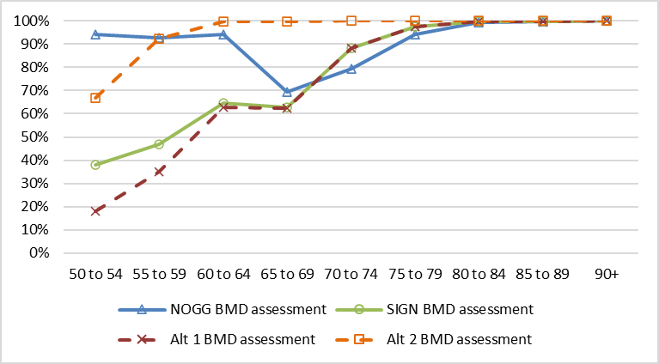
Alt 1 = BMD assessment if 10%+ MOF risk (without BMD) or hip or vertebral fracture
Alt 2 = BMD assessment if 5%+ MOF risk (without BMD) or hip or vertebral fracture
BMD = bone mineral density; CRF = clinical risk factor; MOF = major osteoporotic fracture.
Table 12: Age distribution of women over 50 with CRF eligible for BMD assessment
Strategy | 50 to 54 | 55 to 59 | 60 to 64 | 65 to 69 | 70 to 74 | 75 to 79 | 80 to 84 | 85 to 89 | 90+ | Total
NOGG | 12% | 12% | 12% | 11% | 11% | 11% | 9% | 6% | 3% | 89%
SIGN | 5% | 6% | 8% | 10% | 13% | 12% | 9% | 6% | 3% | 73%
Alt 1 | 2% | 4% | 8% | 10% | 13% | 12% | 9% | 6% | 3% | 68%
Alt 2 | 9% | 11% | 13% | 16% | 14% | 12% | 9% | 6% | 3% | 95%
Alt 1 = BMD assessment if 10%+ MOF risk (without BMD) or hip or vertebral fracture
Alt 2 = BMD assessment if 5%+ MOF risk (without BMD) or hip or vertebral fracture
BMD = bone mineral density; CRF = clinical risk factor (including prior fracture); MOF = major osteoporotic fracture.

The population eligible for treatment
The results below provide information about the demographics of the populations identified for treatment with alternative criteria. Different strategies varied in who they recommended as eligible for treatment. Numbers will therefore depend on both DXA criteria and treatment criteria making interpretation more complex. Treatment criteria have different clinical rationales, and this is important to consider when interpreting results. This analysis cannot determine whether higher numbers are better or worse, and results need to be considered alongside the clinical rationales for the criteria for treatment.
Age
Figure 3 shows the proportion of women over 50 with a CRF vary eligible for treatment by age group with different strategies and Table 13 shows the age distribution of the population eligible for treatment. Differences between strategies vary by age group. For example, in people aged 50-54, treatment rates are around 10% with the SIGN and committee alternative 1 strategies but over 35% with the NOGG strategy. Whereas in people aged 65-79 years treatment rates are highest with the SIGN strategy and lowest with the NOGG strategy. This will be impacted by the SIGN recommendation to treat people over 65 years with BMD T-score <-1. Note that the clinical risk factors used to select the population for the analysis includes age 65 years meaning that everyone is eligible for risk assessment from this point which impacts trends.
Figure 3: Proportion of women over 50 with a CRF eligible for treatment using different criteria in each age band
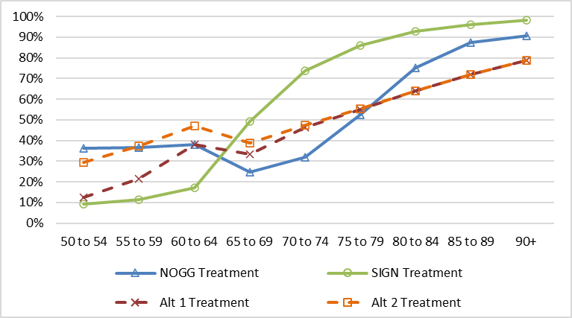
Alt 1 = BMD assessment if 10%+ MOF risk (without BMD) or hip or vertebral fracture
Alt 2 = BMD assessment if 5%+ MOF risk (without BMD) or hip or vertebral fracture
See section Error! Reference source not found. for details of treatment criteria scenarios
BMD = bone mineral density; CRF = clinical risk factor (including prior fracture); MOF = major osteoporotic fracture.
Table 13: Age distribution of women over 50 with CRF eligible for treatment
Strategy | 50 to 54 | 55 to 59 | 60 to 64 | 65 to 69 | 70 to 74 | 75 to 79 | 80 to 84 | 85 to 89 | 90+ | Total
NOGG | 5% | 5% | 5% | 4% | 5% | 6% | 7% | 5% | 3% | 44%
SIGN | 1% | 1% | 2% | 8% | 11% | 10% | 9% | 6% | 3% | 52%
Alt 1 | 2% | 3% | 5% | 6% | 7% | 7% | 6% | 4% | 3% | 41%
Alt 2 | 4% | 5% | 6% | 6% | 7% | 7% | 6% | 4% | 3% | 47%
Alt 1 = BMD assessment if 10%+ MOF risk (without BMD) or hip or vertebral fracture
Alt 2 = BMD assessment if 5%+ MOF risk (without BMD) or hip or vertebral fracture
BMD = bone mineral density; CRF = clinical risk factor (including prior fracture); MOF = major osteoporotic fracture.
Fracture risk
Figure 4 and Table 14 show the risk distributions and average 10-year MOF risk of the population eligible for treatment with the different comparators. Note that FRAX 10-year risk with BMD is shown here as this is the more accurate estimate of true risk in the population (irrespective of whether this was used to select people for BMD assessment / treatment).
Figure 4: Risk distribution in women over 50 with a CRF and eligible for treatment
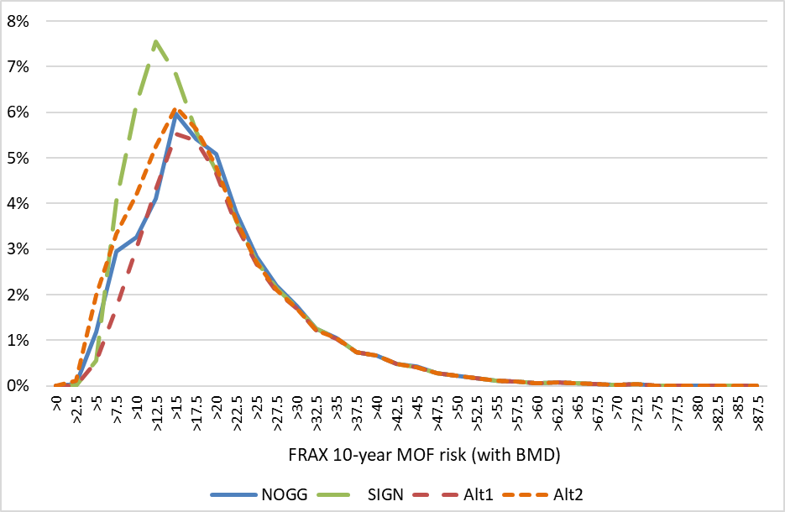
CRF = clinical risk factor (including prior fracture); BMD = bone mineral density; MOF = major osteoporotic fracture
Table 14: Average 10-year FRAX MOF risk (with BMD) for women over 50 with a CRF eligible for treatment
Strategy | Mean | SD | Median | LQ | UQ
NOGG | 21.7 | 10.5 | 19.7 | 14.8 | 26.2
SIGN | 20.3 | 10.2 | 17.8 | 13.2 | 24.7
Alt1 | 22.3 | 10.4 | 20.0 | 15.3 | 26.7
Alt2 | 20.8 | 10.6 | 18.6 | 13.6 | 25.4
Alt 1 = BMD assessment if 10%+ MOF risk (without BMD) or hip or vertebral fracture
Alt 2 = BMD assessment if 5%+ MOF risk (without BMD) or hip or vertebral fracture
BMD = bone mineral density; CRF = clinical risk factor (including prior fracture); LQ = lower quartile; MOF = major osteoporotic fracture. SD = standard deviation; UQ = upper quartile.
BMD
The population eligible for treatment may also differ in terms of BMD distribution due differences in BMD assessment criteria and treatment criteria, including that SIGN includes BMD criteria for treatment eligibility and NOGG does not. Figure 5 shows the BMD distributions for the population eligible for treatment with and without prior fracture.
Note that in the SIGN scenario and Committee-defined alternative scenarios where there is some treatment in people with BMD above -1 is shown this will be because people with hip or vertebral fracture are being treated without BMD restrictions. However, this may be occurring in the analysis due to the lack of covariance between site of fracture and BMD in the simulation rather that a true occurrence and so should be interpreted with caution.
Figure 5: BMD distribution in women 50 years and over with CRF eligible for treatment
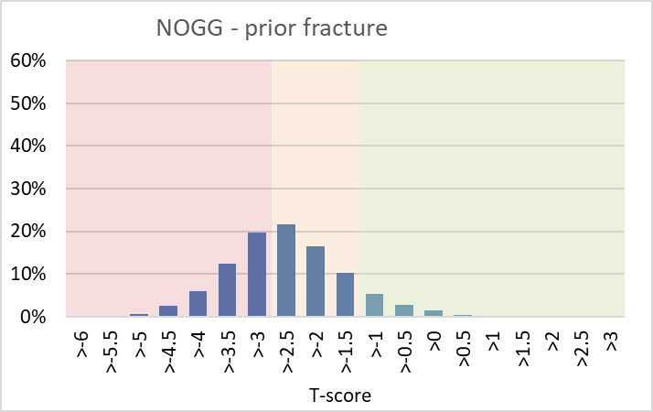 | 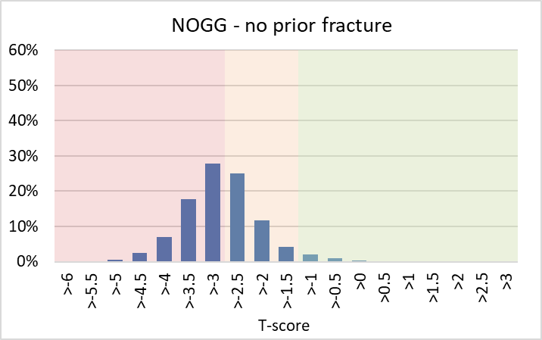
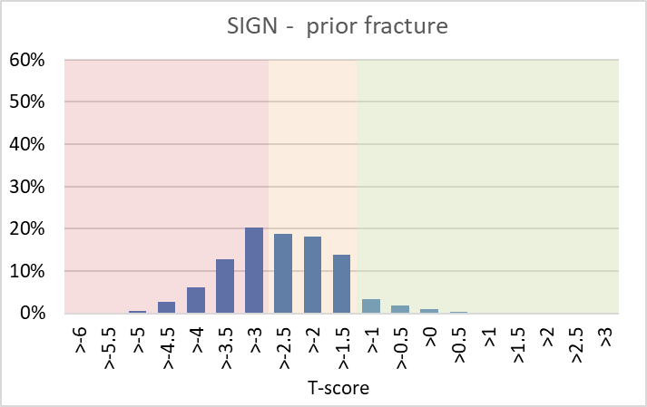 | 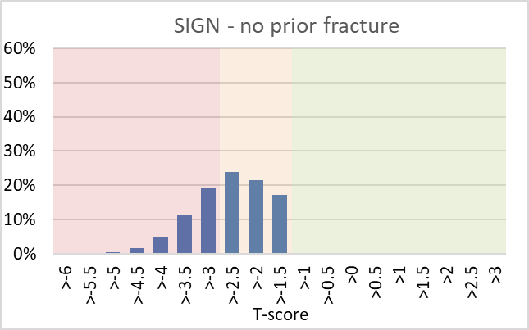
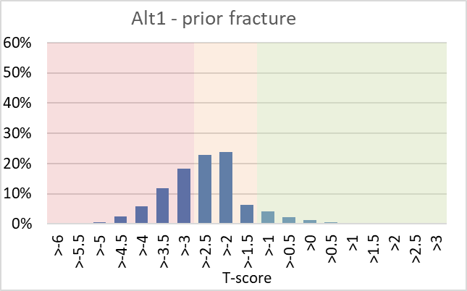 | 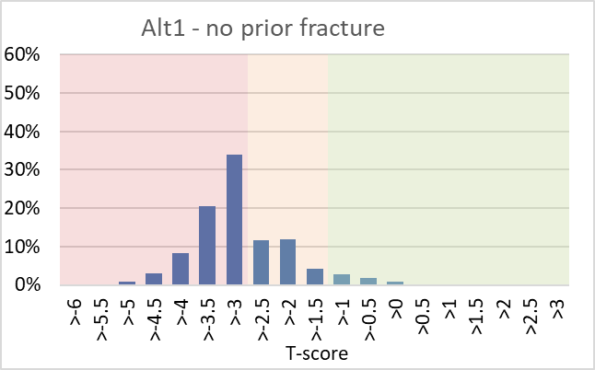
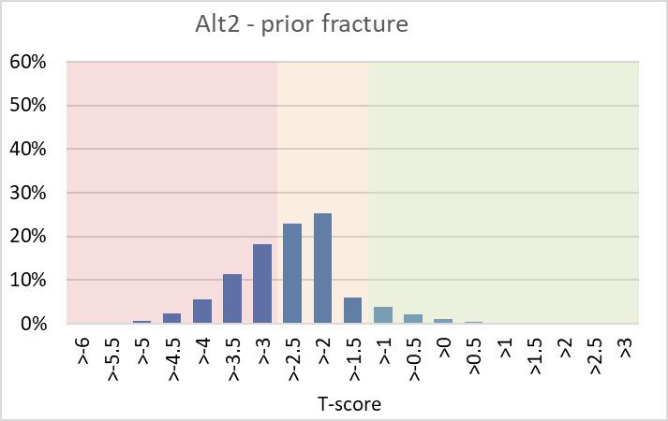 | 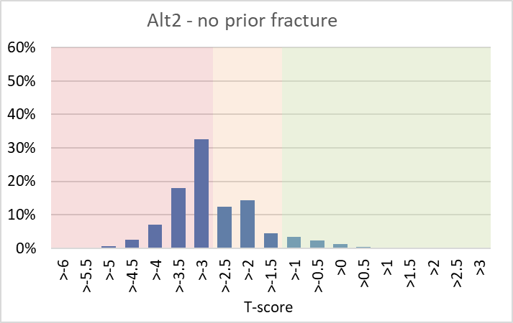
Note: Population is people eligible for treatment in each scenario. CRF = clinical risk factor (including prior fracture); BMD = bone mineral density.
Graph background shading: red = T-score <-2.5; orange = T-score >-2.5 to -1; green >-1
For SIGN, of the people eligible for treatment with either a NHNV fracture, or no fracture and a risk of 10% or above (where BMD criteria are applied): 58% were in the range -1 to -2.5 and 42% were below -2.5. SIGN recommends treating people over 65 in the range -1 to -2.5 with iv zoledronate.

Case finding cost per person treated
Table 15 shows the DXA-related cost to identify 1 person for treatment with each strategy. However, it is important to note that the criteria for treatment varies between comparators and this analysis does not determine if everyone who is treated is treated appropriately, making interpretation complex. When interpreting results consideration should therefore be given to the specific criteria being applied in each strategy and whether they are considered clinically appropriate. For example, the SIGN strategy has the lowest case finding cost per person treated in part due to having the higher treatment eligibility rate but the treatment criteria includes treating people eligible for DXA (prior fragility fracture or 10-year MOF risk 10% or more) over 65 years with BMD >-2.5 to -1 (with iv zoledronate) which is broader than the treatment criteria applied for the committee alternative strategies.
Alt 1 and Alt 2 only vary in terms of the risk threshold used for BMD assessment (Alt1 10% vs Alt2 5%) and so an incremental comparison of the additional cost per additional person treated has been included for this comparison only.
Table 15: Case finding cost per person treated
 | NOGG | SIGN | Alt1 | Alt2
Proportion eligible for DXA | 89% | 73% | 68% | 95%
Average cost per person with CRF - DXA scans | £74 | £61 | £57 | £79
Average cost per person with CRF - Post-DXA appointment | £52 | £43 | £40 | £56
Average case finding cost per person with CRF - total | £127 | £104 | £97 | £135
Proportion eligible for treatment | 44% | 52% | 41% | 47%
Average case finding cost per person treated - total | £285 | £201 | £238 | £285
Average additional case finding cost per person Alt2 vs Alt1 | n/a | n/a | n/a | £38
Additional % eligible for treatment Alt2 vs Alt1 | n/a | n/a | n/a | 6%
Cost per additional person treated Alt2 vs Alt1 | n/a | n/a | n/a | £581
Alt1/2 = committee defined alternative strategy 1/2; CRF = clinical risk factor (including prior fracture).

Summary and discussion

Summary
- DXA eligibility in women over 50 years with a CRF varied depending on the criteria applied:
  - NOGG 89%
  - SIGN 73%
  - Committee alt1 (10% risk or hip/vertebral fragility fracture): 68%
  - Committee alt2 (5% risk or hip/vertebral fragility fracture): 95%
- Differences in DXA eligibility rates between strategies were mostly in the group without prior fracture under 65 years. The biggest difference being in the youngest age group (50-54 years).
- To interpret differences in DXA resource use, treatment rates were also calculated:
  - NOGG 44%
  - SIGN 52%
  - Committee alt1 (10% risk or hip/vertebral fragility fracture): 41%
  - Committee alt2 (5% risk or hip/vertebral fragility fracture): 47%
  - It is noted that committee alternative treatment rates are an approximation as some aspects of the committee recommendations had to be simplified in the analysis.
- Differences in criteria also resulted in differences in the demographics of the population eligible for treatment in terms of age, fracture risk and BMD. For example, a higher proportion of people under 65 years were eligible for treatment with NOGG criteria than with SIGN and committee alternative 1 criteria.
- When interpreting treatment numbers, note that criteria for treatment varied between strategies – including how DXA information is used – and were based on different clinical rationales. This analysis cannot determine whether lower treatment numbers are better (reduced over prescribing) or worse (missed treatment), and results need to be considered alongside the different clinical rationales for the criteria for BMD assessment and treatment.
- Use of committee alternative 1 (incorporating a 10% risk criteria for BMD assessment) is likely to be associated with lower resource use than NOGG which is most widely used in England currently. It may also have lower treatment rates.
- Comparing the two committee alternative strategies (that only varied in terms of the risk criteria for DXA), the 5% risk strategy (Alt2) resulted in an additional 27% of people having DXA and a 6% increase in treatment rates, compared to the 10% risk strategy. The average case finding cost was lower for the 10% risk strategy (Alt1). The cost per additional person identified for treatment with committee alternative 2 compared to alternative 1 was £581 due to the fairly high number of people eligible for BMD assessment compared to only a modest increase in the number of people eligible for treatment.

Limitations and interpretation
Use of a population simulation
The published population simulation was considered the best data identified for this analysis.
The simulation is based on data from a large European dataset used to inform development of the FRAX risk calculator. The reason the simulation was developed was to adjust for a UK age-distribution to make it more relevant to the UK context.
An alternative would have been to use a UK real-world dataset for the analysis but using this population simulation was considered to have advantages over using a UK primary care dataset such as CPRD because the committee advised that certain information is often not well recorded, in particular BMD which is needed to implement some of the criteria for treatment. Risk scores are also unlikely to be recorded and would need to be calculated.
Other similar simulated population analyses that incorporated covariance were not identified. Models that informed TAs have sometimes simulated populations but have not been able to incorporate covariance fully due to it not being published. Guthrie et al (2024) noted this as a limitation of the MTA464 analysis.
Population
The published population simulation used for the analysis was for women over 50 only and so this analysis was only able to look at this population. This is the primary relevant population but does not include all relevant groups, in particular men. It was not limited to post-menopausal women.
The analysis population was restricted to people with a clinical risk factor in order to reflect who might undergo risk assessment. In the analysis people were defined as having a clinical risk factor if they had one of the risk factors in the FRAX calculator or were aged over 65 years. While these risk factors are all included in the committee’s recommendation about indications for risk assessment, in practice, not all these people will be identified or considered appropriate for risk assessment. Identification for risk assessment for people without a prior fragility fracture will generally be through opportunistic identification in primary care and risk assessment rates in this group are considered to be fairly low. In addition, committee discussions for this guideline update suggested that having some single risk factors (e.g. smoking) may not be considered sufficient alone to warrant risk assessment, This would result in a narrower population that used in this analysis. The committee agreed that it was not possible to adjust the population to reflect this as they relied on individual clinical judgements, Lower rates of risk assessment would result in a smaller initial population for the analysis, but this will be common to all strategies.
Age over 65 years (for women) was included as a CRF as this is part of the NICE recommendations about indications for risk assessment. NOGG guidance includes age as a risk factor that may prompt risk assessment but does not include a cut off. SIGN guidance does not list age as a risk factor that should prompt risk assessment. In the analysis the population having risk assessment was the same for all strategies, this was because the aim was to compare the implications of different DXA criteria. Current guidelines also list some clinical risk factors not in risk calculators that are not accounted for in the analysis.
The analysis uses a prevalent population and estimates numbers eligible for DXA and treatment with different criteria applied. It is noted that it is not an implementation analysis as it doesn’t account for people already being on treatment or prior risk assessment.
Risk tool
The analysis uses fracture risk calculated by the FRAX tool as this was what was included in the published population simulation. This is also necessary to implement NOGG recommendations as this specifies use of FRAX as this requires recalculation of risk to include BMD in people classified as at intermediate risk. It was not possible to add calculation of QFracture risk into the population simulation as additional information about risk factors is required that wasn’t part of the simulation. SIGN recommendations include a preference for QFracture but do not exclude use of FRAX. Updated NICE recommendations continue to recommend use of either FRAX or QFracture.
Addition of fracture type to simulated population
Fracture type was not included in the published population simulation used for this analysis but was required to model SIGN criteria and the alternative committee-defined scenario criteria. Age-dependent incident fracture distributions were used to attribute fracture type. This used the current age however as no information about when prior fracture occurred was available. Covariance with other risk factors, including BMD, was not incorporated as information was not available to do so. Therefore, results that rely of fracture type and BMD should be interpreted taking this into account. For example, if hip and vertebral fractures are associated with lower BMD than other fragility fractures this will not be reflected in results.
Multiple fragility fractures
The committee draft recommendations included multiple fragility fractures as an additional criteria for BMD assessment, even when risk is less than 10%. This was not included in this analysis as suitable data was not identified. This may result in an underestimation of DXA rates (and so potentially also treatment rates). The impact is considered likely to be small as this will only impact people with a NHNV fracture and risk below 10% in the analysis (as people with hip or vertebral fracture or risk above 10% will already be eligible for DXA). 6% of people in the analysis had NHNV fracture and risk below 10%. If, for illustration, 25% of these had multiple fragility fractures this would increase DXA rates by 1%.
Reason for DXA
DXA resource was included whether it was related to determination of treatment eligibility or for other purposes such as a baseline measurement or to inform treatment choice. This is important to fully assess differences in DXA resource use because a DXA will only be done once and so if one is done to determine treatment eligibility another will not be required for a baseline measurement.
BMD information is utilised differently in different strategies. In NOGG, it is used to refine risk estimates in people at intermediate risk. Eligibility for treatment is determined by risk thresholds. Those at higher risk are considered eligible for treatment without BMD assessment and recalculation of risk but BMD assessment is still recommended to guide drug choice and provide a baseline for BMD monitoring. In SIGN BMD thresholds are used to determine eligibility for treatment in people with NHNV fragility fracture or 10%+ risk. People with vertebral or hip fragility fracture are considered eligible for treatment without BMD assessment but it is recommended to provide a baseline BMD and/or inform treatment choice. The committee advised that both risk and BMD should be considered, alongside clinical risk factors, patient history and fracture history when making a clinical judgement about the clinical appropriateness of treatment.
Uptake of DXA
The analysis assumes DXA uptake is 100% of those who have a fragility fracture or other CRF. In practice, DXA is not feasible or appropriate for all people and some people may choose not to have one. This will impact all comparators meaning that rates will be lower than in the analysis. If DXA uptake varies by age this may cause additional differences between strategies as age profiles of people eligible for DXA vary.
Committee defined treatment criteria
Implementation of the committee treatment criteria in the analysis required some simplifications and so are an approximation. This was because the population simulation only included risk factor information as required for entry into FRAX.
The population simulation indicated whether or not there was glucocorticoid use at any time, and this was used to approximate the committee criteria related to current or frequent use of systemic glucocorticoids. This will result in an overestimate of treatment numbers. As no information was available about high-dose glucocorticoid use the final treatment criteria was omitted which will result in an underestimate of treatment numbers. This was considered likely to be a small group.
The population simulation includes information about whether or not an individual has secondary osteoporosis. The guideline recommendation includes a treatment criteria related to medicines and secondary cause known to be associated with accelerated bone loss which will be a smaller group than any secondary osteoporosis. However, in the absence of additional information this was used to implement this criteria in the analysis. This will result in an overestimation of treatment numbers.
The committee also highlighted that need for treatment should be a clinical decision taking into consideration risk of fracture, BMD, an individual’s specific clinical risk factors and fracture history rather than only on defined treatment rules.
Interpretating the analysis
This analysis provides quantitative information about the potential differences between alternative BMD assessment and treatment eligibility criteria in terms of resource use and who is identified as eligible for treatment. This can inform explicit consideration of whether the committee is happy with the potential implications of new recommendations, in particular compared to existing practice.
Treatment numbers (and so cost per person identified for treatment) in the analysis need to be interpreted carefully given that criteria for treatment vary between strategies and are based on different clinical rationales. This analysis cannot determine whether lower treatment numbers are better (reduced over prescribing) or worse (missed treatment), and results need to be considered alongside the different clinical rationales for the criteria for BMD assessment and treatment. Higher numbers of people identified as eligible for treatment is only good if they will benefit from treatment, treatment benefit will outweigh treatment risks and treatment is cost-effective.
This analysis does not provide an answer to which option is most cost-effective as it only includes costs related to the initial BMD assessment and does not consider treatment and fracture costs or health benefits.
Which is the most cost-effective set of criteria for BMD assessment and treatment will be affected by a number of different things:
- The cost of identifying people for treatment including DXA costs
- The number of people identified for treatment
- The benefits, harms and costs of treating the people identified for treatment
- The demographics of the population identified for treatment because cost effectiveness of treatment will vary with baseline fracture risk and potentially by age and other factors.
Treatment criteria for different strategies are based on different clinical rationale and so the benefits of treatment may not be the same in the different populations identified for treatment. Clinical studies comparing these strategies were not identified in the clinical review. Interpretation may be impacted by how closely the population considered eligible for treatment aligns with populations in treatment trials that have assessed clinical effectiveness.
This analysis could be extended to a full cost-effectiveness analysis by incorporating treatment modelling to quantify down-stream costs and health effects. This would however require either evidence from a study comparing the strategies included in the analysis, which is not available, or assumptions about whether fracture risk reduction observed in treatment trials will be achieved in all people identified as eligible for treatment in each strategy.
It was agreed that capturing the implications of the committee’s recommendations about treatment criteria compared to alternative interpretations about who should be treated would be complex. In addition, there were practical considerations such as parallel development of new treatment modelling and recommendations as part of a multiple technology appraisal. Extending the analysis was therefore not undertaken as part of the guideline update.

Unit costs

The previous guideline included a comparison of the cost of undertaking DXA in all people compared to a strategy of risk assessment followed by selective DXA. An updated comparison is included below.
Table 16: Cost comparison from NICE CG146 2017 updated
Strategy | Cost breakdown | Units required | Cost per component | Total cost per person
BMD assessment for all | Initial contact | 0-1 | £0-£59 | £143 to £202^{(a)}
 | DXA scan | 1 | £84
 | Post-DXA follow-up | 1 | £59
Risk score + selective BMD assessment | Initial contact and risk assessment | 1 | £59 | £59 to £202^{(b)}
 | DXA scan | 0-1 | £84
 | Post-DXA follow-up | 0-1 | £59
Costings: Initial contact, initial contact & risk assessment, and post-DXA follow-up were all defined as a 15-minute GP consultation based on committee expert opinion (cost source= PSSRU 2023/24). The cost of a DXA scan was calculated by taking the average cost of DXA as reported in the NHS National Cost Collection 2023-24 (Currency code RD40Z).
- £143 if no initial contact appointment required; £202 including initial contact appointment.
- £59 if no DXA scan and £202 if DXA scan. The average cost per person will be between the two and dependant on the proportion of people that would require a DXA scan.
If an initial contact appointment is required with the individual prior to referral for BMD assessment, then costs for a risk score + selective BMD strategy will always be lower than for BMD for all.
However, if an initial contact appointment is not required prior to a BMD assessment if risk assessment is not taking place, then risk score with selective BMD will be lower cost if the rate of BMD assessment is less than 71%.

Evidence statements

Economic evidence statements
- One model-based cost-utility analysis (with a lifetime horizon) found that in women age 70-85 years both with and without fracture risk, a community-based screening programme that used age-dependent FRAX thresholds to determine those eligible for BMD measurement (via DXA scans) and/or treatment was dominant (lower costs and higher QALYs) compared to usual management of osteoporosis (referral for DXA scan and anti-osteoporosis treatment if deemed clinically appropriate by GP), with a 97% probability of the screening programme being cost-effective at a threshold of £20,000 per QALY gained. This analysis was assessed as partially applicable with potentially serious limitations.
- One within-trial cost-utility analysis (with a 5-year time horizon) found that in women age 70-85 years both with and without fracture risk, a community-based screening programme that used age-dependent FRAX thresholds to determine those eligible for BMD measurement (via DXA scans) and/or treatment was cost-effective (ICER of £2,772 per QALY gained) compared to usual management of osteoporosis (referral for DXA scans and anti-osteoporosis treatment if deemed appropriate by GP), with a 93% probability of the screening programme being cost-effective at a threshold of £20,000 per QALY gained. This analysis was assessed as partially applicable with potentially serious limitations.
- A new analysis undertaken as part of the guideline update found that DXA-related resource use was likely to be lower with a strategy using previous hip or vertebral fragility fracture or predicted fracture risk 10%+ to determine eligibility for DXA, compared to one using NOGG criteria, SIGN criteria, or incorporating a 5% risk threshold. Treatment numbers may also be lower.

The committee’s discussion and interpretation of the evidence

The outcomes that matter most
The committee identified the following outcomes to be included in the review; fragility fracture, generic health-related quality of life, mortality, adverse events of tests, adverse events and time to starting treatment.
The committee agreed to include the following fracture outcomes:
- Fragility fracture
- Major osteoporotic fracture (MOF), defined as hip, vertebral (clinical spine), proximal humerus (shoulder), and distal forearm (wrist) fragility fractures
- Vertebral fracture (VF)
- Hip fracture (HF)
- Non-vertebral fractures and non-hip fractures.

The quality of the evidence
For the comparison two-step screening versus usual care, there were two RCTs reporting four outcomes at 5-years or 10-years follow-up. The outcomes from the two studies included fragility fracture (which was defined in the ROSE study as all fragility fractures except fractures of the hand, foot, nose, skull, and similarly in the SCOOP study with the additional exclusion of cervical vertebral fracture), major osteoporotic fracture, hip fracture, health-related quality of life (using the EQ-5D-3L tool), and mortality. The outcomes ranged from high to very low certainty with fragility fracture and hip fracture outcomes rated as very low certainty.
Fracture outcomes were at very serious risk of bias due to concerns about the measurement of outcomes (various methods were used for fracture ascertainment and only verified fractures were included). The outcome fragility fracture was assessed as only partially applicable because both studies contributing to this outcome excluded some types of fragility fractures (for example, fractures of the hand, finger, face, skull, an/or cervical vertebra). The outcome hip fracture was assessed as very low certainty as it was also downgraded for very serious inconsistency due to very high I² (>80%) and serious imprecision (95%CIs of the hazard ratio crossed clinical decision threshold of 0.8). Reasons for this were not explored due to the small number of identified studies. Evidence for quality of life was assessed as low certainty due to the serious risk of bias from concerns about measurement of outcomes. Evidence for mortality was assessed as high certainty.
For the comparison one-step screening versus usual care, one pragmatic RCT reported four outcomes assessed at 3-year follow up. The outcomes from the study included fragility fracture, major osteoporotic fracture, hip fracture, and mortality. All outcomes were assessed as low certainty except for hip fracture which was very low certainty. The trial was assessed as at serious risk of bias because participating GPs were permitted to use an off-protocol application for consult (follow up) notification, which may have improved adherence. In addition, the trial was assessed as only partially applicable because it included a non-protocol intervention (vertebral fracture assessment). The outcome fragility fracture was also assessed as partially applicable because some fragility fractures such as those of the toe, face and skull were excluded. The outcome major osteoporotic fracture was also assessed as partially applicable because it was analysed post hoc. The outcome hip fracture was also downgraded for imprecision because the 95%CI of the hazard ratio crossed one of the clinical decision thresholds (0.8 or 1.25).

Benefits and harms
Two-step screening versus control
Two RCTs, the ROSE (Rubin 2018, Petersen 2024) and SCOOP (Shepstone 2018, Turner 2018) studies, were identified. The two-step screening consisted in a FRAX assessment to determine who received an invitation to have a DXA scan compared to usual care. The Danish ROSE study used a FRAX 10-year risk of MOF threshold of 15% or more, whilst the UK SCOOP study used age-dependent thresholds, to determine whether women received an invitation for a DXA scan. Usual care in the ROSE study consisted of a FRAX assessment although women in this arm were not informed of their estimated fracture risk; in the SCOOP study usual care consisted in the collection of the same demographic and clinical information needed to calculate a FRAX score without such a calculation.
High to very low certainty evidence from the ROSE and SCOOP studies showed no clinically important difference between two-step screening and usual care on any outcome with all outcomes crossing the line of no effect. For hip fracture, there was no clinical difference (HR 0.86 [95%CI 0.63 to 1.17) overall but there was serious heterogeneity (I²>80%) and imprecision. The inconsistency could not be explored by sub-group analysis due to the small number of studies. However, the heterogeneity could be partly due to the different analysis methods used (HR and subHR). The HR is the rate of occurrence in subjects who are currently event-free whilst the subHR is the rate of occurrence in subjects who have not yet experienced a fracture but may have had a completing event. In the ROSE study there was no difference in the event rates between the two groups. However, the SCOOP study had a HR of 0.72 (95%CI 0.59 to 0.89) that suggested that two-step screening had an event rate 28% lower than the usual care group, although there was some imprecision. Unlike the ROSE study, the SCOOP study used calculated FRAX 10-year risk of hip fracture score and age-dependent thresholds to decide eligibility for BMD measurement by DXA. The relative reduction in hazard (time to fracture within follow up time) of 28% corresponds to an absolute risk of 10 fewer hip fractures per 1000. The committee agreed that this reduction in hip fractures was clinically important despite the low absolute risk.
One-step screening versus control
One RCT, the SOS study (Merlijin 2019), was identified and four outcomes at 3-year follow up were reported. The trial compared one-step screening consisting of a DXA scan, vertebral fracture assessment, calculation of an age-dependent FRAX-UK 10-year risk of MOF, fall assessment, and blood tests to exclude secondary osteoporosis to Dutch usual care. The usual care was a screening waiting list where women were offered one-step screening after trial end. Participants with a FRAX score above the age-dependent thresholds or with a vertebral fracture were offered treatment. In line with Dutch guidelines, women in this group with an indication for DXA and VFA at baseline were advised to contact their GP.
Very low certainty evidence showed no clinically important difference on fragility fracture, major osteoporotic fracture, hip fracture and mortality. The committee noted that the absolute risk of one-step screening was 3 more per 1000 (that is, there were less deaths in the usual care group) but did not consider this to be a clinical benefit. The study did not report cause of death, and it was assumed that it was all cause mortality rather than osteoporosis related.

Conclusions and committee experiences
Background
Fragility fracture is a complex condition and the relation to osteoporosis (as defined by areal BMD score) is not straightforward. The committee discussed the need to assess risk, measure BMD if risk is high, and prevent occurrence (primary prevention) or re-occurrence (secondary prevention) of fracture. They agreed using their knowledge and experience that clinical decisions about how to prevent fracture occurrence using information about BMD, if available, should be balanced by consideration of other (modifiable and non-modifiable) risk factors known to increase fracture risk, for example: age, sex, the presence of comorbidities, and lifestyle behaviours (for example, smoking and drinking). Due to the complexities of fragility fracture, especially considering that the majority of fragility fractures occur in people with osteopenia (as defined by BMD T-score above -2.5 and below -1), the decision to treat an individual should be based on their clinical fracture risk profile considering their age, fracture history and other modifiable and non-modifiable risk factors, and when available estimated 10-year fracture risk and BMD score.
Estimating fracture risk can potentially help guide management decisions to prevent and treat fragility fracture by initially identifying people at risk without the need for a DXA scan. This is especially important for patients such as pregnant women since even low doses of radiation may be harmful to a developing foetus. Risk prediction tools (including the UK-validated FRAX and QFracture) include many of these risk factors in their models and are currently preferred to the use of BMD alone to predict fragility fracture (rather than to determine treatment). Although DXA measurement of BMD is ubiquitous in the management and prevention of fracture, reliance on BMD alone to predict fragility fracture will miss many people who will go on to sustain a fracture.
The committee agreed that understanding an individual’s fracture risk is important as it allows consideration of the potential risk-harm trade-offs of treatment and may influence an individual’s desire to start and adhere to treatment. The committee agreed that although estimating fracture risk using a risk prediction model is a very useful part of clinical decision making, it should not be used on its own to decide treatment eligibility. This is because the prediction models do not include all fracture risk factors (such as fracture recency) and two people with different risk factors for fragility fracture can have the same estimated fracture risk.
Published evidence
The committee discussed the limitations of the evidence regarding the effectiveness of using fracture risk prediction tools and bone assessment methods to predict fracture. The evidence was limited to studies in postmenopausal women with only FRAX and measurement of BMD by DXA. The evidence suggested there was no difference in reported outcomes between FRAX with DXA compared to usual care. However, the committee agreed that generally using a risk prediction tool (that is, FRAX in this case) with BMD can be useful to assess risk alongside clinical judgement because it allows the clinician and patient to understand the latter’s individual clinical fracture risk profile. This is especially important given the complex nature of osteoporosis and fragility fracture.
There were no studies comparing different methods or tools to each other as all studies compared FRAX and/or use of BMD to usual care. This evidence could not inform the decision as to which risk prediction tool or bone assessment methods should be recommended. Therefore, the committee considered this evidence alongside the reviews on the validity of risk prediction tools (Evidence review C) and accuracy of bone assessment methods (Evidence review D) to develop recommendations about how they should be used in the management pathway.
Committee recommendations
Risk assessment in people aged 30 to 90
The committee agreed that people aged between 50 and 90 with a previous hip or vertebral fragility fracture or 2 or more fragility fractures would merit measurement of BMD using DXA. They agreed that such a fracture event at this age would increase fracture risk sufficiently to obviate the need to conduct a fracture risk assessment using FRAX or QFracture because people in this group would likely need treatment, and a BMD measurement provides important information to help guide treatment.
When assessing risk in other people in this age category or in people aged between 30 and 49, the committee agreed that using risk prediction tools first is best to avoid unnecessary DXA scans. The committee agreed that FRAX or QFracture risk prediction tools should be used to assess risk (see Evidence report C). As FRAX only applies to people aged 40 and over, QFracture should be used for people aged between 30 - 39 years.
Recommendations for people between the ages of 30 and 50 were made to account for the fact that although people in this group are generally at low risk of fracture, risk is substantially increased either by a history of major osteoporotic fracture or the presence of major risk factors (for example, the use of systemic glucocorticoids, or untreated early menopause or premature ovarian insufficiency). The committee agreed that estimation of fracture risk using FRAX or QFracture should be considered in this group to help guide management decisions to prevent a first or subsequent fragility fracture.
Risk assessment in people aged over 90 years
A recommendation was made that clinical judgment should be used to assess fragility fracture risk for people aged over 90 years. The committee acknowledged that the validated age ranges that the recommended risk assessment tools are intended for use in are different (40-90 for FRAX-UK, 30-99 for QFracture) and it is not possible to get an estimate of an individual’s 10-year risk of MOF or HF outside of the age ranges. The committee noted that although QFracture goes up to the age of 99, it will only calculate the 10-year risk of fracture up to the age of 90. After that it reduces the predicted probability by 1 year (for example, at age 91 it will calculate the 9-year risk of fracture; at age 92, the 8-year risk of fracture). Despite this, the committee acknowledged that QFracture allows calculation of 1 to 10-year fracture risk and clinicians should therefore decide whether calculating an individual’s probability of fracture will be clinically helpful. Therefore, the committee agreed that risk assessment tools should only be used at an upper age limit of 90 years of age. For individuals outside the upper age limit of the intended age range of the tool (90 years for FRAX, or 100 years for QFracture), the committee agreed that clinical judgement should be used to decide how fracture risk should be assessed. The committee discussed how it was important to consider case by case whether using QFracture or DXA was appropriate depending on their individual circumstances (for example mobility issues).
Risk assessment in people under 30 years
For people below the lower age limit of QFracture (that is people under the age of 30), the committee recommended that clinicians should consider directly seeking specialist advice on how to proceed and also consider measuring BMD. The BMD is likely to provide important information to guide any decisions. The committee did not recommend assessing risk using prediction tools as they are not validated for this age group and liaising with the relevant specialists is good clinical practice. For secondary prevention of fragility fracture, already having a fragility fracture would be rare at this age and could indicate secondary osteoporosis. Therefore, there would be a need for investigation to consider the impact of potential causes on the person’s fracture risk. For primary prevention of fracture, the committee agreed that the presence of other major risk factors such as the current use of glucocorticoids or untreated early menopause or premature ovarian insufficiency will also require specialist advice and potential measurement of BMD by DXA scan.
Hormone replacement therapy (HRT)
The committee made a recommendation that when assessing risk, to take into account that fragility fracture risk is decreased while taking HRT. The benefit of HRT is maintained during treatment but decreases once treatment is stopped. The benefit may continue for longer in people who take HRT for longer. It was noted that this protective effect of HRT is considered in the Fracture risk prediction tool but not in FRAX.
Fracture risk threshold, eligibility for DXA measurement of BMD and treatment
The committee discussed the complexities of fragility fracture management and their recommendations about the use of risk prediction tools (see Evidence review C). They highlighted that there is currently a lack of consensus on how information about fracture risk and BMD is used in the management pathway of fragility fracture, with guidelines taking different approaches. As discussed, previously, the committee recommended that BMD should be measured using DXA in people 50 years and over with either a previous hip or vertebral fracture or 2 or more fragility fractures, without requiring a formal fragility fracture risk assessment. This group constitutes those who are at high risk of a secondary occurrence of fragility fracture. The committee discussed that the interpretation of the DXA should still be informed by the presence of other risk factors even though a formal risk assessment was not required to proceed to DXA.
The committee discussed how fracture risk assessment should be integrated into the management of all other adults at risk or suspected risk of fragility fracture. In this context, the committee considered how two other guidelines, NOGG and SIGN (which are both currently used in the UK), have done this.
Fracture risk threshold and eligibility for DXA
Choice of type of threshold
Clinical decision thresholds can be fixed, or they can change according to some risk factor. The NOGG guideline use an age-based relative threshold approach whilst the SIGN guidelines use a fixed threshold-based approach. The NOGG guideline advises use of FRAX to estimate an individual’s 10-year risk of MOF. Four risk thresholds (lower assessment, intervention, upper assessment, very high risk) are used to determine management (lifestyle advice, BMD measurement, treatment, and specialist referral and treatment, respectively). These thresholds increase relative to age until the age of 70 when fixed thresholds are used. For individuals whose initial estimated risk is between the lower and upper assessment thresholds (classified as intermediate risk), it is recommended that BMD information is incorporated into the FRAX score and the revised risk estimates used when determining treatment eligibility against the intervention threshold.
By contrast, the SIGN osteoporosis guideline determines BMD assessment and treatment eligibility based on fixed thresholds. People with a previous hip or vertebral fracture are selected for treatment and for BMD assessment to provide a baseline measurement and to inform treatment decisions. With previous non-hip non-vertebral fractures, BMD assessment is advised with treatment decisions dependant on BMD and age. For people without fractures but with other risk factors, SIGN advises use of a risk prediction tool with a 10% threshold for assessment of BMD. Treatment decisions are based on BMD and age.
The previous NICE guideline for osteoporosis recommended BMD assessment in people close to a treatment threshold but did not define these as they were not within scope. NICE technology appraisals state treatment criteria for specific treatments. The technology appraisal for bisphosphonates (which is the treatment option that is cost effective at the lowest risk levels and so is effectively the treatment threshold) do not explicitly state criteria but refer to a NICE quality standard that includes risk-based treatment thresholds derived from the NOGG guideline.
The committee discussed the benefits and drawbacks of using age-based or fixed fracture risk thresholds to determine treatment eligibility in people who have had a fracture risk assessment using FRAX or QFracture. The committee noted that a fixed threshold was in line with UK practice for managing other conditions in primary care (for example, high cholesterol and fatty liver) and that patients are likely to find a fixed fracture risk threshold easier to understand, use and interpret compared to age-based thresholds. Clinicians on the committee also noted that in their experience, the NOGG system, in which the risk thresholds change relative to the individual’s age up to the age of 70, were difficult to use for this very reason. They also noted that while they believe many organisations use NOGG, the uptake in primary care was limited because of this. They also expressed concern that the age-based approach taken by NOGG has led to over assessing by DXA in people under the age of 60, potentially leading to regular monitoring (including follow up DXA scans) by the health services. Therefore, the committee agreed to use a fixed fracture risk threshold.
Fracture risk threshold level for DXA
The committee discussed the potential impacts of using various risk thresholds such as 5%, 10% and 20% in people who have had a fracture risk assessment but who do not otherwise satisfy the criteria for DXA scan. They agreed using their knowledge and experience that a low threshold such as 5% would likely lead to over-investigation and unduly burden the healthcare system with unnecessary imaging investigations; a high threshold such as 20% would likely lead to missed opportunities for early treatment and prevention.
The committee agreed, using their knowledge and experience, that although a 10% fixed fracture risk threshold might increase the number of DXA scans in an older age group (68+ years; this is the age at which NOGG threshold rises above 10%), there is likely to be a reduction in DXA scan in those under this age (≤67 years). They noted that at age 68, almost every woman with a normal BMI exceeds this 10% fracture threshold.
The committee also highlighted that there uncertainty about treatment benefits at lower risk levels as people included in treatment trials were not likely to have risk below 10%.
The committee discussed whether younger people at risk of fracture but with no fracture history would be missed through use of this 10% fixed threshold. They agreed that although more older people might qualify for DXA (since most people who have a major osteoporotic fracture risk>10% are over 65), it is likely that more young people would be below this risk threshold. The committee agreed that a shift towards older people was appropriate as the burden of fracture was greater in this group. The committee agreed that even if people below the risk threshold were to benefit from these treatments, the benefit harm trade-off is likely to be worse compared to those at higher risk because the absolute benefit of treatment in terms of reducing fractures will be lower (even if the relative treatment effects are constant), while the risks of side effects will be the same.
To supplement the committee’s decision making, a simulation of women over 50 years with either a prior fracture or at least one other risk factor, comparing the NOGG and SIGN guidelines and some additional scenarios, was conducted (see Section Eligibility for treatment
The committee acknowledged that treatment decisions may need to be made in the absence of information about BMD for whatever reason and made recommendations to account for this.
When BMD measurement is not available
The committee recommended making a shared decision with the person about whether to treat without a DXA scan for people who have a 10-year risk of major osteoporotic fracture of 10% or more and for whom a DXA scan is not technically possible (for example, metal implants in hip and lumbar spine) or would not be tolerated. There are various reasons why a DXA scan may not be tolerated (including people who are housebound or living with frailty) and which may delay treatment. The committee emphasised that the decision to treat should still be based on the individual’s fracture risk profile including their fracture history, the presence of risk factors, and (if available) estimated fracture risk (also see below section on whether treatment is appropriate). The committee discussed that this recommendation should not be used to legitimise lack of service provision in the NHS (for example, the scanning centre is far away from where the patient lives, or there is no hoist to lift the patient onto the DXA scanner).
Deciding whether treatment is appropriate
Criteria for starting treatment
The committee agreed, using their knowledge and experience, that the decision to treat should be based on an individual’s clinical fracture risk profile including (if available) the following:
- Fragility fracture risk score (if available)
- BMD (if available)
- The number, and skeletal sites, of previous fragility fractures (especially if they have a previous hip or vertebral fracture)
- Recency of fragility fracture
- Clinical assessment of fracture risk factors.
The committee discussed the need to make a shared decision with the individual how to manage their fracture risk given their circumstances. The committee emphasised that although the risk prediction tools include information about many important fragility fracture risk factors, they do not include all clinical informative variables so even if fracture risk scores are available, a detailed fracture history and clinical assessment of other fracture risk factors will be needed. They highlighted that the same risk could be reached due to different risk factors that may not be equally modifiable by treatment, and this should be taken into account. They agreed that BMD was an important risk factor that should be considered independently.
The committee discussed the role of BMD in deciding whether a person would benefit from treatment. They highlighted that BMD is a continuum and that the lower a person’s BMD the lower their bone strength. They agreed that while the World Health Organization use BMD T-score to define osteoporosis and osteopenia (T-score of -2.5 or less for osteoporosis, and between -2.5 and -1 for osteopenia) there is no specific BMD threshold below which treatment becomes effective. They highlighted that most of the evidence relating to treatment is in people with low BMD and/or fragility fracture and that much of the evidence relating to treatment is in people with a BMD of less than -2.5.
The committee made informal consensus recommendations that pharmacological treatment should be considered for women who had experienced menopause and men aged 50 and over who meet the criteria for DXA and who have any of the following:
- History of hip or vertebral fragility fracture
- BMD T-score of less than or equal to -2.5
- BMD T-score of less than -1.5 and at least one of the following:
  - Any fragility fracture
  - Current or frequent use of systemic glucocorticoids
  - Taking medications or presence of secondary causes associated with accelerated bone loss (for example, aromatase inhibitors or androgen deprivation therapy, or having primary hyperparathyroidism not treated with surgery)
- Aged 65 and over, and BMD T-score less than -1, and high-dose systemic glucocorticoids.
The committee picked these groups because they are at the highest risk of sustaining a fragility fracture and stand to benefit the most from treatment. The committee agreed that a previous fragility vertebral or hip fracture or BMD T-score of less than or equal to -2.5 should be considered for treatment.
For people with a lower BMD T-score of -1.5 or less, the presence of additional risk factors should also form part of the consideration.
The committee discussed the BMD T-score threshold for this group and agreed that not everyone with osteopenia would warrant treatment in this group. The committee agreed, from their knowledge and experience, that a cut-off BMD T-score of less than -1.5 would be appropriate. The committee also agreed using their knowledge and experience, that people aged 65 and over with a BMD score of less than -1 who are on high dose systemic glucocorticoids should be considered for treatment. The committee discussed what a high dose is of systemic glucocorticoids (for example, 15 mg or more a day) but could not define a specific dose because glucocorticoid-induced bone loss is dose dependent and is affected by other risk factors such as age. They noted that patients are often given very high glucocorticoid doses, which is then tapered down when BMD is maintained or improved, and that clinical judgment should be used to determine whether pharmacological treatment is appropriate.
As discussed above, the committee agreed that determining who is at risk of fragility fracture and who would benefit from treatment is not straightforward. The committee discussed the role of fracture recency and BMD information in deciding who might benefit from treatment. They highlighted that fracture risk is highest immediately after fracture and this is not necessarily reflected in risk scores (except for the paid version of FRAX, FRAXplus). The cause of the increased risk is complex and multifactorial, but the committee discussed the increased risk of falls and mobility issues. However, they recognised that this is a complex area because it is not known if the additional risk in this period is modifiable with treatment. The committee agreed that it makes sense to intervene when individuals are most at risk (that is as soon as possible after fracture). Fracture recency may also influence an individual’s desire to start treatment especially because it is a criterion for some treatments (such as romosozumab). The committee agreed that BMD is a continuum and that the lower the BMD the lower a person’s bone strength is but that there is no specific threshold (such as the WHO definitions of osteoporosis and osteopenia) below which treatment becomes effective. Nevertheless, it was noted that most evidence for treatments to prevent fracture and to improve or maintain bone health is in older people with BMD levels defined using the WHO thresholds and so their effectiveness has been measured by its ability to maintain or improve BMD in these groups.
For premenopausal women and men between the age of 30 and 50 who meet the criteria for DXA and have had a major osteoporotic fracture or significant decrease in BMD, the committee recommended seeking specialist advice for management. Sustaining a fracture or losing bone mineral density at this age would be unusual and merit further consideration to establish the cause and consider the need for treatment. The significant decrease in BMD would be on serial measurements. The committee discussed that it would be difficult to define what a significant decrease in BMD would be. Determining when there has been a significant decrease in BMD over time can be based on statistical analysis and/or on clinical relevance. The statistical calculation involves the precision error and the least significant change (LSC), which is the smallest change in BMD that can be considered due to biological change rather than measurement error. For older people the LSC is approximately 4% over two years but the precise value will vary depending on the skill of the clinician and the individual’s characteristics. The committee agreed that the clinical relevance of the BMD change should be considered alongside whether an individual’s BMD is greater than the LSC in deciding whether treatment is appropriate. It was noted that clinical relevance should be considered alongside this statistical change.
Cost effectiveness and resource use below for further details). The results were generally in line with the committee discussion detailed above and the SIGN guidelines, and the committee therefore agreed that a fixed 10% (FRAX or QFracture) 10-year estimated MOF risk threshold should be used to determine eligibility for measurement of BMD by DXA in people who have received a fracture risk assessment using FRAX or QFracture.
Calculation of fracture risk after BMD assessment
The committee discussed whether FRAX estimated fracture risk should be calculated or recalculated following BMD assessment (QFracture does not incorporate BMD data). They agreed that incorporating BMD would likely help better understand an individual’s clinical fracture risk profile, especially in people with previous fracture or secondary osteoporosis, and so may be useful. However, they agreed that recalculation of fracture risk was not necessary and did not make a recommendation relating to this. This is because it is unlikely to sufficiently change the score to the point that it would change management. The committee also discussed whether people who have had a BMD assessment but who have not yet received a fracture risk assessment should receive one. They agreed that although a fracture risk assessment in these cases is, as above, unlikely to change management, it can provide useful clinical information (if this is not already available) for both the clinician and patient. They therefore agreed that calculating or recalculating fracture risk at this stage could be discussed with the patient when appropriate.
DXA scans before treatment
BMD data can inform decisions about whether treatment is appropriate, inform discussions with people about the need for treatment, impact treatment choice and provide a baseline for future monitoring of treatment. Therefore, the committee recommended that a baseline BMD with a DXA scan should be done when starting treatment if possible.
Referrals for DXA to determine eligibility for anabolic treatment
The committee noted that measurement of BMD using DXA is required before initiating anabolic treatment and provides a baseline against which its effectiveness can be measured and monitored. The committee recommended that people who are likely to need anabolic treatment should be fast tracked for a DXA scan, if this is likely to be more than 6 weeks to prevent a delay to the start of their treatment (in line with the NHS England 6-week diagnostic target).
The committee discussed whether people waiting for a DXA scan should initiate anti-resorptive treatment in the meantime. Change in BMD as measured by a DXA scan can only be detected after 2 years, so anti-resorptive treatment can be started before obtaining BMD measurement. The committee recommended that starting antiresorptive treatment should only be considered while waiting for DXA if the person was unlikely to need anabolic treatment. The committee discussed that starting an antiresorptive treatment is not appropriate for people at high risk that may need to start anabolic treatment as it would reduce effectiveness.
Eligibility for treatment
The committee acknowledged that treatment decisions may need to be made in the absence of information about BMD for whatever reason and made recommendations to account for this.
When BMD measurement is not available
The committee recommended making a shared decision with the person about whether to treat without a DXA scan for people who have a 10-year risk of major osteoporotic fracture of 10% or more and for whom a DXA scan is not technically possible (for example, metal implants in hip and lumbar spine) or would not be tolerated. There are various reasons why a DXA scan may not be tolerated (including people who are housebound or living with frailty) and which may delay treatment. The committee emphasised that the decision to treat should still be based on the individual’s fracture risk profile including their fracture history, the presence of risk factors, and (if available) estimated fracture risk (also see below section on whether treatment is appropriate). The committee discussed that this recommendation should not be used to legitimise lack of service provision in the NHS (for example, the scanning centre is far away from where the patient lives, or there is no hoist to lift the patient onto the DXA scanner).
Deciding whether treatment is appropriate
Criteria for starting treatment
The committee agreed, using their knowledge and experience, that the decision to treat should be based on an individual’s clinical fracture risk profile including (if available) the following:
- Fragility fracture risk score (if available)
- BMD (if available)
- The number, and skeletal sites, of previous fragility fractures (especially if they have a previous hip or vertebral fracture)
- Recency of fragility fracture
- Clinical assessment of fracture risk factors.
The committee discussed the need to make a shared decision with the individual how to manage their fracture risk given their circumstances. The committee emphasised that although the risk prediction tools include information about many important fragility fracture risk factors, they do not include all clinical informative variables so even if fracture risk scores are available, a detailed fracture history and clinical assessment of other fracture risk factors will be needed. They highlighted that the same risk could be reached due to different risk factors that may not be equally modifiable by treatment, and this should be taken into account. They agreed that BMD was an important risk factor that should be considered independently.
The committee discussed the role of BMD in deciding whether a person would benefit from treatment. They highlighted that BMD is a continuum and that the lower a person’s BMD the lower their bone strength. They agreed that while the World Health Organization use BMD T-score to define osteoporosis and osteopenia (T-score of -2.5 or less for osteoporosis, and between -2.5 and -1 for osteopenia) there is no specific BMD threshold below which treatment becomes effective. They highlighted that most of the evidence relating to treatment is in people with low BMD and/or fragility fracture and that much of the evidence relating to treatment is in people with a BMD of less than -2.5.
The committee made informal consensus recommendations that pharmacological treatment should be considered for women who had experienced menopause and men aged 50 and over who meet the criteria for DXA and who have any of the following:
- History of hip or vertebral fragility fracture
- BMD T-score of less than or equal to -2.5
- BMD T-score of less than -1.5 and at least one of the following:
  - Any fragility fracture
  - Current or frequent use of systemic glucocorticoids
  - Taking medications or presence of secondary causes associated with accelerated bone loss (for example, aromatase inhibitors or androgen deprivation therapy, or having primary hyperparathyroidism not treated with surgery)
- Aged 65 and over, and BMD T-score less than -1, and high-dose systemic glucocorticoids.
The committee picked these groups because they are at the highest risk of sustaining a fragility fracture and stand to benefit the most from treatment. The committee agreed that a previous fragility vertebral or hip fracture or BMD T-score of less than or equal to -2.5 should be considered for treatment.
For people with a lower BMD T-score of -1.5 or less, the presence of additional risk factors should also form part of the consideration.
The committee discussed the BMD T-score threshold for this group and agreed that not everyone with osteopenia would warrant treatment in this group. The committee agreed, from their knowledge and experience, that a cut-off BMD T-score of less than -1.5 would be appropriate. The committee also agreed using their knowledge and experience, that people aged 65 and over with a BMD score of less than -1 who are on high dose systemic glucocorticoids should be considered for treatment. The committee discussed what a high dose is of systemic glucocorticoids (for example, 15 mg or more a day) but could not define a specific dose because glucocorticoid-induced bone loss is dose dependent and is affected by other risk factors such as age. They noted that patients are often given very high glucocorticoid doses, which is then tapered down when BMD is maintained or improved, and that clinical judgment should be used to determine whether pharmacological treatment is appropriate.
As discussed above, the committee agreed that determining who is at risk of fragility fracture and who would benefit from treatment is not straightforward. The committee discussed the role of fracture recency and BMD information in deciding who might benefit from treatment. They highlighted that fracture risk is highest immediately after fracture and this is not necessarily reflected in risk scores (except for the paid version of FRAX, FRAXplus). The cause of the increased risk is complex and multifactorial, but the committee discussed the increased risk of falls and mobility issues. However, they recognised that this is a complex area because it is not known if the additional risk in this period is modifiable with treatment. The committee agreed that it makes sense to intervene when individuals are most at risk (that is as soon as possible after fracture). Fracture recency may also influence an individual’s desire to start treatment especially because it is a criterion for some treatments (such as romosozumab). The committee agreed that BMD is a continuum and that the lower the BMD the lower a person’s bone strength is but that there is no specific threshold (such as the WHO definitions of osteoporosis and osteopenia) below which treatment becomes effective. Nevertheless, it was noted that most evidence for treatments to prevent fracture and to improve or maintain bone health is in older people with BMD levels defined using the WHO thresholds and so their effectiveness has been measured by its ability to maintain or improve BMD in these groups.
For premenopausal women and men between the age of 30 and 50 who meet the criteria for DXA and have had a major osteoporotic fracture or significant decrease in BMD, the committee recommended seeking specialist advice for management. Sustaining a fracture or losing bone mineral density at this age would be unusual and merit further consideration to establish the cause and consider the need for treatment. The significant decrease in BMD would be on serial measurements. The committee discussed that it would be difficult to define what a significant decrease in BMD would be. Determining when there has been a significant decrease in BMD over time can be based on statistical analysis and/or on clinical relevance. The statistical calculation involves the precision error and the least significant change (LSC), which is the smallest change in BMD that can be considered due to biological change rather than measurement error. For older people the LSC is approximately 4% over two years but the precise value will vary depending on the skill of the clinician and the individual’s characteristics. The committee agreed that the clinical relevance of the BMD change should be considered alongside whether an individual’s BMD is greater than the LSC in deciding whether treatment is appropriate. It was noted that clinical relevance should be considered alongside this statistical change.

Cost effectiveness and resource use
The committee discussed economic considerations related to using risk assessment tools and bone assessment to inform management
Published cost-effectiveness studies
Two UK analyses based on the SCOOP RCT (Shepstone et al 2018) but taking different analytical approaches found that a community screening programme involving systematic identification and risk assessment in women aged 75-80 with and without fracture, followed by DXA and treatment for those meeting age-dependent FRAX hip fracture risk thresholds was cost effective compared to ‘usual management’ of osteoporosis defined as no systematic identification and risk assessment but including referral for DXA scans and treatment if deemed clinically appropriate) (Turner et al. 2018, Soreskog et al. 2020). Turner et al. (2018) undertook a within-trial analysis with a 5-year time horizon and reported an incremental cost-effectiveness ratio of £2,772 per QALY gained, with a 93% probability of being cost-effective at a £20,000 per QALY gained threshold. QALYs were calculated using EQ-5D data collected at 6-month intervals over 5 years during the RCT adjusted for baseline age and EQ-5D.
Soreskog et al. (2020) developed a model with a life-time horizon and found the routine risk assessment strategy was dominant (lower costs and higher QALYs) with a 97% probability of being cost-effective at a £20,000 per QALY gained threshold. The model used data from the same RCT to model fracture numbers and then applied published fracture-specific EQ-5D in order to estimate QALYs. A reduction in fractures with the routine risk assessment strategy resulted in a QALY gain and additional costs related to risk assessment and treatment were offset by reductions in morbidity costs (hospitalisations, outpatient care and nursing home costs).
The committee highlighted that the clinical study only reported a small benefit in terms of hip fracture and did not find a clinically important difference in other fractures, EQ-5D or mortality. It was noted that Shepstone et al (2018) reported slightly higher mean adjusted EQ-5D in the risk assessment group at all timepoints up to 5 years and so this was not inconsistent with the small increase in QALYs reported in the cost-effectiveness analysis. Soreskog et al. (2020) used fracture risk reduction at 5 years from the RCT which was also in the direction of benefit for the risk assessment group and was statistically significant for hip fracture and so this is also consistent with the increased QALYs reported. Uncertainty in estimates of effect were incorporated into both analyses.
The committee noted that identification costs were a large contributor to the overall risk assessment intervention costs however no further details about what these costs related to were reported.
More DXA scans were done in the routine risk assessment group: the proportion of women invited in the risk assessment group subsequently invited to have a DXA scan was 49%; costs for other DXAs were reported as the same between groups implying no difference other than the 49%. By the end of the first year, more women in the risk assessment group had had at least one prescription for an anti-osteoporotic medication compared to the control group (15% versus 4%). Over the 5-year time horizon, the disparity reduced but was still apparent, as 24% of participants in the screening group received at least one prescription for osteoporosis medication compared to 16% in the control group.
The committee noted that the study evaluates a screening approach where people were systematically identified from GP records and given risk assessment and this is not current practice. The usual management group does not have a proscribed approach and reflects standard GP care at the time of the trial (randomisation 2008 to 2009) with no systematic screening – this also will not reflect current practice. In addition, 10-year hip fracture risk was used in the trial when making treatment decisions, but that MOF risk is generally used in current practice.
The committee agreed that this study provided evidence that routine FRAX risk assessment in women aged 70 to 85 combined with DXA and treatment determined by age-dependent risk thresholds may be more cost-effective than usual management at the time of the trial but they were concerned that the trial only showed a small benefit in terms of hip fracture and not other outcomes, and the relevance of the study to current practice.
No other cost-effectiveness analyses were included that compared use of different eligibility criteria for DXA and/or treatment.
As described in section 1.2.3, the committee agreed that risk assessment tools were useful as part of the management pathway but did not base recommendations on the specific strategy used in the SCOOP trial. The clinical considerations for their recommendations about how risk assessment tools and BMD assessment should be used in the management pathway are described above and further economic considerations are described below.
Other cost-effectiveness considerations
The risk threshold for cost-effective treatment
The committee discussed how the cost-effectiveness of treatment may be a relevant consideration when making recommendations about use of risk assessment and DXA to inform management because the objective was to identify people for whom treatment would be appropriate and this should include treatment being cost-effective. For example, if treatment would only be cost-effective above a certain risk level, doing BMD assessment in people below that level may not be warranted if it would not change management, or the risk threshold for cost-effective treatment could be used as a treatment initiation threshold.
The committee noted that various treatments for osteoporosis have been reviewed in NICE technology appraisals that included assessment of cost-effectiveness, and that new cost-effectiveness modelling would be undertaken as part of this guideline update within a new multiple technology appraisal (MTA).
The committee discussed that TA464 included analysis of the fracture risk threshold at which oral bisphosphonates became cost effective, and they were found to be cost effective even at very low risk levels (~1% 10-year MOF risk). However, this threshold was removed from the TA464 recommendation due to concerns raised by the MHRA that its inclusion may lead to use in low-risk populations outside the evidence base. It was noted that updated versions of this analysis have since been published where the 10-year MOF risk threshold for cost-effective treatment with oral bisphosphonates was around 5%.
The committee discussed the role of cost-effectiveness in formulating other current UK guidance and noted that NOGG and SIGN base DXA and treatment criteria on different clinical rationale. Cost-effectiveness of treatment is referenced but not used to derive the specific criteria applied. It was noted that NOGG thresholds increase with age due to clinical reasons related to the risk of someone of that age with a fracture, and not due to cost-effectiveness considerations.
The committee agreed that there were other relevant clinical considerations that need to be taken into account when making recommendations (for example, that treatment trials have not generally included people below 10% risk and information other than risk was relevant when determining whether treatment may be beneficial) and so did not directly use the threshold for cost-effective treatment as a basis for recommendations about identification of people for treatment. The clinical considerations taken into account are described in Section 1.2.4 above.
BMD assessment criteria and treatment criteria
Given the limited published evidence, the committee considered the potential differences in costs and health benefits of relevant alternative strategies using risk assessment and BMD assessment to inform management.
The committee agreed that it was important to avoid resource use related to unnecessary BMD assessment, but also that it was important to identify people that could benefit from treatment.
Different criteria for BMD assessment may result in different numbers of people having DXA. This may also subsequently impact the number and/or characteristics of people identified for treatment and so may ultimately change the number of fractures in the population. Differences in resource use with different strategies would therefore relate to the proportion receiving BMD assessment and associated health care appointments, and also down-stream costs related to treatment and fractures.
The committee agreed that doing BMD assessment in everyone with a fragility fracture or clinical risk factors would result in unnecessary resource use. They agreed that people with hip, vertebral or multiple fragility fractures should have BMD assessment with DXA irrespective of risk, but that risk was an appropriate way to select people for DXA with a NHNV fragility fracture, or with no fragility fracture but clinical risk factors. The committee discussed what risk criteria should be used to select people for DXA.
To help inform the committee’s discussions about criteria for DXA, an analysis was undertaken where alternative criteria were applied within a simulated UK population of women over 50 years with a prior fracture or at least one other clinical risk factor. In particular, the committee wished to explore the implications of using simpler DXA risk criteria compared to the NOGG age-dependent criteria. Treatment criteria were also applied so that treatment numbers could be compared, as this was considered important for interpreting DXA resource use. The analysis included NOGG criteria, SIGN criteria and two committee alternative criteria incorporating a 10% and 5% risk criteria for DXA. It was highlighted that how BMD assessment feeds into downstream decision making and treatment criteria varies between strategies (this is described in more detail in the clinical discussion above) and so analysis results relate to the overall management strategy and not just the DXA criteria. The analysis estimated the proportion receiving DXA, the proportion receiving treatment, and the cost associated with DXA.
The committed noted the limitations of the analysis (see 1.1.10.4.2 Limitations and interpretation) but agreed that it provided evidence that the committee strategy incorporating a 10% risk threshold for DXA was likely to be associated with lower DXA resource use than current NOGG recommendations that are most widely used in England, assuming the population being risk assessed is the same. The analysis found that treatment rates may possibly also be lower than with a NOGG strategy. The committee noted the complexities of comparing treatment numbers between strategies that had different clinical rationales for determining who was eligible for treatment in terms of whether lower numbers represented reduced overprescribing or missed treatment. However, the committee agreed that the clinical basis for identifying people for treatment was more aligned with the treatment evidence base and so was more likely to represent appropriate treatment rather than missed treatment. In addition, they highlighted that the treatment numbers for the committee strategies in the analysis were approximate, as some simplifications had to be made when implementing some of the recommendations that included risk factors in the analysis. The committee also highlighted the importance of clinical judgement when determining whether treatment is appropriate for an individual. The committee criteria for people with multiple fragility fractures had also not been incorporated which would be likely to result in some underestimation. They concluded that the NOGG approach would lead to higher resource use with uncertain benefits.
The committee discussed that when comparing committee defined strategies that only varied in terms of the risk threshold for BMD assessment (10% or 5%), additional people may be identified as eligible for treatment with the 5% strategy. However, they highlighted that treatment trials have generally not included people with risk below 10% and so there was uncertainty about whether they would benefit from treatment. In addition, it was highlighted that people at lower fracture risk may not consider the benefits of treatment worth the potential harms (for example with oral bisphosphonate, gastrointestinal side effects and osteonecrosis of the jaw), and inconvenience of taking treatment and are less likely to wish to start treatment. Given these considerations, they agreed there was uncertainty about whether the benefits of a strategy incorporating a 5% risk threshold for BMD assessment would justify the additional cost. They concluded that the strategy incorporating a 10% risk threshold for BMD assessment was therefore more appropriate than one using a 5% threshold.
Resource impact considerations
The committee discussed whether their recommendations about criteria for DXA and treatment were likely to result in increased resource use in the NHS in England.
The 2012 NICE risk assessment guideline recommended DXA for people close to a treatment initiation threshold followed by recalculation of their risk incorporating the BMD T-score; treatment thresholds themselves were outside the scope. The committee discussed whether the new recommendations would therefore be associated with higher DXA use, as they are not limited to people close to a treatment threshold. They noted that the previous recommendations did not cover DXA for purposes other than risk assessment, such as for a baseline for treatment monitoring or to inform treatment decisions, but that in practice most people starting treatment would have a DXA, and so the new recommendations would not represent a change in practice in this respect.
The committee discussed that in current practice, criteria for DXA and treatment vary locally but that in England they were most commonly based on NOGG guidance. SIGN criteria are most commonly used in Scotland. They agreed that the new recommendations should be associated with lower DXA-related resource use than a NOGG approach when DXA for all purposes are taken into account, based on the analysis undertaken for the guideline. This analysis also found that treatment rates may be slightly lower which could also be associated with lower resource use. The committee did not think this was likely to substantially impact patient outcomes however because they considered it to represent more appropriate treatment rather than missed treatment.
However, the committee highlighted that risk assessment rates are currently low, particularly in people that have not had a fragility fracture, and so if risk assessment increases, resource use associated with DXA and treatment will also subsequently increase due to greater numbers of people being identified as meeting the criteria but this will be irrespective of which criteria for DXA and treatment are used. The committee reiterated the importance of limiting risk assessment in people without a fragility fracture to those with clinical risk factors in order to ensure resource use is best targeted to those most likely to benefit from treatment and to avoid unnecessary DXA resource use.
The committee noted that some areas have capacity issues with DXA and so there can be long waiting lists that delay treatment. They agreed that DXA capacity should be sufficient for timely assessment. NHS England data from November 2024 reported a median waiting time for DXA of around 2.8 weeks but that 19% of people on the waiting list had been so for 6 weeks or more and 6% for 13 weeks or more. They noted that NHS England has already committed to funding 13 DXA scanners to increase capacity.

Other factors the committee took into account
The committee highlighted the role clinicians can play in helping people to understand their own fracture risk and how it might be prevented and to facilitate shared decision making (especially in younger and older people). This is important because people at lower fracture risk (who are mostly young) will often believe the side effects of treatment to outweigh its benefits and so do not start it.
The committee discussed the importance of people knowing their own baseline BMD (both T- and Z-score) because it helps them to understand their own bone health and make informed decisions about whether to start treatment, and through monitoring it can affect adherence to treatment.

Recommendations supported by this evidence review
This evidence review supports recommendations 1.3.1-1.3.9, 1.4.1-1.4.4, and 1.7.1-1.7.3 in the NICE guideline. There is overlap between evidence reviews and recommendations from evidence reports C, D and E.

References

Effectiveness
Merlijn, Thomas, Swart, Karin Ma, van Schoor, Natasja M et al. (2019) The Effect of a Screening and Treatment Program for the Prevention of Fractures in Older Women: A Randomized Pragmatic Trial. Journal of bone and mineral research : the official journal of the American Society for Bone and Mineral Research 34(11): 1993-2000
Petersen, Tanja Gram, Abrahamsen, Bo, Hoiberg, Mikkel et al. (2024) Ten-year follow-up of fracture risk in a systematic population-based screening program: the risk-stratified osteoporosis strategy evaluation (ROSE) randomised trial. EClinicalMedicine 71:102584

Rubin, K H, Rothmann, M J, Holmberg, T et al. (2018) Effectiveness of a two-step population-based osteoporosis screening program using FRAX: the randomized Risk-stratified Osteoporosis Strategy Evaluation (ROSE) study. Osteoporosis international: a journal established as result of cooperation between the European Foundation for Osteoporosis and the National Osteoporosis Foundation of the USA 29(3): 567-578
Shepstone, Lee, Lenaghan, Elizabeth, Cooper, Cyrus et al. (2018) Screening in the community to reduce fractures in older women (SCOOP): a randomised controlled trial. Lancet (London, England) 391(10122): 741-747
Turner, David A, Khioe, Rebekah Fong Soe, Shepstone, Lee et al. (2018) The Cost-Effectiveness of Screening in the Community to Reduce Osteoporotic Fractures in Older Women in the UK: Economic Evaluation of the SCOOP Study. Journal of bone and mineral research : the official journal of the American Society for Bone and Mineral Research 33(5): 845-851

Economic (included studies)
Soreskog, E, Borgstrom, F, Shepstone, L et al. (2020) Long-term cost-effectiveness of screening for fracture risk in a UK primary care setting: the SCOOP study. Osteoporosis international: a journal established as result of cooperation between the European Foundation for Osteoporosis and the National Osteoporosis Foundation of the USA 31(8): 1499-1506
Turner, David A, Khioe, Rebekah Fong Soe, Shepstone, Lee et al. (2018) The Cost-Effectiveness of Screening in the Community to Reduce Osteoporotic Fractures in Older Women in the UK: Economic Evaluation of the SCOOP Study. Journal of bone and mineral research: the official journal of the American Society for Bone and Mineral Research 33(5): 845-851

Other
Kanis, J A, McCloskey, E V, Johansson, H et al. (2008a) Case finding for the management of osteoporosis with FRAX--assessment and intervention thresholds for the UK. Osteoporosis international: a journal established as result of cooperation between the European Foundation for Osteoporosis and the National Osteoporosis Foundation of the USA 19(10): 1395-408
Kanis, J A, Adams, J, Borgström, F, et al. (2008b). The cost-effectiveness of alendronate in the management of osteoporosis. Bone, 42(1), pp.4-15.

Economic analysis
Guthrie B, Rogers G, Livingstone S et al. (2024) The implications of competing risks and direct treatment disutility in cardiovascular disease and osteoporotic fracture: risk prediction and cost effectiveness analysis. Health and Social Care Delivery Research. 12(4):1–275.
Hernlund E, Svedbom A, Ivergård M et al. (2013) Osteoporosis in the European Union: medical management, epidemiology and economic burden. A report prepared in collaboration with the International Osteoporosis Foundation (IOF) and the European Federation of Pharmaceutical Industry Associations (EFPIA). Archives of Osteoporosis 8(1):136
Jones KC, Weatherly H, Birch S et al. (2025) Unit Costs of Health and Social Care 2024 Manual. Technical report. Personal Social Services Research Unit (University of Kent) & Centre for Health Economics (University of York), Kent, UK
Kanis JA, Johnell O, Oden A et al. (2000) Long-term risk of osteoporotic fracture in Malmo. Osteoporosis International 11(8): 669–74.
Kanis JA, Oden A, Johnell O et al. (2001) The burden of osteoporotic fractures: a method for setting intervention thresholds. Osteoporosis International 12(5): 417–27
McCloskey E, Kanis JA, Johansson H et al. (2015) FRAX-based assessment and intervention thresholds – an exploration of thresholds in women aged 50 years and older in the UK. Osteoporosis International 26(8): 2091–9
National Osteoporosis Guidelines Group UK (NOGG). Clinical guideline for the prevention and treatment of osteoporosis. (2024)
NHS England National Cost Collection guidance for acute, mental health, IAPT and community services 2023/24 [online; accessed April 2025]
Scottish Intercollegiate Guidelines Network (SIGN). Management of osteoporosis and the prevention of fragility fractures (SIGN 142). Last updated January 2021.
Singer BR, McLauchlan GJ, Robinson CM et al. (1998) Epidemiology of fractures in 15,000 adults: the influence of age and gender. The Journal of Bone and Joint Surgery British volume 80(2): 243–8
Svedbom A, Hernlund E, Ivergård M et al; EU Review Panel of IOF. (2013) Osteoporosis in the European Union: a compendium of country-specific reports. Archives of Osteoporosis 8(1):137
van der Velde RY, Wyers CE, Curtis EM et al. (2016) Secular trends in fracture incidence in the UK between 1990 and 2012. Osteoporosis International 27(11): 3197–3206
van Staa TP, Dennison EM, Leufkens HG et al. (2001). Epidemiology of fractures in England and Wales. Bone 29(6): 517–522

Appendices
- Review protocols
  - Review protocol for effectiveness of risk prediction tools and bone assessment techniques
Field | Content
Review title | What is the clinical and cost effectiveness of risk prediction tools and bone assessment techniques?
Review question | What is the clinical and cost effectiveness of risk prediction tools for predicting the risk of fragility fracture and bone assessment methods for predicting fragility fracture?
Objective | Fractures associated with osteoporosis, often described as ‘fragility fractures’, typically result from a low impact injury such as a fall from standing height or less which would otherwise not be expected to result in a fracture. Fragility fractures can occur spontaneously with no history of injury and most vertebral fractures do not result from a fall but are precipitated by an activity involving lifting, twisting or bending. This is a review of intervention studies to compare risk prediction tools for predicting the risk of fragility fracture and bone assessment methods for predicting fragility fracture.
Searches | The following databases (from inception) will be searched:  - Cochrane Central Register of Controlled Trials (CENTRAL)  - Cochrane Database of Systematic Reviews (CDSR)  - Embase  - MEDLINE  - Epistemonikos  Searches will be restricted by:  - English language studies  - Human studies  Other searches:  - Reference searching  - Citation searching  - Inclusion lists of systematic reviews  The searches may be re-run 6 weeks before the final committee meeting and further studies retrieved for inclusion if relevant.  The full search strategies will be published in the final review.  Medline search strategy to be quality assured using the PRESS evidence-based checklist (see methods chapter for full details)
Condition | Fragility fracture
Population | Inclusion: Adults (18 years and older) who are at suspected risk of fragility fractures (people with or at risk of primary or secondary osteoporosis or have had a previous fragility fracture).  Exclusion: Children and young people less than 18 years.
Test | Risk prediction tools  - CFracture  - FRAX®-UK/FRAXplus®-UK  - Without bone mineral density assessment (BMD)  - With BMD  - With BMD and trabecular bone score (TBS)  - FRAX®-UK with NOGG thresholds  - IDFracture  - QFracture  Strata: Version or iteration of risk prediction tool; Type of fracture  Bone assessment methods  The following methods to assess bone density and quality to predict MOF and HF will be included:  - Dual X-ray absorptiometry (DXA, DEXA) or dual x-ray and laser (DXL) of hip, spine or forearm  - Quantitative computed tomography scans (QCT), including: asynchronous calibration QCT (phantom-less scanning); high-resolution peripheral QCT (HR-pQCT); peripheral QCT (pQCT); and photon-counting CT  - Quantitative ultrasound (QUS) (for example, Bindex)  - Digital radiography (IBEX BH Software)  The bone assessment methods do not require validation in a UK-only population as there is little variation in bone mineral density between countries. Gold/reference standard is combination of clinical review, self-report, and confirmation of fracture by radiography. QUS measurements can vary substantially between machines, therefore results will be presented by type of machine.  Note: This is an amendment to the initial protocol, undertaken after the initiation of data analysis, to clarify the following risk tools and bone assessment methods:  - addition of IDFracture tool  - clarification that FRAX with additional analyses refers to FRAX with NOGG thresholds.
Comparator | - To each other in sequence or combination  - Usual care/no risk assessment or bone assessment
Types of study to be included | - Randomised controlled trials (RCTs).  - Published NMAs and IPDs will be considered for inclusion.  - Systematic reviews of diagnostic randomised controlled trials:  For a systematic review (SR) to be included it must be conducted in line with the methodological processes described in the NICE manual. If sufficient details are provided, reviewers will either include the SR fully or use it as the basis for further analyses where possible. If sufficient details are not provided to include a relevant SR, the review will only be used for citation searching.  Exclusion:  - Non-randomised studies
Other exclusion criteria | Non-English language studies.  Conference abstracts will be excluded.
Context | All settings where NHS-funded care or social care is provided or commissioned.
Primary outcomes (critical outcomes) | All outcomes are considered equally important for decision making and therefore have all been rated as critical:  - Fragility fracture  - Generic health-related quality of life (continuous outcomes will be prioritised [validated measures])  - EQ-5D  - SF-6D  - SF-36  - SF-12  - Other utility measures (AQOL, HUI, 15D, QWB)  - Mortality  - Adverse events of tests e.g. radiation exposure  - Adverse events of the screening process e.g. those cases missed by tool.  - Starting treatment (time to starting treatment)
Data extraction (selection and coding) | All references identified by the searches and from other sources will be uploaded into EPPI R5 and de-duplicated.  Titles and abstracts of the retrieved citations will be screened to identify studies that potentially meet the inclusion criteria outlined in the review protocol.  Dual sifting will be performed on at least 10% of records; 90% agreement is required. Disagreements will be resolved via discussion between the two reviewers, and consultation with senior staff if necessary.  Full versions of the selected studies will be obtained for assessment. Studies that fail to meet the inclusion criteria once the full version has been checked will be excluded at this stage. Each study excluded after checking the full version will be listed, along with the reason for its exclusion.  A standardised form will be used to extract data from studies. The following data will be extracted: study details (reference, country where study was carried out, type and dates), participant characteristics, inclusion and exclusion criteria, details of the interventions if relevant, setting and follow-up, relevant outcome data and source of funding. One reviewer will extract relevant data into a standardised form, and this will be quality assessed by a senior reviewer.
Risk of bias (quality) assessment | Risk of bias will be assessed using the appropriate checklist as described in Developing NICE guidelines: the manual.  For Intervention reviews  - Systematic reviews: Risk of Bias in Systematic Reviews (ROBIS)  - Randomised Controlled Trial: Cochrane RoB (2.0)
Strategy for data synthesis | Pairwise meta-analyses will be performed using Cochrane Review Manager (RevMan5). Fixed-effects (Mantel-Haenszel) techniques will be used to calculate risk ratios for the binary outcomes where possible. Continuous outcomes will be analysed using an inverse variance method for pooling weighted mean differences.  Heterogeneity between the studies in effect measures will be assessed using the I² statistic and visually inspected. An I² value greater than 50% will be considered indicative of substantial heterogeneity. Sensitivity analyses will be conducted based on pre-specified subgroups using stratified meta-analysis to explore the heterogeneity in effect estimates. If this does not explain the heterogeneity, the results will be presented pooled using random effects.  If sufficient data is available, meta-regression or NMA-meta-regression will be conducted.  - GRADEpro will be used to assess the quality of evidence for each outcome, taking into account individual study quality and the meta-analysis results. The 4 main quality elements (risk of bias, indirectness, inconsistency and imprecision) will be appraised for each outcome. Publication bias will be considered with the guideline committee, and if suspected will be tested for when there are more than 5 studies for that outcome.  The risk of bias across all available evidence was evaluated for each outcome using an adaptation of the ‘Grading of Recommendations Assessment, Development and Evaluation (GRADE) toolbox’ developed by the international GRADE working group http://www.gradeworkinggroup.org/
Analysis of sub-groups | Subgroups that will be investigated if heterogeneity is present:  - Previous treatment/no previous treatment (treatments which affect bone density)  - Different conditions that are an independent factor from bone density  - Women of child-bearing age  - Younger people
Type and method of review | ☒ |  | Intervention
 | ☐ |  | Diagnostic
 | ☐ |  | Prognostic
 | ☐ |  | Qualitative
 | ☐ |  | Epidemiologic
 | ☐ |  | Service Delivery
 | ☐ |  | Other (please specify)
Language | English
Country | England
Anticipated or actual start date | 2023
Anticipated completion date | November 2025
Stage of review at time of this submission | Review stage |  |  | Started | Completed
 | Preliminary searches
 | Piloting of the study selection process
 | Formal screening of search results against eligibility criteria
 | Data extraction
 | Risk of bias (quality) assessment
 | Data analysis
Named contact | 5a. Named contact  Guideline Development Team NGC  5b Named contact e-mail  Carlos.sharpin@nice.org.uk  5e Organisational affiliation of the review  National Institute for Health and Care Excellence (NICE)
Review team members | From NICE:  Carlos Sharpin [Guideline lead]  Julie Neilson [Senior research fellow]  Annette Chalker [Technical analyst]  Kate Lovibond [Senior Health economist]  Muksitur Rahman [Health economist]  Sarah Glover [Information specialist]  Stephen Deed [Information specialist]  Claire Sloan [Information specialist]
Funding sources/sponsor | Development of this systematic review is being funded by NICE.
Conflicts of interest | All guideline committee members and anyone who has direct input into NICE guidelines (including the evidence review team and expert witnesses) must declare any potential conflicts of interest in line with NICE's code of practice for declaring and dealing with conflicts of interest. Any relevant interests, or changes to interests, will also be declared publicly at the start of each guideline committee meeting. Before each meeting, any potential conflicts of interest will be considered by the guideline committee Chair and a senior member of the development team. Any decisions to exclude a person from all or part of a meeting will be documented. Any changes to a member's declaration of interests will be recorded in the minutes of the meeting. Declarations of interests will be published with the final guideline.
Collaborators | Development of this systematic review will be overseen by an advisory committee who will use the review to inform the development of evidence-based recommendations in line with section 3 of Developing NICE guidelines: the manual. Members of the guideline committee are available on the NICE website: https://www.nice.org.uk/guidance/indevelopment/gid-ng10216
Other registration details | NA
Reference/URL for published protocol | NA
Dissemination plans | NICE may use a range of different methods to raise awareness of the guideline. These include standard approaches such as:  - notifying registered stakeholders of publication  - publicising the guideline through NICE's newsletter and alerts  - issuing a press release or briefing as appropriate, posting news articles on the NICE website, using social media channels, and publicising the guideline within NICE.
Keywords | Assessment tool: accuracy; adults; bone assessment; bone mineral density (BMD); calibration; CFracture; computed tomography; dual-X-ray absorptiometry (DEXA, DXA); fragility fracture; fracture risk; FRAX; hip fracture; IDFracture; imaging; prediction tool; osteoporosis; hip fracture; osteoporotic fracture; QFracture; quantitative computed tomography (QCT); quantitative ultrasound (QUS); risk prediction; trabecular bone score; validation; X-ray.
Details of existing review of same topic by same authors | N/A
Current review status | ☐ | Ongoing
 | ☒ | Completed but not published
 | ☐ | Completed and published
 | ☐ | Completed, published and being updated
 | ☐ | Discontinued
Additional information | N/A
Details of final publication | www.nice.org.uk

  - Health economic review protocol

Review question | All questions – health economic evidence
Objectives | To identify health economic studies relevant to any of the review questions in the guideline update.
Search criteria | - Populations, interventions and comparators must be as specified in the clinical review protocol above.  - Studies must be of a relevant health economic study design (cost–utility analysis, cost-effectiveness analysis, cost–benefit analysis, cost–consequences analysis, comparative cost analysis).  - Studies must not be a letter, editorial or commentary, or a review of health economic evaluations. (Recent reviews will be ordered although not reviewed. The bibliographies will be checked for relevant studies, which will then be ordered.)  - Unpublished reports will not be considered unless submitted as part of a call for evidence.  - Studies must be in English.
Search strategy | A global health economic study search will be undertaken for the guideline update using population-specific terms and a health economic study filter – see Appendix B below.  Note that this guideline is being consulted on in two parts, but the health economic search covered the full guideline health economic review.
Review strategy | Studies not meeting any of the search criteria above will be excluded. Studies published before 2009 (including those included in the previous guideline), abstract-only studies and studies from non-OECD countries or the USA will also be excluded.  Studies published 2009 onwards that were included in the previous guideline will be reassessed for inclusion and may be included or selectively excluded based on their relevance to the questions covered in this update and whether more applicable evidence is also identified.  Each remaining study will be assessed for applicability and methodological limitations using the NICE economic evaluation checklist which can be found in appendix H of Developing NICE guidelines: the manual.  Inclusion and exclusion criteria  - If a study is rated as both ‘Directly applicable’ and with ‘Minor limitations’ then it will be included in the guideline. A health economic evidence table will be completed, and it will be included in the health economic evidence profile.  - If a study is rated as either ‘Not applicable’ or with ‘Very serious limitations’ then it will usually be excluded from the guideline. If it is excluded, then a health economic evidence table will not be completed, and it will not be included in the health economic evidence profile.  - If a study is rated as ‘Partially applicable’, with ‘Potentially serious limitations’ or both then there is discretion over whether it should be included.  Where there is discretion  The health economist will make a decision based on the relative applicability and quality of the available evidence for that question, in discussion with the guideline committee if required. The ultimate aim is to include health economic studies that are helpful for decision-making in the context of the guideline and the current NHS setting. If several studies are considered of sufficiently high applicability and methodological quality that they could all be included, then the health economist, in discussion with the committee if required, may decide to include only the most applicable studies and to selectively exclude the remaining studies. All studies excluded on the basis of applicability or methodological limitations will be listed with explanation in the excluded health economic studies appendix below.  The health economist will be guided by the following hierarchies.  Setting:  - UK NHS (most applicable).  - OECD countries with predominantly public health insurance systems (for example, France, Germany, Sweden).  - OECD countries with predominantly private health insurance systems (for example, Switzerland).  - Studies set in non-OECD countries or in the USA will be excluded before being assessed for applicability and methodological limitations.  Health economic study type:  - Cost–utility analysis (most applicable).  - Other type of full economic evaluation (cost–benefit analysis, cost-effectiveness analysis, cost–consequences analysis).  - Comparative cost analysis.  - Non-comparative cost analyses including cost-of-illness studies will be excluded before being assessed for applicability and methodological limitations.  Year of analysis:  - The more recent the study, the more applicable it will be.  - Studies published in 2009 or later (including any such studies included in the previous guideline) but that depend on unit costs and resource data entirely or predominantly from before 2009 will be rated as ‘Not applicable’.  - Studies published before 2009 (including any such studies included in the previous guideline) will be excluded before being assessed for applicability and methodological limitations.  Quality and relevance of effectiveness data used in the health economic analysis:  - The more closely the clinical effectiveness data used in the health economic analysis match with the outcomes of the studies included in the clinical review the more useful the analysis will be for decision-making in the guideline.

- Literature search strategies
The literature searches for this review are detailed below and complied with the methodology outlined in Developing NICE guidelines: the manual.(NICE2014) For more information, please see the Methodology review published as part of the accompanying documents for this guideline.
  - Clinical search literature search strategy
Searches were constructed using a PICO framework where population (P) terms were combined with Intervention (I) and in some cases Comparison (C) terms. Outcomes (O) are rarely used in search strategies as these concepts may not be indexed or described in the title or abstract and are therefore difficult to retrieve. Search filters were applied to the search where appropriate.

Q3.2 What is the clinical and cost effectiveness of risk prediction tools and bone assessment techniques for identifying those at risk of fragility fractures?
Table 17: Database parameters, filters and limits applied
Database | Dates searched | Search filter used
Medline (OVID) | 1946 – 15 November 2024 | Randomised controlled trials  Systematic review studies  Exclusions (animal studies, letters, comments, editorials, case studies/reports)  English language
Embase (OVID) | 1974 – 15 November 2024 | Randomised controlled trials  Systematic review studies  Exclusions (animal studies, letters, comments, editorials, case studies/reports)  English language
The Cochrane Library (Wiley) | Cochrane Reviews to 202 Issue 11 of 12  CENTRAL to 2024 Issue 11 of 12 | Exclusions (clinical trials, conference abstracts)
Epistemonikos (The Epistemonikos Foundation) | Inception to 15 November 2024 | Systematic review studies  Exclusions (Cochrane reviews)  English language

Medline (Ovid) search terms
1 | exp Osteoporosis/
2 | (osteopor* or osteo-por* or osteop?eni* or osteo-p?eni*).tw,kf.
3 | ((age-relat* or agerelat* or perimenopaus* or peri-menopaus* or postmenopaus* or post-menopaus* or menopaus* or pathologic*) adj4 bone* adj4 (los* or mass or architectur* or microarchitectur* or micro-architectur* or dens* or mineral* or content or demineral* or strength* or quality or quantit*)).tw.
4 | ((abnormal* or secondary or early or prematur*) adj4 bone* adj4 (los* or reduc* or mass or architectur* or microarchitectur* or micro-architectur* or dens* or mineral* or content or strength* or quality or quantit*)).tw.
5 | ((low* or reduc* or decreas* or los*) adj4 bone* adj4 (mass or architectur* or microarchitectur* or micro-architectur* or dens* or mineral* or content or strength* or quality or quantit*)).tw.
6 | ((age-relat* or agerelat* or perimenopaus* or peri-menopaus* or postmenopaus* or post-menopaus* or menopaus* or pathologic*) adj4 BMD).tw.
7 | ((low* or los* or reduc* or decreas* or abnormal* or secondary) adj4 BMD).tw.
8 | (bone* adj4 (deteriorat* or weak* or fragil* or decalc* or brittle* or atroph*)).tw.
9 | ((trabecula* or cancellous) adj4 (loss* or thin* or reduc* or decreas* or deteriorat* or low* or abnormal*)).tw.
10 | ((age-relat* or agerelat* or perimenopaus* or peri-menopaus* or postmenopaus* or post-menopaus* or menopaus* or pathologic*) adj4 skeletal adj4 (los* or mass or architectur* or microarchitectur* or micro-architectur* or dens* or mineral* or content or demineral* or strength* or quality or quantit* or decalc* or atroph*)).tw.
11 | ((abnormal* or secondary or early or prematur*) adj4 skeletal* adj4 (los* or reduc* or mass or architectur* or microarchitectur* or micro-architectur* or dens* or mineral* or content or strength* or quality or quantit* or atroph*)).tw.
12 | ((low* or reduc* or decreas* or los*) adj4 skeletal adj4 (mass or architectur* or microarchitectur* or micro-architectur* or dens* or mineral* or content or strength* or quality or quantit*)).tw.
13 | Bone Diseases, Metabolic/
14 | Osteoporotic Fractures/
15 | (fragil* adj4 (fracture or fractures)).tw.
16 | ((low-impact* or low-energy or low-trauma* or insufficien*) adj4 fracture*).tw.
17 | ((risk* or frequen* or inciden* or suscept* or suspect* or predict* or prevent* or stop*) adj4 fracture*).tw.
18 | ((recurrent or recurring or repeat* or history or chronic or previous or prior or habitual) adj4 fracture*).tw.
19 | refracture*.tw.
20 | or/1-19
21 | exp Densitometry/
22 | (densitometr* or BMD-test* or BMD-tool* or densimetr*).tw.
23 | (bone adj4 mineral adj4 dens* adj4 test*).tw.
24 | (bone adj4 mineral adj4 dens* adj4 tool*).tw.
25 | Absorptiometry, Photon/
26 | (absorptiometr* adj4 (dpx* or dual-energ* or dual-photon* or photon*)).tw.
27 | X-Rays/
28 | (x-ray* or xray*).tw.
29 | ((grenz* or roentgen*) adj4 ray*).tw.
30 | (x-radiation* or xradiation*).tw.
31 | (DXA* or DEXA).tw.
32 | (FRAX or FRAXTM or Qfracture* or Q-fracture* or Cfracture* or C-Fracture*).tw.
33 | (fracture* adj2 risk adj2 assess* adj2 tool*).tw.
34 | (QCT* or pQCT* or HR-pQCT* or HRpQCT* or PCD-CT* or PCDCT* or SR-MUCT* or SRMUCT* or HRclinCT* HRclin-CT* or HR-clin-CT* or HR-clinCT*).tw.
35 | (QUS or PEUS or P-EU or P-EUS or PEQUS).tw.
36 | or/21-35
37 | Tomography, X-Ray Computed/
38 | (cat scan* or ct scan* or cine ct or cine-ct or tomodensitomet*).tw.
39 | ((computed or computer assisted or computeriz* or computeris* or electron beam* or axial*) adj4 tomograph*).tw.
40 | Four-Dimensional Computed Tomography/
41 | (4d ct or 4dct or 4-dimensional CT or four dimensional CT).tw.
42 | exp Tomography, Spiral Computed/
43 | ((helical or spiral) adj4 ct*).tw.
44 | exp Ultrasonography/
45 | (ultrasound* or ultra-sound* or ultrason* or sonograph* or echograph* or echotomograph*).tw.
46 | (bindex* or echolight*).tw.
47 | or/37-46
48 | (quantitative* or asynchronous or high-res* or highres or photon-count* or photoncount* or pulse-echo* or pulseecho* or pulsecho*).tw.
49 | 47 and 48
50 | 36 or 49
51 | 20 and 50
52 | randomized controlled trial.pt.
53 | controlled clinical trial.pt.
54 | randomi#ed.ti,ab.
55 | placebo.ab.
56 | randomly.ti,ab.
57 | Clinical Trials as topic.sh.
58 | trial.ti.
59 | or/52-58
60 | Meta-Analysis/
61 | exp Meta-Analysis as Topic/
62 | (meta analy* or metanaly* or metaanaly* or meta regression).ti,ab.
63 | ((systematic* or evidence*) adj3 (review* or overview*)).ti,ab.
64 | (reference list* or bibliograph* or hand search* or manual search* or relevant journals).ab.
65 | (search strategy or search criteria or systematic search or study selection or data extraction).ab.
66 | (search* adj4 literature).ab.
67 | (medline or pubmed or cochrane or embase or psychlit or psyclit or psychinfo or psycinfo or cinahl or science citation index or bids or cancerlit).ab.
68 | cochrane.jw.
69 | ((multiple treatment* or indirect or mixed) adj2 comparison*).ti,ab.
70 | or/60-69
71 | 51 and (59 or 70)
72 | animals/ not humans/
73 | 71 not 72
74 | limit 73 to (letter or historical article or comment or editorial or news or case reports)
75 | 73 not 74
76 | limit 75 to english language

Embase (Ovid) search terms
1 | exp Osteoporosis/
2 | exp Osteopenia/
3 | (osteopor* or osteo-por* or osteop?eni* or osteo-p?eni*).tw,kf.
4 | ((age-relat* or agerelat* or perimenopaus* or peri-menopaus* or postmenopaus* or post-menopaus* or menopaus* or pathologic*) adj4 bone* adj4 (los* or mass or architectur* or microarchitectur* or micro-architectur* or dens* or mineral* or content or demineral* or strength* or quality or quantit*)).tw.
5 | ((abnormal* or secondary or early or prematur*) adj4 bone* adj4 (los* or reduc* or mass or architectur* or microarchitectur* or micro-architectur* or dens* or mineral* or content or strength* or quality or quantit*)).tw.
6 | ((low* or reduc* or decreas* or los*) adj4 bone* adj4 (mass or architectur* or microarchitectur* or micro-architectur* or dens* or mineral* or content or strength* or quality or quantit*)).tw.
7 | ((age-relat* or agerelat* or perimenopaus* or peri-menopaus* or postmenopaus* or post-menopaus* or menopaus* or pathologic*) adj4 BMD).tw.
8 | ((low* or los* or reduc* or decreas* or abnormal* or secondary) adj4 BMD).tw.
9 | (bone* adj4 (deteriorat* or weak* or fragil* or decalc* or brittle* or atroph*)).tw.
10 | ((trabecula* or cancellous) adj4 (loss* or thin* or reduc* or decreas* or deteriorat* or low* or abnormal*)).tw.
11 | ((age-relat* or agerelat* or perimenopaus* or peri-menopaus* or postmenopaus* or post-menopaus* or menopaus* or pathologic*) adj4 skeletal adj4 (los* or mass or architectur* or microarchitectur* or micro-architectur* or dens* or mineral* or content or demineral* or strength* or quality or quantit* or decalc* or atroph*)).tw.
12 | ((abnormal* or secondary or early or prematur*) adj4 skeletal* adj4 (los* or reduc* or mass or architectur* or microarchitectur* or micro-architectur* or dens* or mineral* or content or strength* or quality or quantit* or atroph*)).tw.
13 | ((low* or reduc* or decreas* or los*) adj4 skeletal adj4 (mass or architectur* or microarchitectur* or micro-architectur* or dens* or mineral* or content or strength* or quality or quantit*)).tw.
14 | metabolic bone disease/ or exp bone demineralization/
15 | fragility fracture/
16 | (fragil* adj4 (fracture or fractures)).tw.
17 | ((low-impact* or low-energy or low-trauma* or insufficien*) adj4 fracture*).tw.
18 | ((risk* or frequen* or inciden* or suscept* or suspect* or predict* or prevent* or stop*) adj4 fracture*).tw.
19 | ((recurrent or recurring or repeat* or history or chronic or previous or prior or habitual) adj4 fracture*).tw.
20 | refracture*.tw.
21 | or/1-20
22 | Bone densitometry/
23 | (densitometr* or BMD-test* or densimetr*).tw.
24 | (bone adj4 mineral adj4 dens* adj4 test*).tw.
25 | (bone adj4 mineral adj4 dens* adj4 tool*).tw.
26 | Photon absorptiometry/
27 | (absorptiometr* adj4 (dpx* or dual-energ* or dual-photon* or photon*)).tw.
28 | X ray/ or dual energy X ray absorptiometry/
29 | (x-ray* or xray*).tw.
30 | ((grenz* or roentgen*) adj4 ray*).tw.
31 | (x-radiation* or xradiation*).tw.
32 | (DXA* or DEXA).tw.
33 | FRAX tool/ or Qfracture/
34 | (FRAX or FRAXTM or Qfracture* or Q-fracture* or Cfracture* or C-Fracture*).tw.
35 | (fracture* adj2 risk adj2 assess* adj2 tool*).tw.
36 | (QCT* or pQCT* or HR-pQCT* or HRpQCT* or PCD-CT* or PCDCT* or SR-MUCT* or SRMUCT* or HRclinCT* HRclin-CT* or HR-clin-CT* or HR-clinCT*).tw.
37 | (QUS or PEUS or P-EU or P-EUS or PEQUS).tw.
38 | or/22-37
39 | X-ray computed tomography/
40 | (cat scan* or ct scan* or cine ct or cine-ct or tomodensitomet*).tw.
41 | ((computed or computer assisted or computeriz* or computeris* or electron beam* or axial*) adj4 tomograph*).tw.
42 | Four dimensional computed tomography/
43 | (4d ct or 4dct or 4-dimensional CT or four dimensional CT).tw.
44 | exp Tomography, Spiral Computed/
45 | ((helical or spiral) adj4 ct*).tw.
46 | exp echography/
47 | (ultrasound* or ultra-sound* or ultrason* or sonograph* or echograph* or echotomograph*).tw.
48 | (bindex* or echolight*).tw.
49 | or/39-48
50 | (quantitative* or asynchronous or high-res* or highres or photon-count* or photoncount* or pulse-echo* or pulseecho* or pulsecho*).tw.
51 | 49 and 50
52 | 38 or 51
53 | 21 and 52
54 | random*.ti,ab.
55 | factorial*.ti,ab.
56 | (crossover* or cross over*).ti,ab.
57 | ((doubl* or singl*) adj blind*).ti,ab.
58 | (assign* or allocat* or volunteer* or placebo*).ti,ab.
59 | crossover procedure/
60 | single blind procedure/
61 | randomized controlled trial/
62 | double blind procedure/
63 | or/54-62
64 | systematic review/
65 | meta-analysis/
66 | (meta analy* or metanaly* or metaanaly* or meta regression).ti,ab.
67 | ((systematic* or evidence*) adj3 (review* or overview*)).ti,ab.
68 | (reference list* or bibliograph* or hand search* or manual search* or relevant journals).ab.
69 | (search strategy or search criteria or systematic search or study selection or data extraction).ab.
70 | (search* adj4 literature).ab.
71 | (medline or pubmed or cochrane or embase or psychlit or psyclit or psychinfo or psycinfo or cinahl or science citation index or bids or cancerlit).ab.
72 | cochrane.jw.
73 | ((multiple treatment* or indirect or mixed) adj2 comparison*).ti,ab.
74 | or/64-73
75 | 53 and (63 or 74)
76 | (conference abstract* or conference review or conference paper or conference proceeding).db,pt,su.
77 | 75 not 76
78 | nonhuman/ not human/
79 | 77 not 78
80 | (letter or editorial).pt.
81 | 79 not 80
82 | limit 81 to english language

Cochrane Library (Wiley) search terms
#1 | MeSH descriptor: [Osteoporosis] explode all trees
#2 | ((osteopor* or osteo-por* or osteopeni* or osteo-peni* or osteopaeni* or osteo-paeni*)):ti,ab,kw
#3 | (((age-relat* or agerelat* or perimenopaus* or peri-menopaus* or postmenopaus* or post-menopaus* or menopaus* or pathologic*) near/4 bone* near/4 (los* or mass or architectur* or microarchitectur* or micro-architectur* or dens* or mineral* or content or demineral* or strength* or quality or quantit*))):ti,ab,kw
#4 | (((abnormal* or secondary or early or prematur*) near/4 bone* near/4 (los* or reduc* or mass or architectur* or microarchitectur* or micro-architectur* or dens* or mineral* or content or strength* or quality or quantit*))):ti,ab,kw
#5 | (((low* or reduc* or decreas* or los*) near/4 bone* near/4 (mass or architectur* or microarchitectur* or micro-architectur* or dens* or mineral* or content or strength* or quality or quantit*))):ti,ab,kw
#6 | (((age-relat* or agerelat* or perimenopaus* or peri-menopaus* or postmenopaus* or post-menopaus* or menopaus* or pathologic*) near/4 BMD)):ti,ab,kw
#7 | (((low* or los* or reduc* or decreas* or abnormal* or secondary) near/4 BMD)):ti,ab,kw
#8 | ((bone* near/4 (deteriorat* or weak* or fragil* or decalc* or brittle* or atroph*))):ti,ab,kw
#9 | (((trabecula* or cancellous) near/4 (loss* or thin* or reduc* or decreas* or deteriorat* or low* or abnormal*))):ti,ab,kw
#10 | (((age-relat* or agerelat* or perimenopaus* or peri-menopaus* or postmenopaus* or post-menopaus* or menopaus* or pathologic*) near/4 skeletal near/4 (los* or mass or architectur* or microarchitectur* or micro-architectur* or dens* or mineral* or content or demineral* or strength* or quality or quantit* or decalc* or atroph*))):ti,ab,kw
#11 | (((abnormal* or secondary or early or prematur*) near/4 skeletal* near/4 (los* or reduc* or mass or architectur* or microarchitectur* or micro-architectur* or dens* or mineral* or content or strength* or quality or quantit* or atroph*))):ti,ab,kw
#12 | (((low* or reduc* or decreas* or los*) near/4 skeletal near/4 (mass or architectur* or microarchitectur* or micro-architectur* or dens* or mineral* or content or strength* or quality or quantit*))):ti,ab,kw
#13 | MeSH descriptor: [Bone Diseases, Metabolic] this term only
#14 | MeSH descriptor: [Osteoporotic Fractures] this term only
#15 | ((fragil* near/4 (fracture or fractures))):ti,ab,kw
#16 | (((low-impact* or low-energy or low-trauma* or insufficien*) near/4 fracture*)):ti,ab,kw
#17 | (((risk* or frequen* or inciden* or suscept* or suspect* or predict* or prevent* or stop*) near/4 fracture*)):ti,ab,kw
#18 | (((recurrent or recurring or repeat* or history or chronic or previous or prior or habitual) near/4 fracture*)):ti,ab,kw
#19 | (refracture*):ti,ab,kw
#20 | {or #1-#19}
#21 | MeSH descriptor: [Densitometry] explode all trees
#22 | ((densitometr* or BMD-test* or densimetr*)):ti,ab,kw
#23 | ((bone near/4 mineral near/4 dens* near/4 test*)):ti,ab,kw
#24 | ((absorptiometr* near/4 (dpx* or dual-energ* or dual-photon* or photon*))):ti,ab,kw
#25 | MeSH descriptor: [X-Rays] this term only
#26 | ((x-ray* or xray*)):ti,ab,kw
#27 | (((grenz* or roentgen*) near/4 ray*)):ti,ab,kw
#28 | ((x-radiation* or xradiation*)):ti,ab,kw
#29 | ((DXA* or DEXA)):ti,ab,kw
#30 | ((FRAX or FRAXTM or Qfracture* or Q-fracture* or Cfracture* or C-Fracture*)):ti,ab,kw
#31 | ((fracture* near/2 risk near/2 assess* near/2 tool*)):ti,ab,kw
#32 | (QCT* or pQCT* or HR-pQCT* or HRpQCT* or PCD-CT* or PCDCT* or SR-MUCT* or SRMUCT* or HRclinCT* HRclin-CT* or HR-clin-CT* or HR-clinCT*)
#33 | (QUS or PEUS or P-EU or P-EUS or PEQUS)
#34 | {or #21-#33}
#35 | MeSH descriptor: [Tomography, X-Ray Computed] this term only
#36 | ((cat scan* or ct scan* or cine ct or cine-ct or tomodensitomet*)):ti,ab,kw
#37 | (((computed or computer assisted or computeriz* or computeris* or electron beam* or axial*) near/4 tomograph*)):ti,ab,kw
#38 | MeSH descriptor: [Four-Dimensional Computed Tomography] this term only
#39 | (("4d ct" or 4dct or "4 dimensional CT" or "four dimensional CT")):ti,ab,kw
#40 | MeSH descriptor: [Tomography, Spiral Computed] explode all trees
#41 | (((helical or spiral) near/4 ct*)):ti,ab,kw
#42 | MeSH descriptor: [Ultrasonography] explode all trees
#43 | ((ultrasound* or ultra-sound* or ultrason* or sonograph* or echograph* or echotomograph*)):ti,ab,kw
#44 | ((bindex* or echolight*)):ti,ab,kw
#45 | {or #35-#44}
#46 | ((quantitative* or asynchronous or high-res* or highres or photon-count* or photoncount* or pulse-echo* or pulseecho* or pulsecho*)):ti,ab,kw
#47 | #45 and #46
#48 | #34 or #47
#49 | #20 and #48
#50 | ((clinicaltrials or trialsearch* or trial-registry or trials-registry or clinicalstudies or trialsregister* or trialregister* or trial-number* or studyregister* or study-register* or controlled-trials-com or current-controlled-trial or AMCTR or ANZCTR or ChiCTR* or CRiS or CTIS or CTRI* or DRKS* or EU-CTR* or EUCTR* or EUDRACT* or ICTRP or IRCT* or JAPIC* or JMCTR* or JRCT or ISRCTN* or LBCTR* or NTR* or ReBec* or REPEC* or RPCEC* or SLCTR or TCTR* or UMIN*):so or (ctgov or ictrp)):an
#51 | #49 not #50
#52 | conference:pt
#53 | #51 not #52

Epistemonikos search terms
1 | (title:((osteopor* OR osteo-por* OR osteopaeni* OR osteo-paeni* OR osteopeni* OR osteo-peni*)) OR abstract:((osteopor* OR osteo-por* OR osteopaeni* OR osteo-paeni* OR osteopeni* OR osteo-peni*))) OR (title:((fragil* AND (fracture OR fractures))) OR abstract:((fragil* AND (fracture OR fractures)))) OR (title:(((low-impact* OR low-energy OR low-trauma* OR insufficien*) AND fracture*)) OR abstract:(((low-impact* OR low-energy OR low-trauma* OR insufficien*) AND fracture*)
2 | (title:((densitometr* OR BMD-test* OR densimetr*)) OR abstract:((densitometr* OR BMD-test* OR densimetr*))) OR (title:((bone AND mineral AND dens* AND test*)) OR abstract:((bone AND mineral AND dens* AND test*))) OR (title:((QCT* OR pQCT* OR HR-pQCT* OR HRpQCT* OR PCD-CT* OR PCDCT* OR SR-MUCT* OR SRMUCT* OR HRclinCT* HRclin-CT* OR HR-clin-CT* OR HR-clinCT*)) OR abstract:((QCT* OR pQCT* OR HR-pQCT* OR HRpQCT* OR PCD-CT* OR PCDCT* OR SR-MUCT* OR SRMUCT* OR HRclinCT* HRclin-CT* OR HR-clin-CT* OR HR-clinCT*))) OR (title:((QUS OR PEUS OR P-EU OR P-EUS OR PEQUS)) OR abstract:((QUS OR PEUS OR P-EU OR P-EUS OR PEQUS))) OR (title:((asynchronous OR high-res* OR highres OR photon-count* OR photoncount* OR pulse-echo* OR pulseecho* OR pulsecho*)) OR abstract:((asynchronous OR high-res* OR highres OR photon-count* OR photoncount* OR pulse-echo* OR pulseecho* OR pulsecho* OR risk-predict*))))
3 | 1 and 2

  - Health economics literature search strategy
Health economic evidence was identified by conducting searches using terms for a population at risk of fragility fracture. The following databases were searched: NHS Economic Evaluation Database (NHS EED - this ceased to be updated after 31st March 2015), Health Technology Assessment database (HTA - this ceased to be updated from 31st March 2018) and The International Network of Agencies for Health Technology Assessment (INAHTA). Searches for recent evidence were run on Medline and Embase from 2014 onwards for health economics, and all years for quality-of-life studies.
Table 18: Database parameters, filters and limits applied
Database | Dates searched | Search filters and limits applied
Medline (OVID) | Health Economics  1 January 2014 – 22 August 2025 | Health economics studies  Quality of life studies  Exclusions (animal studies, letters, comments, editorials, case studies/reports)  English language
Embase (OVID) | Health Economics  1 January 2014 – 22 August 2025 | Health economics studies  Quality of life studies  Exclusions (animal studies, letters, comments, editorials, case studies/reports, conference abstracts)  English language
NHS Economic Evaluation Database (NHS EED)  (Centre for Research and Dissemination - CRD) | Inception –31st March 2015
Health Technology Assessment Database (HTA)  (Centre for Research and Dissemination – CRD) | Inception – 31st March 2018
The International Network of Agencies for Health Technology Assessment (INAHTA) | Inception - 22 August 2025 | English language

Medline (Ovid) search terms

1 | exp Osteoporosis/
2 | (osteopor* or osteo-por* or osteop?eni* or osteo-p?eni*).tw,kf.
3 | ((age-relat* or agerelat* or perimenopaus* or peri-menopaus* or postmenopaus* or post-menopaus* or menopaus* or pathologic*) adj4 bone* adj4 (los* or mass or architectur* or microarchitectur* or micro-architectur* or dens* or mineral* or content or demineral* or strength* or quality or quantit*)).tw.
4 | ((abnormal* or secondary or early or prematur*) adj4 bone* adj4 (los* or reduc* or mass or architectur* or microarchitectur* or micro-architectur* or dens* or mineral* or content or strength* or quality or quantit*)).tw.
5 | ((low* or reduc* or decreas* or los*) adj4 bone* adj4 (mass or architectur* or microarchitectur* or micro-architectur* or dens* or mineral* or content or strength* or quality or quantit*)).tw.
6 | ((age-relat* or agerelat* or perimenopaus* or peri-menopaus* or postmenopaus* or post-menopaus* or menopaus* or pathologic*) adj4 BMD).tw.
7 | ((low* or los* or reduc* or decreas* or abnormal* or secondary) adj4 BMD).tw.
8 | (bone* adj4 (deteriorat* or weak* or fragil* or decalc* or brittle* or atroph*)).tw.
9 | ((trabecula* or cancellous) adj4 (loss* or thin* or reduc* or decreas* or deteriorat* or low* or abnormal*)).tw.
10 | ((age-relat* or agerelat* or perimenopaus* or peri-menopaus* or postmenopaus* or post-menopaus* or menopaus* or pathologic*) adj4 skeletal adj4 (los* or mass or architectur* or microarchitectur* or micro-architectur* or dens* or mineral* or content or demineral* or strength* or quality or quantit* or decalc* or atroph*)).tw.
11 | ((abnormal* or secondary or early or prematur*) adj4 skeletal* adj4 (los* or reduc* or mass or architectur* or microarchitectur* or micro-architectur* or dens* or mineral* or content or strength* or quality or quantit* or atroph*)).tw.
12 | ((low* or reduc* or decreas* or los*) adj4 skeletal adj4 (mass or architectur* or microarchitectur* or micro-architectur* or dens* or mineral* or content or strength* or quality or quantit*)).tw.
13 | Bone Diseases, Metabolic/
14 | Osteoporotic Fractures/
15 | (fragil* adj4 (fracture or fractures)).tw.
16 | ((low-impact* or low-energy or low-trauma* or insufficien*) adj4 fracture*).tw.
17 | ((risk* or frequen* or inciden* or suscept* or suspect* or predict* or prevent* or stop*) adj4 fracture*).tw.
18 | ((recurrent or recurring or repeat* or history or chronic or previous or prior or habitual) adj4 fracture*).tw.
19 | refracture*.tw.
21 | or/1-19
22 | Economics/
23 | Value of Life/
24 | exp "Costs and Cost Analysis"/
25 | exp Economics, Hospital/
26 | exp Economics, Medical/
27 | Economics, Nursing/
28 | Economics, Pharmaceutical/
29 | exp "Fees and Charges"/
30 | exp Budgets/
31 | budget*.ti,ab.
32 | cost*.ti.
33 | (economic* or pharmaco?economic*).ti.
34 | (price* or pricing*).ti,ab.
35 | (cost* adj2 (effective* or utilit* or benefit* or minimi* or unit* or estimat* or variable*)).ab.
36 | (financ* or fee or fees).ti,ab.
37 | (value adj2 (money or monetary)).ti,ab.
38 | or/22-37
39 | 21 and 38
40 | limit 39 to ed=20140101-20250822
41 | limit 39 to dt=20140101-20250822
42 | quality-adjusted life years/
43 | sickness impact profile/
44 | (quality adj2 (wellbeing or well being)).ti,ab.
45 | sickness impact profile.ti,ab.
46 | disability adjusted life.ti,ab.
47 | (qal* or qtime* or qwb* or daly*).ti,ab.
48 | (euroqol* or eq5d* or eq 5*).ti,ab.
49 | (qol* or hql* or hqol* or h qol* or hrqol* or hr qol*).ti,ab.
50 | (health utility* or utility score* or disutilit* or utility value*).ti,ab.
51 | (hui or hui1 or hui2 or hui3).ti,ab.
52 | (health* year* equivalent* or hye or hyes).ti,ab.
53 | discrete choice*.ti,ab.
54 | rosser.ti,ab.
55 | (willingness to pay or time tradeoff or time trade off or tto or standard gamble*).ti,ab.
56 | (sf36* or sf 36* or short form 36* or shortform 36* or shortform36*).ti,ab.
57 | (sf20 or sf 20 or short form 20 or shortform 20 or shortform20).ti,ab.
58 | (sf12* or sf 12* or short form 12* or shortform 12* or shortform12*).ti,ab.
59 | (sf8* or sf 8* or short form 8* or shortform 8* or shortform8*).ti,ab.
60 | (sf6* or sf 6* or short form 6* or shortform 6* or shortform6*).ti,ab.
61 | or/42-60
62 | 22 and 61
63 | 40 or 41 or 62
64 | animals/ not humans/
65 | 63 not 64
66 | limit 765 to (letter or historical article or comment or editorial or news or case reports)
67 | 5 not 66
68 | limit 67 to english language

Embase (Ovid) search terms
1 | exp osteoporosis/
2 | exp Osteopenia/
3 | (osteopor* or osteo-por* or osteop?eni* or osteo-p?eni*).tw,kf.
4 | ((age-relat* or agerelat* or perimenopaus* or peri-menopaus* or postmenopaus* or post-menopaus* or menopaus* or pathologic*) adj4 bone* adj4 (los* or mass or architectur* or microarchitectur* or micro-architectur* or dens* or mineral* or content or demineral* or strength* or quality or quantit*)).tw.
5 | ((abnormal* or secondary or early or prematur*) adj4 bone* adj4 (los* or reduc* or mass or architectur* or microarchitectur* or micro-architectur* or dens* or mineral* or content or strength* or quality or quantit*)).tw.
6 | ((low* or reduc* or decreas* or los*) adj4 bone* adj4 (mass or architectur* or microarchitectur* or micro-architectur* or dens* or mineral* or content or strength* or quality or quantit*)).tw.
7 | ((age-relat* or agerelat* or perimenopaus* or peri-menopaus* or postmenopaus* or post-menopaus* or menopaus* or pathologic*) adj4 BMD).tw.
8 | ((low* or los* or reduc* or decreas* or abnormal* or secondary) adj4 BMD).tw.
9 | (bone* adj4 (deteriorat* or weak* or fragil* or decalc* or brittle* or atroph*)).tw.
10 | ((trabecula* or cancellous) adj4 (loss* or thin* or reduc* or decreas* or deteriorat* or low* or abnormal*)).tw.
11 | ((age-relat* or agerelat* or perimenopaus* or peri-menopaus* or postmenopaus* or post-menopaus* or menopaus* or pathologic*) adj4 skeletal* adj4 (los* or mass or architectur* or microarchitectur* or micro-architectur* or dens* or mineral* or content or demineral* or strength* or quality or quantit* or decalc* or atroph*)).tw.
12 | ((abnormal* or secondary or early or prematur*) adj4 skeletal* adj4 (los* or reduc* or mass or architectur* or microarchitectur* or micro-architectur* or dens* or mineral* or content or strength* or quality or quantit* or atroph*)).tw.
13 | ((low* or reduc* or decreas* or los*) adj4 skeletal* adj4 (mass or architectur* or microarchitectur* or micro-architectur* or dens* or mineral* or content or strength* or quality or quantit*)).tw.
14 | metabolic bone disease/ or exp bone demineralization/
15 | fragility fracture/
16 | (fragil* adj4 (fracture or fractures)).tw.
17 | ((low-impact* or low-energy or low-trauma* or insufficien*) adj4 fracture*).tw.
18 | ((risk* or frequen* or inciden* or suscept* or suspect* or predict* or prevent* or stop*) adj4 fracture*).tw.
19 | ((recurrent or recurring or repeat* or history or chronic or previous or prior or habitual) adj4 fracture*).tw.
20 | refracture*.tw.
21 | or/1-20
22 | health economics/
23 | exp economic evaluation/
24 | exp health care cost/
25 | exp fee/
26 | budget/
27 | funding/
28 | budget*.ti,ab.
29 | cost*.ti.
30 | (economic* or pharmaco?economic*).ti.
31 | (price* or pricing*).ti,ab.
32 | (cost* adj2 (effective* or utilit* or benefit* or minimi* or unit* or estimat* or variable*)).ab.
33 | (financ* or fee or fees).ti,ab.
34 | (value adj2 (money or monetary)).ti,ab.
35 | or/22-34
36 | 21 and 35
37 | Limit 36 to dd=20140101-20250822
38 | Limit 36 to dc=20140101-20250822
39 | 37 or 38
40 | quality adjusted life year/
41 | "quality of life index"/
42 | short form 12/ or short form 20/ or short form 36/ or short form 8/
43 | sickness impact profile/
44 | (quality adj2 (wellbeing or well being)).ti,ab.
45 | sickness impact profile.ti,ab.
46 | disability adjusted life.ti,ab.
47 | (qal* or qtime* or qwb* or daly*).ti,ab.
48 | (euroqol* or eq5d* or eq 5*).ti,ab.
49 | (qol* or hql* or hqol* or h qol* or hrqol* or hr qol*).ti,ab.
50 | (health utility* or utility score* or disutilit* or utility value*).ti,ab.
51 | (hui or hui1 or hui2 or hui3).ti,ab.
52 | (health* year* equivalent* or hye or hyes).ti,ab.
53 | discrete choice*.ti,ab.
54 | rosser.ti,ab.
55 | (willingness to pay or time tradeoff or time trade off or tto or standard gamble*).ti,ab.
56 | (sf36* or sf 36* or short form 36* or shortform 36* or shortform36*).ti,ab.
57 | (sf20 or sf 20 or short form 20 or shortform 20 or shortform20).ti,ab.
58 | (sf12* or sf 12* or short form 12* or shortform 12* or shortform12*).ti,ab.
59 | (sf8* or sf 8* or short form 8* or shortform 8* or shortform8*).ti,ab.
60 | (sf6* or sf 6* or short form 6* or shortform 6* or shortform6*).ti,ab.
61 | or/04-60
62 | 21 and 61
63 | 37 or 38 or 62
64 | Nonhuman/ not Human/
65 | 63 not 64
66 | limit 65 to english language
67 | (conference abstract* or conference review or conference paper or conference proceeding).db,pt,su.
68 | 66 not 67
69 | Clinical trial.pt.
70 | 68 not 69
71 | (letter or editorial).pt.
72 | 70 not 71

NHS EED and HTA (CRD) search terms
1 | MeSH DESCRIPTOR osteoporosis EXPLODE ALL TREES
2 | (((osteopor* or osteo-por* or osteopeni* or osteopaeni* or osteo-peni* or osteopaeni*)))
3 | (((age-relat* or agerelat* or perimenopaus* or peri-menopaus* or postmenopaus* or post-menopaus* or menopaus* or pathologic*) adj4 bone* adj4 (los* or mass or architectur* or microarchitectur* or micro-architectur* or dens* or mineral* or content or demineral* or strength* or quality or quantit*)))
4 | (((abnormal* or secondary or early or prematur*) adj4 bone* adj4 (los* or reduc* or mass or architectur* or microarchitectur* or micro-architectur* or dens* or mineral* or content or strength* or quality or quantit*)))
5 | (((low* or reduc* or decreas* or los*) adj4 bone* adj4 (mass or architectur* or microarchitectur* or micro-architectur* or dens* or mineral* or content or strength* or quality or quantit*)))
6 | (((age-relat* or agerelat* or perimenopaus* or peri-menopaus* or postmenopaus* or post-menopaus* or menopaus* or pathologic*) adj4 BMD))
7 | (((low* or los* or reduc* or decreas* or abnormal* or secondary) adj4 BMD))
8 | ((bone* adj4 (deteriorat* or weak* or fragil* or decalc* or brittle* or atroph*)))
9 | (((trabecula* or cancellous) adj4 (loss* or thin* or reduc* or decreas* or deteriorat* or low* or abnormal*)))
10 | ((((age-relat* or agerelat* or perimenopaus* or peri-menopaus* or postmenopaus* or post-menopaus* or menopaus* or pathologic*) adj4 skeletal adj4 (los* or mass or architectur* or microarchitectur* or micro-architectur* or dens* or mineral* or content or demineral* or strength* or quality or quantit* or decalc* or atroph*))))
11 | ((((abnormal* or secondary or early or prematur*) adj4 skeletal* adj4 (los* or reduc* or mass or architectur* or microarchitectur* or micro-architectur* or dens* or mineral* or content or strength* or quality or quantit* or atroph*))))
12 | ((((low* or reduc* or decreas* or los*) adj4 skeletal adj4 (mass or architectur* or microarchitectur* or micro-architectur* or dens* or mineral* or content or strength* or quality or quantit*))))
13 | MeSH DESCRIPTOR Bone Diseases, Metabolic
14 | MeSH DESCRIPTOR osteoporotic fractures
15 | ((fragil* adj4 (fracture or fractures)))
16 | (((low-impact* or low-energy or low-trauma* or insufficien*) adj4 fracture*))
17 | (((risk* or frequen* or inciden* or suscept* or suspect* or predict* or prevent* or stop*) adj4 fracture*))
18 | (((recurrent or recurring or repeat* or history or chronic or previous or prior or habitual) adj4 fracture*))
19 | (refracture*)
20 | #1 OR #2 OR #3 OR #4 OR #5 OR #6 OR #7 OR #8 OR #9 OR #10 OR #11 OR #12 OR #13 OR #14 OR #15 OR #16 OR #17 OR #18 OR #19

INAHTA search terms
1 | ("Osteoporosis"[mhe])
2 | (((osteopor* or osteopeni* or osteopaeni*))[Title] OR ((osteopor* or osteopeni* or osteopaeni*))[abs])
3 | (((age-relat* or agerelat* or perimenopaus* or peri-menopaus* or postmenopaus* or post-menopaus* or menopaus* or pathologic*) AND bone* AND (los* or mass or architectur* or microarchitectur* or micro-architectur* or dens* or mineral* or content or demineral* or strength* or quality or quantit*)))[Title] OR (((age-relat* or agerelat* or perimenopaus* or peri-menopaus* or postmenopaus* or post-menopaus* or menopaus* or pathologic*) AND bone* AND (los* or mass or architectur* or microarchitectur* or micro-architectur* or dens* or mineral* or content or demineral* or strength* or quality or quantit*)))[abs]
4 | (((abnormal* or secondary or early or prematur*) AND bone* AND (los* or reduc* or mass or architectur* or microarchitectur* or micro-architectur* or dens* or mineral* or content or strength* or quality or quantit*)))[Title] OR (((abnormal* or secondary or early or prematur*) AND bone* AND (los* or reduc* or mass or architectur* or microarchitectur* or micro-architectur* or dens* or mineral* or content or strength* or quality or quantit*)))[abs]
5 | (((low* or reduc* or decreas* or los*) AND bone* AND (mass or architectur* or microarchitectur* or micro-architectur* or dens* or mineral* or content or strength* or quality or quantit*))) OR (((low* or reduc* or decreas* or los*) AND bone* AND (mass or architectur* or microarchitectur* or micro-architectur* or dens* or mineral* or content or strength* or quality or quantit*)))
6 | (((age-relat* or agerelat* or perimenopaus* or peri-menopaus* or postmenopaus* or post-menopaus* or menopaus* or pathologic*) AND BMD))[Title] OR (((age-relat* or agerelat* or perimenopaus* or peri-menopaus* or postmenopaus* or post-menopaus* or menopaus* or pathologic*) AND BMD))[abs]
7 | ((low* or los* or reduc* or decreas* or abnormal* or secondary) AND BMD))[Title] OR (((low* or los* or reduc* or decreas* or abnormal* or secondary) AND BMD))[abs]
8 | ((bone* AND (deteriorat* or weak* or fragil* or decalc* or brittle* or atroph*)))[Title] OR ((bone* AND (deteriorat* or weak* or fragil* or decalc* or brittle* or atroph*)))[abs]
9 | (((trabecula* or cancellous) AND (loss* or thin* or reduc* or decreas* or deteriorat* or low* or abnormal*)))[Title] OR (((trabecula* or cancellous) AND (loss* or thin* or reduc* or decreas* or deteriorat* or low* or abnormal*)))[abs]
10 | (((age-relat* or agerelat* or perimenopaus* or peri-menopaus* or postmenopaus* or post-menopaus* or menopaus* or pathologic*) AND skeletal AND (los* or mass or architectur* or microarchitectur* or micro-architectur* or dens* or mineral* or content or demineral* or strength* or quality or quantit* or decalc* or atroph*)))[Title] OR (((age-relat* or agerelat* or perimenopaus* or peri-menopaus* or postmenopaus* or post-menopaus* or menopaus* or pathologic*) AND skeletal AND (los* or mass or architectur* or microarchitectur* or micro-architectur* or dens* or mineral* or content or demineral* or strength* or quality or quantit* or decalc* or atroph*)))[abs]
11 | (((abnormal* or secondary or early or prematur*) AND skeletal* AND (los* or reduc* or mass or architectur* or microarchitectur* or micro-architectur* or dens* or mineral* or content or strength* or quality or quantit* or atroph*)))[Title] OR (((abnormal* or secondary or early or prematur*) AND skeletal* AND (los* or reduc* or mass or architectur* or microarchitectur* or micro-architectur* or dens* or mineral* or content or strength* or quality or quantit* or atroph*)))[abs]
12 | (((low* or reduc* or decreas* or los*) AND skeletal AND (mass or architectur* or microarchitectur* or micro-architectur* or dens* or mineral* or content or strength* or quality or quantit*)))[Title] OR (((low* or reduc* or decreas* or los*) AND skeletal AND (mass or architectur* or microarchitectur* or micro-architectur* or dens* or mineral* or content or strength* or quality or quantit*)))[abs]
13 | "Bone Diseases, Metabolic"[mh]
14 | "Osteoporotic Fractures"[mh]
15 | (fragil* AND (fracture or fractures))
16 | ((low-impact* or low-energy or low-trauma* or insufficien*) AND fracture*)
17 | ((risk* or frequen* or inciden* or suscept* or suspect* or predict* or prevent* or stop*) AND fracture*)
18 | ((recurrent or recurring or repeat* or history or chronic or previous or prior or habitual) AND fracture*)
19 | refracture*
20 | #1 OR #2 OR #3 OR #4 OR #5 OR #6 OR #7 OR #8 OR #9 OR #10 #11 OR #12 OR #13 OR #14 OR #15 OR #16 OR #17 OR #18 OR #19
- Effectiveness evidence study selection
Figure 6: Flow chart of clinical study selection for the reviews of effectiveness of risk prediction tools and bone assessment method
Papers included in review, n=5
Full-text papers assessed for eligibility, n=39
Full-text articles excluded, n=34
Reasons for exclusion – See Appendix J
Records excluded based on title and abstract, n=7401
Records identified through database searching, excluding duplicates, n=7440

- Effectiveness evidence
  - Merlijn, 2019
Bibliographic Reference | Merlijn, Thomas; Swart, Karin Ma; van Schoor, Natasja M; Heymans, Martijn W; van der Zwaard, Babette C; van der Heijden, Amber A; Rutters, Femke; Lips, Paul; van der Horst, Henriette E; Niemeijer, Christy; Netelenbos, J Coen; Elders, Petra Jm; The Effect of a Screening and Treatment Program for the Prevention of Fractures in Older Women: A Randomized Pragmatic Trial.; Journal of bone and mineral research : the official journal of the American Society for Bone and Mineral Research; 2019; vol. 34 (no. 11); 1993-2000

Study details
Secondary publication of another included study- see primary study for details | NA
Other publications associated with this study included in review | NA
Trial name / registration number | SALT Osteoporosis Study (SOS)/ NTR2430
Study type | Randomised controlled trial (RCT)  Assessor-blinded pragmatic parallel group RCT
Study location | Netherlands
Study setting | GP registries
Study dates | July 2010 to July 2017
Sources of funding | The SALT Osteoporosis Study has been largely funded by Stichting Achmea Gezondheidszorg. Health care costs have been compensated by Achmea and VGZ Zorgverzekeraar. Additional financial support has been provided by Stichting Artsen Laboratorium en Trombosedienst.
Inclusion criteria | Women were included if they had ≥1 clinical risk factor for fractures, as assessed with a baseline questionnaire: a previous fracture after age 50 years, a parental hip fracture, low body weight (body mass index [BMI] <19 kg/m2 ), rheumatoid arthritis, early menopause (<45 years of age), malabsorption syndrome, chronic liver disease, type I diabetes mellitus, or immobility (severe walking difficulties and/or use of walking aid).
Exclusion criteria | A short life expectancy according to the GP, current use of anti‐osteoporosis medication or in preceding 5 years, recent densitometry, terminal illness, body weight >135 kg, or corticosteroid use ≥7.5 mg prednisone equivalent/day. Women were either excluded by their GP or by using the information on the questionnaire.
Recruitment / selection of participants | Women aged 65 to 90 years were recruited from GP registries
Intervention(s) | Screening group participants received FRAX combined with BMD assessed with DXA and instant vertebral assessment, fall risk assessment and clinical chemistry screening. Participants were followed up at 1.5 and 3 years with questionnaires.
Population subgroups | NA
Comparator | Usual care including baseline clinical risk factors and following Dutch guidelines for management (waiting list to undergo screening after the trial ends).
Number of participants | 11032 participants
Duration of follow-up | 1.5 and 3-year FU by questionnaire. Mean follow-up was 3.7 years
Indirectness | Directness was a concern for this study due to the inclusion of VFA in the intervention group.
Additional comments | Fractures are self-reported on follow-up questionnaires and then verified with GP or hospital medical record.

Study arms
One-step screening (N = 5575)
Recruitment / selection of participants | Participants recruited from GP registries
Intervention(s) | Participants received DXA, VFA, or FRAX evaluation
Comparator | Usual care (waiting list).
Duration of follow-up | Mean follow-up was 3.7 years

Usual care (N = 5457)
Study location | the Netherlands
Recruitment / selection of participants | Participants recruited from GP registries
Intervention(s) | Participants received DXA, VFA, or FRAX evaluation
Comparator | Usual care (waiting list).
Duration of follow-up | Mean follow-up was 3.7 years

Characteristics
Arm-level characteristics
Characteristic | One-step screening (N = 5575) | Usual care (N = 5457)
% Female  Sample size | n = 5575 ; % = 100 | n = 5457 ; % = 100
Mean age (SD)  Mean (SD) | 75 (6.7) | 75 (6.8)
Comorbidities  Sample size | n = NA ; % = NA | n = NA ; % = NA
Early menopause  Sample size | n = 758 ; % = 14 | n = 720 ; % = 13
Diabetes type I  Sample size | n = 63 ; % = 1 | n = 66 ; % = 1
Rheumatoid arthritis  Sample size | n = 122 ; % = 2 | n = 101 ; % = 2
Malabsorption syndrome  Sample size | n = 159 ; % = 3 | n = 128 ; % = 2
Chronic liver disease  Sample size | n = 25 ; % = 0.5 | n = 31 ; % = 0.6

Outcomes
Outcomes
Outcome | One-step screening vs Usual care, N2 = 5405, N1 = 5516
Fragility fracture  3-year FU. Adjusted for baseline alcohol use  Hazard ratio/95% CI | 0.91 (0.81 to 1.03)
Major osteoporotic fracture  3-year FU. Adjusted for baseline alcohol use  Hazard ratio/95% CI | 0.91 (0.80 to 1.04)
Hip fracture  3-year FU. Adjusted for baseline alcohol use  Hazard ratio/95% CI | 0.91 (0.71 to 1.15)
Mortality  3-year FU. Adjusted for baseline alcohol use  Hazard ratio/95% CI | 1.03 (0.91 to 1.17)
n1=One-step screening, n2=usual care
Critical appraisal - Cochrane Risk of Bias tool (RoB 2.0) Normal RCT
Fragility fracture: One-step screening versus Usual care
Section | Question | Answer
Overall bias and Directness | Risk of bias judgement | High  High risk of bias due to deviations from intended intervention (GPs allowed to use off-protocol application for consult (follow up) notification, may have improved adherence)
Overall bias and Directness | Overall Directness | Partially applicable  (Intervention is partially applicable because trial includes non-protocol intervention (VFA); outcome is partially applicable due to exclusion of fragility fractures of the skull, finger, hand, toe and foot.)
Critical appraisal - Cochrane Risk of Bias tool (RoB 2.0) Normal RCT
Major osteoporotic fracture: One-step screening versus Usual care
Section | Question | Answer
Overall bias and Directness | Risk of bias judgement | High  (High risk of bias due to deviations from intended intervention (GPs allowed to use off-protocol application for consult (follow up) notification, may have improved adherence))
Overall bias and Directness | Overall Directness | Partially applicable  (Intervention is partially applicable because trial includes non-protocol intervention (VFA); outcome is partially applicable because analysis was post hoc.)
Critical appraisal - Cochrane Risk of Bias tool (RoB 2.0) Normal RCT
Hip fracture: One-step screening versus Usual care
Section | Question | Answer
Overall bias and Directness | Risk of bias judgement | High  (High risk of bias due to deviations from intended intervention (GPs allowed to use off-protocol application for consult (follow up) notification, may have improved adherence))
Overall bias and Directness | Overall Directness | Partially applicable  (Intervention is partially applicable because trial includes non-protocol intervention (VFA)).
Critical appraisal - Cochrane Risk of Bias tool (RoB 2.0) Normal RCT
Mortality: One-step screening versus Usual care
Section | Question | Answer
Overall bias and Directness | Risk of bias judgement | High  (High risk of bias due to deviations from intended intervention (GPs allowed to use off-protocol application for consult (follow up) notification, may have improved adherence))
Overall bias and Directness | Overall Directness | Partially applicable  (Intervention is partially applicable because trial includes non-protocol intervention (VFA)).

  - Petersen, 2024
Bibliographic Reference | Petersen, Tanja Gram; Abrahamsen, Bo; Hoiberg, Mikkel; Rothmann, Mette Juel; Holmberg, Teresa; Gram, Jeppe; Bech, Mickael; Akesson, Kristina E.; Javaid, M. Kassim; Hermann, Anne Pernille; Rubin, Katrine Hass; Ten-year follow-up of fracture risk in a systematic population-based screening program: the risk-stratified osteoporosis strategy evaluation (ROSE) randomised trial; EClinicalMedicine; 2024; vol. 71; 102584

Study details
Secondary publication of another included study- see primary study for details | See Rubin 2018
Other publications associated with this study included in review | NA
Trial name / registration number | ROSE/ NCT01388244
Study type | Randomised controlled trial (RCT)  Participant-blinded parallel group RCT
Study location | See primary study
Study setting | See primary study
Study dates | See primary study
Sources of funding | See primary study
Inclusion criteria | See primary study
Exclusion criteria | See primary study
Recruitment / selection of participants | See primary study
Intervention(s) | See primary study
Population subgroups | See primary study
Comparator | See primary study
Number of participants | See primary study
Duration of follow-up | 10 years
Indirectness | See primary study
Additional comments | FRAX ≥15%: DXA-scanned vs control group  Screening n= 5009  Control n= 7026  Initial population:  Screening n= 17072  Control n= 17157  All fractures outcome data reported from first instance data.

Study arms
Two-step screening (N = 5009)
Women with FRAX 10-year risk of MOF score ≥ 15% invited for DXA scan. Patients who had DXA scan could then be indicated for medication treatment.

Usual care (N = 7026)
FRAX score calculated but women were not informed of the result.

Outcomes
Outcomes
Outcome | Two-step screening vs Usual care, 10 year, N2 = 17157, N1 = 17072
Major osteoporotic fracture  10-year FU. Sub hazard ratio adjusted for age and comorbidity.  Hazard ratio/95% CI | 1 (0.95 to 1.05)
Hip fracture  10-year FU. Sub hazard ratio adjusted for age and comorbidity.  Hazard ratio/95% CI | 0.99 (0.95 to 1.03)
Mortality  10-year FU. Cox proportional hazards model, adjusted for age and comorbidity.  Hazard ratio/95% CI | 1 (0.96 to 1.04)
Major osteoporotic fracture - Polarity - Lower values are better
Hip fracture - Polarity - Lower values are better
Mortality - Polarity - Lower values are better
n1=two-step screening, n2=usual care.

Critical appraisal - Cochrane Risk of Bias tool (RoB 2.0) Normal RCT
Major osteoporotic fracture: Two-step screening versus Usual care
Section | Question | Answer
Overall bias and Directness | Risk of bias judgement | High  (High risk of bias for measurement of outcome (various methods of fracture ascertainment used))
Overall bias and Directness | Overall Directness | Directly applicable
Critical appraisal - Cochrane Risk of Bias tool (RoB 2.0) Normal RCT
Hip fracture: Two-step screening versus Usual care
Section | Question | Answer
Overall bias and Directness | Risk of bias judgement | High  (High risk of bias for measurement of outcome (various methods of fracture ascertainment used))
Overall bias and Directness | Overall Directness | Directly applicable
Critical appraisal - Cochrane Risk of Bias tool (RoB 2.0) Normal RCT
Mortality: Two-step screening versus Usual care
Section | Question | Answer
Overall bias and Directness | Risk of bias judgement | Low
Overall bias and Directness | Overall Directness | Directly applicable
  - Rubin, 2018
Bibliographic Reference | Rubin, K H; Rothmann, M J; Holmberg, T; Hoiberg, M; Moller, S; Barkmann, R; Gluer, C C; Hermann, A P; Bech, M; Gram, J; Brixen, K; Effectiveness of a two-step population-based osteoporosis screening program using FRAX: the randomized Risk-stratified Osteoporosis Strategy Evaluation (ROSE) study.; Osteoporosis international : a journal established as result of cooperation between the European Foundation for Osteoporosis and the National Osteoporosis Foundation of the USA; 2018; vol. 29 (no. 3); 567-578

Study details
Secondary publication of another included study- see primary study for details | NA
Other publications associated with this study included in review | Petersen 2024 reports 10-year FU
Trial name / registration number | Risk-stratified Osteoporosis Strategy Evaluation study (ROSE)/ NCT01388244
Study type | Randomised controlled trial (RCT)
Study location | Denmark
Study setting | Not specified.
Study dates | Inclusion took place from February 2010 to November 2011. DXA scans were carried out between March 2010 and July 2013.
Sources of funding | The ROSE study was supported by INTERREG (4A JNR 08/ 4177), the Region of Southern Denmark (JNR 08/8133), and Odense University Hospital (JNR 11/5761).
Inclusion criteria | Women aged 65-80 years who were inhabitants of the Southern region of Denmark (information from clinical trials registry)
Exclusion criteria | Self-reported use of anti-osteoporotic treatment and a diagnose of osteoporosis and the inability to give informed consent (information from clinical trials registry).
Recruitment / selection of participants | Data linked from several Danish Health Registries covering all people living in Denmark, including information on fracture outcome, comorbidity, and prescriptions of anti-osteoporotic medication.
Intervention(s) | Two step screening programme:  Self-administered questionnaire was used to calculate FRAX score and calculating 10-year probability. FRAX was only calculated if no more than three items were missing on FRAX variables. Women were offered a DXA scan if had a 10-year probability of major osteoporotic fractures over or equal to 15%. DXA scan results sent to participant and GP to decide on treatment (information on treatment recommendations sent to GP from Danish national guidelines)
Population subgroups | NA
Comparator | Control group - Completed self-administered questionnaire to calculate FRAX score but were not informed of their FRAX result and did not receive a DXA scan. Women received FRAX but were not informed of the result.
Number of participants | 34229 study population  18605 participants with FRAX calculation  Screening group = 9279 with FRAX calculation  Control group = 9326 with FRAX calculation
Duration of follow-up | 5 years (median)
Indirectness | None
Additional comments | Intention-to-treat analysis (whole study population)  Per protocol 1 (participants included with FRAX)  Per protocol 2 (DXA scanned patients vs. Control group with FRAX ≥15%

Study arms
Two-step screening (N = 17072)
Other publications associated with this study included in review | NA
Trial name / registration number | Rose study/ NCT01388244
Exclusion criteria | Self-reported use of anti-osteoporotic treatment and a diagnose of osteoporosis and the inability to give informed consent.
Intervention(s) | Women who were invited to receive a DXA scan following a FRAX score of ≥ 15%.
Comparator | Control group - did not receive DXA scan after FRAX
Number of participants | 18605 participants with FRAX
Additional comments | Intention-to-treat analysis
Women with FRAX 10-year risk of MOF score ≥ 15% invited for DXA scan. Patients who had DXA scan could then be indicated for medication treatment.

Usual care (N = 17157)
Other publications associated with this study included in review | NA
Trial name / registration number | Rose study/ NCT01388244
Exclusion criteria | Self-reported use of anti-osteoporotic treatment and a diagnose of osteoporosis and the inability to give informed consent.
Intervention(s) | Women who were invited to receive a DXA scan following a FRAX score of ≥ 15%.
Comparator | Control group - did not receive DXA scan after FRAX
Number of participants | 18605 participants with FRAX
Additional comments | Intention-to-treat analysis
FRAX score calculated but women not informed of the result.

Characteristics
Arm-level characteristics
Characteristic | Two-step screening (N = 17072) | Usual care (N = 17157)
% Female  Sample size | n = 17072; % = 100 | n = 17157; % = 100
Mean age (SD)  Median (Q1, Q3)  Custom value | 71 (68, 76) | 71 (68, 76)
Comorbidities  Sample size | n = NA; % = NA | n = NA; % = NA
Charlson index= 0  Sample size | n = 9605; % = 56.3 | n = 9577; % = 55.8
Charlson index= 1  Sample size | n = 979; % = 5.7 | n = 957; % = 5.6
Charlson index= 2  Sample size | n = 6488; % = 38 | n = 6623; % = 38.6

Outcomes
Outcomes
Outcome | Two-step screening vs Usual care, 5 year, N2 = 17157, N1 = 17072
Fragility fracture  5-year FU. Sub hazard ratio, adjusted for age and comorbidity. Includes all fragility fractures, excluding fractures of finger, toe, skull and face.  Hazard ratio/95% CI | 1 (0.95 to 1.06)
n1=two-step screening group, n2=usual care group.
Critical appraisal - Cochrane Risk of Bias tool (RoB 2.0) Normal RCT
Fragility fracture: Two-step screening versus Usual care
Section | Question | Answer
Overall bias and Directness | Risk of bias judgement | High  (High risk of bias for measurement of outcome (various methods of fracture ascertainment used).
Overall bias and Directness | Overall Directness | Partially applicable  (Outcome is partially applicable due to exclusion of fragility fractures of finger, toe, skull and face).
  - Shepstone, 2018
Bibliographic Reference | Shepstone, Lee; Lenaghan, Elizabeth; Cooper, Cyrus; Clarke, Shane; Fong-Soe-Khioe, Rebekah; Fordham, Richard; Gittoes, Neil; Harvey, Ian; Harvey, Nick; Heawood, Alison; Holland, Richard; Howe, Amanda; Kanis, John; Marshall, Tarnya; O'Neill, Terence; Peters, Tim; Redmond, Niamh; Torgerson, David; Turner, David; McCloskey, Eugene; Screening in the community to reduce fractures in older women (SCOOP): a randomised controlled trial.; Lancet (London, England); 2018; vol. 391 (no. 10122); 741-747

Study details
Secondary publication of another included study- see primary study for details | NA
Other publications associated with this study included in review | See Turner 2018 for quality-of-life outcomes
Trial name / registration number | Scoop study/ ISRCTN 55814835
Study type | Randomised controlled trial (RCT)  Open (non-blinded) parallel group RCT
Study location | United Kingdom
Study setting | Primary practice
Study dates | February 2007 to December 2015
Sources of funding | The study was jointly funded by Arthritis Research UK and the UK Medical Research Council.
Inclusion criteria | Women aged 70–85 years were identified through primary care lists.
Exclusion criteria | Women who were currently on prescription anti-osteoporotic drugs and any individuals deemed to be unsuitable to enter a research study (e.g., known dementia, terminally ill, or recently bereaved).
Recruitment / selection of participants | Recruited from primary practice lists.
Intervention(s) | FRAX: participants' 10-year probability of hip and major osteoporotic fracture was calculated using the FRAX risk algorithm with later invitation to a DXA scan if high risk. The 10-year probability of hip fracture for each participant was compared with an assessment threshold for each 5-year age group. Each participant was classified as high or low risk of fracture depending on whether their individual 10-year hip fracture probability was below or above the threshold probability for their age. Results communicated to the participant and GP by letter, participants above threshold recommended to make a doctor’s appointment to discuss treatment options.
Population subgroups | NA
Comparator | Usual management- no information to participants or GP provided.
Number of participants | 12495 participants
Duration of follow-up | 5 years
Indirectness | None
Additional comments | No additional comments.

Study arms
Two-step screening (N = 6233)
Secondary publication of another included study- see primary study for details | Turner, 2018
Other publications associated with this study included in review | Turner, 2018
Intervention(s) | FRAX with later invitation to a DXA scan.
Comparator | Usual management
Additional comments
FRAX using age-dependent thresholds to determine whether women receive invitation for DXA scan

Usual care (N = 6250)
Secondary publication of another included study- see primary study for details | Turner, 2018
Other publications associated with this study included in review | Turner, 2018
Intervention(s) | FRAX with later invitation to a DXA scan.
Comparator | Usual management
Additional comments
Demographic and clinical information required for FRAX collected but no FRAX score calculated

Characteristics
Arm-level characteristics
Characteristic | Two-step screening (N = 6233) | Usual care (N = 6250)
% Female  Sample size | n = 6233 ; % = 100 | n = 6250 ; % = 100
Mean age (SD)  Mean (SD) | 75.4 (4.16) | 75.5 (4.14)
Ethnicity  Sample size | n = NA ; % = NA | n = NA ; % = NA
White  Sample size | n = 6157 ; % = 99 | n = 6160 ; % = 99
Black  Sample size | n = 26 ; % = 1 | n = 26 ; % = 1
Asian  Sample size | n = 25 ; % = 1 | n = 18 ; % = 1
Other  Sample size | n = 15 ; % = 1 | n = 23 ; % = 1
Comorbidities  Sample size | n = NA ; % = NA | n = NA ; % = NA
Rheumatoid arthritis  Sample size | n = 426 ; % = 7 | n = 410 ; % = 7

Outcomes
Outcomes
Outcome | Two-step screening vs Usual care, N2 = 6250, N1 = 6233
Fragility fracture  5-year FU. Cox proportional hazards model, adjusted for recruiting region, baseline FRAX and falls.  Hazard ratio/95% CI | 0.94 (0.85 to 1.03)
Hip fracture  10-year FU. Cox proportional hazards model, adjusted for recruiting region, baseline FRAX and falls.  Hazard ratio/95% CI | 0.72 (0.59 to 0.89)
Mortality  Cox proportional hazards model, adjusted for recruiting region, baseline FRAX and falls.  Hazard ratio/95% CI | 1.05 (0.93 to 1.19)
Fragility fracture - Polarity - Lower values are better
Hip fracture - Polarity - Lower values are better
Mortality - Polarity - Lower values are better
n1=two-step screening group, n2=usual care

Critical appraisal - Cochrane Risk of Bias tool (RoB 2.0) Normal RCT
Fragility fracture: Two-step screening versus Usual care
Section | Question | Answer
Overall bias and Directness | Risk of bias judgement | High  (High risk of bias for measurement of outcome (various methods of fracture ascertainment used such as self-report, hospital episodes statistics, primary care Read codes, radiology records. Only verified fractures included))
Overall bias and Directness | Overall Directness | Partially applicable  (Outcome is partially applicable due to exclusion of fragility fractures of the skull, finger, hand, toe and foot).
Critical appraisal - Cochrane Risk of Bias tool (RoB 2.0) Normal RCT
Hip fracture: Two-step screening versus Usual care
Section | Question | Answer
Overall bias and Directness | Risk of bias judgement | High  (High risk of bias for measurement of outcome (various methods of fracture ascertainment used such as self-report, hospital episodes statistics, primary care Read codes, radiology records. Only verified fractures included))
Overall bias and Directness | Overall Directness | Directly applicable
Critical appraisal - Cochrane Risk of Bias tool (RoB 2.0) Normal RCT
Mortality: Two-step screening versus Usual care
Section | Question | Answer
Overall bias and Directness | Risk of bias judgement | Low
Overall bias and Directness | Overall Directness | Directly applicable
  - Turner, 2018
Bibliographic Reference | Turner, David A; Khioe, Rebekah Fong Soe; Shepstone, Lee; Lenaghan, Elizabeth; Cooper, Cyrus; Gittoes, Neil; Harvey, Nicholas C; Holland, Richard; Howe, Amanda; McCloskey, Eugene; O'Neill, Terence W; Torgerson, David; Fordham, Richard; The Cost-Effectiveness of Screening in the Community to Reduce Osteoporotic Fractures in Older Women in the UK: Economic Evaluation of the SCOOP Study.; Journal of bone and mineral research : the official journal of the American Society for Bone and Mineral Research; 2018; vol. 33 (no. 5); 845-851

Study details
Secondary publication of another included study- see primary study for details | Shepstone, 2018
Other publications associated with this study included in review | NA
Trial name / registration number | SCOOP study/ ISRCTN 55814835
Study type | Randomised controlled trial (RCT)  Open (non-blinded) parallel group RCT
Study location | See primary study
Study setting | See primary study
Study dates | See primary study
Sources of funding | See primary study
Inclusion criteria | See primary study
Exclusion criteria | See primary study
Recruitment / selection of participants | See primary study
Intervention(s) | See primary study
Population subgroups | See primary study
Comparator | See primary study
Number of participants | See primary study
Duration of follow-up | See primary study
Indirectness | See primary study
Additional comments

Study arms
Two-step screening (N = 6233)
Other publications associated with this study included in review | Shepstone, 2018
Study location | United Kingdom
Study setting | Primary care practices
Study dates | 2009 to 2014
Sources of funding | The Arthritis Research United Kingdom (ARUK), formerly the Arthritis Research Campaign (ARC), and the Medical Research Council (MRC) of the UK, jointly funded this trial.
Inclusion criteria | Women aged 70 to 85 who are not currently on prescription medication to prevent osteoporotic fractures.
Exclusion criteria | Women already on prescriptions for anti-osteoporosis medicines (apart from vitamin D or calcium) were excluded.
Recruitment / selection of participants | Recruited from primary practice
Intervention(s) | FRAX plus DXA scan. Individuals subsequently above a second age-dependent threshold, with the inclusion of the BMD measure, were recommended for treatment by their GP.
Population subgroups | NA
Comparator | Standard management, which include deferral for DXA scans and anti-osteoporosis treatments if deemed clinically appropriate by a GP
Number of participants | 12,483 participants
Duration of follow-up | 5 years
Indirectness | None
FRAX risk assessment tool in addition to BMD measurements

Usual care (N = 6250)
Other publications associated with this study included in review | Shepstone, 2018
Study location | United Kingdom
Study setting | Primary care practices
Study dates | 2009 to 2014
Sources of funding | The Arthritis Research United Kingdom (ARUK), formerly the Arthritis Research Campaign (ARC), and the Medical Research Council (MRC) of the UK, jointly funded this trial.
Inclusion criteria | Women aged 70 to 85 who are not currently on prescription medication to prevent osteoporotic fractures.
Exclusion criteria | Women already on prescriptions for anti-osteoporosis medicines (apart from vitamin D or calcium) were excluded.
Recruitment / selection of participants | Recruited from primary practice
Intervention(s) | FRAX plus DXA scan. Individuals subsequently above a second age-dependent threshold, with the inclusion of the BMD measure, were recommended for treatment by their GP.
Population subgroups | NA
Comparator | Standard management, which include deferral for DXA scans and anti-osteoporosis treatments if deemed clinically appropriate by a GP
Number of participants | 12,483 participants
Duration of follow-up | 5 years
Indirectness | None

Characteristics
Study-level characteristics
Characteristic | Study (N = 12483)
% Female  Sample size | n = 12483; % = 100
Mean age (SD)  Mean (SD) | 75.2 (NR)

Arm-level characteristics
Characteristic | Two-step screening (N = 6233) | Usual care (N = 6250)
Quality of life  EQ-5D-3L at baseline  Custom value | 0.764 | 0.773

Outcomes
Quality of life (EQ-5D-3L)
Outcome | Two-step screening, N = 6233 | Usual care, N = 6250
Quality of life (Developer calculated SD from mean difference and CI provided in study)  EQ-5D-3L at 5-years FU  Mean (SD) | 0.67 (0.37) | 0.67 (0.37)
Quality of life - Polarity - Higher values are better

Critical appraisal - Cochrane Risk of Bias tool (RoB 2.0) Normal RCT
Quality of life (EQ-5D-3L): Two-step screening versus Usual care
Section | Question | Answer
Overall bias and Directness | Risk of bias judgement | High  (High risk of bias due to missing outcome data (Comparison of complete case analysis set to cases missing one or more EQ-5D values indicates missing cases had significantly lower baseline EQ-5D, more incident fractures, and higher fracture-related healthcare costs))
Overall bias and Directness | Overall Directness | Directly applicable

- Forest plots
  - Two-step screening versus usual care
Figure 7: Fragility fracture
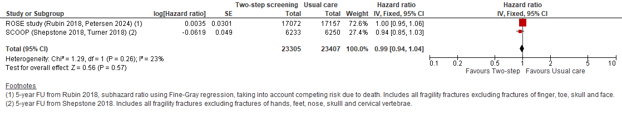
Figure 8: Major osteoporotic fracture
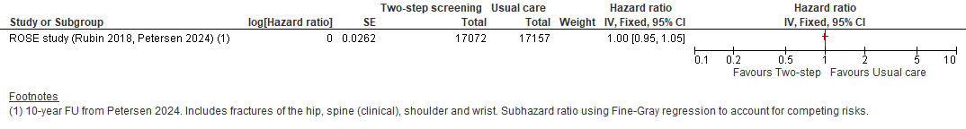
Figure 9: Hip fracture
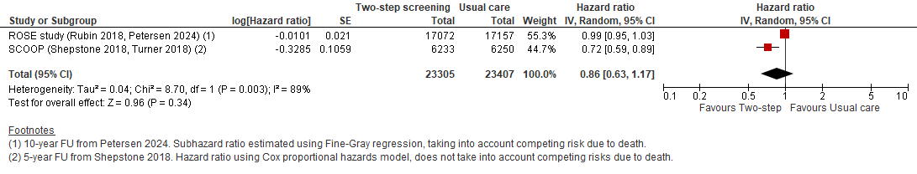
Figure 10: Quality of life (final values, range -0.59 to 1, higher is better)
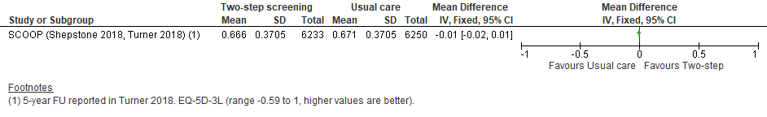

Figure 11: Mortality
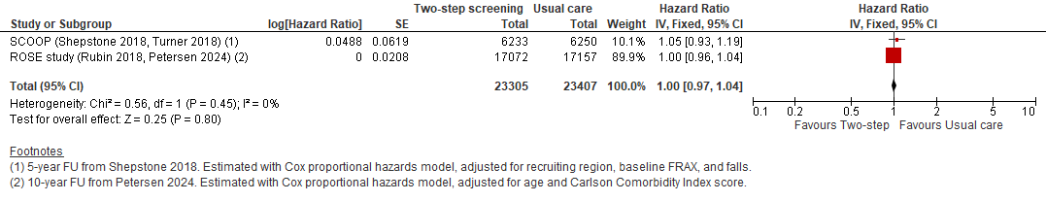
  - One-step screening versus usual care
Figure 12: Fragility fracture
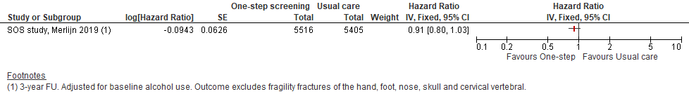
Figure 13: Major osteoporotic fracture
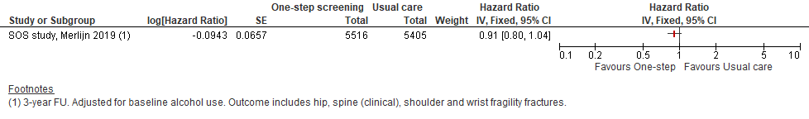
Figure 14: Hip fracture
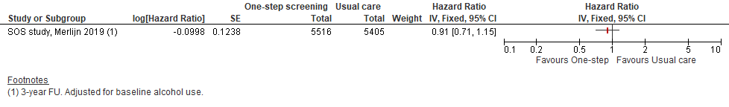
Figure 15: Mortality
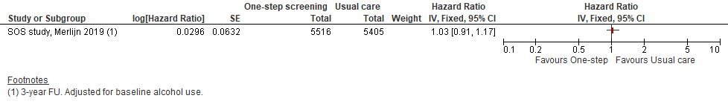

- Full GRADE tables
Table 19: Clinical evidence profile: Two-step screening vs. usual care – participants not on osteoporotic treatment
Certainty assessment |  |  |  |  |  |  | № of patients |  | Effect |  | Certainty | Importance
№ of studies | Study design | Risk of bias | Inconsistency | Indirectness | Imprecision | Other considerations | Two-step screening | usual care | Relative  (95% CI) | Absolute  (95% CI)
Fragility fracture (follow-up: 5 years; assessed with: ICD-10 fracture codes)
2 | randomised trials | very seriousª | not serious | serious^{b} | not serious | none | 23305 participants | 23407 participants | HR 0.99  (0.94 to 1.04) | 2 fewer per 1,000  (from 12 fewer to 8 more) | ⨁◯◯◯  Very low^{a,b} | CRITICAL
Major osteoporotic fracture (follow-up: 10 years; assessed with: ICD-10 fracture codes)
1 | randomised trials | very serious^{c} | not serious^{d} | not serious | not serious | none | 17072 participants | 17157 participants | HR 1.00  (0.95 to 1.05) | 0 fewer per 1,000  (from 8 fewer to 8 more) | ⨁⨁◯◯  Low^{c,d} | CRITICAL
Hip fracture (follow-up: range 5 years to 10 years; assessed with: ICD-10 code and surgical code)
2 | randomised trials | very seriousª | very serious^{e} | not serious | serious^{f} | none | 23305 participants | 23407 participants | HR 0.86  (0.63 to 1.17) | 7 fewer per 1,000  (from 19 fewer to 9 more) | ⨁◯◯◯  Very low^{a,e,f} | CRITICAL
Quality of life (follow-up: 5 years; assessed with: EQ-5D-3L (range -0.59 to 1, where 1 is the best possible health state))
1 | randomised trials | very serious^{c} | not serious^{d} | not serious | not serious^{g} | none | 6233 | 6250 | - | MD 0.01 lower  (0.02 lower to 0.01 higher) | ⨁⨁◯◯  Low^{c,d,g} | CRITICAL
Mortality (follow up: range 5 years to 10 years; assessed with: Danish Civil Registration System or ONS)
2 | randomised trials | not serious | not serious | not serious | not serious | none | 23305 participants | 23407 participants | HR 1.00  (0.97 to 1.03) | 0 fewer per 1,000  (from 6 fewer to 6 more) | ⨁⨁⨁⨁  High | CRITICAL
Abbreviations: HR, hazard ratio; FU, follow up
Notes:
a. Outcome is at very serious risk of bias because both studies are at high risk of bias due either to measurement of outcome (various methods used for fracture ascertainment; only verified fractures included)
b. Serious indirectness as both studies excluded some fragility fractures (for example, finger, hand, toe, skull, face, and/or cervical vertebrae).
c. Outcome is at very serious risk of bias because study is at high risk of bias due to measurement of outcome (various methods used for fracture ascertainment; only verified fractures included)
d. Heterogeneity not assessed as there is only one study.
e. Very serious inconsistency with i2>80% suggesting heterogeneity.
f. Serious imprecision because 95% CI crosses 1 clinical decision threshold (0.8 or 1.25).
g. Established MID for this outcome is +/-0.03.
Table 20: Clinical evidence profile: One-step screening vs. usual care – participants not on osteoporotic treatment
Certainty assessment |  |  |  |  |  |  | № of patients |  | Effect |  | Certainty | Importance
№ of studies | Study design | Risk of bias | Inconsistency | Indirectness | Imprecision | Other considerations | One-step screening | usual care | Relative  (95% CI) | Absolute  (95% CI)
Fragility fracture (follow-up: 3 years; assessed with: Self-reported and verified by GP or hospital records)
1 | randomised trials | very seriousª | not serious^{b} | serious^{c,d} | not serious | none | 5575 participants | 5457 participants | HR 0.91  (0.81 to 1.03) | 9 fewer per 1,000  (from 20 fewer to 3 more) | ⨁⨁◯◯  Very low^{a,b,c,d} | CRITICAL
Major osteoporotic fracture (follow-up: 3 years; assessed with: Self-report verified by GP or hospital records)
1 | randomised trials | very seriousª | not serious^{b} | serious^{c,e} | not serious | none | 5575 participants | 5457 participants | HR 0.91  (0.80 to 1.04) | 7 fewer per 1,000  (from 16 fewer to 3 more) | ⨁⨁◯◯  Very low^{a,b,c,e} | CRITICAL
Hip fracture (follow up: 3 years; assessed with: Self-report verified by GP or hospital records)
1 | randomised trials | very seriousª | not serious^{b} | serious^{c} | serious^{f} | none | 5575 participants | 5457 participants | HR 0.91  (0.71 to 1.15) | 2 fewer per 1,000  (from 7 fewer to 4 more) | ⨁◯◯◯  Very low^{a,b,c,f} | CRITICAL
Mortality (follow-up: 3 years; assessed with: GP or hospital records, family reported)
1 | randomised trials | very seriousª | not serious^{b} | serious^{c} | not serious | none | 5575 participants | 5457 participants | HR 1.03  (0.91 to 1.17) | 3 more per 1,000  (from 8 fewer to 14 more) | ⨁⨁◯◯  Very low^{a,b,c} | CRITICAL

Abbreviations: HR, hazard ratio.
Notes:
a. Trial at high risk of bias due to deviations from intended intervention (GPs allowed to use off-protocol application for consult (follow up) notification, may have improved adherence).
b. Heterogeneity not assessed as there is only one study.
c. Intervention is partially applicable due to intervention including non-protocol intervention (VFA).
d. Outcome is partially applicable due to exclusion of fragility fractures of the skull, finger, hand, toe and foot.
e. Study is partially applicable because analysis for this outcome was completed post-hoc.
f. Serious imprecision because 95% CI crosses 1 clinical decision threshold (0.8 or 1.25).

- Economic evidence study selection
Note that this guideline is being consulted on it two parts, but the health economic review search covered the full guideline. Only studies related to part 1 are included below. Studies that may be relevant to part 2 are noted but are not finalised.
Figure 16: Flow chart of health economic study selection
TBC= to be checked. These review questions will form the second instalment of this guideline update.

- Supplementary search for review questions F and G. Search methods in Appendix B of relevant evidence reports.
- Non-relevant population, intervention, comparison, design or setting; non-English language.

Records screened in 1st sift, n=5,006
Full-text papers assessed for eligibility in 2nd sift, n=244

Records excluded^{(b)} in 1st sift, n=4,762
Papers excluded^{(b)} in 2nd sift, n=181
Part 1
Papers included, n=4 (4 studies)

Studies included by review:
- Review A: n=0
- Review B: n=0
- Review C, D, E: n=2
- Review F: n=1
- Review G: n=1
- Review H: n=0
Part 2: TBC
Part 1
Papers selectively excluded, n=2 (2 studies)
Studies selectively excluded by review:

- Review A: n=0
- Review B: n=0
- Review C, D, E: n=2
- Review F: n=0
- Review G: n=0
- Review H: n=0
Part 2: TBC

Population at risk of fragility fracture search: Records identified through database searching, n=4,822
Additional records identified through other sources: CG146, n=0; reference searching, n=2; provided by committee members; n=0
Full-text papers assessed for applicability and quality of methodology (part 1), n=7
Part 1
Papers excluded, n=1 (1 study)

Studies excluded by review:
- Review A: n=0
- Review B: n=0
- Review C, D, E: n=1
- Review F: n=0
- Review G: n=0
- Review H: n=0
Part 2: TBC

Supplementary vertebral fracture assessment search^{(a)}: Records identified through database searching, n=182
Papers awaiting assessment (part 2), n= 56

- Economic evidence tables

  - Effectiveness of risk prediction tools and bone assessment methods

Study | Soreskog 2020
Study details | Population & interventions | Costs | Health outcomes | Cost effectiveness
Economic analysis: Cost-utility analysis (Health outcome: QALYs)  Study design: Probabilistic decision analytic model informed by SCOOP RCT (Shepstone 2018) included in the clinical review.  Approach to analysis:  Cohort Markov model with 6-monthly cycles where patients started in the ‘well’ state:  - Well (without fracture)  - Hip fracture  - Vertebral fracture  - Proximal humerus fracture  - Wrist fracture  - Other osteoporotic fracture^{(a)}  - Dead  Patients who sustained a hip/vertebral fracture transitioned to the post hip/vertebral fracture state in the cycle following the fracture and remained there until sustaining a new vertebral or hip/vertebral fracture or death occurred.  Perspective: UK NHS  Time horizon: Lifetime horizon until death or age of 100 (mean of 14 years).  Treatment effect duration:^{(b)} modelled for a maximum of 5 years (i.e., the follow-up time in the SCOOP study). Thereafter, women in the screening arm were assumed to be at the same fracture risk as the usual management arm.  Discounting: Costs: 3.5%; Outcomes: 3.5% | Population:  Adult women (aged 70 to 85 years old) across seven UK geographical regions. Women already on prescriptions for anti-osteoporosis medicines (apart from vitamin D or calcium) were excluded.  Cohort settings:  Start age: 76 years  Male: 0%  Intervention 1:  Usual management: this included referral for DXA scans and anti-osteoporosis treatments if deemed clinically appropriate by their GP.  Intervention 2:  FRAX plus BMD measures: Participants had 10- year hip fracture probabilities computed from clinical risk factors using the FRAX tool. Those above an age-dependent threshold^{(c)} were invited to have a DXA scan to assess BMD and were given treatment based on age-dependent FRAX+BMD thresholds. | Total costs (mean per patient):^{(d)}  DSA:  Intervention 1: £9,596  Intervention 2: £9,310  Incremental (2-1): Saves £286 (95% CI: NR)  PSA: Incremental (2-1): Saves £281 (95% CI: -579, -77)  Currency & cost year:  2013/14 UK pounds  Cost components incorporated:  Routine risk assessment intervention costs  Identification of eligible patients, administration of FRAX questionnaire and risk calculation, BMD measurement via DXA scans, calculation and clinical review of final fracture risk, written notification of initial and final fracture risk, and a GP consultation for identified high fracture risk individuals.  Other  Non-intervention related DXA scans and osteoporosis medication costs.  Fracture-related costs  Inpatient, outpatient, nursing care. | QALYs (mean per patient):  DSA:  Intervention 1: 7.359  Intervention 2: 7.374  Incremental (2-1): 0.015 QALYs (95% CI: NR)  PSA: Incremental (2-1): 0.015 QALYs (95% CI 0.007, 0.023) | ICER (Intervention 2 versus Intervention 1):^{(d)}  DSA: Dominant (lower costs and higher QALYs)  PSA:  - Probability Intervention 2 cost-effective (£20K/30K threshold): 97%/98%.  Analysis of uncertainty (DSA):  Study results were robust under sensitivity analyses where a 10-year time horizon was applied, alongside a discount rate of 0% for costs and outcomes and the assumption that 100% of excess mortality was attributable to fractures. Screening was found to be cost-neutral at the start age of 71 years.  DSA assuming that screening had an effect only on the risk of hip fracture also remained dominant, with a cost-saving of £241 and QALY gain of 0.011.
Data sources
Health outcomes: The population modelled and fracture risks were based on to the SCOOP study. Published quality of life weights were applied to health states. Quality-of-life weights EQ-5D-3L; UK population valuation tariff. Cost sources: Costs related to drugs, administration and screening intervention were derived from the SCOOP within-in trial economic analysis which used resource use from SCOOP combined with UK national unit costs. Costs in the first and subsequent years after fracture were derived from two published retrospective UK cohort analyses.
Comments
Source of funding: Arthritis Research UK and Medical Research Council of the UK. Limitations: 2013/2014-unit costs and 2001-2013 resource use may not reflect current NHS context. Hierarchical structure of the Markov model causes a slight underestimation of the number of less severe fractures, as patients suffering a hip or vertebral fracture cannot subsequently sustain wrist or other fractures in following cycles (i.e. remain in post hip/vertebral state). Limited information provided about fracture costs and what costs were as incorporated, whether published costs were inflated, and whether national unit costs were used. Some potentially relevant resource use was not included in Turner 2018 costs such as routine primary care contacts (may increase with increased treatment rates). Other: Screening method utilised 10-year risk of hip fracture from FRAX rather than risk of any major osteoporotic fracture. DSA result showed that cost-effectiveness of screening may be age-dependent, which could not be explored further given the age-range of the population sample.
Overall applicability:^{(e)} Partially applicable Overall quality:^{(f)} Potentially serious limitations
Abbreviations: 95% CI= 95% confidence interval; BMD assessment= bone mineral density assessment; BNF= British National Formulary; CUA= cost–utility analysis; DSA= deterministic sensitivity analysis; DXA scan= dual-energy X-ray absorptiometry (DXA) scan; EQ-5D-3L= EuroQol-5 Dimensions, three-level version (scale: 0.0 [death] to 1.0 [full health], negative values mean worse than death); FRAX= fracture risk assessment tool; GP= general practitioner; ICER= incremental cost-effectiveness ratio; NR= not reported; PSA= probability sensitivity analysis; PSSRU= Personal Social Services Research Unit; QALYs= quality-adjusted life years; RCT= randomised controlled trial; SCOOP= Screening Of Older women for Prevention of fracture.
- “Other osteoporotic fracture” was a composite health state comprising pelvis, rib, humerus, tibia, clavicle, scapula, sternum, and other femoral fractures.
- For studies where the time horizon is longer than the treatment duration, an assumption needs to be made about the continuation of the study effect. For example, does a difference in utility between groups during treatment continue beyond the end of treatment and if so for how long.
- See Table 22 for BMD and treatment threshold by age group.
- See Table 21 and Table 23 for breakdown of costs and effects.
- Directly applicable / Partially applicable / Not applicable
- Minor limitations / Potentially serious limitations / Very serious limitations
Table 21: Base case deterministic cost-effectiveness results from Soreskog 2020
 | Usual management | Screening | Screening vs usual management
Mean costs, per patient (£)
Hospitalisations | 3,059 | 2,934 | -125
Nursing home | 6,056 | 5,645 | -410
Outpatient | 378 | 363 | -15
Total morbidity cost | 9,493 | 8,942 | -551
Drugs | 12 | 43 | 31
Treatment management | 92 | 326 | 234
Total intervention cost | 104 | 369 | 265
Total cost | 9,596 | 9,310 | -286
Effects, per patient
Life years | 10.485 | 10.487 | 0.002
QALYs | 7.359 | 7.37 | 0.015
Cost-effectiveness ratios
Cost/Life year |  |  | Screening dominant
Cost/QALY |  |  | Screening dominant

Study | Turner 2018
Study details | Population & interventions | Costs | Health outcomes | Cost effectiveness
Economic analysis: Cost-utility analysis (Health outcome: QALYs)  Study design:  Within-trial analysis of the SCOOP RCT (Shepstone 2018) included in clinical review.  Approach to analysis:  Analysis of individual-level resource use and EQ-5D-3L to estimate costs and QALYs; national unit costs applied. Used seemingly unrelated regression and adjusted for baseline EQ-5D and age. Bootstrapping was undertaken to estimate uncertainty in the ICER.  Perspective: UK NHS  Time horizon: 5 years Treatment effect duration:^{(a)} n/a Discounting: Costs: 3.5%; Outcomes: 3.5% | Population:  Adult women with and without previous fracture (aged 70 to 85 years old) across seven UK geographical regions. Women already on prescriptions for anti-osteoporosis medicines (apart from vitamin D or calcium) were excluded.  Patient characteristics:  N: 12,483  Mean age: 76 years  Male: 0%  Intervention 1:  Usual management: this included referral for DXA scans and anti-osteoporosis treatments if deemed clinically appropriate by their GP.  Intervention 2:  FRAX plus BMD measures: Participants had 10- year hip fracture probabilities computed from clinical risk factors using the FRAX tool. Those above an age-dependent threshold^{(b)} were invited to have a DXA scan to assess BMD and were given treatment based on age-dependent FRAX+BMD thresholds.^{(b)} | Total costs (mean per patient):^{(c)}  Intervention 1: £900 (unadjusted)  Intervention 2: £968 (unadjusted)  Incremental (2-1): £66 (95% CI: -£21 to £153; p=NR)  Currency & cost year:  2013/14 UK pounds  Cost components incorporated:  Routine risk assessment intervention costs  Identification of eligible patients, administration of FRAX questionnaire and risk calculation, BMD measurement via DXA scans, calculation and clinical review of final fracture risk, written notification of initial and final fracture risk, and a GP consultation for identified high fracture risk individuals.  Other  Non-intervention related DXA scans and osteoporosis medication costs.  Fracture-related costs  Procedure costs, inpatient stay, outpatient attendance. | QALYs (mean per patient):  Intervention 1: 3.266 (unadjusted)  Intervention 2: 3.274 (unadjusted)  Incremental (2-1): 0.0237 (95% CI: -0.0034 to 0.0508, p=NR) | ICER (Intervention 2 versus Intervention 1):^{(e)}  CUA  - £2,772 per QALY gained (95% CI: NR, p=NR)  - Probability Intervention 2 cost-effective (£20K/30K threshold): 93%/NR.  Analysis of uncertainty:^{(e)}  Complete case analysis  - Excluded participants missing >1 EQ-5D question or questionnaire not returned) and required multiple imputation)  - Incremental costs £99 (CI: 3, 196)  - Incremental QALYs 0.0214 (CI: -0.0113, 0.054)  - ICER: £4,646 per QALY gained (95% CI: NR, p=NR)  - Probability Intervention 2 cost-effective (£20K/30K threshold): 83%/NR.
Data sources
Health outcomes: Within-trial analysis of EQ-5D data; responses collected at baseline, 6-months 12-months and then annually thereafter up to five years’ follow-up. QALYs were estimated using an area under the curve approach using EQ-5D responses. Where there was a single missing EQ-5D question, but the participant had completed the other four questions, the missing question was imputed using a ‘hot-decking’ approach. Individuals with complete EQ-5D data, including those imputed using ‘hot-decking’(complete case analysis set). Multiple imputation was applied to participants missing more than one EQ-5D question, or where the questionnaire had not been returned. Quality-of-life weights: EQ-5D-3L; UK population valuation tariff. Cost sources: Within-trial analysis of resource use data with national unit costs applied. Resource use required to undertake the screening process, and the incidence of fractures were recorded as part of the SCOOP study: 49% of women in the screening group were invited to have a DXA scan but this proportion was not reported for the control group. By the end of the first year, more women in the screening group had had at least one prescription for an anti-osteoporotic medication compared to the control group (15% versus 4%). Over the 5-year time horizon, 24% of participants in the screening group received at least one prescription for osteoporosis medication compared to 16% in the control group.
Comments
Source of funding: Arthritis Research UK and Medical Research Council of the UK. Limitations: 2008-2013 resource use estimates, and 2013/14 UK unit costs may not reflect current NHS context. Within-trial analysis and so outcomes only reflect this study and not the wider evidence base identified in the clinical review. The 5-year time horizon will not capture long-term costs and benefits. Some potentially relevant resource use was not collected such as routine primary care contacts (may increase with increased treatment rates) and admissions to residential care (may be impacted by reduced fracture). Some pharmaceutical funding declared by authors but not related to this work. Other: Screening method utilised 10-year risk of hip fracture from FRAX rather than risk of any major osteoporotic fracture.
Overall applicability:^{(f)} Partially applicable Overall quality:^{(g)} Potentially serious limitations
Abbreviations: 95% CI= 95% confidence interval; BMD assessment= bone mineral density assessment; DXA scan= dual-energy X-ray absorptiometry scan; EQ-5D-3L= EuroQol-5 Dimensions, three-level version (scale: 0.0 [death] to 1.0 [full health], negative values mean worse than death); FRAX= fracture risk assessment tool; GP= general practitioner; ICER= incremental cost-effectiveness ratio; NR= not reported; QALYs= quality-adjusted life years; RCT= randomised controlled trial; SCOOP= Screening Of Older women for Prevention of fracture.
- For studies where the time horizon is longer than the treatment duration, an assumption needs to be made about the continuation of the study effect. For example, does a difference in utility between groups during treatment continue beyond the end of treatment and if so for how long.
- See Table 22 for BMD and treatment threshold by age group.
- See Table 23 for a breakdown of screening costs and Table 24 for a total cost breakdown.
- Directly applicable / Partially applicable / Not applicable
- Minor limitations / Potentially serious limitations / Very serious limitations
Table 22: FRAX hip fracture risk thresholds for invitation for BMD measurement and treatment by age group in SCOOP trial
Age group | BMD threshold (FRAX no BMD) | Treatment threshold (FRAX+BMD^{(b)})
70–74 years | 5.18% | 5.24%
75–79 years | 6.81% | 6.87%
80–84 years | 8.46% | 8.52%
85 years+ | 8.39% | 8.99%
Abbreviations: BMD=bone mineral density. FRAX=Fracture Risk Assessment Tool.
- After BMD measurement with score added into risk calculator
Table 23: The costs of the screening intervention from the SCOOP trial (Turner 2018)
Category of resource use | Number of items | Cost per item | Total cost | SCOOP denominator | Cost per person
Identification of eligible patients | 52,033 | £10.70 | £556,753 | 12,483 | £44.60
Resource to administer screening questionnaire | 6,515 | £3.65 | £23,780 | 6515 | £3.65
Calculation of initial WHO risk algorithm | 6,233 | £0.49 | £3,054 | 6,233 | £0.49
Notification of initial fracture risk, letters to participants and GPs | 6,233 | £1.30 | £8,103 | 6,233 | £1.30
BMD assessment using DXA scans | 3,064 | £69.00 | £211,416 | 6,233 | £33.92
Calculation of final fracture risk | 3,064 | £0.21 | £643 | 6,233 | £0.10
Clinical review of final fracture risk | 3,064 | £0.00 | £0 | 6,233 | £0.00
Notification of final fracture risk result (questionnaire + DXA in selected cases) | 3,064 | £1.30 | £3,983 | 6,233 | £0.64
Oversight of screening process | 6,233 | £0.00 | £0 | 6,233 | £0.00
GP consultations | 898 | £134.00 | £120,332 | 6,233 | £19.31
Total |  |  |  |  | £104
Abbreviations: BMD= bone mineral density; DXA= dual-energy X-ray absorptiometry scan; GP= general practitioner; SCOOP (denominator)= Screening Of Older women for Prevention of fracture (6,233 participants were in the intervention group); WHO= world health organisation.
Table 24: Total average discounted costs by cost category in the SCOOP trial (Turner 2018)
Whole sample |  |  |  | Complete case analysis
Cost type | Control | Intervention | Difference (95% CI) | Control | Intervention | Difference (95% CI)
Inpatient | £531 | £482 | -49.6 (-133, 34) | £393 | £378 | -14.5 (-105, 76)
A&E | £162 | £160 | -2 ( -10.7, 6.7 | £138 | £134 | -3.9 (-13, 6)
Outpatient | £191 | £201 | 9.8 (-4, 24) | £181 | £194 | 12.6 (-5, 30)
Medicines | £8 | £13 | 5.6 (3.5, 7.8) | £8 | £14 | 5.7 (3, 8)
Non-SCOOP DXA | £9 | £9 | 0.1 ( -0.6, 0.4) | £9 | £9 | 0.4 ( -0.2, 1)
Cost of screening intervention | - | £104 | - | - | £104 | -
Total | £900 | £968 | 68 (-21, 157) | £728 | £833 | 104 (8, 201)
Abbreviations: 95% CI= 95% confidence interval; A&E= accident and emergency services; DXA= dual-energy X-ray absorptiometry scan; SCOOP= Screening Of Older women for Prevention of fracture. See Table 23 for cost breakdown of screening intervention.

- Health economic analysis – additional methods and results
  - Comparators – additional information
    - NOGG criteria for BMD assessment and treatment
The NOGG criteria for BMD assessment and treatment applied in the analysis are summarised below – age-dependent thresholds can be viewed online in the NOGG guideline:
- If previous fracture or other clinical risk factor, risk assessment using FRAX is recommended. People are categorised as low, intermediate, high or very high risk based on FRAX 10-year MOF risk without BMD and NOGG age-dependent thresholds.
- People with high or very high risk are recommended for treatment. BMD assessment is still recommended to provide baseline BMD and inform treatment choices.
- People with intermediate risk are recommended for BMD assessment to refine their risk estimate. FRAX 10-year MOF and hip fracture risk with BMD is calculated and people categorised as high or very high risk for either MOF or hip fracture using NOGG age-dependent intervention thresholds are recommended for treatment.
    - SIGN osteoporosis guideline criteria for BMD assessment and treatment
The SIGN criteria for BMD assessment and treatment applied in the analysis are summarised below:
- If previous hip or vertebral fracture treatment is recommended. BMD assessment recommended to provide a baseline measurement and/or inform treatment choice.
- If previous NHNV fracture BMD assessment is recommended, with treatment recommended in people with a T-score of -2.5 or below and, in those 65+ years old, between -1.0 and -2.5.
- If no fracture but other clinical risk factor, risk assessment using QFracture (preferred) or FRAX is recommended (without BMD). People with a 10-year MOF risk of 10% or more are recommended for BMD assessment. Treatment is recommended in people with a T-score of -2.5 or below and, in those 65+ years old, also between -1.0 and -2.5.
    - Committee alternative criteria for BMD assessment and treatment
The draft recommendations that were used to inform the committee alternative criteria are below.
Criteria for DXA
1.3.1 Offer a dual-energy X-ray absorptiometry (DXA) scan to measure bone mineral density (BMD) when assessing fragility fracture risk in people aged between 50 and 90 who have had either:
- a previous hip or vertebral fragility fracture
- 2 or more fragility fractures.
1.4.1 Consider measuring BMD with a DXA scan to help guide treatment decisions for people with a 10-year risk of major osteoporotic fracture of 10% or more.
The criteria of 2 or more fragility fractures was not included in the analysis as it was not available within the population simulation and was feasible to incorporate.
Criteria for treatment
1.7.2 Consider pharmacological treatment for men aged 50 and over and women who have experienced menopause, if their condition meets the criteria for a DXA scan (see recommendations 1.3.1 and 1.4.1) and they have any of following:
- a previous hip or vertebral fragility fracture
- BMD T-score of -2.5 or less
- BMD T-score of -1.5 or less and any of the following:
  - any fragility fracture
  - current or frequent use of systemic glucocorticoids (for example, a daily dose of 5 mg or more prednisolone or equivalent for over 3 months, or intermittent use of higher doses)
  - medicines or secondary causes known to be associated with accelerated bone loss (for example, aromatase inhibitors or androgen deprivation therapy, or having primary hyperparathyroidism not treated with surgery)
- BMD T-score of -1.0 or less and both of the following:
  - aged over 65 and
  - current use of high-dose systemic glucocorticoids.
The population simulation only includes risk factor information as required for entry into FRAX. The following simplifications were therefore made in the analysis.
The population simulation indicated the use of glucocorticoid use at any time but not additional information. This was used to approximate current or frequent use of systemic glucocorticoids. As no information was available about high-dose glucocorticoid use the final treatment criteria was omitted.
The population simulation includes information about whether an individual has secondary osteoporosis. The guideline recommendation includes a treatment criteria related to medicines and secondary cause known to be associated with accelerated bone loss which will be a smaller group than any secondary osteoporosis. However, in the absence of additional information this was used to implement this criteria in the analysis.
  - Incorporation of fracture type – additional information
Estimates of fracture type distributions by age were based on data from an International Osteoporosis Foundation (IOF) report (Svedbom 2013, Hernlund 2013), which provided country-specific fracture incidence rates by site and age band. For the UK, hip fracture incidence was sourced from Singer (1998), while rates for other fracture types were estimated using relative ratios derived from Kanis 2000, based on Swedish data. Since this analysis depends on the relative frequency of various fracture types, the Swedish data was the primary source. These estimates were also used in the two most recent NICE osteoporosis treatment technology appraisals (TA791 and TA991). More recent suitable data was not identified – this is discussed further below.
Summary of the IOF Report (Hernlund 2013, Svedbom 2013)
Vertebral Fractures
The incidence of vertebral fractures was determined solely from clinically relevant cases, excluding fractures identified only through morphometric (radiographic) methods. This approach assumes that individuals with clinically apparent vertebral fractures are more likely to be diagnosed and treated.
Other Fractures
This category included fractures of the clavicle, femur, forearm (defined as distal forearm, distal radius, and wrist), humerus, pelvis, rib, scapula, and sternum.
Sources of non-hip fracture incidence data
Age- and sex-specific incidence rates for vertebral and other non-hip fractures were assumed to follow the same ratios to hip fracture incidence as those reported in a long-term study of osteoporotic fractures conducted in Malmö, Sweden (Kanis 2000). This study is considered a robust data source because it maintained thorough records of all radiographic referrals for hip (1991), distal forearm (1994), proximal humerus (1987), and clinical vertebral fractures (1993 and 1994) within a defined geographic area.
The IOF report noted that incidence rates for 'other fractures' were entirely derived from Swedish data and are considered complete. However, apart from distal forearm and humerus fractures (which are presumably sourced from Kanis 2000), the report did not specify the original sources for the incidence data used.
Data issues
The IOF report highlighted findings from a UK primary care dataset analysis (Van Staa, 2001), which showed significantly lower-than-expected fracture rates—suggesting substantial underreporting.
Newer data
A more recent UK study by Van der Velde (2016) reported fracture incidence by hip/femur, vertebral and distal forearm across 5-year age bands, using data from a UK primary care source (latest data from 2012). However, the hip/femur classification in this dataset was broader than just hip fractures, making it unsuitable for estimating hip fracture incidence. Although Van der Velde’s reported rates for vertebral fractures were higher than those in the Van Staa study—indicating potential improvements in data quality—the IOF approach was still preferred, due to persisting concerns about the reliability and completeness of the primary care dataset. This issue was also highlighted by the committee as a known limitation.
We also considered whether HES could be used to provide up to date relative rates of fracture type. The IOF report notes the importance of incidence of fracture types other than hip fracture being based not only on hospital admission data as they may not involve a hospital admission. Based on this we concluded that only hip fracture incidence would be fully captured using HES data.

  - Additional results
    - Clinical risk factors in simulated population (women 50+ years)
Figure 17: Clinical risk factor prevalence in women 50+ years
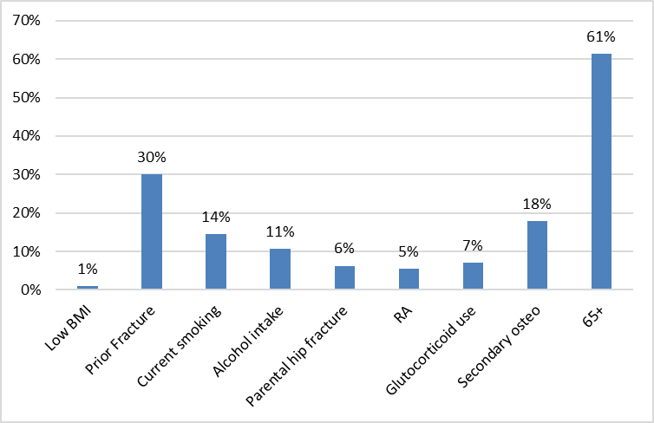
BMI = body mass index; RA = rheumatoid arthritis.
Figure 18: Clinical risk factor prevalence by age
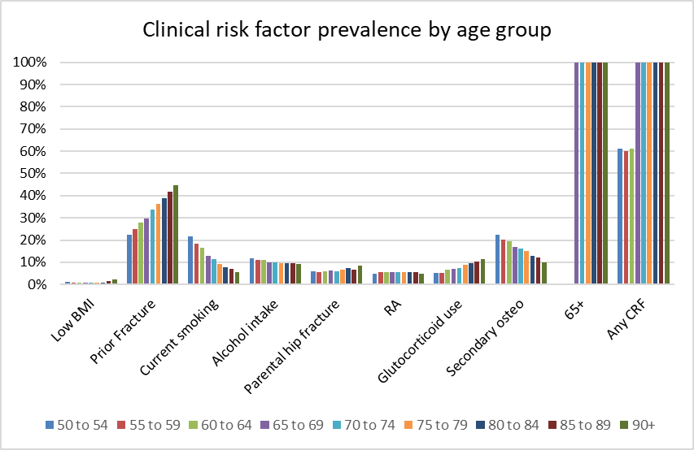
BMI = body mass index; RA = rheumatoid arthritis.
Note that the sum of risk factor prevalence will be greater than prevalence of any CRF because risk factors can co-occur.

    - Breakdown of initial risk categorisations overall and by age band
Overall
Figure 19 shows the proportion of people initial risk category for women over 50 with a CRF for each comparator.
Figure 19: Initial categorisation by comparator (women over 50 with CRF)
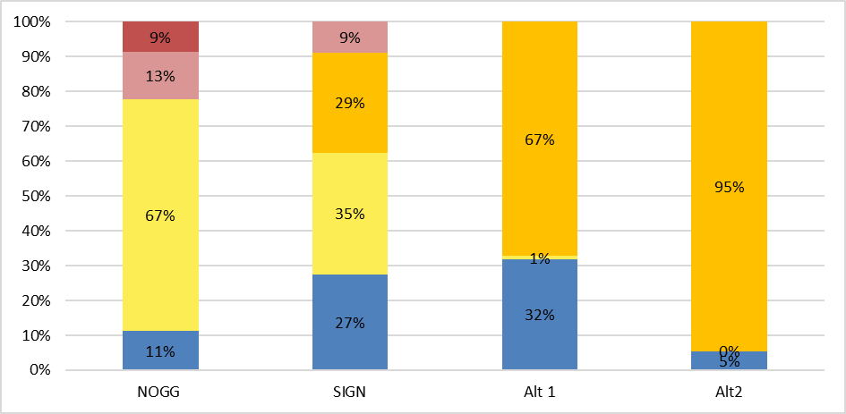
Key:
- Blue = low risk and no BMD assessment or treatment (NOGG: below age-dependent threshold; SIGN: no fragility fracture and below 10% risk; Alt1/2: no hip or vertebral fracture and below 10%/5% risk).
- Yellow and orange = categories where BMD assessment is required to determine treatment eligibility (NOGG: people at intermediate risk; SIGN: people with a NHNV fracture (orange), or with risk 10% or above and no fracture (yellow); Alt1/2: people with risk 10%/5% or above (orange), or people with lower risk but a H/V fracture.
- Red = categories where people are recommended for treatment without need for a BMD assessment but have a BMD assessment to provide a baseline measurement and/or inform treatment choice (NOGG: people at high or very high risk; SIGN people with hip or vertebral fracture; none specified for committee alternative strategy for this analysis)
Abbreviations: Alt = Committee defined alternative strategy; BMD = bone mineral density; CRF = clinical risk factor; NHNV = non-hip non-vertebral.

    - Breakdown into NOGG initial risk categories (based on FRAX MOF without BMD) by age band
Figure 20 shows the proportion of people in each initial risk category by age band using NOGG criteria.
People at low risk are not recommended to have BMD assessment. People in the intermediate risk category are indicated for BMD assessment to refine their risk score prior to determining eligibility for treatment. People in the high and very high-risk categories are indicated for treatment, but BMD assessment is recommended by NOGG to provide a baseline measurement and/or inform treatment decisions. People without a CRF are not considered for BMD assessment or treatment in the analysis with any of the comparators.
Figure 20: Breakdown of NOGG initial risk categorisation by age
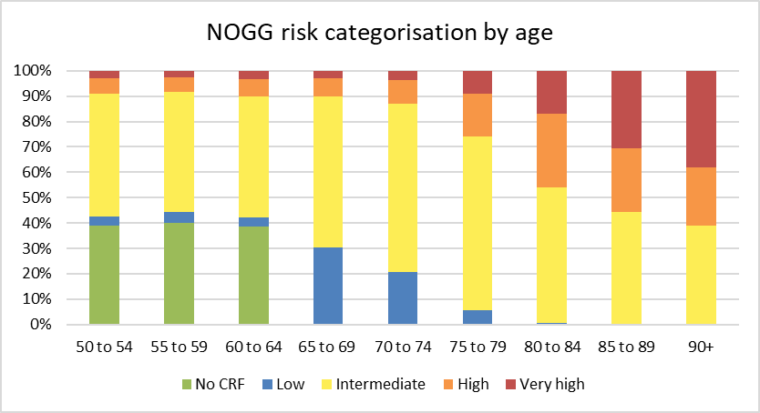
Risk categories based on age-dependent thresholds (see section I.1.1).

    - Breakdown into SIGN initial risk categories (based on FRAX MOF without BMD) by age band
Figure 21 shows the proportion of people in each initial risk category by age band using SIGN criteria.
People with a hip or vertebral fracture are considered eligible for treatment without BMD assessment but BMD assessment is recommended to provide a baseline. People with NHNV fracture or high risk of fracture (10%+ 10-year MOF risk without BMD) are recommended for BMD assessment (with treatment eligibility determined by T-score). People without a CRF are not considered for BMD assessment or treatment in the analysis with any of the comparators.
Figure 21: Breakdown of SIGN initial risk categorisation by age
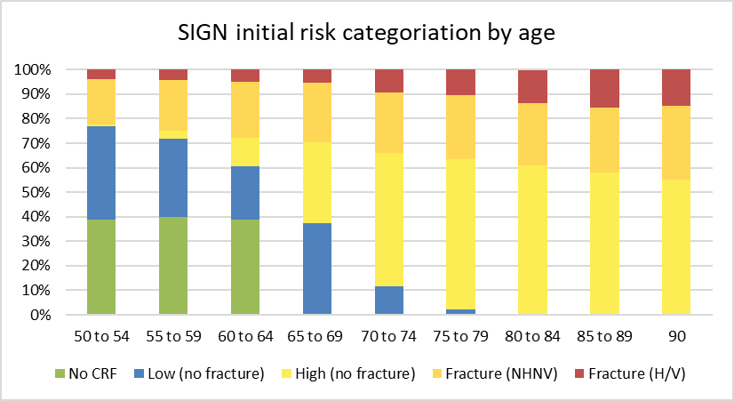
Source: High = 10% risk or greater; Low = <10% risk

Breakdown into initial risk categories (based on FRAX MOF without BMD) for committee-defined alternative scenarios by age band
Figure 22 shows the proportion of people in each initial risk category by age band using the committee defined alternative strategies.
In these two alternative strategies based on discussion with the committee people with high risk of fracture (10%+ or 5%+ 10-year MOF risk without BMD) and people with lower risk but a hip or vertebral fracture were considered eligible for BMD assessment. People without a CRF are not considered for BMD assessment or treatment in the analysis with any of the comparators.
Figure 22: Breakdown of alternative scenarios initial risk categorisation by age
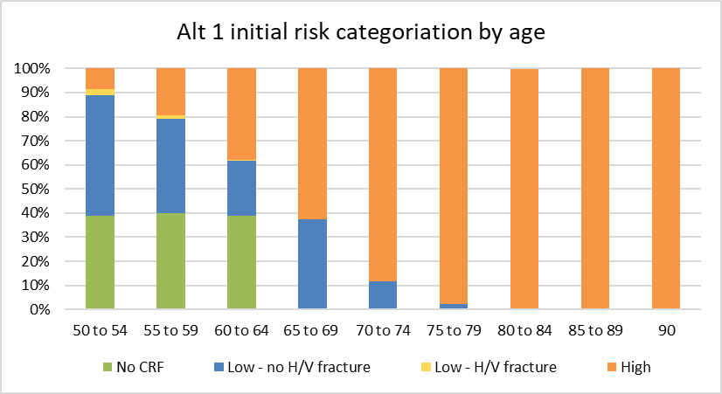
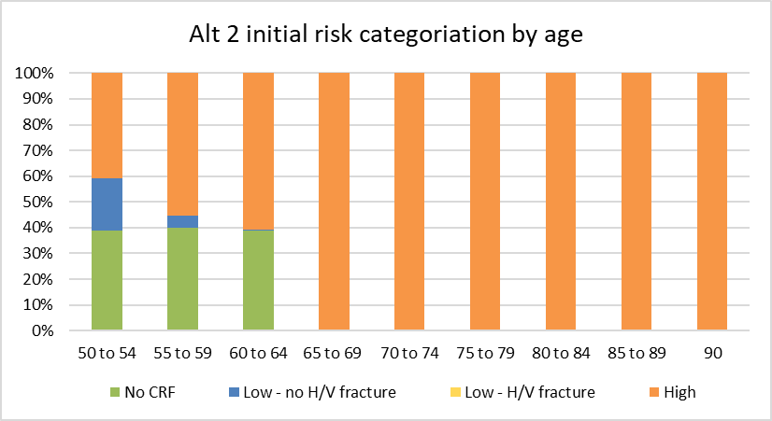
Alt 1: High risk = 10%+; Low risk = <10%. Alt 2: High risk = 5%+; Low risk = <5%.

- Excluded studies
  - Clinical evidence studies
Table 25: Studies excluded from the clinical review
Study | Exclusion Reason
(2018) Does Simultaneous Computed Tomography and Quantitative Computed Tomography Show Better Prescription Rate than Dual-energy X-ray Absorptiometry for Osteoporotic Hip Fracture?. Hip & pelvis 30(4): 233-240 | - Study design not relevant to this review protocol
(2003) [Osteoporosis--prevention, diagnosis and treatment. A systematic literature review. SBU conclusions and summary]. Läkartidningen 100(45): 3590-5 | - Study not reported in English
Adami, G, Biffi, A, Porcu, G et al. (2023) A systematic review on the performance of fracture risk assessment tools: FRAX, DeFRA, FRA-HS. Journal of endocrinological investigation | - Data not reported in an extractable format or a format that can be analysed
Amstrup, Anne Kristine, Jakobsen, Niels Frederik Breum, Moser, Emil et al. (2016) Association between bone indices assessed by DXA, HR-pQCT and QCT scans in post-menopausal women. Journal of bone and mineral metabolism 34(6): 638-645 | - Study design not relevant to this review protocol
Bartl, R (2006) RECORD study: secondary prevention of low-trauma fractures in elderly patients. Internist 47(5): 541-544 | - Study not reported in English
Baskin, E, Dinur, T, Lebel, E et al. (2016) Comparison of Bone Mineral Density by Dual-Energy X-Ray Absorptiometry and Bone Strength by Speed-of-Sound Ultrasonography in Adults With Gaucher Disease. Journal of clinical densitometry 19(4): 465-470 | - Study design not relevant to this review protocol
Blake, Glen M and Fogelman, Ignac (2007) The role of DXA bone density scans in the diagnosis and treatment of osteoporosis. Postgraduate medical journal 83(982): 509-17 | - Review article but not a systematic review
Blake, Glen M and Fogelman, Ignac (2009) The clinical role of dual energy X-ray absorptiometry. European journal of radiology 71(3): 406-14 | - Review article but not a systematic review
Cejka, D., Patsch, J.M., Weber, M. et al. (2011) Bone microarchitecture in hemodialysis patients assessed by HR-pQCT. Clinical Journal of the American Society of Nephrology 6(9): 2264-2271 | - Study design not relevant to this review protocol
Deshpande, Nachiket, Hadi, Moustafa S, Lillard, Jock C et al. (2023) Alternatives to DEXA for the assessment of bone density: a systematic review of the literature and future recommendations. Journal of neurosurgery. Spine 38(4): 436-445 | - Data not reported in an extractable format or a format that can be analysed
Djokoto, C., Tomlinson, G., Waldman, S. et al. (2004) Relationship among MRTA, DXA, and QUS. Journal of Clinical Densitometry 7(4): 448-456 | - Study design not relevant to this review protocol
Duboeuf, F, Jergas, M, Schott, A M et al. (1995) A comparison of bone densitometry measurements of the central skeleton in post-menopausal women with and without vertebral fracture. The British journal of radiology 68(811): 747-53 | - Study design not relevant to this review protocol
Escobio-Prieto, Isabel, Blanco-Diaz, Maria, Pinero-Pinto, Elena et al. (2023) Quantitative Ultrasound and Bone Health in Elderly People, a Systematic Review. Biomedicines 11(4) | - Data not reported in an extractable format or a format that can be analysed
Gerdhem, Paul, Magnusson, Hakan, Karlsson, Magnus K et al. (2002) Ultrasound of the phalanges is not related to a previous fracture. A comparison between ultrasound of the phalanges, calcaneus, and DXA of the spine and hip in 75-year-old women. Journal of clinical densitometry : the official journal of the International Society for Clinical Densitometry 5(2): 159-66 | - Study design not relevant to this review protocol
Grados, Franck, Fechtenbaum, Jacques, Flipon, Elisabeth et al. (2009) Radiographic methods for evaluating osteoporotic vertebral fractures. Joint bone spine 76(3): 241-7 | - Review article but not a systematic review
Ihama, F. (2020) Assessment of fracture risk assessment tools in care home residents. Future Healthcare Journal 7: 86 | - Data not reported in an extractable format or a format that can be analysed
Lehmann, O., Mineeva, O., Veshchezerova, D. et al. (2024) Fracture risk prediction in postmenopausal women with traditional and machine learning models in a nationwide, prospective cohort study in Switzerland with validation in the UK Biobank. Journal of Bone and Mineral Research 39(8): 1103 | - Study design not relevant to this review protocol
Mallee, WH, Wang, J, Poolman, RW et al. (2015) Computed tomography versus magnetic resonance imaging versus bone scintigraphy for clinically suspected scaphoid fractures in patients with negative plain radiographs. Cochrane Database of Systematic Reviews | - Study does not contain an intervention relevant to this review protocol
Martin, J C; Campbell, M K; Reid, D M (1999) A comparison of radial peripheral quantitative computed tomography, calcaneal ultrasound, and axial dual energy X-ray absorptiometry measurements in women aged 45-55 yr. Journal of clinical densitometry : the official journal of the International Society for Clinical Densitometry 2(3): 265-73 | - Data not reported in an extractable format or a format that can be analysed
Massie, A; Reid, D M; Porter, R W (1993) Screening for osteoporosis: comparison between dual energy X-ray absorptiometry and broadband ultrasound attenuation in 1000 perimenopausal women. Osteoporosis international: a journal established as result of cooperation between the European Foundation for Osteoporosis and the National Osteoporosis Foundation of the USA 3(2): 107-10 | - Study design not relevant to this review protocol
Mecozzi, B and Anselmetti, GC (1992) Quantitative computerized tomography in the study of osteoporosis. Our experience. Minerva endocrinologica 17(4): 163-167 | - Study not reported in English
Meertens, Robert, Lopez, Ben, Crone, Ben et al. (2024) Development of an opportunistic diagnostic prediction algorithm for osteoporosis and fragility fracture risk estimates from forearm radiographs (The OFFER1 Study). JBMR plus 8(4): ziae020 | - Study design not relevant to this review protocol
Minniti, Davide, Davini, Ottavio, Gualano, Maria Rosaria et al. (2014) Techniques for diagnosing osteoporosis: a systematic review of cost-effectiveness studies. International journal of technology assessment in health care 30(3): 273-81 | - Study design not relevant to this review protocol
Muftic, Mirsad; Selimovic, Elma Kucukalic; Miladinovic, Ksenija (2013) Osteoporosis--comparative study between quantitative ultrasound of calcaneus and DXA. Medical archives (Sarajevo, Bosnia and Herzegovina) 67(4): 289-91 | - Study design not relevant to this review protocol
Patel, R., Blake, G.M., Panayiotou, E. et al. (2010) Clinical evaluation of a phalangeal bone mineral density assessment system. Journal of Clinical Densitometry 13(3): 292-300 | - Study design not relevant to this review protocol
Phillips, J., Krist, A., Wilder, L. et al. (2003) Is osteoporosis screening in postmenopausal women effective?. Journal of Family Practice 52(4): 331-333 | - Not a peer-reviewed publication
Prins, SH, Jørgensen, HL, Jørgensen, LV et al. (1998) The role of quantitative ultrasound in the assessment of bone: a review. Clinical physiology (Oxford, England) 18(1): 3-17 | - Review article but not a systematic review
Queally, J M, Kiernan, C, Shaikh, M et al. (2013) Initiation of osteoporosis assessment in the fracture clinic results in improved osteoporosis management: a randomised controlled trial. Osteoporosis international: a journal established as result of cooperation between the European Foundation for Osteoporosis and the National Osteoporosis Foundation of the USA 24(3): 1089-94 | - Data not reported in an extractable format or a format that can be analysed
Ramirez-Perez, E., Clark, P., Deleze, M. et al. (2014) Impact of osteoporosis-associated vertebral fractures on health-related quality of life in the Mexican population. Revista de Investigacion Clinica 66(3): 225-233 | - Study design not relevant to this review protocol
Robinson, P J, Bell, R J, Lanzafame, A et al. (2013) Comparison of plain vertebral X-ray and dual-energy X-ray absorptiometry for the identification of older women for fracture prevention in primary care. Internal medicine journal 43(1): 38-45 | - Study design not relevant to this review protocol
Shur, J., Hardiman, H., Alexander, H. et al. (2013) Radial quantitative ultrasound in comparison to dual-energy x-ray absorptiometry in the osteoporosis clinic: An institutional experience combined with meta-analysis of published literature. Nuclear Medicine Communications: 383-384 | - Conference abstract
Subasinghe, H W A S, Lekamwasam, S, Ball, P et al. (2019) Performance of Sri Lankan FRAX algorithm without bone mineral density and with Quantitative Ultrasound data input. The Ceylon medical journal 64(1): 17-24 | - Study design not relevant to this review protocol
Thomsen, K, Jepsen, D B, Matzen, L et al. (2015) Is calcaneal quantitative ultrasound useful as a prescreen stratification tool for osteoporosis?. Osteoporosis international: a journal established as result of cooperation between the European Foundation for Osteoporosis and the National Osteoporosis Foundation of the USA 26(5): 1459-75 | - Data not reported in an extractable format or a format that can be analysed
Ye, Carrie, Leslie, William D., Morin, Suzanne N. et al. (2023) Adjusting FRAX Estimates of Fracture Probability Based on a Positive Vertebral Fracture Assessment. JAMA network open 6(8): e2329253 | - Study design not relevant to this review protocol
  - Health Economic studies
If any published health economic studies relevant to this question met the inclusion criteria (relevant population, comparators, economic study design, published 2009 or later and not from non-OECD country or USA) but were excluded following appraisal of applicability and methodological quality they are listed below with reasons. See the health economic protocol for more details.
Table 26: Studies excluded from the health economic review
Reference | Reason for exclusion
Martin-Sanchez M, Comas M, Posso M et al. (2019) Cost-Effectiveness of the Screening for the Primary Prevention of Fragility Hip Fracture in Spain Using FRAX®. Calcified Tissue International. 105(3):263-270. | Selectively excluded due to a combination of limited applicability and methodological limitations. The key reasons being that the analysis does not use QALYs and is from a non-UK perspective (Spain). The analysis only incorporates hip fractures.
National Institute for Health and Care Excellence (2017) Osteoporosis: assessing the risk of fragility fracture (CG146). A comparison of the cost of undertaking DXA in all people compared to a strategy of risk assessment followed by selective DXA. | Selectively excluded as an updated analysis incorporating current costs is presented in section 1.1.11.
Söreskog E, Lopez B, Bean T et al. (2025) Exploring the potential cost-effectiveness and societal burden implications of screening for fracture risk in a UK general radiography setting. BMC Musculoskeletal Disorders. 26, 112 | Excluded as direct costs of intervention (e.g., software, licence) does not appear to be included among the cost calculations, which was considered a significant omission. Additionally, the relevance of the population to the protocol and the definition of usual care used were uncertainties that limited applicability.

