RESUME
A. DHIVYADARSHINI
Phone: 9500701126 | Email: dhivyaanand08@gmail.com

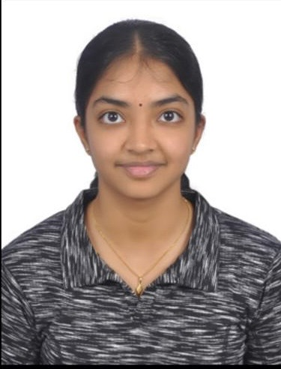

CAREER OBJECTIVE
To apply my knowledge of computer science, programming, data science, and emerging technologies to practical challenges while continuously developing my technical, analytical, and problem-solving skills.

EDUCATION
Vellore Institute of Technology (VIT), Vellore
Degree Programme: B.Tech. in Computer Science and Engineering (CSE Core)
Indian Institute of Technology Madras (IIT Madras)
BS Degree Programme

TECHNICAL SKILLS
- Python Programming
- MySQL
- Data Science and Artificial Intelligence
- Data Mining and Machine Learning
- Algorithmic Trading
- Linux
- Cybersecurity

PROJECTS & ACADEMIC WORK
Hotel Management System
- Built a hotel management project using Python and MySQL.
- Created a graphical user interface (GUI) for user interaction.
Fit Classifier using Orange Data Mining
- Built and evaluated a fit classifier using Orange Data Mining.
- Applied data-mining and classification concepts to the project.
Algorithmic-Based Trading
- Explored the use of computational techniques in financial-market trading.
Review Article on Automated Cars
- Worked on a review article about automated cars and related technologies.

CERTIFICATIONS
- Certified in Data Science and Artificial Intelligence by IIT Madras.
- Certified in Python Programming.
- Currently working towards a certification in Linux.

EXTRACURRICULAR ACTIVITIES
Bharathi Scouts and Guides
- Served as Vice-Captain and won the Best Adventure Guide award at a Bharathi Scouts and Guides camp in Avadi (Insert photos of me at the camp).
Junior Red Cross
- Volunteered at a blood donation camp and participated in fundraising activities for an orphanage (Insert videos from the orphanage and self-defence programmes). Also participated in self-defence and first-aid programmes.
Sports
- Participated in sports and related activities (Insert photos).

VOLUNTEERING
- Volunteered at CRDVE Expo during Gravitas, Motoverse, and Karniverse, supporting event activities and community engagement.

INTERNSHIP
City Union Bank
- Upcoming internship opportunity.

AREAS OF INTEREST
Data Science & AI • Financial Technology • Algorithmic Trading • Cybersecurity • Linux

