Joana Ibarra

Eric Kelley

Misael Varajas

Paul Ojo

**HelpingHands Interaction Design**

**Introduction**

HelpingHands is an application that is aimed at troubled orphans that are preparing to age out of foster care, have not yet found a permanent solution, and are struggling with finishing school. Through the use of HelpingHands, the user can: talk with an anonymous counselor through the use of a chat box, video chat or traditionally chat with their own personal mentor, and look for potential places of employment.

**Persona**



Elizabeth is a 17-year-old orphan attending high school. She lives in a group home.

Elizabeth wants to finish school, feel motivated, and get a job related to her interests so that she may be able to find a permanent housing solution so that she won’t go homeless when she ages out of the foster care system.

HelpingHands can provide Elizabeth with a personal mentor to help guide her through school by helping her choose classes and guide her through this rough stage in her life. Her mentor will also be able to help Elizabeth secure an internship/job or help her get into college if she chooses to. HelpingHands will also provide Elizabeth to an anonymous counselor that Elizabeth can share and confide in so that she can become a better person and take care of her mental health.

**Wireframes**

(First-time user)

Homepage:

A screenshot of a cell phone

Description generated with high confidence

Support System

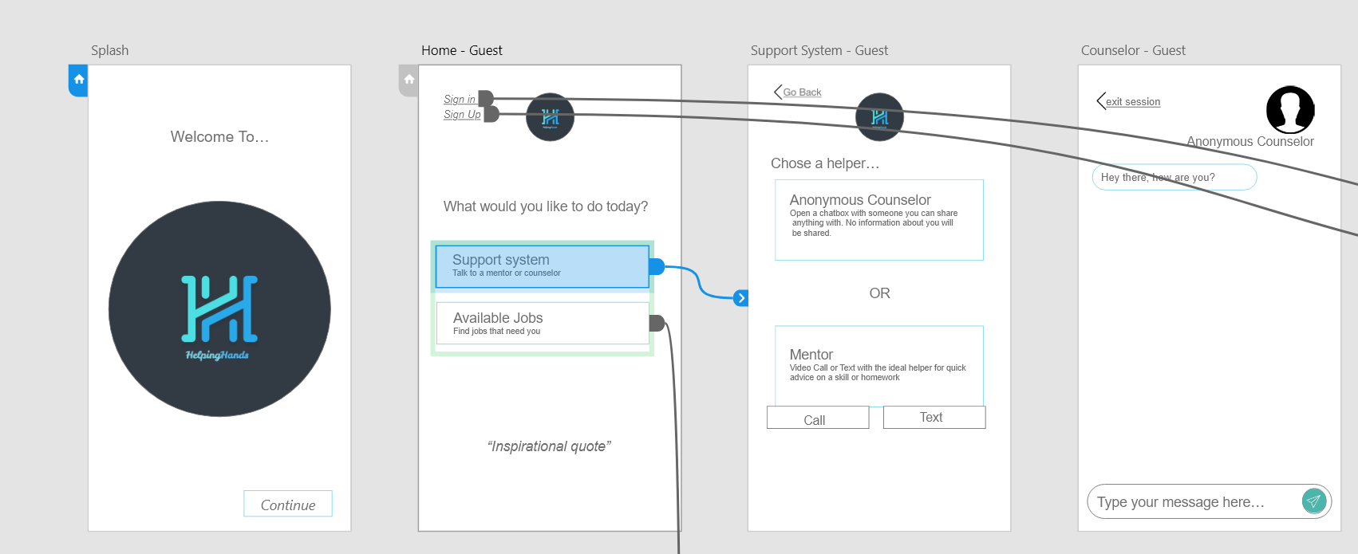

Support System (Mentor & Anonymous counsellor):

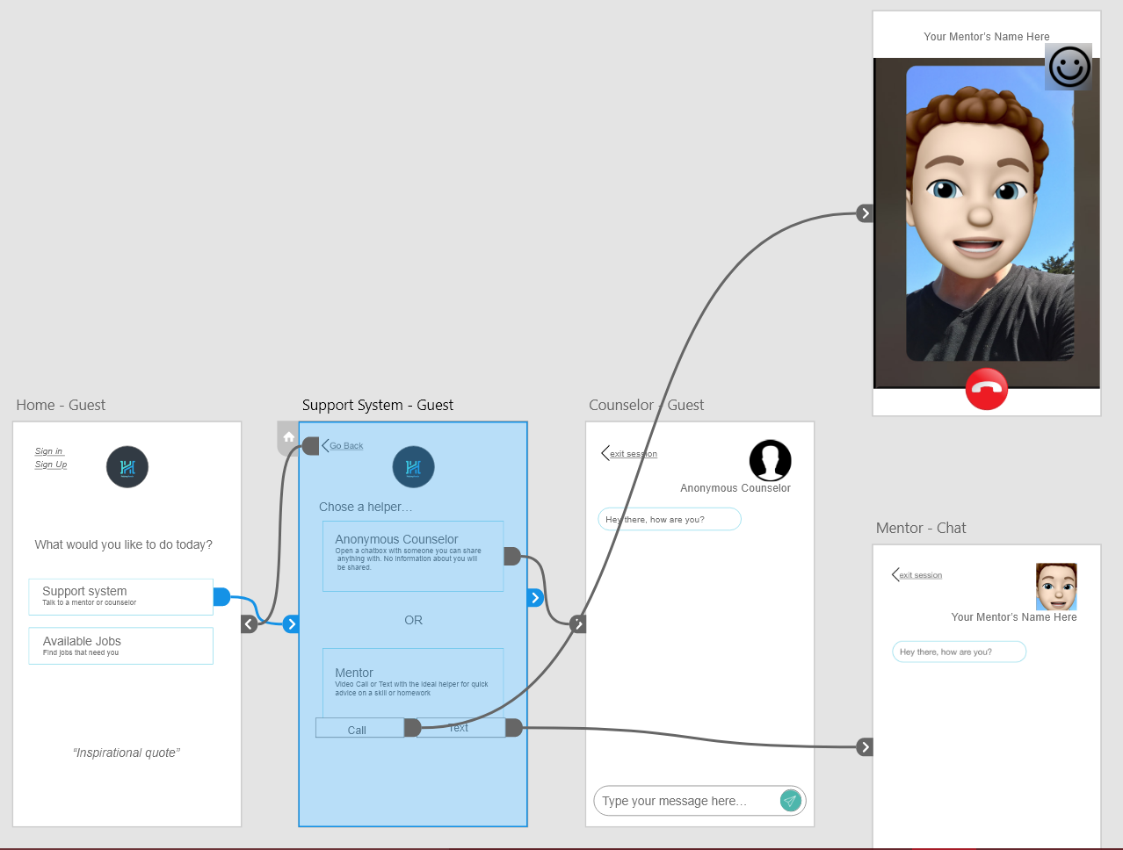

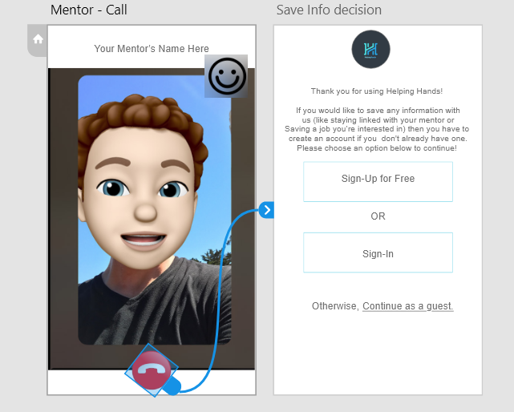

Job availability and search:

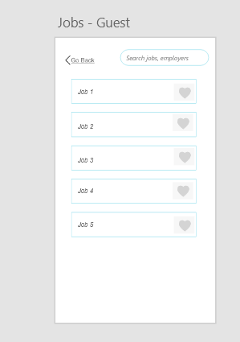

Like experience? Sign-Up!:

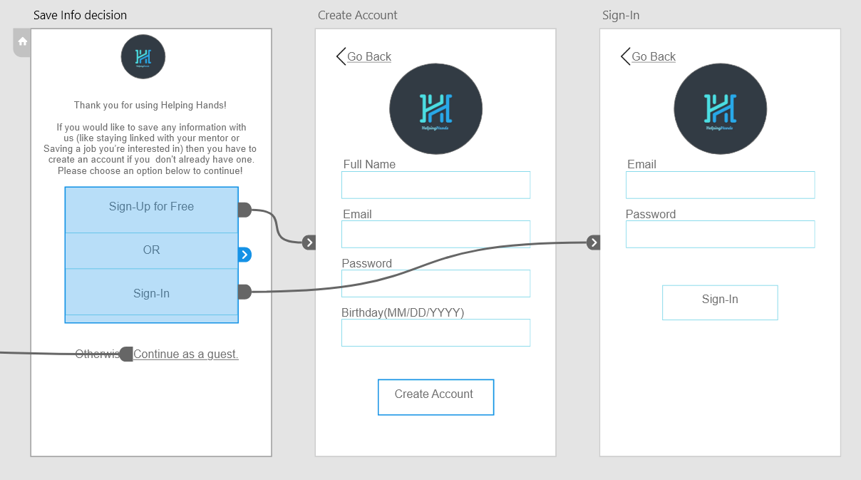

Full wireframe demo: https://xd.adobe.com/view/425e7867-c3e0-4d36-45c1-34924725da63-346f/

**Flowchart**

