xyChess

Tyler Wheaton

University of Missouri – Kansas City

Table of Contents
Vision Statement 3
Requirements 4
Product Backlog 5
Sprint #1 6
Review 6
Retrospective 6
Sprint #2 7
Review 7
Retrospective 7
Sprint #3 8
Review 8
Retrospective 8
Sprint #4 9
Review 9
Retrospective 9
Sprint #5 10
Review 10
Retrospective 10
Sprint #6 11
Review 11
Retrospective 11

Vision Statement

xyChess will be a simple Android app that will allow two players to play against each other in chess. It will feature an interactive gameboard, move restriction, time-limit options, win/lose notifications, and game history in PGN format. In the future it could be expanded to include online play, as well as a computer opponent to play against.

Requirements
A discussion of what your application is required to have in functionality. It should identify user roles and goals/actions, and what the key features of the app should be.
Actor | Goal
User | Press ‘new game’ to reset the chessboard with confirmation dialog.
User | Make consecutive moves on chessboard until win or draw
User | Copy game history in PGN format to clipboard
System | Restrict illegal moves
System | Notify player of ‘check’, ‘checkmate’, and ‘stalemate’
System | Store moves made by players throughout a game in PGN format

Product Backlog
This will be updated throughout the semester as new PBIs are added, larger items are broken into smaller ones, and completed items removed.

Story ID | Story | Story Points  (in est. hours) | Priority | Status
0 | As a user, I would like to open a new game and move pieces around the board. | 10 | 1 | Not Started
1 | As a user, I would like to know when I am in check, checkmate, or stalemate. | 3 | 3 | NS
2 | As a system, I would like to check game states in order to restrict moves and notify players about the status of the game. | 12 | 2 | NS
3 | As a system, I would like to save the legal moves committed by the players to be displayed as a copiable PGN textbox. | 7 | 4 | NS

Sprint #1

Sprint Backlog
Story ID | Story / Task | Estimated  Hours | Actual  Hours
0 | As a System, I would like to create a new board when the app is started. | 4 | 7
0 | As a User, I would like to press a button to reset the board. | 2 | ~
0 | As a User, I would like to move pieces around the board. | 4 | ~
2 | As a System, I would like to restrict players from making illegal moves. | 7 | ~
2 | As a System, I would like to detect when the game is in check, checkmate, or stalemate. | 5 | ~
1 | As a User, I would like to be notified of check, checkmate, or stalemate. | 3 | ~
 |  |  | 7

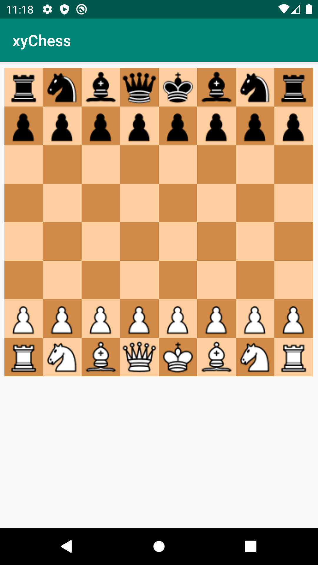
Review
This increment we added a visual representation of the board.

Retrospective
Most time was spent deciding / learning how to implement the basic data structures and UI elements for storing and displaying the chess board. Unfortunately, this was unavoidable given our team’s lack of experience with Android, Java, and UI design. We have tasked half of the team with focusing on honing their Android UI design skills, while others will continue to focus on implementing the backend.

Sprint #2

Sprint Backlog
Story ID | Story / Task | Estimated  Hours | Actual  Hours

Review

[Screenshots, etc go here. This is where you discuss the product, describing what was done this sprint (potentially shippable product increment) and what was planned for the sprint but was not done. ]

Retrospective
[This is where you discuss the process. What went well (and are you planning to do more of that?) What didn’t go so well (and do you have a way to do less of that)? What changes are you planning to make in how you plan & carry out the next sprint?]

Sprint #3

Sprint Backlog
Story ID | Story / Task | Estimated  Hours | Actual  Hours

Review

[Screenshots, etc go here. This is where you discuss the product, describing what was done this sprint (potentially shippable product increment) and what was planned for the sprint but was not done. ]

Retrospective
[This is where you discuss the process. What went well (and are you planning to do more of that?) What didn’t go so well (and do you have a way to do less of that)? What changes are you planning to make in how you plan & carry out the next sprint?]

Sprint #4

Sprint Backlog
Story ID | Story / Task | Estimated  Hours | Actual  Hours

Review

[Screenshots, etc go here. This is where you discuss the product, describing what was done this sprint (potentially shippable product increment) and what was planned for the sprint but was not done. ]

Retrospective
[This is where you discuss the process. What went well (and are you planning to do more of that?) What didn’t go so well (and do you have a way to do less of that)? What changes are you planning to make in how you plan & carry out the next sprint?]

Sprint #5

Sprint Backlog
Story ID | Story / Task | Estimated  Hours | Actual  Hours

Review

[Screenshots, etc go here. This is where you discuss the product, describing what was done this sprint (potentially shippable product increment) and what was planned for the sprint but was not done. ]

Retrospective
[This is where you discuss the process. What went well (and are you planning to do more of that?) What didn’t go so well (and do you have a way to do less of that)? What changes are you planning to make in how you plan & carry out the next sprint?]

Sprint #6

Sprint Backlog
Story ID | Story / Task | Estimated  Hours | Actual  Hours

Review

[Screenshots, etc go here. This is where you discuss the product, describing what was done this sprint (potentially shippable product increment) and what was planned for the sprint but was not done. ]

Retrospective
[This is where you discuss the process. What went well (and are you planning to do more of that?) What didn’t go so well (and do you have a way to do less of that)? What changes are you planning to make in how you plan & carry out the next sprint?]

