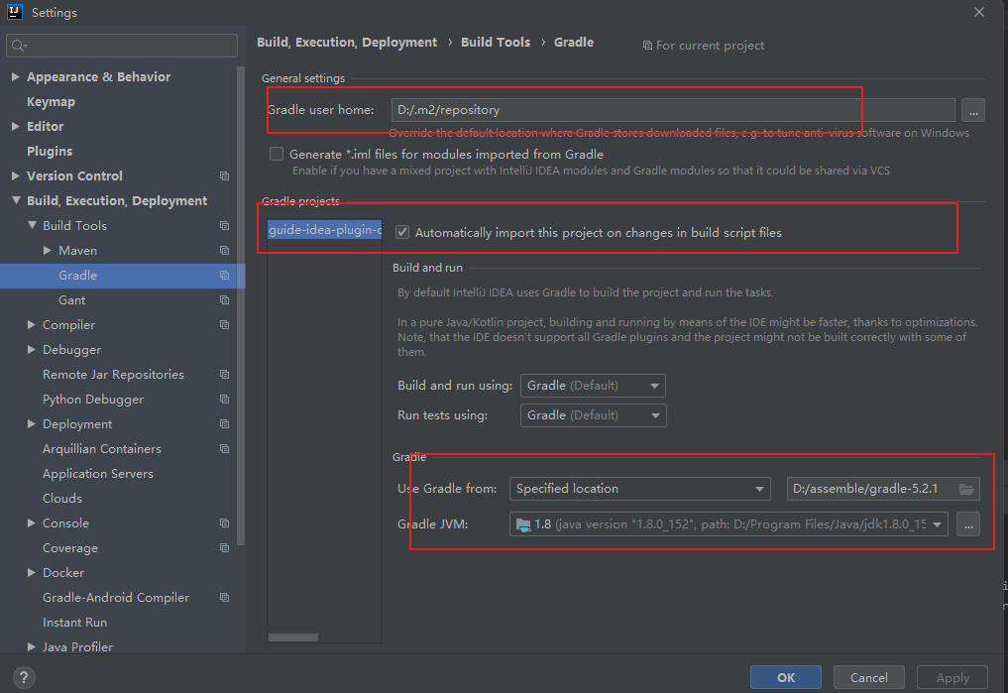



gradle国内镜像：

https://mirrors.cloud.tencent.com/gradle/