**CREATING UI FOR THE APP**

The user interface for an Android app is built using a hierarchy of **layouts** and **widgets**.

Layouts are invisible containers that control how its child views are positioned on the screen.

Widgets are UI components such as buttons and text boxes.

To get started open : **app > res > layout > activity_main.xml.**

Lets take example from the app. Shown below is the layout for rssi_info.

**app > res > layout > list_item_view_rssi_info.xml.**

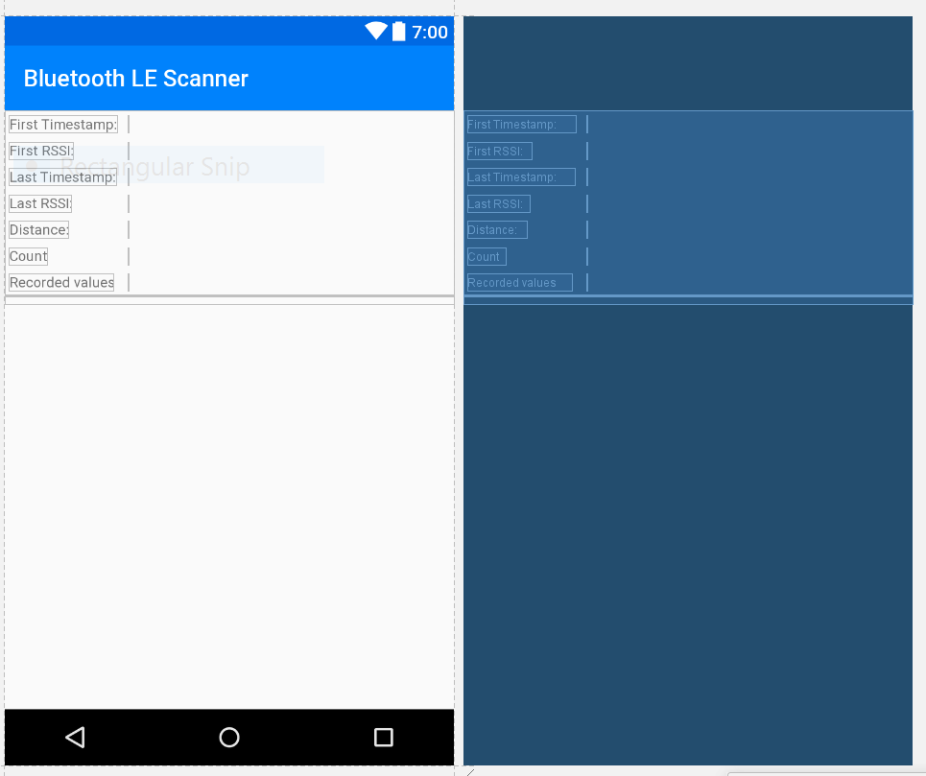

The image shows the layout and blueprint of activity showing device info.

The screen follows **Grid Layout.**

It can be easily formed using the options on the palette on left side of design interface.

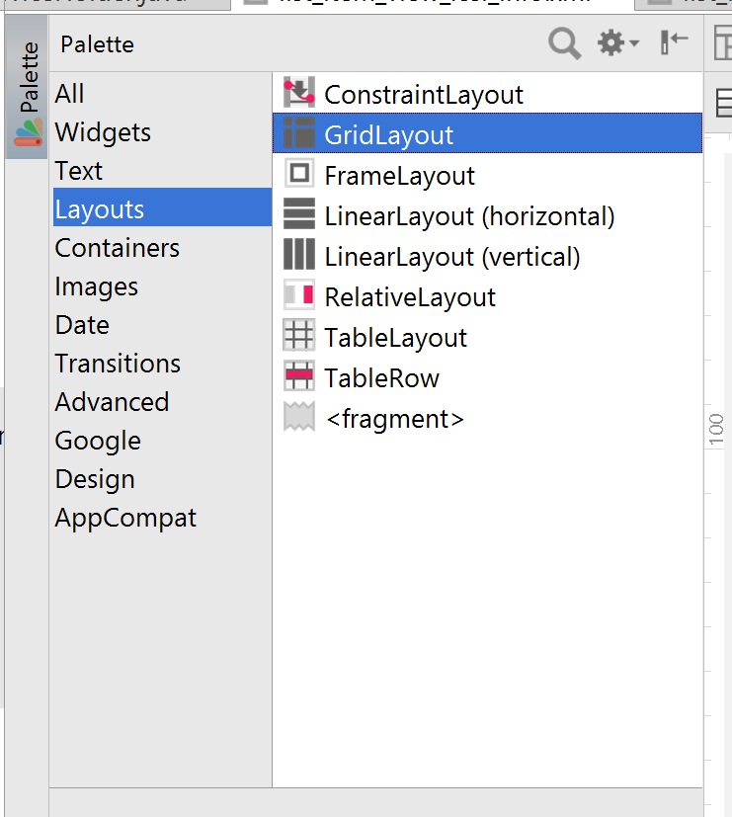

The left column contains the name of the parameter such as first rssi value.

The right column has the unique id reference which can be invoked via java code and values be written to it while processing.

Design can be done using GUI palette or using xml code.

<TextView

style="@style/GridLayoutTitleTextView"

android:layout_width="wrap_content"

android:layout_height="wrap_content"

android:text="@string/label_first_rssi" />

<TextView

android:id="@+id/firstRssi"

style="@style/GridLayoutDataTextView" />

XML and java codes contains formatting references from another xml file, strings.xml.

Example, to print value in meters we use, formatter_meters whse definition is provided in strings.xml.