# ACS -560 SOFTWARE ENGINEERING

# HW 5 ASSIGNMENT

# NAME : RASENDER SINGH

**SWAGATH BOLLINENI HONORE HODARY**

# DATE : 06 OCT 2014

1) Major modules of project and connection between them:

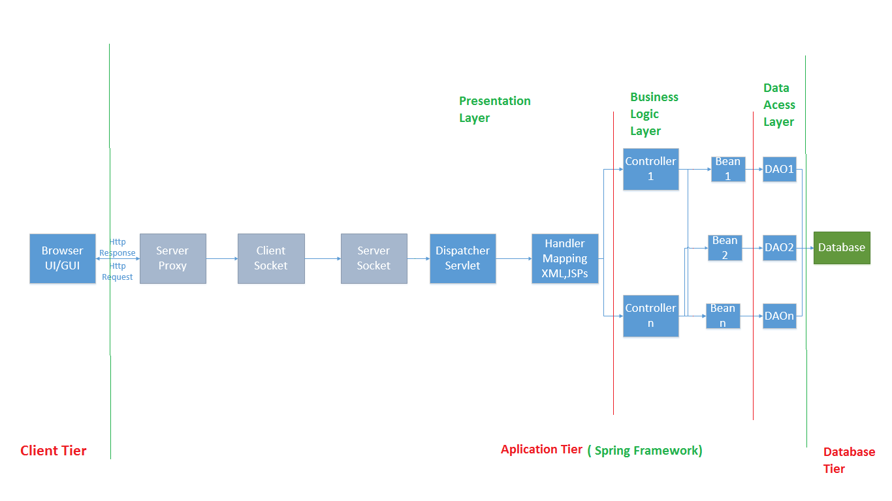

We are going to Implement these below modules

1. Dispatcher Servlet

2.Handler Mapping

3.Controllers

4. Beans/POJOs

5.Data Access objects (DAO)

6. Database

2) Class Diagram

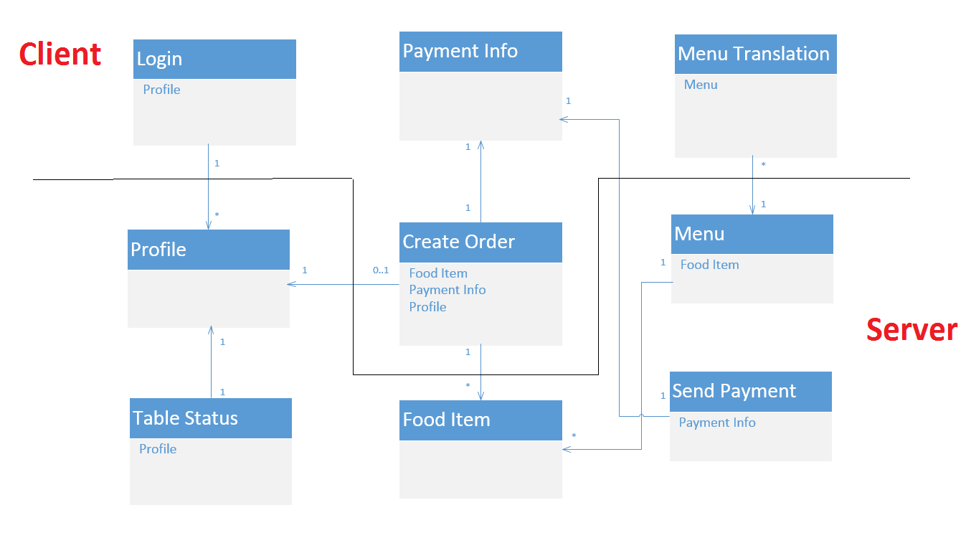

3) Sequence Diagram

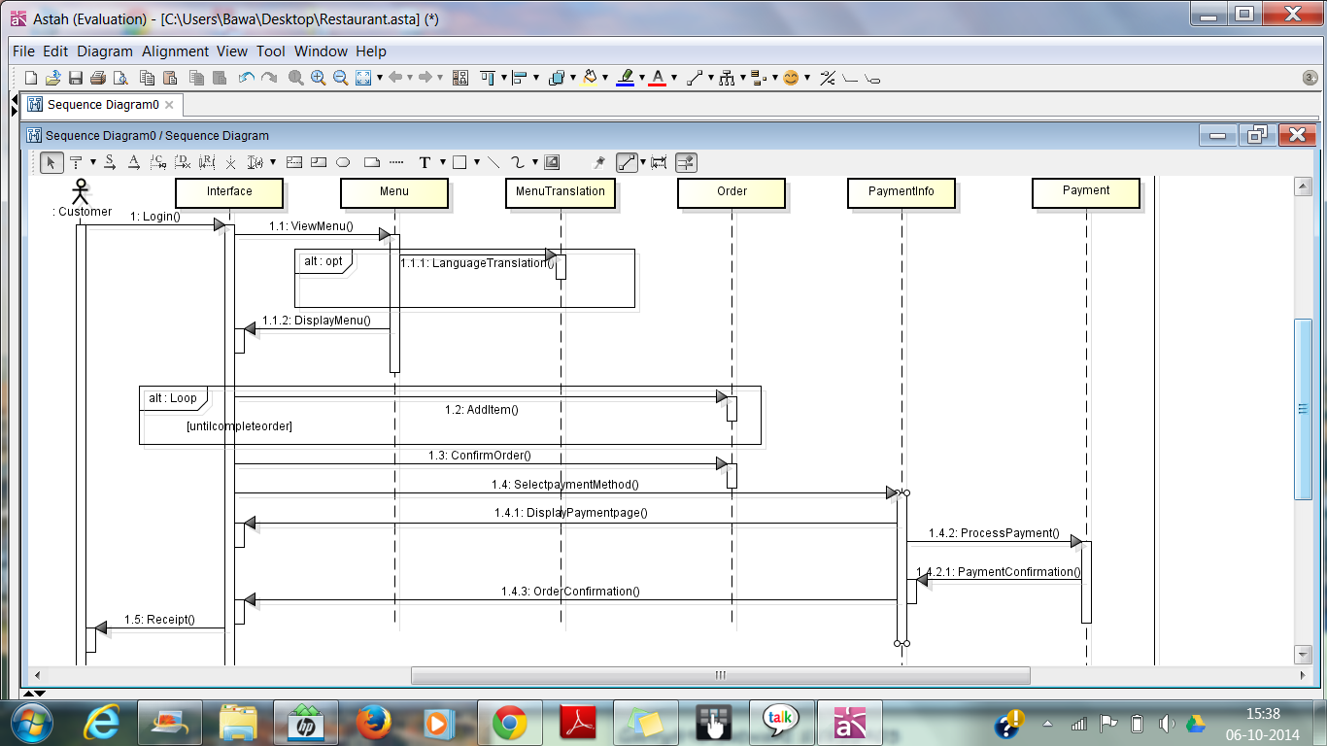

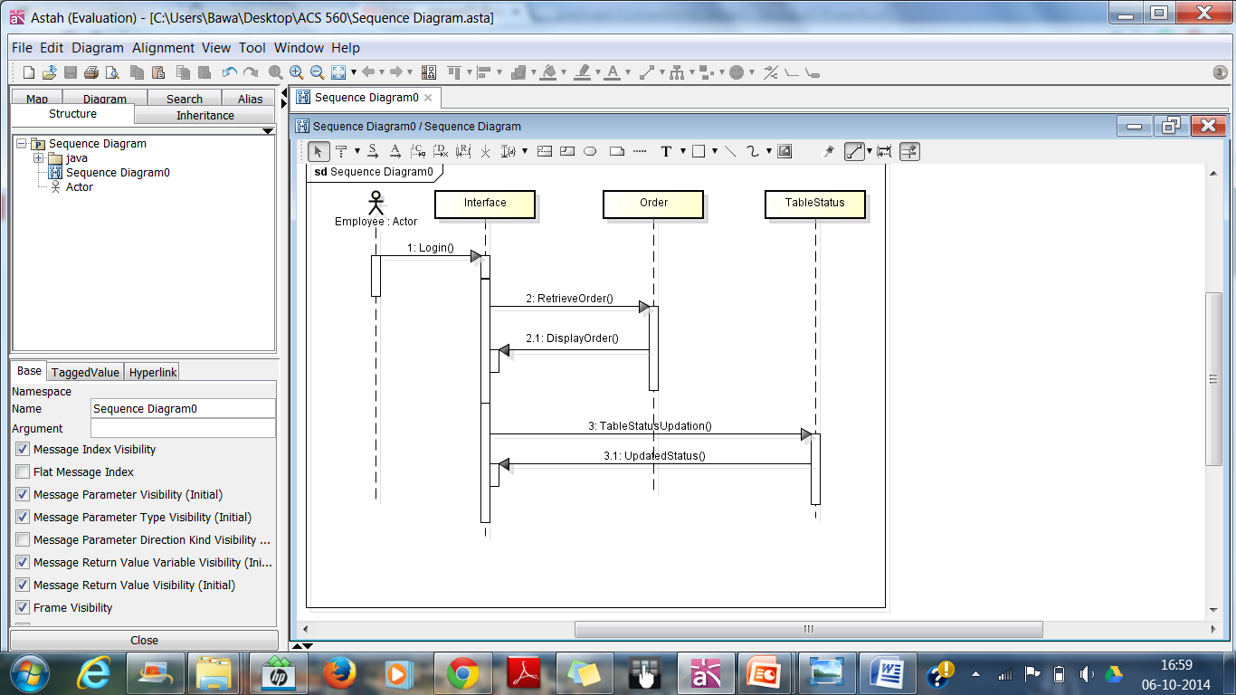

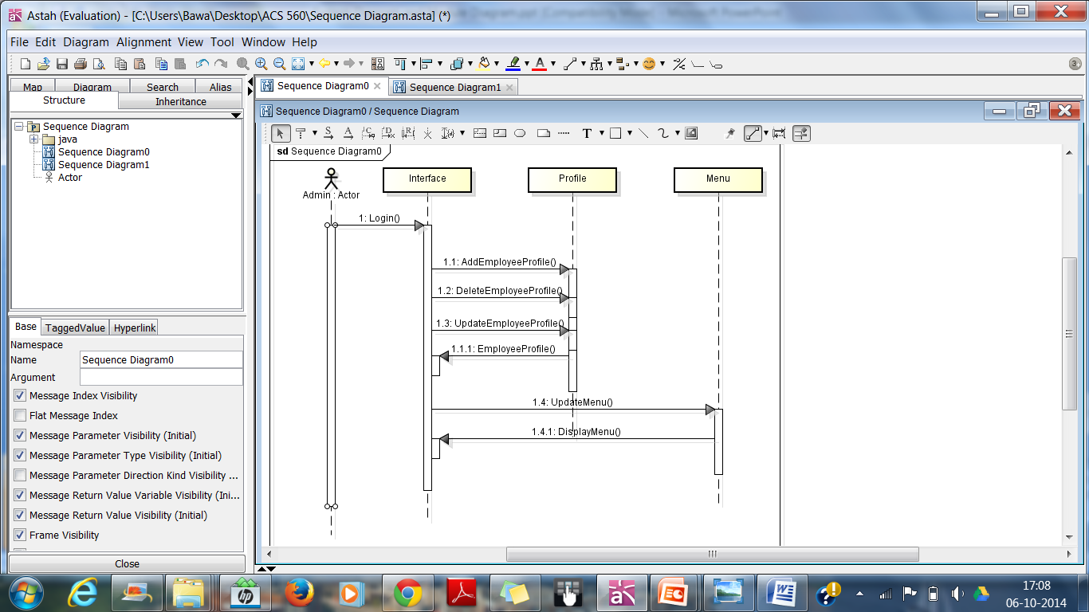

GITHUB link:

https://github.com/xyzrestaurant/Project