Design thinking tools applied for an Emergency Response App


A Report Submitted to

Visvesvaraya Technological University, Belagavi
in partial fulfilment of requirements of
II semester Innovation and Design Thinking - 22ME2AEIDT of
BACHELOR OF ENGINEERING in Computer Science Engineering

Shivam Kumar Shashwat Anand Shailja Kriti Shaurya Raj Shreyansh Jain
Submitted by

1BF25CS243
1BM25CS267
1BF25CS240
1BM25CS268
1BM25CS273

Under the mentorship of

Santhosh Somashekhar
Assistant Professor Department of Mechanical Engineering


Department of Computer Science Engineering
B. M. S. COLLEGE OF ENGINEERING
(Autonomous Institution Affiliated to VTU, Belagavi)
Post Box No. 1908, Bull Temple Road, Bengaluru – 560 019 02 - 2026

1

B. M. S. COLLEGE OF ENGINEERING
Post Box No. 1908, Bull Temple Road, Bengaluru – 560 019

Department of Computer Science Engineering

Certificate

Certified that the seminar entitled Aerial express is a Bonafide work carried out by

Shivam Kumar Shashwat Anand Shailja Kriti Shaurya Raj Shreyansh Jain
1BF25CS243
1BM25CS267
1BF25CS240
1BM25CS268
1BM25CS273

in partial fulfillment for the award of Bachelor of Engineering in Computer Science Engineering of the Visvesvaraya Technological University, Belgaum, during the year 2025–
26. It is certified that all corrections / suggestions indicated for internal assessment have been incorporated in the report deposited in the departmental library. The report has been approved as it satisfies the academic requirements in respect of the course Innovation and Design Thinking (22ME1AEIDT) prescribed for the said degree.

Signature of the Mentor Signature of HOD (Santhosh Somashekhar)

Signature of Principal

Semester End Examination
Name of the Examiners Signature with Date

1.

2.

Declaration

I hereby declare that the report entitled for an emergency response app has been independently carried out by me at Department of Computer Science Engineering, under the guidance of Somanath Somashekhar, Assistant Professor, Department of Mechanical Engineering, B. M. S. College of Engineering, Bengaluru, in partial fulfilment of the requirements of the degree of Bachelor of Engineering in Computer Science Engineering of Visvesvaraya Technological University, Belagavi.

I further declare that I have not submitted this report either in part or in full to any other university for the award of any degree.

Shivam Kumar Shashwat Anand Shailja Kriti Shaurya Raj Shreyansh Jain
1BF25CS243
1BM25CS267
1BF25CS240
1BM25CS268
1BM25CS273

Place: Bengaluru Date: 10/02/2026

Content

Chapters | Content | Page No.s
1 | INTRODUCTION | 1
2 | Empathize | 2
3 | Define | 3-4
4 | Ideate | 5
5 | Prototype | 6
6 | The User Interface | 7
7 | Deployment | 8
8 | Benefits and Future scope | 9
9 | Conclusion | 10
10 | References | 11

ABSTRACT

In today’s fast-paced world, timely assistance during emergencies is critical to save lives and reduce damage. The Emergency Response App is designed to provide quick and reliable support during situations such as medical emergencies, accidents, natural disasters, and personal safety threats. The app enables users to instantly alert emergency services, nearby hospitals, police stations, or trusted contacts with minimal user interaction. The system integrates features such as real-time location tracking, one-tap SOS alerts, emergency contact notifications, and access to essential first-aid information. By using GPS and mobile communication technologies, the app ensures accurate location sharing, allowing responders to reach the victim faster. The app is user- friendly, reliable, and accessible to people of all age groups, especially during high-stress situations. The Emergency Response App aims to bridge the gap between victims and emergency services by reducing response time and improving coordination. This solution enhances public safety and provides a practical approach to managing emergencies efficiently using modern mobile technology. In today’s fast-paced world, timely assistance during emergencies is critical to save lives and reduce damage. The Emergency Response App is designed to provide quick and reliable support during situations such as medical emergencies, accidents, natural disasters, and personal safety threats. The app enables users to instantly alert emergency services, nearby hospitals, police stations, or trusted contacts with minimal user interaction.The system integrates features such as real-time location tracking, one-tap SOS alerts, emergency contact notifications, and access to essential first-aid information. By using GPS and mobile communication technologies, the app ensures accurate location sharing, allowing responders to reach the victim faster. The app is user-friendly, reliable, and accessible to people of all age groups, especially during high-stress situations. The Emergency Response App aims to bridge the gap between victims and emergency services by reducing response time and improving coordination. This solution enhances public safety and provides a practical approach to managing emergencies efficiently using modern
mobile technology.

CHAPTER 1. INTRODUCTION
  - Overview

In the fast-moving world of rush, adrenaline, and rapid transit, individuals often overlook the aspect that matters most: safety. As the pace of life accelerates, so does the risk of unforeseen incidents on the road. The "Responder" project is an initiative designed to dive deep into the analysis of road safety and provide a relative, high-impact technological solution.

"Responder" is an Intelligent Personal Safety & Crash Detection System. It is designed as a mobile application that acts as a guardian angel for commuters. By leveraging the advanced sensor capabilities inherent in modern smartphones, Responder bridges the critical communication gap that exists between the moment of an accident and the arrival of emergency help.
  - Motivation
The motivation behind this project stems from a grim reality. Road accidents are a leading cause of death globally, and particularly in India. Often, the difference between life and death is not the severity of the crash itself, but the delay in receiving medical attention.
In many severe accidents—such as solo crashes on highways or late-night driving incidents—victims are often rendered unconscious, pinned inside vehicles, or are in a state of shock that prevents them from physically reaching their phone to dial emergency services (like 112 or 911). This inability to communicate is the primary problem Responder seeks to solve. We believe that technology should speak for the user when the user cannot speak for themselves

  - Objectives
The primary objectives of the Responder project are:
To Automate Safety: To create a system that detects vehicle crashes without any human intervention using accelerometer and gyroscope data.
To Reduce Response Time: To ensure that emergency contacts and services are notified within seconds of an accident, capitalizing on the "Golden Hour."
To Prevent False Alarms: To implement a robust verification system that distinguishes between dropped phones and actual vehicle collisions.
To Promote Safer Driving: To provide users with analytics on their driving behavior, fostering a culture of preventative safety.

CHAPTER 2: PHASE 1 - EMPATHIZE
  - Understanding the Issues
The first stage of our Design Thinking process was "Empathize." We sought to understand the users—drivers, commuters, and their families—and the specific pain points they face regarding road safety.
We identified that fear and uncertainty are major psychological factors. Drivers often worry about "what if" scenarios, while families worry when a loved one is traveling alone.
  - The Reality of Road Accidents in India
To ground our project in reality, we analyzed data from the Ministry of Road Transport & Highways, Government of India. The statistics are alarming:
High Incident Rate: Lakhs of road accidents occur in India annually.
Casualties: Approximately 6.1 Lakh people are involved in these incidents every year.
Unreported Data: It is crucial to note that these numbers are based only upon reported data; the actual figures could be significantly higher.

  - The "Golden Hour" Significance
Our research highlighted a critical medical concept known as the "Golden Hour." Definition: The "Golden Hour" is the first hour immediately following a traumatic injury.
Significance: Medical evidence suggests that trauma patients have a significantly higher chance of survival if they receive definitive medical care within this 60-minute window.
The Problem: In current scenarios, response times are often delayed by minutes or even hours because bystanders may not be present, or the victim is unable to call for help. Every minute lost during this hour drastically reduces survival rates.
Furthermore, we realized that safety isn't just about post-accident response. It is also about prevention. Analyzing driving behaviors beforehand can reduce the occurrence of accidents.

CHAPTER 3: PHASE 2 - DEFINE

  - Problem Statement
Based on our empathy research, we defined the core problem statement that guides this project:
"Users need a way to automatically alert emergency services and emergency contacts immediately after a crash, specifically when they are physically unable to interact with their devices."
  - Root Cause Analysis (Fishbone Diagram)
To thoroughly understand why this problem exists and why current solutions fail, we employed a Fishbone (Ishikawa) Diagram analysis. We categorized the causes into four main pillars:
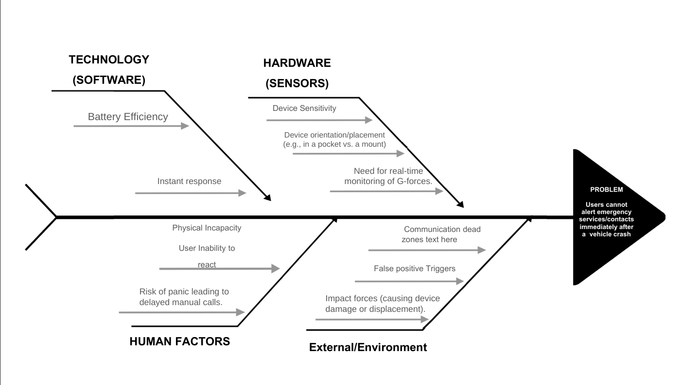
    - Technology (Software)
Battery Efficiency: Continuous monitoring of sensors can drain battery life, discouraging users from keeping safety apps active.
Instant Response: Software must process data in milliseconds to trigger an alert before the phone potentially loses power due to impact damage.
    - Hardware (Sensors)
Device Sensitivity: Sensors might be too sensitive (triggering on hard braking) or not sensitive enough.
Device Orientation: The phone might be in a pocket, a dashboard mount, or a cup holder. The system must account for these different orientations.
Real-time Monitoring: The need for constant monitoring of G-forces without lag.
    - Human Factors
Physical Incapacity: The primary issue is the user being unconscious or pinned.
Panic & Shock: Even if conscious, a victim may be in a state of shock, leading to delayed manual calls. Inability to React: Reaction times in high-stress situations are significantly slowed.
    - External/Environment
Communication Dead Zones: Accidents often happen on highways with poor signal.
False Positive Triggers: Dropping the phone or throwing it onto a car seat should not trigger an SOS.
Impact Forces: High-impact collisions can damage the device itself, meaning the software has a split second to send the distress signal.

CHAPTER 4: PHASE 3 - IDEATE
  - The Solution Strategy
In the Ideate phase, we brainstormed ways to solve the defined problem. The winning idea was to leverage the high-fidelity sensors already present in modern Android smartphones to create a "Virtual Black Box."
Instead of requiring users to buy expensive hardware dongles for their cars, we utilize the device they already carry.
  - Hardware Utilization (Sensor Fusion)
We identified four specific hardware components available in almost every smartphone that can be repurposed for crash detection:
Accelerometer:
Usage: This is the primary sensor. It detects sudden deceleration. In a crash, a vehicle goes from high speed to zero almost instantly, creating a massive spike in G-force.
Threshold: We look for G-force spikes significantly higher than normal braking (e.g., >4G). Gyroscope:
Usage: This measures orientation and rotation.
Significance: It detects violent rotation, which is indicative of rollovers or the car spinning out of control— movements that rarely happen in normal driving.
Light/Proximity Sensors:
Usage: These provide context awareness.
Context: They help detect if the phone is trapped (e.g., in a deployed airbag or a crushed pocket) or if it has been thrown clear of the vehicle.
Microphone:
Usage: Acoustic validation.
Signature: The app listens for the specific acoustic signature of a crash, such as the high-frequency sound of glass breaking or the crunching of metal, to validate the sensor data.
Sends an SMS with precise Latitude/Longitude coordinates to trusted contacts. Auto-dials Emergency Services (112).
User Control: This allows the driver to cancel the alarm if it was a false positive (e.g., phone dropped). Action: If the countdown reaches zero (meaning the user is unable to cancel), the app: Sends an SMS with precise Latitude/Longitude coordinates to trusted contacts.
Auto-dials Emergency Services (112).

CHAPTER 5: PHASE 4 - PROTOTYPE

  - User Interface Design
The User Interface (UI) was designed with high-stress situations in mind. It uses high contrast, large buttons, and clear typography. The design philosophy centers on "One-Tap Safety."
  - Screen Walkthroughs
    - Home Screen (Responder Active)
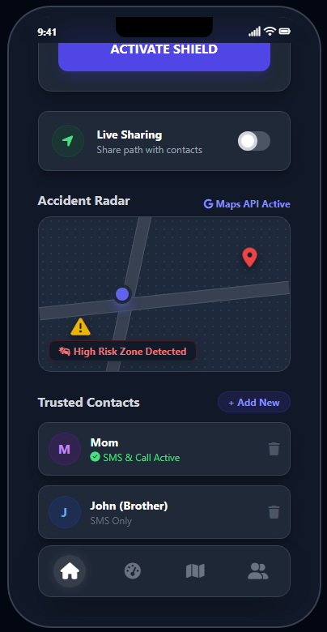
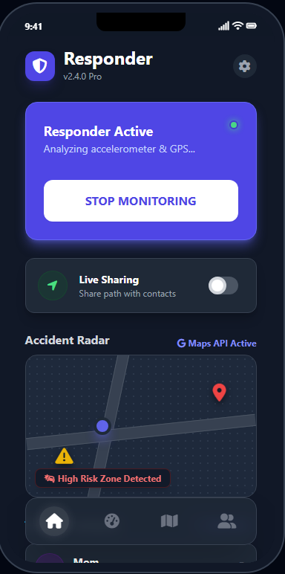
The home screen features a dark theme (to reduce glare at night) with a large, pulsating "Stop Monitoring" button. This clearly indicates that the "Shield" is active. It also features a "Live Sharing" toggle, allowing users to share their real-time path with contacts during late-night drives.
    - Crash Detected Screen
This is the most critical screen. It features a bright Red background to alert the user. Countdown: A large central timer counts down from 10.
Cancel Button: A prominent "I AM OKAY" button allows for immediate cancellation. Status: It displays "Sending SOS in..." to inform the user of the impending .
    - Driving Analysis Dashboard
To address the preventative aspect, we prototyped a driving analysis screen. Scoring: Users receive a safety score (e.g., 73/100).
Metrics: It breaks down driving into "Braking" (Normal vs. Hard), "Acceleration" (Steady vs. Rapid), and "Cornering Stability."
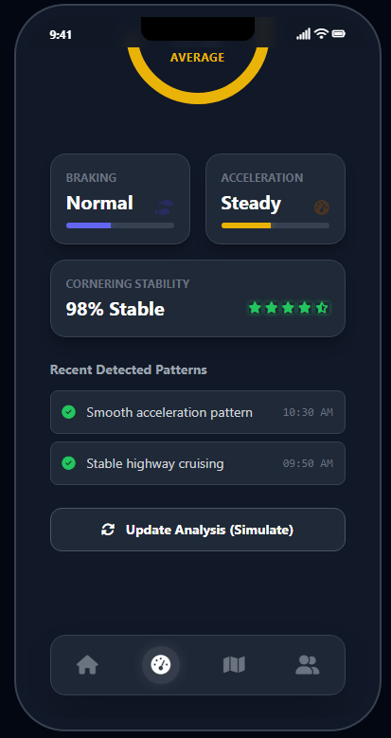
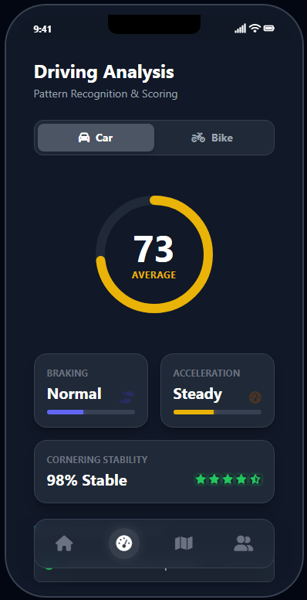
Patterns: It identifies recent patterns like "Stable highway cruising" to reinforce positive behavior.
  - Additional Features
Nearby Crash Report: Using the Google Maps API combined with the software's own database, the app alerts users when they are entering a high-risk zone where other crashes have occurred.
Vehicle Type: Users can toggle between "Car" and "Bike" modes, adjusting the sensor sensitivity algorithms accordingly (as bikes have different vibration patterns).

CHAPTER 6: PHASE 5 - TEST & DEPLOYMENT

The deployment of a life-safety application requires rigorous testing. We have outlined a four-phase deployment strategy.
  - Phase 1: Calibration (Alpha) Scope: Internal testing.
Method: Data collection from 50 devices.
Goal: To tune sensor sensitivity. This phase is crucial for filtering out "noise"—distinguishing between hitting a deep pothole or a speed bump and an actual collision. We use this data to train our threshold values.
  - Phase 2: Pilot (Closed Beta)
Scope: 500 users in a single city (Bengaluru).
Integration: Testing integration with local SMS gateways to ensure message delivery reliability. Latency Checks: Measuring the time taken from "Crash Detected" to "SMS Received

6.3 Phase 3: Launch (Public Release) Scope: Regional Android launch.
Enhancements: Data collected from various real-world conditions (rain, off-road driving) will be used to further refine the algorithm.
6.4 Phase 4: Scale (Future) Scope: International launch.
Advanced Tech: transitioning from standard Google Maps API to SpaceX Live Imagery (theoretical integration) for real-time visual confirmation of accident sites in remote areas
CHAPTER 7: BENEFITS AND FUTURE SCOPE

  - Benefits (Impact)
The "Responder" system offers profound benefits to society and individuals:
Saving Lives: By reducing the emergency response time, we maximize the effectiveness of the "Golden Hour."
Peace of Mind: For families of daily commuters, the app provides assurance that they will be notified instantly if something goes wrong.
Data-Driven Safety: The driving analysis tools help create better drivers, attacking the root cause of accidents (human error).
  - Future Scope
The potential for Responder extends beyond a standalone app:
Ride-Sharing Integration: The API could be integrated into apps like Uber, Ola, or Lyft to protect passengers and drivers.
Fleet Management: Logistics companies can use the software to monitor truck fleets for accidents and unsafe driving behavior.
Bluetooth & IoT: Future versions will integrate with car Bluetooth systems. This allows the app to read data directly from the car’s On-Board Diagnostics (OBD) for even more accurate crash data (e.g., airbag deployment status).

CHAPTER 8: CONCLUSION

The "Responder" project successfully demonstrates that expensive hardware is not always necessary to solve critical problems. By intelligently applying Design Thinking tools—Empathizing with victims, Defining the technical barriers, Ideating on sensor fusion, and Prototyping a user-centric solution—we have created a viable "Virtual Black Box" for every commuter.
Responder does not just detect crashes; it connects generations through technology, ensuring that no matter where you are, you are never truly alone on the road. It empowers users with a digital guardian that stands ready to act when they need it most.

REFERENCES

Statistics Data: Ministry of Road Transport & Highways, Government of India.
AI Engine: Google Gemini (used for data integration and application logic). Development Environment: Visual Studio Code.
Mapping Service: Google Maps Platform APIs.
Design Thinking Framework: Stanford school

