**Name** : Vaibhav Soni

**Enrolment No.** : IU2141230287

**Branch** : CSE – A

**Sem** : 7

**Subject** : Cyber Security

**Lab – 1**

**Aim :** TCP Scanning using NMAP.

**Output :**

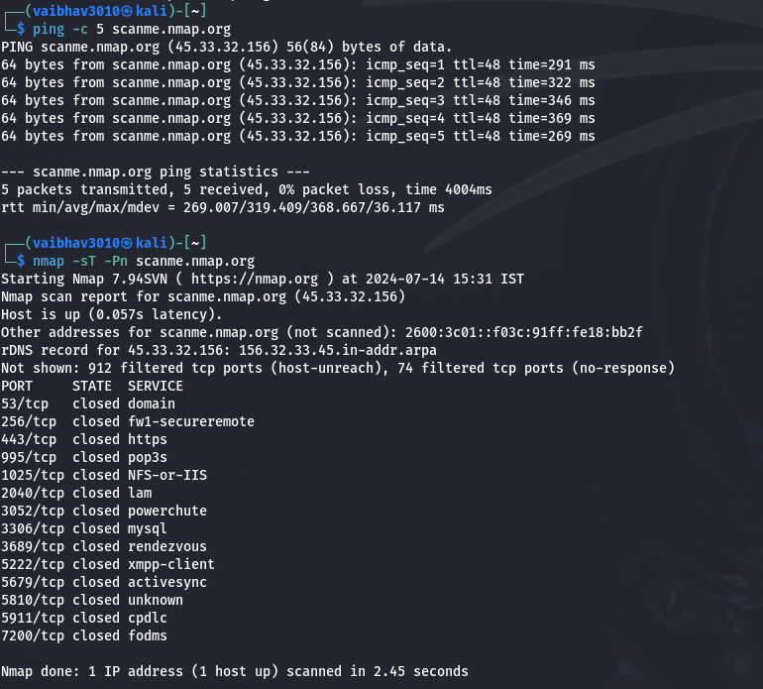

**Conclusion :**

* The `ping` command executed on `scanme.nmap.org` shows successful connectivity, with 5 packets transmitted and received, and no packet loss. The round-trip times range from 269 ms to 369 ms, indicating a stable connection with a consistent response time. This confirms that the host is reachable over the network, despite some latency.
* The `nmap` scan using the `-sT -Pn` options reveals that `scanme.nmap.org` is up but has all scanned ports closed. The scan checked numerous ports, such as 53 (domain), 443 (https), and 3306 (mysql), and found them all closed. Additionally, it reported that 912 filtered ports were not reachable, suggesting that firewall or filtering rules are in place, preventing access to these ports. This indicates a highly secured network configuration on the target host.