**Name** : Vaibhav Soni

**Enrolment No.** : IU2141230287

**Branch** : CSE – A

**Sem** : 7

**Subject** : Cyber Security

**Lab – 3**

**Aim :** TCP / UDP connectivity using Netcat.

**TCP Server Input :**

nc -nlvp 8989

**TCP Server Output :**

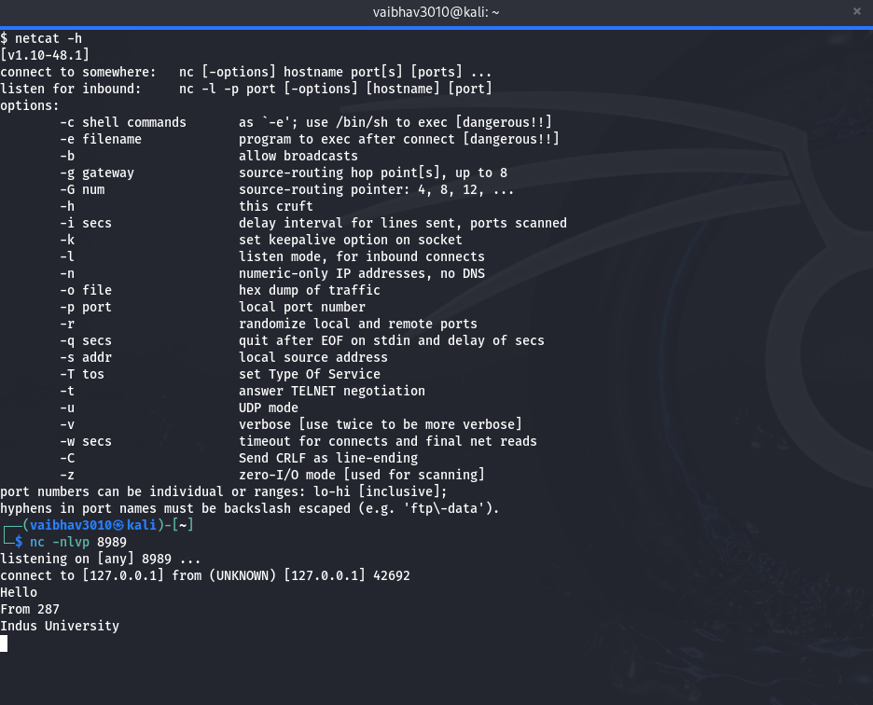

* The command `nc -nlvp 8989` uses Netcat (`nc`) to listen on port 8989. The options are: `-n` to avoid DNS lookups, `-l` to enable listening mode, `-v` for verbose output, and `-p 8989` to specify the port number. This command is commonly used to set up a simple TCP server for testing and debugging network connections.

**TCP Client Input :**

nc -nv 127.0.0.1 8989

**TCP Client Output :**

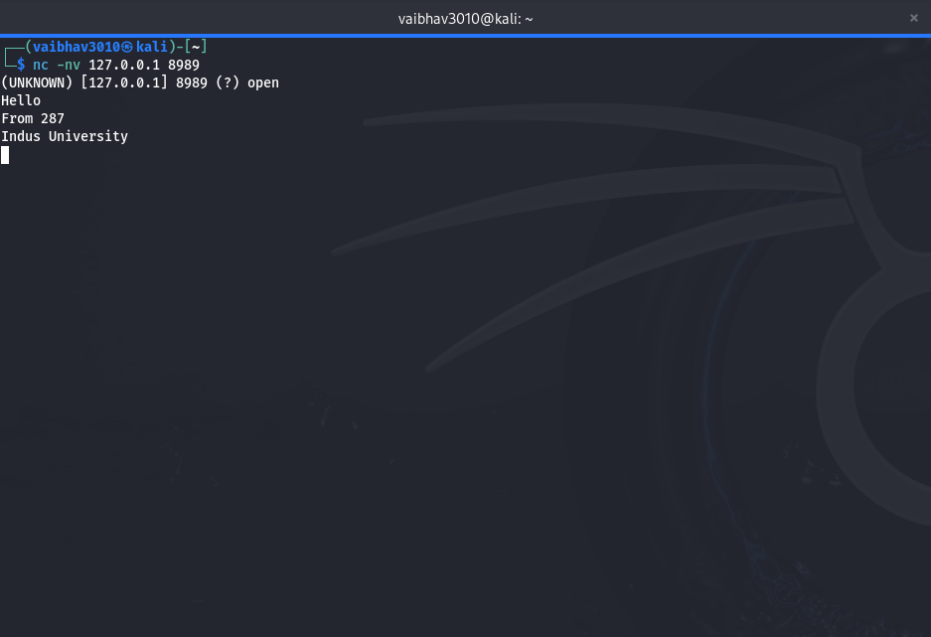

* The command `nc -nv 127.0.0.1 8989` uses Netcat (`nc`) to establish a connection to the IP address 127.0.0.1 (localhost) on port 8989. The `-n` option avoids DNS lookups, and the `-v` option makes the output more verbose. This is often used to test connectivity to a specific port on the local machine.

**UDP Server Input :**

nc -ul -p 8989

**UDP Server Output :**

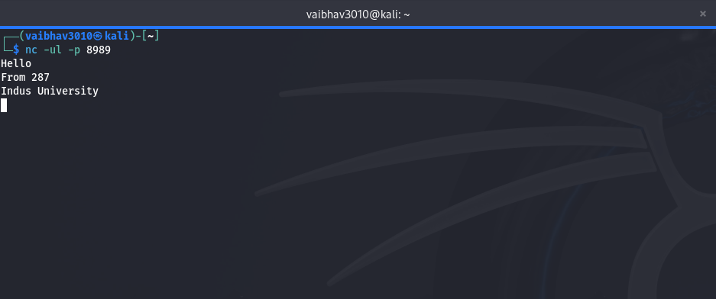

* The command `nc -ul -p 8989` uses Netcat (`nc`) to listen for UDP packets on port 8989. The options `-u` specifies UDP mode, `-l` tells Netcat to listen for incoming connections, and `-p 8989` designates the port number to listen on. This setup is often used for testing UDP communication and for creating simple UDP servers.

**UDP Client Input :**

nc -u 127.0.0.1 8989

**UDP Client Output :**

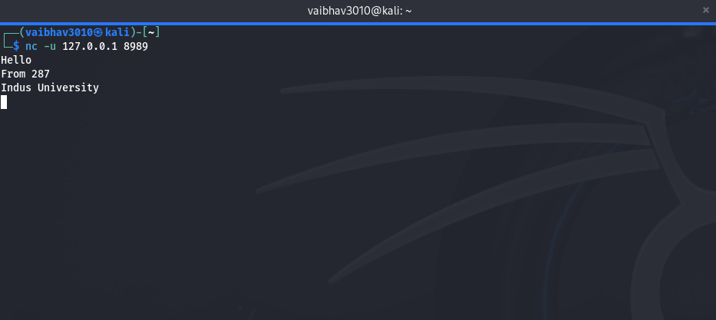

* The command `nc -u 127.0.0.1 8989` uses Netcat (`nc`) to send data to the IP address 127.0.0.1 (localhost) on port 8989 using the UDP protocol (`-u`). This command is often used for testing UDP communication between hosts.