**Name** : Vaibhav Soni

**Enrolment No.** : IU2141230287

**Branch** : CSE – A

**Sem** : 7

**Subject** : Cyber Security

**Lab – 4.1**

**Aim :** Prepare a VM for Installation of OpenVAS.

**Input :**

sudo apt update

**Output :**

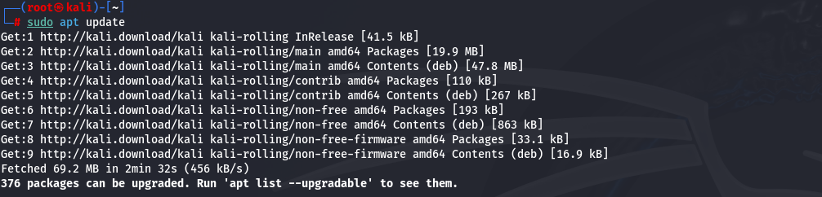

**Input :**

sudo apt upgrade -y

**Output :**

