**Name** : Vaibhav Soni

**Enrolment No.** : IU2141230287

**Branch** : CSE – A

**Sem** : 7

**Subject** : Cyber Security

**Lab – 4.2**

**Aim :** Install and Config OpenVAS on Kali Linux.

**Input :**

sudo apt install gvm

**Output :**

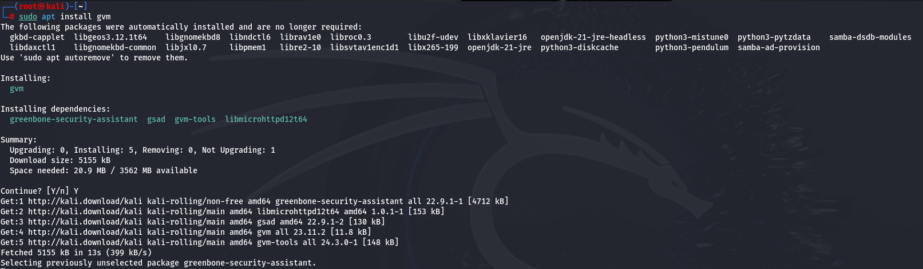

**Input :**

sudo gvm-setup

**Output :**



**Input :**

sudo gvm-check-setup

**Output :**

