**Name** : Vaibhav Soni

**Enrolment No.** : IU2141230287

**Branch** : CSE – A

**Sem** : 7

**Subject** : Cyber Security

**Lab – 4.3**

**Aim :** Vulnerability Scanning using OpenVAS on Kali Linux.

**Input :**

sudo greenbone-feed-sync

**Output :**

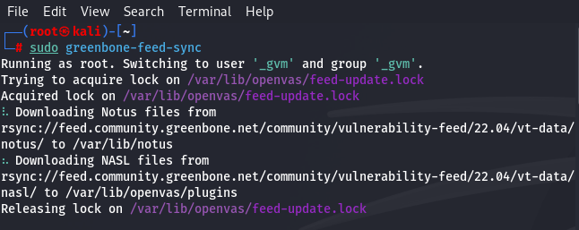

**Input :**

sudo gvm-start

**Output :**

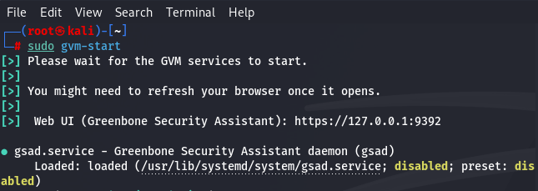

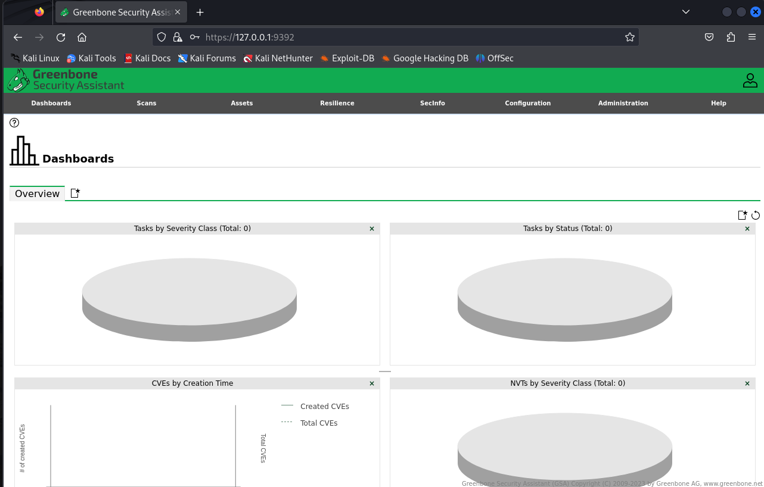

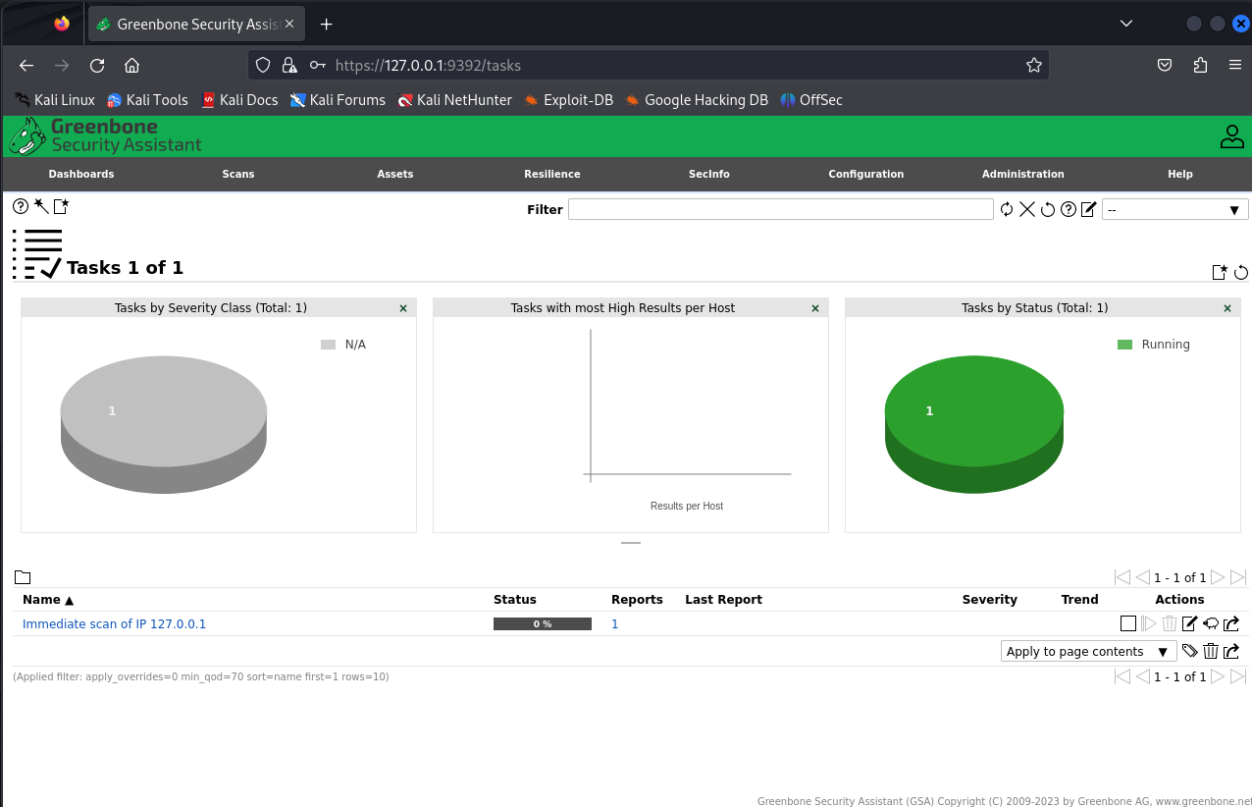

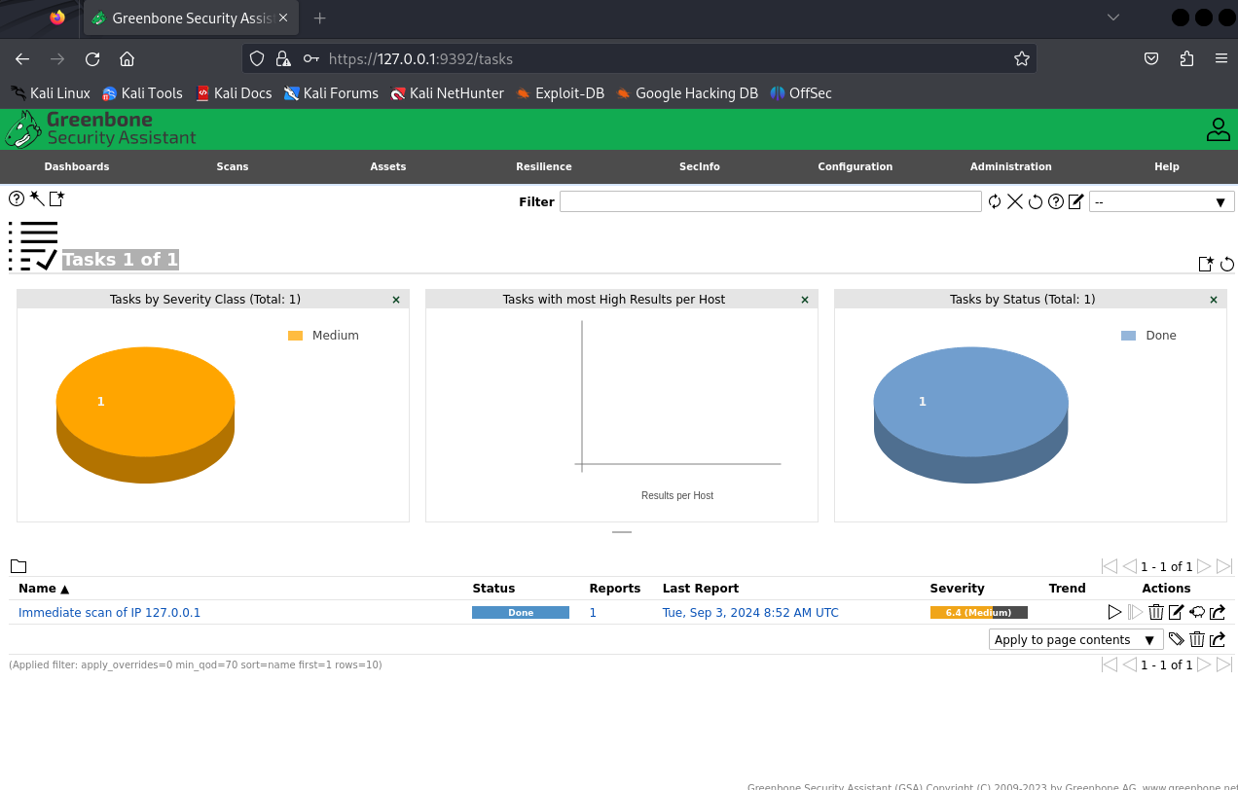

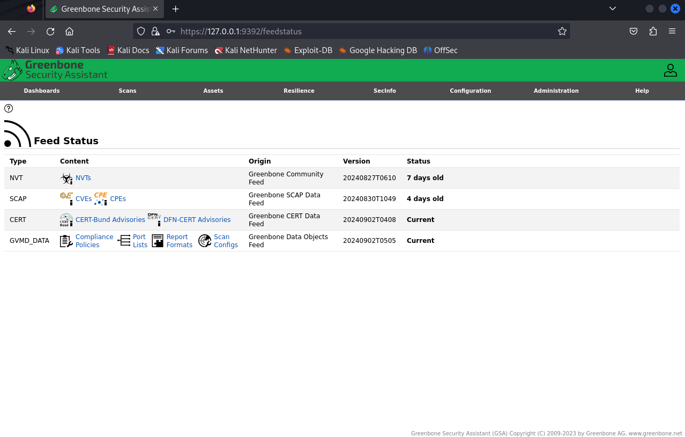

**Summary Report of Findings:**

**1. Scan Results Overview:**

* **Number of Tasks:** 1
* **Task Name:** Immediate scan of IP 127.0.0.1
* **Task Status:** Completed (Status: Done)
* **Severity of Issues:** Medium (6.4 score)
* **Trend:** No visible trend indicated, implying either stable findings or lack of trend data.

**2. Severity and Host Analysis:**

* The scan identified issues classified under the "Medium" severity class.
* There were no "High" severity results per host recorded, which may suggest no critical vulnerabilities were detected.

**3. Feed Status and Updates:**

* **NVT Feed:** Last updated 7 days ago.
* **SCAP Feed:** Last updated 4 days ago.
* **CERT Feed:** Currently up to date.
* **GVMD Data Feed:** Currently up to date.

**Key Points:**

* The scan identified a medium-severity issue with the local host (127.0.0.1).
* The scan task is completed and marked as "Done."
* No high-severity vulnerabilities were detected.
* Most data feeds are current, with the SCAP feed updated 4 days ago and the NVT feed being 7 days old.