**Name**: Vaibhav Soni **Enrolment No.**: IU2141230287 **Branch**: CSE – A

**Sem**: 7

**Subject**: Cyber Security

**Lab – 7**

**Aim: Write a program to sniff packet sent over the local network.**

**Outputs:**

1. **Installing “Scapy”**

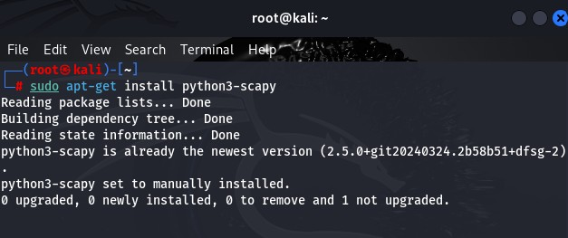

1. **Opening Scapy using root terminal**

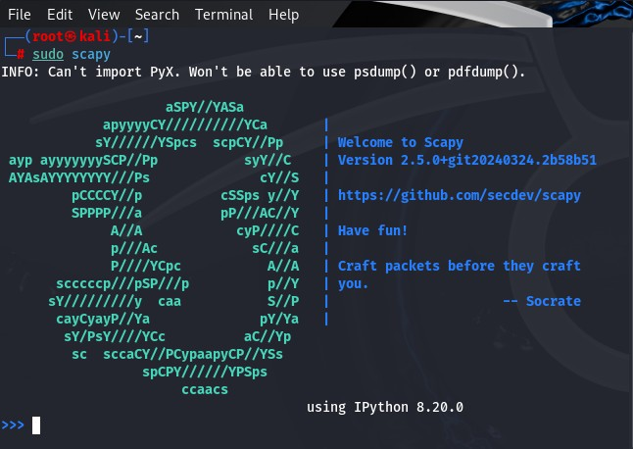

1. **Sniffing packets using scapy**

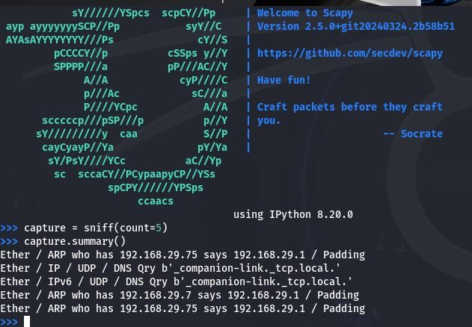

**Summary:**

The captured packets include ARP and DNS traffic. Three ARP packets show hosts (192.168.29.75 and 192.168.29.7) querying for the MAC address of 192.168.29.1, likely the default gateway. The remaining two packets are UDP- based DNS queries, where a host is attempting to resolve the local domain companion-link._tcp.local.

This appears to be a multicast DNS request, often used for service discovery in local networks. Overall, the network traffic indicates hosts trying to communicate with the gateway and discover services in the local network.