CA-HMCD for Low-Altitude Safety: Interpretable Coalition Allocation with Mechanism Validation and Solver-Specific Boundaries
Abstract
Dynamic low-altitude safety requires heterogeneous response resources to be combined under changing task demand, capacity, expenditure, and reconfiguration constraints. We present CA-HMCD, an interpretable rolling coalition-allocation framework that separates type-conditioned compatibility, headroom-bounded complementarity, capability-overlap penalties, history-aware candidate reduction, solver backends, and true-state feasibility repair. Evidence was organized in four registered layers: public-data-informed replay over 44 UZH-FPV and Anti-UAV410 units with 30 nested seeds; a formal no-pruning control; 2,070 controlled mechanism trajectories; and 750 engineering-scenario solver trajectories. Complementarity increased the independent service endpoint at scale 2 by 0.0049 (95% BCa CI 0.0033-0.0070), while its complete-objective effect was not significant. At volatility 0.30, stability reduced switching by 3.46 events but decreased immediate service by 0.0205. None of three registered redundancy diagnostics was supported. Under perception noise 0.30, true-state repair increased feasibility by 0.7944 with a service cost of 0.0240. Exact HiGHS and fixed-K modes showed no Holm-significant quality difference in five engineering scenarios, and the registered real-time gate failed in all 64 scale-deadline cells. The contribution is therefore an auditable value and safety-control framework with scenario-specific solver guidance, not a claim of universal quality, speed, or field superiority.
Keywords: heterogeneous resource allocation; coalition formation; low-altitude safety; true-state repair; mixed-integer optimization; public-data-informed replay

1. Introduction
Low-altitude safety systems increasingly need to coordinate responses to multiple events whose location, scale, speed, density, priority, and admissible response window change over time. Airports, energy facilities, industrial zones, urban corridors, and large public venues may all require a controller to combine sensing-derived task states with limited and heterogeneous response resources [1-3]. The allocation problem is therefore not a static choice of one resource for one task. It is a rolling decision problem in which several active tasks compete for resources with different operating ranges, response speeds, persistence, consumption profiles, service capacities, and availability states.
This setting makes coalition structure part of the decision. A heterogeneous coalition can be valuable when its members provide complementary capabilities, yet adding resources with highly overlapping capabilities can increase physical expenditure without a commensurate service gain. The allocation inherited from the previous period also matters: aggressive re-optimization can improve an instantaneous score while generating repeated switching and unstable operating plans. Failures and task arrivals further create a distinction between an allocation proposed from perceived information and one that remains feasible under the evaluated true state.
Multi-robot and multi-agent task-allocation research provides mature taxonomies and optimization models for heterogeneous capabilities, task coupling, temporal requirements, and resource constraints [4,5,10,15,16]. Coalition-formation methods make multi-resource execution explicit [6-9,17,18,22], while auction, consensus, formal-specification, and learning-based methods address communication, adaptation, and online computation [11-14,19-27]. These foundations resolve important parts of the problem, but they do not by themselves provide a unified rolling model that separates task-specific complementarity from capability duplication, controls inter-period reconfiguration, and evaluates every method after the same true-state feasibility operation.
The question addressed here is therefore: how can heterogeneous response resources be assembled into feasible task-specific coalitions that preserve an interpretable service-cost trade-off while remaining stable across decision periods and auditable under finite search? A suitable method must distinguish pair-level compatibility from coalition-level value, keep physical expenditure separate from a soft redundancy preference, limit a combinatorial candidate space without deleting safer history-consistent alternatives, and expose rather than hide the consequences of a bounded node budget.
We address this question with Complementarity-Aware Heterogeneous Multi-Agent Cooperative Decision-Making (CA-HMCD). The method represents response resources by four capability classes: Type-I pointwise high-precision, Type-II area-effect, Type-III discrete-consumption, and Type-IV maneuvering-tracking resources. It constructs feasible resource coalitions for each active task, combines independent resource scores with a headroom-bounded complementarity gain, applies a separate capability-overlap penalty, and solves the retained coalition-selection problem using an objective-aware greedy warm start and candidate-level branch-and-bound. History-aware dominance and diversity retention control the candidate pool. If the node budget is exhausted, the best feasible incumbent is returned and the remaining bound is recorded before true-state feasibility control and external evaluation.
The study makes three evidence-bounded contributions. First, it provides a closed mathematical model in which coalition success is bounded, physical expenditure alone enters the hard budget, and redundancy remains a soft structural preference. Second, it introduces an auditable solution workflow with history-aware pruning, incumbent-preserving fallback, and strict separation between perceived-state decisions, true-state control, and experiment-only evaluation. Third, it evaluates the method under a frozen replay protocol that combines measured three-dimensional UZH-FPV motion and measured Anti-UAV410 image-plane observation patterns with simulated response resources. Statistical inference uses the public trajectory or predefined composed workload as the independent unit; the 30 seeds per unit quantify stochastic variation rather than inflate the public-data sample size. The resulting claim is deliberately limited to controlled public-data-informed simulation rather than field deployment.

2. Related Work

2.1. Heterogeneous task allocation
Multi-robot task allocation formalizes the assignment of tasks to agents with different capabilities, capacities, and temporal roles. Foundational taxonomies distinguish single- from multi-agent tasks, instantaneous from time-extended assignments, and loosely from tightly coupled execution [5,16]. Recent reviews and algorithms extend this view to energy-aware allocation, formal task specifications, task precedence, safe planning, production scheduling, and human-robot teams [4,12,13,15,20,21,23-26,47,50-54]. These approaches establish the importance of capability and constraint representation. For the present problem, however, an assignment utility alone is insufficient because the incremental value of a resource depends on both the active task and the other resources already assigned to it.

2.2. Coalition formation and combinatorial allocation
Coalition formation provides the closest formal basis for tasks that require or benefit from several agents. Early work developed approximation methods for task allocation through agent coalitions and characterized the computational trade-off in coalition-structure generation [6,7]. Later studies incorporated heterogeneous resource constraints, battery limits, game-theoretic clustering, dynamic coalition policies, and scalable coalition mechanisms [8,9,17,18,22,55]. These methods make multi-resource execution explicit, but their value models commonly emphasize feasibility, completion, energy, or total utility. CA-HMCD differs by separating independent coalition aggregation, task-specific heterogeneous complementarity, capability overlap, physical expenditure, response time, and history-dependent switching within one rolling decision model.

2.3. Dynamic, distributed, and learning-based allocation
Dynamic allocation research addresses uncertain task completion, temporal constraints, communication loss, schedule dependencies, and changing resource availability. Sequential decision and conflict-resolution decompositions, reactive temporal-logic planning, interleaved allocation and motion planning, and stochastic-hazard formulations all improve the representation of time and uncertainty [10,19,20,23,25,26,48,49]. Auction and consensus mechanisms offer lower-cost distributed coordination under communication limits [11,13,27], whereas reinforcement-learning approaches learn allocation or coalition policies that can reduce online optimization cost [14,18,31,33,36,39-47]. These approaches occupy different positions on the transparency-computation spectrum. The present work prioritizes explicit constraints, auditable value terms, and a recorded fallback path. Its evaluation therefore includes matched full-candidate mixed-integer and evolutionary-search references, while published distributed and learned policies remain outside the present comparison.

2.4. Low-altitude safety resource coordination
Low-altitude safety research has emphasized geofencing, route deconfliction, situational awareness, detection, path planning, and coordinated aerial operations [1-3,28-39]. Adjacent work on air-ground networks and edge-resource allocation shows how distributed agents can coordinate communication and computing resources [40-46], but its objectives differ from response-task service. The engineering allocation problem considered here begins after upstream sensing and assessment have produced task features and risk priorities. It asks how four abstract response-resource classes should be assigned singly or in combination under availability, response-time, capacity, and budget constraints.

2.5. Position of the present study
The literature therefore provides strong foundations for heterogeneous assignment, coalition formation, dynamic planning, and low-altitude coordination, but leaves a narrower methodological gap. Existing studies rarely combine task-conditioned complementarity, independent redundancy diagnostics, inter-period stability, true-state feasibility repair, and common external evaluation in one reproducible rolling allocation procedure. CA-HMCD targets this gap. Its intended contribution is not a universal replacement for exact, distributed, or learned allocation; it is an interpretable formulation whose performance and computational boundary can be tested under matched trajectories and evaluator rules.

3. Problem Formulation
We formulate low-altitude safety response coordination as a finite-horizon dynamic coalition-allocation problem. At each period, a centralized controller assigns heterogeneous resources to concurrently active tasks under changing task characteristics, resource availability, parallel service capacity, a physical expenditure budget, and a cost for changing the preceding allocation. The formulation distinguishes the allocation proposed from the perceived state from the final allocation that remains feasible under the true state.
Table 1. Principal notation used in the formulation.
Symbol | Definition
I, J, J(t) | Resource set, potential-task set, and active-task set at period t
g_i, b_i | Class and parallel service capacity of resource i
a_i(t), z_j(t) | Normalized resource-attribute and task-feature vectors
chi_i(t), B(t) | Binary resource availability and period physical-expenditure budget
rho_j(t), tau_bar_j(t) | Task risk priority and maximum admissible response time
m_ij(t), T_ij(t), s_ij(t) | Compatibility, response time, and standalone success score
C_j(t), S | Candidate-coalition set for task j and one candidate coalition
S_j^ind, G_j, S_j | Independent aggregate score, bounded complementarity gain, and coalition score
C_j^phys, D_j^red, T_j, U_j | Physical expenditure, redundancy penalty, response time, and local utility
y_jS, x_ij, omega_j | Coalition-selection, resource-task assignment, and service indicators
X^P(t), X^F(t) | Proposed allocation and final true-state-feasible allocation
S_j^F(t-1), U-tilde_j | Previous final coalition and history-adjusted candidate contribution
UB_frontier, Delta_gap^ret | Unexpanded-frontier upper bound and retained-pool gap bound
J_dec(t), J_ext(t), E_svc(t) | Decision objective, complete-model objective, and solver-decoupled service endpoint

3.1. Dynamic state and task requirements
Let I = {1,...,M} denote the resource set, J = {1,...,N} the potential-task set, and J(t) the active-task set. Resource i has class g_i in {Type-I, Type-II, Type-III, Type-IV}, capacity b_i, and a normalized attribute vector containing operating range, response speed, persistence, single-use consumption, baseline response capability, and continuous availability. Task j is described by scale, speed, spatial level, group density, risk priority, and a maximum response-time window. It also specifies a coalition-size interval and minimum counts for required resource classes.
$Ω(t)=\{A(t),Z(t),χ(t),B(t),X^{F}(t−1)\}$ | (1)
$a_{i}(t)=[R_{i},v_{i}^{r},c_{i},e_{i},q_{i},η_{i}(t)]$ | (2)
$z_{j}(t)=[s_{j}(t),v_{j}^{t}(t),h_{j}(t),n_{j}(t),ρ_{j}(t),{\overline{τ}}_{j}(t)]$ | (3)
The online controller observes a perceived state, denoted by Omega-hat(t), which may differ from the true state Omega(t). Candidate generation and global selection use the perceived state. The true state is reserved for the final feasibility check, repair, and experimental evaluation.

3.2. Pair scores and feasible coalitions
For each resource-task pair, m_ij(t) in [0,1] measures compatibility, T_ij(t) is the normalized response time, and s_ij(t) in [0,1] is a standalone success score. The latter is an interpretable simulation score rather than a calibrated probability of a physical response outcome.
$s_{ij}(t)=m_{ij}(t)q_{i}χ_{i}(t)exp[−1.35T_{ij}(t)]$ | (4)
$𝒞_{j}(t)=\{S⊆ℐ:ℓ_{j}≤|S|≤u_{j}, χ_{i}(t)=1, T_{ij}(t)≤{\overline{τ}}_{j}(t), \sum_{i∈S}{I[}g_{i}=g]≥{\underset{―}{b}}_{jg}\}$ | (5)
Equation (5) is evaluated for every active task and all resource classes. Coalition size, availability, response-time admissibility, and minimum class requirements are feasibility conditions, not objective terms that can be traded against service value.

3.3. Coalition value
Coalition value separates bounded response benefit, physical expenditure, and duplicated-capability preference. Independent resource contributions are first aggregated without a complementarity term.
$S_{j}^{ind}(S,t)=1−\prod_{i∈S}{[1−}s_{ij}(t)]$ | (6)
$G_{j}^{raw}(S,t)=\sum_{i<k, i,k∈S}{μ_{ikj}}(t),μ_{ikj}(t)≥0$ | (7a)
$G_{j}(S,t)=[1−S_{j}^{ind}(S,t)][1−exp(−G_{j}^{raw}(S,t))]$ | (7b)
$S_{j}(S,t)=S_{j}^{ind}(S,t)+G_{j}(S,t)∈[0,1]$ | (7c)
The complementarity term therefore uses only the score headroom left by independent aggregation and cannot raise the coalition score above one. Physical expenditure and the pairwise capability-overlap penalty are kept separate.
$C_{j}^{phys}(S,t)=\sum_{i∈S}{(0.20+0.80}e_{i})$ | (8a)
$D_{j}^{red}(S,t)=λ_{R}\sum_{i<k, i,k∈S}{d_{ik}^{red}}(t),T_{j}(S,t)=\max_{i∈S}T_{ij}(t)$ | (8b)
$U_{j}(S,t)=ρ_{j}(t)S_{j}(S,t)−α_{C}C_{j}^{phys}(S,t)−β_{T}T_{j}(S,t)−D_{j}^{red}(S,t)$ | (9)
Only C_j^phys represents budget-consuming expenditure. D_j^red is a soft structural penalty and does not make a physically affordable allocation budget-infeasible.

3.4. Rolling coalition selection
$x_{ij}(t)=\sum_{S∈𝒞_{j}(t):i∈S}{y_{jS}}(t),ω_{j}(t)=\sum_{S∈𝒞_{j}(t)}{y_{jS}}(t)$ | (10)
$H(t)=\sum_{j=1}^{N}{\sum_{i=1}^{M}{|}}x_{ij}(t)−x_{ij}^{F}(t−1)|$ | (11)
$J_{dec}(t)=\sum_{j}{\sum_{S∈𝒞_{j}(t)}{U_{j}}}(S,t)y_{jS}(t)−λ_{S}H(t)−γ_{U}\sum_{j}{δ_{j}}(t)ρ_{j}(t)[1−ω_{j}(t)]$ | (12)
The selector chooses at most one coalition per active task, respects each resource's parallel capacity, and keeps total physical expenditure within B(t). The risk-weighted unserved-task term allows a task to remain unassigned when the system is constrained while making omission of a high-risk task more costly.
$\sum_{S∈𝒞_{j}(t)}{y_{jS}}(t)≤δ_{j}(t),\sum_{j}{\sum_{S:i∈S}{y_{jS}}}(t)≤b_{i}χ_{i}(t)$ | (13a)
$\sum_{j}{\sum_{S∈𝒞_{j}(t)}{C_{j}^{phys}}}(S,t)y_{jS}(t)≤B(t),y_{jS}(t)∈\{0,1\}$ | (13b)

3.5. True-state feasibility and external evaluation
$X^{F}(t)=ℛ[X^{P}(t),Ω(t),X^{F}(t−1)]$ | (14)
The repair operator checks availability, response-time reachability, coalition structure, capacity, and physical budget under the true state. It removes infeasible or lower-marginal-value coalitions and may insert feasible positive-marginal-value coalitions. Repair guarantees final feasibility in the modeled constraint system; it does not recover the globally optimal allocation that would have been selected from perfect information.
$J_{ext}(t)=\sum_{j:ω_{j}^{F}(t)=1}{U_{j}^{full}}(S_{j}^{F},t)−λ_{S}H^{F}(t)−γ_{U}\sum_{j}{δ_{j}}(t)ρ_{j}(t)[1−ω_{j}^{F}(t)]$ | (15)
The complete-model evaluator always uses the same value model, regardless of the components used by a compared method to make its decision. Redundancy is additionally reported through the same-type pair ratio, mean capability overlap, and marginal-gain waste. These diagnostics are computed after allocation and are not hidden decision terms.
$R_{type}=\frac{\sum_{(j,i,k)∈𝒫}{I[}g_{i}=g_{k}]}{\left|𝒫\right|},R_{ovlp}=\frac{1}{\left|𝒫\right|}\sum_{(j,i,k)∈𝒫}{o_{ik}}$ | (16a)
$R_{waste}=\frac{\sum_{j}{[}\sum_{i∈S_{j}^{F}}{s_{ij}}−S_{j}^{ind}]}{\sum_{j}{\sum_{i∈S_{j}^{F}}{s_{ij}}}}$ | (16b)
The formulation is centralized and discrete in time. It assumes that upstream sensing and assessment provide normalized task features, resource attributes, availability, and risk priorities. Continuous trajectories, communication-network dynamics, collision avoidance, task duration, and physical response effects are outside the current model.

4. CA-HMCD Method

4.1. Overview
CA-HMCD is a centralized rolling allocation procedure that turns a perceived task-resource state into a set of task-specific candidate coalitions, selects a globally feasible combination, and then validates the proposal against the true state. The online path and the experiment-only evaluation path are kept separate (Fig. 1). The four resource classes retain engineering distinctions in precision, area effect, discrete consumption, and maneuvering-tracking without tying the formulation to a particular platform.
Table 2. Response-resource classes and modeled distinctions.
Class | Response-resource category | Main modeled distinction
Type-I | Pointwise high-precision response resource | Target-specific compatibility and rapid response
Type-II | Area-effect response resource | Area effect and parallel service capacity
Type-III | Discrete-consumption response resource | Per-use consumption and physical expenditure
Type-IV | Maneuvering-tracking response resource | Mobility, tracking, and repositioning

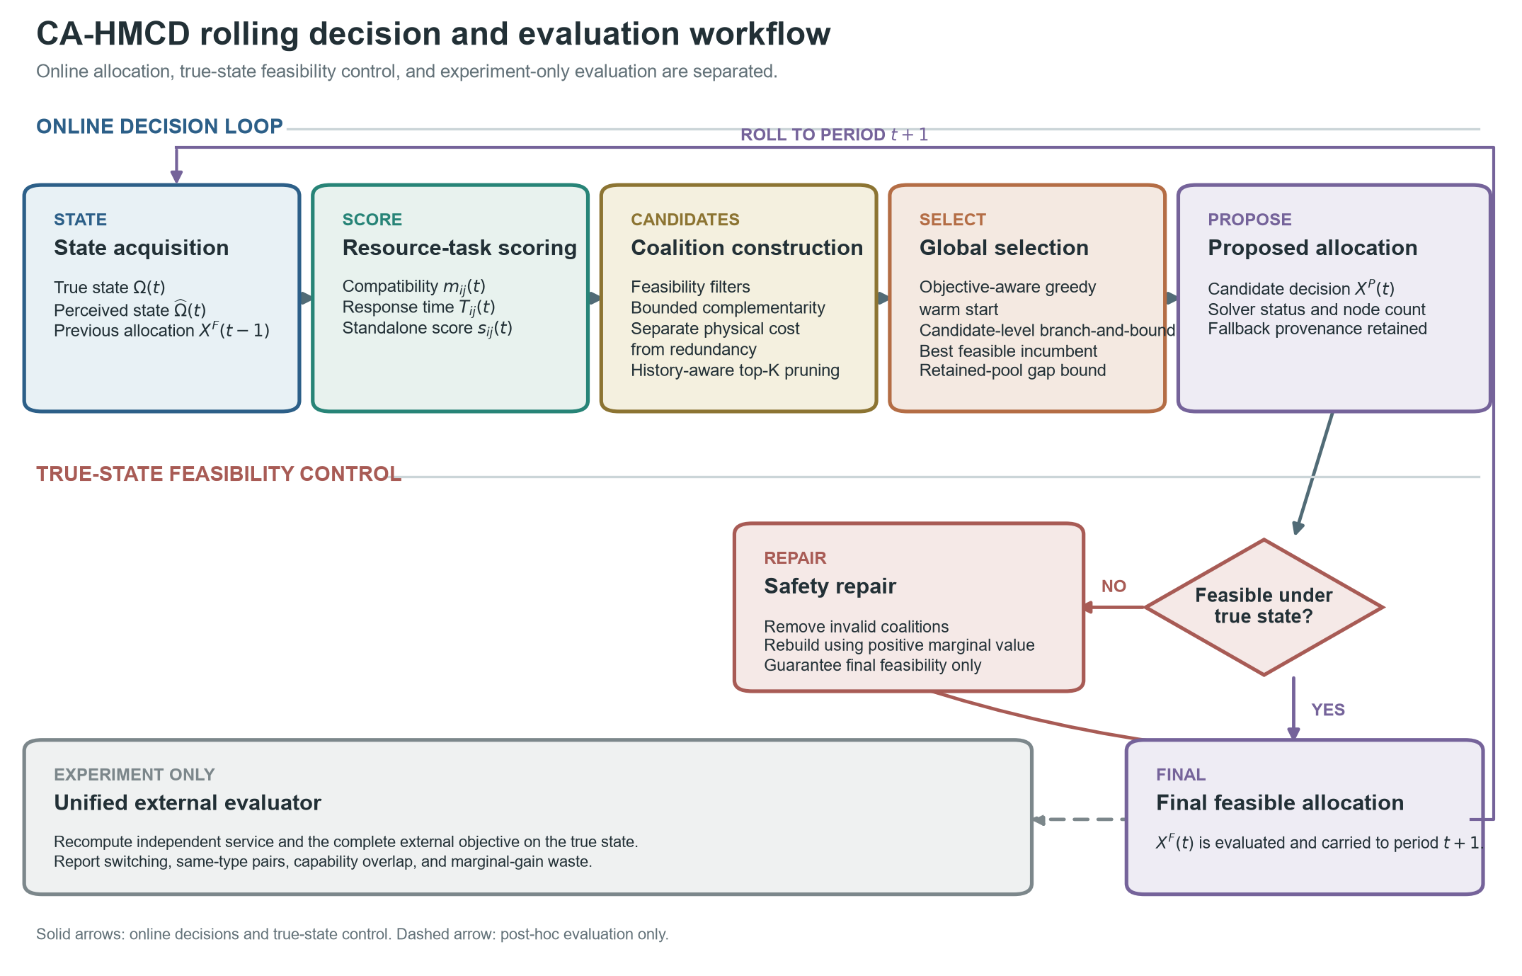
Fig. 1. CA-HMCD rolling decision and evaluation workflow. Pair scoring, coalition construction, history-aware candidate reduction, objective-aware warm start, and candidate-level branch-and-bound operate on the perceived state. The best feasible incumbent is retained when the node budget is reached. True-state repair produces the final allocation, which is then scored by a solver-decoupled service endpoint, the complete-model objective, and redundancy diagnostics. Dashed evaluation paths do not affect the online allocation.

4.2. Type-conditioned pair valuation
Resource availability alone does not imply suitability for a task. CA-HMCD therefore computes compatibility and response time before coalition construction. For matching, each resource is represented by operating range, response speed, persistence, and inverse consumption. The desired capability vector depends on the resource class and the current task features.
$u_{i}=(R_{i},v_{i}^{r},c_{i},1−e_{i})$ | (17)
$m_{ij}(t)=clip\left(\sum_{d=1}^{4}{w_{d}}[1−|u_{id}−d_{g_{i},d}(z_{j}(t))|],0,1\right)$ | (18)
$T_{ij}(t)=clip\left(\frac{0.25+0.55s_{j}(t)+0.30v_{j}^{t}(t)}{0.45+v_{i}^{r}} , 0 , 2\right)$ | (19)
The matching weights are w = (0.28, 0.28, 0.20, 0.24). The desired Type-I vector emphasizes target-specific precision and speed; Type-II emphasizes task scale and density; Type-III emphasizes discrete consumption; and Type-IV emphasizes mobility and tracking. All coefficients are normalized simulation parameters rather than measurements from a deployed system.

4.3. Complementarity and redundancy functions
For each resource pair, capability distance is the mean absolute difference across range, speed, persistence, and consumption. Heterogeneous pairs receive a non-negative task-conditioned complementarity score; same-class pairs receive no complementarity bonus. Capability overlap produces a soft redundancy penalty, with a larger coefficient for same-class pairs.
$d_{ik}^{cap}=\frac{1}{4}\sum_{d=1}^{4}{|}{\overset{\sim }{a}}_{id}−{\overset{\sim }{a}}_{kd}|,o_{ik}=1−d_{ik}^{cap}$ | (20)
$μ_{ikj}=σ[b(g_{i},g_{k})+0.025d_{ik}^{cap}+0.015n_{j}]forg_{i}≠g_{k}$ | (21)
$d_{ik}^{red}=0.045o_{ik} if g_{i}=g_{k},d_{ik}^{red}=0.012max(0,o_{ik}) otherwise$ | (22)
The type-pair bonus b is 0.045 for Type-I/Type-IV and Type-II/Type-III pairs and 0.025 for the remaining heterogeneous pairs. The nominal complementarity scale is sigma = 1.0. The objective coefficients are alpha_C = 0.12, beta_T = 0.08, lambda_R = 0.12, lambda_S = 0.10, and gamma_U = 0.20.

4.4. Candidate construction and history-aware reduction
For each active task, the method enumerates subsets within the permitted coalition-size range and rejects subsets that violate availability, response-time, or minimum class-count requirements. It then computes the bounded coalition score, physical expenditure, redundancy penalty, response time, and local utility. The resulting set is reduced by conservative history-aware dominance followed by fixed-K diversity retention (Fig. 2).
${\overset{\sim }{U}}_{j}(S,t)=U_{j}(S,t)−λ_{S}|S△S_{j}^{F}(t−1)|$ | (23a)
$A⪯_{j}B⟺A⊆B, {\overset{\sim }{U}}_{j}(A,t)≥{\overset{\sim }{U}}_{j}(B,t), S_{j}(A,t)≥S_{j}(B,t), C_{j}^{phys}(A,t)≤C_{j}^{phys}(B,t), T_{j}(A,t)≤T_{j}(B,t)$ | (23b)
Candidate A dominates B only if A is a subset of B, A is no worse in history-adjusted utility and coalition score, and A is no greater in physical expenditure and response time, with at least one strict comparison. The subset requirement prevents the replacement from creating an additional shared-capacity conflict. A feasible previous-period coalition is protected before diversity pruning. If more than K candidates remain, the procedure allocates representation across coalition sizes and resource identities, then fills unused positions by rank. This fixed-K step is an empirical search-control mechanism and is not claimed to be lossless in general.
Proposition 1 (history-aware dominance safety). If A satisfies Eq. (23b) for B, replacing B by A in any globally feasible completion preserves feasibility and does not decrease J_dec. Proof. Because A is a subset of B, every resource-capacity load weakly decreases. Its physical expenditure is no greater, so the period budget remains feasible; A is itself a feasible candidate, so task-level structural and response constraints remain satisfied. The task remains served and therefore has the same unserved-risk term, whereas Eq. (23b) makes its utility-minus-switching contribution no smaller. All other task contributions are unchanged. Hence a globally optimal completion containing B has a no-worse feasible completion containing A, and deleting B is lossless under the stated conditions.
$X^{all}⊇X^{pre}⊇X^{dom}⊇X^{K}$ | (23c)
$Δ_{tot}=\underset{Δ_{screen}}{\underset{⏟}{J^{*}(X^{all})−J^{*}(X^{pre})}}+\underset{0}{\underset{⏟}{J^{*}(X^{pre})−J^{*}(X^{dom})}}+\underset{Δ_{K}}{\underset{⏟}{J^{*}(X^{dom})−J^{*}(X^{K})}}+\underset{Δ_{search}}{\underset{⏟}{J^{*}(X^{K})−J_{dec}(X^{P})}}$ | (23d)
Equation (23d) separates the compatibility-screen loss, the zero loss certified for dominance, the fixed-K retention loss, and node-truncation search loss. The implementation records resource counts, enumerated subsets, feasible candidates, candidates removed by dominance, candidates removed by diversity retention, and preservation of the previous coalition at every decision period. No compatibility screen is applied in the primary scenarios.
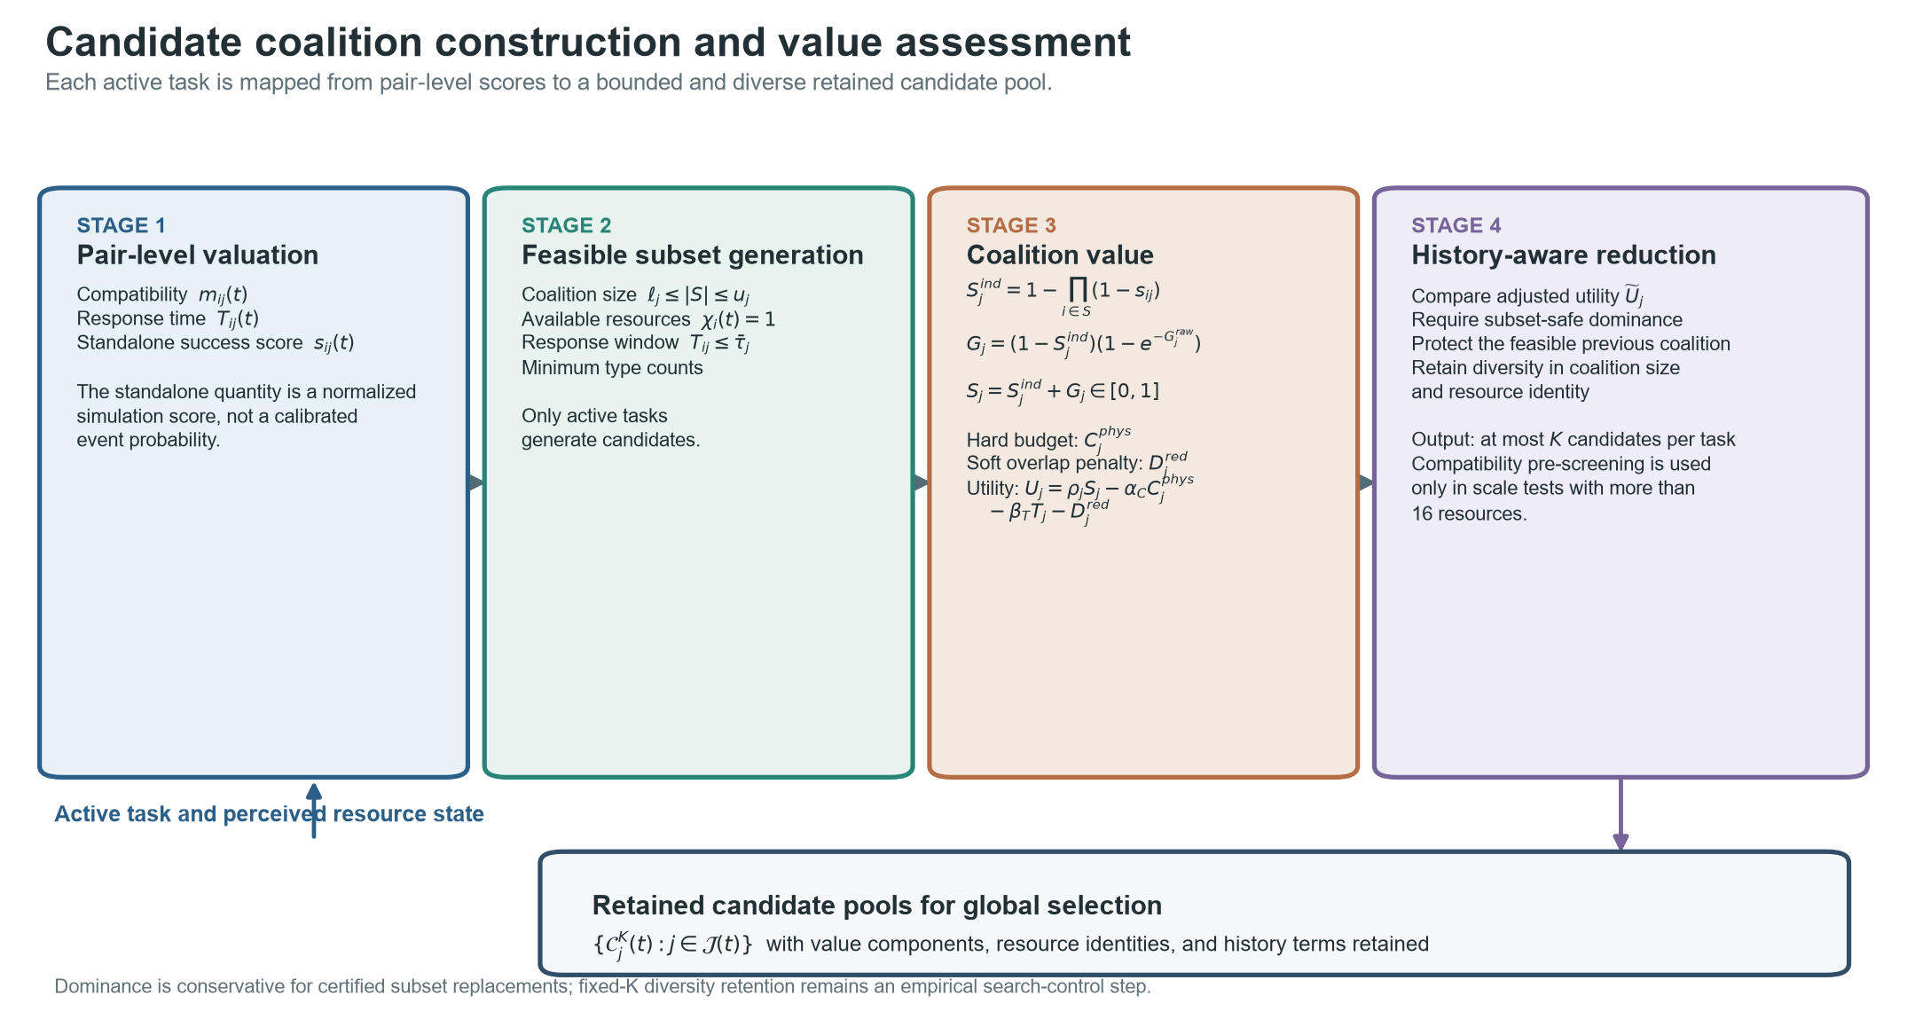
Fig. 2. Candidate coalition construction and value assessment. Resource-task compatibility, response time, and standalone success score are computed on the perceived state. Feasible subsets satisfy coalition-size, availability, response-window, and type-count constraints. Independent aggregation and headroom-bounded complementarity determine the coalition score; physical expenditure enters the hard budget, whereas capability overlap remains a soft penalty. History-aware subset dominance and diversity retention produce at most K candidates per task.

4.5. Global selection, warm start, and fallback
The retained candidate sets are searched at the coalition level. Active tasks are expanded in descending risk priority, and each task contributes its retained coalitions plus an explicit no-service option. A greedy solution first initializes a complete feasible incumbent using the exact objective gain relative to leaving the same task unserved.
$Δ_{j}^{svc}(S,t)=U_{j}(S,t)+γ_{U}ρ_{j}(t)−λ_{S}\{|S△S_{j}^{F}(t−1)|−|S_{j}^{F}(t−1)|\}$ | (24)
Candidate-level branch-and-bound then tracks resource usage, physical expenditure, accumulated utility, and the selected coalition map. Branches are pruned when they violate capacity or budget or when an optimistic retained-candidate bound cannot exceed the incumbent. Exact switching and unserved-task terms are applied to complete allocations. If the node limit is reached, the algorithm returns the better of the search incumbent and the greedy warm start. The solver status distinguishes incumbent fallback from greedy fallback.
$q_{j}=max\{0,\max_{S∈C_{j}^{K}}[U_{j}(S,t)+γ_{U}ρ_{j}(t)]\},UB(p)=U_{acc}(p)+Q_{acc}(p)−γ_{U}\sum_{j∈J(t)}{ρ_{j}}(t)+\sum_{r=p}^{L}{q_{j_{r}}}$ | (25a)
$Δ_{gap}^{ret}=max\{0,UB_{frontier}−J_{dec}(X^{P})\}$ | (25b)
Here Q_acc is the unserved-risk penalty avoided by tasks already assigned at the node. Proposition 2 (bound admissibility). Equation (25a) is an upper bound on every feasible completion below that node. For each unexpanded task it takes the better of no service and its largest retained local contribution plus avoided unserved-risk penalty. It ignores shared capacity, physical budget, and switching penalties; enforcing any of these restrictions can only weakly decrease the completion objective. Summing the per-task optimistic terms therefore bounds every descendant. Equation (25b) is consequently an absolute optimality-gap bound for the retained candidate pool only; it does not bound Delta_screen or Delta_K.

4.6. True-state repair and unified evaluation
The proposed allocation is recomputed under the true state. Invalid, over-capacity, or over-budget coalitions are removed in descending order of service marginal value. For active tasks that remain unserved, feasible true-state candidates are regenerated and positive-marginal-value candidates are inserted when capacity and budget permit. The repaired allocation becomes the history state for the next period. Every method then passes through the same complete-model evaluator. The solver-decoupled service endpoint uses risk-weighted independent success, coverage, response quality, physical-cost efficiency, and final feasibility, and excludes CA-HMCD's complementarity, redundancy, switching, and solver-state terms.
$E_{svc}=Fclip\left(0.55R_{succ}+0.20C_{cov}+0.15Q_{T}+0.10E_{C}C_{cov},0,1\right)$ | (25c)
F is the final feasibility indicator; R_succ is risk-weighted aggregation of standalone success scores; C_cov is active-task coverage; Q_T is mean response-window quality; and E_C is physical-cost efficiency. This endpoint is independent of solver status and excludes complementarity, redundancy, switching, and candidate utility, but it deliberately reuses task risk, standalone scores, response time, and physical cost from the common simulation state. It is therefore described as solver-decoupled and model-consistent, rather than fully model-independent.
$J_{base}=\sum_{j:ω_{j}^{F}=1}{\left[ρ_{j}S_{j}^{ind} − α_{C}C_{j}^{phys} − β_{T}T_{j}\right]}−γ_{U}\sum_{j}{δ_{j}}ρ_{j}(1−ω_{j}^{F})$ | (25d)
J_base is reported only as a diagnostic baseline. It retains compatibility-conditioned standalone scores, response time, physical expenditure, and the unserved-risk term, while excluding complementarity, redundancy, and switching. J_ext remains the complete-model true-state outcome.

4.7. Procedure, complexity, and implementation limits
Algorithm 1. CA-HMCD rolling allocation with objective-aware warm start, bounded search, true-state repair, and external evaluation.
Input: perceived states, true states, X^F(0), candidate limit K, node limit L_max
Output: final allocations, solver records, and external-evaluation records

FOR t = 1 TO T DO
Update active tasks, resource availability, failures, and task features
FOR each active task j DO
Compute m_ij(t), T_ij(t), and s_ij(t) from the perceived state
C_j <- EnumerateFeasibleCoalitions(j)
Evaluate S_j, C_j^phys, D_j^red, T_j, and U_j for every coalition
[C_j, n_dom] <- HistoryAwareDominance(C_j, X^F(t-1))
[C_j, n_K] <- DiversityPrune(C_j, K)
END FOR
X^G <- ObjectiveAwareGreedy({C_j}, X^F(t-1))
[X^P, incumbent, UB_frontier, status] <- BranchAndBound({C_j}, X^G, L_max)
IF the node limit is reached THEN
X^P <- better of the best feasible incumbent and X^G under J_dec
Record UB_frontier - J_dec(X^P) for the retained candidate pool
END IF
IF X^P is infeasible under the true state THEN
X^F <- TrueStateFeasibilityRepair(X^P, true state, X^F(t-1))
ELSE
X^F <- X^P
END IF
[J_ext, E_svc, diagnostics] <- EvaluateFinalAllocation(X^F, true state)
Record X^F, solver provenance, bounds, candidate counts, and diagnostics
END FOR
RETURN all final allocations and records

The implementation exposes two solver profiles for the same CA-HMCD value model. CA-HMCD-Exact sends the complete feasible candidate pool to HiGHS, whereas CA-HMCD-FixedK applies the conservative subset-dominance rule and fixed-K diversity retention before incumbent-preserving search. The formal No-Pruning control disables both candidate-reduction stages while preserving the same workload, node ceiling, evaluator, and repair operator. Thus, value-model evidence is separated from candidate-compression and solver-backend evidence.
$O\left(\sum_{s=ℓ_{j}}^{u_{j}}{(}{M \atop s})\right)for candidate generation,O((K+1)^{L})for retained selection$ | (26)
The combinatorial counts above are worst-case values before feasibility and upper-bound pruning. The subset-dominance proposition is lossless under its stated conditions, but the formal replay removed no candidates by dominance; observed compression came from the non-lossless fixed-K diversity stage. Visited nodes, end-to-end runtime, fallback activation, retained-incumbent selection, and upper-bound gaps are therefore reported as applicability evidence rather than implementation detail.

5. Experimental Protocol

5.1. Layered evidence design
The evaluation was organized as an evidence ladder rather than a single pooled benchmark. Public-data replay tested whether the task-side pipeline accepts measured three-dimensional motion and measured observation patterns. A formal no-pruning control isolated candidate reduction. Controlled mechanism experiments intervened on compatibility, complementarity, redundancy, stability, and true-state repair. Static scale-deadline and engineering-scenario experiments then compared exact, fixed-K, evolutionary, greedy, and auction backends. Each layer retained its own independent unit and Holm families.
Table 3. Registered evidence layers. Counts refer to complete paired comparisons in the unified statistical registry; evidence layers are interpreted separately and are not pooled.
Evidence layer | Independent unit | Design | Comparisons | Holm families | Primary question
Public-data replay and supplements | Public trajectory/composed workload | 44 units; 30 nested seeds | 516 | 141 | Task-side transportability and benchmark behavior
Static scale-deadline boundary | Complete seed instance | 16 scales x 4 deadlines; 30 seeds | 576 | 36 | Exact versus fixed-K real-time gate
Controlled mechanisms | Complete seeded trajectory | 2,070 trajectories | 280 | 84 | Module effects and repair
Engineering solver applicability | Complete seeded trajectory | 5 scenarios x 5 methods x 30 seeds | 220 | 55 | Scenario- and deadline-specific method choice

5.2. Public-data replay and no-pruning control
The frozen replay used 16 quality-controlled UZH-FPV trajectories as measured three-dimensional motion sources and 28 preregistered Anti-UAV410 composed workloads as measured image-plane observation and visibility sources [56,57]. Anti-UAV410 workloads comprised ten load-2, eight load-4, six load-6, and four load-8 compositions. Thirty stochastic resource and task realizations were nested within each public-data unit. These seeds quantify conditional stochastic variation and were not treated as 30 additional public trajectories.
The formal No-Pruning control reused baseline records only after protocol, model, evaluator, replay-hash, and per-period state fingerprints matched. It disabled dominance pruning and fixed-K retention but preserved the 4,000-node ceiling. The control therefore estimates candidate reduction under a common bounded-search budget; it does not imply that an unpruned run exhausts the global coalition space after hitting that ceiling.

5.3. Controlled mechanism and disturbance experiments
Mechanism experiments used 30 complete 12-period seed trajectories per registered cell and a shared K = 12 candidate pool. Compatibility and complete-model ablations were tested in five engineering-shaped scenarios. Complementarity scale was varied from 0 to 2 in the public-event scenario, and state volatility from 0 to 0.30 in the urban corridor. A same-type-dense stress scenario compared the complete model with No-Redundancy using same-type pair ratio, capability overlap, marginal-gain waste, service, and complete objective. Perception noise from 0 to 0.30 compared RepairOn with RepairOff using final feasibility, independent service, and the true-state complete objective.
The five engineering scenarios represent airport corridor, energy facility, public event, urban corridor, and industrial zone demand structures. Response resources remain simulated Type-I pointwise high-precision, Type-II area-effect, Type-III discrete-consumption, and Type-IV maneuvering-tracking resources. The experiments support controlled mechanism interpretation, not performance claims for specific physical countermeasure systems.

5.4. Solver, deadline, and robustness experiments
The static boundary experiment compared CA-HMCD-FixedK with CA-HMCD-Exact across 16 resource-task scales, four preregistered deadlines (50, 100, 200, and 500 ms), and 30 paired seeds. Gate B required an optimal exact reference, an exact deadline miss, at least 95% fixed-K deadline hits, full feasibility, and simultaneous service, coverage, and objective-loss limits. The engineering applicability experiment compared FixedK, Exact-HiGHS [58], Genetic-Algorithm [59], Greedy, and External-Auction in five scenarios using 30 paired trajectories and 12 periods.
A separate one-factor sensitivity study varied six coefficients at three registered levels for CA-HMCD, Greedy, and External-Auction. The 54 parameter-method configurations comprised 1,620 complete trajectories. This analysis tests relative ordering over the registered synthetic ranges; it neither estimates interactions among coefficients nor calibrates deployment values.

5.5. Outcomes and unified statistical analysis
The solver-decoupled service endpoint combines risk-weighted standalone success, coverage, response-window quality, physical-cost efficiency, and final feasibility. It excludes complementarity, redundancy, switching, candidate utility, and solver status, but deliberately reuses the common task and resource state; it is therefore model-consistent rather than fully model-independent. The complete objective, switch count, physical cost, three redundancy diagnostics, candidate counts, nodes, fallback, deadline hits, and repair activation were reported separately.
Every principal paired contrast reports the mean difference and 95% BCa bootstrap interval, unadjusted P value, Holm-adjusted P value, paired Cohen's dz, rank-biserial correlation, and favorable-direction win rate. Proportions use Wilson intervals in their source tables. Response time is computed only over task-periods served by both compared methods. Holm families were prespecified within endpoint, scenario, and experimental question; they were not replaced by one omnibus family. The unified registry contains 1,592 comparisons in 316 families.

5.6. Reproducibility and reporting boundaries
Formal runners rejected incomplete method sets, reduced seed counts, state mismatches, and fingerprint differences. The release retains protocols, environment specifications, episode and period records, paired statistics, bounded-outcome intervals, common-task response tables, Holm-family registries, figure source data, code hashes, and deterministic spot checks. Verification status is reported as ANALYZED rather than externally replicated. Runtime results remain workstation- and implementation-specific.

6. Results

6.1. Public replay identified load-dependent performance
Table 4. Public-data-informed replay contrasts on the complete true-state objective. Values are CA-HMCD minus comparator mean paired differences with 95% cluster-level BCa intervals and Holm-adjusted P values.
Stratum | vs Greedy [95% CI] | Holm P | vs External-Auction [95% CI] | Holm P
Anti-UAV410 load 2 | 0.0012 [-0.0002, 0.0038] | 0.7500 | 0.0028 [-0.0002, 0.0096] | 0.6094
Anti-UAV410 load 4 | 0.0129 [0.0059, 0.0211] | 0.0391 | 0.0198 [0.0120, 0.0291] | 0.0391
Anti-UAV410 load 6 | 0.0481 [0.0306, 0.0726] | 0.1562 | 0.0446 [0.0246, 0.0640] | 0.1562
Anti-UAV410 load 8 | 0.0720 [0.0265, 0.1175] | 0.6250 | 0.0762 [0.0324, 0.1200] | 0.6250
UZH-FPV single target | 0.0000 [0.0000, 0.0000] | 1.0000 | -0.0005 [-0.0009, -0.0002] | 0.0513

The public replay did not identify a universal advantage (Table 4; Fig. 3). At Anti-UAV410 load 4, CA-HMCD increased the complete objective by 0.0129 versus Greedy and 0.0198 versus External-Auction (both Holm-adjusted P = 0.0391). At load 2, the objective intervals crossed zero, and CA-HMCD service was lower than External-Auction by 0.0061 (95% CI -0.0113 to -0.0029; Holm-adjusted P = 0.0117). At loads 6 and 8, mean objective and service differences against the two lightweight baselines were positive, but four- to six-workload strata did not pass the five-comparison Holm families.
UZH-FPV produced identical CA-HMCD and Greedy outcomes and a lower service endpoint than External-Auction (-0.0096, 95% CI -0.0150 to -0.0056; Holm-adjusted P = 0.00073). The measured three-dimensional trajectories therefore establish input compatibility and a single-target boundary, not superiority.
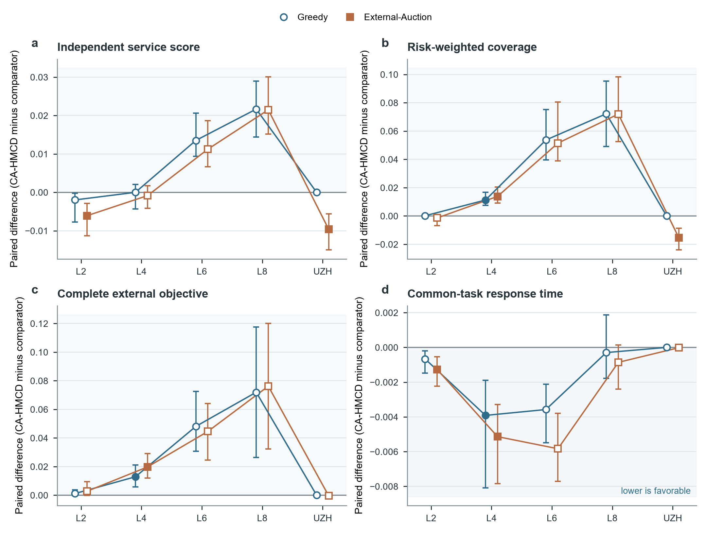
Fig. 3. Public-data-informed replay performance across UZH-FPV and Anti-UAV410 task loads. Independent units are public trajectories or preregistered composed workloads, with 30 stochastic seeds nested within each unit. Points show independent-unit means and uncertainty is computed over those units. The task-side public data do not constitute response-system field validation.

6.2. Candidate compression was computationally active but not lossless
The formal no-pruning control separated the two candidate-reduction stages. Feasible candidate count before and after conservative dominance was identical in every replay stratum, so the theoretically safe dominance rule made no empirical reduction. Fixed-K diversity retention reduced the episode-level candidate pool by approximately 92% and sharply limited node expansion. No-Pruning reached the 4,000-node ceiling in nearly all Anti-UAV410 runs and produced larger fallback and gap bounds.
Compression did not uniformly improve allocation quality. At load 4, CA-HMCD minus No-Pruning objective was 0.0088 [0.0041, 0.0144] (Holm-adjusted P = 0.0703). At load 8, the service difference was -0.0255 [-0.0281, -0.0224] (Holm-adjusted P = 0.5000), favoring the unpruned pool, while common-task response time favored CA-HMCD by -0.0128 [-0.0168, -0.0089]. UZH-FPV allocations were identical. Fixed-K retention is therefore a quality-complexity trade-off, not a lossless substitute for complete candidates.

6.3. Complementarity was conditional and stability imposed a measurable trade-off
In the registered public-event sweep, the complementarity service effect increased with scale and reached 0.0049 [0.0033, 0.0070] at scale 2 (Holm-adjusted P = 7.39e-05; Fig. 4a). The complete-objective effect was 0.0074 [-0.0026, 0.0196] (Holm-adjusted P = 0.7312; Fig. 4b). Thus, complementarity changed coalition service in the intended direction but did not establish a universal complete-objective improvement.
Stability reduced switching at every nonzero volatility level. At volatility 0.30, CA-HMCD minus No-Stability switch count was -3.4583 [-3.8472, -3.0528] (Holm-adjusted P = 9.00e-06), while the immediate service difference was -0.0205 [-0.0256, -0.0156] (Holm-adjusted P = 1.80e-05; Fig. 4c,d). The stability term therefore trades some instantaneous service for a less volatile allocation plan.
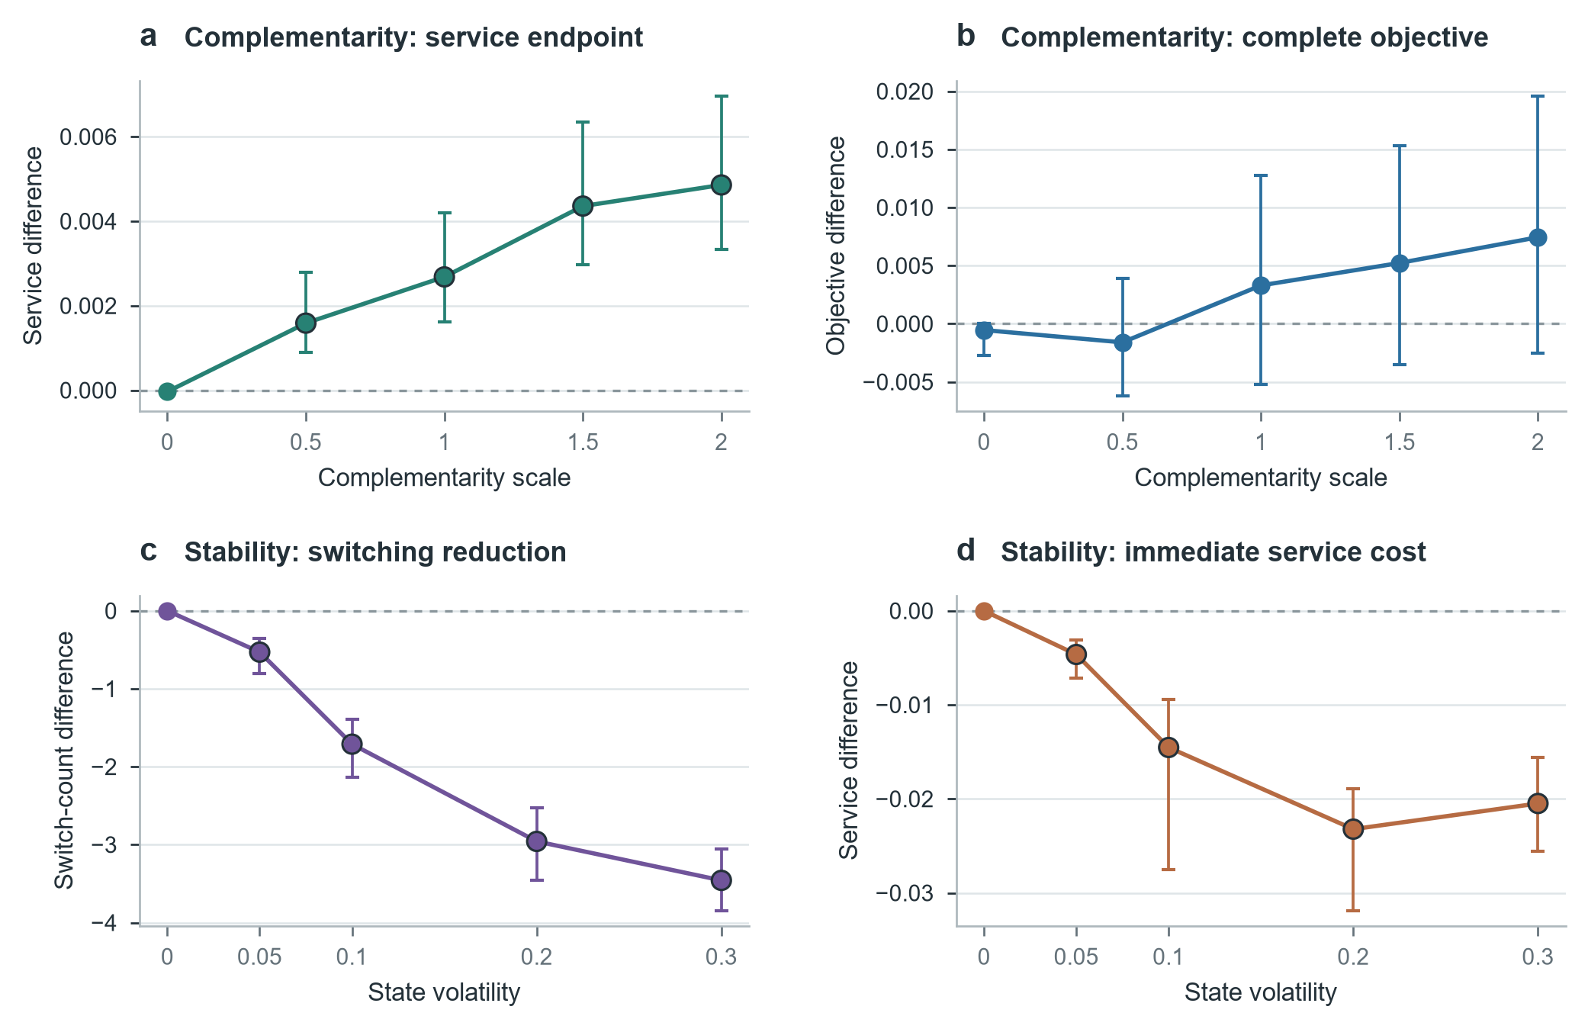
Fig. 4. Controlled validation separates complementarity gains from stability trade-offs. a,b, CA-HMCD minus No-Synergy across complementarity scale. c,d, CA-HMCD minus No-Stability across state volatility. Points are paired means and bars are 95% BCa intervals over 30 complete seed trajectories. Complementarity is supported at the service endpoint, whereas stability reduces switching with an immediate service cost.

6.4. The registered redundancy mechanism was not empirically supported
The same-type-dense stress experiment produced no supported effect for the three independent redundancy diagnostics (Fig. 5). The same-type pair ratio was unchanged; capability overlap changed by -2.27e-05, and marginal-gain waste by 5.07e-08. All three Holm-adjusted P values were 1. The independent service difference was effectively zero, and the complete-objective difference was -0.0011 (95% CI -0.0056 to 0; Holm-adjusted P = 1).
These zero results are not treated as equivalence. They show that the registered workload did not activate a measurable marginal effect of the redundancy penalty. The term remains a transparent modeling safeguard, but the manuscript does not credit it with demonstrated operational benefit.
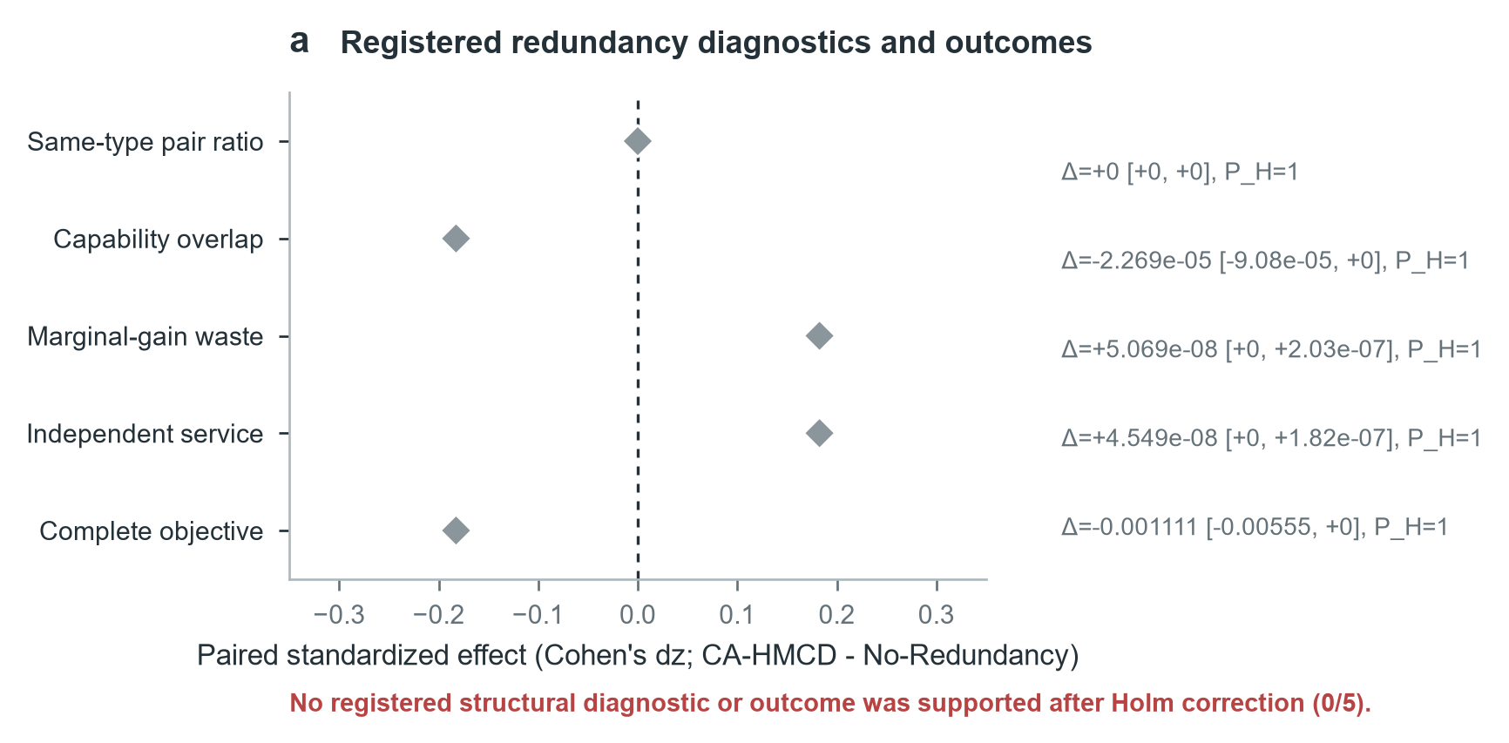
Fig. 5. Registered redundancy diagnostics and outcomes. Standardized paired effects compare CA-HMCD with No-Redundancy; text reports raw differences, 95% BCa intervals, and Holm-adjusted P values. None of the three structural diagnostics or two outcome contrasts was supported after Holm correction.

6.5. True-state repair restored feasibility at an immediate service cost
Controlled perception disturbance activated the repair operator at every nonzero noise level (Fig. 6). At noise 0.30, RepairOn minus RepairOff feasibility was 0.7944 [0.7444, 0.8444] (Holm-adjusted P = 6.56e-06). The independent service difference was -0.0240 [-0.0386, -0.0106] (Holm-adjusted P = 0.0058), while the feasible complete-objective difference was 0.4444 [0.4025, 0.4897] (Holm-adjusted P = 7.30e-06).
The result closes the implementation-only gap observed in the disturbance-free public replay. Repair recovers true-state feasibility rather than restoring the no-noise objective, and its immediate service cost must remain explicit. The evidence is an empirical property of the registered simulation and repair rule, not a universal safety guarantee.
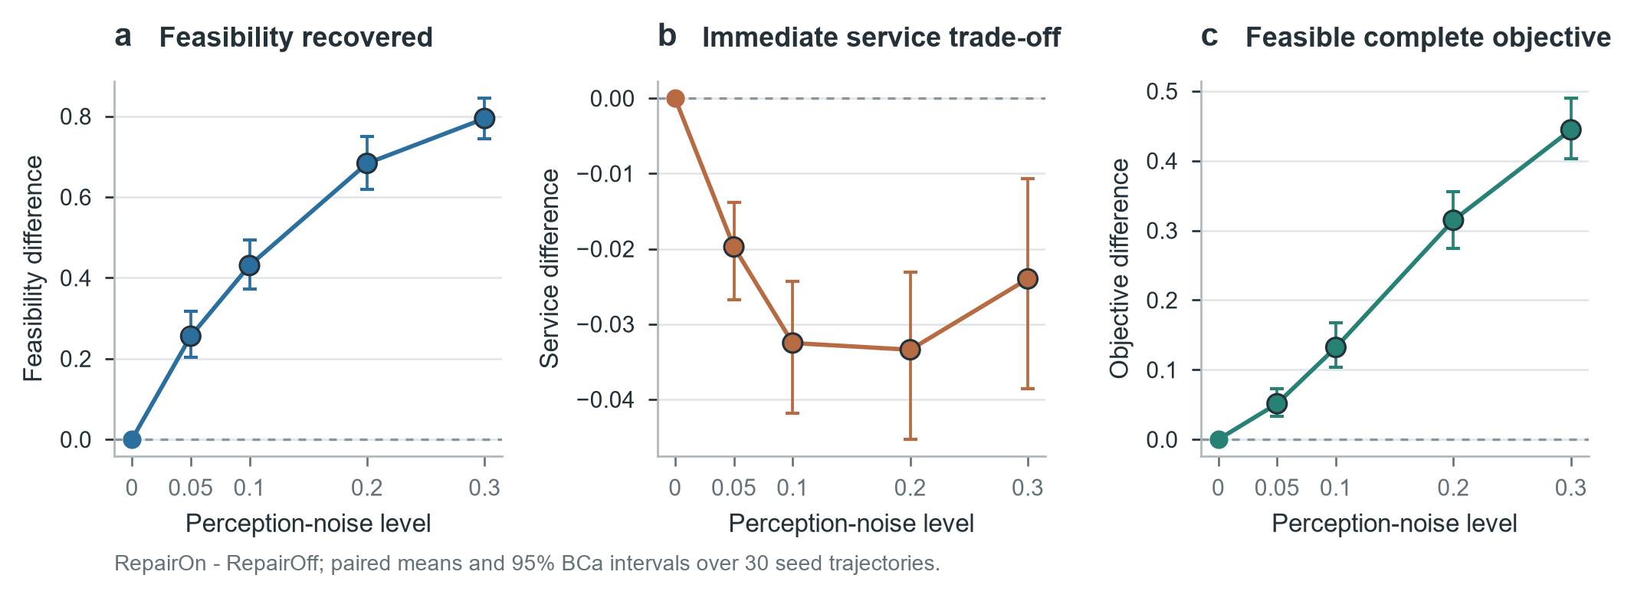
Fig. 6. True-state repair under perception disturbance. a, Feasibility recovered by RepairOn relative to RepairOff. b, Immediate service trade-off. c, Complete true-state objective after enforcing feasibility. Points and bars are paired means and 95% BCa intervals over 30 complete trajectories.

6.6. Solver and deadline choices were scenario-specific
Table 5. Descriptive method-selection matrix for five controlled engineering scenarios. Inferential comparisons remain in the unified registry; the 100-ms column selects the highest-objective method among those meeting the deadline in at least 95% of periods.
Scenario | Quality first | Service first | Fastest | 100-ms eligible
Airport Corridor | CA-HMCD-FixedK | CA-HMCD-FixedK | External-Auction | CA-HMCD-FixedK
Energy Facility | External-Auction | CA-HMCD-FixedK | External-Auction | External-Auction
Public Event | CA-HMCD-Exact | CA-HMCD-Exact | External-Auction | CA-HMCD-Exact
Urban Corridor | Genetic-Algorithm | CA-HMCD-Exact | External-Auction | CA-HMCD-FixedK
Industrial Zone | Genetic-Algorithm | CA-HMCD-FixedK | External-Auction | CA-HMCD-Exact

External-Auction was fastest in all five scenarios, while the genetic algorithm was slowest. Quality- and service-first choices differed by scenario (Table 5; Fig. 7). CA-HMCD-FixedK and CA-HMCD-Exact showed no Holm-significant complete-objective or service difference in any scenario. Their runtime ordering also changed: FixedK was faster in the airport and energy scenarios but slower in public-event, urban, and industrial scenarios.
The preregistered static real-time gate failed in all 64 scale-deadline cells. Exact HiGHS was optimal in all cells; the exact-miss condition occurred in 47, fixed-K achieved the required deadline hit rate in only two, and neither of those cells separated it from an exact method that also met the deadline. Candidate construction accounted for 74-100% of fixed-K decision time. The current implementation therefore provides no validated real-time advantage over complete-candidate HiGHS.
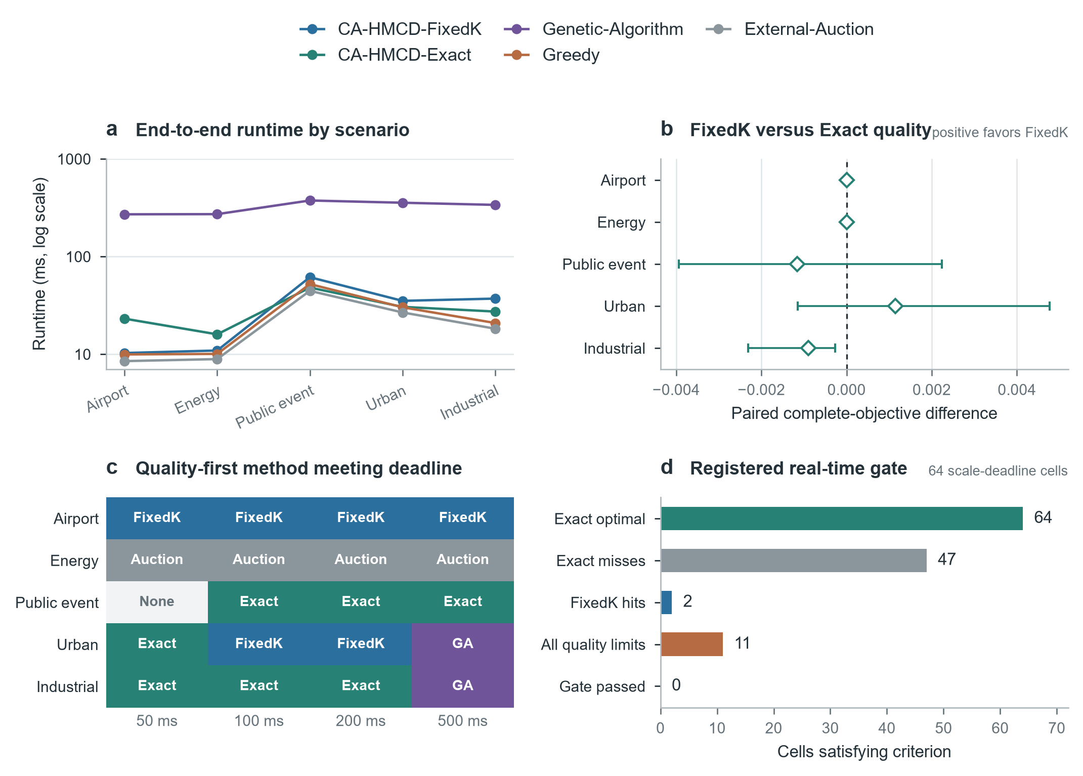
Fig. 7. Solver and deadline operating boundaries. a, End-to-end runtime by engineering scenario. b, FixedK-minus-Exact complete-objective contrasts. c, Quality-first method among those meeting each deadline in at least 95% of periods. d, Registered real-time gate criteria across 64 scale-deadline cells. No universal method or validated real-time boundary was observed.

6.7. One-factor sensitivity preserved relative ranking but not absolute performance
Table 6. Registered one-factor parameter sensitivity. Advantage is the range of paired CA-HMCD-minus-comparator service differences against Greedy and External-Auction.
Coefficient | Levels | CA-HMCD service range | Advantage range | Holm significant
Physical-cost weight | 0.06;0.12;0.24 | 0.0531 | 0.0083 to 0.0276 | 6/6
Response-time weight | 0.04;0.08;0.16 | 0.0234 | 0.0153 to 0.0203 | 6/6
Unserved-task penalty | 0.1;0.2;0.4 | 0.0392 | 0.0144 to 0.0229 | 6/6
Redundancy penalty | 0.06;0.12;0.24 | 0.0004 | 0.0162 to 0.0181 | 6/6
Switching penalty | 0.05;0.1;0.2 | 0.0806 | 0.0043 to 0.0352 | 6/6
Complementarity scale | 0.5;1;1.5 | 0.0015 | 0.0162 to 0.0191 | 6/6

All 36 registered CA-HMCD service contrasts against Greedy and External-Auction were positive and Holm-significant within the six one-factor families. Absolute service varied most with the switching penalty (range 0.0806) and physical-cost weight (0.0531), but changed little with redundancy penalty (0.0004) and complementarity scale (0.0015). This supports relative numerical robustness over the registered synthetic ranges, not parameter invariance, interaction robustness, or engineering calibration.

7. Discussion

7.1. The contribution is a decision framework, not solver superiority
The combined evidence changes the central interpretation of CA-HMCD. Its principal contribution is an auditable separation of resource-task valuation, coalition interaction, temporal stability, candidate compression, optimization backend, true-state safety control, and external evaluation. HiGHS is the better default when the complete candidate problem fits the observed deadline, and External-Auction is the lightest option in several scenarios. CA-HMCD-FixedK is useful only where its transparent structural controls and measured quality-computation trade-off match the operating requirement.

7.2. Mechanism evidence is asymmetric
Stability and repair have the clearest empirical roles. Stability consistently reduces switching but surrenders some immediate service, making its coefficient a policy choice rather than a free gain. Repair restores feasibility under controlled perception disturbance, again with a measurable service cost. Complementarity changes service in the intended direction in the registered public-event sweep but does not produce a universal complete-objective benefit. Redundancy remains unsupported and is retained only because it expresses a defensible soft preference that can be retested under correlated failures, sequential response, or empirically measured capability duplication.

7.3. Candidate construction, not optimization alone, defines the runtime boundary
The no-pruning and static boundary experiments show why a bounded candidate count is not synonymous with a real-time method. Conservative dominance was inactive, fixed-K retention caused the actual compression, and candidate construction dominated decision time. At some engineering scales, complete enumeration followed by HiGHS was faster than constructing and ranking the bounded pool. A credible future real-time version therefore requires an interruptible or incremental constructor, cheap pre-valuation bounds, indexed nondominance maintenance, and deadline-aware termination before full intermediate-pool formation.

7.4. Engineering relevance is present but remains semi-synthetic
The four resource classes preserve meaningful distinctions among pointwise high-precision, area-effect, discrete-consumption, and maneuvering-tracking response resources. Public trajectories add measured motion and observation interruption, while the five engineering scenarios expose different concurrency and deadline regimes. This is stronger evidence than an unconstrained synthetic benchmark, but the response-side capabilities, costs, engagement outcomes, and protected-zone geometry remain simulated. The results support controlled engineering analysis and solver selection, not field effectiveness.

7.5. Statistical boundaries and next experiments
Cluster-aware public-replay inference prevents nested stochastic seeds from inflating the public-data sample. The resulting small high-load strata explain why large mean effects and uniform workload directions can coexist with non-significant Holm tests. The appropriate next evidence is more independent multi-target public workloads, not additional nested seeds. Controlled experiments should also introduce correlated resource failures, measured response-side performance, communication delay, and joint coefficient perturbations.
The present study also leaves two practical decisions open. First, parameter values require expert elicitation, measured resource tests, or hardware-in-the-loop calibration. Second, the operating profile should be selected from an explicit policy: Exact when candidate enumeration is affordable, FixedK when its registered approximation is acceptable, and a lightweight auction or greedy policy when deadline risk dominates model fidelity. Reporting this boundary is more useful than assigning one method a context-free rank.

8. Conclusion
CA-HMCD provides an interpretable rolling framework for forming heterogeneous response coalitions under service, cost, stability, and true-state feasibility constraints. The unified evaluation supports a context-dependent complementarity effect, a clear stability-service trade-off, and effective feasibility repair under registered disturbance. It does not support an operational redundancy benefit, a lossless fixed-K approximation, a universal solver winner, or a validated real-time advantage.
The practical value of the method lies in making these choices visible: the same value model can use an exact or bounded backend, the safety operator is evaluated separately from allocation quality, and scenario-specific deadline evidence determines the recommended operating profile. The current evidence is a controlled simulation study of interpretable coalition allocation for low-altitude safety. Field claims require response-side measurements, more independent multi-target trajectories, calibrated parameters, and hardware-in-the-loop or operational validation.

Data availability
UZH-FPV and Anti-UAV410 were reused under their original access conditions and are not redistributed. The project package retains source identifiers and hashes, quality-control and split registries, derived replay tables, formal episode and period outputs, figure source data, and the 1,592-row unified statistical registry with 316 Holm families. The public repository identifier will be inserted after author deposit: [AUTHOR_INPUT_NEEDED: repository DOI].

Code availability
The release candidate contains the simulation, public-data adapters, formal runners, exact, fixed-K, evolutionary, greedy and auction baselines, statistical analyses, manuscript builder, tests, environment specification, checksummed manifest, and reproduction instructions. The authors must select the final software licence and creator metadata before release: [AUTHOR_INPUT_NEEDED: software licence and creator list].

References
[1] Kim J, Atkins E. Airspace Geofencing and Flight Planning for Low-Altitude, Urban, Small Unmanned Aircraft Systems. Applied Sciences. 2022;12(2):576. https://doi.org/10.3390/app12020576
[2] Mumm H, Lonstein W, Ryan J, Carter C. Counter Unmanned Aircraft Systems Technologies and Operations. 2020. https://doi.org/10.4148/npp.27820
[3] Maalouf G, Jepsen JH, Jensen K. Airspace Situational Awareness: Proposed Airspace Safety Concepts and State-of-the-Art Review of UAS Aircraft Detection Technologies. In: 2024 International Conference on Unmanned Aircraft Systems (ICUAS). 2024. https://doi.org/10.1109/ICUAS60882.2024.10557082
[4] Aziz H, Pal A, Pourmiri A, Ramezani F, Sims B. Task Allocation Using a Team of Robots. Current Robotics Reports. 2022;3(4):227-238. https://doi.org/10.1007/s43154-022-00087-4
[5] Gerkey BP, Mataric MJ. A Formal Analysis and Taxonomy of Task Allocation in Multi-Robot Systems. The International Journal of Robotics Research. 2004;23(9):939-954. https://doi.org/10.1177/0278364904045564
[6] Shehory O, Kraus S. Methods for Task Allocation via Agent Coalition Formation. Artificial Intelligence. 1998;101(1-2):165-200. https://doi.org/10.1016/S0004-3702(98)00045-9
[7] Sandholm T, Larson K, Andersson M, Shehory O, Tohme F. Coalition Structure Generation with Worst Case Guarantees. Artificial Intelligence. 1999;111(1-2):209-238. https://doi.org/10.1016/S0004-3702(99)00036-3
[8] Zhang L, Liang D, Li M, Yang W, Yang S. Coalition Formation Game Approach for Task Allocation in Heterogeneous Multi-Robot Systems under Resource Constraints. In: 2024 IEEE/RSJ International Conference on Intelligent Robots and Systems (IROS). 2024. https://doi.org/10.1109/IROS58592.2024.10801429
[9] Calvo A, Capitan J. Optimal Task Allocation for Heterogeneous Multi-robot Teams with Battery Constraints. In: 2024 IEEE International Conference on Robotics and Automation (ICRA). 2024. https://doi.org/10.1109/ICRA57147.2024.10611147
[10] Choudhury S, Gupta JK, Kochenderfer MJ, Sadigh D, Bohg J. Dynamic Multi-Robot Task Allocation under Uncertainty and Temporal Constraints. Autonomous Robots. 2021. https://doi.org/10.1007/s10514-021-10022-9
[11] Otte MW, Kuhlman MJ, Sofge D. Multi-Robot Task Allocation with Auctions in Harsh Communication Environments. In: 2017 International Symposium on Multi-Robot and Multi-Agent Systems (MRS). 2017. https://doi.org/10.1109/MRS.2017.8250928
[12] Schillinger P, Garcia S, Makris A, et al. Adaptive Heterogeneous Multi-Robot Collaboration from Formal Task Specifications. Robotics and Autonomous Systems. 2021;145:103866. https://doi.org/10.1016/j.robot.2021.103866
[13] Mahato P, Saha S, Sarkar C, Shaghil M. Consensus-Based Fast and Energy-Efficient Multi-Robot Task Allocation. Robotics and Autonomous Systems. 2023;159:104270. https://doi.org/10.1016/j.robot.2022.104270
[14] Dai W, Rai U, Chiun J, Cao Y, Sartoretti G. Heterogeneous Multi-Robot Task Allocation and Scheduling via Reinforcement Learning. IEEE Robotics and Automation Letters. 2025;10(3):2654-2661. https://doi.org/10.1109/LRA.2025.3534682
[15] Chakraa H, Guerin F, Leclercq E, Lefebvre D. Optimization Techniques for Multi-Robot Task Allocation Problems: Review on the State-of-the-Art. Robotics and Autonomous Systems. 2023;168:104492. https://doi.org/10.1016/j.robot.2023.104492
[16] Korsah GA, Stentz A, Dias MB. A Comprehensive Taxonomy for Multi-Robot Task Allocation. The International Journal of Robotics Research. 2013;32(12):1495-1512. https://doi.org/10.1177/0278364913496484
[17] Verma A, Gautam A, Dutta A, Shekhawat VS, Mohan S. CF-HMRTA: Coalition Formation for Heterogeneous Multi-Robot Task Allocation. Journal of Intelligent & Robotic Systems. 2025;111(3). https://doi.org/10.1007/s10846-025-02287-4
[18] Bezerra LCD, dos Santos AMG, Park S. Learning Policies for Dynamic Coalition Formation in Multi-Robot Task Allocation. IEEE Robotics and Automation Letters. 2025;10(9):9216-9223. https://doi.org/10.1109/LRA.2025.3592080
[19] Chen Z, Kan Z. Real-Time Reactive Task Allocation and Planning of Large Heterogeneous Multi-Robot Systems with Temporal Logic Specifications. The International Journal of Robotics Research. 2024;44(4):640-664. https://doi.org/10.1177/02783649241278372
[20] Arbanas Ferreira B, Petrovic T, Orsag M, Martinez-de Dios JR, Bogdan S. Distributed Allocation and Scheduling of Tasks With Cross-Schedule Dependencies for Heterogeneous Multi-Robot Teams. IEEE Access. 2024;12:74327-74342. https://doi.org/10.1109/ACCESS.2024.3404823
[21] Heppner G, Oberacker D, Roennau A, Dillmann R. Behavior Tree Capabilities for Dynamic Multi-Robot Task Allocation with Heterogeneous Robot Teams. In: 2024 IEEE International Conference on Robotics and Automation (ICRA). 2024:4826-4833. https://doi.org/10.1109/ICRA57147.2024.10610515
[22] Martin JG, Muros FJ, Maestre JM, Camacho EF. Multi-Robot Task Allocation Clustering Based on Game Theory. Robotics and Autonomous Systems. 2023;161:104314. https://doi.org/10.1016/j.robot.2022.104314
[23] Gosrich W, Mayya S, Narayan S, Malencia M, Agarwal S, Kumar V. Multi-Robot Coordination and Cooperation with Task Precedence Relationships. In: 2023 IEEE International Conference on Robotics and Automation (ICRA). 2023:5800-5806. https://doi.org/10.1109/ICRA48891.2023.10160998
[24] Lei T, Chintam P, Luo C, Liu L, Jan GE. A Convex Optimization Approach to Multi-Robot Task Allocation and Path Planning. Sensors. 2023;23(11):5103. https://doi.org/10.3390/s23115103
[25] Neville G, Chernova S, Ravichandar H. D-ITAGS: A Dynamic Interleaved Approach to Resilient Task Allocation, Scheduling, and Motion Planning. IEEE Robotics and Automation Letters. 2023;8(2):1037-1044. https://doi.org/10.1109/LRA.2023.3234824
[26] Tihanyi D, Lu Y, Karaca O, Kamgarpour M. Multi-Robot Task Allocation for Safe Planning Against Stochastic Hazard Dynamics. In: 2023 European Control Conference (ECC). 2023:1-6. https://doi.org/10.23919/ECC57647.2023.10178126
[27] Galati G, Primatesta S, Rizzo A. Auction-Based Task Allocation and Motion Planning for Multi-Robot Systems with Human Supervision. Journal of Intelligent & Robotic Systems. 2023;109(2). https://doi.org/10.1007/s10846-023-01935-x
[28] Skaltsis GM, Shin HS, Tsourdos A. A Review of Task Allocation Methods for UAVs. Journal of Intelligent & Robotic Systems. 2023;109(4). https://doi.org/10.1007/s10846-023-02011-0
[29] Liu H, Shao Z, Zhou Q, Tu J, Zhu S. Task Allocation Algorithm for Heterogeneous UAV Swarm with Temporal Task Chains. Drones. 2025;9(8):574. https://doi.org/10.3390/drones9080574
[30] Wang S, Qiao P, Yue Q, Xu Z, Shang Q. Research on Dynamic Particle Swarm Optimization for Multi-Objective Reconnaissance Task Allocation of UAVs. Drones. 2025;9(8):556. https://doi.org/10.3390/drones9080556
[31] Alqefari S, Menai MEB. Multi-UAV Task Assignment in Dynamic Environments: Current Trends and Future Directions. Drones. 2025;9(1):75. https://doi.org/10.3390/drones9010075
[32] Ghauri SA, Sarfraz M, Qamar RA, Sohail MF, Khan SA. A Review of Multi-UAV Task Allocation Algorithms for a Search and Rescue Scenario. Journal of Sensor and Actuator Networks. 2024;13(5):47. https://doi.org/10.3390/jsan13050047
[33] Tang X, Li X, Yu R, Wu Y, Ye J, Tang F, Chen Q. Digital-Twin-Assisted Task Assignment in Multi-UAV Systems: A Deep Reinforcement Learning Approach. IEEE Internet of Things Journal. 2023;10(17):15362-15375. https://doi.org/10.1109/JIOT.2023.3263574
[34] Debnath D, Vanegas F, Sandino J, Hawary AF, Gonzalez F. A Review of UAV Path-Planning Algorithms and Obstacle Avoidance Methods for Remote Sensing Applications. Remote Sensing. 2024;16(21):4019. https://doi.org/10.3390/rs16214019
[35] Yang Y, Xiong X, Yan Y. UAV Formation Trajectory Planning Algorithms: A Review. Drones. 2023;7(1):62. https://doi.org/10.3390/drones7010062
[36] Zhao X, Yang R, Zhong L, Hou Z. Multi-UAV Path Planning and Following Based on Multi-Agent Reinforcement Learning. Drones. 2024;8(1):18. https://doi.org/10.3390/drones8010018
[37] Frattolillo F, Brunori D, Iocchi L. Scalable and Cooperative Deep Reinforcement Learning Approaches for Multi-UAV Systems: A Systematic Review. Drones. 2023;7(4):236. https://doi.org/10.3390/drones7040236
[38] Debie E, Kasmarik K, Garratt M. Swarm Robotics: A Survey from a Multi-Tasking Perspective. ACM Computing Surveys. 2023;56(2):1-38. https://doi.org/10.1145/3611652
[39] Ekechi CC, Elfouly T, Alouani A, Khattab T. A Survey on UAV Control with Multi-Agent Reinforcement Learning. Drones. 2025;9(7):484. https://doi.org/10.3390/drones9070484
[40] Zakaryia SA, Meaad M, Nabil T, Hussein MK. Task Offloading and Resource Allocation for Multi-UAV Asset Edge Computing with Multi-Agent Deep Reinforcement Learning. Computing. 2025;107(5). https://doi.org/10.1007/s00607-025-01472-5
[41] Hady MA, Hu S, Pratama M, Cao Z, Kowalczyk R. Multi-Agent Reinforcement Learning for Resources Allocation Optimization: A Survey. Artificial Intelligence Review. 2025;58(11). https://doi.org/10.1007/s10462-025-11340-5
[42] Chen Y, Sun Y, Yu H, Taleb T. Joint Task and Computing Resource Allocation in Distributed Edge Computing Systems via Multi-Agent Deep Reinforcement Learning. IEEE Transactions on Network Science and Engineering. 2024;11(4):3479-3494. https://doi.org/10.1109/TNSE.2024.3375374
[43] Xu Y, Zheng L, Wu X, Tang Y, Liu W, Sun D. Joint Resource Allocation for UAV-Assisted V2X Communication With Mean Field Multi-Agent Reinforcement Learning. IEEE Transactions on Vehicular Technology. 2025;74(1):1209-1223. https://doi.org/10.1109/TVT.2024.3466116
[44] Alam MM, Moh S. Joint Optimization of Trajectory Control, Task Offloading, and Resource Allocation in Air-Ground Integrated Networks. IEEE Internet of Things Journal. 2024;11(13):24273-24288. https://doi.org/10.1109/JIOT.2024.3390168
[45] Wang C, Wang Y, Yuan Y, Peng S, Li G, Yin P. Joint Computation Offloading and Resource Allocation for End-Edge Collaboration in Internet of Vehicles via Multi-Agent Reinforcement Learning. Neural Networks. 2024;179:106621. https://doi.org/10.1016/j.neunet.2024.106621
[46] Li Y, Zhang X, Zeng T, Duan J, Wu C, Wu D, Chen X. Task Placement and Resource Allocation for Edge Machine Learning: A GNN-Based Multi-Agent Reinforcement Learning Paradigm. IEEE Transactions on Parallel and Distributed Systems. 2023;34(12):3073-3089. https://doi.org/10.1109/TPDS.2023.3313779
[47] Yuan Z, Wang R, Kim T, Zhao D, Obi I, Min BC. Adaptive Task Allocation in Multi-Human Multi-Robot Teams Under Team Heterogeneity and Dynamic Information Uncertainty. In: 2025 IEEE International Conference on Robotics and Automation (ICRA). 2025:1-7. https://doi.org/10.1109/ICRA55743.2025.11127646
[48] Zhu C, Zhu J, Si W, Wang X, Wang F. Multi-Agent Reinforcement Learning with Synchronized and Decomposed Reward Automaton Synthesized from Reactive Temporal Logic. Knowledge-Based Systems. 2024;306:112703. https://doi.org/10.1016/j.knosys.2024.112703
[49] Liu Z, Guo M, Bao W, Li Z. Fast and Adaptive Multi-Agent Planning Under Collaborative Temporal Logic Tasks via Poset Products. Research. 2024;7:0337. https://doi.org/10.34133/research.0337
[50] Shakeri Z, Benfriha K, Varmazyar M, Talhi E, Quenehen A. Production Scheduling with Multi-Robot Task Allocation in a Real Industry 4.0 Setting. Scientific Reports. 2025;15(1). https://doi.org/10.1038/s41598-024-84240-3
[51] Zhao D, Yang C, Zhang T, Yang J, Hiroshi Y. A Task Allocation Approach of Multi-Heterogeneous Robot System for Elderly Care. Machines. 2022;10(8):622. https://doi.org/10.3390/machines10080622
[52] Ali A, Azevedo-Sa H, Tilbury DM, Robert LP. Heterogeneous Human-Robot Task Allocation Based on Artificial Trust. Scientific Reports. 2022;12(1). https://doi.org/10.1038/s41598-022-19140-5
[53] Msala Y, Hamed O, Talea M, Aboulfatah M. A New Method for Improving the Fairness of Multi-Robot Task Allocation by Balancing the Distribution of Tasks. Journal of Robotics and Control. 2023;4(6):743-753. https://doi.org/10.18196/jrc.v4i6.18650
[54] Rema C, Costa P, Silva MF, Pires EJS. Task Scheduling with Mobile Robots: A Systematic Literature Review. Robotics. 2025;14(6):75. https://doi.org/10.3390/robotics14060075
[55] Arjun K, Parlevliet D, Wang H, et al. Optimizing Coalition Formation Strategies for Scalable Multi-Robot Task Allocation: A Comprehensive Survey of Methods and Mechanisms. Robotics. 2025;14(7):93. https://doi.org/10.3390/robotics14070093
[56] Delmerico J, Cieslewski T, Rebecq H, Faessler M, Scaramuzza D. Are We Ready for Autonomous Drone Racing? The UZH-FPV Drone Racing Dataset. 2019 International Conference on Robotics and Automation (ICRA). 2019:6713-6719. https://doi.org/10.1109/ICRA.2019.8793887
[57] Huang B, Li J, Chen J, Wang G, Zhao J, Xu T. Anti-UAV410: A Thermal Infrared Benchmark and Customized Scheme for Tracking Drones in the Wild. IEEE Transactions on Pattern Analysis and Machine Intelligence. 2024;46(5):3009-3023. https://doi.org/10.1109/TPAMI.2023.3335338
[58] Huangfu Q, Hall JAJ. Parallelizing the dual revised simplex method. Mathematical Programming Computation. 2018;10:119-142. https://doi.org/10.1007/s12532-017-0130-5
[59] Holland JH. Adaptation in Natural and Artificial Systems: An Introductory Analysis with Applications to Biology, Control, and Artificial Intelligence. Ann Arbor: University of Michigan Press; 1975.

