Complementarity-Aware Rolling Coalition Allocation for Low-Altitude Safety: A Public-Data-Informed Replay Study
Abstract
Dynamic low-altitude safety response requires heterogeneous resources to be assigned to concurrent tasks under time, capacity, expenditure, and reconfiguration constraints. We present Complementarity-Aware Heterogeneous Multi-Agent Cooperative Decision-Making (CA-HMCD), an interpretable rolling coalition-allocation method combining type-conditioned compatibility, bounded complementarity, capability-overlap penalties, history-aware candidate reduction, incumbent-preserving search, and true-state feasibility control. A frozen public-data-informed replay used 16 UZH-FPV trajectories and 28 Anti-UAV410 composed workloads, with 30 stochastic seeds nested within each of 44 independent units. The eight-method comparison included full-candidate HiGHS mixed-integer programming and a genetic algorithm. CA-HMCD matched their allocation quality at load 2 and in single-target replay but lost objective, service, and coverage at loads 6 and 8; HiGHS-MILP was also faster end to end. A separate controlled sensitivity study evaluated 54 parameter-method configurations over 1,620 seeded trajectories. All 36 registered service contrasts against Greedy and External-Auction were positive and Holm-significant within six prespecified families, although absolute service varied most with the switching and physical-cost weights. All final replay allocations were feasible. These results support CA-HMCD as an auditable controlled-simulation formulation with stable relative behavior over the registered parameter ranges, while identifying fixed-K candidate retention, bounded search, and response-side calibration as limits on operational claims.
Keywords: heterogeneous resource allocation; coalition formation; low-altitude safety; public-data-informed replay; mixed-integer optimization; parameter robustness

1. Introduction
Low-altitude safety systems increasingly need to coordinate responses to multiple events whose location, scale, speed, density, priority, and admissible response window change over time. Airports, energy facilities, industrial zones, urban corridors, and large public venues may all require a controller to combine sensing-derived task states with limited and heterogeneous response resources [1-3]. The allocation problem is therefore not a static choice of one resource for one task. It is a rolling decision problem in which several active tasks compete for resources with different operating ranges, response speeds, persistence, consumption profiles, service capacities, and availability states.
This setting makes coalition structure part of the decision. A heterogeneous coalition can be valuable when its members provide complementary capabilities, yet adding resources with highly overlapping capabilities can increase physical expenditure without a commensurate service gain. The allocation inherited from the previous period also matters: aggressive re-optimization can improve an instantaneous score while generating repeated switching and unstable operating plans. Failures and task arrivals further create a distinction between an allocation proposed from perceived information and one that remains feasible under the evaluated true state.
Multi-robot and multi-agent task-allocation research provides mature taxonomies and optimization models for heterogeneous capabilities, task coupling, temporal requirements, and resource constraints [4,5,10,15,16]. Coalition-formation methods make multi-resource execution explicit [6-9,17,18,22], while auction, consensus, formal-specification, and learning-based methods address communication, adaptation, and online computation [11-14,19-27]. These foundations resolve important parts of the problem, but they do not by themselves provide a unified rolling model that separates task-specific complementarity from capability duplication, controls inter-period reconfiguration, and evaluates every method after the same true-state feasibility operation.
The question addressed here is therefore: how can heterogeneous response resources be assembled into feasible task-specific coalitions that preserve an interpretable service-cost trade-off while remaining stable across decision periods and auditable under finite search? A suitable method must distinguish pair-level compatibility from coalition-level value, keep physical expenditure separate from a soft redundancy preference, limit a combinatorial candidate space without deleting safer history-consistent alternatives, and expose rather than hide the consequences of a bounded node budget.
We address this question with Complementarity-Aware Heterogeneous Multi-Agent Cooperative Decision-Making (CA-HMCD). The method represents response resources by four capability classes: Type-I pointwise high-precision, Type-II area-effect, Type-III discrete-consumption, and Type-IV maneuvering-tracking resources. It constructs feasible resource coalitions for each active task, combines independent resource scores with a headroom-bounded complementarity gain, applies a separate capability-overlap penalty, and solves the retained coalition-selection problem using an objective-aware greedy warm start and candidate-level branch-and-bound. History-aware dominance and diversity retention control the candidate pool. If the node budget is exhausted, the best feasible incumbent is returned and the remaining bound is recorded before true-state feasibility control and external evaluation.
The study makes three evidence-bounded contributions. First, it provides a closed mathematical model in which coalition success is bounded, physical expenditure alone enters the hard budget, and redundancy remains a soft structural preference. Second, it introduces an auditable solution workflow with history-aware pruning, incumbent-preserving fallback, and strict separation between perceived-state decisions, true-state control, and experiment-only evaluation. Third, it evaluates the method under a frozen replay protocol that combines measured three-dimensional UZH-FPV motion and measured Anti-UAV410 image-plane observation patterns with simulated response resources. Statistical inference uses the public trajectory or predefined composed workload as the independent unit; the 30 seeds per unit quantify stochastic variation rather than inflate the public-data sample size. The resulting claim is deliberately limited to controlled public-data-informed simulation rather than field deployment.

2. Related Work

2.1. Heterogeneous task allocation
Multi-robot task allocation formalizes the assignment of tasks to agents with different capabilities, capacities, and temporal roles. Foundational taxonomies distinguish single- from multi-agent tasks, instantaneous from time-extended assignments, and loosely from tightly coupled execution [5,16]. Recent reviews and algorithms extend this view to energy-aware allocation, formal task specifications, task precedence, safe planning, production scheduling, and human-robot teams [4,12,13,15,20,21,23-26,47,50-54]. These approaches establish the importance of capability and constraint representation. For the present problem, however, an assignment utility alone is insufficient because the incremental value of a resource depends on both the active task and the other resources already assigned to it.

2.2. Coalition formation and combinatorial allocation
Coalition formation provides the closest formal basis for tasks that require or benefit from several agents. Early work developed approximation methods for task allocation through agent coalitions and characterized the computational trade-off in coalition-structure generation [6,7]. Later studies incorporated heterogeneous resource constraints, battery limits, game-theoretic clustering, dynamic coalition policies, and scalable coalition mechanisms [8,9,17,18,22,55]. These methods make multi-resource execution explicit, but their value models commonly emphasize feasibility, completion, energy, or total utility. CA-HMCD differs by separating independent coalition aggregation, task-specific heterogeneous complementarity, capability overlap, physical expenditure, response time, and history-dependent switching within one rolling decision model.

2.3. Dynamic, distributed, and learning-based allocation
Dynamic allocation research addresses uncertain task completion, temporal constraints, communication loss, schedule dependencies, and changing resource availability. Sequential decision and conflict-resolution decompositions, reactive temporal-logic planning, interleaved allocation and motion planning, and stochastic-hazard formulations all improve the representation of time and uncertainty [10,19,20,23,25,26,48,49]. Auction and consensus mechanisms offer lower-cost distributed coordination under communication limits [11,13,27], whereas reinforcement-learning approaches learn allocation or coalition policies that can reduce online optimization cost [14,18,31,33,36,39-47]. These approaches occupy different positions on the transparency-computation spectrum. The present work prioritizes explicit constraints, auditable value terms, and a recorded fallback path. Its evaluation therefore includes matched full-candidate mixed-integer and evolutionary-search references, while published distributed and learned policies remain outside the present comparison.

2.4. Low-altitude safety resource coordination
Low-altitude safety research has emphasized geofencing, route deconfliction, situational awareness, detection, path planning, and coordinated aerial operations [1-3,28-39]. Adjacent work on air-ground networks and edge-resource allocation shows how distributed agents can coordinate communication and computing resources [40-46], but its objectives differ from response-task service. The engineering allocation problem considered here begins after upstream sensing and assessment have produced task features and risk priorities. It asks how four abstract response-resource classes should be assigned singly or in combination under availability, response-time, capacity, and budget constraints.

2.5. Position of the present study
The literature therefore provides strong foundations for heterogeneous assignment, coalition formation, dynamic planning, and low-altitude coordination, but leaves a narrower methodological gap. Existing studies rarely combine task-conditioned complementarity, independent redundancy diagnostics, inter-period stability, true-state feasibility repair, and common external evaluation in one reproducible rolling allocation procedure. CA-HMCD targets this gap. Its intended contribution is not a universal replacement for exact, distributed, or learned allocation; it is an interpretable formulation whose performance and computational boundary can be tested under matched trajectories and evaluator rules.

3. Problem Formulation
We formulate low-altitude safety response coordination as a finite-horizon dynamic coalition-allocation problem. At each period, a centralized controller assigns heterogeneous resources to concurrently active tasks under changing task characteristics, resource availability, parallel service capacity, a physical expenditure budget, and a cost for changing the preceding allocation. The formulation distinguishes the allocation proposed from the perceived state from the final allocation that remains feasible under the true state.
Table 1. Principal notation used in the formulation.
Symbol | Definition
I, J, J(t) | Resource set, potential-task set, and active-task set at period t
g_i, b_i | Class and parallel service capacity of resource i
a_i(t), z_j(t) | Normalized resource-attribute and task-feature vectors
chi_i(t), B(t) | Binary resource availability and period physical-expenditure budget
rho_j(t), tau_bar_j(t) | Task risk priority and maximum admissible response time
m_ij(t), T_ij(t), s_ij(t) | Compatibility, response time, and standalone success score
C_j(t), S | Candidate-coalition set for task j and one candidate coalition
S_j^ind, G_j, S_j | Independent aggregate score, bounded complementarity gain, and coalition score
C_j^phys, D_j^red, T_j, U_j | Physical expenditure, redundancy penalty, response time, and local utility
y_jS, x_ij, omega_j | Coalition-selection, resource-task assignment, and service indicators
X^P(t), X^F(t) | Proposed allocation and final true-state-feasible allocation
S_j^F(t-1), U-tilde_j | Previous final coalition and history-adjusted candidate contribution
UB_frontier, Delta_gap^ret | Unexpanded-frontier upper bound and retained-pool gap bound
J_dec(t), J_ext(t), E_svc(t) | Decision objective, complete-model objective, and solver-decoupled service endpoint

3.1. Dynamic state and task requirements
Let I = {1,...,M} denote the resource set, J = {1,...,N} the potential-task set, and J(t) the active-task set. Resource i has class g_i in {Type-I, Type-II, Type-III, Type-IV}, capacity b_i, and a normalized attribute vector containing operating range, response speed, persistence, single-use consumption, baseline response capability, and continuous availability. Task j is described by scale, speed, spatial level, group density, risk priority, and a maximum response-time window. It also specifies a coalition-size interval and minimum counts for required resource classes.
$Ω(t)=\{A(t),Z(t),χ(t),B(t),X^{F}(t−1)\}$ | (1)
$a_{i}(t)=[R_{i},v_{i}^{r},c_{i},e_{i},q_{i},η_{i}(t)]$ | (2)
$z_{j}(t)=[s_{j}(t),v_{j}^{t}(t),h_{j}(t),n_{j}(t),ρ_{j}(t),{\overline{τ}}_{j}(t)]$ | (3)
The online controller observes a perceived state, denoted by Omega-hat(t), which may differ from the true state Omega(t). Candidate generation and global selection use the perceived state. The true state is reserved for the final feasibility check, repair, and experimental evaluation.

3.2. Pair scores and feasible coalitions
For each resource-task pair, m_ij(t) in [0,1] measures compatibility, T_ij(t) is the normalized response time, and s_ij(t) in [0,1] is a standalone success score. The latter is an interpretable simulation score rather than a calibrated probability of a physical response outcome.
$s_{ij}(t)=m_{ij}(t)q_{i}χ_{i}(t)exp[−1.35T_{ij}(t)]$ | (4)
$𝒞_{j}(t)=\{S⊆ℐ:ℓ_{j}≤|S|≤u_{j}, χ_{i}(t)=1, T_{ij}(t)≤{\overline{τ}}_{j}(t), \sum_{i∈S}{I[}g_{i}=g]≥{\underset{―}{b}}_{jg}\}$ | (5)
Equation (5) is evaluated for every active task and all resource classes. Coalition size, availability, response-time admissibility, and minimum class requirements are feasibility conditions, not objective terms that can be traded against service value.

3.3. Coalition value
Coalition value separates bounded response benefit, physical expenditure, and duplicated-capability preference. Independent resource contributions are first aggregated without a complementarity term.
$S_{j}^{ind}(S,t)=1−\prod_{i∈S}{[1−}s_{ij}(t)]$ | (6)
$G_{j}^{raw}(S,t)=\sum_{i<k, i,k∈S}{μ_{ikj}}(t),μ_{ikj}(t)≥0$ | (7a)
$G_{j}(S,t)=[1−S_{j}^{ind}(S,t)][1−exp(−G_{j}^{raw}(S,t))]$ | (7b)
$S_{j}(S,t)=S_{j}^{ind}(S,t)+G_{j}(S,t)∈[0,1]$ | (7c)
The complementarity term therefore uses only the score headroom left by independent aggregation and cannot raise the coalition score above one. Physical expenditure and the pairwise capability-overlap penalty are kept separate.
$C_{j}^{phys}(S,t)=\sum_{i∈S}{(0.20+0.80}e_{i})$ | (8a)
$D_{j}^{red}(S,t)=λ_{R}\sum_{i<k, i,k∈S}{d_{ik}^{red}}(t),T_{j}(S,t)=\max_{i∈S}T_{ij}(t)$ | (8b)
$U_{j}(S,t)=ρ_{j}(t)S_{j}(S,t)−α_{C}C_{j}^{phys}(S,t)−β_{T}T_{j}(S,t)−D_{j}^{red}(S,t)$ | (9)
Only C_j^phys represents budget-consuming expenditure. D_j^red is a soft structural penalty and does not make a physically affordable allocation budget-infeasible.

3.4. Rolling coalition selection
$x_{ij}(t)=\sum_{S∈𝒞_{j}(t):i∈S}{y_{jS}}(t),ω_{j}(t)=\sum_{S∈𝒞_{j}(t)}{y_{jS}}(t)$ | (10)
$H(t)=\sum_{j=1}^{N}{\sum_{i=1}^{M}{|}}x_{ij}(t)−x_{ij}^{F}(t−1)|$ | (11)
$J_{dec}(t)=\sum_{j}{\sum_{S∈𝒞_{j}(t)}{U_{j}}}(S,t)y_{jS}(t)−λ_{S}H(t)−γ_{U}\sum_{j}{δ_{j}}(t)ρ_{j}(t)[1−ω_{j}(t)]$ | (12)
The selector chooses at most one coalition per active task, respects each resource's parallel capacity, and keeps total physical expenditure within B(t). The risk-weighted unserved-task term allows a task to remain unassigned when the system is constrained while making omission of a high-risk task more costly.
$\sum_{S∈𝒞_{j}(t)}{y_{jS}}(t)≤δ_{j}(t),\sum_{j}{\sum_{S:i∈S}{y_{jS}}}(t)≤b_{i}χ_{i}(t)$ | (13a)
$\sum_{j}{\sum_{S∈𝒞_{j}(t)}{C_{j}^{phys}}}(S,t)y_{jS}(t)≤B(t),y_{jS}(t)∈\{0,1\}$ | (13b)

3.5. True-state feasibility and external evaluation
$X^{F}(t)=ℛ[X^{P}(t),Ω(t),X^{F}(t−1)]$ | (14)
The repair operator checks availability, response-time reachability, coalition structure, capacity, and physical budget under the true state. It removes infeasible or lower-marginal-value coalitions and may insert feasible positive-marginal-value coalitions. Repair guarantees final feasibility in the modeled constraint system; it does not recover the globally optimal allocation that would have been selected from perfect information.
$J_{ext}(t)=\sum_{j:ω_{j}^{F}(t)=1}{U_{j}^{full}}(S_{j}^{F},t)−λ_{S}H^{F}(t)−γ_{U}\sum_{j}{δ_{j}}(t)ρ_{j}(t)[1−ω_{j}^{F}(t)]$ | (15)
The complete-model evaluator always uses the same value model, regardless of the components used by a compared method to make its decision. Redundancy is additionally reported through the same-type pair ratio, mean capability overlap, and marginal-gain waste. These diagnostics are computed after allocation and are not hidden decision terms.
$R_{type}=\frac{\sum_{(j,i,k)∈𝒫}{I[}g_{i}=g_{k}]}{\left|𝒫\right|},R_{ovlp}=\frac{1}{\left|𝒫\right|}\sum_{(j,i,k)∈𝒫}{o_{ik}}$ | (16a)
$R_{waste}=\frac{\sum_{j}{[}\sum_{i∈S_{j}^{F}}{s_{ij}}−S_{j}^{ind}]}{\sum_{j}{\sum_{i∈S_{j}^{F}}{s_{ij}}}}$ | (16b)
The formulation is centralized and discrete in time. It assumes that upstream sensing and assessment provide normalized task features, resource attributes, availability, and risk priorities. Continuous trajectories, communication-network dynamics, collision avoidance, task duration, and physical response effects are outside the current model.

4. CA-HMCD Method

4.1. Overview
CA-HMCD is a centralized rolling allocation procedure that turns a perceived task-resource state into a set of task-specific candidate coalitions, selects a globally feasible combination, and then validates the proposal against the true state. The online path and the experiment-only evaluation path are kept separate (Fig. 1). The four resource classes retain engineering distinctions in precision, area effect, discrete consumption, and maneuvering-tracking without tying the formulation to a particular platform.
Table 2. Response-resource classes and modeled distinctions.
Class | Response-resource category | Main modeled distinction
Type-I | Pointwise high-precision response resource | Target-specific compatibility and rapid response
Type-II | Area-effect response resource | Area effect and parallel service capacity
Type-III | Discrete-consumption response resource | Per-use consumption and physical expenditure
Type-IV | Maneuvering-tracking response resource | Mobility, tracking, and repositioning

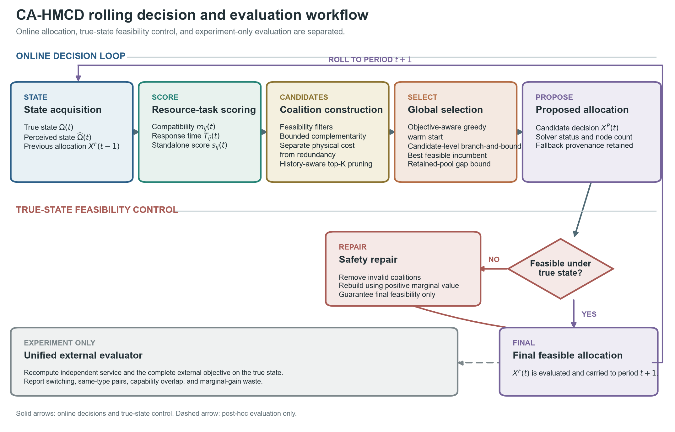
Fig. 1. CA-HMCD rolling decision and evaluation workflow. Pair scoring, coalition construction, history-aware candidate reduction, objective-aware warm start, and candidate-level branch-and-bound operate on the perceived state. The best feasible incumbent is retained when the node budget is reached. True-state repair produces the final allocation, which is then scored by a solver-decoupled service endpoint, the complete-model objective, and redundancy diagnostics. Dashed evaluation paths do not affect the online allocation.

4.2. Type-conditioned pair valuation
Resource availability alone does not imply suitability for a task. CA-HMCD therefore computes compatibility and response time before coalition construction. For matching, each resource is represented by operating range, response speed, persistence, and inverse consumption. The desired capability vector depends on the resource class and the current task features.
$u_{i}=(R_{i},v_{i}^{r},c_{i},1−e_{i})$ | (17)
$m_{ij}(t)=clip\left(\sum_{d=1}^{4}{w_{d}}[1−|u_{id}−d_{g_{i},d}(z_{j}(t))|],0,1\right)$ | (18)
$T_{ij}(t)=clip\left(\frac{0.25+0.55s_{j}(t)+0.30v_{j}^{t}(t)}{0.45+v_{i}^{r}} , 0 , 2\right)$ | (19)
The matching weights are w = (0.28, 0.28, 0.20, 0.24). The desired Type-I vector emphasizes target-specific precision and speed; Type-II emphasizes task scale and density; Type-III emphasizes discrete consumption; and Type-IV emphasizes mobility and tracking. All coefficients are normalized simulation parameters rather than measurements from a deployed system.

4.3. Complementarity and redundancy functions
For each resource pair, capability distance is the mean absolute difference across range, speed, persistence, and consumption. Heterogeneous pairs receive a non-negative task-conditioned complementarity score; same-class pairs receive no complementarity bonus. Capability overlap produces a soft redundancy penalty, with a larger coefficient for same-class pairs.
$d_{ik}^{cap}=\frac{1}{4}\sum_{d=1}^{4}{|}{\overset{\sim }{a}}_{id}−{\overset{\sim }{a}}_{kd}|,o_{ik}=1−d_{ik}^{cap}$ | (20)
$μ_{ikj}=σ[b(g_{i},g_{k})+0.025d_{ik}^{cap}+0.015n_{j}]forg_{i}≠g_{k}$ | (21)
$d_{ik}^{red}=0.045o_{ik} if g_{i}=g_{k},d_{ik}^{red}=0.012max(0,o_{ik}) otherwise$ | (22)
The type-pair bonus b is 0.045 for Type-I/Type-IV and Type-II/Type-III pairs and 0.025 for the remaining heterogeneous pairs. The nominal complementarity scale is sigma = 1.0. The objective coefficients are alpha_C = 0.12, beta_T = 0.08, lambda_R = 0.12, lambda_S = 0.10, and gamma_U = 0.20.

4.4. Candidate construction and history-aware reduction
For each active task, the method enumerates subsets within the permitted coalition-size range and rejects subsets that violate availability, response-time, or minimum class-count requirements. It then computes the bounded coalition score, physical expenditure, redundancy penalty, response time, and local utility. The resulting set is reduced by conservative history-aware dominance followed by fixed-K diversity retention (Fig. 2).
${\overset{\sim }{U}}_{j}(S,t)=U_{j}(S,t)−λ_{S}|S△S_{j}^{F}(t−1)|$ | (23a)
$A⪯_{j}B⟺A⊆B, {\overset{\sim }{U}}_{j}(A,t)≥{\overset{\sim }{U}}_{j}(B,t), S_{j}(A,t)≥S_{j}(B,t), C_{j}^{phys}(A,t)≤C_{j}^{phys}(B,t), T_{j}(A,t)≤T_{j}(B,t)$ | (23b)
Candidate A dominates B only if A is a subset of B, A is no worse in history-adjusted utility and coalition score, and A is no greater in physical expenditure and response time, with at least one strict comparison. The subset requirement prevents the replacement from creating an additional shared-capacity conflict. A feasible previous-period coalition is protected before diversity pruning. If more than K candidates remain, the procedure allocates representation across coalition sizes and resource identities, then fills unused positions by rank. This fixed-K step is an empirical search-control mechanism and is not claimed to be lossless in general.
Proposition 1 (history-aware dominance safety). If A satisfies Eq. (23b) for B, replacing B by A in any globally feasible completion preserves feasibility and does not decrease J_dec. Proof. Because A is a subset of B, every resource-capacity load weakly decreases. Its physical expenditure is no greater, so the period budget remains feasible; A is itself a feasible candidate, so task-level structural and response constraints remain satisfied. The task remains served and therefore has the same unserved-risk term, whereas Eq. (23b) makes its utility-minus-switching contribution no smaller. All other task contributions are unchanged. Hence a globally optimal completion containing B has a no-worse feasible completion containing A, and deleting B is lossless under the stated conditions.
$X^{all}⊇X^{pre}⊇X^{dom}⊇X^{K}$ | (23c)
$Δ_{tot}=\underset{Δ_{screen}}{\underset{⏟}{J^{*}(X^{all})−J^{*}(X^{pre})}}+\underset{0}{\underset{⏟}{J^{*}(X^{pre})−J^{*}(X^{dom})}}+\underset{Δ_{K}}{\underset{⏟}{J^{*}(X^{dom})−J^{*}(X^{K})}}+\underset{Δ_{search}}{\underset{⏟}{J^{*}(X^{K})−J_{dec}(X^{P})}}$ | (23d)
Equation (23d) separates the compatibility-screen loss, the zero loss certified for dominance, the fixed-K retention loss, and node-truncation search loss. The implementation records resource counts, enumerated subsets, feasible candidates, candidates removed by dominance, candidates removed by diversity retention, and preservation of the previous coalition at every decision period. No compatibility screen is applied in the primary scenarios.
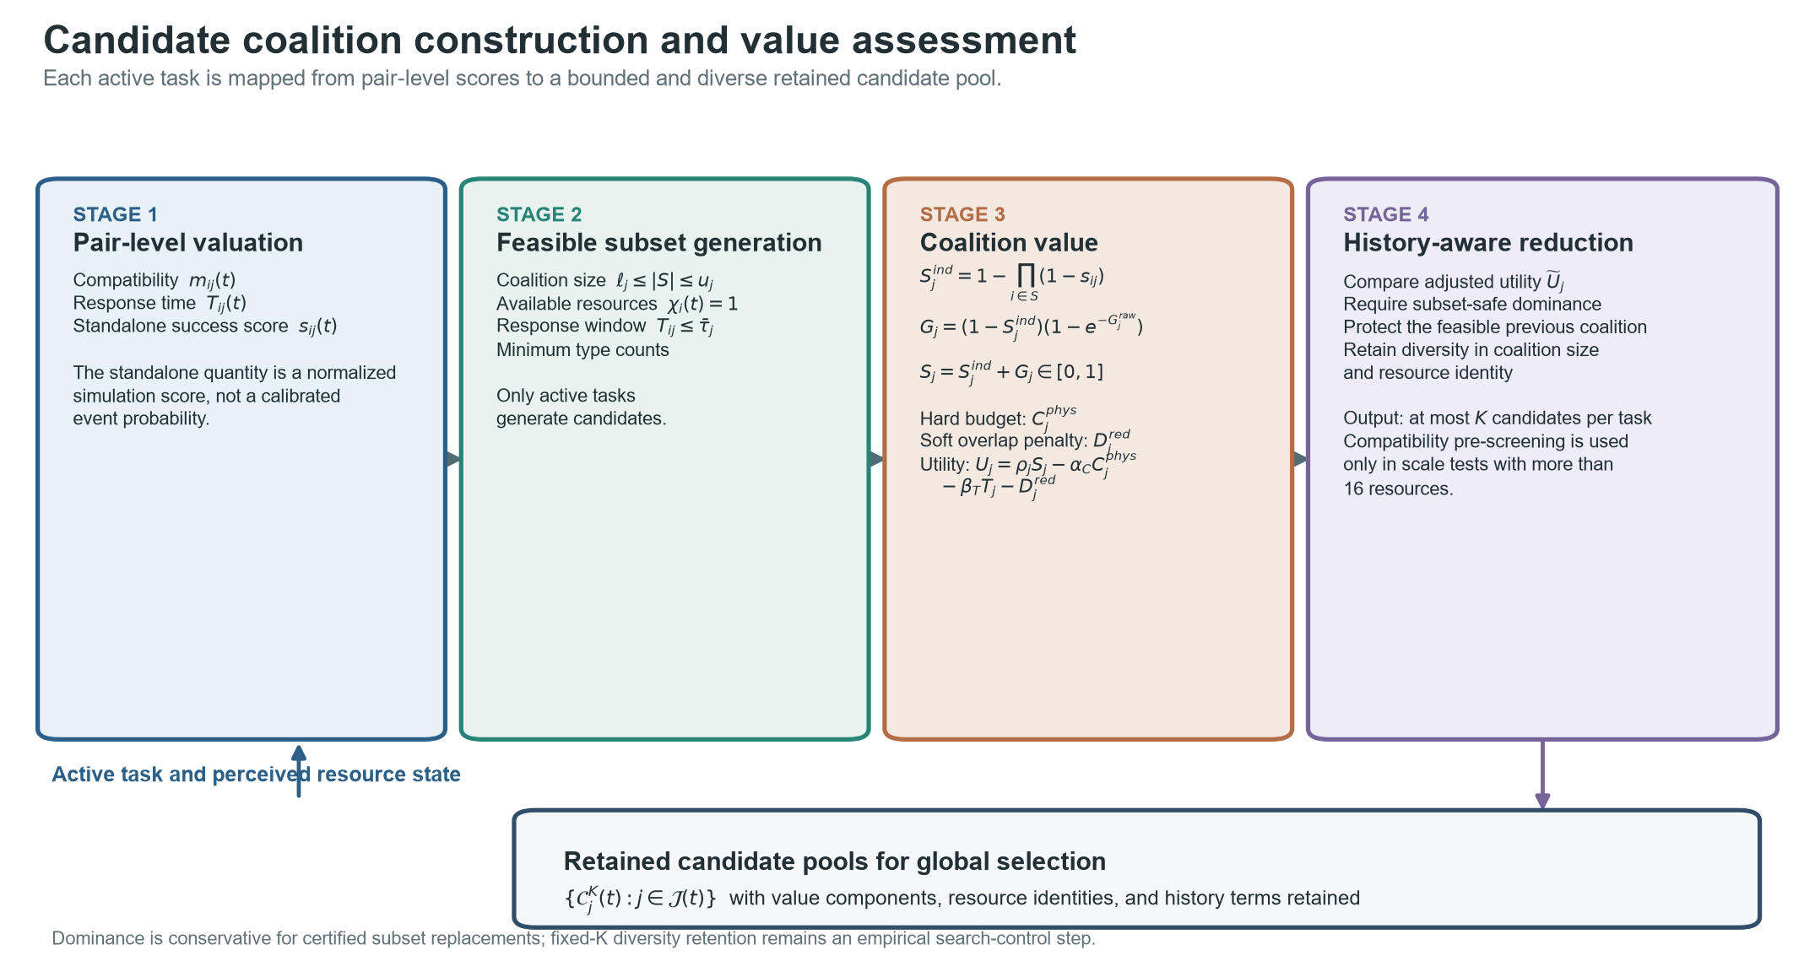
Fig. 2. Candidate coalition construction and value assessment. Resource-task compatibility, response time, and standalone success score are computed on the perceived state. Feasible subsets satisfy coalition-size, availability, response-window, and type-count constraints. Independent aggregation and headroom-bounded complementarity determine the coalition score; physical expenditure enters the hard budget, whereas capability overlap remains a soft penalty. History-aware subset dominance and diversity retention produce at most K candidates per task.

4.5. Global selection, warm start, and fallback
The retained candidate sets are searched at the coalition level. Active tasks are expanded in descending risk priority, and each task contributes its retained coalitions plus an explicit no-service option. A greedy solution first initializes a complete feasible incumbent using the exact objective gain relative to leaving the same task unserved.
$Δ_{j}^{svc}(S,t)=U_{j}(S,t)+γ_{U}ρ_{j}(t)−λ_{S}\{|S△S_{j}^{F}(t−1)|−|S_{j}^{F}(t−1)|\}$ | (24)
Candidate-level branch-and-bound then tracks resource usage, physical expenditure, accumulated utility, and the selected coalition map. Branches are pruned when they violate capacity or budget or when an optimistic retained-candidate bound cannot exceed the incumbent. Exact switching and unserved-task terms are applied to complete allocations. If the node limit is reached, the algorithm returns the better of the search incumbent and the greedy warm start. The solver status distinguishes incumbent fallback from greedy fallback.
$q_{j}=max\{0,\max_{S∈C_{j}^{K}}[U_{j}(S,t)+γ_{U}ρ_{j}(t)]\},UB(p)=U_{acc}(p)+Q_{acc}(p)−γ_{U}\sum_{j∈J(t)}{ρ_{j}}(t)+\sum_{r=p}^{L}{q_{j_{r}}}$ | (25a)
$Δ_{gap}^{ret}=max\{0,UB_{frontier}−J_{dec}(X^{P})\}$ | (25b)
Here Q_acc is the unserved-risk penalty avoided by tasks already assigned at the node. Proposition 2 (bound admissibility). Equation (25a) is an upper bound on every feasible completion below that node. For each unexpanded task it takes the better of no service and its largest retained local contribution plus avoided unserved-risk penalty. It ignores shared capacity, physical budget, and switching penalties; enforcing any of these restrictions can only weakly decrease the completion objective. Summing the per-task optimistic terms therefore bounds every descendant. Equation (25b) is consequently an absolute optimality-gap bound for the retained candidate pool only; it does not bound Delta_screen or Delta_K.

4.6. True-state repair and unified evaluation
The proposed allocation is recomputed under the true state. Invalid, over-capacity, or over-budget coalitions are removed in descending order of service marginal value. For active tasks that remain unserved, feasible true-state candidates are regenerated and positive-marginal-value candidates are inserted when capacity and budget permit. The repaired allocation becomes the history state for the next period. Every method then passes through the same complete-model evaluator. The solver-decoupled service endpoint uses risk-weighted independent success, coverage, response quality, physical-cost efficiency, and final feasibility, and excludes CA-HMCD's complementarity, redundancy, switching, and solver-state terms.
$E_{svc}=Fclip\left(0.55R_{succ}+0.20C_{cov}+0.15Q_{T}+0.10E_{C}C_{cov},0,1\right)$ | (25c)
F is the final feasibility indicator; R_succ is risk-weighted aggregation of standalone success scores; C_cov is active-task coverage; Q_T is mean response-window quality; and E_C is physical-cost efficiency. This endpoint is independent of solver status and excludes complementarity, redundancy, switching, and candidate utility, but it deliberately reuses task risk, standalone scores, response time, and physical cost from the common simulation state. It is therefore described as solver-decoupled and model-consistent, rather than fully model-independent.
$J_{base}=\sum_{j:ω_{j}^{F}=1}{\left[ρ_{j}S_{j}^{ind} − α_{C}C_{j}^{phys} − β_{T}T_{j}\right]}−γ_{U}\sum_{j}{δ_{j}}ρ_{j}(1−ω_{j}^{F})$ | (25d)
J_base is reported only as a diagnostic baseline. It retains compatibility-conditioned standalone scores, response time, physical expenditure, and the unserved-risk term, while excluding complementarity, redundancy, and switching. J_ext remains the complete-model true-state outcome.

4.7. Procedure, complexity, and implementation limits
Algorithm 1. CA-HMCD rolling allocation with objective-aware warm start, bounded search, true-state repair, and external evaluation.
Input: perceived states, true states, X^F(0), candidate limit K, node limit L_max
Output: final allocations, solver records, and external-evaluation records

FOR t = 1 TO T DO
Update active tasks, resource availability, failures, and task features
FOR each active task j DO
Compute m_ij(t), T_ij(t), and s_ij(t) from the perceived state
C_j <- EnumerateFeasibleCoalitions(j)
Evaluate S_j, C_j^phys, D_j^red, T_j, and U_j for every coalition
[C_j, n_dom] <- HistoryAwareDominance(C_j, X^F(t-1))
[C_j, n_K] <- DiversityPrune(C_j, K)
END FOR
X^G <- ObjectiveAwareGreedy({C_j}, X^F(t-1))
[X^P, incumbent, UB_frontier, status] <- BranchAndBound({C_j}, X^G, L_max)
IF the node limit is reached THEN
X^P <- better of the best feasible incumbent and X^G under J_dec
Record UB_frontier - J_dec(X^P) for the retained candidate pool
END IF
IF X^P is infeasible under the true state THEN
X^F <- TrueStateFeasibilityRepair(X^P, true state, X^F(t-1))
ELSE
X^F <- X^P
END IF
[J_ext, E_svc, diagnostics] <- EvaluateFinalAllocation(X^F, true state)
Record X^F, solver provenance, bounds, candidate counts, and diagnostics
END FOR
RETURN all final allocations and records

The primary six-method replay retained K = 12 candidates per active task, used 10 response resources and 12 rolling periods, and applied a 4,000-node search budget to the optimization-based CA-HMCD configuration. The external-baseline supplement preserved the same workloads, states, resources, and periods but disabled compatibility screening, dominance pruning, and diversity retention so that HiGHS-MILP and Genetic-Algorithm operated on the complete feasible candidate pool.
$O\left(\sum_{s=ℓ_{j}}^{u_{j}}{(}{M \atop s})\right)for candidate generation,O((K+1)^{L})for retained selection$ | (26)
The combinatorial counts above are worst-case values before feasibility and upper-bound pruning. Visited nodes, end-to-end runtime, fallback activation, retained-incumbent selection, and upper-bound gaps are therefore reported as applicability evidence rather than incidental implementation diagnostics.

5. Experimental Protocol

5.1. Research questions and registered evidence design
The evaluation addressed seven questions: how performance changes with concurrent task load; whether the stability and complementarity terms contribute to the complete-model true-state objective; whether coalition structure changes independently of the objective; whether the method remains compatible with measured three-dimensional motion and measured observation patterns; where bounded search reaches its fallback boundary; whether the retained-pool solution remains competitive with full-candidate optimization and evolutionary search; and whether its relative service behavior persists over the six registered coefficient ranges.
Table 3. Registered public-data-informed replay strata. The independent unit is an original trajectory or a predefined composed workload; 30 stochastic seeds are nested within every unit.
Dataset/stratum | Task-side evidence | Load | Independent units | Nested seeds | Experimental role
UZH-FPV [56] | Measured 3-D position | 1 | 16 trajectories | 30 | Single-target motion replay
Anti-UAV410 [57] | Measured boxes/visibility | 2 | 10 workloads | 30 | Low concurrency
Anti-UAV410 [57] | Measured boxes/visibility | 4 | 8 workloads | 30 | Intermediate concurrency
Anti-UAV410 [57] | Measured boxes/visibility | 6 | 6 workloads | 30 | High concurrency
Anti-UAV410 [57] | Measured boxes/visibility | 8 | 4 workloads | 30 | Search-boundary stress

All 16 quality-controlled UZH-FPV trajectories were reserved as independent external motion sources. For Anti-UAV410, the official training split was restricted to development, the validation split to calibration, and all 120 test sequences to evaluation. Each test sequence was assigned exactly once to one of 28 composed workloads: ten at load 2, eight at load 4, six at load 6, and four at load 8. Nominal, visibility, fast-motion, and scale/small-target strata were proportionally balanced within each load group.

5.2. Replay construction and engineering boundary
The UZH-FPV adapter read Leica ground-truth positions, removed duplicate times and implausible transitions, retained the longest physically plausible chain, trimmed stationary acquisition, and converted the trajectory to a local frame. The Anti-UAV410 adapter read annotated image-plane boxes, visibility states, and sequence attributes, selected a predefined event window, and preserved disappearance and reappearance during resampling. Every source was mapped to 12 rolling decision periods.
Public data supplied task-side motion or observation patterns only. Protected-zone registration, concurrent composition of independent Anti-UAV410 videos, task-risk and response-window parameters, the four response-resource classes, resource effectiveness, physical expenditure, and allocation outcomes remained simulated. The experiment is therefore a public-data-informed semi-synthetic replay, not an operational field trial.

5.3. Compared methods and fairness controls
The primary comparison included CA-HMCD, Greedy, External-Auction, No-Synergy, No-Stability, and Random. A preregistered supplement added HiGHS-MILP, a standard binary mixed-integer optimization reference [58], and Genetic-Algorithm, a standard evolutionary-search reference [59]. Both added methods optimized the registered rolling value model over the complete feasible candidate pool. HiGHS-MILP used a 4,000-node ceiling with zero relative MIP-gap target; Genetic-Algorithm used a population of 64, 4,000 fitness evaluations per decision period, tournament selection, uniform crossover, mutation, deterministic feasibility repair, and the complete-pool greedy solution as a protected warm start.
Every method received the same perceived state, true state, task-arrival offsets, resource realization, active-task identifiers, physical budget, and registered seed. The primary six-method replay contained 7,920 runs and 95,040 period records. The two external baselines added 2,640 runs and 31,680 period records, giving 10,560 unique method-by-workload-seed runs across eight methods. A separate 1,320-run CA-HMCD replay in the locked Python 3.12 environment was used only for matched runtime comparison. The external methods used the same feasible candidates observed before CA-HMCD diversity retention, and all allocations were recomputed by the same true-state evaluator. A separate controlled synthetic sensitivity experiment used the same v2.3 value model, external evaluator, 12-period horizon, balanced activity process, and 30 paired seeds for every configuration. One coefficient at a time was scanned at three registered levels while the other coefficients remained at their reference values. Six coefficients and three methods yielded 54 configurations and 1,620 complete seeded trajectories.

5.4. Outcomes and external evaluation
The primary service endpoint combined risk-weighted standalone success, task coverage, response-window quality, physical-cost efficiency, and final feasibility. It excluded complementarity gains, redundancy penalties, switching penalties, candidate utilities, and solver state. The complete true-state external objective was analyzed separately because it includes the modeled service-cost-stability trade-off. Additional endpoints were risk-weighted coverage, response time on task-periods served by both methods, switching count, physical cost, three independent redundancy diagnostics, runtime, visited nodes, fallback activation, upper-bound gap, repair activation, and final feasibility.

5.5. Statistical analysis
The independent inferential unit was an original UZH-FPV trajectory or a predefined Anti-UAV410 composed workload. Thirty paired random seeds were nested within each unit and averaged before inference; decision periods, tasks, and stochastic seeds were not treated as independent public-data observations. Within each dataset/load stratum, CA-HMCD was compared with the other five algorithms using two-sided paired Wilcoxon signed-rank tests across independent units.
Every comparison reports the mean paired difference (CA-HMCD minus comparator), a 95% bias-corrected and accelerated cluster-bootstrap confidence interval based on 10,000 resamples, the unadjusted P value, the Holm-adjusted P value, paired Cohen's dz, rank-biserial correlation, and the favorable-direction cluster win rate. The primary six-method analysis retained 60 endpoint-by-stratum Holm families with five contrasts each. The external-baseline supplement declared 60 additional endpoint-by-stratum families with two contrasts each, yielding 120 fully reported comparisons. The inferential decision remained Holm-adjusted P < 0.05. Because the BCa interval estimates a mean difference while the Wilcoxon test uses signed ranks, interval exclusion alone was not described as family-wise significance at small n. The complete external-baseline registry is supplied as Supplementary Table S8. The parameter study treated one complete seeded 12-period trajectory as its independent unit. For each coefficient, the three registered levels and two CA-HMCD comparator contrasts formed one six-member Holm family, giving 36 comparisons in six families. Full configuration means are reported in Supplementary Table S9, and effect estimates, 95% BCa intervals, unadjusted P values, Holm-adjusted P values, paired Cohen's dz, rank-biserial correlations, and win rates are reported in Supplementary Table S10.
Coverage and other [0,1] metrics used bounded BCa intervals over cluster means with 5,000 resamples. Binary cluster prevalence used Wilson score intervals. Response-time comparisons were restricted to task-periods served by both methods, averaged within seed and then within independent unit, and interpreted jointly with coverage. Approximate 80% power sensitivity under the conservative first Holm step corresponded to paired dz values of 1.08, 1.21, 1.40, 1.71, and 0.85 for n = 10, 8, 6, 4, and 16, respectively. The calculation was a sample-size sensitivity analysis, not achieved power.

5.6. Reproducibility and validation scope
The formal runners completed every registered workload and rejected partial algorithm sets, reduced seed counts, workload filters, and fingerprint mismatches. All 15,840 paired state groups passed in each formal replay session, and every final allocation was feasible. The external-baseline and matched CA-HMCD sessions shared protocol fingerprint b0043867b0802dbabaf4183e6e204bfaddcc4a1aceb8197831096e87500fdcea, simulation hash b6fae78029a59e65c6a49fe25cd11e4d2fa9d5c912ced55ad9b8a4b92c126ef1, Python 3.12.14, SciPy 1.18.1, and HiGHS 1.12.0. The matched CA-HMCD run reproduced all prior non-timing outcomes with maximum absolute difference 0. The 54-configuration sensitivity source contained the registered 1,620 records, 30 seeds per configuration, and model/evaluator versions ca-hmcd-stage1-closure-v2.3 and complete-v3-stage1-closure. The release candidate includes checksummed source registries, protocols, episode-level results, analysis scripts, complete statistical registries, and environment specifications.

6. Results

6.1. Performance changed with concurrent task load
Table 4. Primary paired comparisons with External-Auction. Differences are CA-HMCD minus External-Auction; positive service and coverage values favor CA-HMCD. Confidence intervals are 95% paired cluster BCa intervals. Statistical significance is determined by the Holm-adjusted P value.
Stratum | Endpoint | Difference [95% CI] | Raw P | Holm P | dz | Win rate
Anti-UAV410 load 2 | Service | -0.0061 [-0.0113, -0.0029] | 0.00391 | 0.0117 | -0.881 | 5.0%
Anti-UAV410 load 2 | Coverage | -0.0014 [-0.0068, 0.0000] | 1.0000 | 1.0000 | -0.316 | 45.0%
Anti-UAV410 load 4 | Service | -0.0009 [-0.0041, 0.0017] | 0.6406 | 1.0000 | -0.194 | 37.5%
Anti-UAV410 load 4 | Coverage | 0.0138 [0.0091, 0.0205] | 0.00781 | 0.0391 | 1.601 | 100.0%
Anti-UAV410 load 6 | Service | 0.0112 [0.0066, 0.0186] | 0.0312 | 0.1562 | 1.407 | 100.0%
Anti-UAV410 load 6 | Coverage | 0.0515 [0.0390, 0.0804] | 0.0312 | 0.1562 | 2.037 | 100.0%
Anti-UAV410 load 8 | Service | 0.0215 [0.0151, 0.0301] | 0.1250 | 0.6250 | 2.555 | 100.0%
Anti-UAV410 load 8 | Coverage | 0.0720 [0.0526, 0.0983] | 0.1250 | 0.6250 | 2.825 | 100.0%
UZH-FPV single-target | Service | -0.0096 [-0.0150, -0.0056] | 0.00024 | 0.00073 | -0.981 | 9.4%
UZH-FPV single-target | Coverage | -0.0153 [-0.0240, -0.0087] | 0.00024 | 0.00073 | -0.956 | 9.4%

CA-HMCD did not show a uniform advantage across loads (Table 4; Fig. 3). At load 2, its independent service score was lower than External-Auction by a paired difference of -0.0061 [-0.0113, -0.0029] (Holm P = 0.0117), while coverage was indistinguishable. At load 4, service remained similar, but coverage increased by 0.0138 [0.0091, 0.0205] and the complete external objective increased by 0.0198 [0.0120, 0.0291]; both comparisons had Holm P = 0.0391. Relative to Greedy at the same load, coverage increased by 0.0113 [0.0075, 0.0168] and the objective by 0.0129 [0.0059, 0.0211], again with Holm P = 0.0391.
At loads 6 and 8, the service, coverage, and complete-objective estimates favored CA-HMCD over both Greedy and External-Auction, and every independent workload favored CA-HMCD for service and coverage. For example, the service difference from External-Auction was 0.0112 [0.0066, 0.0186] at load 6 and 0.0215 [0.0151, 0.0301] at load 8. Neither comparison reached the registered family-wise threshold (Holm P = 0.1563 and 0.6250) because these strata contained only six and four independent workloads. These findings are therefore effect estimates with consistent direction, not Holm-confirmed high-load superiority.
On task-periods served by both methods, response time was lower than External-Auction at load 2 (-0.0013 [-0.0022, -0.0005], Holm P = 0.0234) and load 4 (-0.0051 [-0.0078, -0.0033], Holm P = 0.0391). The load-6 estimate remained favorable but was not significant after Holm correction, and the load-8 and UZH-FPV estimates were near zero. Because this endpoint is conditional on common service, it was interpreted together with coverage rather than as a replacement for service availability.
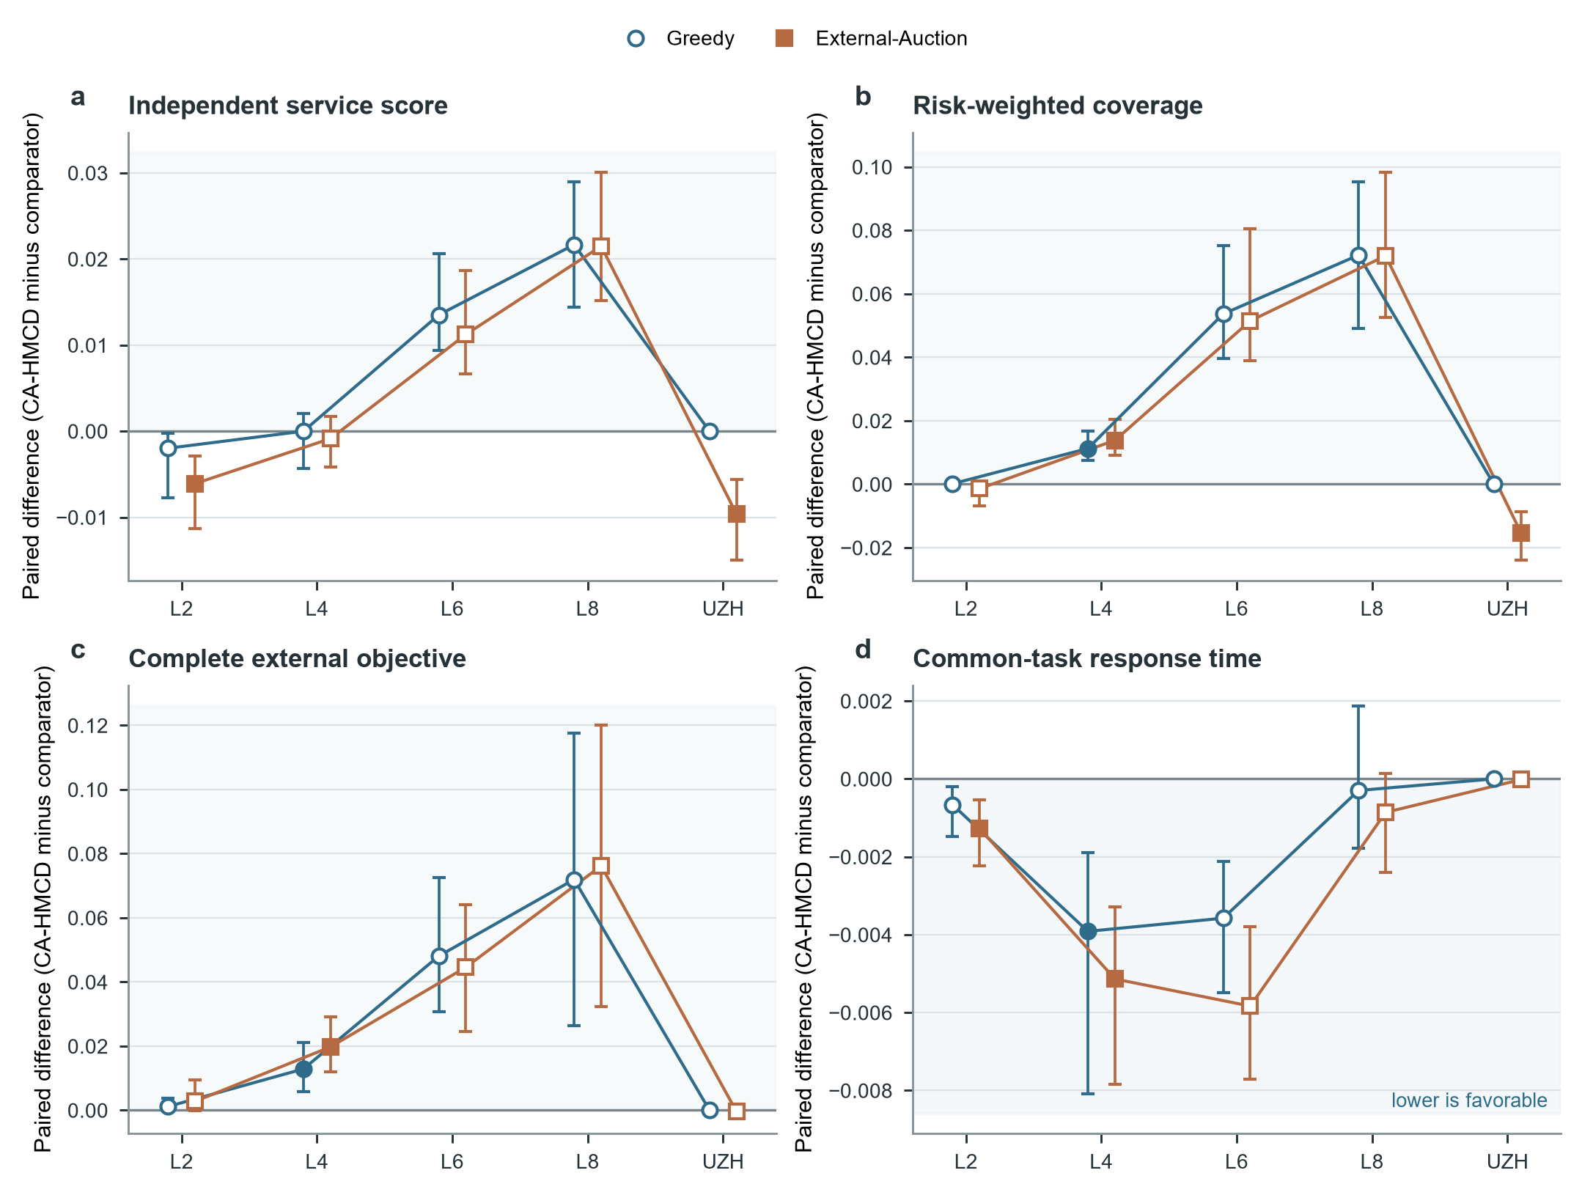
Fig. 3. Load-dependent performance under public-data-informed replay. a, Independent service score. b, Risk-weighted coverage. c, Complete true-state external objective. d, Response time restricted to task-periods served by both methods. Points are mean paired independent-unit differences and bars are 95% paired cluster BCa intervals. Filled markers denote Holm-adjusted P < 0.05 within the registered five-comparison family; open markers denote non-significant comparisons. Blue circles compare CA-HMCD with Greedy and orange squares compare it with External-Auction. Positive values favor CA-HMCD in a-c; negative values favor CA-HMCD in d. Independent units were Anti-UAV410 composed workloads (n = 10, 8, 6, and 4 at loads 2, 4, 6, and 8) and UZH-FPV trajectories (n = 16). Source data are provided with the figure files.

6.2. Stability protected the full objective; complementarity was conditional
Table 5. Module comparisons on the complete external objective. Positive differences favor the complete CA-HMCD configuration; intervals are 95% paired cluster BCa intervals.
Stratum | CA-HMCD - No-Synergy [95% CI] | Holm P | CA-HMCD - No-Stability [95% CI] | Holm P
Anti-UAV410 load 2 | 0.0005 [0.0000, 0.0015] | 0.7500 | 0.1229 [0.1044, 0.1482] | 0.00977
Anti-UAV410 load 4 | 0.0048 [0.0016, 0.0100] | 0.0391 | 0.3340 [0.3170, 0.3665] | 0.0391
Anti-UAV410 load 6 | -0.0015 [-0.0043, 0.0008] | 0.4375 | 0.4268 [0.3594, 0.4585] | 0.1562
Anti-UAV410 load 8 | -0.0024 [-0.0036, -0.0016] | 0.6250 | 0.4993 [0.4758, 0.5370] | 0.6250
UZH-FPV single-target | 0.0000 [0.0000, 0.0000] | 1.0000 | 0.0319 [0.0270, 0.0374] | 0.00015

The stability term produced the most consistent complete-objective contribution (Table 5; Fig. 4). At loads 2 and 4, CA-HMCD exceeded No-Stability by 0.1229 [0.1044, 0.1482] and 0.3340 [0.3170, 0.3665] (Holm P = 0.0098 and 0.0391). The UZH-FPV difference was 0.0319 [0.0270, 0.0374] (Holm P = 0.00015). At loads 6 and 8, the objective differences remained large and positive but did not reach the family-wise threshold at n = 6 and n = 4.
Removing stability increased immediate service while sharply increasing switching and physical cost. Across loads 2-8, CA-HMCD used 2.06-5.69 fewer switches and 0.48-1.02 less normalized physical cost than No-Stability. Thus, stability contributed through a lower-reconfiguration operating plan rather than through maximal single-period service.
Complementarity did not provide a universal aggregate benefit. CA-HMCD exceeded No-Synergy at load 4 by 0.0048 [0.0016, 0.0100] (Holm P = 0.0391), but the load-6 estimate crossed zero and the load-8 estimate was negative. UZH-FPV produced no difference because the single-target replay did not require a heterogeneous coalition. The evidence supports complementarity as a conditional value component, not as an independently performance-improving mechanism in every regime.
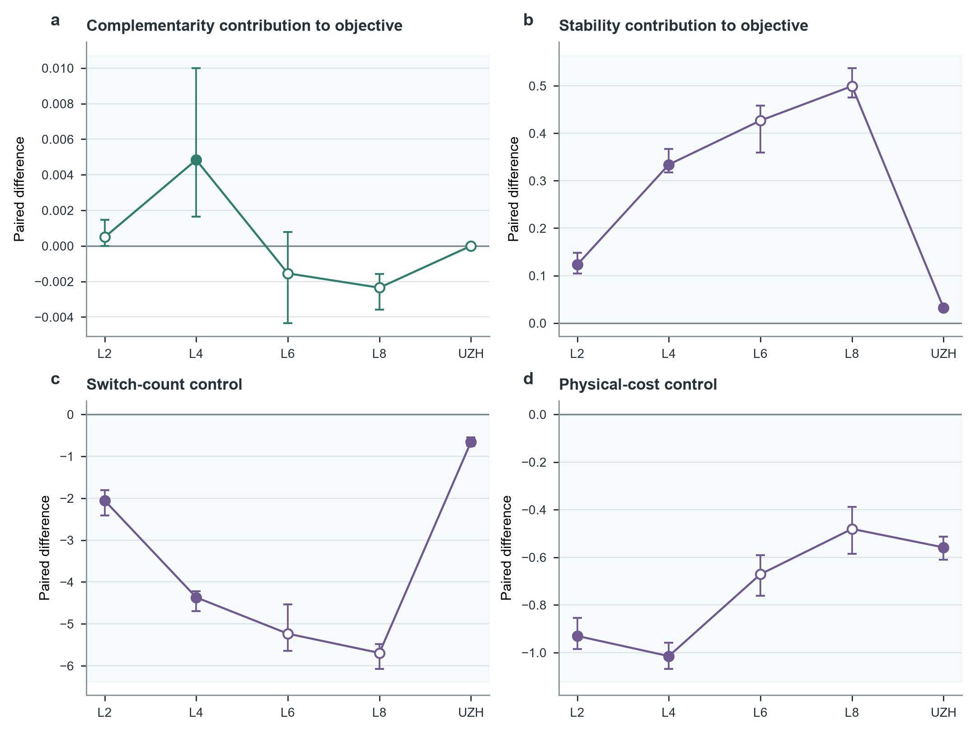
Fig. 4. Module contribution and the complementarity-stability distinction. a, Complete-objective difference from No-Synergy. b, Complete-objective difference from No-Stability. c, Switch-count difference from No-Stability. d, Physical-cost difference from No-Stability. Points are mean paired independent-unit differences and bars are 95% paired cluster BCa intervals. Filled markers indicate Holm-adjusted P < 0.05. Positive values are favorable in a and b; negative values are favorable in c and d. The figure shows a load-dependent complementarity effect and a more consistent stability benefit through reduced reconfiguration and expenditure. Source data are provided with the figure files.

6.3. Coalition structure changed without proving an isolated redundancy benefit
CA-HMCD generally selected coalitions with less duplicated capability than Greedy and External-Auction (Fig. 5). At load 4, the same-type pair ratio, capability overlap, and marginal-gain waste were lower than Greedy by 0.1049, 0.1349, and 0.0157 and lower than External-Auction by 0.3330, 0.2402, and 0.0296; all six comparisons had Holm P = 0.0391. The same directions persisted at loads 6 and 8, but the small numbers of independent workloads prevented family-wise confirmation.
These structural diagnostics are descriptive of the returned coalitions and should not be read as an isolated causal estimate of the redundancy penalty. The formal comparison did not include a dedicated No-Redundancy algorithm, and lower overlap need not always be operationally preferable when repeated capability protects against correlated failure. The supported conclusion is narrower: CA-HMCD changed coalition composition in the intended direction relative to the two external baselines, while the utility of that change remained load- and model-dependent.
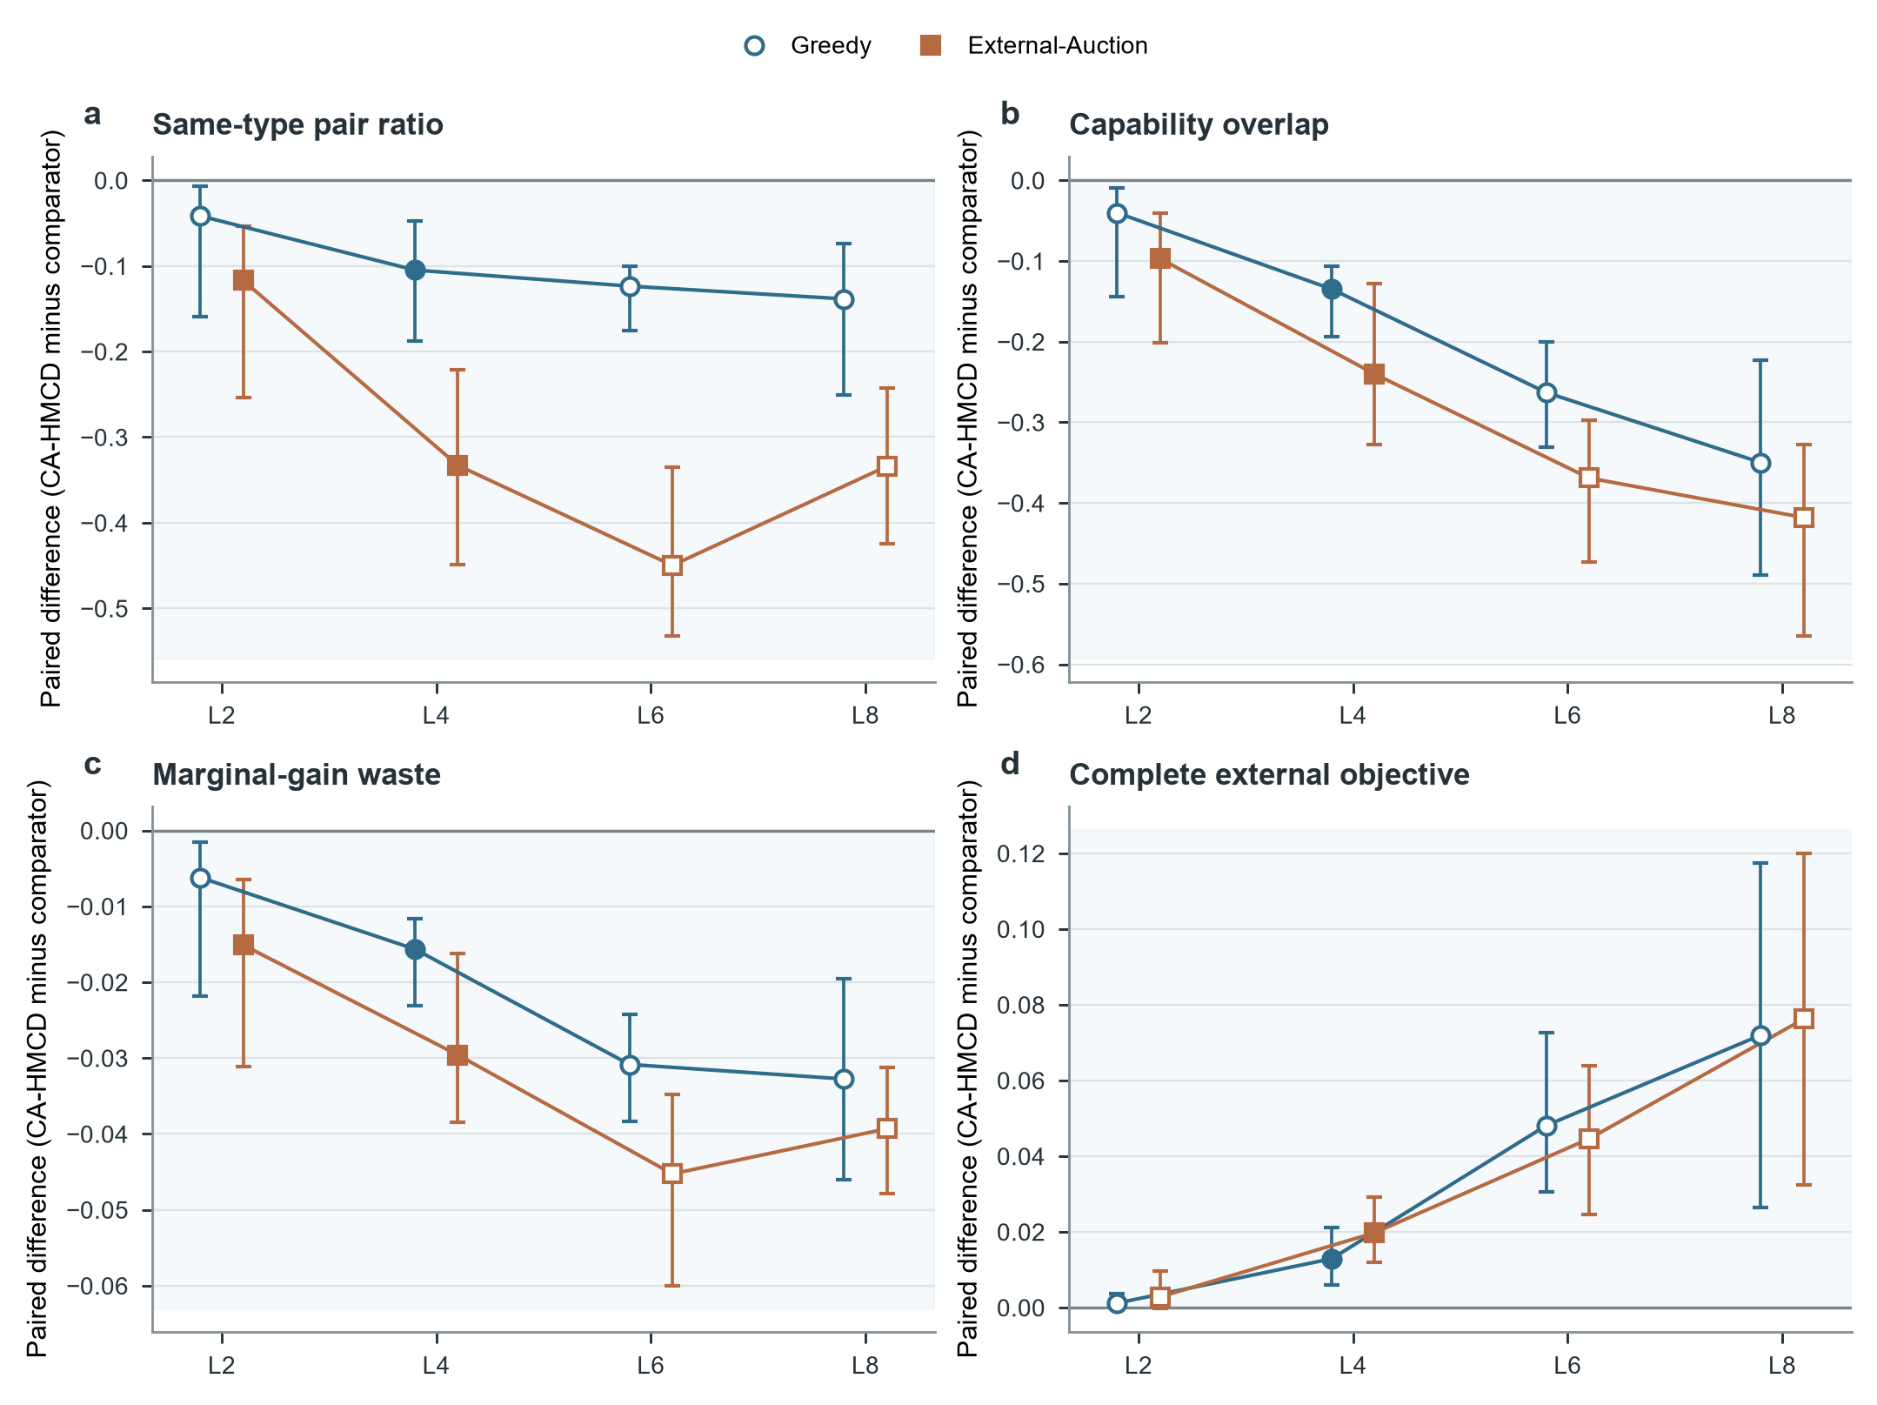
Fig. 5. Coalition structure and redundancy diagnostics across Anti-UAV410 task load. a, Same-type pair ratio. b, Capability overlap. c, Marginal-gain waste. d, Complete true-state external objective. Blue circles compare CA-HMCD with Greedy and orange squares compare it with External-Auction. Points are mean paired workload differences and bars are 95% paired cluster BCa intervals. Filled markers denote Holm-adjusted P < 0.05. Negative values in a-c indicate less duplicated structure under CA-HMCD; positive values in d indicate a higher complete objective. The diagnostics establish a structural difference but do not isolate the redundancy coefficient from the complete allocation model. Source data are provided with the figure files.

6.4. Public-data replay established traceability and a single-target boundary
The primary six-method execution audit found complete workload and algorithm coverage: 44 independent units, 1,320 registered workload-seed units, 7,920 method runs, 95,040 period records, and 15,840 passing paired state-audit groups (Fig. 6). The external supplement added 2,640 method runs and 31,680 period records under the same registry. Every final allocation was feasible. No run required true-state repair and no active-task mismatch occurred, so the replay verifies the final feasibility implementation but does not provide comparative evidence for repair or interrupted-perception recovery.
The UZH-FPV stratum further bounded the performance claim. CA-HMCD and Greedy returned identical service, coverage, and objective means. CA-HMCD was lower than External-Auction by -0.0096 [-0.0150, -0.0056] in service and by -0.0153 [-0.0240, -0.0087] in coverage (both Holm P = 0.00073), whereas the complete-objective difference was small and did not cross the family-wise threshold (Holm P = 0.0513). UZH-FPV therefore supports integration with measured three-dimensional motion but not a single-target superiority claim.
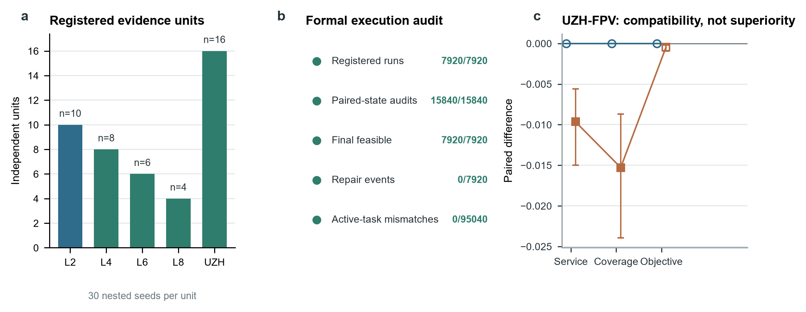
Fig. 6. Public-data evidence base, execution audit, and UZH-FPV boundary. a, Numbers of independent Anti-UAV410 workloads and UZH-FPV trajectories; 30 paired stochastic seeds were nested within every unit. b, Formal execution and fairness audit counts. Zero repair events and zero active-task mismatches are reported as scope boundaries, not as evidence of repair effectiveness. c, UZH-FPV paired differences for independent service, coverage, and the complete external objective. Blue circles compare CA-HMCD with Greedy and orange squares compare it with External-Auction; bars are 95% paired cluster BCa intervals and filled markers denote Holm-adjusted P < 0.05. Source data are provided with the figure files.

6.5. Bounded search exposed the high-load computational boundary
Table 6. Computational and feasibility boundary for CA-HMCD. Runtime and nodes are descriptive means; fallback is the proportion of runs containing at least one bounded-search fallback with a bounded 95% cluster-bootstrap interval.
Stratum | Independent n | Runtime (ms) | Mean nodes | Runs with fallback [95% CI] | Final feasible
Anti-UAV410 load 2 | 10 | 58.8 | 34.1 | 0.0% [0.0, 0.0] | 100.0%
Anti-UAV410 load 4 | 8 | 136.4 | 303.1 | 0.0% [0.0, 0.0] | 100.0%
Anti-UAV410 load 6 | 6 | 194.6 | 1752.9 | 76.7% [62.2, 87.8] | 100.0%
Anti-UAV410 load 8 | 4 | 299.8 | 3288.7 | 100.0% [100.0, 100.0] | 100.0%
UZH-FPV single-target | 16 | 44.6 | 7.4 | 0.0% [0.0, 0.0] | 100.0%

Mean end-to-end runtime increased from 58.8 ms at load 2 to 136.4, 194.6, and 299.8 ms at loads 4, 6, and 8, while mean visited nodes increased from 34 to 303, 1,753, and 3,289 (Table 6; Fig. 7). No CA-HMCD run at loads 2 or 4 used fallback. Runs containing at least one fallback rose to 76.7% [62.2%, 87.8%] at load 6 and 100% [100%, 100%] at load 8. Every load-6 and load-8 independent workload contained at least one fallback-affected seed.
Across the 258 fallback-affected CA-HMCD runs, the incumbent-preserving rule selected an improved search incumbent in 211 runs rather than reverting to the greedy warm start. The mean reported upper-bound gap increased from approximately 0.15 at load 6 to 0.70 at load 8, while the retained incumbent improved on the greedy warm start by approximately 0.02 and 0.08 objective units. These diagnostics show that fallback preserves a feasible, sometimes improved allocation, but they also identify a clear loss-of-optimality and scalability boundary.
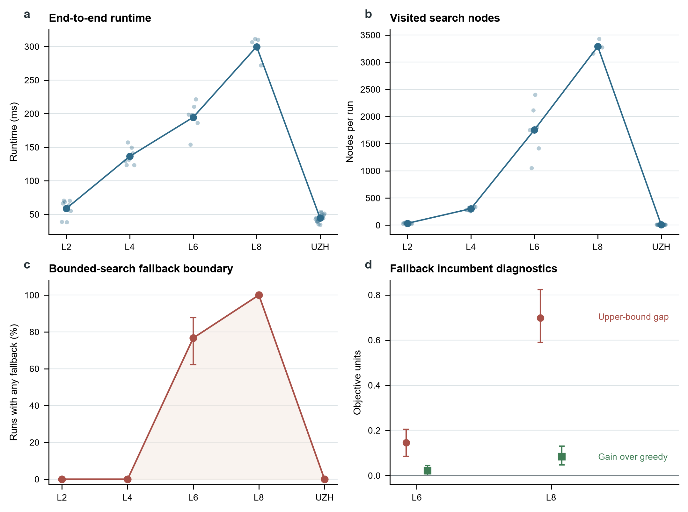
Fig. 7. Runtime, search effort, and fallback boundary. a, End-to-end runtime by independent unit; pale points are unit means and the dark line is the stratum mean. b, Mean visited search nodes by independent unit. c, Percentage of runs containing at least one fallback event, with bounded 95% cluster-bootstrap intervals. d, Mean fallback upper-bound gap and gain over the greedy warm start at loads 6 and 8; bars span the observed independent-workload range. Runtime and node values are descriptive because a hardware-complete benchmark record was unavailable. Source data are provided with the figure files.

6.6. Full-candidate baselines exposed the retained-pool performance boundary
Table 7. Environment-matched comparison with full-candidate optimization and evolutionary-search references. Values are means across independent workload-level aggregates after averaging 30 nested seeds. HiGHS-MILP and Genetic-Algorithm retained every feasible candidate; CA-HMCD retained the fixed-K diversity pool. Inferential details are provided in Supplementary Table S8.
Stratum | Method | Objective | Service | Coverage | Candidates | End-to-end (ms)
Anti-UAV410 load 2 | CA-HMCD | 0.053 | 0.552 | 0.859 | 16.4 | 55.2
Anti-UAV410 load 2 | HiGHS-MILP | 0.053 | 0.552 | 0.859 | 205.1 | 18.3
Anti-UAV410 load 2 | Genetic-Algorithm | 0.053 | 0.552 | 0.859 | 205.1 | 67.1
Anti-UAV410 load 4 | CA-HMCD | 0.120 | 0.563 | 0.896 | 33.0 | 113.1
Anti-UAV410 load 4 | HiGHS-MILP | 0.120 | 0.564 | 0.898 | 412.7 | 34.5
Anti-UAV410 load 4 | Genetic-Algorithm | 0.118 | 0.564 | 0.896 | 412.7 | 100.8
Anti-UAV410 load 6 | CA-HMCD | 0.143 | 0.529 | 0.848 | 50.7 | 182.1
Anti-UAV410 load 6 | HiGHS-MILP | 0.172 | 0.545 | 0.894 | 623.0 | 46.3
Anti-UAV410 load 6 | Genetic-Algorithm | 0.167 | 0.545 | 0.888 | 623.0 | 122.5
Anti-UAV410 load 8 | CA-HMCD | 0.094 | 0.500 | 0.804 | 66.9 | 245.7
Anti-UAV410 load 8 | HiGHS-MILP | 0.158 | 0.528 | 0.890 | 827.5 | 57.4
Anti-UAV410 load 8 | Genetic-Algorithm | 0.142 | 0.526 | 0.883 | 827.5 | 145.5
UZH-FPV single-target | CA-HMCD | -0.002 | 0.515 | 0.829 | 10.4 | 35.7
UZH-FPV single-target | HiGHS-MILP | -0.002 | 0.515 | 0.829 | 130.8 | 9.3
UZH-FPV single-target | Genetic-Algorithm | -0.002 | 0.515 | 0.829 | 130.8 | 53.5

The full-candidate references changed the interpretation of the retained-pool method (Table 7). At Anti-UAV410 load 2, CA-HMCD and HiGHS-MILP returned identical complete-model objective, service, and coverage means; differences from Genetic-Algorithm were also negligible. At load 4, the CA-HMCD objective differed from HiGHS-MILP by -0.0002 [-0.0008, 0.0001] and from Genetic-Algorithm by 0.0022 [0.0003, 0.0056], with Holm P = 0.5625 and 0.3906. Its service and coverage were slightly lower than HiGHS-MILP, but the corresponding two-comparison Holm P values were 0.0625. CA-HMCD was faster on tasks served by both methods than Genetic-Algorithm at load 4 (-0.00124 [-0.00199, -0.00060], Holm P = 0.0156).
At loads 6 and 8, both full-candidate methods returned higher objective, service, and coverage values. Relative to HiGHS-MILP, the CA-HMCD objective differences were -0.0290 [-0.0496, -0.0176] and -0.0635 [-0.0845, -0.0424]; relative to Genetic-Algorithm, they were -0.0246 [-0.0424, -0.0131] and -0.0478 [-0.0681, -0.0373]. All independent workloads favored the full-candidate methods for the three quality endpoints. Nevertheless, the Holm-adjusted P values were 0.0625 at load 6 and 0.2500 at load 8 because the strata contained only six and four independent workloads. These estimates identify a consistent high-load loss without converting small-n interval exclusion into a multiplicity-controlled claim.
The environment-matched runtime comparison did not show an online-computation advantage for the current implementation. Mean end-to-end time for CA-HMCD, HiGHS-MILP, and Genetic-Algorithm was 55.2, 18.3, and 67.1 ms at load 2; 113.1, 34.5, and 100.8 ms at load 4; 182.1, 46.3, and 122.5 ms at load 6; and 245.7, 57.4, and 145.5 ms at load 8. HiGHS-MILP was faster in every stratum, while Genetic-Algorithm became faster than CA-HMCD from load 4 onward. The full-pool references also required no safety repair, fallback, or node-limit recovery. In the UZH-FPV single-target stratum, all three methods returned identical quality outcomes, defining a regime in which the extra coalition machinery provided no measurable allocation benefit.

6.7. Relative performance persisted across 54 parameter-method configurations
Table 8. Registered one-factor parameter sensitivity summary. Service values are CA-HMCD means at the three levels in ascending order. Advantage is the range of paired CA-HMCD-minus-comparator service differences across Greedy and External-Auction. The complete 54-row configuration table and 36-row inferential registry are Supplementary Tables S9 and S10.
Coefficient | Levels | CA-HMCD service | Service range | Advantage range | Holm significant
Physical-cost weight | 0.06;0.12;0.24 | 0.366 / 0.348 / 0.313 | 0.0531 | 0.0083 to 0.0276 | 6/6
Response-time weight | 0.04;0.08;0.16 | 0.357 / 0.348 / 0.334 | 0.0234 | 0.0153 to 0.0203 | 6/6
Unserved-task penalty | 0.1;0.2;0.4 | 0.329 / 0.348 / 0.369 | 0.0392 | 0.0144 to 0.0229 | 6/6
Redundancy penalty | 0.06;0.12;0.24 | 0.348 / 0.348 / 0.348 | 0.0004 | 0.0162 to 0.0181 | 6/6
Switching penalty | 0.05;0.1;0.2 | 0.375 / 0.348 / 0.294 | 0.0806 | 0.0043 to 0.0352 | 6/6
Complementarity scale | 0.5;1;1.5 | 0.348 / 0.348 / 0.349 | 0.0015 | 0.0162 to 0.0191 | 6/6

The registered sensitivity analysis covered six coefficients, three levels per coefficient, three methods, 30 paired seeds, and 12 decision periods, giving 54 configurations and 1,620 complete seeded trajectories (Table 8). All 36 CA-HMCD service contrasts against Greedy and External-Auction were positive and Holm-significant within the six prespecified parameter families. The weakest contrast occurred at lambda_switch = 0.2 against External-Auction: 0.0043 [0.0013, 0.0112], Holm P = 0.0305, paired dz = 0.353, and a 65% seed-level win rate.
Relative ordering did not imply parameter invariance. The CA-HMCD service range was 0.0806 for the switching penalty and 0.0531 for the physical-cost weight, compared with 0.0392 for the unserved-task penalty and 0.0234 for the response-time weight. The corresponding ranges were only 0.0015 for the complementarity scale and 0.0004 for the redundancy penalty. The experiment therefore supports stable relative performance over the registered synthetic ranges, while showing that absolute service remains sensitive to the coefficients governing reconfiguration and physical expenditure. It does not calibrate deployment thresholds or replace independent public-trajectory validation.

7. Discussion

7.1. Central interpretation
The combined replay supports a narrower conclusion than general superiority. Relative to Greedy and External-Auction, CA-HMCD changed the service-cost-stability trade-off and produced its clearest family-wise gains at intermediate Anti-UAV410 load. The stronger full-candidate comparison showed a different boundary: CA-HMCD matched allocation quality at low load and remained close at load 4, but lost objective, service, and coverage at loads 6 and 8. It also retained shorter response times on commonly served tasks in several strata, yet the current implementation was slower end to end than HiGHS-MILP throughout. CA-HMCD is therefore best interpreted as an auditable rolling formulation whose candidate-reduction trade-off is acceptable only in the tested low-to-intermediate-load regimes, not as a universally competitive solver.

7.2. Stability and complementarity play different roles
The component evidence separates the roles of stability and complementarity. Stability reduced reconfiguration and physical expenditure strongly enough to improve the full external objective even though No-Stability often achieved higher immediate service. This is a direct consequence of optimizing a rolling plan rather than a sequence of isolated decisions. Complementarity was less uniform: its aggregate contribution was positive at load 4, near zero at load 6, negative at load 8, and absent in the single-target regime. These results support a bounded design interpretation in which complementarity uses remaining service headroom, but they do not establish a physical synergy law or a universally beneficial coefficient.

7.3. Structural redundancy diagnostics require contextual interpretation
The three redundancy diagnostics showed that CA-HMCD generally returned fewer same-type pairs, lower capability overlap, and less marginal-gain waste than the two external baselines. This evidence is useful because it reveals how coalition structure changes even when endpoint differences are uncertain. It does not imply that all repeated capability is wasteful. Redundancy can be valuable under correlated failure, spatial separation, sequential engagement, or asymmetric task-loss costs. A dedicated No-Redundancy ablation and empirically calibrated failure dependencies are needed before the penalty itself can be credited with an independent operational benefit.

7.4. Public data strengthen task-side realism but do not constitute field validation
UZH-FPV and Anti-UAV410 replace purely generated task trajectories with measured motion and observation patterns, improving traceability and exposing distinct operating regimes. Nevertheless, the response resources, protected zones, concurrent composition, risk mapping, response windows, costs, and outcomes remain simulated. The study therefore establishes that the allocation pipeline can consume real task-side dynamics; it does not establish effectiveness against operational low-altitude events. The absence of repair activation also means that the true-state repair operator remains a verified implementation feature rather than an empirically supported performance contributor.

7.5. Statistical and computational boundaries
The cluster-aware analysis prevents the 30 stochastic seeds from being mistaken for 30 independent public trajectories. This correction materially changes the strength of the high-load claim: large paired effects and 100% workload win rates coexist with non-significant Holm tests at n = 6 and n = 4. The appropriate response is not to treat the results as null or to ignore multiplicity, but to report the effect estimates and acquire more independent public trajectories or workload compositions.
The full-candidate references connect the bounded-search diagnostics to an observable quality loss. Incumbent preservation avoided a crude return to Greedy, but fixed-K diversity retention removed most feasible candidates and fallback became routine at high load. The matched HiGHS result further shows that candidate reduction did not compensate for its own generation and branch-and-bound overhead in this ten-resource setting. The next algorithmic step should therefore test adaptive K, earlier constraint-aware generation, direct MILP warm starts, or decomposition against the same full-candidate reference. Published distributed or learned allocation policies remain a separate comparison need; the generic genetic algorithm is an evolutionary-search reference rather than a reproduction of an application-specific learned model.

7.6. Parameter robustness is relative, not a calibration claim
The 54-configuration study closes a specification-sensitivity gap without expanding the operational claim. CA-HMCD retained a positive service difference from Greedy and External-Auction throughout the registered one-factor scans, including the weakest high-switching-penalty comparison. This consistency reduces the likelihood that the earlier synthetic ranking was produced by one isolated reference setting. However, the large service ranges for the switching and physical-cost weights show that the absolute operating point is not coefficient-free. Because the sensitivity study used seeded synthetic trajectories rather than independent public workloads, its inference concerns numerical specification robustness, not transportability or response-resource calibration. Expert elicitation, measured resource tests, or hardware-in-the-loop data are still required to assign operational coefficient ranges.

8. Conclusion
This study closed the mathematical and algorithmic definition of CA-HMCD and evaluated it under a frozen public-data-informed replay with eight allocation methods and 10,560 unique method-by-workload-seed runs. Against Greedy and External-Auction, its clearest family-wise benefit occurred at intermediate Anti-UAV410 load. Against stronger full-candidate references, CA-HMCD matched quality at low load and in single-target replay but lost objective, service, and coverage at loads 6 and 8; HiGHS-MILP was also faster end to end. A separate 54-configuration sensitivity study found positive Holm-controlled service differences from the two original comparators throughout all six registered coefficient scans, while identifying the switching and physical-cost weights as the main sources of absolute variation. The contribution is therefore an interpretable and reproducible allocation formulation with measured candidate-reduction and parameter-sensitivity boundaries, not evidence of operational or state-of-the-art superiority. Adaptive candidate retention and response-side engineering calibration are required before broader deployment claims are justified.
The same experiment defines the boundary of the contribution. High-load service and coverage estimates were favorable but under-resolved after Holm correction; complementarity was not uniformly beneficial; UZH-FPV did not support a single-target superiority claim; no replay activated safety repair; and bounded-search fallback became dominant at loads 6 and 8. CA-HMCD should therefore be viewed as an interpretable and reproducible coalition-allocation procedure for controlled low-altitude safety simulation. Operational effectiveness requires additional independent public workloads, real perception and communication disturbances, calibrated response-resource models, and field or high-fidelity hardware-in-the-loop validation.

Data availability
This study reused UZH-FPV and Anti-UAV410 under their original access conditions; the source datasets are not redistributed by the authors. The release candidate contains source identifiers and hashes, quality-control and split registries, derived replay tables, episode-level outputs, aggregate source data, and the complete 516-row statistical comparison registry with 141 prespecified Holm families. The public repository DOI will be inserted after author deposit: [AUTHOR_INPUT_NEEDED: repository DOI].

Code availability
The versioned release candidate contains the simulation, public-data adapters, formal replay runner, baseline implementations, statistical analyses, manuscript builder, tests, environment specification, checksummed manifest, and reproduction instructions. The software licence and final creator metadata must be selected by the authors before public release: [AUTHOR_INPUT_NEEDED: software licence and creator list].

References
[1] Kim J, Atkins E. Airspace Geofencing and Flight Planning for Low-Altitude, Urban, Small Unmanned Aircraft Systems. Applied Sciences. 2022;12(2):576. https://doi.org/10.3390/app12020576
[2] Mumm H, Lonstein W, Ryan J, Carter C. Counter Unmanned Aircraft Systems Technologies and Operations. 2020. https://doi.org/10.4148/npp.27820
[3] Maalouf G, Jepsen JH, Jensen K. Airspace Situational Awareness: Proposed Airspace Safety Concepts and State-of-the-Art Review of UAS Aircraft Detection Technologies. In: 2024 International Conference on Unmanned Aircraft Systems (ICUAS). 2024. https://doi.org/10.1109/ICUAS60882.2024.10557082
[4] Aziz H, Pal A, Pourmiri A, Ramezani F, Sims B. Task Allocation Using a Team of Robots. Current Robotics Reports. 2022;3(4):227-238. https://doi.org/10.1007/s43154-022-00087-4
[5] Gerkey BP, Mataric MJ. A Formal Analysis and Taxonomy of Task Allocation in Multi-Robot Systems. The International Journal of Robotics Research. 2004;23(9):939-954. https://doi.org/10.1177/0278364904045564
[6] Shehory O, Kraus S. Methods for Task Allocation via Agent Coalition Formation. Artificial Intelligence. 1998;101(1-2):165-200. https://doi.org/10.1016/S0004-3702(98)00045-9
[7] Sandholm T, Larson K, Andersson M, Shehory O, Tohme F. Coalition Structure Generation with Worst Case Guarantees. Artificial Intelligence. 1999;111(1-2):209-238. https://doi.org/10.1016/S0004-3702(99)00036-3
[8] Zhang L, Liang D, Li M, Yang W, Yang S. Coalition Formation Game Approach for Task Allocation in Heterogeneous Multi-Robot Systems under Resource Constraints. In: 2024 IEEE/RSJ International Conference on Intelligent Robots and Systems (IROS). 2024. https://doi.org/10.1109/IROS58592.2024.10801429
[9] Calvo A, Capitan J. Optimal Task Allocation for Heterogeneous Multi-robot Teams with Battery Constraints. In: 2024 IEEE International Conference on Robotics and Automation (ICRA). 2024. https://doi.org/10.1109/ICRA57147.2024.10611147
[10] Choudhury S, Gupta JK, Kochenderfer MJ, Sadigh D, Bohg J. Dynamic Multi-Robot Task Allocation under Uncertainty and Temporal Constraints. Autonomous Robots. 2021. https://doi.org/10.1007/s10514-021-10022-9
[11] Otte MW, Kuhlman MJ, Sofge D. Multi-Robot Task Allocation with Auctions in Harsh Communication Environments. In: 2017 International Symposium on Multi-Robot and Multi-Agent Systems (MRS). 2017. https://doi.org/10.1109/MRS.2017.8250928
[12] Schillinger P, Garcia S, Makris A, et al. Adaptive Heterogeneous Multi-Robot Collaboration from Formal Task Specifications. Robotics and Autonomous Systems. 2021;145:103866. https://doi.org/10.1016/j.robot.2021.103866
[13] Mahato P, Saha S, Sarkar C, Shaghil M. Consensus-Based Fast and Energy-Efficient Multi-Robot Task Allocation. Robotics and Autonomous Systems. 2023;159:104270. https://doi.org/10.1016/j.robot.2022.104270
[14] Dai W, Rai U, Chiun J, Cao Y, Sartoretti G. Heterogeneous Multi-Robot Task Allocation and Scheduling via Reinforcement Learning. IEEE Robotics and Automation Letters. 2025;10(3):2654-2661. https://doi.org/10.1109/LRA.2025.3534682
[15] Chakraa H, Guerin F, Leclercq E, Lefebvre D. Optimization Techniques for Multi-Robot Task Allocation Problems: Review on the State-of-the-Art. Robotics and Autonomous Systems. 2023;168:104492. https://doi.org/10.1016/j.robot.2023.104492
[16] Korsah GA, Stentz A, Dias MB. A Comprehensive Taxonomy for Multi-Robot Task Allocation. The International Journal of Robotics Research. 2013;32(12):1495-1512. https://doi.org/10.1177/0278364913496484
[17] Verma A, Gautam A, Dutta A, Shekhawat VS, Mohan S. CF-HMRTA: Coalition Formation for Heterogeneous Multi-Robot Task Allocation. Journal of Intelligent & Robotic Systems. 2025;111(3). https://doi.org/10.1007/s10846-025-02287-4
[18] Bezerra LCD, dos Santos AMG, Park S. Learning Policies for Dynamic Coalition Formation in Multi-Robot Task Allocation. IEEE Robotics and Automation Letters. 2025;10(9):9216-9223. https://doi.org/10.1109/LRA.2025.3592080
[19] Chen Z, Kan Z. Real-Time Reactive Task Allocation and Planning of Large Heterogeneous Multi-Robot Systems with Temporal Logic Specifications. The International Journal of Robotics Research. 2024;44(4):640-664. https://doi.org/10.1177/02783649241278372
[20] Arbanas Ferreira B, Petrovic T, Orsag M, Martinez-de Dios JR, Bogdan S. Distributed Allocation and Scheduling of Tasks With Cross-Schedule Dependencies for Heterogeneous Multi-Robot Teams. IEEE Access. 2024;12:74327-74342. https://doi.org/10.1109/ACCESS.2024.3404823
[21] Heppner G, Oberacker D, Roennau A, Dillmann R. Behavior Tree Capabilities for Dynamic Multi-Robot Task Allocation with Heterogeneous Robot Teams. In: 2024 IEEE International Conference on Robotics and Automation (ICRA). 2024:4826-4833. https://doi.org/10.1109/ICRA57147.2024.10610515
[22] Martin JG, Muros FJ, Maestre JM, Camacho EF. Multi-Robot Task Allocation Clustering Based on Game Theory. Robotics and Autonomous Systems. 2023;161:104314. https://doi.org/10.1016/j.robot.2022.104314
[23] Gosrich W, Mayya S, Narayan S, Malencia M, Agarwal S, Kumar V. Multi-Robot Coordination and Cooperation with Task Precedence Relationships. In: 2023 IEEE International Conference on Robotics and Automation (ICRA). 2023:5800-5806. https://doi.org/10.1109/ICRA48891.2023.10160998
[24] Lei T, Chintam P, Luo C, Liu L, Jan GE. A Convex Optimization Approach to Multi-Robot Task Allocation and Path Planning. Sensors. 2023;23(11):5103. https://doi.org/10.3390/s23115103
[25] Neville G, Chernova S, Ravichandar H. D-ITAGS: A Dynamic Interleaved Approach to Resilient Task Allocation, Scheduling, and Motion Planning. IEEE Robotics and Automation Letters. 2023;8(2):1037-1044. https://doi.org/10.1109/LRA.2023.3234824
[26] Tihanyi D, Lu Y, Karaca O, Kamgarpour M. Multi-Robot Task Allocation for Safe Planning Against Stochastic Hazard Dynamics. In: 2023 European Control Conference (ECC). 2023:1-6. https://doi.org/10.23919/ECC57647.2023.10178126
[27] Galati G, Primatesta S, Rizzo A. Auction-Based Task Allocation and Motion Planning for Multi-Robot Systems with Human Supervision. Journal of Intelligent & Robotic Systems. 2023;109(2). https://doi.org/10.1007/s10846-023-01935-x
[28] Skaltsis GM, Shin HS, Tsourdos A. A Review of Task Allocation Methods for UAVs. Journal of Intelligent & Robotic Systems. 2023;109(4). https://doi.org/10.1007/s10846-023-02011-0
[29] Liu H, Shao Z, Zhou Q, Tu J, Zhu S. Task Allocation Algorithm for Heterogeneous UAV Swarm with Temporal Task Chains. Drones. 2025;9(8):574. https://doi.org/10.3390/drones9080574
[30] Wang S, Qiao P, Yue Q, Xu Z, Shang Q. Research on Dynamic Particle Swarm Optimization for Multi-Objective Reconnaissance Task Allocation of UAVs. Drones. 2025;9(8):556. https://doi.org/10.3390/drones9080556
[31] Alqefari S, Menai MEB. Multi-UAV Task Assignment in Dynamic Environments: Current Trends and Future Directions. Drones. 2025;9(1):75. https://doi.org/10.3390/drones9010075
[32] Ghauri SA, Sarfraz M, Qamar RA, Sohail MF, Khan SA. A Review of Multi-UAV Task Allocation Algorithms for a Search and Rescue Scenario. Journal of Sensor and Actuator Networks. 2024;13(5):47. https://doi.org/10.3390/jsan13050047
[33] Tang X, Li X, Yu R, Wu Y, Ye J, Tang F, Chen Q. Digital-Twin-Assisted Task Assignment in Multi-UAV Systems: A Deep Reinforcement Learning Approach. IEEE Internet of Things Journal. 2023;10(17):15362-15375. https://doi.org/10.1109/JIOT.2023.3263574
[34] Debnath D, Vanegas F, Sandino J, Hawary AF, Gonzalez F. A Review of UAV Path-Planning Algorithms and Obstacle Avoidance Methods for Remote Sensing Applications. Remote Sensing. 2024;16(21):4019. https://doi.org/10.3390/rs16214019
[35] Yang Y, Xiong X, Yan Y. UAV Formation Trajectory Planning Algorithms: A Review. Drones. 2023;7(1):62. https://doi.org/10.3390/drones7010062
[36] Zhao X, Yang R, Zhong L, Hou Z. Multi-UAV Path Planning and Following Based on Multi-Agent Reinforcement Learning. Drones. 2024;8(1):18. https://doi.org/10.3390/drones8010018
[37] Frattolillo F, Brunori D, Iocchi L. Scalable and Cooperative Deep Reinforcement Learning Approaches for Multi-UAV Systems: A Systematic Review. Drones. 2023;7(4):236. https://doi.org/10.3390/drones7040236
[38] Debie E, Kasmarik K, Garratt M. Swarm Robotics: A Survey from a Multi-Tasking Perspective. ACM Computing Surveys. 2023;56(2):1-38. https://doi.org/10.1145/3611652
[39] Ekechi CC, Elfouly T, Alouani A, Khattab T. A Survey on UAV Control with Multi-Agent Reinforcement Learning. Drones. 2025;9(7):484. https://doi.org/10.3390/drones9070484
[40] Zakaryia SA, Meaad M, Nabil T, Hussein MK. Task Offloading and Resource Allocation for Multi-UAV Asset Edge Computing with Multi-Agent Deep Reinforcement Learning. Computing. 2025;107(5). https://doi.org/10.1007/s00607-025-01472-5
[41] Hady MA, Hu S, Pratama M, Cao Z, Kowalczyk R. Multi-Agent Reinforcement Learning for Resources Allocation Optimization: A Survey. Artificial Intelligence Review. 2025;58(11). https://doi.org/10.1007/s10462-025-11340-5
[42] Chen Y, Sun Y, Yu H, Taleb T. Joint Task and Computing Resource Allocation in Distributed Edge Computing Systems via Multi-Agent Deep Reinforcement Learning. IEEE Transactions on Network Science and Engineering. 2024;11(4):3479-3494. https://doi.org/10.1109/TNSE.2024.3375374
[43] Xu Y, Zheng L, Wu X, Tang Y, Liu W, Sun D. Joint Resource Allocation for UAV-Assisted V2X Communication With Mean Field Multi-Agent Reinforcement Learning. IEEE Transactions on Vehicular Technology. 2025;74(1):1209-1223. https://doi.org/10.1109/TVT.2024.3466116
[44] Alam MM, Moh S. Joint Optimization of Trajectory Control, Task Offloading, and Resource Allocation in Air-Ground Integrated Networks. IEEE Internet of Things Journal. 2024;11(13):24273-24288. https://doi.org/10.1109/JIOT.2024.3390168
[45] Wang C, Wang Y, Yuan Y, Peng S, Li G, Yin P. Joint Computation Offloading and Resource Allocation for End-Edge Collaboration in Internet of Vehicles via Multi-Agent Reinforcement Learning. Neural Networks. 2024;179:106621. https://doi.org/10.1016/j.neunet.2024.106621
[46] Li Y, Zhang X, Zeng T, Duan J, Wu C, Wu D, Chen X. Task Placement and Resource Allocation for Edge Machine Learning: A GNN-Based Multi-Agent Reinforcement Learning Paradigm. IEEE Transactions on Parallel and Distributed Systems. 2023;34(12):3073-3089. https://doi.org/10.1109/TPDS.2023.3313779
[47] Yuan Z, Wang R, Kim T, Zhao D, Obi I, Min BC. Adaptive Task Allocation in Multi-Human Multi-Robot Teams Under Team Heterogeneity and Dynamic Information Uncertainty. In: 2025 IEEE International Conference on Robotics and Automation (ICRA). 2025:1-7. https://doi.org/10.1109/ICRA55743.2025.11127646
[48] Zhu C, Zhu J, Si W, Wang X, Wang F. Multi-Agent Reinforcement Learning with Synchronized and Decomposed Reward Automaton Synthesized from Reactive Temporal Logic. Knowledge-Based Systems. 2024;306:112703. https://doi.org/10.1016/j.knosys.2024.112703
[49] Liu Z, Guo M, Bao W, Li Z. Fast and Adaptive Multi-Agent Planning Under Collaborative Temporal Logic Tasks via Poset Products. Research. 2024;7:0337. https://doi.org/10.34133/research.0337
[50] Shakeri Z, Benfriha K, Varmazyar M, Talhi E, Quenehen A. Production Scheduling with Multi-Robot Task Allocation in a Real Industry 4.0 Setting. Scientific Reports. 2025;15(1). https://doi.org/10.1038/s41598-024-84240-3
[51] Zhao D, Yang C, Zhang T, Yang J, Hiroshi Y. A Task Allocation Approach of Multi-Heterogeneous Robot System for Elderly Care. Machines. 2022;10(8):622. https://doi.org/10.3390/machines10080622
[52] Ali A, Azevedo-Sa H, Tilbury DM, Robert LP. Heterogeneous Human-Robot Task Allocation Based on Artificial Trust. Scientific Reports. 2022;12(1). https://doi.org/10.1038/s41598-022-19140-5
[53] Msala Y, Hamed O, Talea M, Aboulfatah M. A New Method for Improving the Fairness of Multi-Robot Task Allocation by Balancing the Distribution of Tasks. Journal of Robotics and Control. 2023;4(6):743-753. https://doi.org/10.18196/jrc.v4i6.18650
[54] Rema C, Costa P, Silva MF, Pires EJS. Task Scheduling with Mobile Robots: A Systematic Literature Review. Robotics. 2025;14(6):75. https://doi.org/10.3390/robotics14060075
[55] Arjun K, Parlevliet D, Wang H, et al. Optimizing Coalition Formation Strategies for Scalable Multi-Robot Task Allocation: A Comprehensive Survey of Methods and Mechanisms. Robotics. 2025;14(7):93. https://doi.org/10.3390/robotics14070093
[56] Delmerico J, Cieslewski T, Rebecq H, Faessler M, Scaramuzza D. Are We Ready for Autonomous Drone Racing? The UZH-FPV Drone Racing Dataset. 2019 International Conference on Robotics and Automation (ICRA). 2019:6713-6719. https://doi.org/10.1109/ICRA.2019.8793887
[57] Huang B, Li J, Chen J, Wang G, Zhao J, Xu T. Anti-UAV410: A Thermal Infrared Benchmark and Customized Scheme for Tracking Drones in the Wild. IEEE Transactions on Pattern Analysis and Machine Intelligence. 2024;46(5):3009-3023. https://doi.org/10.1109/TPAMI.2023.3335338
[58] Huangfu Q, Hall JAJ. Parallelizing the dual revised simplex method. Mathematical Programming Computation. 2018;10:119-142. https://doi.org/10.1007/s12532-017-0130-5
[59] Holland JH. Adaptation in Natural and Artificial Systems: An Introductory Analysis with Applications to Biology, Control, and Artificial Intelligence. Ann Arbor: University of Michigan Press; 1975.

