

WEB-BASED APPLICATION DEVELOPMENT
(CSE 3023)

LAB REPORT 3

NAME : LIM CHIA YING
MATRIC : S75063
DATE : 14 APRIL 2026
GROUP : K1
PROGRAMME : COMPUTER SCIENCE (SOFTWARE ENGINEERING)

Lab Exercise

header.jsp
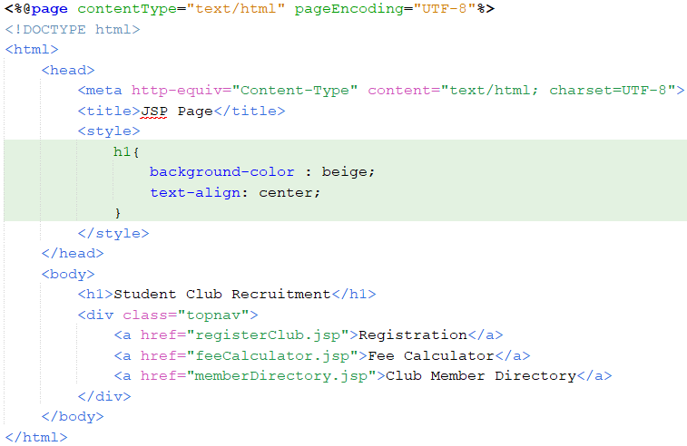
footer.jsp
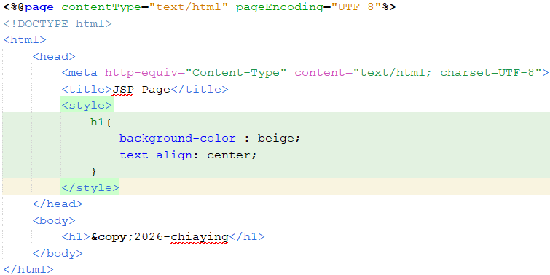

registerClub.jsp
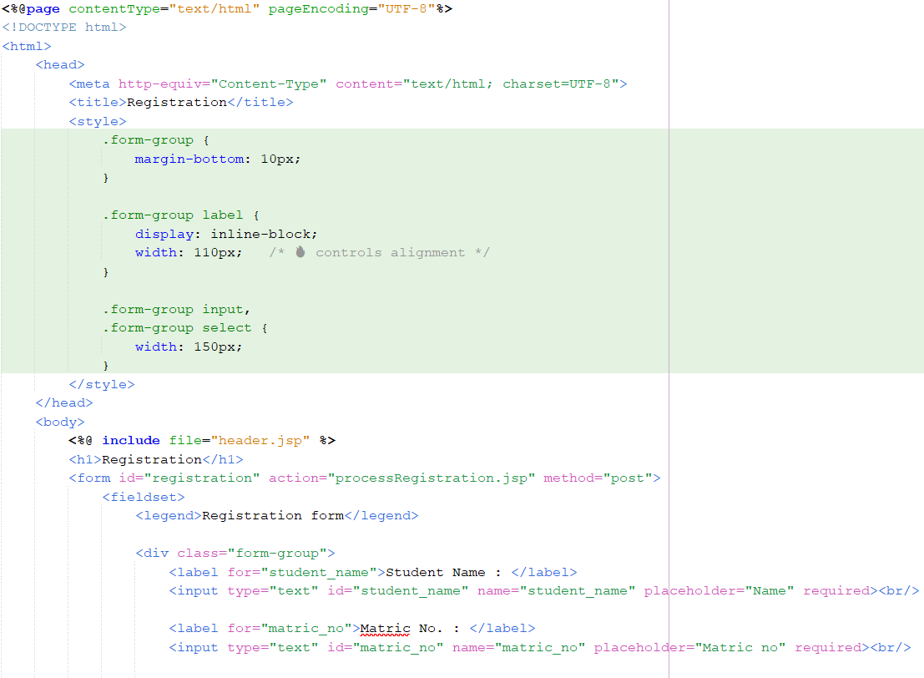
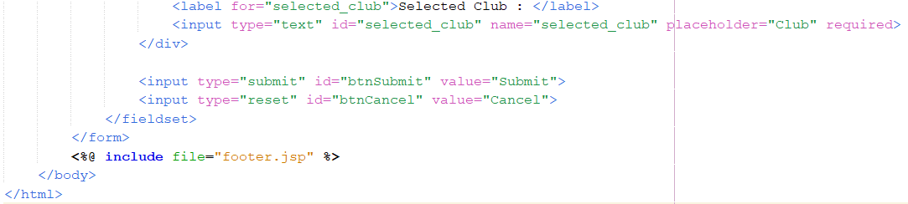

processRegistration.jsp
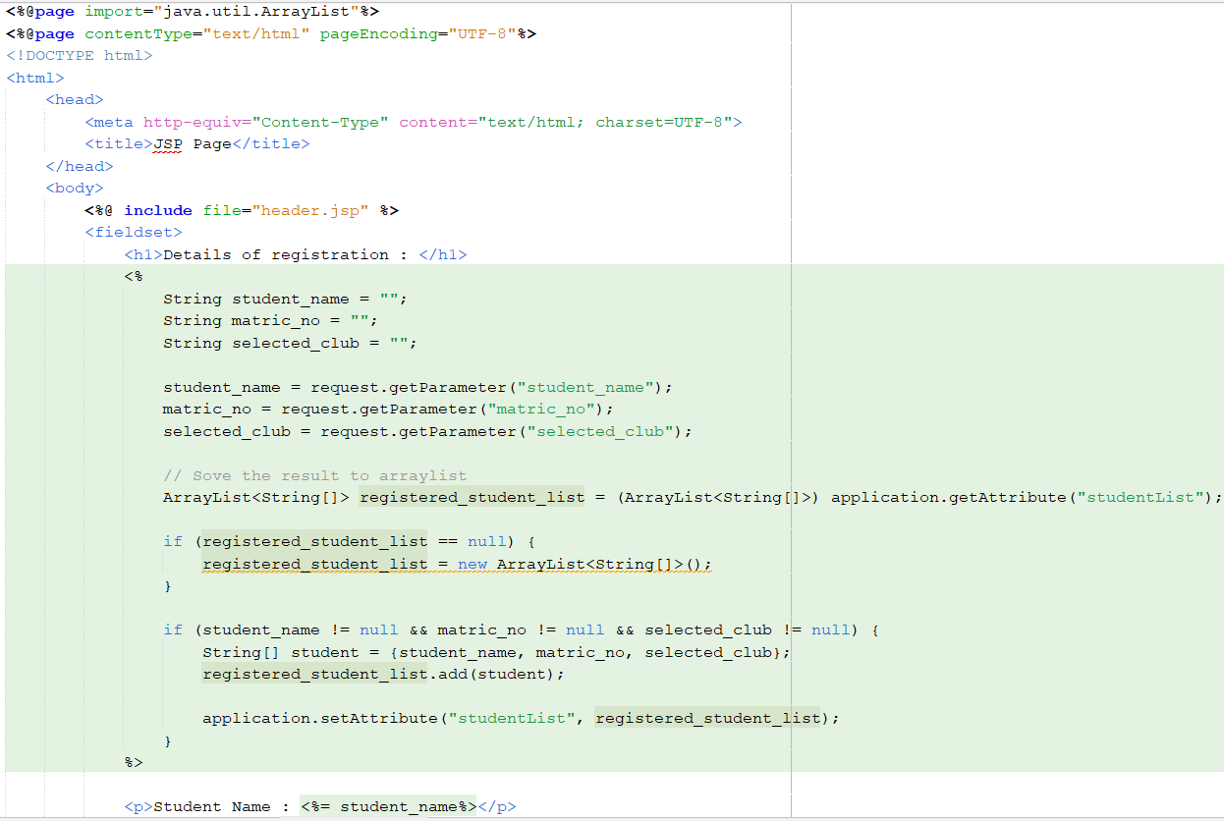
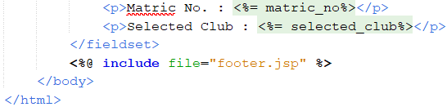
feeCalculator.jsp
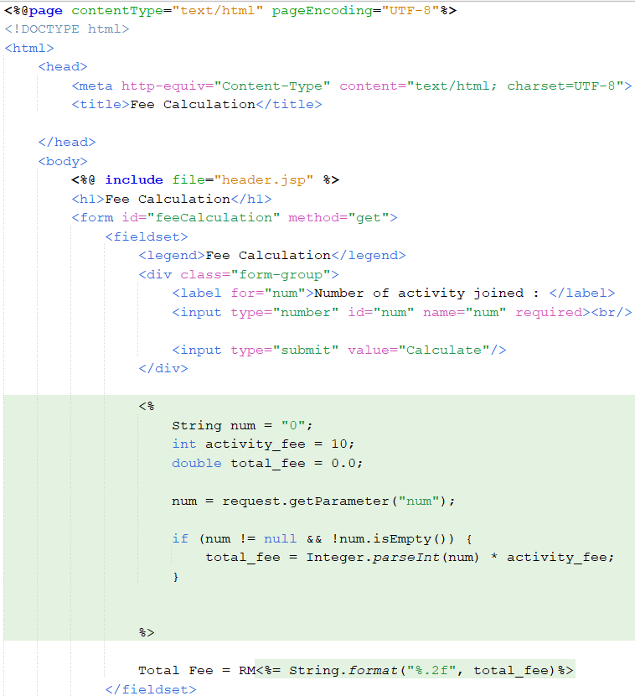
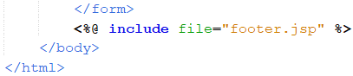
memberDirectory.jsp
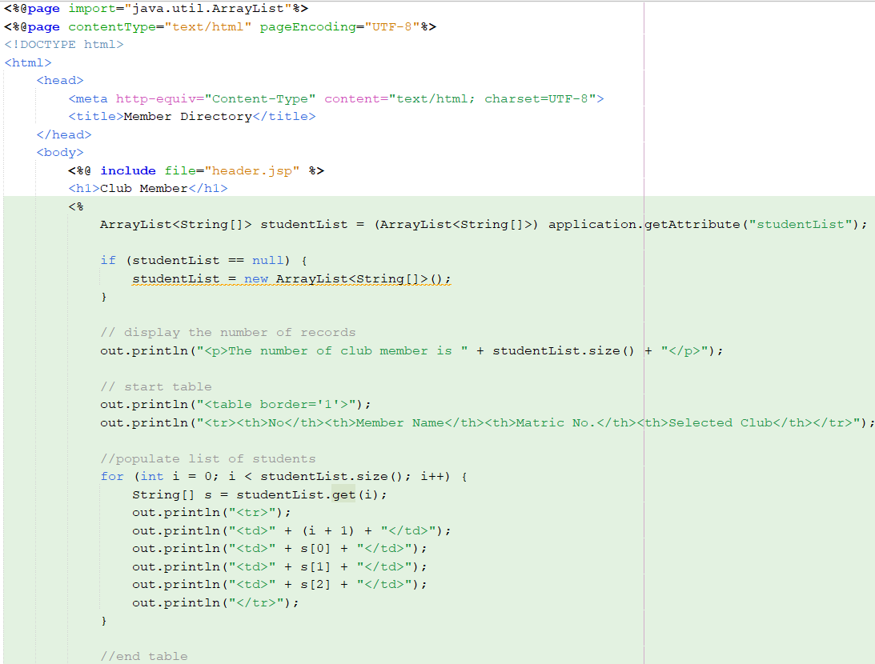
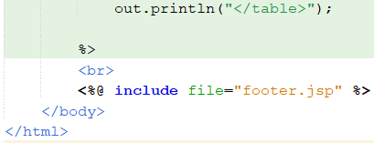

Output
